

# Practices for Secure Software Report

Table of Contents

Document Revision History 3

Client 3

Instructions 3

Developer 4

1. Algorithm Cipher 4

2. Certificate Generation 4

3. Deploy Cipher 4

4. Secure Communications 4

5. Secondary Testing 4

6. Functional Testing 4

7. Summary 4

8. Industry Standard Best Practices 4

## Document Revision History

| **Version** | **Date** | **Author** | **Comments** |
| --- | --- | --- | --- |
| **1.0** | **06/23/2024** | **Devin Wheeler** |  |

## Client



## Instructions

Submit this completed practices for secure software report. Replace the bracketed text with the relevant information. You must document your process for writing secure communications and refactoring code that complies with software security testing protocols.

* Respond to the steps outlined below and include your findings.
* Respond using your own words. You may also choose to include images or supporting materials. If you include them, make certain to insert them in all the relevant locations in the document.
* Refer to the Project Two Guidelines and Rubric for more detailed instructions about each section of the template.

## Developer

Devin Wheeler

## Algorithm Cipher

For securing Artemis Financial's application, I recommend using the Advanced Encryption Standard (AES) algorithm. AES is a widely trusted encryption algorithm used globally for securing sensitive data. It supports key sizes of 128, 192, and 256 bits. This makes it highly secure and versatile. AES operates on symmetric key encryption, meaning the same key is used for both encryption and decryption, which simplifies the process while maintaining security. The algorithm also utilizes random numbers to generate unique encryption keys, enhancing its security. Historically, AES replaced the older DES algorithm due to its superior strength and efficiency, and it continues to be the standard for encryption in both government and private sectors.

## Certificate Generation

Insert a screenshot below of the CER file.

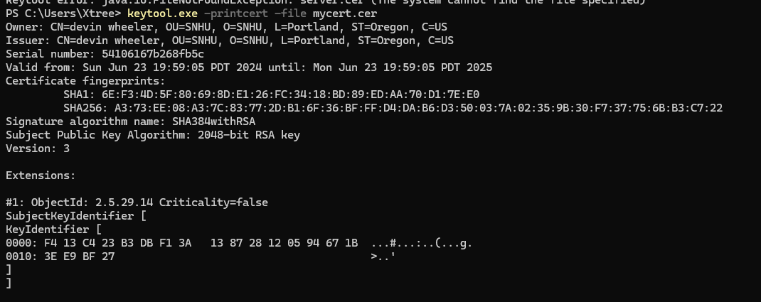

## Deploy Cipher

Insert a screenshot below of the checksum verification.

## Secure Communications

Insert a screenshot below of the web browser that shows a secure webpage.

## Secondary Testing

Insert screenshots below of the refactored code executed without errors and the dependency-check report.

## Functional Testing

Insert a screenshot below of the refactored code executed without errors.

## Summary

The code for Artemis Financial's application has been refactored to enhance security and ensure compliance with security testing. Refactoring helped areas identified in the vulnerability assessment process, such as cryptography and client/server. The implementation of the SHA-256 hashing algorithm enhances data integrity by generating checksums that can detect any changes to the data. Additionally, the application was configured to use HTTPS, providing secure transmission of data and preventing theft. By adding these layers of security, we strengthened the overall security of the application, helping align it with industry-standard best practices to protect sensitive information and ensure security measures are in place.

## Industry Standard Best Practices

Applying industry-standard best practices for secure coding was important in stopping known security vulnerabilities. These practices included the use of well-established cryptographic algorithms and ensuring secure communication protocols. By maintaining existing security measures and adding new layers of protection, the application’s overall security was enhanced. This approach helps the long-term safety and integrity of Artemis Financial's data and operations.