Submitted by – B.G Devinda Kavishka
CL/HDCSE/CMU/125/48
Lecture – Ms.sandali
CSE5009 – Web Application

3rd semester Assignment

Qualification |  | Module Number and Title
HD in Computing and Software Engineering/ HD in Network technology and Cyber Security |  | Web Application- CSE5009 “Web Development”
Student Name & No. |  | Assessor
Devinda kavishka No CL/HDCSE/CMU/125/48 |  | Ms. Sandali
Hand out date |  | Submission Date
2025-07-23 |  | 2025-09-12
Assessment type  WRIT1-Coursework | Duration/Length of Assessment Type  1month &19 days (3000 Words) | Weighting of Assessment  100%
Assignment Cover Sheet

Learner declaration

I Devinda Kavishka CL/HDCSE/CMU/125/48…………………………………………………<name of the student and registration number>,
certify that the work submitted for this assignment is my own and research sources are fully acknowledged.

Marks Awarded
First assessor
IV marks
Agreed grade
Signature of the assessor |  | Date
Feedback Form
International College of Business & Technology
Module: Web Development CSE5009
Student:
Assessor:
Assignment: Develop Website & Analyzing
Strong features Of Your Work
Area for improvement
Marks Awarded



Submitted by – B.G Devinda Kavishka
CL/HDCSE/CMU/125/48
Lecture – Ms.sandali
CSE5009 – Web Application

Web Application & Development

Acknowledgement

For their invaluable advice continuous encouragement and helpful feedback during the creation process I am also incredibly grateful to my instructor and my friends. Their knowledge and experience greatly improved the Quality of this work.

Executive Summary

An interactive web-based application has been developed by the green life wellness center an important health and lifestyle organization Colombo with goal of improving its online visibility and providing holistic wellness services more successfully. The goal of this project is to develop a comprehensive platform that combines efficient service administrator with crucial information regarding wellness practices.

Table of Contents
Acknowledgement 5
Executive Summary 6
Introduction 8
Task 1 8
Analyzing website before creating new website because of refer another websites Strength and weakness. 8
Task 1 9
B .Site Map 13
Task 2 14
Green Wellness Services Website – UI Plan 14
Information Architecture (Sitemap) 18
Technologies 19
Task 3 26
Testing Overview 26
Test Plan 28
Test Cases 30
Conclusion 34
Reference 35

Turnitian Report

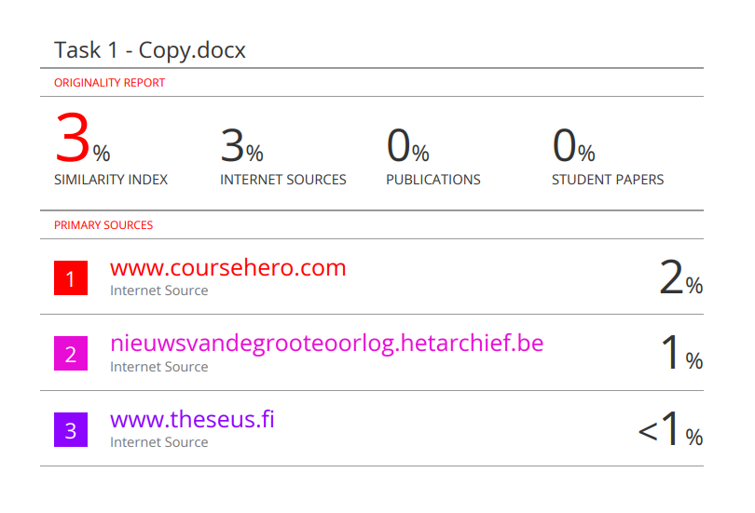

Introduction

Task 1

Analyzing website before creating new website because of refer another websites Strength and weakness.

Task 2
Describe UI plan and implementation back-end functionalities.

Task 3
Website test overviews, test plan and test case.

Task 1

- I will be creating website and Green Life wellness center for Health Management System. All task and functions. So, I am comparing with another website about same topic.
- I am comparing those websites weakness points, user-friendly interfaces and User logins forms etc.

Web site criteria (Ayurveda.com) | Description
Design | Design interfaces are good and colors matching are really good  Typography –Font Families are very clear and calming  Font Size looking good but typography lack modern accessibility standards for small font’s mobile phone.  Visual Balance- Layout structure is good desktop but not suitable for smart phones and some images are very large.
UX | Navigations- clear top navigation bar with drop down menu  Mobile Responsive- The site is averagely responsive but image sizes and buttons are very large.  Page Load time –very past  Search functionality – Lacks any internal Search bar so some users not attractive this website and users should be time wasted for take some information.
Features | Informal Only No user login forms and booking system, respond message filed.
Strengths | Visual Design – Earth and calming color scheme that matches Ayurveda branding.  Creative logo and consistent font use.  User interfaces – Well labeled menu and centered layout easy to use navigation bar.  Functionality – Provide comprehensive information for Ayurveda and Education and Article blogs.  Responsiveness – Desktop users for very suitable Application.  Accessibility – Basic Navigation
Weakness | Visual Design – Some sections space between not consistent.  User interface – Some font sizes are small on phone  Functionality – Not Include internal search functionality on website.  Responsiveness – Mobile users for no suitable There are so many reasons  Ex- Image and button Sizes are large.

Web site criteria (MindBodyGreen.com) | Description
Design | Design interfaces color scheme feels attractive to the eye Both Desktop & Mobile application have different font families and not followed suitable typography. Text sizes should be small for mobile phone.  Typography –Fonts are well chosen and understandable the body and text work with very well but no use suitable guidelines & rules for mobile phones.  Font Size looking good but typography lack modern accessibility standards for small font’s mobile phone.  Visual Balance- Layout structure is good desktop but not suitable for smart phones and some images are very large.
UX | Navigations- With dropdown menu for categories the website main navigation bar is simple use.  Mobile Responsive- The website is responsive to some level while it functions on mobile device connecting on smaller screen is challenging due to the big buttons and large image.  Page Load time –very past  Search functionality – Lacks any internal Search bar so some users not attractive this website and users should be time wasted for take some information.
Features | The website main task is providing information. interactive answer forms, appointments, scheduling and user login systems are missing.
Strengths | Visual Design – Earth and calming color scheme that matches Ayurveda branding.  Creative logo and consistent font use.  User interfaces – Well labeled menu and centered layout easy to use navigation bar. And desktop experience is very smooth.  Functionality – Provide comprehensive information for Ayurveda and Education and Article blogs.  Responsiveness – Desktop users for very suitable Application.  Accessibility – Basic Navigation
Weakness | Visual Design – Some sections space between not consistent.  User interface – Some font sizes are small on phone  Functionality – Not Include internal search functionality on website.  Responsiveness – Mobile users for no suitable There are so many reasons  Ex- Image and button Sizes are large.

B .Site Map
Home

Services

About US

Contact

Sign up

Login
Therapy

Yoga

Neutralization

Physiotherapy

Company Desc

Our vision

Our Mission

Client

Admin

Therapist

Appointment Schedule

Programs Register

Submit Inquiries

View Message

Review client profile and edit

Manage appointment

Follow inquires & response

Therapist Register

Review client profile

Manage appointment

Follow inquires & response

Task 2

Green Wellness Services Website – UI Plan
I am Created Website for this Company and Research lot of websites weakness points so I could Identified issues there are Search functionalities Issue, not include booking requests forms. Because I am Include all task in my website. And this website has different roles there are Clients, Admin, and Therapists. Includes Databases and clean codes all forms for website.

- Object and Success Criteria
Primary goal
- Increase awareness health issues and improve your online Presence.
- Already added Submit Inquiries form and Client and Therapists communication.
- Give Client, Therapists, and administrator access to safe role-based parts.

- User Permissions
Include different types of roles there are Client, Admin and therapists
Client Task
- Appointment Scheduling – This task is for Created a form with the Therapist’s Name, booking date and time slot Drop down so the clients could book an appointment and All Clients Booked Appointments data displayed on the admin dashboard or therapist dashboard so all data is managed Admin, Therapist. and data Saved with the Database.

- Wellness Programme Register - I created a wellness programme list and clients can register for all Programs and this task created form Validation with customer name, phone number, email and service list (drop down). and all data saved with the database

- Submit Inquiries- Customers can send inquiries for this task. our programs and our services. this task, I created a form with input fields for customer name, email, contact number, inquiry text area and all data is saved in the database.

- View Message Responds – Customers send inquiries, and all inquiries are viewed by the admin and therapist Following these inquiries and they respond to the inquiries so fetching the data table from the database and clients can see the response message.

Admin Task
- Review Client Profile – Fetch data from the table created in the database and display that data in the admin dashboard as a table.so admin can access clients’ details update. Update button clicks after open sign in form and includes all the database data on input fields.

- Manage Appointments – Fetch data from the table created in the database and display that data in the admin dashboard as a table and add with table edit button click after open booking form with all data include input fields.

- Follow Up Inquires - Fetch data from the table created in the database and display that data in the admin dashboard as a table and last row add normal form with send response button.

- Register Programme Clients - Admin has access clients register our programs and services.

Therapist Task
- Review Client Profile - Fetch data from the table created in the database and display that data in the therapist dashboard as a table no access clients Profile data update.

- Manage Appointments -– Fetch data from the table created in the database and display that data in the therapist dashboard as a table and add with table edit button click after open booking form with all data include input fields.

- Follow Up Inquires -- Fetch data from the table created in the database and display that data in the therapist dashboard as a table and last row add normal form with send response button.

Information Architecture (Sitemap)

Public
- Home
- About
- Services
- Contact
- Footer

Home
- Displays a welcome Message introducing our business.
About
- Contains a brief description our company and include our vision and mission statement.
Service
- Include our company Services There are Yoga, Neutralization, Massage therapy etc.…

Signup Form
- A user registration form with input fields and signup button and allows new users to register with the system.

Login Form
- Allows registered users to log in using their username and password.

- A search functionality to help customer easily find information within the system.

- Footer includes quick links and some information there are our location, address, telephone no, our company open and close time.

Technologies

Front end-technologies

HTML

- Web pages are structured using Html stand Hypertext markup language.
- Heading, Paragraphs, buttons, form, links are among elements that it identifies.
- Making a form or style area for your website, for instance

CSS

- Html elements layout and appearance can be changed with CSS
- Colors, fonts, spacing, and responsive design may all be added using it
- Such as styling button to make it appear modern and attractive.

JavaScript

- JavaScript is a scripting language used to create a dynamic and interactive features.

Back end Technologies
- Php is very important for create website. Developer makes a website includes forms and there are register, login, contact us etc. so customer can interact with website and customer can inputs all details in these forms text fields. Customer all data saved with database so these tasks are doing with PHP.

- It manages form submissions, user authentication and data processing and database communication.

b. Database Implementation for backend features
- User Authentication form – This task I am used Registration form and Login form.

- Sign up form
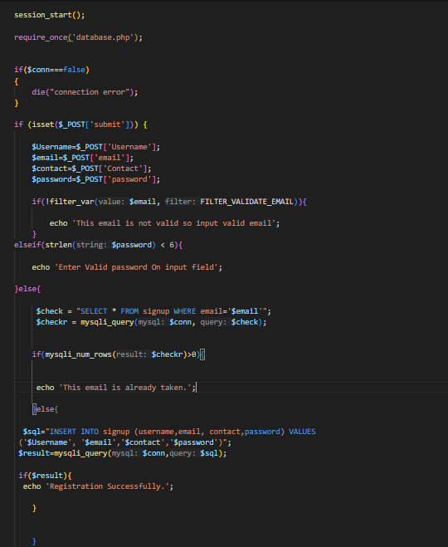

In order to manage user registration and php script gather data from an html verifies it looks for duplicates and entire then it into a database. It user database. Php to include database connection and session start for managing user data. If the database connection is unsuccessful this script terminates execution. After data insert and before check email is valid and password length is correct .if all information’s are corrected display message Registration successfully.
- Login form
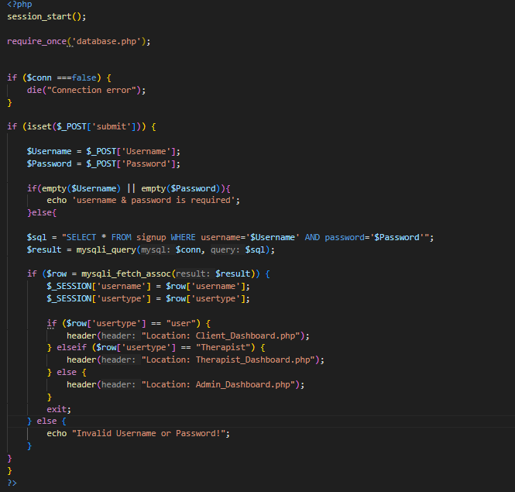

In order to manage Login Data match with database and php script gather data from an html verifies it looks for username password are not empty. It user database. Php to include database connection and session start for managing login data. If the database connection is unsuccessful this script terminates execution. After select user name and password into a database after result variable data include in database after this result variable data fetch row variable if user type is user open client dashboard and user type is therapist open therapist dashboard or open admin dashboard because of all data should be matched with database no matched data with database display error message invalid username or password.

- Client Dashboard

- Client main task appointment scheduling for green wellness services and then admin and therapist manage them so I am used database table data fetch with form and save button click after update all data in database.
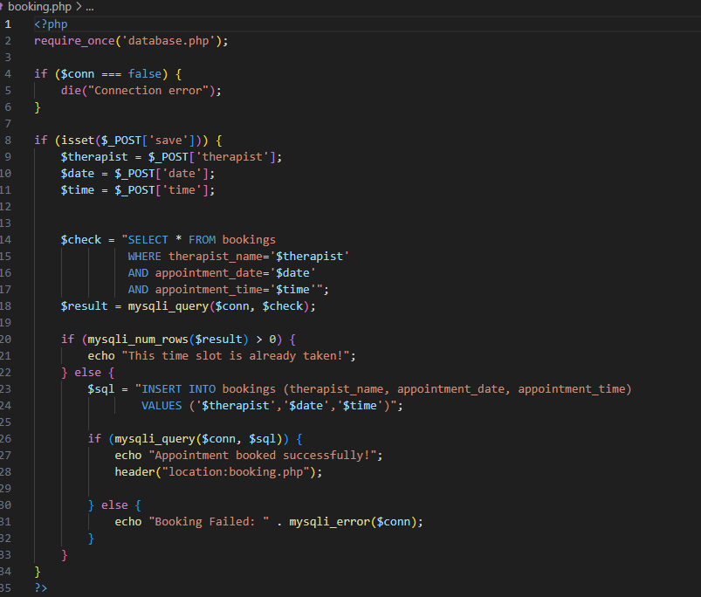

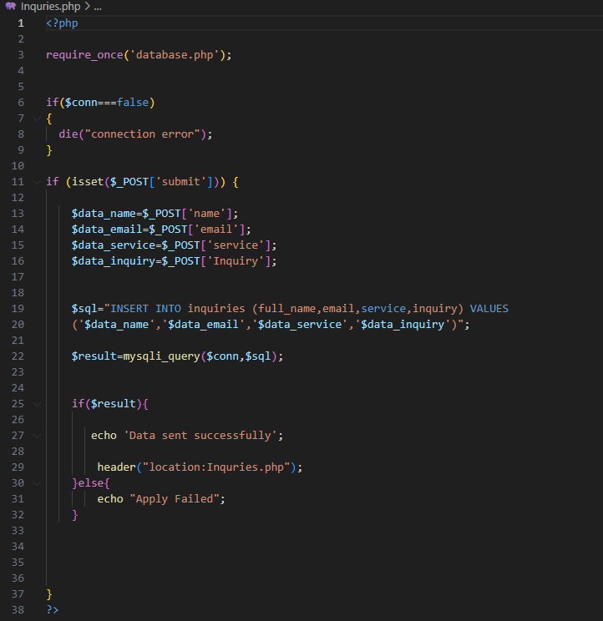
- Client Dashboard another task is Submit inquiries for Green Wellness Services and this inquiries for doing response admin and therapists.

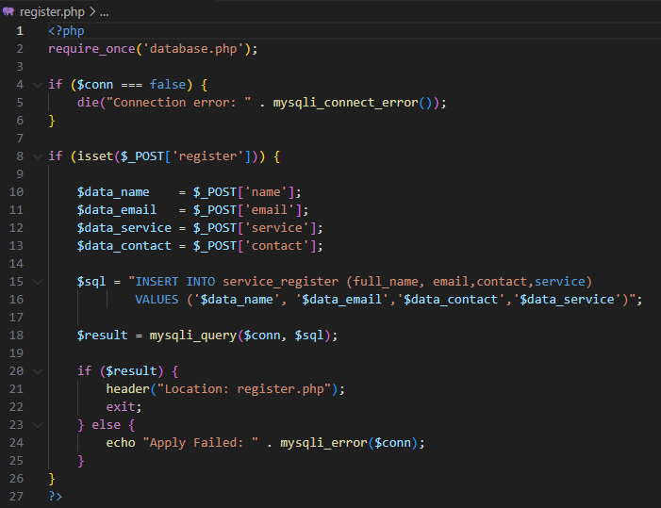
- Clients can register wellness programs in green wellness company.

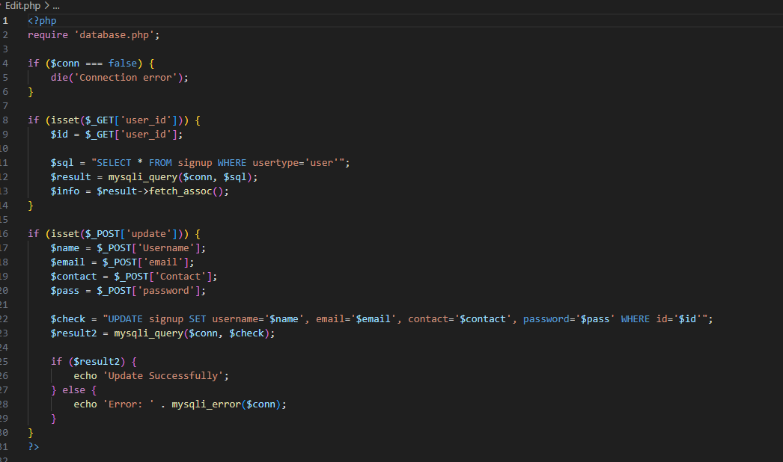
- Admin Can client profile manage

Task 3

- Project – Green wellness center – web Application
- Type – Manual Testing
- Purpose – I need verify that all website functionalities working correctly with different user roles (clients, therapist, Admin) without the use of automated tools.

Testing Overview

- A key phase in development process testing verifies that website function properly is safe easy to use and satisfies the needs of all user roles including clients, therapists, administration staff.
- The Manual testing primary goal is to simulate actual user behavior in order to verify that the web application is operation as designed. Inquiries therapist dashboard, appointment scheduling, user registration, login and admin controls are just few of the elements that will be tested for usability, accuracy and error management.

- Scope of Testing

- Manual Testing will cover all areas.

Functional Testing – Forms for user registration and login, booking and rescheduling appointments, submitting and managing inquiries the administrator manages the client’s profile and the therapist has access to it. User management, service registration, Inquiries response, customer booking data management and more are admin features.

Clients’ features – Booking Appointments, Wellness Programs register, submit inquiries and view admin and therapist response message list.)

Validation Testing – Verifying form validations for clients, administrators and therapists. Form validations for clients’ dashboards include making appointments, registering for wellness programs, submitting questions and verifying all necessary fields.

Username, email, contact information, password and questions are the input types. An error message if the input is not correct.

Testing for compatibility with several browser (chrome, Firefox, Edge).
Compatibility of Device (windows).

Test Plan

- Project – Green wellness center – web Application
- Type – Manual Testing
- Ready for – Lifestyle health types of web platform
- Testing – Functional user interface, usability, basic security and compatibility.

- Test plan objective

- In order to make sure the green life wellness Center online application satisfies functional, usability and security criteria for all users rolls based access clients, therapists, administrator this manual test plan aims to specify the scope, strategy time table and responsibilities testing.

- Scope of testing

- User registration and login
- Appointment Booking Management
- Submitting questions and response
- Therapist and admin access review client profiles then admin add another similar feature admin can update clients profile details.
- Important testing task in role base access control.
- Input validation
- Search functionality for health service and content.

- Testing Items

- Features that will be put to the test features of the module role handling ,password validation ,login and user management registration schedule booking ,viewing ,updating assignment of the therapist answering inquiries asking , viewing and responding admin and therapist profile of the client view /edit personal information view client records and answer questions via the therapist portal.Admin portal all user can see control the therapists management of services from layout ,button actions and ui/ux navigation filtering of material and search services and basic security form input validation and session time out.

Testing Strategy
- The staging/test environment will be manually tested against a range of device and browsers. We used the following techniques.

- Black box testing – Pay attention to input and expected results.
- Positive testing – Confirm that valid input behaves correctly.
- Negative testing – Verify system behavior using invalid inputs through.
- Make sure users have right access according to their jobs by using role-based testing.

Test Cases

- Sign up form test case
Test No. | Test Situation | Test methods | Test information | Expected Results
TC 01 | Registration successful | Signup forms open  Include valid inputs  Submit of form | Username -Devinda  Email-devinda23@gmail.com  Contact -0761240025  Password -123456 | Registration Successfully.
TC 02 | Not Valid emails | Include valid input on text field and after submit. | Username -Devinda  Email-devinda23gmail.com  Contact -0761240025  Password -123456 | This email is not valid so input valid email.
TC 03 | Weak Password | Enter a password that is less than six characters. | Username -Devinda  Email-devinda23@gmail.com  Contact -0761240025  Password -123 | Enter Valid password  On input field
TC 04 | Entry Duplicate email | User already register with email | Username -Devinda  Email-devinda23@gmail.com  (already in db.)  Contact -0761240025  Password -123456 | Display error message This email is already taken.

Login Form Test cases

Test ID | Test Scenario | Test Steps | Test Data | Expected results
TC 01 | Successful Login with user | Open login form  Input username & password and submit | Username – Devinda  Password -7890 | Mover a client  Dashboard
TC 02 | Successful Login with therapist | Open login form  Input username & password and submit | Username – Yohan  Password -12345 | Mover Therapist  Dashboard
TC 03 | Successful Login with Admin | Open login form  Input username & password and submit | Username – Deshan  Password -12345678 | Mover a Admin  Dashboard
TC 04 | Not valid Username | Your Input user name is not in DB. | Username – Dkavishka  Password - 7890 | Invalid username or password
TC 05 | Not valid password | You include username is valid but password is wrong. | Username –Devinda  Password -67890 | Invalid username or password.
TC 06 | Empty validation input fields. | Be sure to leave the  Username and or password unfilled. | Username or password fields are blank. | Username and  Password is required.

Client Programs register
Test ID | Test Scenario | Test Steps | Test Data | Expected results
TC 01 | Successful service registration. | Fill out the form all input field in correctly and after submit. | Name-Devinda  Email–devinda23@gmail.com  Contact -0761240025  Service –yoga | Registration successfully for wellness programs
TC 02 | Absence  for necessary fields | Leave at least one field empty and send in | Name-  Email–devinda23@gmail.com  Contact -0761240025  Service –yoga | The form should not be submitted and the browser displays a warning about needed fields.

Question Submitting form test case
Test ID | Test Scenario | Test Data | Expected results
TC 01 | Provide accurate information | Full name-Devinda kavishka  Email – devinda23@gmail.com  Services - yoga  Inquiry –Date change | Data Insert Successfully.
TC 02 | A necessary field  Is missing | Full name-Devinda kavishka  Email –  Services - yoga  Inquiry – booking date change | Please fill out this field.
TC03 | Email type is incorrect | Full name-Devinda kavishka  Email – devinda23gmail.com  Services - yoga  Inquiry – booking date change | Not valid email

Booking Appointment form test cases
Test ID | Test Scenario | Test Data | Expected results
TC 01 | The Booking was successful | Name of therapist-therapist 1  Date – 2025-09-06  Time -9.00 -9.30 | All data saved in database and Appointment booked successfully.
TC 02 | Booking for double admission | Name of Therapist-therapist 1  Date – 2025-09-06  Time -9.00 -9.30 | This time slot has been already reserved.
TC 03 | Therapist is different and data and time slot are same. | Therapist name-therapist 2  Date – 2025-09-06  Time -9.00 -9.30 | Appointment booked successfully.
TC 04 | Blank Date field | Therapist name-therapist 4  Date –  Time -9.00 -9.30 | Please select an item this list. And please fil out this field.
TC 05 | Blank time field | Therapist name-therapist 5  Date – 2025-09-09  Time - | Please select an item this list.
TC 06 | Blank therapist field | Therapist -  Date – 2025-09-06  Time -9.00 -9.30 | Please select an item this list.

Conclusion

An important step toward using digital transformation to improve client satisfaction and improve operational efficiency is suggest interactive web application for green wellness center. The program will function as a comprehensive solution created to need clients, therapists and administrative staff by combining detailed wellness information, service booking secure user administration. And I am creating Three dashboard with secure role.

Reference

https://ayurveda.com/
https://www.mindbodygreen.com/
https://www.browserstack.com/guide/test-plan-vs-test-case

