1. Need more Clerification on this.

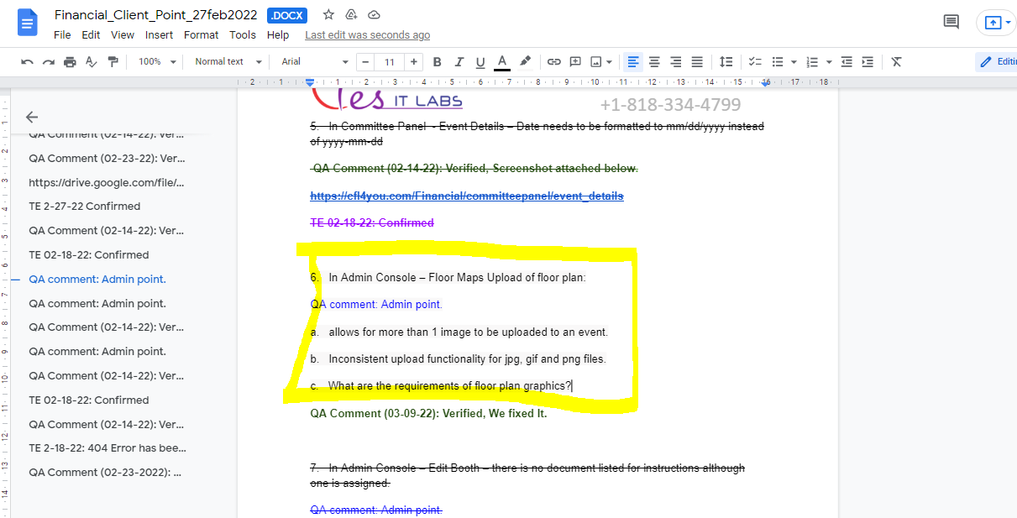  
  
  
  
2. New Change Request: 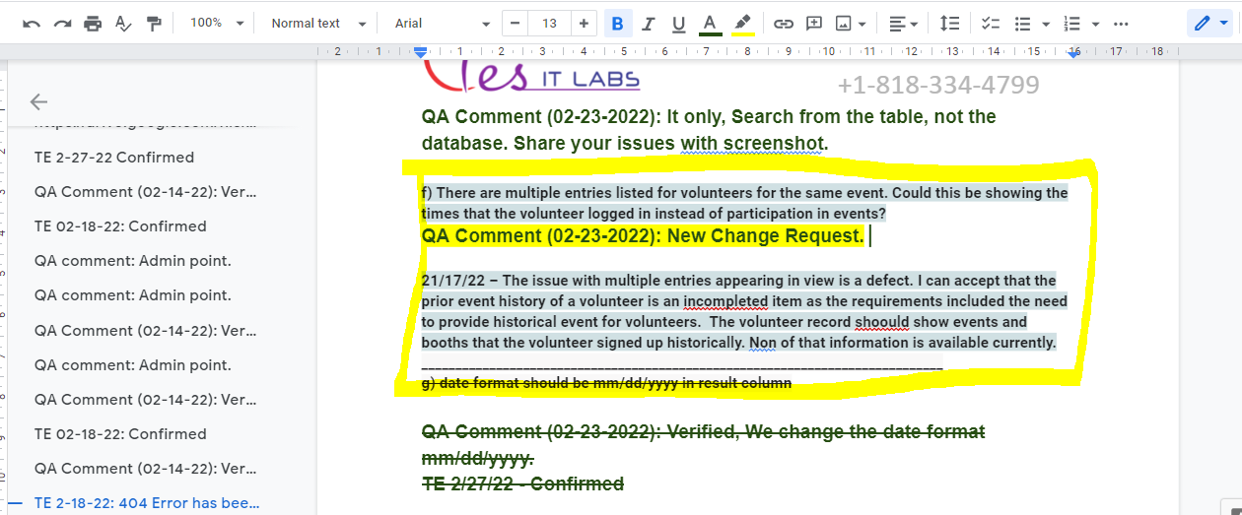  
  
**f) There are multiple entries listed for volunteers for the same event. Could this be showing the times that the volunteer logged in instead of participation in events?  
  
Dev comment : In this I do not understand what list they are talking about, is they are talking about the list of management of volunteers or the history of volunteers.  
  
  
21/17/22 – The issue with multiple entries appearing in view is a defect. I can accept that the prior event history of a volunteer is an incompleted item as the requirements included the need to provide historical event for volunteers.  The volunteer record should show events and booths that the volunteer signed up historically. Non of that information is available currently.  
  
Dev comment :Which view are you talking about, do you want to show volunteer history only when there are booths or events assigned to that volunteer?**