Part One Extra Credit | Least Runtime, Longest Waiter
The policy selected for SCHED_OTHER is similar to a fair scheduler which ranks tasks by how little CPU they have consumed but gives interactive, I/O-dependent tasks an increased priority by boosting their allocated I/O time.
We define an other_wait_bonus(…) method to allow long-waiting tasks the ability to gradually gain higher priority. In our research, we find this method is similar to a lightweight multi-level feedback queue that tracks per-task runtime instead of discrete queues. This method combines historical wait time (sinfo.wait_time) in addition to ongoing waits (last_wait_tick) then divides by a constant – arbitrarily chosen to be four (or a right shift of two) – to normalize magnitude with respect to other tasks and priorities. Tasks with a higher wait bonus will take priority over other tasks with a similar runtime.
Our scheduler utilizes other_effective_runtime to provide an effective runtime that considers both the total CPU time the process has been running for (sinfo.execution_time) and I/O time (sinfo.io_time). This provides a metric that is lower for interactive or I/O-dependent tasks so they are picked before CPU-intensive tasks even if both utilize SCHED_OTHER.
To uphold the nature of least runtime, longest waiter, proc_is_better will pick a task with a smaller effective runtime over a task with a longer effective runtime. If the effective runtimes are tied, then we prioritize the one with a longer wait bonus. If this also results in a tie, then we fall back to the RR sequence token and finally PID.
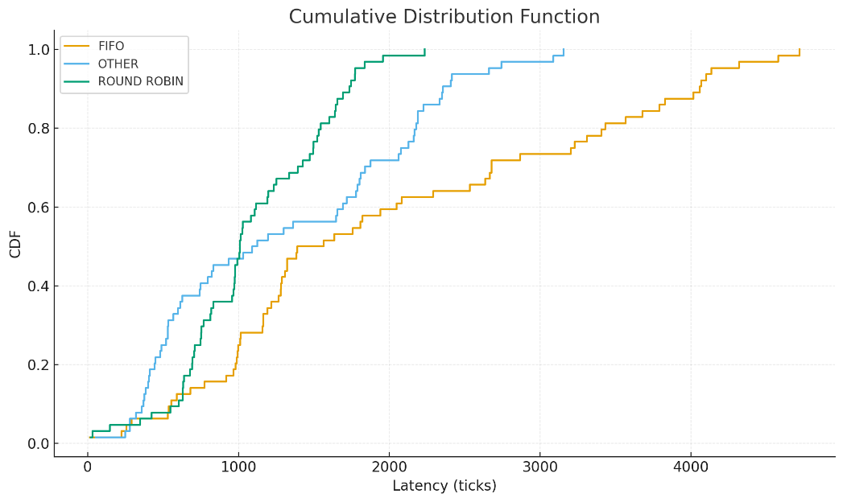
The results of our scheduler are pictured below. The results suggest a performance between RR and FIFO, but closer to that of RR. We find that SCHED_OTHER has a better initial performance but, with many CPU-intensive tasks, the wait-ageing cannot prevent a long tail. We find RR slices the CPU every tick, so no task waits long, thereby mitigating the tail. With FIFO, we trivially find one long job blocks everyone, contributing to overall latency – not only on the tail end. More shorter, I/O-dependent tasks may provide better results for SCHED_OTHER.

