

**AIRLINE RESERVATION SYSTEM**

**Software Requirement Specification (SRS) Document**

**Sprint 1 Implementation**

**Project Timeline: 20.10.2022 to 27.10.2022**

**INDEX**

1. Introduction

1.1 Purpose ------------------------------- 4

1.2 Intended audience ------------------------------- 4

1.3 Intended use ------------------------------- 4

1.4 Scope ------------------------------- 5

2. Overall description ------------------------------- 5

2.1 Assumptions and dependency ------------------------------- 6

3. System feature and requirements ------------------------------- 6

3.1 Functionality

3.1.1 F01-> Admin Login ------------------------------- 6

3.1.2 F02-> Add Customer ------------------------------- 6

3.1.3 F03-> Display Customer Details ------------------------------ 7

3.1.4 F04-> Search Customer Details ------------------------------ 7

3.1.5 F05-> Add Flight ------------------------------7

3.1.9 F09-> Display flight Details ----------------------------7

3.1.10 F10-> Search flight Details -----------------------------7

3.2 Technical Requirements ---------------------------8

3.2.1 TR01-> C Programming language -------------------------- 8

3.2.2 TR02-> Files input/output operation ------------------------------ 8

3.2.3 TR03-> Use Data Structure and

dynamic memory allocation ------------------------------ 8

3.3 Non Functional Requirements

3.3.1 NFR01-> Makefile ------------------------------ 8

3.3.2 NFR02-> Valgrind tool ------------------------------ 8

3.3.3 NFR03-> Ctags ------------------------------ 8

3.4 System Features --------------------------------8

4. Data Flow Diagram

4.1 DFD level 0 ------------------------------- 9

4.2 DFD level 1 ---------------------------------10

1.**Introduction**

Airline reservation systems were first introduced in the late 1950s as relatively simple standalone systems to control flight inventory, maintain flight schedules, seat assignments and aircraft loading. The modern airline reservation system is comprehensive suite of products to provide a system that assists with a variety of airline management tasks and service customer needs from the time of initial reservation through completion of the flight.

One of the most common modes of travel is travelling by air. Customers who wish to travel by air nowadays have a wide variety of airlines and range of timings to choose from. Nowadays competition is so fierce between airlines that there are lot of discounts and a lot of luxuries given to customers that will give an edge to the airline.

The World Wide Web has become tremendously popular over the last four years and currently most of the airlines have made provision for online reservation of their flights. The Internet has become a major resource for people looking for making reservations online without the hassle of meeting travel agents. My project intends to Serve these purposes. It intends to check all the available airline databases and return a string of results, which can help them in their travel plans.

**1**.**1 Purpose:**

The main purpose of this software is to reduce the manual errors involved in the airline reservation process and make it convenient for the users to book the flights as when they require such that they can you utilize this software to make reservation.

The name of the software is “Airline Reservation System”. This software provides options for viewing different flights available with different source and destination for a particular date and provides admin with the facility to book a ticket to the customers request.

**1.2 Intended Audienc**e:-The document is intended to be read by, Client.

**1.3** **Intended Use: -**

* Development Team
* Maintenance Team
* Clients

Since this a general-Purpose Software any one can access it.

**1.4** **Scope: -**

Airline Reservation System is one the modifications that were carried out in the Passenger Service. System so that the working and availability of Service area can be broadened. This is basically an interface of Global distribution System to carry out reservations on the desired airline from any place. Airline Reservation System make the life of passengers very easy as they don’t need to stand in queues for getting their seats reserved and they can easily make reservations on any airline just from a single system. On the other hand, it also removed an extra burden from the Airline Department as most of the passengers and travel agencies use this service instead of making reservations from the counters.

1.The software will display view of customer and flight details of every reservation.

2.For security and privacy of the reservation, the Airline Reservation System comply only admin with different access level.

3.The system will store and recognize customer flight reservations.

**2. Overall Description: -**

Airline reservation systems are systems that allow an airline to sell their inventory. It contains information on schedules and contains a database of reservations which contains passenger name records and of tickets issued. Airline reservation system are part of [passenger service systems](https://en.wikipedia.org/wiki/Passenger_service_system) , which are applications supporting the direct contact with the passenger.

Airline Reservation System eventually evolved into the [computer reservations system](https://en.wikipedia.org/wiki/Computer_reservations_system). A computer reservation system is used for the reservations of a particular airline and interfaces with a [global distribution system](https://en.wikipedia.org/wiki/Global_distribution_system)  which supports travel agencies and other distribution channels in making reservations for most major airlines in a single system

**2.1 Assumptions and Dependency: -**

* System should have any flavor of Linux installed.
* System should have either 4GB or more RAM.
* The service is used preferably on a desktop or laptop.

**3.System Features and Requirements: -**

* 1. **Functionality:**

**3.1.1 F01-> Admin Login.**

int admin( ) : It will check for the admin credentials. This is the function that is built in the Airline Reservation System to log in as admin, It requires both username and password to get admin access.

void menu_admin():It will display the menu for admin

This is the function which is used to display the menu for admin which contains

1. Book the tickets
2. Flights
3. Exit

**3.1.2 F02-> Add Customer.**

The function void addcustomer( ) helps in adding the customer details. This function is used to add details of the customer like customer ID, age, source city, destination city ,travel date and number of seats required.

**3.1.3 F03-> Display Customer Details**:

The function void displaycustomer( ) displays customer details. This function is used to display the details of the customer Id, Customer age, source and destination city, travelling date, Number of seats.

**3.1.4 F04-> Search Customer Details:**

Thefunction void searchcustomer( ) helps to search and display the customer detailsThis function is used to search and display the details of the customer . Based on the customer Id the details are displayed.

**3.1.5 F05-> Add Flight:**

This function void addflight( ) helps in adding the flights. This is the function which is used to add flights, the requirements to add flights are

( a ) Name of the flight

( b ) Name of the source city

( c ) Name of the destination city

( d ) Number of seats available

The above are the required data to add a flight.

**3.1.6 F06->Display Flight Details**:

This function void displayflight( ) displays flight details. This is the function which displays the flight details like flight name, flight number, name of the source city and also destination city with number of seats available.

**3.1.7 F07->Search Flight**

This function void searchflight( ) will helps in searching flights. This is the function which is used to search a flight using the flight number. It displays the flight name, destination city and also number of seats available.

**3.2 Technical Requirements: -**

1. C programming language
2. Use file input/output operations to read and write the data from the different files.
3. Use data structure of your choice and dynamic memory allocation for all operations**.**

3.3 Non functional Requirements :

**Tools to be used:**

* Valgrind
* Splint
* Makefile
* C tags

**4.System Features:**

### Supportability:The system is easy to use.

* Design Constraints: The system is built using only C language.
* Usability
* Reliability & Availability**:** The system is available 24/7 that is whenever the user would like to use the system, they can use it up to its functionalities.

### Performance: The system will work on the user’s terminal**.**

**4. Data Flow Diagram:**

**4.1:DFD Level 0:**

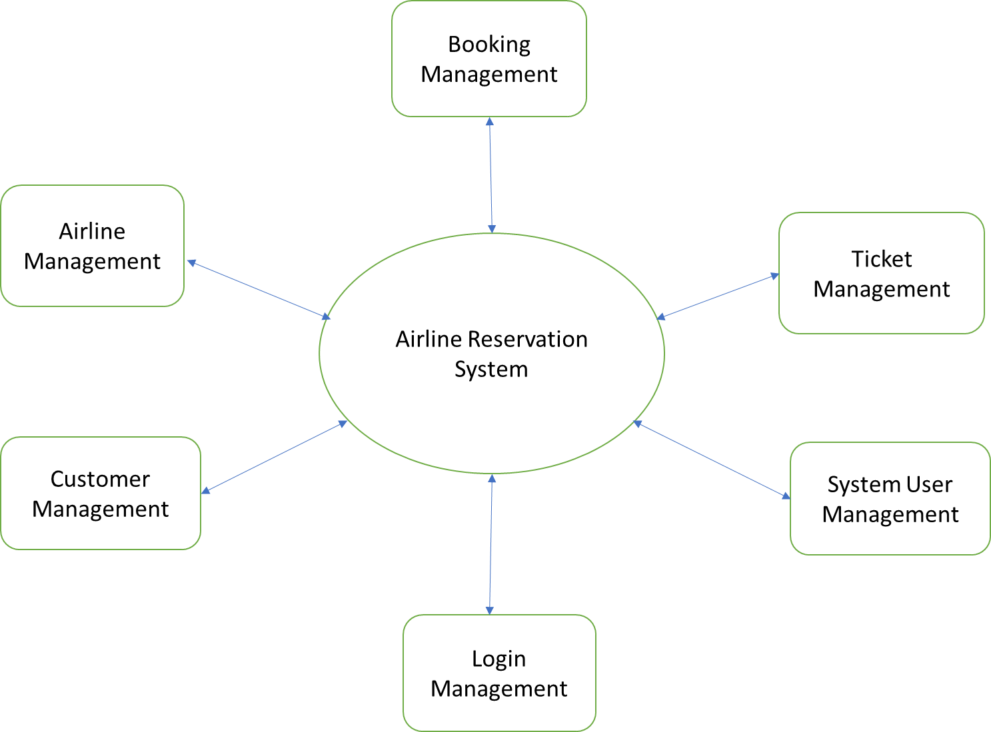

**4.2:DFD Level 1:**

