Jenkins output :  
  
  
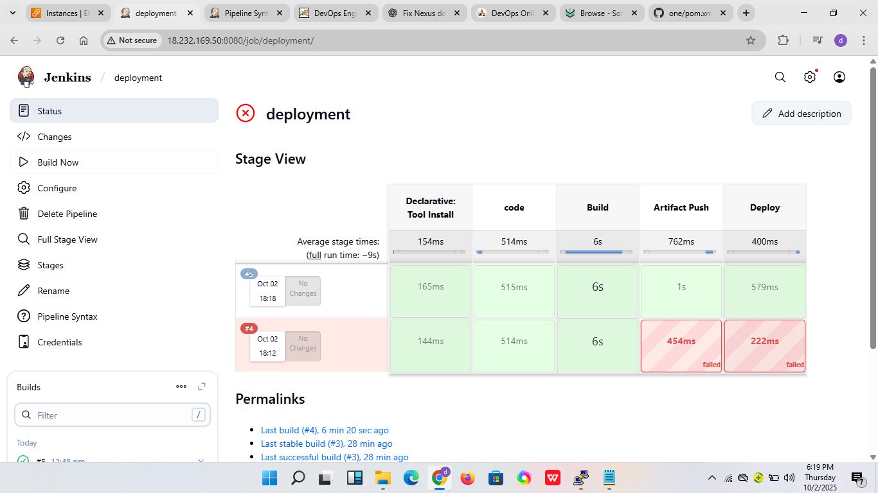  
  
  
Nexus output:

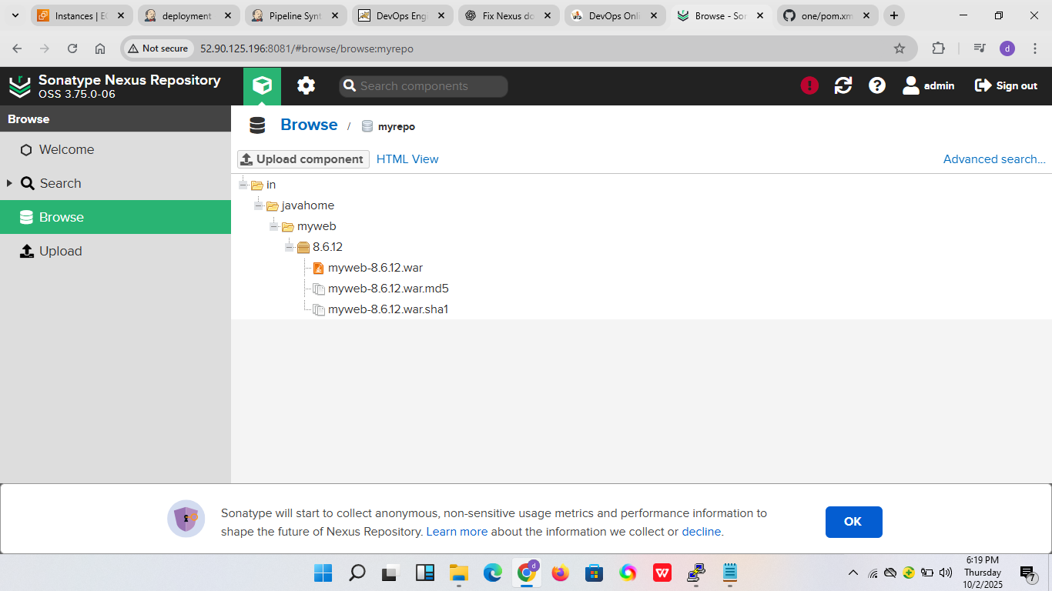  
  
  
  
  
Tomcat output :

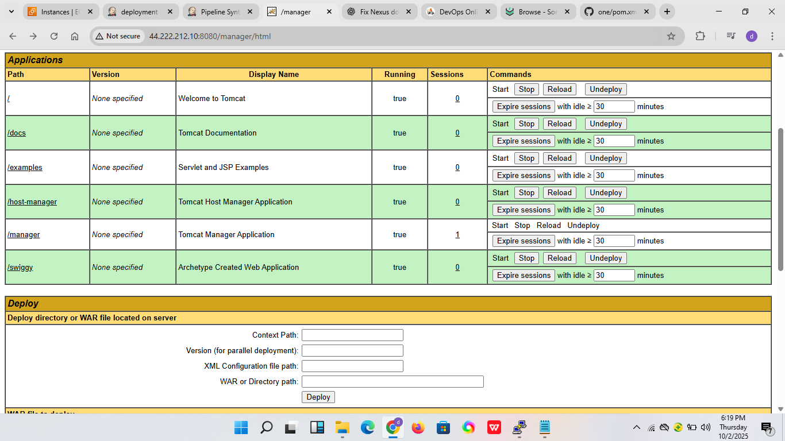  
  
  
FINAL webpage output:  
  
