**SOFTWARE REQURIMENT SPECIFICATION (SRS) FOR**

**CRIMINAL RECORD MANAGEMENT (CRM)**

**1. INTRODUCTION**

In this project, we are going to deal about the criminal’s record. In modern days crime is increasing day to day. To combat such Crimes and to provide safety to citizen, police department plays a vital responsibility for the safety of the society. After registering the FIR from any citizen, Police starts their work and on that basis they arrest criminals if proofs are found against them. Once criminals are arrested, police starts investigation from them.

* 1. **PURPOSE**

This project is aimed at developing a criminal record management system that is a collection of registers and reports for the effective management of prisons. Besides this police and government officials can see crime/criminals reports for their purpose.

Criminal Record management is intended to help the Jail Superintendent, Police officers and CBI officers to know the appropriate details of the criminal i.e. the criminal may be new (or) the criminal who is already in the Jail. Criminal Record Management (CRM) System allows user to store police department’s case details, Complaint Details, FIR Details, etc. This Software Package allows Police Departments to store all the details related to the department and use them whenever necessary.

**1.2SCOPE**

We define the features of CRM which are required for the project as scope

**In Scope**

1. The system should have a login. Login for user and admin.

2. System should support for Data Entry module for Complaint registration for each prisoner entering in the Jail.

3. Police officers should have a read only access to the information of prisoners and view complaint status.

4. Criminal register management

5. Case History Details management

6. Prisoners register management.

7. Data managers must be able to add or update the data of Jailers.

8. User authentication.

**Out of Scope:**

1. FIR Management

2. Managing Postmortem details

3. Manage list about most wanted criminals

**1.3. DEFINATIONS, ACRONYMS AND ABBREVATIONS**

* **Criminal**-criminals are the persons whose guilt/offence are proven in court and given punishment by court.
* **Most-wanted**-These Criminals are still not arrested or they flee away from police custody and police are searching for them.
* **Released person**-They are released by court as the charge against them not proved.
* **Investigation Officer-**Investigation officer is the police officer who investigates the case. There may be more than one investigation officers in one police station.
* **GUI-**Graphical User interface with the system with mouse control and other easy to use control features like the menus etc.
* **HTML**– Hypertext Markup Language is a markup language used to design static web pages.
* **SRS** – Software Requirements Specification
* **CRM** – Crime Record Management
* **End users** – The people who will be actually using the system

**1.4REFERENCES:**

* **IEEE SRS format**
* [**http://www.apit.ap.gov/**](http://www.apit.ap.gov/)
* [**http://www.appstatepolice.org/**](http://www.appstatepolice.org/)

**1.5 OVERVIEW:**

Criminal Record Management is a web based application. This application provides facility for reporting crimes, complaints, show most wanted person details online. Jail Superintendent is allotted highest authority of ministry. The duty of the Jail superintendent is to register the Criminals. He can also search for any information regarding this system.2nd User i.e.., Police Officer can transfer the Criminal to another Jail and can access full information of the criminal.

His role is to access the information of the criminals.4th user i.e., judge can also transfer the Criminals to another location and also can access the information of the Criminals. In manual system the process of Criminal record generation is not so fast and friendly for the official’s i.e.., CRIMINAL RECORD MANAGMENT. The server can be any web server.

**2. Overall Description:**

**2.1 Product Perspective:**

The web pages (XHTML/JSP) are present to provide the user interface on customer client side. Communication between customer and server is provided through URL.

CRM is intended to be a stand-alone product and should not depend on the availability of other software. It should run on both UNIX and Windows based platform.

**2.2 Product Functions:**

|  |  |  |
| --- | --- | --- |
| Class of use cases | Use cases | Description of use cases |
| Use case related to  Installation | Installation | CRM Installation |
| Use case related to  System Authorization | Login | 1. Login into the account.  2.Change the password |
| Change password |
| Use case related to  Register | Registration | Register new criminals |
| Use case related to  Search | Search | Search the criminal is already present in the database or not |
| Use case related to  Record | Record | To record the already existing criminals |
| Use case related to  Delete | Delete | Delete the criminal record if the crime done by him doesn’t matter a lot. |
| Use case related to  Securities | Create security | 1.Create a new security  2.Rename an existing security  3. Delete existing security. |
|  |
| Delete Security |
| Use case related to  Information display | View data | Show details of criminals. |
| Use case related to release dairy | Viewing releasing dairy | Information of release date of prisoners |
| Use case related to meetings | Meeting Details | All information about the persons meeting the prisoner |
| Use case related to transfer | Details of Jail | Moving the person from one jail to another. |
| Use case related to Update | Updating | To update the details of criminal if already present. |

**2.3 User Characteristics:**

a. The user should be familiar with CRM related terminology like criminal, most wanted, released person, Investigation officer, CRM.

b. The user should know the basic details of criminals such as name/blood group.

c. Operator should be computer literate.

d. There will be a screen to display various information related to FIR.

e. A login screen for entering username, password will be provided.

f. There will be a screen for taking and modifying the information of the terms related to FIR.

**2.4 Principal Actors:**

The two principal actors in CRM are “user” and “system”.

**2.5 General Constraints:**

1. For full working CRM requires Internet connection.

2. CRM is multi-user software.

**2.6 Assumptions and Dependencies:**

**1.** Users are related to different branch of police Departments.

2. The information entered in Records should be correct.

3. User can fill the registration form.

**3 Specific Requirements:**

**3.1 Functional Requirements:**

We describe the functional requirements by giving various use cases.

**3.1.1 Functional Requirement 1**

**Introduction:** Login

This functional requirement allows the user to access information after logged in.

**Input:** User name and password are supplied as inputs.

**Processing:**

1. Start the application. User prompted for username and password.
2. User gives the user name and password.
3. System does authentication.
4. Main screen is displayed.

**Output:** After providing valid user name and password the required functionality is displayed.

**3.1.2 Functional Requirement 2**

**Introduction:** Change password

This functional requirement allows the user to change his password if he forgot his password.

**Input:** Old password, new password and confirmation of new password are supplied as inputs.

**Processing:**

1. User initiates the password change command.
2. User is prompted for old password, new password and confirmation of new password.
3. User gives the old password, new password and confirms new password.
4. System does authentication.
5. New password is registered with the system.
6. User gets a message to his mail id and mobile that the password was changed.

**Output:** New password is confirmed and sent to user’s mail id.

**3.1.3 Functional Requirement 3**

**Introduction:** Registration of new password.

This functional requirement allows a new criminal to register by providing his details.

**Input:** Criminal name, father name, mobile number, crime type , etc are provided as inputs.

**Processing:**

1. User enters his details.
2. Submits the details.
3. If any of the details are not entered or found as blank then he is prompted to fill all the details.
4. System does authentication.
5. User will be displayed a screen with successful registration message.

**Output:** A screen is displayed with a message that “You are successfully registered…”.

**3.1.4 Functional Requirement 4**

**Introduction:** Search the criminal.

This functional requirement allows the user to search for a criminal.

**Input:** Criminal name, Aadhaar card number are supplied as inputs.

**Processing:**

1. Enter criminal name and Aaadhaar number.
2. Click on search button.
3. If the criminal name and Aadhaar number exist then criminal details will be displayed.
4. If the given input does not exist in the record then the user will be displayed a message that “The criminal you are searching for does not exist”.

**Output:** Criminal details are displayed.

**3.1.5 Functional Requirement 5**

**Introduction:** Update

This functional requirement allows the user to update the criminal details.

**Input:** Criminal name, Aadhaar number, reason of update are supplied as inputs.

**Processing:**

1. User enters a valid user name.
2. User enters a valid Aadhaar number.
3. Valid reason should be entered by the user for updating the criminal details.
4. System does authentication.
5. User will be displayed a message that the details are updated successfully.

**Output:** Message will be displayed as “Details are updated successfully”.

**3.1.6 Functional Requirement 6**

**Introduction:** Transfer

This functional requirement allows the user to transfer the criminal.

**Input:** Criminal name, Aadhaar number, source, destination are supplied as inputs.

**Processing:**

1. User enters a valid user name and Aadhaar number.
2. User enters the source and destination areas.
3. System does authentication.
4. Displays criminal details after transfer.

**Output:** Criminal details are displayed after transfer.

**3.1.7 Functional Requirement 7**

**Introduction:** Location of the criminal

This functional requirement allows the user to trace the location of the criminal.

**Input:** Criminal name and Aadhaar card number are supplied as input

**Processing:**

1. Criminal name is entered by the user.
2. User enters Aadhaar card number.
3. System does authentication.
4. Location of the criminal is displayed.

**Output:** Location of the criminal is displayed.

**3.1.8 Functional Requirement 8**

**Introduction:** Assigning works for the criminal.

This functional requirement allows the user to assign works for the criminal.

**Input:** Criminal name, Aadhaar number, type of work will be supplied as inputs.

**Processing:**

1. User enters a valid username and Aadhaar number.
2. Based on his crime type, he will be assigned works.
3. User clicks on submit.
4. System does authentication.

**Output:** The assigned works are displayed.

**3.2 External Interface Requirements:**

The external interface is a dynamically generated web page with professional graphics. The user screen is split into two parts and the vertical part is again divided into two pats. The right frame displays the information related to criminal that is given in the search box. The top frame contains the users. The left frame contains the pages related to users.

**3.3 Performance Requirements:**

1. Should run on 500 MHz, 256 MB machine.

2. 90% of the responses should be within 2 sec.

3. Responses to view information shall take no longer than 5 seconds to appear on the screen.

**3.4 Design Constraints:**

1. Security: The files in which the information regarding securities and portfolios should be secured against malicious deformations.

2. Fault Tolerance: Data should not become corrupted in case of system crash or power failure.

**3.5 Security Requirements:**

1. System will use secured database to maintain records.
2. System will have different types of users and every user has access constraints.
3. Data should be secured and it should not be leaked outside.

**3.6 Maintainability Requirements:**

1. Maintenance of Records up-to-date.

2. Database backup and DDL Script.

3. Our application should be designed to be easily be maintained and repaired.

**3.7 Reliability Requirements:**

Reliability is the probability that the system will be able to process all work correctly and completely without being aborted. Reliability is evaluated as follows:

**3.8 Availability Requirements:**

1. Online or Offline help to above said users, Application deployment executive and developer.

2. 24*7 availability.

3. Secure access of confidential data. SSL can be used.

**3.9 Database Requirements:**

1. Use of GUI like JASPER to show strategic data to admin.

**3.10Documentation Requirements:**

1. Simplicity of interface.

2. Printouts for employment disbursal and history etc.

**3.11 Safety Requirements:**

1. System use shall not cause any harm to human users.

2. The database may get crashed at any certain time due to virus or opening system failure. Therefore, it is required to take the database backup.

**3.12 Operational Requirements:**

Once the implementation plan is decided, it is essential that the user of the system is made familiar and comfortable with the environment. Users have to be made aware that what can be achieved with the system. The user of the system should be given general idea of system before he uses the system.

**3.13 Site adaption:**

**STRUCTURE ORIENTED ANALYSIS**

DFD for jail superintendent:

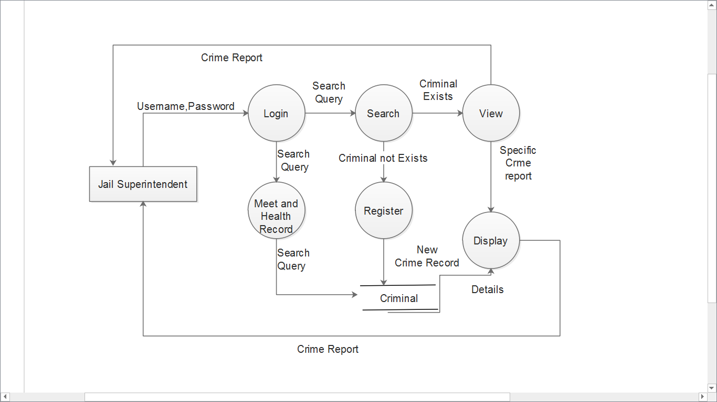

DFD for police officer:

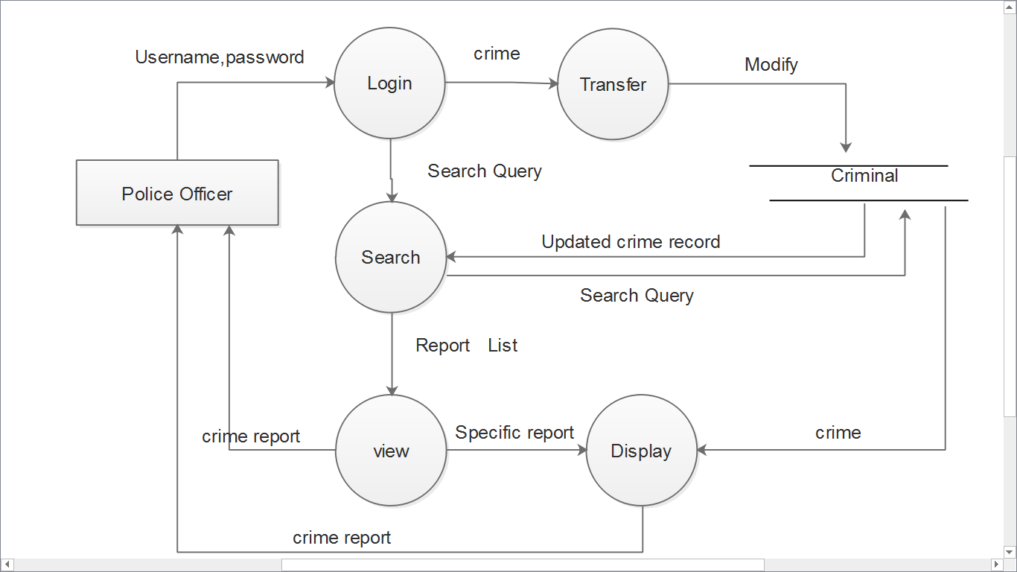

DFD for CBI officer:

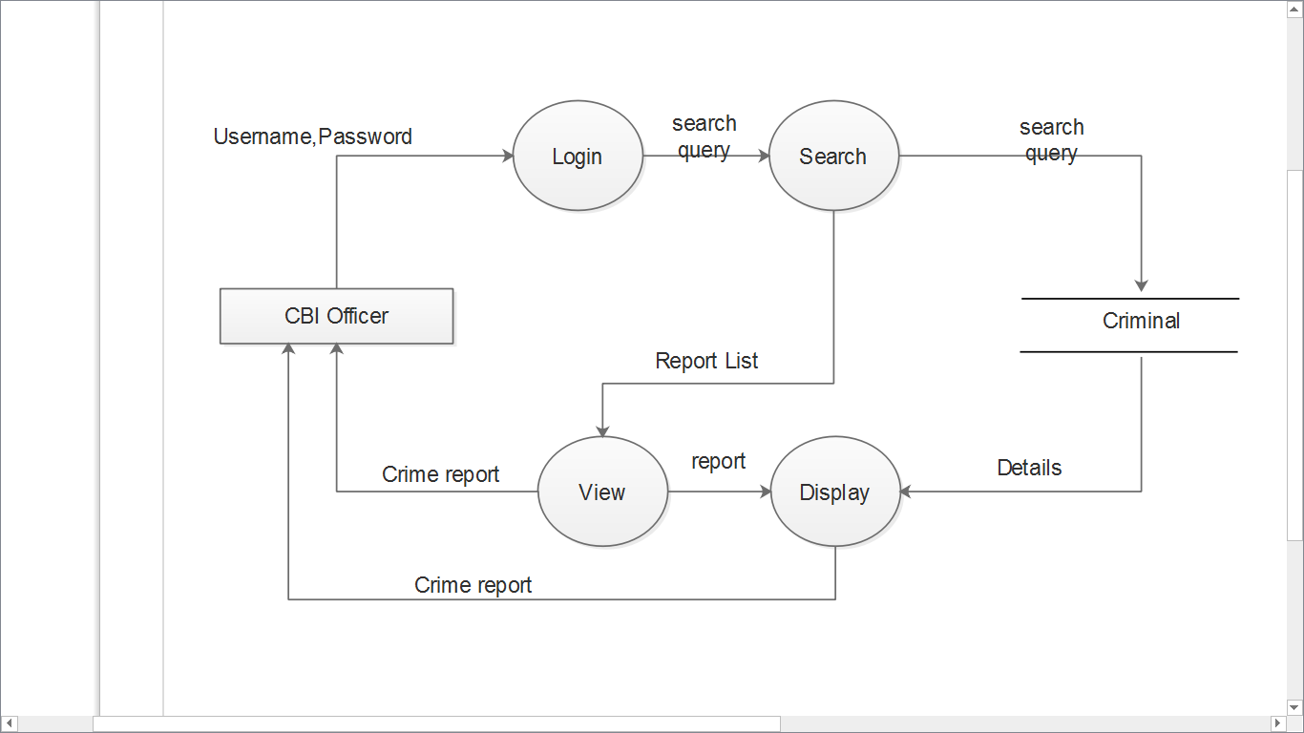

DFD for judge:

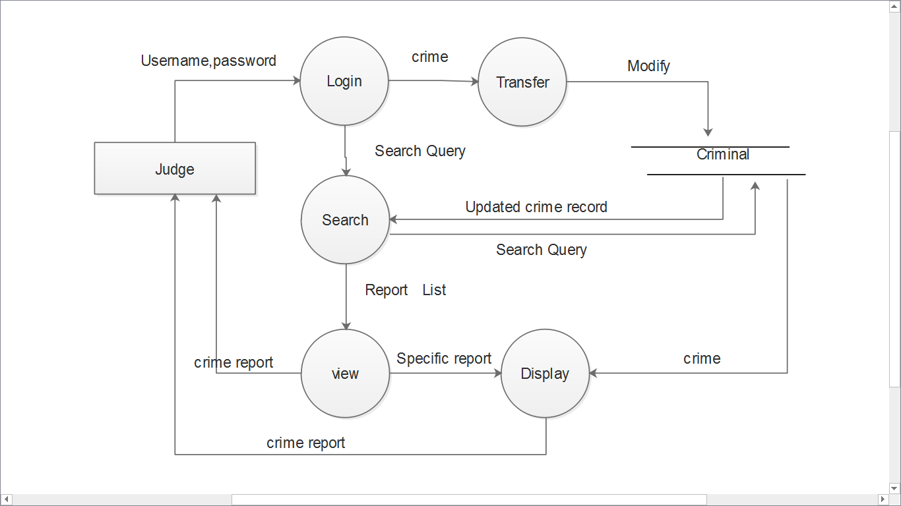

**DATA ORIENTED ANALYSIS:**

Relation between entity and attribute table:

|  |  |
| --- | --- |
| ENTITY | ATTRIBUTE |
| Criminal  Jail  Crime  Work  Meet  Health record  Cell | Cname, Aadhaar no, Address, Gender, ID, Blood group  Aadhaar no, Jname, Jailorname, Jaddress  ID, Type, Description  Aadhaar no, Amount paid  Cname, Aadhaar no, ID, Time, Date, Fname  Aadhaar no, Weight, ID, BP  Cell-ID, Capacity |

DATA DESCRIPTION TABLE

|  |  |
| --- | --- |
| DATA ITEM | DESCRIPTION |
| Criminal  Cname  Jail  Crime  Jailor Name  Meet  ID  Health record  Cell | This entity is used to store the details of the criminals.  Name of the criminal.  This entity is used to say the information about what is the name or the number of the jail he is present.  This is used to hold information about the type of the crime done by the criminal.  It is used to see under whose control are the criminals.  It is used to hold the information of the meeting persons of the criminal.  The number given to the criminal.  The details of health of the criminal are stored.  The jail can have many cells. It is used to trace the cell number of the jail where the criminal is kept. |

OBJECT ORIENTED ANALYSIS

**Use case Specifications**:

**Use case related to installation:**

**Use Case 1:** Installation

Primary Actor: Administrator

Pre-Condition: Internet connection available.

Main Scenario:

1. User initiates CRM installation program.

2. System asks the user for the home directory in which all the working

will be created. User is also asked for the initial login and password.

3. User specifies the home directory and login/password.

4. System creates the working files in the specified home directory.

Working files contain:

a. Information of Criminal.

b. Current Location of Jail.

c. Backup & Restore of data.

Alternate Scenario:

a. Network failure.

b. Installation aborted.

**Use cases related to system authorization:**

**Use Case 2**: Login

Primary Actor: Jail Superintendent, Police Officer, CBI Officer, Administrator, Judge

Pre-Condition: Internet connection available

Main Scenario:

1. Start the application. User prompted for login and password. 2. User gives the login and password.

3. System does authentication.

4. Main screen is displayed.

Alternate Scenario:

1. Authorization fails.

2. Prompt the user that he typed the wrong password.

3. Allow him to re-enter the password. Give him 3 chances.

**Use Case 3:** Change Password

Primary Actor: Jail Superintendent, Police Officer, CBI Officer, Administrator, Judge

Pre-Condition: Certain User logged in

Main Scenario:

1. User initiates the password change command.

2. User is prompted for old password, new password and confirm new

Password.

3. User gives the old password, new password and confirm newPassword.

4. System does authentication.

5. New password is registered with the system.

6.User gets a message to his mail-id and mobile that password was changed.

Alternate Scenario:

1. Authorization fails.

2. Prompt the user that he typed the wrong password.

3. Allow him to re-enter the password. Give him 3 chances 4.New password and confirm new password do not match.

5. Allow him to re-enter the attributes. Give 3 chances.

**Use case related to Registration:**

**Use case 4:** Registration

Primary actor: Jail superintendent

Pre-condition: Internet connection available.

Main Scenario:

1. The visitor accesses the registration page for new ID.  
2. He/she fills up the criminal details like name/blood group/type of crime etc. and submits.  
3. The completeness of data is checked on client side.  
4. The Database is updated.

Alternate Scenario:

1. The data completeness check fails and the user is prompted to provide all details.

2. The database update fails.

**Use case related to search:**

**Use Case 5:** Search

Primary Actor: Jail Superintendent, Police Officer, CBI Officer, JudgePre-Condition: Certain User logged in.

Main Scenario:

1. User clicks on search box

2. System asks the user for the name of Criminal.

3. User enters name/blood group/Jail no/DNA/Image.

4. Click on the search button

Alternate Scenario:

1. Criminal name does not exist.

2. Criminal name exists but finger print /blood group does not match.

**Use Case 6:** Record

Primary Actor: Administrator

Pre-Condition: Administrator logged in

Main Scenario:

1. Maintain the database

2. Grant role to other user

3. Revoke role from other users.

4. Back and restore the data

Alternate Scenario:

1. Data missing of Certain Criminal

2. Backup and restore is done every day

**Use cases related to securities:**

**Use Case 7:** Create a security.

Primary Actor: Administrator.

Pre-Condition: User logged in.

Main Scenario:

1. User selects the data in which the security is to be created.

2. User initiates the “create security” functionality.

3. System asks the user to enter the attributes of the security.

4. User specifies the following fields:

a. Name of Criminal or place

b. *Type*: where the Criminal is

5. An empty security of specified attributes is created.

Alternate Scenario:

1. A security with the given name already exists.

2. Security creation fails, error message is displayed.

**Use Case 8:** Delete security.

Primary Actor: Administrator

Pre-Condition: User logged in.

Main Scenario:

1. User selects the portfolio.

2. User initiates the “delete security” functionality.

3. System asks for the security name.

4. Security is deleted.

Alternate Scenario:

1. Security does not exist.

2. Deletion fails, error message is displayed.

**Use cases related to information display:**

**Use Case 9:** Display

Primary Actor: User.

Pre-Condition: User logged in.

Main Scenario:

1. User clicks on search box.

2. System asks the user for the name of Criminal.

3. User enters name/blood group/Jail no/DNA/Image.

4. Click on the display button.

5. Then the details of the criminal are displayed.

Alternate Scenario:

1. Criminal name does not exists.

2. Criminal name exists but finger print /blood group does not match.

**Use Case 10:** Display Security

Primary Actor: User

Pre-Condition: User logged in.

Main Scenario:

1. User selects the option of viewing a particular security (selects a portfolio from the left pane, refer user screens in Appendix C).

2. System displays all the transactions.

**Use case related to view release dairy:**

**Use case 11:** View release dairy

Primary actor: Administrator, Police Officer

Pre-Condition: User logged in.

1. User must be logged in

2. He/she has to be at his home page

Main scenario:

1. Retrieved the release diary information from the data base.

2. Viewing of data.

Alternate Scenario:

1. Retrieval of data failed.

**Use case related to Meetings:**

**Use case 12:** Meeting data

Primary Actor: Administrator

Pre-condition: Administrator should be logged in to his account to access this option

Main Scenario:

1. Verification status is checked
2. If OK then it is approved.
3. The database is updated

Alternate Scenario:

1. The prisoner did not meet any one.

**Use case related to Transfer:**

**Use case 13: Transfer**

Primary Actor: Police officer, Judge.

Pre-condition: User logged in.

Main Scenario:

1. Check the crime of the criminal.
2. If the crime is severe and approved by the Judge then transfer.

Alternate Scenario:

1. The criminal will be placed in the same Jail according to his punishment.

**Use case related to update:**

**Use case 14:** Update

Primary Actor: Jail superintendent

Pre-condition: Logged in.

Main Scenario:

1. Criminal name is given.
2. Verification status is checked
3. If the criminal name is present in the database the database is updated.

Alternate Scenario:

1. Register the criminal.