# Chapter 2 – Analysis

## 2.1) Introduction to Analysis

Simply, analysis is about analyzing and gathering the information of the software at various stages to know the detail of the project. It is a systematic examination and evaluation of data or information which is done to determine the needs or conditions of the project to meet the requirements of the project.

It is about understanding the problem in depth which may include quantification of capacities, security, robustness and even the uncertainties of the project, which will have factors that need to be considered carefully for the betterment of the project.

Importance of analysis for my project are explained below:

* It helps to gather the important information affecting different aspects of the costumers.
* It helps to understand the problems of local people who are unable to keep in touch with physical market place.
* It helps to meet the quality design of the project which exceeds the requirement for the problem.
* It helps on quality implementation of the project which puts all the work together so it functions as a firm entirely.
* It also helps to understand the project which are involved in different areas.

## 2.2) Analysis Methodology

The methodology that is used to undertake an analysis technique for the project development is said to be analysis methodology. Among various approaches for software development such as: Soft System Approach, Hard System Approach, Combined Approach, etc., I am going to take Soft System Approach for my project.

**Soft System Methodology (SSM)**, is a tool (not system design tool) for system requirement investigation which allow the designer to model how the system should operate and what operations the system should perform and more importantly why system should operate.

Simply, it is an approach in which project is analyzed in more people focused way before taking it to the hard approach.

Examples: PEST, SWOT, CATWOE, ETHICS, Rich Picture, Root Definition, etc.

**Advantages:**

* It recognizes that the user interaction is also equally important as technical considerations
* It clarifies the problem area of a system as more people interaction is involved
* It helps to bring different sectors of a project together.

Following are the steps while applying soft approach:

* Analyze and produce **Rich picture**

Rich picture is a drawing of a scenario that will help our project to illustrate the main elements and relationship that needs to be considered. It is called rich picture because it helps to illustrate the richness and the complexity of our project. It helps to explore, acknowledge and define a complex mechanism for learning about the situation. It also helps to express the situation through diagram to create a preliminary mental model.

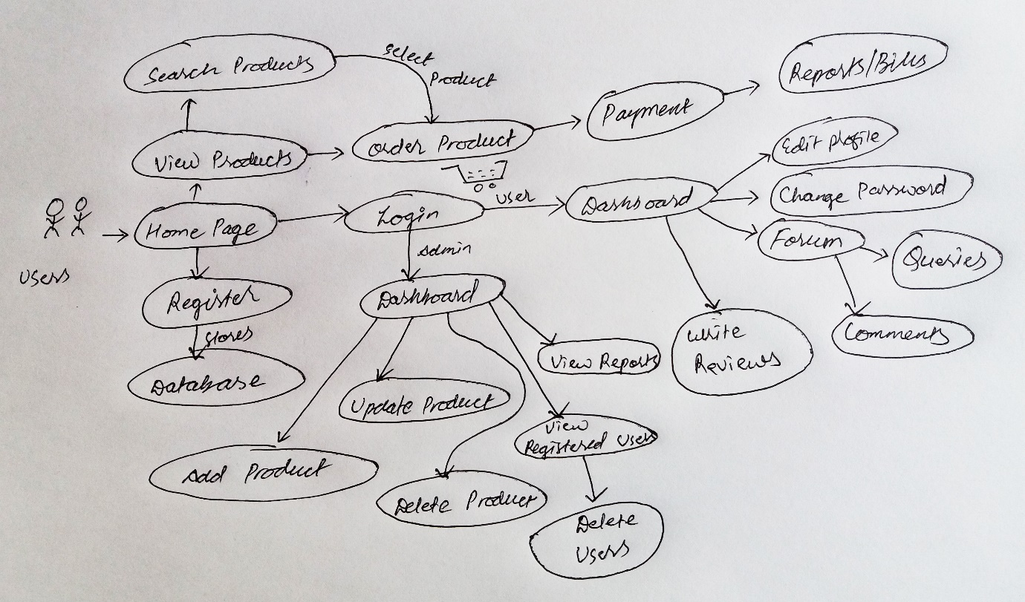

Figure: Rich Picture

* Define **root definition** of parts of Information system

Root Definition is a mission statement of the particular system. It helps to clarify the problems that are currently seen in the system and describe the aim and functions of the currently developing system.

**Where and when to use it?**

It can be used while investing a situation in order to obtain a clear and understanding common system of interest.

In general, an individual or a team can undertake this definition. Because the outcome is more efficient, good and complete if it is performed by a team or a skilled individual. It also helps to focus on the quality of the outcome, that depends upon the experience of the team or an individual.

**How to do it?**

When developing the SSM, we need discover a good Root Definition. For ensuring good definition, **CATWOE** was developed and now widely used. It stands for **C**ustomer, **A**ctors, **T**ransformation, **W**orldview, **O**wner and **E**nvironment.

**Customer** = Those individuals who buys products.

**Actor** = Those who are accountable for carrying out the activities.

**Transformation** = It is the activity that change the input and output or that provide services to the client.

**Worldview** = It is the basic worldview for the transformation which may have wide-reaching or long lasting effects of the analysis.

**Owner** = Those individuals who invests for the project

**Environment** = The key constraints outside the system boundary that are significant to the system. (Burge, 2015)

* Produce **conceptual models** of system

The model which is constructed by the help of rich picture and root definition to represent a system by easily understanding the different models of the system can be said as **conceptual model**.

Primary advantage of conceptual model includes:

* **Establishes Entities**

By establishing entities and relation, various entities and concepts for the software development life cycle can be ensured.

* **Defines Project Scope**

It can be used to define project scope because it helps in managing and scheduling time.

* **Base Model for Other models**

Many other models need to be generated beyond the roughly sketched concepts, conceptual model acts as a base model for other data models such as logical data models and so on.

* **High-Level Understanding**

Conceptual Model acts as an extraordinary tool by giving high level understanding of a system throughout the software development lifecycle.

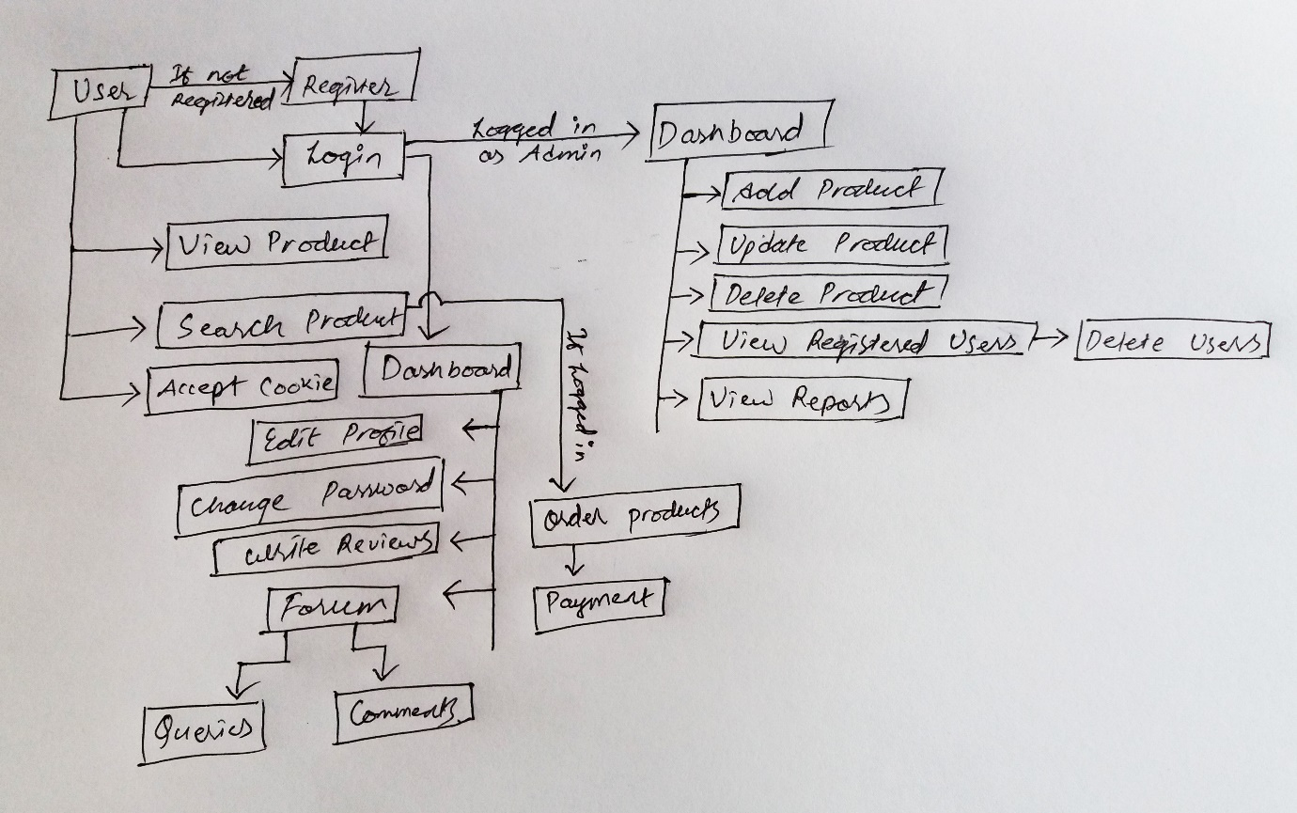

Figure: Conceptual Diagram

* Compare concept of the system with actual system

This step helps to compare two different aspect of conceptual model analysis and real world project analysis. As not everything is perfect in the model.

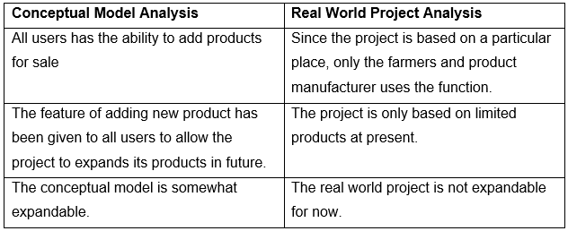

* Define and select feasible options for development
* Implement the system

## 2.3) Feasibility Study

The study which is done by taking all of the relevant factors like: scheduling, economic, technical, marketing, cultural, operational, ethical and comprehensive feasibility study to discover the prospect of completing the project successfully on time is said to be feasibility study.

**Importance of Feasibility Study for my project:**

1. It helps to study the practicality of a proposed plan
2. It helps to determine whether the project is practically possible or not
3. Factors can be determined by understanding time, cost and other.

The different feasibility study that I performed in my project are given in the table below.

|  |  |  |  |
| --- | --- | --- | --- |
| **S.N** | **Feasibility Study** | **What does this study find out?** | **How it is related to my project?** |
| **1** | Schedule Feasibility Study | Is there enough time to work on the project?  Can the project be completed in given time? | I have created WBS, Gantt Charts and milestones for this project. The tasks are performed based on those timelines till now and will also be followed in upcoming further. |
| **2** | Economic Feasibility Study | Is the allocated budget enough to complete the project?  Does the project benefit outweighs the project cost? | The project will have the feature of locating location of buyer in the future. For now it is economically feasible and the benefits that the local people will get from this project will be higher than the costs . |
| **3** | Technical Feasibility Study | Is the technical requirement for the project available?  Is the knowledge skill required for the project sufficient? | My current technical equipment is sufficient for this project (i.e. Toshiba Laptop). I also have a good internet connection available. My skills required for the project is good and it is getting better with time and effort. |
| **4** | Marketing Feasibility Study | What is the market that is project is targeting for?  Will people want the project after it is developed? | The project will be a beneficial system for the local people who sculpt handmade arts. By following a good marketing strategy, the project market will cover the whole of Lalitpur district first. |
| **5** | Cultural Feasibility Study | Will the project result in negative or positive impact to the culture? | The project is a marketing web based applications that focuses to market mostly locally hand made products. |
| **6** | Operational Feasibility Study | How well the project be able to solve the problems of the targeted people presented? | Since it is an online information management system and market for the local products, it is currently lacking, the project will be highly advantageous to the local people of Lalitpur District. |
| **7** | Ethical Feasibility Study | Is the project ethically acceptable by the users? | The focus of the project is to help the local people and seller by eliminating the brokers between them. It is ethically acceptable by the targeted people. |
| **8** | Comprehensive Feasibility Study | How does the project impact on different factors like, cultural, ethical, marketing etc.? | Feasibility tests for these factors are performed above. |

## 2.4) Requirement Analysis

### 2.4.1) Functional Requirement

Simply, Functional Requirement (FR) means, those functions or features which are most important and suitable for a project development. It can include technical, hardware-software and their functionality required to perform the user needs and tasks.

FR suitable for my project is listed in the table below:

|  |  |  |  |  |
| --- | --- | --- | --- | --- |
| **FR ID** | **Title** | **Description** | **Rational** | **Dependencies** |
| FR 1 | Registration | It would help to create new user account | To maintain user confidentiality | N/A |
| FR 2 | Login | It would give access to do all the additional function in the application | To verify user | FR 1 |
| FR 3 | Admin Login | It would give permission to the administration, to do any kind of add, delete and update item in the application | For admin verification | N/A |
| FR 4 | Admin Logout | Admin would be able to get out of the system as they want | To get out of the admin panel | FR 3 |
| FR 5 | Add Item | Admin would be able to add item in the application | To add new and interesting item | FR 2 |
| FR 6 | Update Item | Admin would be able to make change in the item added previously | To update existing item | FR 5 |
| FR 7 | Delete Item | Admin would be able to delete the added item | To remove item from the application | FR 5 |
| FR 8 | Update Account | Users would be able to edit their account as they want | To maintain user interaction | FR 2 |
| FR 9 | Authentication | It would help the system to identify the right user | To validate the user who are trying to login in the system | FR 1 |
| FR 10 | Post Queries | It would help to post any kind of doubtful question in a forum | To be clear about any unclear questions | FR 9, FR 2 |
| FR 11 | Post Comment | It would help to post a comment in a required post | For explaining the unclear question to the users | FR 10 |
| FR 12 | Rate and Review | It would help to rate and give review of the listed items in the system | To identify best item among other items | FR 2, FR 5 |
| FR 13 | Order Items | It would help user to order the selected items that they chose | To order select item | FR 2, FR 5 |
| FR 14 | Create Bill | It would help to create an electronic receipt of the ordered item | To get the price of ordered item | FR 2, FR 13 |
| FR 15 | Sales Record | It would help to keep a record of the ordered items | To keep record of all sold item | FR 13 |
| FR 16 | Email Services (Newsletter) | It would help users to get notified for any news or events or items | To get notification on new items or posts | N/A |
| FR 17 | Accept Cookie | It would help to the betterment of user using the application | For user easiness | FR 2 |
| FR 18 | Search Items | It would help to find the required products for the users | To find required item easily | N/A |
| FR 19 | Logout | Users would be able to logout of the system as their needs | To get out of the user’s dashboard | FR 2 |

### 2.4.2) Non-Functional Requirements

Simply, Non-Functional Requirements (NFR) describes how the system attributes such as security, performance, reliability, maintainability, scalability and usability works. It is also known as system qualities which ensure the usability and effectiveness of the entire system.

NFR suitable for my project is listed in the table below:

|  |  |  |  |  |
| --- | --- | --- | --- | --- |
| **NFR ID** | **Title** | **Description** | **Rational** | **Dependencies** |
| NFR 1 | Security | System should have secured security feature to protect user’s data | To protect and secure user’s data | FR 1, FR 2, FR 17 |
| NFR 2 | Performance | System should perform well in any conditions | To make sure that user gets good and better performance | N/A |
| NFR 3 | Reliability | System should be reliable so the users are fully satisfied | To make sure the users get true and genuine information | FR 5, FR 6, FR 11 |
| NFR 4 | Availability | System should be available 24/7/365 without any issue | To make sure user gets to use system all time and anytime they want | N/A |
| NFR 5 | Environment | System should not hamper in the environment | To make sure that system will not harm to the environment more than it should | N/A |
| NFR 6 | Maintainability | System should be maintainable whenever any uncertainties occurs | To make sure that system is maintained | N/A |
| NFR 7 | Capacity | System should function with same ability for all the users using system | To make sure that system can handle large number of user with same efficiency | N/A |
| NFR 8 | Supportability | System should be supportable in different operating systems and distributions | To make sure that project is run in each and every popular operating systems and distributions | N/A |
| NFR 9 | Scalability | System should be adequate to any change | Capacity to adequate | N/A |
| NFR 10 | Data Integrity | The data should have their originality | Unauthorized access to the data should be restricted | N/A |

### 2.4.3) MoSCoW Prioritization

Also known as MoSCoW method, it us used to determine which requirement should be included in a certain system delivery. It helps to minimize the risk as importance is given to the most important work of the project. Importance of MoSCoW Prioritization are explained below:

1. For classifying important task and give time, cost and effort accordingly to the projects that are in progress
2. It is simplistic and high level requirement prioritization
3. We don’t need any prior knowledge or training to understand the concept

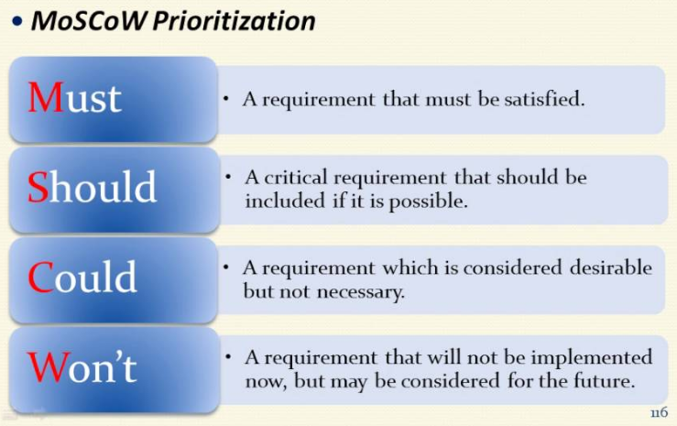

Figure: MoSCoW Prioritization

The four level of the prioritization are explained below:

* **M**ost Have: It is the most top priority items that the project need in order to move forward.
* **S**hould Have: It is not critical to launch, but priority items are considered to be important.
* **C**ould Have: It is a requirement that the priority items are desirable but not necessary.
* **W**ould not Have: It is a requirement that will not be implemented now, but such priority items may be included in a future.

MoSCoW Prioritization of Functional Requirement:

|  |  |  |
| --- | --- | --- |
| **FR ID** | **Title** | **MoSCoW** |
| FR 1 | Registration | Must Have |
| FR 2 | Login | Must Have |
| FR 3 | Admin Login | Must Have |
| FR 4 | Admin Logout | Must Have |
| FR 5 | Add Item | Must Have |
| FR 6 | Update Item | Must Have |
| FR 7 | Delete Item | Must Have |
| FR 8 | Update Account | Must Have |
| FR 9 | Authentication | Must Have |
| FR 10 | Post Queries | Must Have |
| FR 11 | Post Comment | Could Have |
| FR 12 | Rate and Review | Could Have |
| FR 13 | Order Items | Must Have |
| FR 14 | Create Bill | Should Have |
| FR 15 | Sales Record | Should Have |
| FR 16 | Email Services (Newsletter) | Should Have |
| FR 17 | Accept Cookie | Could Have |
| FR 18 | Search Items | Should Have |
| FR 19 | Logout | Must Have |

MoSCoW Prioritization of Non Functional Requirement

|  |  |  |
| --- | --- | --- |
| **NFR ID** | **Title** | **MoSCoW** |
| NFR 1 | Security | Should Have |
| NFR 2 | Performance | Must Have |
| NFR 3 | Reliability | Must Have |
| NFR 4 | Availability | Won’t Have |
| NFR 5 | Environment | Won’t Have |
| NFR 6 | Maintainability | Should Have |
| NFR 7 | Capacity | Should Have |
| NFR 8 | Supportability | Should Have |
| NFR 9 | Scalability | Could Have |
| NFR 10 | Data Integrity | Should Have |

### 2.4.4) Software Requirements Specification (SRS)

A Software Requirement Specification also known as System Requirement Specification, is a set of document that helps to explain the feature and behavior of a software requirement. It also provides various hardware and software description while developing a system. The hardware and software requirements required for my project is given below.

* Pre-project requirements

The hardware and software required for developing the project from the beginning to ending is said to be Pre-project requirements.

|  |  |
| --- | --- |
| **Hardware** | **Software** |
| * Laptop (Toshiba Satellite) * Processor (i3 intel) * RAM (6 GB) * Hard Disk Space (1TB) | * Windows 10 (Operating System) * Sublime Text 3 (Text Editor) * XAMPP (Local Server) * MySQL (Database) * Google Chrome (Browser) * Star UML * ProjectLibre * Visual Paradigm |

* Post project requirements

The hardware and software that is required to run the project smoothly without any bugs or error is said to be post project requirement.

|  |  |
| --- | --- |
| **Hardware** | **Software** |
| * Android and IOS devices * Good internet connection * Minimum Core 2 Duo or above processor * RAM: Minimum 4 GB or above * Hard Disk space (Minimum 100GB) | **Operating System**   * All windows platform from Windows 7   **Browsers**   * Google Chrome * Opera * Mozilla Firefox * Safari * Tor |

## 2.5) Use Case Diagram

Use Case Diagram is the representation of a user’s interaction with the system which helps to show the relationship between the user and the different use case involved in the system. It helps to distinguish the role of the different users/actors on the function of the system.

The advantages of creating use case diagram for the project can be listed below:

1. It is easy to understand and represent the system’s functionalities
2. It helps to identify the role of different users
3. It helps to explain the system to any non-technical person

The symbol description used for this diagram are explained in short below:

1. Rectangular box helps to represent the system of the project
2. Actors helps to represent the actions in the system
3. Use Case helps to represent the action that is performed in the system
   1. Include Relationship
   2. Extend Relationship
   3. Generalization Relationship

The following use case diagrams for my project is displayed and explained below:

* + 1. Admin Use Case Diagram:

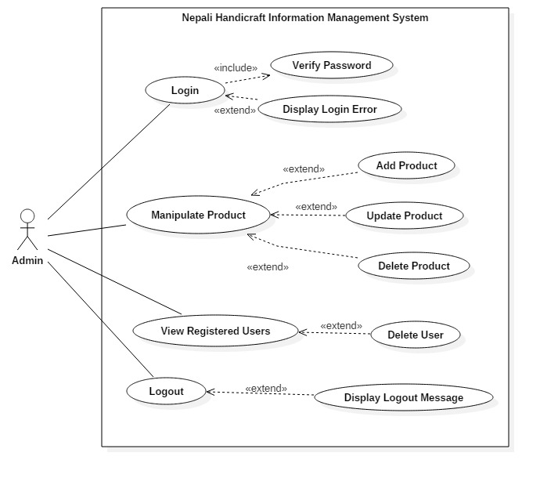

Figure: Use Case diagram of Admin

**Scenario Description:**

Actor: Admin

The super user of the system who can do each and every activity mentioned below:

* It can Login to the system
* It can manipulate the product data, that is it can perform CRUD operations
* It can view registered users and also delete as per the user’s request
* It can logout of the system so that admin privilege is not accessible by any unauthorized people.
  + 1. Unregistered Users Use Case Diagram:

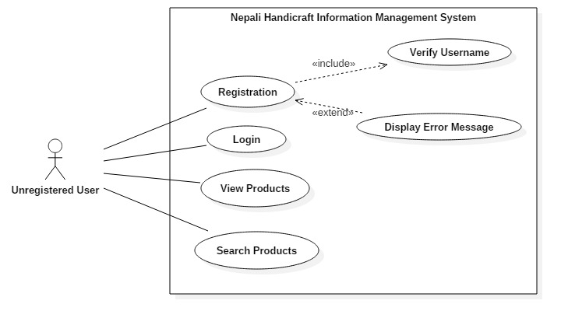

Figure: Use Case diagram of Unregistered User

**Scenario Description:**

Actor: Unregistered User

The unregistered user is also a part of the system who can do activity mentioned below:

* Unregistered User can register to the system to get login access.
* Unregistered User can login into the system and act as a user.
* Unregistered User can view the listed products which are listed by admin.
* Unregistered User can search for the required products.
  + 1. Registered Users Use Case Diagram:

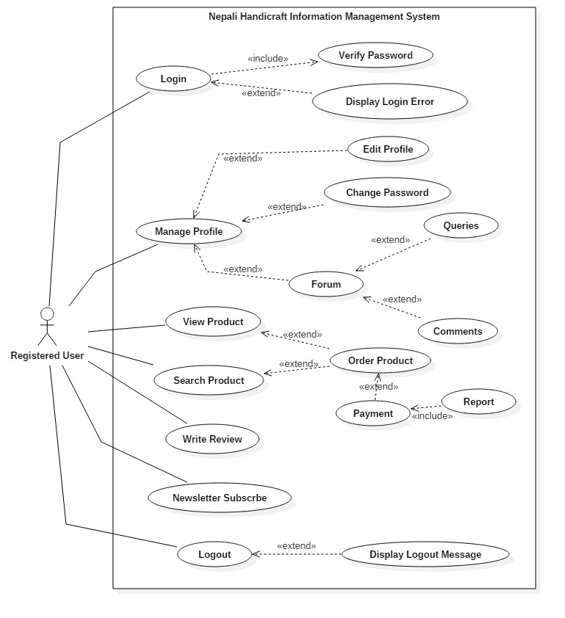

Figure: Use Case diagram of Registered User

**Scenario Description:**

Actor: Registered User

The Registered user is also a part of the system who can do activity mentioned below:

* Registered User can login into the system and act as a user for ordering products.
* Registered User can manage their profile:
  + They can update their profile information,
  + They can change password,
  + They can ask any queries regarding products,
  + They can reply to any asked queries.
* Registered User can write a review for the testimonials.
* Registered Users can enter their email address for subscription.
* Registered Users can logout of the system so that user privilege is not is not accessible by any other unauthorized person.