# Chapter 3 - Design

Design, this is the third and important phase while designing any application or a software which is intended to accomplish certain goals. Simply, Design is the process of transforming user’s requirement into some suitable form, which helps the programmer in software coding and implementation. (Anon., 2019) Designing phase helps to give us the answer of “**HOW**” question. We user various tools and techniques even models to develop the logical solutions which is later implemented in the system.

Some of the importance of design while developing my project are listed below:

1. It helps to understand the requirement in better way.
2. It helps to increase reusability and prevent redundancy.
3. It helps to allow both admin and users to realize how the application is going to function.
4. It helps to create class and objects obtained during analysis, which will eventually help to make the work of programmer easy.

For doing this phase, I have used **Star UML**, a software which is used to make different class, object, use case diagram, component diagram, etc. **Visual Paradigm,** a UML CASE tool for making ER Diagram. **Belsamiq Mockup 3,** a user interface designing tool for developing Paper Prototypes.

## 3.1) Structural Modeling

### 3.1.1) Final Class Diagram

### 3.1.2) Flow Chart

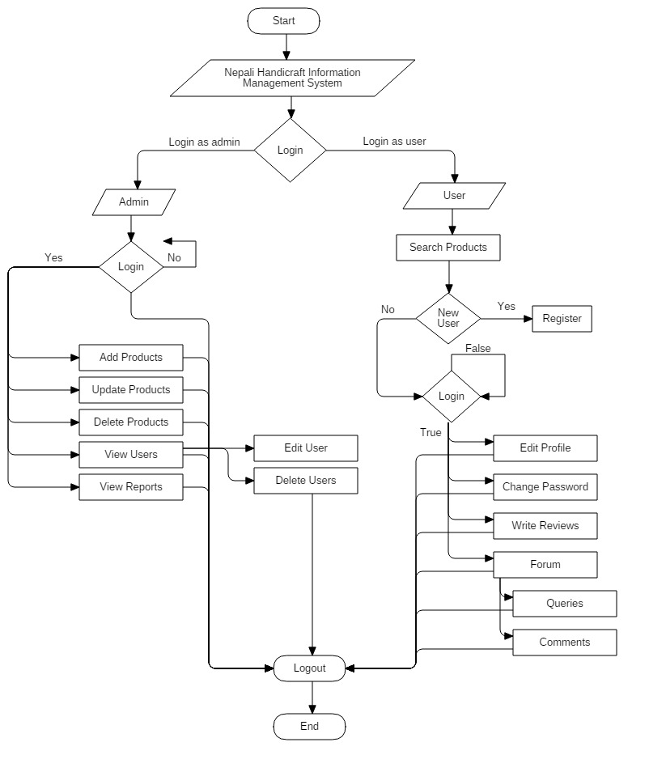

## 3.2) Behavioral Modeling

### 3.2.1) Activity Diagram

### 3.2.2) Sequence Diagram

## 3.3) Database Modeling

### 3.3.1) Data Dictionary

User Register Table

|  |  |  |  |  |
| --- | --- | --- | --- | --- |
| **Attributes** | **Datatype** | **Primary Key** | **Foreign Key** | **Nullable** |
| u_id | int(11) | Yes | No | No |
| fname | varchar(50) | No | No | Yes |
| lname | varchar(50) | No | No | Yes |
| e_mail | varchar(50) | No | No | Yes |
| telephone | bigint(50) | No | No | Yes |
| address | varchar(50) | No | No | Yes |
| city | varchar(50) | No | No | Yes |
| country | enum | No | No | Yes |
| region | enum | No | No | Yes |
| gender | enum | No | No | Yes |
| password | varchar(255) | No | No | Yes |
| confirm_passowrd | varchar(255) | No | No | Yes |

Admin Table

|  |  |  |  |  |
| --- | --- | --- | --- | --- |
| **Attributes** | **Datatype** | **Primary Key** | **Foreign Key** | **Nullable** |
| a_id | int(11) | Yes | No | No |
| username | varchar(255) | No | No | Yes |
| password | varchar(255) | No | No | Yes |

Product Table

|  |  |  |  |  |
| --- | --- | --- | --- | --- |
| **Attributes** | **Datatype** | **Primary Key** | **Foreign Key** | **Nullable** |
| p_id | int(11) | Yes | No | No |
| a_id | int(11) | No | Yes | No |
| pname | varchar(50) | No | No | Yes |
| description | varchar(50) | No | No | Yes |
| image | varchar(255) | No | No | Yes |
| original_price | double | No | No | Yes |
| product_price | double | No | No | Yes |
| date | date | No | No | Yes |

Order Table

|  |  |  |  |  |
| --- | --- | --- | --- | --- |
| **Attributes** | **Datatype** | **Primary Key** | **Foreign Key** | **Nullable** |
| o_id | int(11) | Yes | No | No |
| u_id | int(11) | No | Yes | No |
| p_id | int(11) | No | Yes | No |
| date | date | No | No | Yes |

Forum Table Question

|  |  |  |  |  |
| --- | --- | --- | --- | --- |
| **Attributes** | **Datatype** | **Primary Key** | **Foreign Key** | **Nullable** |
| fq_id | int(11) | Yes | No | No |
| u_id | int(11) | No | Yes | No |
| question | text | No | No | Yes |
| date | date | No | No | Yes |

Forum Table Comment

|  |  |  |  |  |
| --- | --- | --- | --- | --- |
| **Attributes** | **Datatype** | **Primary Key** | **Foreign Key** | **Nullable** |
| fc_id | int(11) | Yes | No | No |
| u_id | int(11) | No | Yes | No |
| fq_id | int(11) | No | Yes | No |
| comment | text | No | No | Yes |
| date | date | No | No | Yes |

Forum Table

|  |  |  |  |  |
| --- | --- | --- | --- | --- |
| **Attributes** | **Datatype** | **Primary Key** | **Foreign Key** | **Nullable** |
| f_id | int(11) | Yes | No | No |
| fq_id | int(11) | No | Yes | No |
| fc_id | int(11) | No | Yes | No |

### 3.3.2) ER Diagram

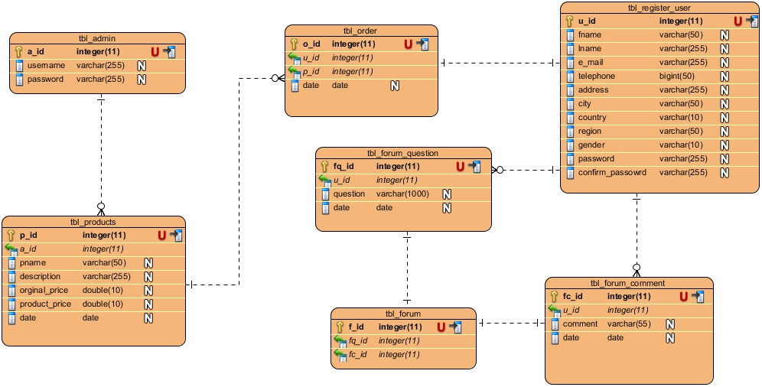

## 3.4) Architectural Design

3.5) Paper Prototyping

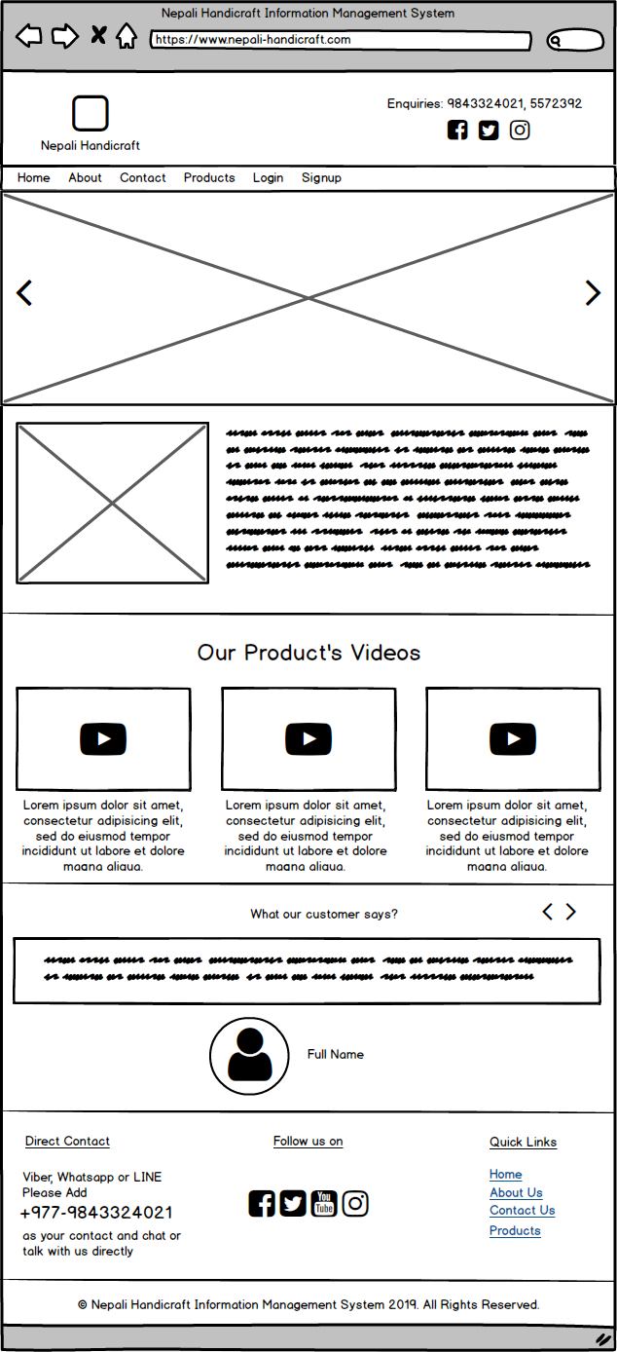

Fig: Homepage

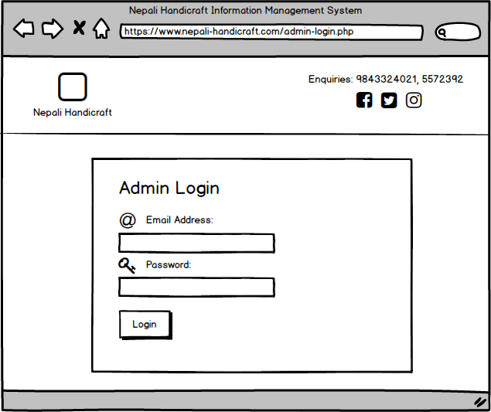

Fig: Admin Login

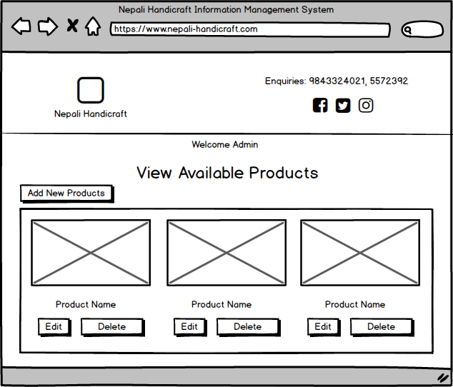

Fig: View Available Products

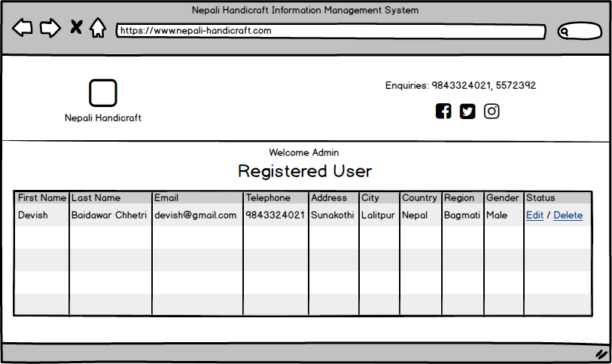

Fig: View Registered Users

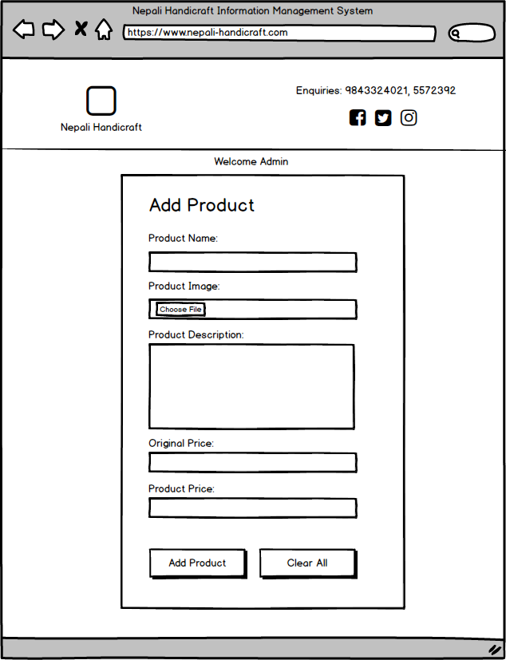

Fig: Add Product

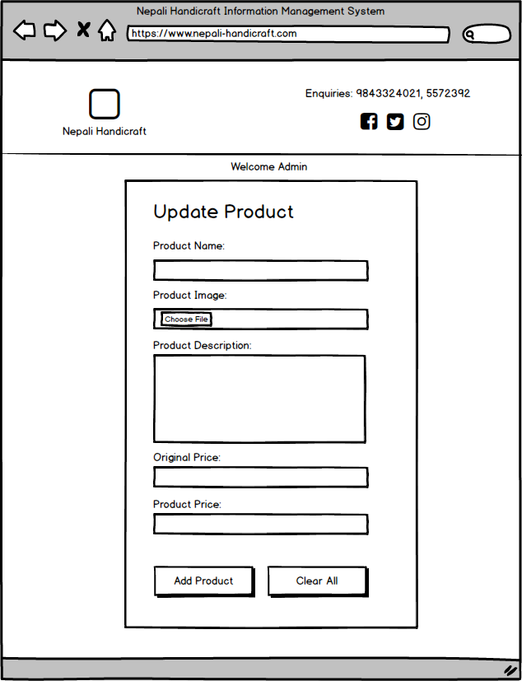

Fig: Update Product

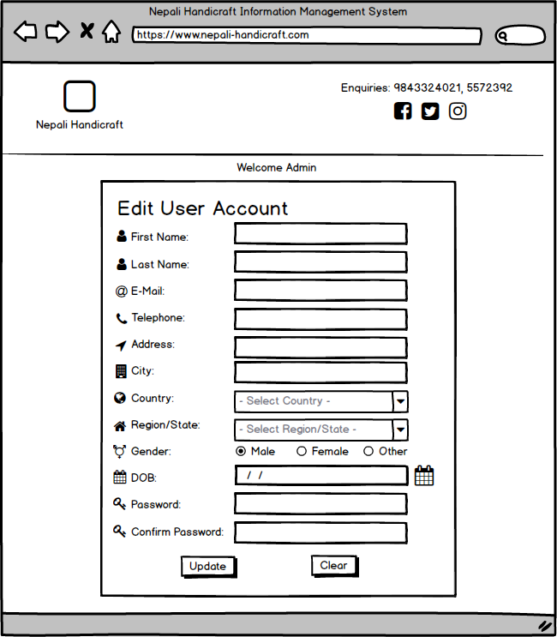

Fig: Admin edit user

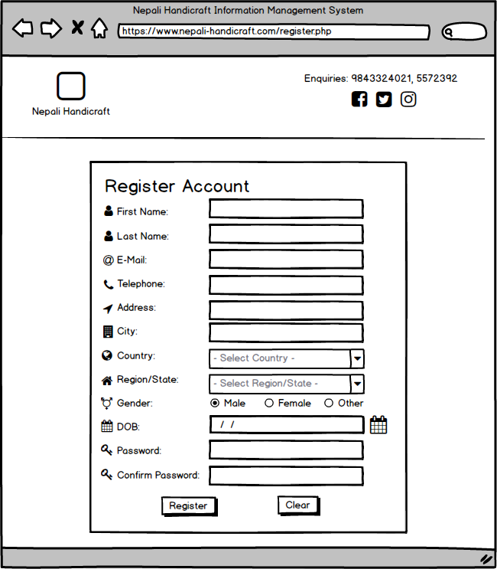

Fig: Register New user

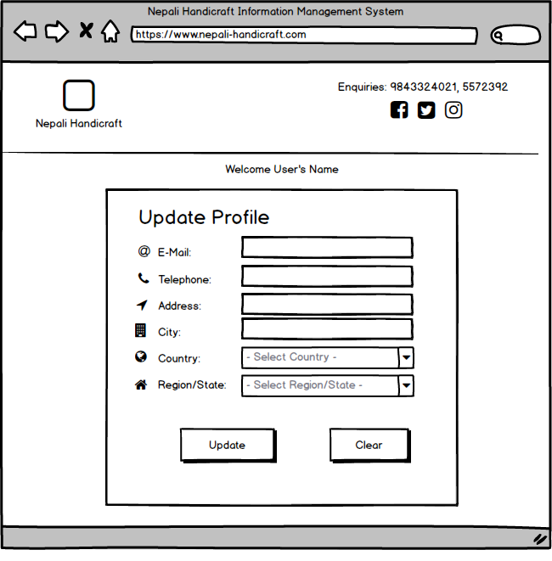

Fig: Update User’s Details

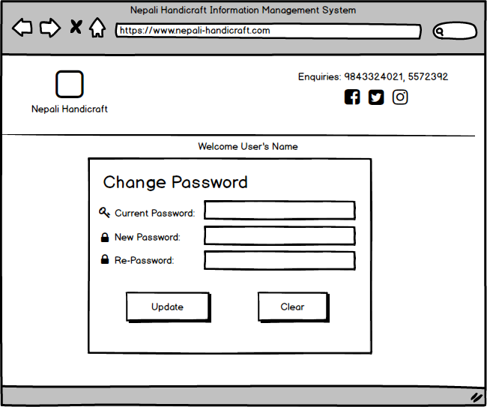

Fig: Change Password

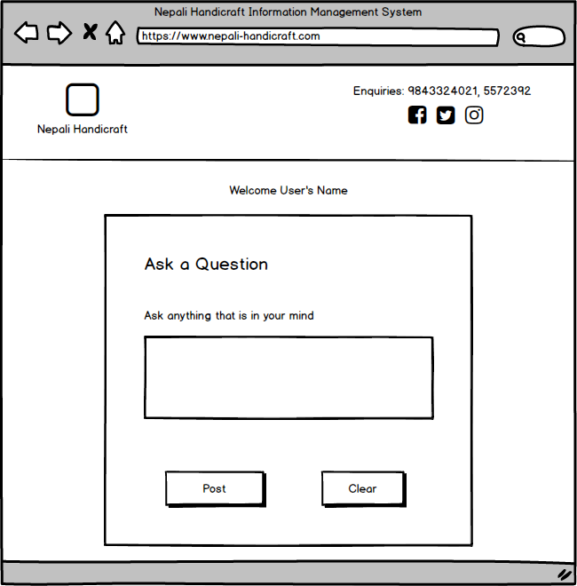

Fig: Forum Ask Question

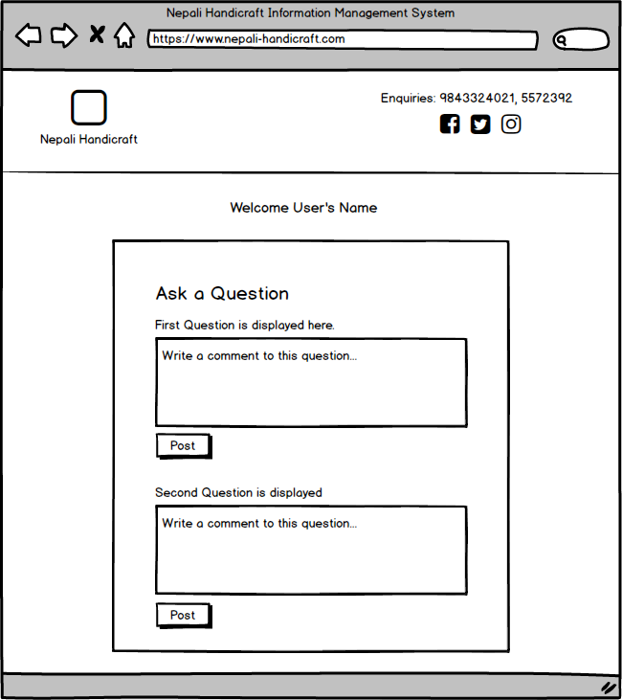

Fig: Forum Comment

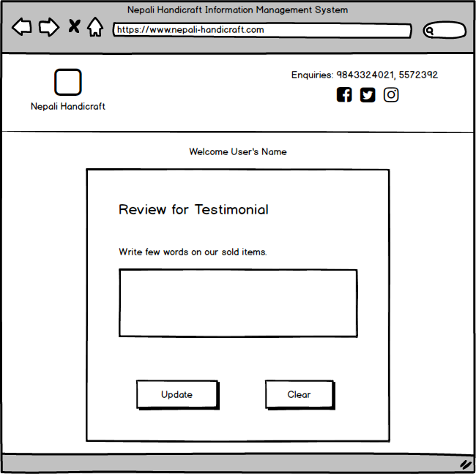

Fig: Review for testimonial

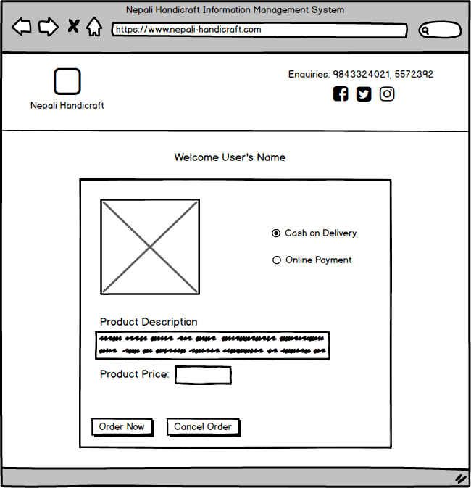

Fig: Order Required Product