Project Proposal on

**Nepali Handicraft (Information Management System)**

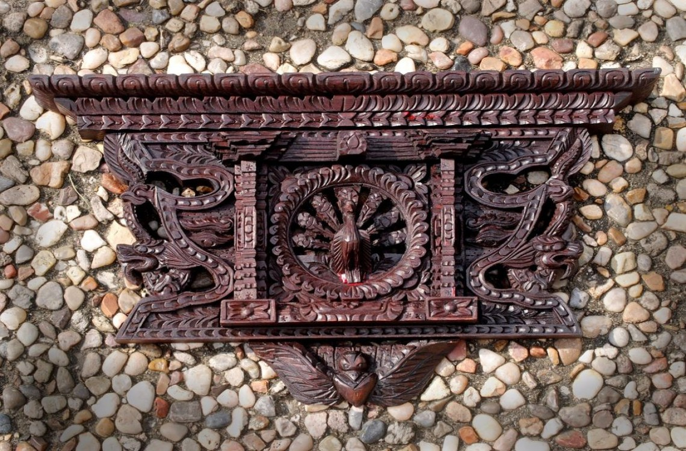

By

**Devish Baidawar Chhetri**

00174648

Computing Project

Level 5 Diploma in Computing

Softwarica College of IT & E-Commerce

Kathmandu, Nepal

Submission Date: 9th April 2019

**Submitted to: Sudeep Lal Bajimaya**

**(Module Instructor)**

Contents

1. Introduction 3

1.1) Introduction to the project 3

1.2) Background of the project 3

1.3) Problem Statement 3

1.4) Description of the project 4

1.4.1) Features of the project 4

1.5) Overview of the project 4

2. The scope of the project 5

2.1) Scope 5

2.2) Limitation 5

2.3) Aims 5

2.4) Objectives 5

2.5) Overview of the scope of the project 6

3. Development Methodology 7

3.1) Description of the methodology chosen 7

3.2) Design Pattern 8

3.3) Architecture 9

4. Project Planning 10

4.1) WBS (Work Breakdown Structure) 10

4.2) Milestones 11

4.3) Gantt Chart 13

5. Risk Management 14

6. Configuration Management 16

7. Conclusion 18

8.References and Bibliography 18

# Introduction

## Introduction to the project

This will be the project of “Nepali Handicraft. (Information Management System)” for all the people around the world. It will be a non-profit organization of private sector business and artistic community. It will help the member to improve their productivity and introduce their handicrafts to the world. This will also help to manage handicrafts products more systematically and scientifically as the user or any foreigner can order from the internet at a reasonable price.

## Background of the project

Nepali Handicraft Information Management System is a popular system for retrieving the knowledge on handicraft works done by the people inside Kathmandu valley. People have their shop including beautiful handcrafted arts and equipment.

As the technology developing, neighbouring countries are making the same handcrafted arts and equipment by the help of huge and expensive machines, due to this originality of the products are fading day by day.

## Problem Statement

After developing this Information Management System, it will be able to give all the necessary description with its key and historical information to the peoples. Mostly to those tourists who are willing to learn more on the specific art or handicraft. This will automatically overcome with old paper transactions, which had cost valuable time and cost.

## Description of the project

For developing this project, I will use PHP as a core programming language and Xampp (MySQL) for the database. I will make simple, easy and good looking Graphical User Interface for the end users so, the end users will find comfortable to use the application. And to store user details and information on handicraft items, I will store these on the database.

### 1.4.1) Features of the project

* It will provide information on different types of handicraft item,
* Easy GUI that will help users to get addicted to the product,
* Products will be able to view online and order accordingly,
* Products will be sold at cheaper compared to any other physical stores,
* The account can be easily created and updated,
* Passwords of the users will be safe and encrypted,
* Inactive users for 1 year will be deleted,
* Special items will be sold on auction.

## Overview of the project

Today’s condition of the market is very low. Handicraft items are not sold as it should be. Many tourists visit many places but they don’t know what type of handcrafted arts and items they can find in their visit. So, This application is going to make the work easy, fast and more effective. As GUI will be easy users will be attracted to the application, products will be already online so they can spend their time as much as they can and only take their decision for buying the products, products can easily be seen with their prices. Users will also find products in cheap compared to the products sold at the physical market. And also the user’s information and password will be safe from any kind of security threats.

# 2. The scope of the project

## 2.1) Scope

This project will attract more visitors from abroad who are on a short or even on a long trip vacation, as it will give the true information about the art and its cultural heritage behind it. It will preserve and promote our handicraft products. It will also place the best market value of locally hand made products.

## 2.2) Limitation

• Will only work on the web-based application,

• Bad internet connection can prompt unaccess to the website,

• The quality of the product is not 100% assured.

## 2.3) Aims

• To provide Nepali handicraft items for all the visitors at a reasonable price,

• To create communication between any two persons,

• To store information about arts and galleries with their histories.

## 2.4) Objectives

• Creating a user-friendly GUI,

• Making Application secure,

• Designing different types of diagram for the flow of the application,

• Gathering valuable and important data and information,

• Analyzing collected data for legit information of specific history,

• Protect user’s profile and data,

• Save time and increase in effectiveness,

• Decrease the long process of work.

## 2.5) Overview of the scope of the project

This project can be used by any other similar projects around the globe but, one needs to change their design and features according to their needs. As this application will give ideas and information about handicraft items, it will also have some limitations. The user needs to be connected to the internet for viewing different items and products. Looking at the product online and in the real market may seem different than expected. It means items can be good as well as not good. But the GUI of the application will be good and secure. Different phases of the diagram will be drawn as per the flow of the application. Legit data and information will be updated on the application.

# 3. Development Methodology

## 3.1) Description of the methodology chosen

For the development of this project, I will be using waterfall methodology. The waterfall model is a linear, sequential approach to the software development lifecycle that is popular in product development and software engineering. (Rouse, 2019)

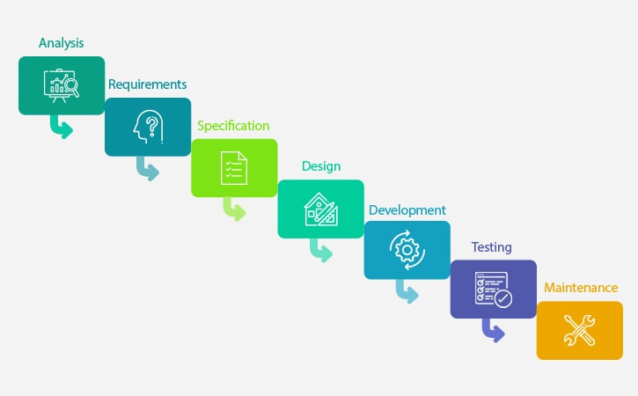

Fig: Waterfall Model

I will choose the waterfall model because of the following reasons:

• It is simple and very easy to understand the processes,

• Milestones, stages, and task are easily defined and arranged,

• Phases are carefully processed and completed one stage at a time,

• Each phase have its own delivery and a reviewing process,

• It is predictive, sequential and planning oriented.

As my project is going to be not very large, I think that waterfall methodology is going to be a good approach. All the requirement is visible and also the user’s participation is not so important for the development of this project. Also, waterfall methodology will help me to make my application good as each phase is started after finishing the current phase.

## 3.2) Design Pattern

For the development of this project, I will be using the Model View Controller (MVC) design pattern.

**Model:** It contains only the pure application of the data. It does not contain any logical describing how to display the information to a user. (Kumar, 2017)

**View:** It displays the model’s data to a user. It knows how to access the model’s data but it does not know what the users can do to alter the data. (Kumar, 2017)

**Controller:** It exists between the model and the view. It controls the data flow into the model and updates when the data is changed. (Tutorials Point, 2017)

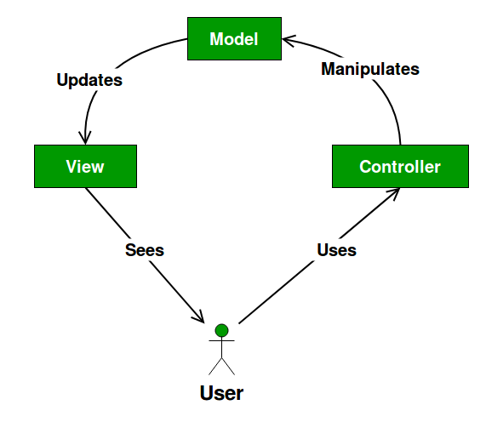

Fig: MVC Design Pattern

## 3.3) Architecture

For the development of this project, I will be using Client-Server as an Architecture.

**Client-Server Architecture:**

It is an architecture of a computer network, in which the client requests a service from a centralized server and the centralized server gives service to a remote processor or a client-server.

Advantages:

* Access, resource and the integrity of the data are controlled by the centralized server,
* We can increase the number of client and server separately in the network,
* We can easily replace, repair and upgrade a server without affecting the users.

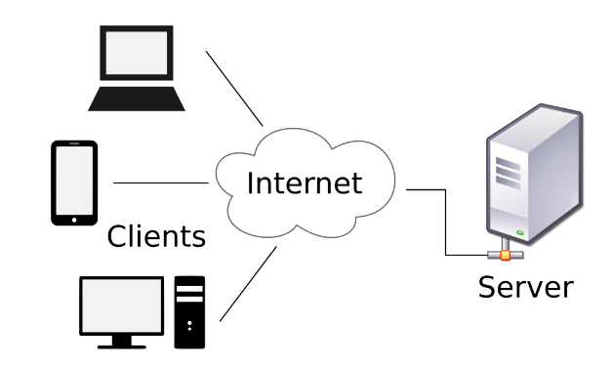

Fig: Client-Server Architecture

In this project, using this architecture client can easily access the resources, data, and files which are stored in the server. It will help to interact front-end (**client**) with users and back-end (**server**) with the shared resources. While deployment of the project any problem may arise, during that time this architecture will act as scalability. Which means it can be scaled in mainly two types they are Horizontal Scaling and Vertical Scaling.

**Horizontal Scaling:** It simply means adding or removing the client’s workstation on a slight performance impact.

**Vertical Scaling:** It simply means upgrading or migrating server to a larger and faster server.

# 4. Project Planning

## 4.1) WBS (Work Breakdown Structure)

WBS is a fundamental project management technique or method for undertaking the different parts of the application. It will give the vital structure to the itemized direction for schedule development and control. It will further enable us to manage the project and issue.

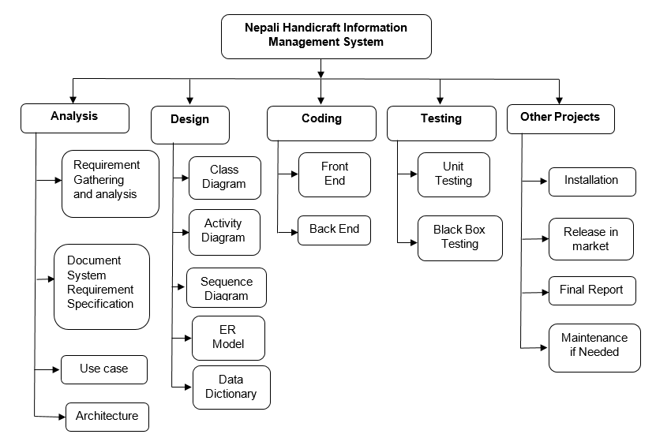

Fig: Work Breakdown Structure

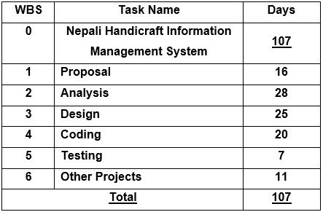

Fig: WBS time estimation

## 4.2) Milestones

It is the task of zero duration that will help to represent a clear and sequence event that incrementally builds up until our project is complete. It will help us to show an important achievement of the project. It will also help to maintain a certain level of progress of the project, and such progress will help us to complete our project on time.

The time duration for the first task is set to 16 days which is the proposal of the project. I am planning to finish a proposal in 16 days because it is the core document that will help us to give an overview of our project.

I'll set the time duration of analysis for 28 days. I will set time duration for requirement gathering and analysis, document system requirement specifications, use case, and architecture for 8, 5, 8, and 7 days respectively. The reason for taking 28 days in an analysis is because analysis will act as the blueprint for the project and it will also help later to have a clear understanding of the project's needs and requirements.

For designing, I will take 25 days approximately. In design, I will make a Class diagram as a Structural Model which will help to represent the static view of a project. Activity Diagram and Sequence Diagram as Behavioral Diagram which will help to focus on dynamic aspects of a project. ER Modeling, Data Dictionary and Reviewing final design under Database Design because it will help the project to improve its data consistency and also it will help to increase the performance of the database system.

For coding, I will give 20 days’ maximum. For developing Frontend - 7 days and Backend - 13 days. As for designing frontend, it is comparatively easy to Backend. Backend requires complex and logical problem-solving skills so time duration for the backend is likely twice to the frontend.

For testing, I will give 3 and 4 days for unit testing and black-box testing respectively. These testing will help to keep the project's code organized and well documented. It will also help to test the behavioral of the project.

And for doing other projects, I will allocate 11 days. In this duration, I will install and release the project in the market. After completing, I will prepare a final report and maintain the project if required.

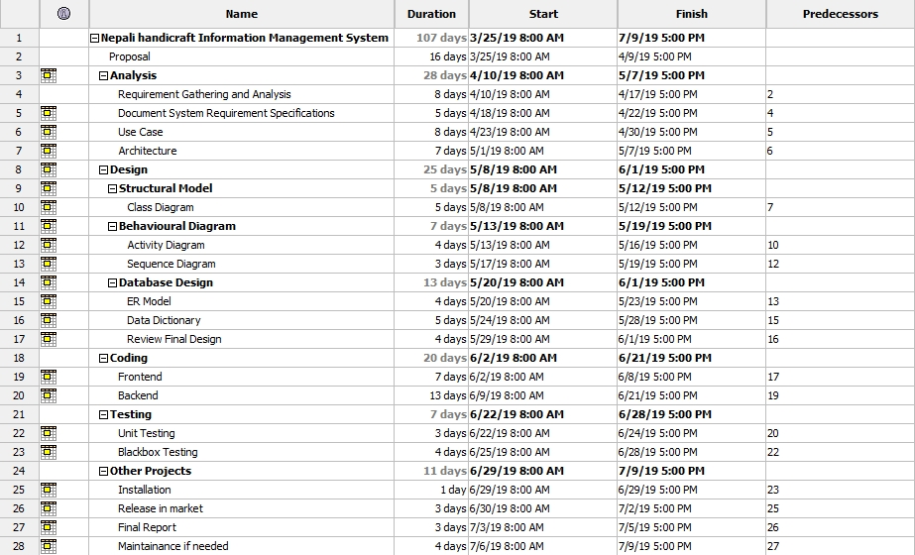

Fig: Milestones

## 4.3) Gantt Chart

Gantt Chart, it is a type of chart which will show the task to be done in a vertical axis and time interval for doing the task on the horizontal axis. We can find the horizontal bars in the graph that will show the length of the particular part of a project to be done.

It is one of the important charts for planning and scheduling our project that will help us to identify how long our project will take to complete and to determine the required resource for the development of the project.

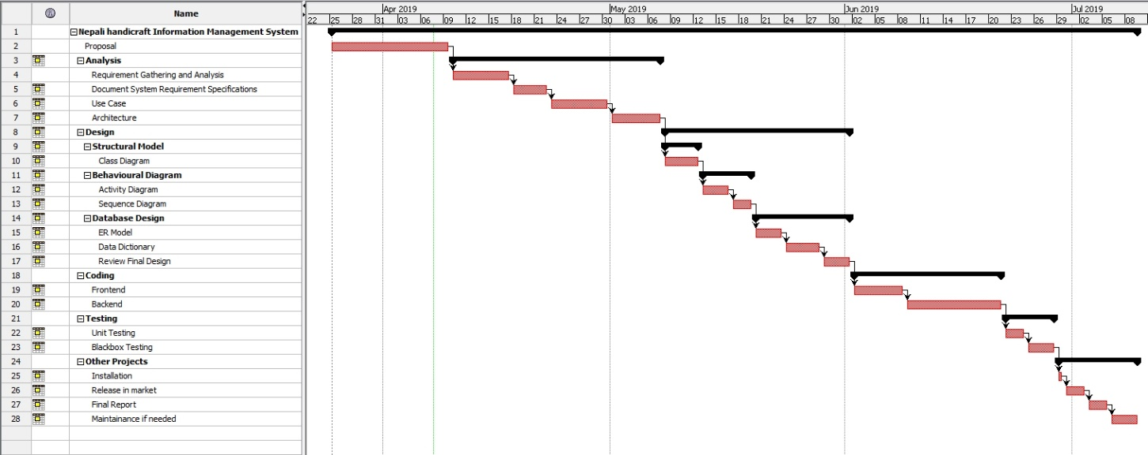

Fig: Gantt Chart

Gantt Chart consists of horizontal and vertical lines that intersect each other to form a small square representing the unit of measurement, which may be days. It can be days, weeks or months. The shaded bar will represent the operation or the work center of the project. Here, the horizontal axis will represent the total lifespan of the project whereas the vertical axis will represent the list of the task of a project. The horizontal bar of different varying lengths will represent the sequence of the project. For example: After completing one task, another task will start which will give both, time as well as the sequence of the operation of the project.

# 5. Risk Management

Risk Management is the process of identifying the strength, weaknesses, opportunities, and threats of our project. It is important in the project because without it, we cannot define our objectives for the future. And if we define our objectives without taking risk management then we may lose the track once any risk occurs. Our project will go effectively if the risk is managed wisely.

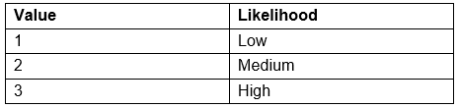

Fig: Risk Likelihood

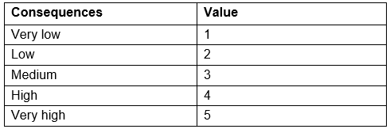

Fig: Risk Consequences Values

For identifying risk, we will use the following formula:

**Impact = Likelihood x Consequence**

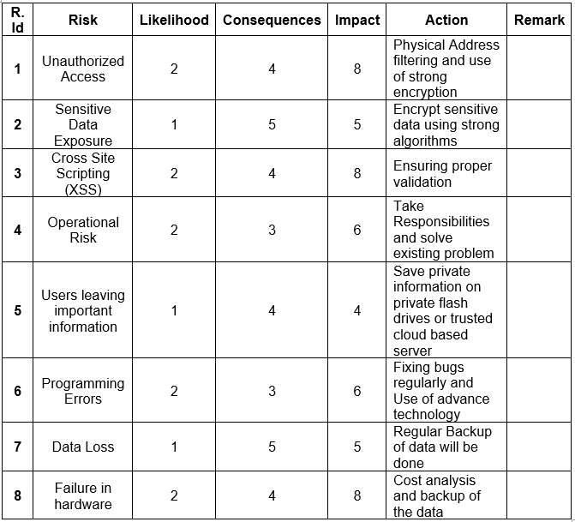

Fig: Risk Management Table

Some of the basic steps of risk management lifecycle are explained below:

1. **Identification:** We cannot manage our risk if we don’t know the risk. So identifying risk is the first step for risk management.
2. **Assessment:** Once the risk is identified, it needs to be examined in terms of likelihood and impact. This will then identify which risks should be in first priority.
3. **Treatment:** After accessing the risk, an approach for treating each risk should now be characterized.
4. **Monitoring:** Once the risk is identified, accessed and treated now we cannot leave it. It needs to be processed and reviewed, which is essential for proactive risk management.
5. **Reporting:** After all these four stages, the report of each four stages above should be described briefly for effective risk management.

# 6. Configuration Management

Configuration Management is the process of establishing and maintaining the regularity or uniformity of a project’s performance and functional attributes with its information throughout its life. It helps to manage all the configurations of the project through five key stages:

1. **Planning:** It deals with how will we record, track, control, and audit the project.
2. **Identification:** It includes functionality, requirements, design requirement and any other specifications of the project.
3. **Controlling:** It must be assessed, approved, and well documented.
4. **Status accounting:** It helps to control the version of the project and also trace out the changes made throughout the project.
5. **Auditing:** It includes all the tests to prove that the product conforms with the configuration requirements. (Wrike, 2019)

Following is the folders that manage the project:

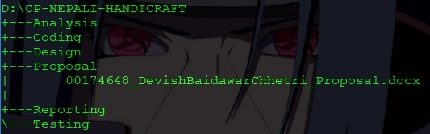

Fig: Project Backup in Internal Drive

External backup is created for any uncertainty of data loss, hardware failure, and other factors.

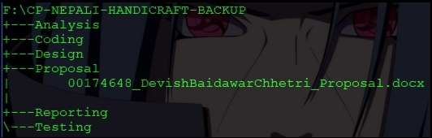

Fig: Project Backup in External Drive

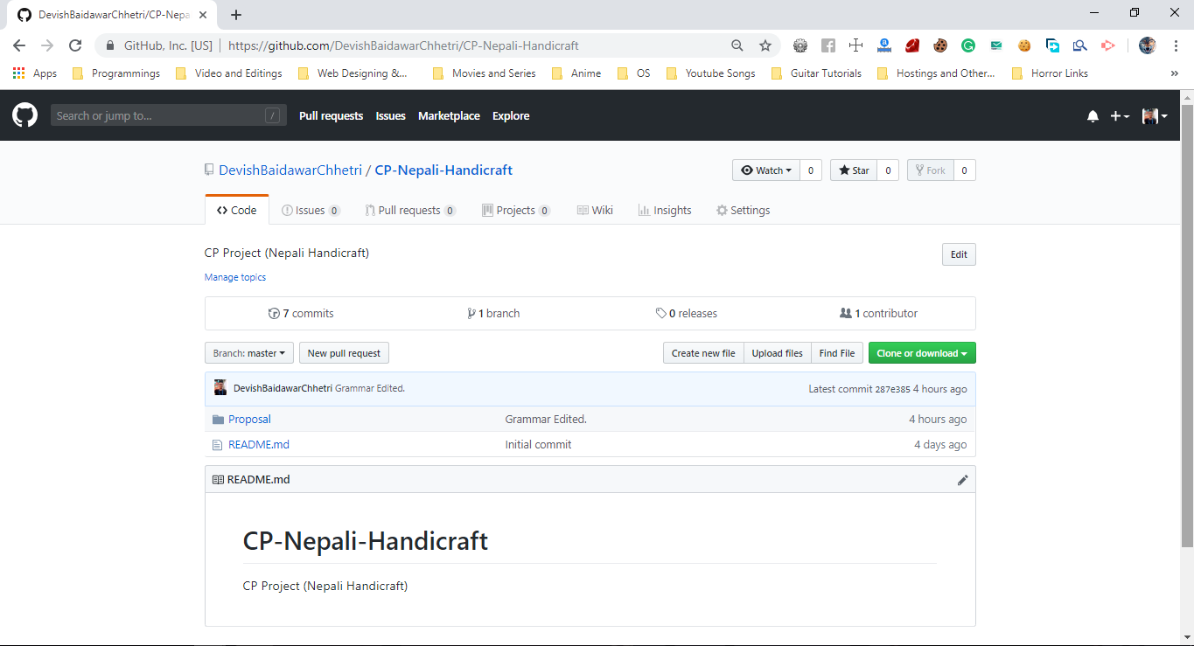

Fig: Screenshot of GitHub’s Repository

**GitHub Profile:** <https://github.com/DevishBaidawarChhetri>

**GitHub Repository URL:** <https://github.com/DevishBaidawarChhetri/CP-Nepali-Handicraft>

# 7. Conclusion

Hence, Nepali Handicraft Information Management System will help all the people to gain information about the old and popular handicraft items with its unique and popular history. Foreigners will also be able to watch local handicraft items and also they can buy it if they want. As this project is going to be web-based, everyone will have access to the web application.

Users can create account and view items. This project will allow admin to post and delete an item, update the price to the item. Once the user is logged in, the user can buy the product one at a time.

I will use PHP and MySQL as programming language and database, Sublime Text 3 as my text editor for code and markup purposes. I will be using Bootstrap which is a free and open source product for developing front-end framework in an easier and faster way.

# 

# 8.References and Bibliography

Kumar, S., 2017. *mvc-design-pattern.* [Online]   
Available at: https://www.geeksforgeeks.org/mvc-design-pattern/  
[Accessed 06 April 2019].

Rouse, M., 2019. *waterfall-model.* [Online]   
Available at: https://searchsoftwarequality.techtarget.com/definition/waterfall-model  
[Accessed 06 April 2019].

Tutorials Point, 2017. *design_pattern/mvc_pattern.* [Online]   
Available at: https://www.tutorialspoint.com/design_pattern/mvc_pattern.htm  
[Accessed 06 April 2019].

Wrike, 2019. *what-is-configuration-management-in-project-management.* [Online]   
Available at: https://www.wrike.com/project-management-guide/faq/what-is-configuration-management-in-project-management/  
[Accessed 07 April 2019].