1. import matplotlib.pyplot as plt

data=[34,18,100,27,54,52,93,59,61,87,68,85,78,82,91]

plt.boxplot(data,vert=0,patch_artist=True)

plt.show()

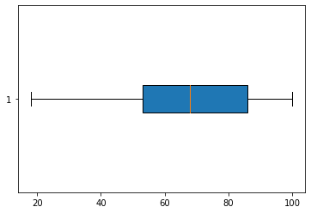

1. import matplotlib.pyplot as plt

data1=[72,76,24,14,67,52,75,78,31,32]

data2=[62,5,91,25,36,32,96,95,30,90]

data3=[23,89,12,78,72,89,25,69,68,86]

bdata=(data1,data2,data3)

box=plt.boxplot(bdata,vert=1,patch_artist=True)

colors=['green','red','pink']

for p, color in zip(box['boxes'],colors):

p.set_facecolor(color)

plt.show()

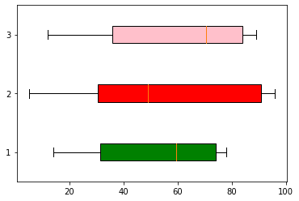

1. import matplotlib.pyplot as plt

data1=[72,76,24,14,67,52,75,78,31,32]

box=plt.boxplot(data1,vert=0,patch_artist=True)

colors='black'

for p in box['boxes']:

p.set_facecolor(colors)

plt.show()

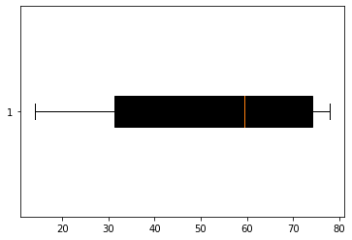

1. import matplotlib.pyplot as plt

umemp_rate=[6.1,5.8,5.7,5.7,5.8,5.6,5.5,5.3,5.2,5.2]

index_price=[1500,1520,1525,1523,1515,1540,1547,1560,1555,1565]

plt.scatter(umemp_rate,index_price,c='b')

plt.xlabel('umemp_rate',fontsize=16)

plt.ylabel('index_price',fontsize=16)

plt.title('Relationship between unemployement Rate and stock index price',fontsize=20)

plt.show()

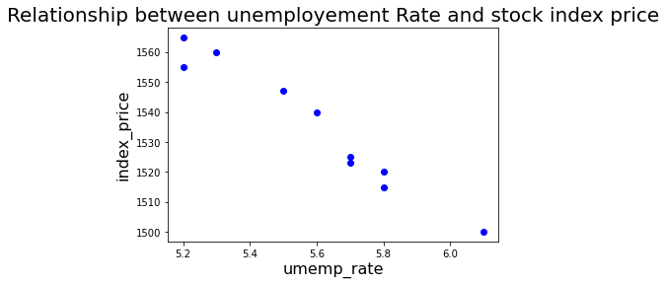

1. import matplotlib.pyplot as plt

data=[19,26,25,37,32,28,22,23,29,34,39,31]

box=plt.boxplot(data,vert=0,patch_artist=True)

colors='black'

for p in box['boxes']:

p.set_facecolor(colors)

plt.show()

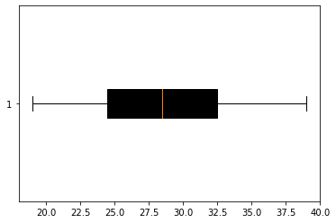

1. import matplotlib.pyplot as plt

import numpy as np

clas=['I','II','III','IV','V','VI','VII','VIII','IX','X']

strength=[40,43,45,47,49,38,50,37,43,39]

colors=['red','yellow','green','blue','pink','orange','violet','grey','cyan','black']

plt.bar(clas,strength,color=colors,align='center')

plt.xlabel(clas)

plt.ylabel(strength)

plt.show()

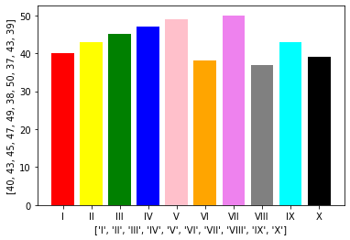

1. import pandas as pd

s=pd.Series([1,2,3,4,5],index=['a','b','c','d','e'])

print(s)

print(s.iloc[1:4])

print(s.loc['b':'e'])

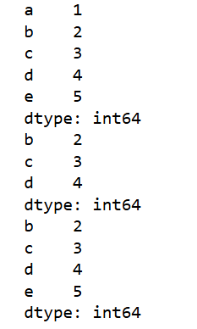

1. import pandas as pd

s=pd.Series({'Jan':31,'Feb':28,'March':31,"April":30})

print(s)

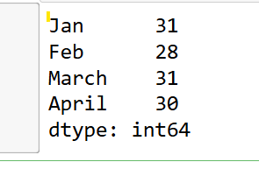

1. import matplotlib.pyplot as plt

import numpy as np

x=np.arange(-10,10,1)

y=x**2

plt.plot(x,y)

plt.show()

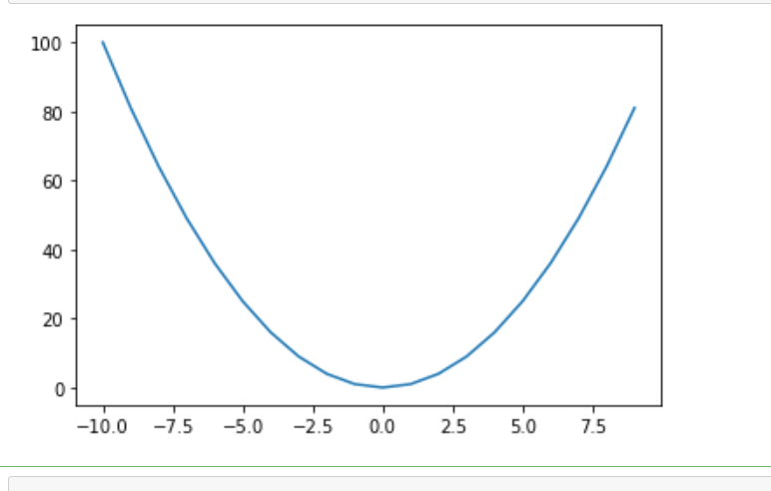

1. import matplotlib.pyplot as plt

weights=[78,72,69,81,63,67,65,79,74,71,83,71,79,80]

plt.hist(weights,bins=[50,55,60,65,70,75,80,85],color='pink',edgecolor='violet')

plt.title('Histogram of muffin weights')

plt.xlabel('Weight in grams')

plt.ylabel('Frequency')

plt.show()

