- get all documents.
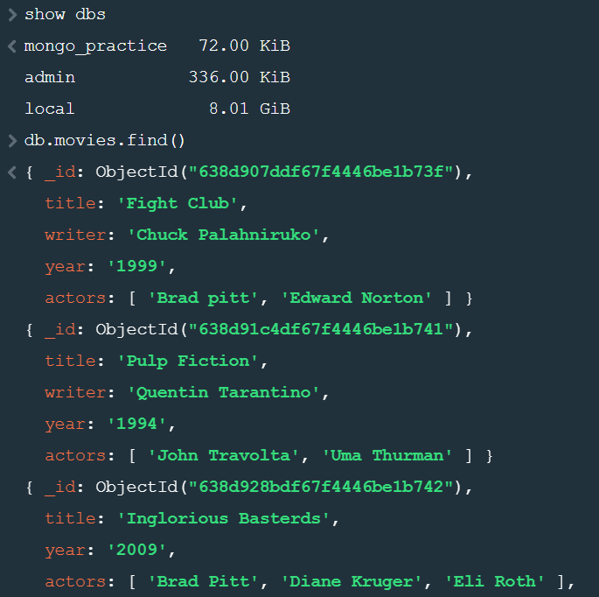
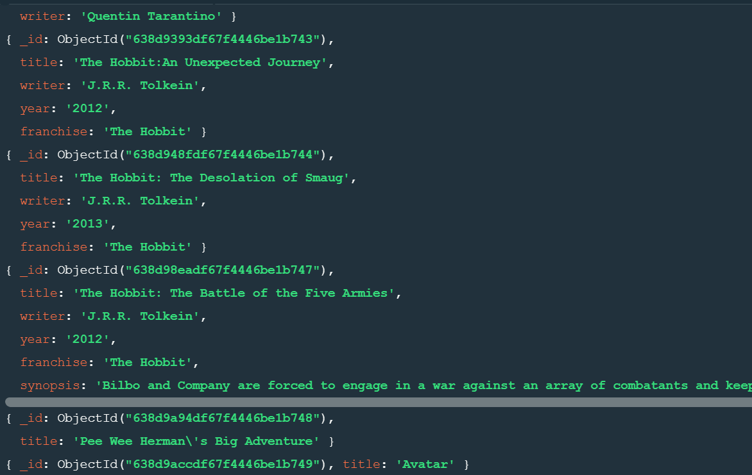

- get all documents with writer set to "Quentin Tarantino".
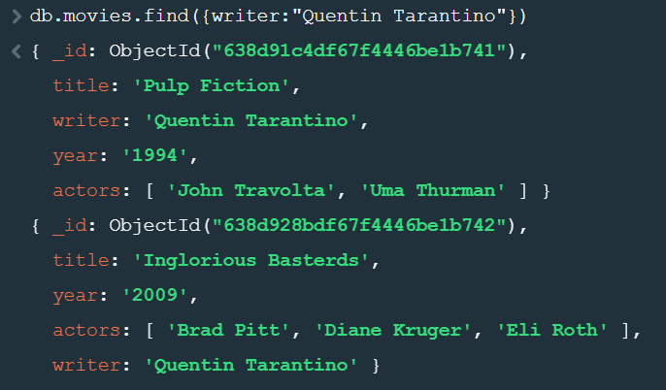

- get all documents where actors include "Brad Pitt".

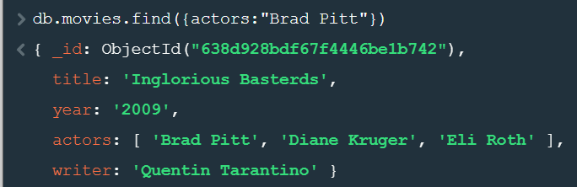

- get all documents with franchise set to "The Hobbit".
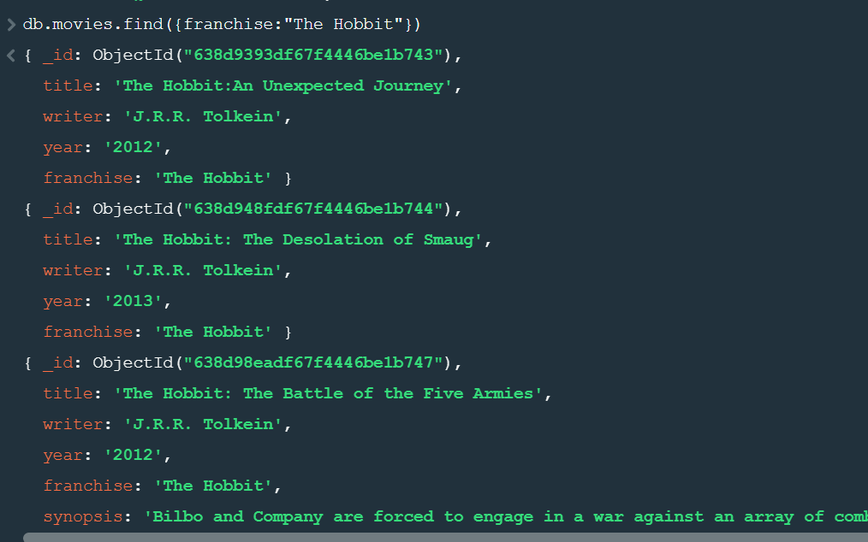

- get all movies released in the 90s.
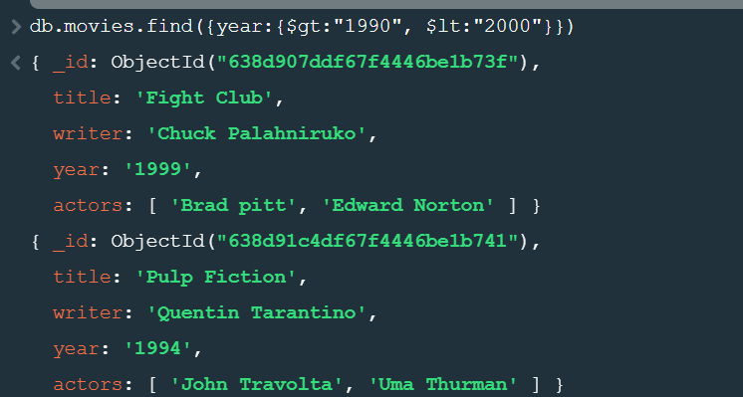

- get all movies released before the year 2000 or after 2010.
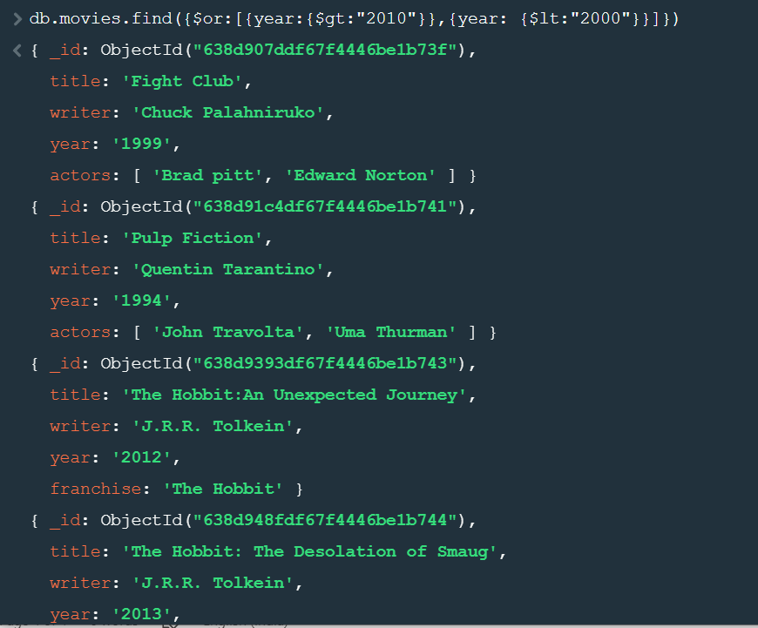


Update Documents
1. add a synopsis to "The Hobbit: An Unexpected Journey" : "A reluctant hobbit, Bilbo Baggins, sets out to the Lonely Mountain with a spirited group of dwarves to reclaim their mountain home - and the gold within it - from the dragon Smaug."
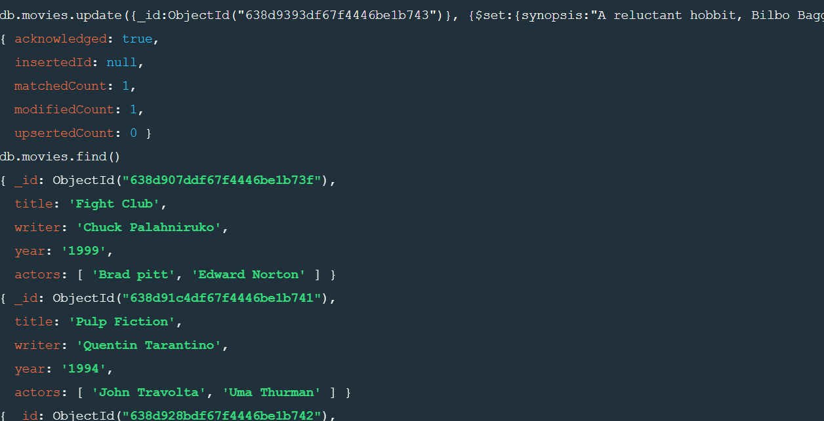

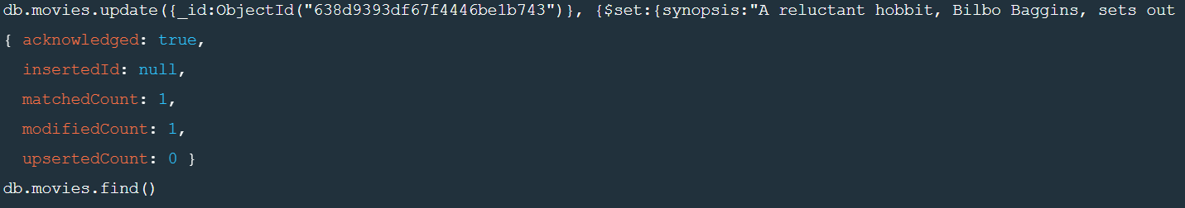
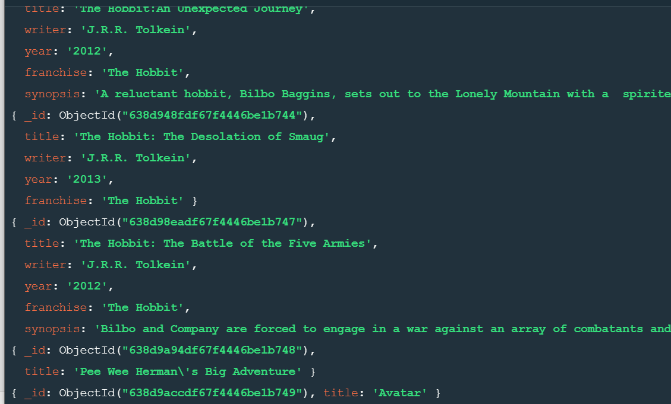

- add a synopsis to "The Hobbit: The Desolation of Smaug" : "The dwarves, along with Bilbo Baggins and Gandalf the Grey, continue their quest to reclaim Erebor, their homeland, from Smaug. Bilbo Baggins is in possession of a mysterious and magical ring."

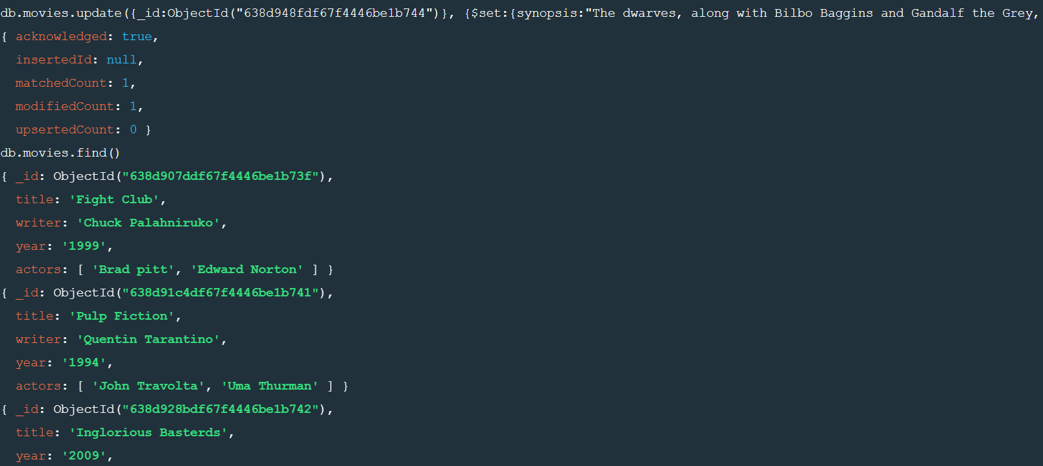

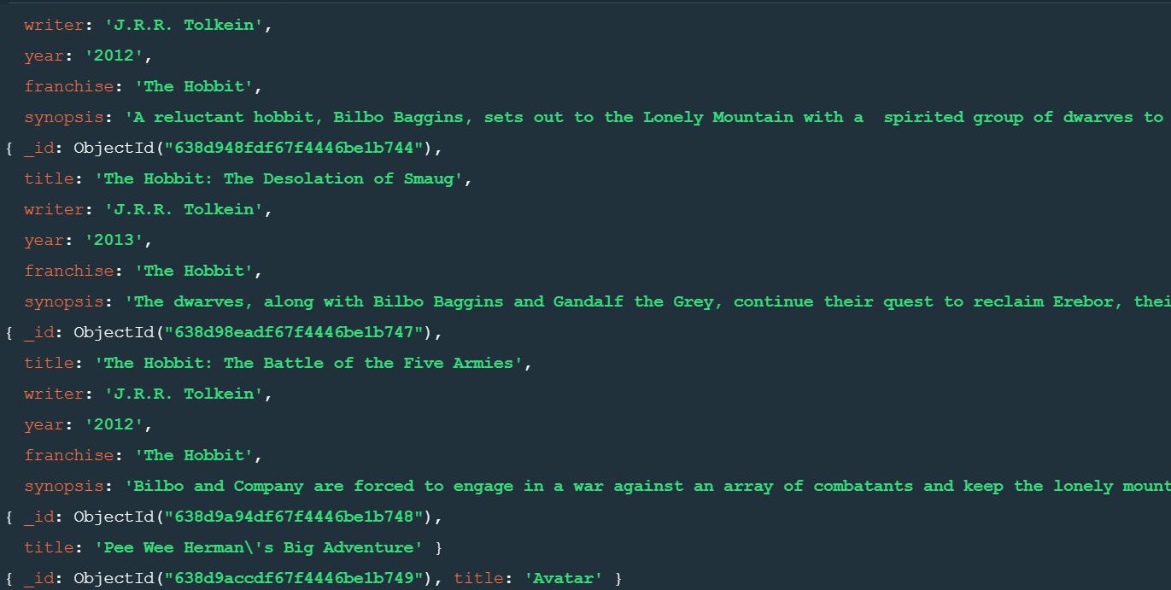

- add an actor named "Samuel L. Jackson" to the movie "Pulp Fiction".
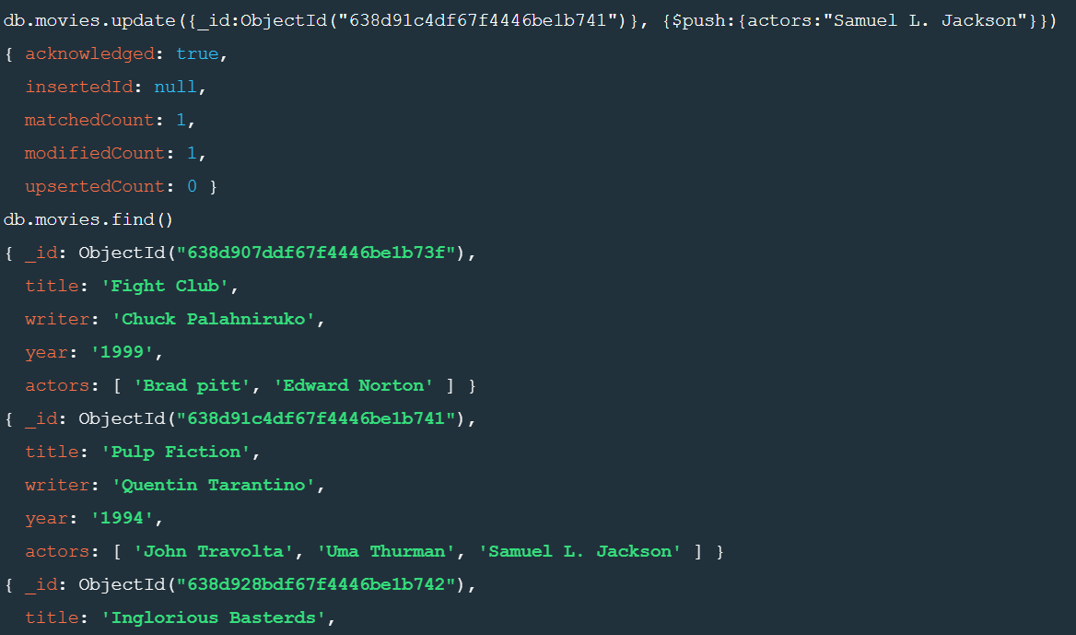

Text Search
- find all movies that have a synopsis that contains the word "Bilbo".
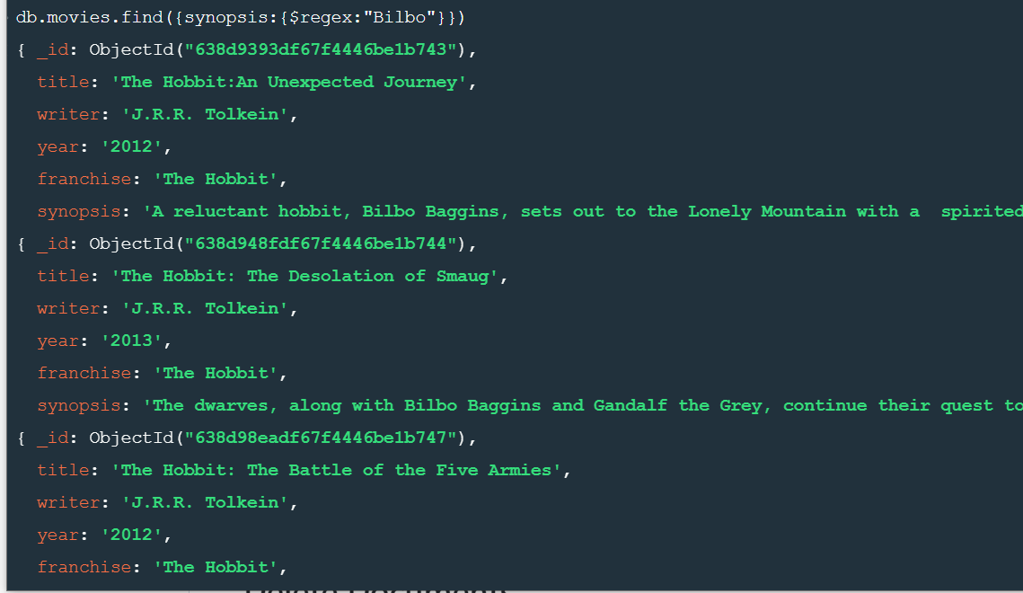

- find all movies that have a synopsis that contains the word "Gandalf"
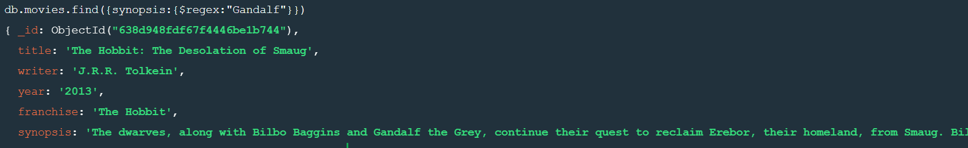

- find all movies that have a synopsis that contains the word "Bilbo" and not the word "Gandalf".
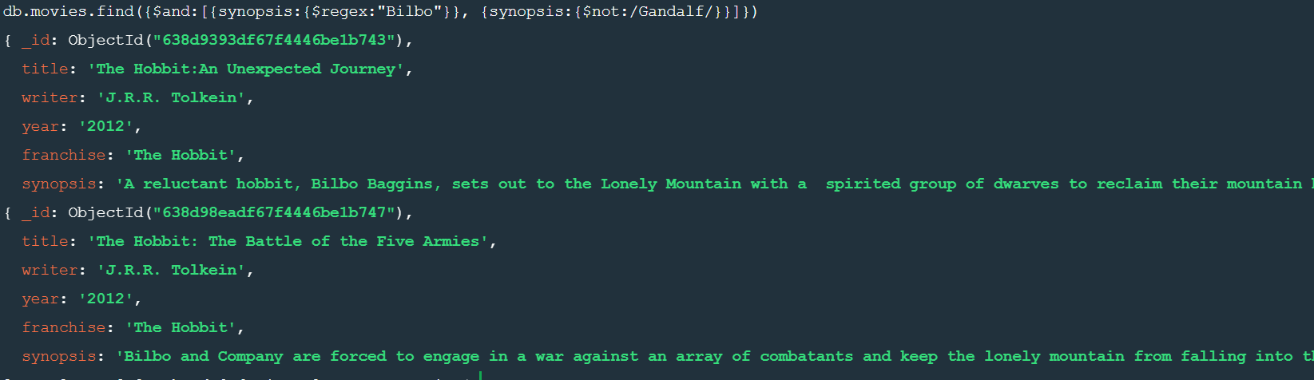

- find all movies that have a synopsis that contains the word "dwarves" or "hobbit".
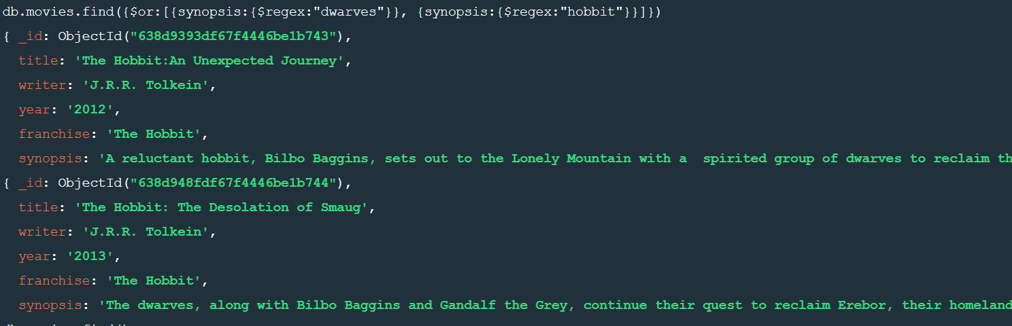
- find all movies that have a synopsis that contains the word "gold" and "dragon".
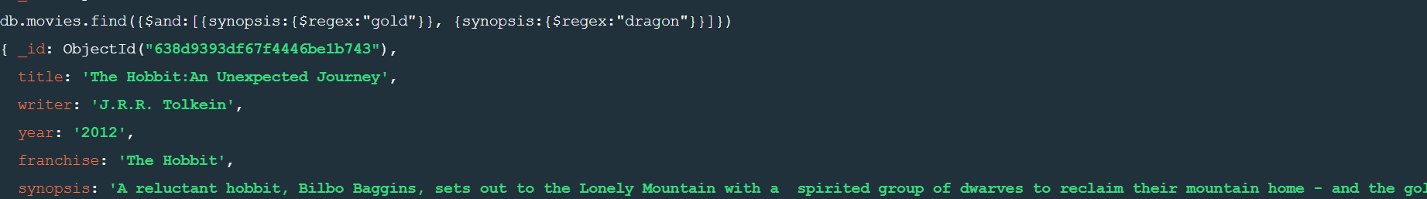

Delete Documents

- delete the movie "Pee Wee Herman's Big Adventure".

- delete the movie "Avatar".
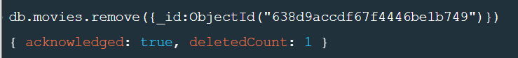

Querying related collections
  - find all users
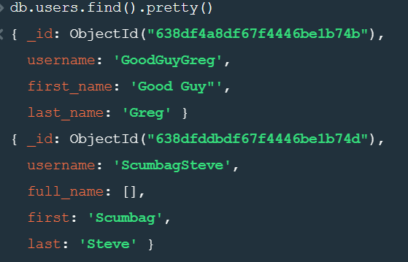

- find all posts
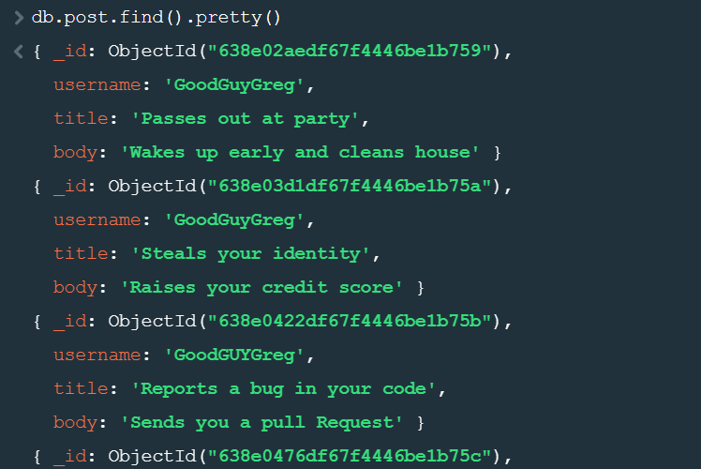
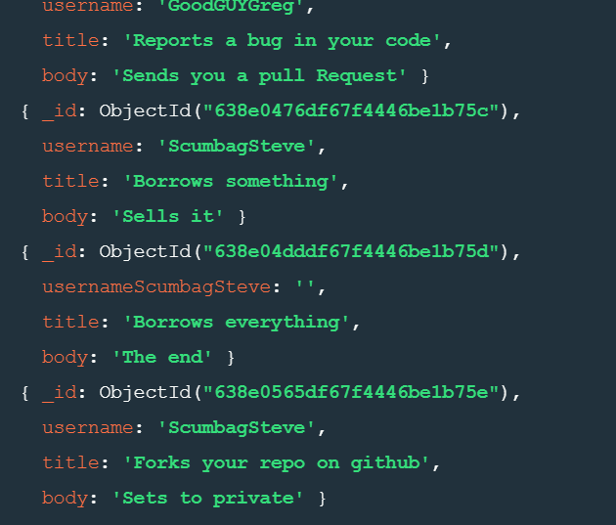
- find all posts that was authored by "GoodGuyGreg"
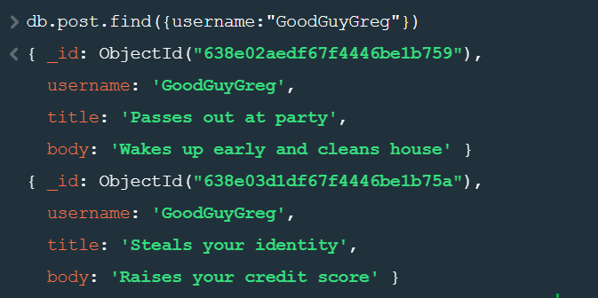

- find all posts that was authored by "ScumbagSteve".
