**Q1. What is Stationary Time Series?**

* + Time series is stationary if it’s devoid of a trend or any seasonal effects.
  + The summary statistics of a stationary time series will remain constant or vary minimally over time. e.g. mean and variance.
  + The ways used to test the stationarity of a series
* Visually-easiest
* Statistical measures — mean, variance, etc.
* Statistical test- considered the most effective one.



**Q2. What is a White Noise Time Series? Why does it matter?**

* **White noise is an important concept in time series forecasting.**
* **If a time series is white noise, it is a sequence of random numbers and cannot be predicted. If the series of forecast errors are not white noise, it suggests improvements could be made to the predictive model.**
* A time series is white noise if the variables are independent and identically distributed with a mean of zero.
* This means that all variables have the same variance (sigma^2) and each value has a zero correlation with all other values in the series.
* If the variables in the series are drawn from a Gaussian distribution, the series is called Gaussian white noise.

**Why Does it Matter?**

* White noise is an important concept in time series analysis and forecasting.
* It is important for two main reasons:
* Predictability: If your time series is white noise, then, by definition, it is random. You cannot reasonably model it and make predictions.
* Model Diagnostics: The series of errors from a time series forecast model should ideally be white noise.
* Model Diagnostics is an important area of time series forecasting.
* Time series data are expected to contain some white noise component on top of the signal generated by the underlying process.

For example:

**y(t) = signal(t) + noise(t)**

* Once predictions have been made by a time series forecast model, they can be collected and analyzed. The series of forecast errors should ideally be white noise.
* When forecast errors are white noise, it means that all of the signal information in the time series has been harnessed by the model in order to make predictions. All that is left is the random fluctuations that cannot be modeled.
* A sign that model predictions are not white noise is an indication that further improvements to the forecast model may be possible.

**Example of White Noise Time Series**

* In this section, we will create a **Gaussian white noise series in Python** and perform some checks.
* It is helpful to create and review a white noise time series in practice. It will provide the **frame of reference and example plots and statistical tests** to use and compare on your own time series projects to check if they are white noise.
* Firstly, we can **create a list of 1,000 random Gaussian variables** using the **gauss()** function from the **random** module.
* We will draw variables from a Gaussian distribution with a **mean (mu) of 0.0** and a **standard deviation (sigma) of 1.0.**
* Once created, we can wrap the list in a Pandas Series for convenience.

**Q3. What is Seasonality?**

* Seasonality in time-series data refers to a pattern that occurs at a regular interval. This is different from regular cyclic trends, such as the rise and fall of stock prices, that re-occur regularly but don’t have a fixed period.
* There’s a lot of insight to be gained from understanding seasonality patterns in your data and you can even use it as a baseline to compare your time-series machine learning models.
* There are two types of seasonality that you may come across when analyzing time-series data.

**Additive Seasonality**

* It’s pretty rare for actual time series to have constant crest and trough values and instead, we typically see some kind of general trend like an increase or a decrease over time. In our sales price plot, for example, the median price tends to go up over time.
* If the amplitude of our seasonality tends to remain the same, then we have what’s called an additive seasonality. Below is an example of an additive seasonality.

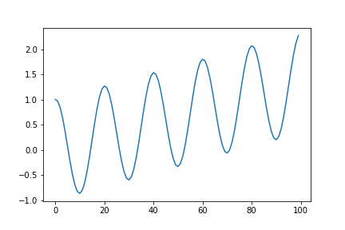

Additional seasonality

A great way to think about it is by imagining we took our standard cosine wave and simply added a trend to it:

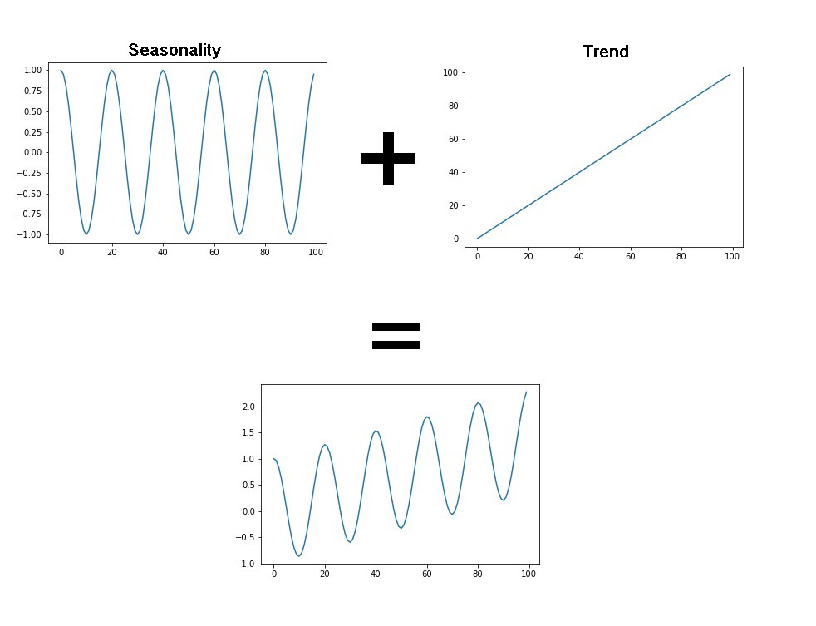

We can even think of our basic cosine model from earlier as an additive model with a constant trend! We can model additive time series using the following simple equation:

Y[t] = T[t] + S[t] + e[t]

Y[t]: Our time-series function  
T[t]: Trend (general tendency to move up or down)  
S[t]: Seasonality (cyclic pattern occurring at regular intervals)  
e[t]: Residual (random noise in the data that isn’t accounted for in the trend or seasonality.

## Multiplicative Seasonality

## The other type of seasonality that you may encounter in your time-series data is multiplicative. In this type, the amplitude of our seasonality becomes larger or smaller based on the trend. An example of multiplicative seasonality is given below.

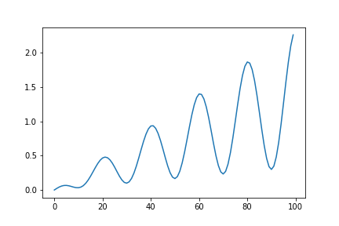

Multiplicative Seasonality

We can apply a similar train of thought as we used with our additive model and imagine that we took our cosine wave but instead of adding the trend, we multiplied it (hence the name multiplicative seasonality)

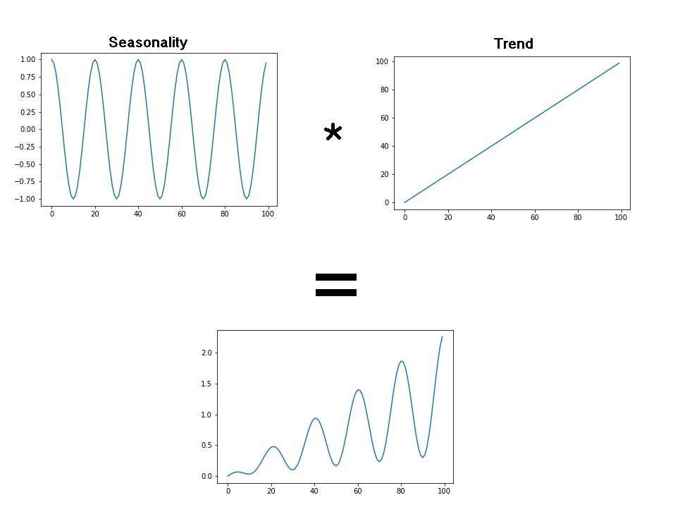

Multiplicative seasonality

We can model this with a similar equation as our additive model by just swapping the additions for multiplications.

Y[t] = T[t] *S[t] *e[t]

**Q4. What is Non stationary Time series data?.Explain the types of Non Stationary Processes.**

* Time series whose statistical properties change over time is called a non-stationary time series. Thus a time series with a trend or seasonality is non-stationary in nature. This is because the presence of trend or seasonality will affect the mean, variance and other properties at any given point in time.

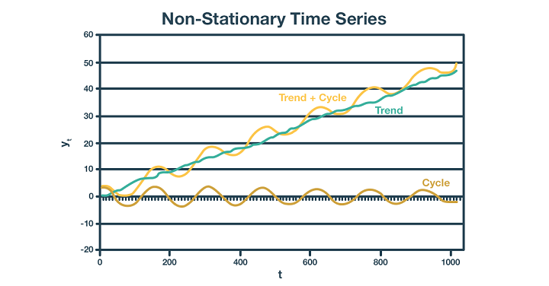

## Types of Non-Stationary Processes

* Before we get to the point of transformation for the non-stationary financial time series data, we should distinguish between the different types of non-stationary processes. This will provide us with a better understanding of the processes and allow us to apply the correct transformation.
* Examples of non-stationary processes are random walk with or without a drift (a slow steady change) and deterministic trends (trends that are constant, positive, or negative, independent of time for the whole life of the series

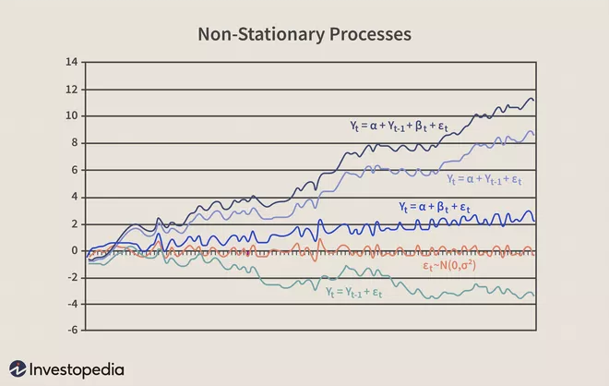

* **Pure Random Walk (Yt = Yt-1 + εt )** Random walk predicts that the value at time "t" will be equal to the last period value plus a stochastic (non-systematic) component that is a white noise, which means εtis independent and identically distributed with mean "0" and variance "σ²." Random walk can also be named a process integrated of some order, a process with a unit root or a process with a stochastic trend. It is a non-mean-reverting process that can move away from the mean either in a positive or negative direction. Another characteristic of a random walk is that the variance evolves over time and goes to infinity as time goes to infinity; therefore, a random walk cannot be predicted.
* **Random Walk with Drift** **(Yt = α + Yt-1+ εt )** If the random walk model predicts that the value at time "t" will equal the last period's value plus a constant, or drift (α), and a white noise term (εt), then the process is random walk with a drift. It also does not revert to a long-run mean and has variance dependent on time.
* **Deterministic Trend (Yt = α + βt + εt)** Often a random walk with a drift is confused for a deterministic trend. Both include a drift and a white noise component, but the value at time "t" in the case of a random walk is regressed on the last period's value (Yt-1), while in the case of a deterministic trend it is regressed on a time trend (βt). A non-stationary process with a deterministic trend has a mean that grows around a fixed trend, which is constant and independent of time.
* **Random Walk with Drift and Deterministic Trend (Yt = α + Yt-1+ βt + εt)** Another example is a non-stationary process that combines a random walk with a drift component (α) and a deterministic trend (βt). It specifies the value at time "t" by the last period's value, a drift, a trend, and a stochastic component.

**Q5. What is an Augumented Dickey fuller Test? and why do we use it?**

* Augmented Dickey Fuller test (ADF Test) is a common statistical test used to test whether a given Time series is stationary or not. It is one of the most commonly used statistical test when it comes to analyzing the stationary of a series.

As the name suggest, the ADF test is an ‘augmented’ version of the Dickey Fuller test.

* The ADF test expands the Dickey-Fuller test equation to include high order regressive process in the model.

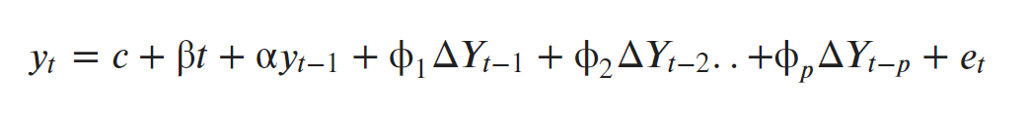

* If you notice, we have only added more differencing terms, while the rest of the equation remains the same. This adds more thoroughness to the test.
* The null hypothesis however is still the same as the Dickey Fuller test.
* A key point to remember here is: Since the null hypothesis assumes the presence of unit root, that is α=1, the p-value obtained should be less than the significance level (say 0.05) in order to reject the null hypothesis. Thereby, inferring that the series is stationary.
* However, this is a very common mistake analysts commit with this test. That is, if the p-value is less than significance level, people mistakenly take the series to be non-stationary.

## ADF Test in Python

So, how to perform a Augmented Dickey-Fuller test in Python?

The statsmodel package provides a reliable implementation of the ADF test via the adfuller() function in statsmodels.tsa.stattools. It returns the following outputs:

1. The p-value
2. The value of the test statistic
3. Number of lags considered for the test
4. The critical value cutoffs.

When the test statistic is lower than the critical value shown, you reject the null hypothesis and infer that the time series is stationary.

**why do we use ADF test?**

* Augmented Dickey Fuller test (ADF Test) is a common statistical test used **to test whether a given Time series is stationary or not**. It is one of the most commonly used statistical test when it comes to analyzing the stationary of a series