Objective
Design a multi-cloud architecture utilizing AWS and Google Cloud services.
Cloud Providers
AWS
- EC2
- S3
Google Cloud
- Cloud Storage
- BigQuery
Interoperability
The backend application hosted on AWS transfers data to Google Cloud Storage for backup and analytics processing.
Benefits
- High Availability
- Vendor Independence
- Disaster Recovery
- Better Scalability
Result
Successfully designed a multi-cloud architecture demonstrating interoperability between AWS and Google Cloud Platform

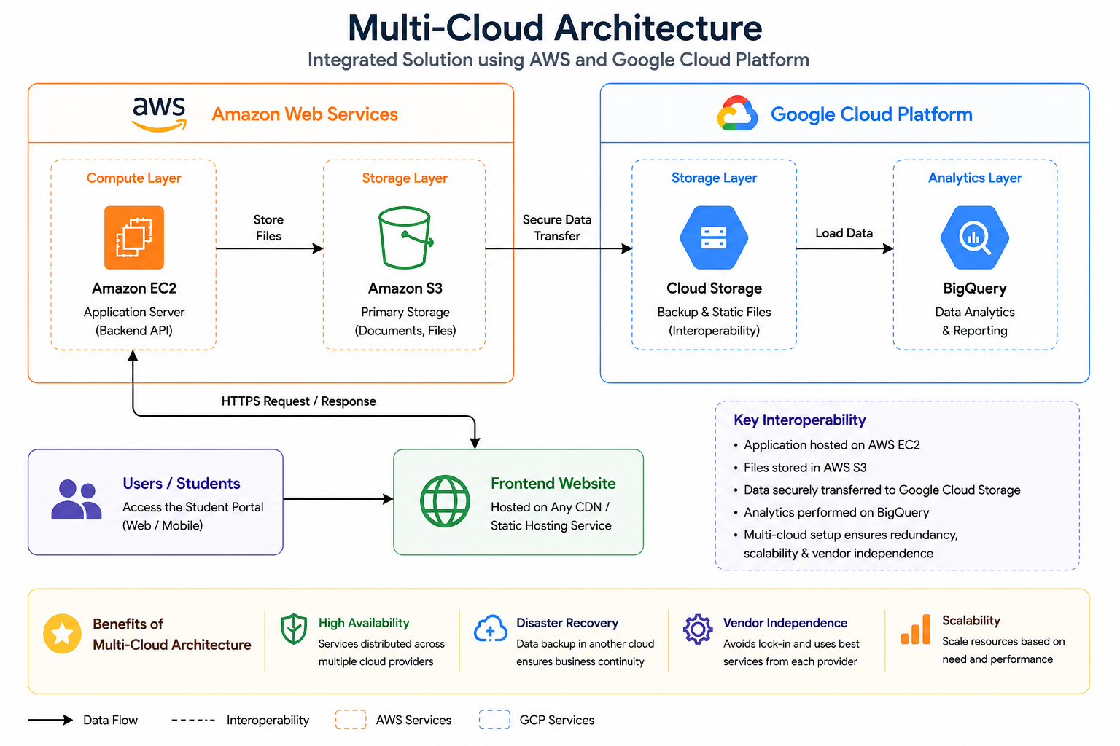
Figure 1. Multi-Cloud Architecture Diagram
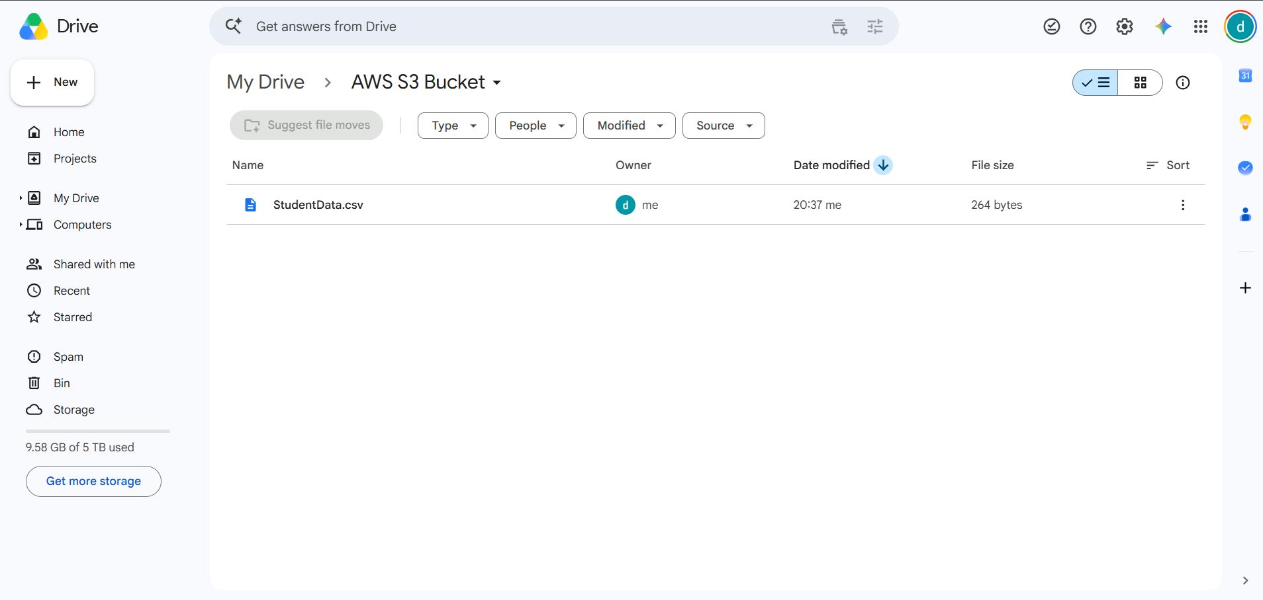
Figure 2. AWS S3 Bucket
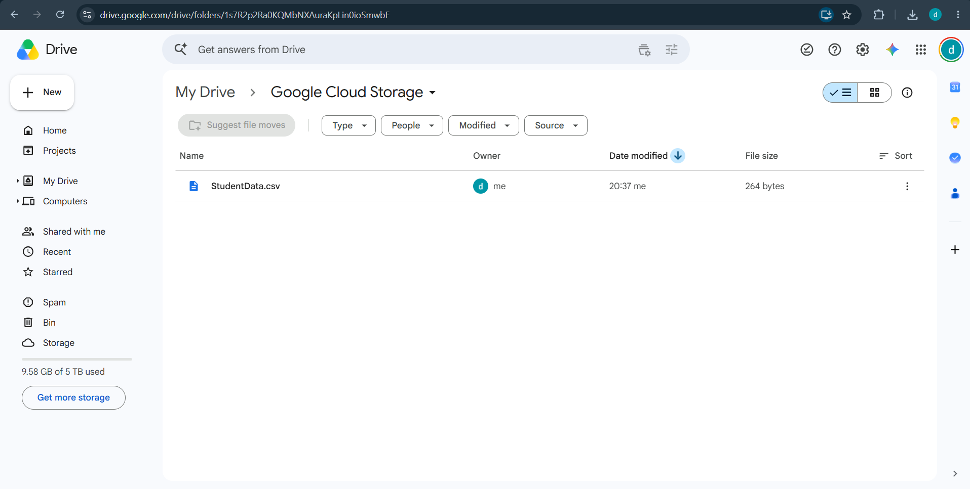
Figure 3. Google Cloud Storage

