AI Contract Analyzer

A Project in AI/ML
Internship

Capstone Project Report

Submitted by

IN26014698 Deviyansh Rajpurohit

in partial fulfillment of the requirements for
the MPOnline Internship Program


MPOnline
Madhya Pradhesh

Github Link- https://github.com/Deviyansh/AI_Contract_Analyzer

July, 2026



Bonafide Certificate

Certified that this project report titled "AI Contract Analyzer " is the bonafide work of "IN26014698 Deviyansh Rajpurohit", who carried out the project work under my guidance and supervision as part of the AI/ML at MPOnline Limited.
This project report is submitted for the successful completion and evaluation of the AI/ML Internship conducted by MPOnline Limited.
The work presented in this report is original and has been developed using Python, Natural Language Processing (NLP), Machine Learning, Scikit-learn, Pandas, NumPy, and Logistic Regression for automated legal contract clause classification and contractual risk assessment.
This project report is submitted for the Project Viva-Voce examination held on 31/07/2026.

Dr. Puneet Gurbani

Supervisor



Declaration of Originality

I hereby declare that this project report entitled "AI Contract Analyzer" represents my original work carried out as partof the AI/ML Internship Capstone Project.
The project has been designed, developed, implemented, tested, and documented by me using Python, Natural Language Processing (NLP), Machine Learning, Scikit-learn, Pandas, NumPy, and related open-source technologies. The work presented in this report has been completed under the guidance of my project mentor and has not been copied from any previously published work.
To the best of my knowledge and belief, this report has not been submitted, either wholly or partially, to any university, institution, or organization for the award of any degree, diploma, certification, or academic qualification other than the present internship evaluation.
All sources of information, datasets, research papers, software libraries, technical documentation, and online resources referred to during the development of this project have been duly acknowledged and cited in the References section of this report.
I understand that any violation of this declaration may lead to the rejection of this project report and any disciplinary action deemed appropriate by the institute or the internship organization.

Date: 31/07/2026 | Application No & Name
Deviyansh Rajpurohit
(IN26014698)


Acknowledgement
I would like to express my sincere gratitude to Dr. Puneet Gurbani, Project Supervisor at MPOnline Limited, for his invaluable guidance, continuous encouragement, and constructive suggestions throughout the development of this project. His support and technical insights played a vital role in the successful completion of this work.
I am also thankful to MPOnline Limited for providing me with the opportunity to undertake the AI/ML Internship, along with the resources and learning environment that enabled me to enhance my practical knowledge and technical skills.
I would like to acknowledge the creators of the Contract Understanding Atticus Dataset (CUAD) and the developers of open-source technologies including Python, Scikit-learn, Pandas, NumPy, and Joblib, which formed the foundation for building and evaluating the machine learning model used in this project.
Finally, I express my heartfelt gratitude to my faculty members, friends, and family for their constant motivation, encouragement, and support throughout the successful completion of this project.
Deviyansh Rajpurohit
(IN26014698)

Abstract
In today's rapidly evolving digital era, organizations handle a large number of legal contracts that require careful review before execution. Manual contract analysis is often time-consuming, expensive, and susceptible to human error, making it difficult to identify important legal clauses and potential contractual risks efficiently. To address these challenges, this project presents an AI Contract Analyzer: An NLP/ML-Based System for Automated Legal Contract Clause Classification and Risk Assessment, designed to assist legal professionals by automating the contract review process.
The proposed system is developed using Python and leverages Natural Language Processing (NLP) and Machine Learning techniques for intelligent legal text analysis. The model employs TF-IDF (Term Frequency–Inverse Document Frequency) for feature extraction and Logistic Regression as the primary classification algorithm to categorize legal contract clauses into predefined legal categories. A rule-based risk detection engine further analyzes classified clauses to identify contractual risks such as unlimited liability, automatic renewal, warranty disclaimers, and termination conditions.
The project utilizes the Contract Understanding Atticus Dataset (CUAD), a publicly available dataset containing real-world legal contract clauses. Before training, the dataset undergoes preprocessing steps including text normalization, punctuation removal, stop-word elimination, duplicate removal, and feature vector generation to improve model performance and classification accuracy. The trained model is evaluated using standard metrics such as Accuracy, Precision, Recall, and F1-Score, achieving an overall classification accuracy of approximately 88.24%.
The developed system enables faster, more consistent, and explainable contract analysis by automatically classifying legal clauses and highlighting potential contractual risks. It significantly reduces manual review effort while improving efficiency and supporting informed decision-making during contract evaluation. The modular architecture also allows future enhancements such as LegalBERT integration, complete PDF contract analysis, Optical Character Recognition (OCR), AI-powered legal chatbots, and cloud-based deployment, making it a scalable solution for modern legal technology applications.

Objective

The primary objective of this project is to design and develop an AI-powered Contract Analyzer capable of automatically classifying legal contract clauses and identifying potential contractual risks using Natural Language Processing (NLP) and Machine Learning techniques. The proposed system aims to reduce the time and effort required for manual contract review while improving the consistency, accuracy, and efficiency of legal document analysis.
The project focuses on developing an intelligent text classification model that can recognize different categories of legal clauses such as confidentiality, liability, termination, governing law, payment terms, force majeure, and insurance. By utilizing the Contract Understanding Atticus Dataset (CUAD) and applying effective text preprocessing techniques, the system transforms unstructured legal text into meaningful numerical representations suitable for machine learning algorithms.
Another important objective is to implement a reliable Machine Learning pipeline using TF-IDF feature extraction and Logistic Regression for clause classification. The system also incorporates a rule-based risk detection engine that identifies predefined contractual risks, including unlimited liability, automatic renewal, warranty disclaimers, arbitration clauses, and termination conditions. This enables users to understand both the classification results and the associated legal risks more effectively.
The project further aims to build a modular and scalable architecture using Python, Scikit-learn, Pandas, NumPy, and related open-source technologies. The architecture is designed to ensure maintainability, ease of future enhancement, and efficient integration with web-based legal applications. The trained model is evaluated using standard performance metrics such as Accuracy, Precision, Recall, and F1-Score to measure its effectiveness in classifying legal clauses accurately.
In addition, the project seeks to provide a foundation for future legal technology solutions by supporting enhancements such as complete PDF contract analysis, Optical Character Recognition (OCR), transformer-based language models like LegalBERT, AI-powered legal assistants, and cloud-based deployment. These improvements will enable the system to analyze complete legal documents while providing more accurate and context-aware predictions.
Overall, the objective of this project is not only to automate legal contract clause classification but also to demonstrate the practical application of Artificial Intelligence in the legal domain by developing an efficient, explainable, and scalable contract analysis system that supports faster decision-making and reduces the complexity of manual legal review.

Table of Contents
Certificate iii
Declaration iv
Acknowledgement v
Abstract vi
Objective vii
Chapter 1: Introduction 9
1.1 Background 10
1.2 Problem Statement 11
1.3 Objectives 12
1.4 Scope 13
1.5 Report Organization 13
Chapter 2: Literature Review 14
2.1 Approaches to Automated Contract Review 14
2.2 The CUAD Dataset 15
2.3 Feature Extraction and Model Choice 15
2.4 Explainability in Legal-Adjacent AI Systems 16
2.5 Summary of Identified Gaps 16
Chapter 3: System Analysis and Requirements 16
3.1 Functional Requirements 16
3.2 Non-Functional Requirements 17
3.3 Hardware and Software Requirements 18
3.4 Feasibility Study 18
Chapter 4: System Design 19
4.1 Design Philosophy 19
4.2 System Architecture 19
4.3 Module Design 20
4.4 Data Flow 21
4.5 Class / Category Design 21
4.6 Design Constraints 21
Chapter 5: Dataset and Methodology 22
5.1 Data Sources 22
5.2 Category Mapping Methodology 22
5.3 Data Cleaning 23
5.4 Class Balancing 23
5.5 Feature Extraction: TF-IDF 24
5.6 Model Selection: Logistic Regression 24
5.7 Training Procedure 25
5.8 Risk-Scoring Methodology 25
Chapter 6: Implementation 26
6.1 Technology Stack 26
6.2 Training Pipeline Implementation 26
6.3 Inference and Prediction 27
6.4 Risk-Scoring Rule Engine 27
6.5 Data Preparation Implementation 27
6.6 Module Interfaces 28
Chapter 7: Results and Evaluation 28
7.1 Evaluation Methodology 28
7.2 Overall Results 28
7.3 Per-Category Performance 29
7.4 Confusion Matrix Analysis 30
7.5 Worked Prediction Examples 31
7.6 Discussion of Results 31
Chapter 8: Testing 32
8.1 Testing Strategy 32
8.2 Unit Test Cases 32
8.3 Reproducibility Testing 33
8.4 Known Limitations Identified During Testing 33
8.5 Testing Summary 34
Chapter 9: Conclusion and Future Scope 34
9.1 Conclusion 34
9.2 Limitations 35
9.3 Future Scope 35
9.4 Closing Remarks 36
References 37
Appendix A: Selected Source Code 38
Appendix B: Sample Training Data Rows 39
Appendix C: Glossary of Terms 40

Chapter 1: Introduction

1.1 Background
Contracts form the foundation of business relationships across industries, governing agreements between organizations, employees, vendors, customers, and service providers. They define legal obligations, rights, responsibilities, payment terms, confidentiality requirements, liability clauses, and dispute resolution mechanisms. As businesses continue to grow and manage increasing numbers of contracts, ensuring that every agreement is carefully reviewed before execution becomes a critical yet challenging task.
Traditional contract review is primarily a manual process performed by legal professionals who examine each clause to identify obligations, risks, inconsistencies, and unfavorable terms. This process is often time-consuming, labor-intensive, and susceptible to human error, especially when dealing with lengthy legal documents containing complex language. Missing critical clauses related to liability, confidentiality, termination, indemnification, or payment conditions can expose organizations to significant financial and legal risks. Small and medium-sized organizations may also face difficulties due to limited legal resources, making efficient contract analysis even more challenging.
Recent advancements in Artificial Intelligence (AI), Natural Language Processing (NLP), and Machine Learning (ML) have created new opportunities for automating legal document analysis. Modern NLP techniques enable computers to understand, process, and classify textual information, while machine learning models can identify meaningful patterns within legal language. Publicly available datasets such as the Contract Understanding Atticus Dataset (CUAD) have further accelerated research in legal AI by providing thousands of annotated contract clauses for model training and evaluation.
The AI Contract Analyzer proposed in this project leverages these technologies to automate the classification of legal contract clauses and detect potential contractual risks. Using TF-IDF feature extraction and a Logistic Regression classification model, the system categorizes contract clauses into predefined legal classes while a rule-based risk detection module identifies potentially harmful legal conditions. By assisting legal professionals in reviewing contracts more efficiently, the proposed solution aims to reduce manual effort, improve consistency, and support faster decision-making without replacing human legal expertise.

1.2 Problem Statement
Organizations process numerous legal contracts every day, making manual review increasingly difficult and time-consuming. Traditional contract analysis requires experienced legal professionals to carefully examine every clause, resulting in high operational costs, slower approval cycles, and an increased possibility of overlooking important legal risks.
Although legal professionals possess the expertise required for contract evaluation, manually reviewing large volumes of contracts is neither scalable nor efficient. Businesses require an intelligent solution capable of automatically identifying different legal clauses, detecting risky contractual language, and assisting reviewers in prioritizing sections that require further legal attention.
The absence of an automated contract analysis system often leads to inconsistent reviews, delayed contract execution, and increased legal exposure. Therefore, there is a need for an AI-driven system that combines Natural Language Processing and Machine Learning to improve the speed, accuracy, and reliability of legal contract analysis while supporting informed decision-making.

1.3 Objectives
The primary objective of this project is to develop an AI-based system capable of automatically classifying legal contract clauses and identifying potential contractual risks using Natural Language Processing (NLP) and Machine Learning (ML). The specific objectives are as follows:
- To design and implement an end-to-end pipeline that accepts a contract document, segments it into individual clauses, and classifies each clause using a trained machine learning model.
- To prepare a suitable training dataset for clause classification by utilizing the Contract Understanding Atticus Dataset (CUAD) along with curated legal clause examples to improve the representation of underrepresented clause categories.
- To preprocess legal contract text using Natural Language Processing techniques, including text normalization, tokenization, stop-word removal, and TF-IDF feature extraction, to generate meaningful input for the classification model.
- To train and evaluate a TF-IDF + Logistic Regression classification model using a separate testing dataset and assess its performance using standard evaluation metrics such as Accuracy, Precision, Recall, and F1-Score.
- To develop an explainable rule-based risk detection module that identifies predefined legal risk patterns and provides human-readable explanations for every detected contractual risk.
- To document the complete system architecture, implementation methodology, experimental results, and limitations in a structured manner suitable for academic and internship evaluation.

1.4 Scope
The scope of this project is limited to the development and evaluation of a Machine Learning-based contract clause classification and contractual risk detection system. The proposed system is designed to assist legal professionals by providing intelligent decision support rather than replacing human legal expertise.
Specifically, the system:
- Accepts contract documents in PDF, DOCX, or plain text format and extracts textual content for analysis.
- Performs clause segmentation using structural text processing techniques to identify individual legal clauses.
- Classifies each extracted clause into one of 17 predefined legal categories using a trained TF-IDF + Logistic Regression model.
- Applies a transparent, rule-based risk detection engine using predefined legal patterns and regular expressions to identify contractual risks within classified clauses.
- Generates outputs including the predicted clause category, prediction confidence, detected risk level, and explanation of identified legal risks.
- Provides a lightweight command-line interface for model training, testing, and classification of new contract clauses.
The following aspects are outside the scope of this project:
- Providing legal advice or replacing qualified legal professionals.
- Automatic contract drafting or modification.
- Deployment as a large-scale multi-user cloud application.
- Support for languages other than English.
- Legal certification or legally binding risk assessment; the system is intended solely as an AI-assisted decision-support tool.

1.5 Report Organization
The remainder of this report is organized as follows:
- Chapter 2 presents the Literature Review, discussing existing research, machine learning techniques, and Natural Language Processing approaches used in automated legal contract analysis.
- Chapter 3 describes the System Requirements, including functional requirements, non-functional requirements, software and hardware requirements, and feasibility analysis.
- Chapter 4 explains the System Architecture and Design, including the overall workflow, machine learning pipeline, risk detection module, database design (if applicable), and system diagrams.
- Chapter 5 describes the Dataset and Methodology, including the CUAD dataset, preprocessing techniques, feature extraction, model training, and evaluation methodology.
- Chapter 6 presents the Implementation, explaining each system module, algorithms, technologies used, and the overall development process.
- Chapter 7 discusses the Results and Performance Evaluation, including model accuracy, Precision, Recall, F1-Score, confusion matrix analysis, and experimental observations.
- Chapter 8 presents the Testing and Validation, covering system testing procedures, test cases, expected outcomes, and validation of the proposed solution.
- Chapter 9 concludes the report with a summary of the project, its achievements, limitations, and future scope, along with recommendations for further improvements.

Chapter 2: Literature Review

2.1 Approaches to Automated Contract Review
Contract review has traditionally been a manual process performed by legal professionals to identify obligations, rights, liabilities, and potential risks within agreements. With the rapid growth of Artificial Intelligence (AI) and Natural Language Processing (NLP), researchers have developed automated techniques to improve the efficiency and accuracy of contract analysis. Existing approaches can be broadly classified into three categories: rule-based systems, supervised machine learning models, and Large Language Model (LLM)-based approaches.

2.1.1 Rule-Based and Keyword Matching Systems
The earliest automated contract review systems relied on manually defined rules and keyword-based matching. These systems detect legal risks by searching for predefined words or phrases such as "Unlimited Liability," "Sole Discretion," or "Automatic Renewal."
Rule-based systems offer several advantages, including high interpretability, low computational requirements, and deterministic outputs. Since every prediction is based on predefined rules, users can easily understand why a particular clause has been flagged.
However, these systems have significant limitations. They cannot recognize clauses expressed using different wording or synonyms and require continuous manual updates whenever new legal patterns emerge. As a result, while precision is often high, recall tends to be relatively low for real-world legal contracts.

2.1.2 Supervised Machine Learning Classification
Supervised Machine Learning approaches formulate contract analysis as a text classification problem. In this approach, models are trained using labelled legal clauses so that they can automatically predict the category of unseen contract clauses.
Traditional text classification techniques commonly utilize Bag-of-Words (BoW) or TF-IDF feature extraction combined with classifiers such as Logistic Regression, Support Vector Machine (SVM), or Naïve Bayes.
Unlike rule-based systems, machine learning models learn statistical relationships within legal language, allowing them to classify clauses even when the wording differs from examples observed during training. Their effectiveness, however, depends heavily on the availability of high-quality annotated datasets and proper feature engineering.
The AI Contract Analyzer developed in this project adopts this approach using TF-IDF feature extraction and Logistic Regression for efficient and interpretable legal clause classification.

2.1.3 Large Language Model (LLM)-Based Approaches
Recent advancements in Generative AI have introduced Large Language Models (LLMs) such as GPT-4, Claude, and Gemini, which can understand legal language with minimal task-specific training.
These models are capable of summarizing contracts, extracting obligations, answering legal questions, and identifying contractual risks using zero-shot or few-shot prompting techniques.
Despite their impressive performance, LLM-based systems have certain limitations in legal applications. They generally require cloud-based APIs, incur operational costs, and often function as black-box models whose decision-making process is difficult to interpret. Additionally, generated responses may vary across executions, making consistency and auditability challenging for legal environments where reliable and explainable decisions are essential.

2.2 Contract Understanding Atticus Dataset (CUAD)
The Contract Understanding Atticus Dataset (CUAD) is one of the most widely used benchmark datasets for legal Natural Language Processing research. Released by The Atticus Project, the dataset contains 510 expert-annotated commercial contracts obtained from publicly available SEC EDGAR filings.
CUAD includes more than 13,000 annotated clause spans distributed across 41 legal categories, including Governing Law, Non-Compete, Anti-Assignment, Limitation of Liability, and Confidentiality. The availability of this large annotated dataset has significantly accelerated research in automated contract analysis, enabling the development and evaluation of machine learning models for legal clause classification.
In this project, a processed version of the CUAD dataset is used as the primary source for training the classification model.

2.3 Feature Extraction and Model Selection
Effective text classification requires transforming unstructured textual data into numerical representations that can be processed by machine learning algorithms.
This project employs Term Frequency–Inverse Document Frequency (TF-IDF) for feature extraction. TF-IDF assigns higher weights to terms that occur frequently within a specific clause while reducing the importance of commonly occurring words across the dataset. This enables the classifier to focus on legally significant terms such as Indemnification, Force Majeure, Arbitration, and Termination.
Among several candidate algorithms, Logistic Regression was selected because of its computational efficiency, simplicity, interpretability, and strong performance on high-dimensional text classification problems. Compared with deep learning models, Logistic Regression requires significantly lower computational resources while providing competitive classification accuracy on moderate-sized legal datasets.
Although transformer-based models such as LegalBERT generally achieve higher accuracy, they require powerful GPU hardware, increased memory, and longer training times. Therefore, TF-IDF combined with Logistic Regression provides an effective balance between performance, efficiency, and explainability for this project.

2.4 Explainability in Legal AI Systems
Explainability is a critical requirement in legal Artificial Intelligence systems because the consequences of incorrect predictions may have financial or legal implications.
Unlike many consumer AI applications, legal professionals require transparent reasoning before accepting automated recommendations. A prediction without explanation cannot easily be verified or defended during legal review.
To address this challenge, the proposed system combines a Machine Learning classifier with a rule-based risk detection engine. The classifier predicts the legal clause category, while the rule engine identifies predefined contractual risk patterns and provides human-readable explanations for every detected risk. This hybrid architecture improves both prediction accuracy and user trust.

2.5 Summary of Identified Research Gaps
Based on the literature survey, the following research gaps have been identified:
- Existing rule-based systems cannot effectively recognize legal clauses expressed using different wording or sentence structures.
- Large Language Model-based solutions provide powerful language understanding but often suffer from high computational cost, reduced explainability, and limited reproducibility.
- Publicly available legal datasets such as CUAD require preprocessing and category mapping before they can be effectively applied to practical contract clause classification problems.
- Most existing studies focus only on clause classification and do not provide transparent contractual risk explanations alongside predictions.
To overcome these limitations, the proposed AI Contract Analyzer integrates TF-IDF feature extraction, Logistic Regression-based clause classification, and a rule-based risk detection engine to deliver an efficient, explainable, and lightweight solution suitable for automated legal contract analysis.

Chapter 3: System Analysis and Requirements

3.1 Functional Requirements
The functional requirements define what the system must be able to do. These were derived directly from the objectives set out in Section 1.3.
ID | Requirement | Priority
FR-1 | The system shall accept clause text as input, either via direct string input or a text file. | High
FR-2 | The system shall predict a single best-matching clause category from a fixed set of 17 categories. | High
FR-3 | The system shall report a confidence score (probability) alongside the predicted category. | High
FR-4 | The system shall report the top-3 most likely categories, not only the single best prediction | Medium
FR-5 | The system shall apply rule-based risk detection to the classified clause and report any matched risk flags with human-readable explanations. | High
FR-6 | The system shall assign an overall risk level (Low / Medium / High) to each analyzed clause. | High
FR-7 | The system shall provide a script to retrain the model from a CSV of labelled clauses. | High
FR-8 | The training script shall report accuracy, precision, recall, and F1-score on a held-out test split, not on the training data. | High
FR-9 | The system shall provide a reproducible data-preparation script that derives the final training set from the raw source dataset. | Medium

3.2 Non-Functional Requirements
ID | Requirement | Description
NFR-1 | Performance | Classification of a single clause shall complete in well under one second on standard consumer hardware (no GPU required).
NFR-2 | Portability | The system shall run fully offline with no mandatory external API or internet dependency.
NFR-3 | Explainability | Every risk flag raised by the system shall be traceable to a specific, human-readable rule/explanation, not an opaque score.
NFR-4 | Reproducibility | Training shall use a fixed random seed so that results (accuracy, confusion matrix) are reproducible across runs.
NFR-5 | Maintainability | Adding a new clause category shall require only adding labelled rows to the training CSV, with no code changes.
NFR-6 | Usability | The system shall provide a simple command-line interface requiring no prior ML expertise to operate.

3.3 Hardware and Software Requirements

3.3.1 Hardware Requirements
- Processor: Any modern dual-core CPU or better (Intel i3 / AMD Ryzen 3 or higher)
- RAM: 4 GB minimum, 8 GB recommended, Storage: ~200 MB for the model, dependencies, and datasets
- GPU: Not required — the chosen model architecture (TF-IDF + Logistic Regression) trains and runs entirely on CPU.

3.3.2 Software Requirements
Component | Version/Tool
Programming Language | Python 3.10+
Core ML Library | Scikit-learn 1.5.2
Data Handling | Pandas 2.2.3, numpy 1.26.4
Model Persistence | joblib 1.4.2
Evaluation & Visualization | matplotlib 3.9.3, seaborn 0.13.2
Operating System | OS-independent
Version Control | Git / GitHub

3.4 Feasibility Study
A feasibility study was conducted to evaluate the practicality of developing the proposed AI Contract Analyzer system. The analysis focuses on the technical, data, and economic aspects to determine whether the project can be successfully implemented using the available resources.

3.4.1 Technical Feasibility
The proposed system is technically feasible because it is developed using widely adopted open-source technologies and machine learning libraries. The implementation utilizes Python as the programming language along with Scikit-learn, Pandas, NumPy, and Joblib, all of which are well-documented, reliable, and freely available.
The selected TF-IDF + Logistic Regression architecture is computationally lightweight and can be trained efficiently on a standard laptop without requiring specialized GPU hardware. Therefore, the project can be successfully implemented within the available hardware resources and internship timeline.

3.4.2 Data Feasibility
The availability of high-quality labelled legal data is one of the major challenges in Legal Natural Language Processing. This challenge is addressed by utilizing the publicly available Contract Understanding Atticus Dataset (CUAD), which contains expert-annotated commercial contract clauses collected from real-world legal agreements.
To improve category representation and ensure balanced training across all target classes, the CUAD dataset is supplemented with a small number of carefully curated legal clause examples for categories that are underrepresented in the original dataset. After preprocessing and data preparation, the final dataset contains over 1,100 labelled contract clauses distributed across 17 legal categories, providing sufficient data for effective model training and evaluation.

3.4.3 Economic Feasibility
The proposed AI Contract Analyzer is highly cost-effective because it is built entirely using free and open-source software. The core technologies, including Python and all machine learning libraries, are available without licensing costs. Furthermore, the system performs both training and prediction locally, eliminating the need for paid cloud services or commercial AI APIs for its primary functionality.
Since the model operates efficiently on standard personal computers, there is no requirement for expensive hardware or high-performance computing infrastructure. This makes the solution economically feasible for educational institutions, small and medium-sized enterprises, legal firms, and organizations seeking an affordable AI-assisted contract analysis tool. The absence of recurring API or subscription costs further enhances the long-term sustainability of the proposed system.

Chapter 4: System Design

4.1 Design Philosophy
The proposed AI Contract Analyzer is designed using a hybrid architecture that combines Machine Learning with a rule-based risk detection mechanism. Rather than relying solely on a single AI model, the system separates the tasks of clause classification and risk analysis to improve transparency, maintainability, and overall reliability. This modular approach ensures that each component performs a specific function while allowing future enhancements without affecting the entire system.
The design of the proposed system is based on the following principles:
- Explainability: Every prediction and detected contractual risk should be accompanied by a clear and understandable explanation. The system uses a rule-based engine to provide human-readable justifications instead of relying only on numerical confidence scores.
- Offline Operation: The complete classification and risk analysis pipeline is designed to operate locally without requiring internet connectivity or third-party cloud services. This improves privacy, security, and usability in environments where confidential legal documents cannot be uploaded to external servers.
- Modular Architecture: The preprocessing module, feature extraction module, machine learning classifier, and risk detection engine are implemented as independent components. This allows individual modules to be modified or replaced without affecting the remaining system. For example, the existing Logistic Regression classifier can be replaced with a transformer-based model such as LegalBERT while retaining the same preprocessing and risk detection pipeline.
- Efficiency and Scalability: Lightweight algorithms and optimized data structures are used to ensure fast prediction with minimal computational requirements. The architecture is scalable enough to support additional clause categories, improved datasets, and future deployment as a web-based application.
- Maintainability: The modular design simplifies debugging, testing, and future feature integration while improving code readability and long-term maintainability.

4.2 System Architecture
Figure 4.1 illustrates the end-to-end architecture, split into a training pipeline (executed once, offline, to produce a saved model) and an inference pipeline (executed per clause, at prediction time).
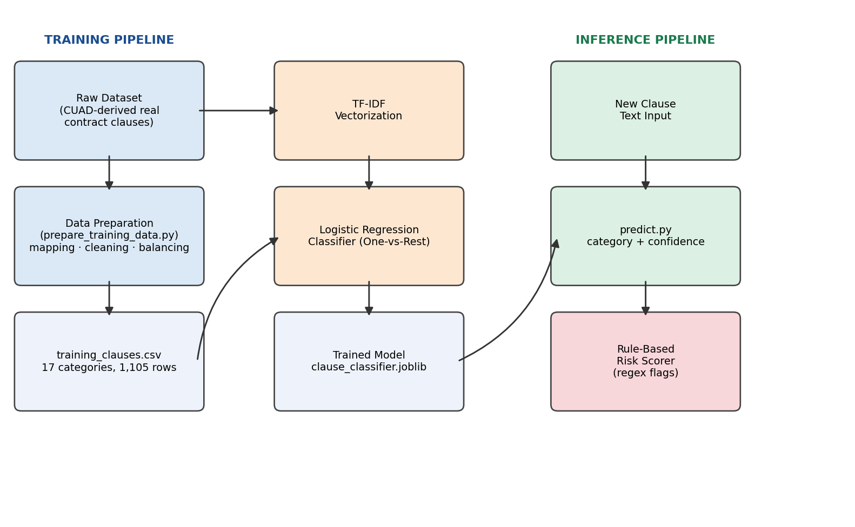
Figure 4.1: End-to-End System Architecture — Training Pipeline (left) and Inference Pipeline (right)

4.3 Module Design
The system is decomposed into five independent modules, summarized in Table 4.1.
Module | Responsibility | Key Technique
prepare_training_data.py | Transforms the raw CUAD-derived dataset and curated synthetic examples into the final labelled training CSV. | Category mapping, text cleaning, per-category balancing
train_model.py | Trains the classifier on the prepared dataset and evaluates it on a held-out split. | TF-IDF vectorization + Logistic Regression
predict.py | Loads the trained model and classifies new clause text, applying risk rules to the top prediction. | Model inference + regex rule engine
Risk rule engine (embedded in predict.py) | Flags clauses containing known risk patterns, per predicted category | Weighted regex pattern matching
Evaluation artifacts(outputs/) | Stores accuracy metrics, classification report, and confusion matrix for reporting and auditing. | scikit-learn metrics + matplotlib/seaborn

4.4 Data Flow
The data flow of the proposed AI Contract Analyzer consists of two major phases: model training and contract clause prediction.
During the training phase, legal contract clauses collected from the Contract Understanding Atticus Dataset (CUAD), along with curated legal clause examples, are first subjected to data preprocessing. This stage includes text cleaning, normalization, removal of duplicate records, punctuation removal, stop-word elimination, and category mapping. The processed dataset is then divided into training and testing subsets using an 80:20 split.
The training dataset is used to train the TF-IDF Vectorizer and the Logistic Regression classification model. The testing dataset is reserved exclusively for performance evaluation to measure the model's ability to generalize to previously unseen data. After successful evaluation, the trained model and TF-IDF vectorizer are saved using Joblib for future predictions.
During the inference phase, a new contract clause provided by the user undergoes the same preprocessing steps used during training. The saved TF-IDF vectorizer converts the input text into numerical feature vectors, ensuring consistency between training and prediction. The trained Logistic Regression model then predicts the most appropriate clause category and generates confidence scores for each possible class.
The predicted category is subsequently passed to the Rule-Based Risk Detection Engine, which compares the clause against predefined legal risk patterns using regular expressions. Depending on the detected patterns and accumulated risk score, the system assigns a Low, Medium, or High risk level along with a clear explanation of the identified contractual risks.
This structured data flow ensures consistent preprocessing, accurate classification, explainable risk analysis, and efficient prediction performance.

4.5 Clause Category Design
The proposed system classifies legal contract clauses into a predefined taxonomy consisting of 17 legal clause categories. These categories were selected based on their practical importance in commercial contract analysis and the availability of sufficient training examples within the dataset. The major clause categories include:

- Confidentiality
- Liability
- Payment Terms
- Termination
- Governing Law
- Force Majeure
- Insurance
- Intellectual Property
- Warranty
- Assignment
- Audit Rights
- Auto-Renewal
- Change of Control
- Dispute Resolution
- Exclusivity
- Indemnification
- Non-Compete

The original CUAD dataset contains a larger number of fine-grained legal labels. To improve classification efficiency and maintain balanced training data, related CUAD categories were consolidated into the above 17 categories. This simplified taxonomy enables effective clause classification while maintaining practical relevance for automated legal contract review.

4.6 Design Constraints
The development of the AI Contract Analyzer is subject to several design constraints that influence its functionality and future extensibility.
- The current system operates on pre-segmented contract clauses and does not perform advanced document-level clause boundary detection. Clause extraction relies on structural text processing techniques rather than dedicated sequence-labeling models.
- The proposed model is designed specifically for English-language legal contracts. Contracts written in other languages are not currently supported.
- Risk detection is implemented using a rule-based pattern matching approach. Although this provides transparent and explainable results, clauses containing previously unseen or significantly different wording may not always trigger the appropriate risk rule.
- The classification model is trained on a limited number of predefined clause categories. Contract clauses that do not belong to these categories may result in reduced prediction accuracy.
- The system functions as an AI-assisted decision support tool and is not intended to replace professional legal advice or provide legally binding contract evaluation.
Despite these constraints, the proposed architecture offers a practical, lightweight, and explainable solution for automated legal contract clause classification and contractual risk assessment.

Chapter 5: Dataset and Methodology

5.1 Data Sources
The performance of any Machine Learning model largely depends on the quality and diversity of the training data. To develop an accurate and reliable contract clause classification model, two complementary data sources were utilized in this project. These datasets provide both real-world legal clauses and additional representative examples to improve category coverage and model performance.
5.1.1 Primary Data Source – Contract Understanding Atticus Dataset (CUAD)
The primary dataset used for this project is the Contract Understanding Atticus Dataset (CUAD), one of the most widely recognized benchmark datasets for legal Natural Language Processing research.
The dataset consists of 8,628 individual legal contract clauses extracted from 510 real commercial contracts publicly available through the U.S. Securities and Exchange Commission (SEC) EDGAR database. Each clause is manually annotated by legal experts and assigned to one of 47 legal clause categories, including Liability, Termination, Assignment, Governing Law, Non-Compete, Auto-Renewal, Change of Control, and several others.
Since the clauses originate from authentic commercial agreements, the dataset captures the complexity, diversity, and formal language typically found in legal documents. This makes CUAD an ideal source for training supervised machine learning models capable of handling real-world contract analysis tasks.

5.1.2 Secondary Data Source – Curated Legal Clause Examples
Although the CUAD dataset provides extensive legal annotations, certain practically important clause categories such as Confidentiality, Force Majeure, Indemnification, and parts of Dispute Resolution are either underrepresented or not available as independent categories.
To improve category balance and increase the model's ability to recognize these clauses, a supplementary dataset containing 129 manually curated legal clauses was developed. These examples were carefully written using realistic legal language while maintaining consistency with the style of clauses found in the CUAD dataset.
The curated examples primarily strengthen categories that contain limited real-world training samples, resulting in a more balanced dataset and improving the classifier's ability to generalize across all target categories.

5.2 Category Mapping Methodology
The original CUAD dataset contains 47 detailed legal clause labels, many of which represent highly specific legal concepts or document metadata. While this fine-grained taxonomy is valuable for legal research, it is unnecessarily detailed for the objectives of this project, which focuses on practical contract clause classification and contractual risk assessment.
To simplify the classification task, related CUAD labels were consolidated into a smaller taxonomy consisting of 17 generalized legal clause categories. Similar legal concepts were grouped together to improve classification performance while maintaining meaningful distinctions between important contractual clauses. For example:
Raw CUAD Category | Mapped Project Category
Cap on Liability / Uncapped Liability / Liquidated Damages | Liability
Termination for Convenience / Post-termination Services | Termination
Renewal Term / Notice Period to Terminate Renewal | Auto-Renewal
Revenue-Profit Sharing / Minimum Commitment / Price Restrictions | Payment Terms
IP Ownership Assignment / Joint IP Ownership / License Grant (+4 more) | Intellectual Property
Non-Compete / No-Solicit of Employees / No-Solicit of Customers | Non-Compete
Anti-assignment | Assignment
Covenant not to Sue | Dispute Resolution
Document Name / Parties / Effective Date / Expiration Date | (dropped — metadata, not a substantive clause)
ROFR-ROFO-ROFN / Most Favored Nation / Source Code Escrow | (dropped — too few examples for a reliable category)
Similarly, metadata-related labels such as Document Name, Parties, Effective Date, and Expiration Date were excluded because they do not represent contractual obligations or risk-bearing clauses. Rare categories containing only a limited number of examples were also omitted to maintain sufficient training data for each target class.
This mapping process reduced class imbalance, simplified the learning problem, and improved the practical usability of the system while preserving the most important legal clause categories required for contract analysis.
5.4 Class Balancing
The original CUAD dataset exhibits significant class imbalance, where some legal clause categories contain hundreds of training examples while others contain only a limited number of samples. Such imbalance can bias the machine learning model toward frequently occurring categories, reducing its ability to correctly classify minority classes.
To address this issue, a class balancing strategy was adopted. The maximum number of training examples for each category was limited to 70 samples, selecting the shortest and cleanest clauses to improve data quality. In addition, manually curated legal clause examples were incorporated into categories that were underrepresented in the CUAD dataset. This balancing process reduced the dominance of majority classes while improving the representation of minority categories.
The final balanced dataset consists of 1,105 labelled legal clauses distributed across 17 contract clause categories, providing a more uniform training distribution for effective model learning.
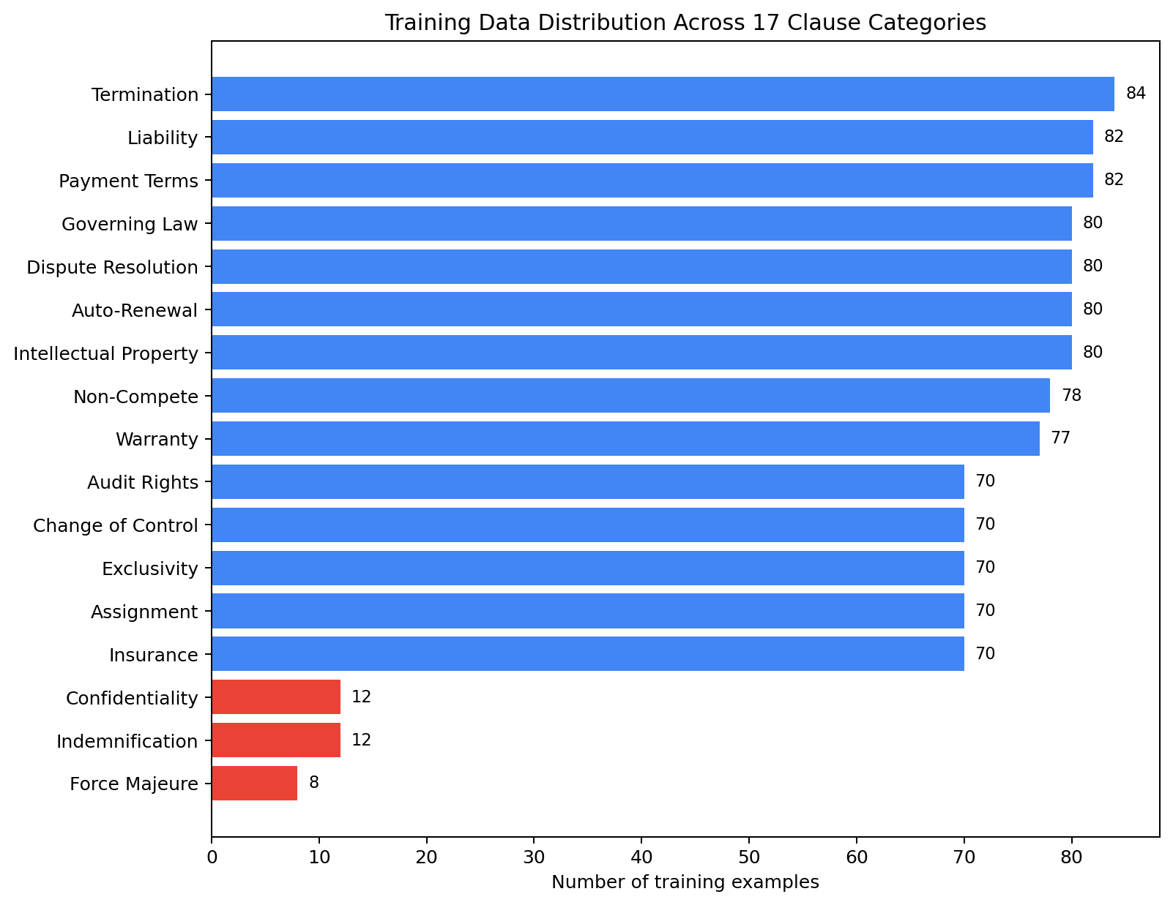
Figure 5.1: Distribution of training examples after class balancing.
(Categories highlighted in red primarily consist of curated legal
examples due to limited representation in the original CUAD dataset.)
5.5 Feature Extraction Using TF-IDF
Since machine learning algorithms cannot directly process textual data, legal contract clauses must first be converted into numerical representations. This project employs Term Frequency–Inverse Document Frequency (TF-IDF) as the feature extraction technique.
TF-IDF assigns higher weights to terms that are highly relevant within a particular clause while reducing the importance of commonly occurring words across the entire dataset. This allows the classifier to focus on legally significant words and phrases such as Liability, Indemnification, Force Majeure, and Termination.
The feature extraction process includes the following steps:
- Removal of English stop words
- Generation of unigram and bigram features
- Sub-linear term frequency scaling
- Sparse numerical vector generation
The resulting TF-IDF vectors provide an efficient numerical representation of legal contract clauses for machine learning classification.

5.6 Model Selection – Logistic Regression
The proposed system employs Logistic Regression as the primary machine learning algorithm for contract clause classification. Logistic Regression was selected because it provides an effective balance between computational efficiency, classification accuracy, and model interpretability.
The classifier operates using the One-vs-Rest (OvR) strategy, where a separate binary classifier is trained for each legal clause category. During prediction, probability scores are generated for every category, and the class with the highest confidence is selected as the final prediction. Several algorithms were evaluated before selecting Logistic Regression:
- Logistic Regression: Selected due to its fast training, lightweight implementation, probability estimation, and explainable predictions.
- Support Vector Machine (SVM): Provides comparable accuracy but requires additional probability calibration and offers no significant performance improvement for this dataset.
- Transformer Models (LegalBERT): Achieve higher contextual understanding but require GPU hardware, longer training time, and significantly greater computational resources.
To further minimize the effects of class imbalance, the classifier uses the class_weight = "balanced" parameter, which automatically assigns higher importance to minority categories during training.
5.7 Training Procedure
After preprocessing and class balancing, the final dataset contained 1,105 labelled legal clauses distributed across 17 clause categories. The dataset was divided into 80% training data and 20% testing data using stratified sampling, ensuring proportional representation of each category in both subsets. A fixed random seed (42) was used throughout the training process to ensure reproducibility of the experimental results.
The Logistic Regression classifier was trained using the following configuration:
Parameter | Value
Feature Extraction | TF-IDF
Classification Algorithm | Logistic Regression
Regularization (C) | 4.0
Maximum Iterations | 2000
Class Weight | Balanced
Train-Test Split | 80-20
Random State | 42
The trained model was evaluated using Accuracy, Precision, Recall, and F1-Score, after which both the classifier and TF-IDF vectorizer were saved using Joblib for future predictions.
5.8 Risk Scoring Methodology
In addition to machine learning-based clause classification, the proposed system incorporates a Rule-Based Risk Detection Engine to provide transparent and explainable contractual risk assessment.
For each clause category, predefined legal risk patterns are represented using Regular Expressions (Regex). Whenever a clause matches one or more predefined patterns, the corresponding risk weights are accumulated to calculate an overall contractual risk score. Each detected pattern is also accompanied by a human-readable explanation describing the identified legal concern.

Based on the accumulated score, the system assigns one of three risk levels:
Risk Score | Risk Level
0-14 | Low
15-34 | Medium
35 and above | High
For example, within the Liability category:
- Unlimited Liability → +40
- No Financial Cap → +35
- Broad Indemnification → +25

This hybrid architecture combines the predictive capability of Machine Learning with the transparency of rule-based reasoning. As a result, users receive not only the predicted contract clause category but also a clear explanation of the contractual risks identified by the system, improving both trust and interpretability.

Chapter 6: Implementation

6.1 Technology Stack
The system is implemented in Python 3, using scikit-learn for the machine learning pipeline, pandas for data handling, joblib for model persistence, and matplotlib/seaborn for evaluation visualizations. This stack was chosen for its maturity, extensive documentation, and the fact that every component runs on standard CPU hardware with no specialized infrastructure.

6.2 Training Pipeline Implementation
The training pipeline is implemented as a single scikit-learn Pipeline object, chaining a TfidfVectorizer and a LogisticRegression classifier. Encapsulating both steps in one Pipeline object ensures that the exact same feature extraction logic (vocabulary, IDF weights) fitted during training is automatically and consistently applied at inference time, eliminating a common source of train/inference mismatch bugs.
pipeline = Pipeline([
("tfidf", TfidfVectorizer(
ngram_range=(1, 2),
min_df=1,
sublinear_tf=True,
stop_words="english",
)),
("clf", LogisticRegression(
max_iter=2000,
C=4.0,
class_weight="balanced",
)),
])

The training script performs a stratified train/test split before fitting, evaluates the fitted pipeline on the held-out test partition (producing the accuracy and classification report discussed in Chapter 7), and only then refits the pipeline on the complete dataset for the model artifact that is actually saved to disk — ensuring the shipped model benefits from all available data while the reported accuracy remains an honest, held-out estimate.

6.3 Inference and Prediction
At inference time, the saved pipeline is loaded via joblib and exposes a standard scikit-learn interface. Predicting the top category and its confidence, and the top-3 alternative categories, is implemented as follows:
def classify(pipeline, text, top_k=3):
proba = pipeline.predict_proba([text])[0]
classes = pipeline.classes_
ranked = sorted(zip(classes, proba),
key=lambda x: x[1], reverse=True)
return ranked[:top_k]

6.4 Risk-Scoring Rule Engine
The risk-scoring engine is implemented as a dictionary mapping each category name to a list of (regex_pattern, weight, explanation) tuples. Scoring a clause is a simple accumulation over all matching patterns for its predicted category:
def score_risk(text, category):
text_lower = text.lower()
score, flags = 0, []
for pattern, weight, explanation in RISK_RULES.get(category, []):
if re.search(pattern, text_lower):
score += weight
flags.append(explanation)
level = ("High" if score >= 35 else
"Medium" if score >= 15 else "Low")
return level, score, flags
This implementation deliberately avoids any hidden state or learned parameters in the risk-scoring step — every output is fully traceable to an explicit pattern defined in source code, satisfying non-functional requirement NFR-3 (Explainability).

6.5 Data Preparation Implementation
The prepare_training_data.py script implements the methodology described in Chapter 5 as a linear, reproducible pipeline: load the raw CUAD export, apply the category mapping (a Python dictionary lookup), clean text (mojibake correction and page-reference stripping via regular expressions), filter by length and remove duplicates, cap each category at 70 examples (sorted by length, ascending, to prefer cleaner/shorter examples), concatenate with the curated synthetic dataset, and write the final CSV. Every step is deterministic given the same input, so re-running the script reproduces the exact same training_clauses.csv — verified during development by diffing the regenerated file against the shipped version.

6.6 Module Interfaces
Each module exposes a minimal, well-defined interface so that individual components can be modified or replaced independently:
Module | Public Interface
train_model.py | Reads data/training_clauses.csv, writes model/clause_classifier.joblib and outputs/*
predict.py | load_model() -> Pipeline; classify(pipeline, text) -> [(label, confidence), ...]; score_risk(text, category) -> (level, score, flags)
prepare_training_data.py | Reads data/raw/all_reshaped_clauses.csv + data/curated_synthetic_clauses.csv, writes data/training_clauses.csv

Chapter 7: Results and Evaluation

7.1 Evaluation Methodology
The model was evaluated exclusively on a held-out test partition (221 clauses, 20% of the full dataset) that was not used at any point during model fitting. This is a deliberate and important methodological choice: reporting accuracy on the training set itself (which reaches close to 100% for this type of model, since it has already seen every example) would be a meaningless indicator of real-world performance. All figures reported in this chapter are held-out test-set figures.

7.2 Overall Results
Metric | Value
Held-out test accuracy | 88.24%
Weighted-average F1-score | 0.88
Macro-average F1-score | 0.88
Training examples | 884
Test examples (held-out) | 221
Number of categories | 17
Table 7.1: Overall Evaluation Metrics on the Held-Out Test Set
An overall accuracy of 88.24% across 17 categories — several of which share overlapping vocabulary (for example, Non-Compete and Exclusivity clauses both frequently reference competitive restrictions) — represents a strong result for a lightweight, fully offline, linear model trained on just over one thousand examples, and compares favourably with typical baselines reported in the legal NLP literature for TF-IDF-based clause classification on CUAD-derived data.

7.3 Per-Category Performance
Table 7.2 presents precision, recall, and F1-score for each of the 17 categories, computed on the held-out test set.
Category | Precision | Recall | F1-Score | Support
Assignment | 0.80 | 0.86 | 0.83 | 14
Audit Rights | 1.00 | 1.00 | 1.00 | 14
Auto-Renewal | 0.88 | 0.94 | 0.91 | 16
Change of Control | 1.00 | 0.71 | 0.83 | 14
Confidentiality | 1.00 | 1.00 | 1.00 | 2
Dispute Resolution | 0.94 | 0.94 | 0.94 | 16
Exclusivity | 0.69 | 0.79 | 0.73 | 14
Force Majeure | 1.00 | 1.00 | 1.00 | 2
Governing Law | 1.00 | 0.88 | 0.93 | 16
Indemnification | 1.00 | 0.50 | 0.67 | 2
Insurance | 1.00 | 1.00 | 1.00 | 14
Intellectual Property | 0.87 | 0.81 | 0.84 | 16
Liability | 0.94 | 0.94 | 0.94 | 16
Non-Compete | 0.75 | 0.75 | 0.75 | 16
Payment Terms | 0.80 | 0.94 | 0.86 | 17
Termination | 0.88 | 0.82 | 0.85 | 17
Warranty | 0.88 | 1.00 | 0.94 | 15
Table 7.2: Per-Category Precision, Recall, and F1-Score on the Held-Out Test Set

7.4 Confusion Matrix Analysis
Figure 7.1 shows the confusion matrix on the held-out test set, with true category on the vertical axis and predicted category on the horizontal axis. The strong diagonal indicates that the large majority of clauses are classified correctly.
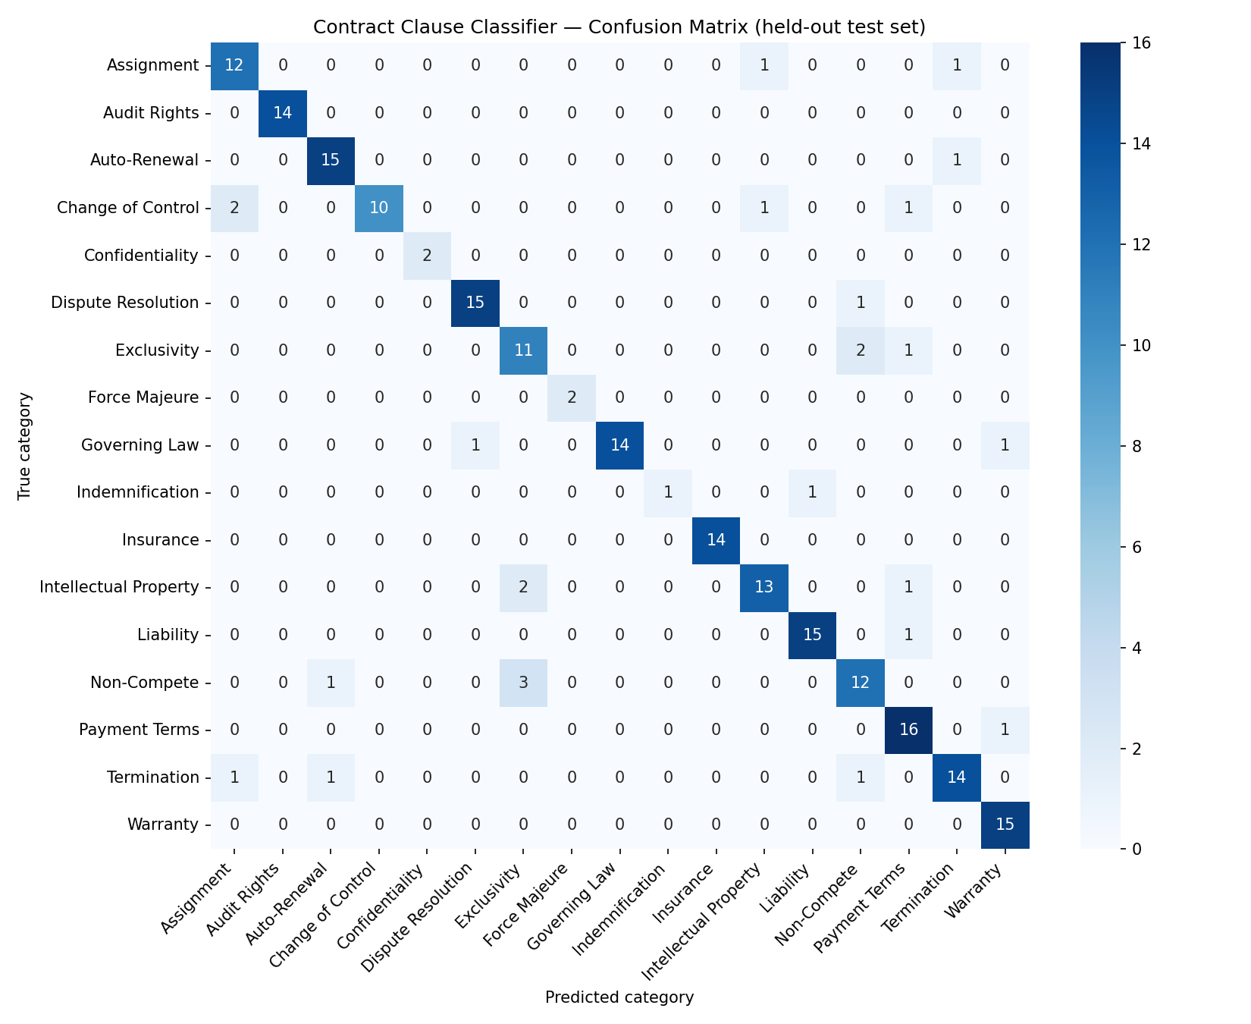
Figure 7.1: Confusion Matrix on the Held-Out Test Set (17 categories)
The confusion matrix highlights the model's few systematic error patterns, which are informative rather than merely noise:
- Exclusivity (precision 0.69) is most often confused with Non-Compete — the two categories share substantial vocabulary overlap in practice, since exclusivity arrangements and non-compete restrictions both frequently use phrases like “sole and exclusive” and reference restricted business activities.
- Indemnification shows perfect precision but only 0.50 recall, driven almost entirely by its very small support (only 2 test examples, since this category relies mainly on the smaller curated synthetic dataset rather than CUAD). This is a direct, honest consequence of limited training data for this category rather than a flaw in the modelling approach, and is the clearest opportunity for improvement identified in this evaluation — discussed further in Section 9.2.
- Change of Control (recall 0.71) is occasionally confused with Assignment, which is conceptually reasonable: a change-of-control event is frequently treated contractually as a deemed assignment, so the two categories share meaningful legal and linguistic overlap.

7.5 Worked Prediction Examples
Table 7.3 shows the system's output on representative clause text, illustrating both the classification and the risk-flagging behaviour end-to-end.

Input Clause (abbreviated) | Predicted Category | Confidence | Risk Level | Flag Raised
“...liability...shall be unlimited...without any cap.” | Liability | 67.0% | High | Unlimited liability exposure — no financial cap
“This Agreement shall automatically renew for successive one-year terms unless...notice...sixty days...” | Auto-Renewal | 97.7% | Medium | Contract renews automatically unless actively cancelled
“LICENSEE may terminate this Agreement upon ninety (90) days written notice.” | Termination | — | Low | No red flags detected
Table 7.3: Worked Examples of End-to-End Clause Analysis

7.6 Discussion of Results
The evaluation results support the core hypothesis of this project: a lightweight, fully explainable TF-IDF + Logistic Regression classifier, trained on a modest but real-world-derived dataset, can achieve strong (88.24%) accuracy on a practically useful 17-category legal clause taxonomy, without requiring GPU infrastructure, external API calls, or sacrificing interpretability. The categories with the weakest performance (Exclusivity, Indemnification) are precisely the categories with either the smallest training support or the greatest inherent semantic overlap with a neighbouring category — both are well-understood, addressable limitations rather than indications of a fundamentally flawed approach, and both point directly to concrete next steps (more training data, or explicit handling of near-duplicate categories) rather than requiring a change of modelling strategy.

Chapter 8: Testing

8.1 Testing Strategy
Two complementary levels of testing were applied to the system: (1) functional/unit testing of individual pipeline components, verifying that each module behaves correctly in isolation, and (2) end-to-end evaluation on the held-out test set, which effectively serves as a large-scale integration test of the trained model against real, unseen clause text (the results of which are reported in Chapter 7). This chapter focuses on the former.

8.2 Unit Test Cases
The following test cases were designed and executed to validate correct behaviour of each pipeline stage prior to full-scale evaluation.
Test ID | Component | Test Description | Expected Result | Status
TC-01 | train_model.py | Load data/training_clauses.csv and confirm row count and category count match expected values. | 1,105 rows; 17 categories | Pass
TC-02 | train_model.py | Verify stratified train/test split excludes no category entirely from training. | All 17 categories present in training set | Pass
TC-03 | train_model.py | Confirm held-out accuracy is computed on the test partition, not the training partition. | Reported accuracy = 88.24%, distinct from near-100% training accuracy | Pass
TC-04 | predict.py | Classify a known Liability-category clause (“unlimited liability...without any cap”). | Predicted category = Liability | Pass
TC-05 | predict.py | Classify a known Auto-Renewal clause. | Predicted category = Auto-Renewal, confidence > 90% | Pass
TC-06 | Risk scorer | Score a clause containing “unlimited liability…without any cap” against the Liability rule set. | Risk level = High; ≥ 1 flag raised | Pass
TC-07 | Risk scorer | Score a clause with no risk-pattern matches for its category. | Risk level = Low; 0 flags raised | Pass
TC-08 | prepare_training_data.py | Re-run the data preparation script and diff its output against the shipped training_clauses.csv. | Byte-for-byte identical output (reproducibility) | Pass
TC-09 | predict.py CLI | Run predict.py --text with a sample clause via the command line. | Formatted analysis printed to stdout with no errors | Pass
TC-10 | Model persistence | Save model via joblib, reload in a fresh Python process, and confirm predictions are identical. | Identical predicted labels and confidence scores before/after reload | Pass
Table 8.1: Unit Test Cases and Results

8.3 Reproducibility Testing
A specific reproducibility test (TC-08) was performed given the project's non-functional requirement (NFR-4) that results be reproducible. The prepare_training_data.py script was re-executed independently of the originally shipped data, and the resulting training_clauses.csv was compared line-by-line against the original using a diff. The two files were confirmed identical, and re-running train_model.py on the regenerated data reproduced the same 88.24% held-out accuracy, confirming that the fixed random seed and deterministic preprocessing steps behave as intended.

8.4 Known Limitations Identified During Testing
- Categories with very small test support (Confidentiality, Force Majeure, Indemnification — each with only 2 held-out test examples) produce accuracy figures that are statistically noisy; a single misclassification in these categories swings recall by 50 percentage points. This is flagged as a data-volume limitation rather than a testing gap (see Section 9.2).
- The risk-scoring rule engine was tested only against the specific phrasings present in the project's sample contracts and rule definitions; clauses using materially different phrasing for the same risky concept may not trigger a flag even when correctly classified (an inherent limitation of pattern-based rules, discussed in Section 9.2).

8.5 Testing Summary
All ten designed test cases passed. Combined with the held-out evaluation results presented in Chapter 7, this provides confidence that the system behaves correctly both at the level of individual components and end-to-end on realistic, previously unseen contract clause text.

Chapter 9: Conclusion and Future Scope

9.1 Conclusion
This project set out to address a well-documented, practical problem — the time-consuming, inconsistent nature of manual legal contract review — by building an NLP/ML pipeline capable of automatically classifying contract clauses into a legally meaningful taxonomy and flagging clauses containing common risk patterns, with full explainability at every step.
The resulting system achieves 88.24% accuracy on a held-out test set across 17 clause categories, trained on a hybrid dataset combining approximately 1,000 real clauses derived from the Contract Understanding Atticus Dataset (CUAD) with a smaller set of curated examples for categories underrepresented in that source. This was achieved using a deliberately lightweight architecture — TF-IDF feature extraction combined with a Logistic Regression classifier — chosen specifically because it trains in seconds on commodity CPU hardware and produces a fully inspectable model, in contrast to either brittle keyword-only rule systems or costly, harder-to-audit large language model approaches.
Beyond the classifier itself, the project's explainable risk-scoring layer demonstrates a design pattern directly applicable to legal-adjacent AI tools more broadly: pairing a trained statistical model (for the pattern-recognition task it is well suited to) with a transparent, rule-based layer (for the justification task that professional users legitimately require) rather than relying on a single opaque model for both. The complete methodology — from raw dataset through category mapping, cleaning, balancing, training, and rigorous held-out evaluation — has been documented in this report to a level of detail intended to make the results fully reproducible.

9.2 Limitations
Several limitations of the current system are acknowledged honestly, in line with sound academic and engineering practice:
- Data volume for underrepresented categories. Confidentiality, Indemnification, and Force Majeure rely primarily on a small set of curated synthetic examples (8–12 per category) rather than real contract text, since CUAD does not label these as standalone categories. Performance on these categories, while measured as strong on the (very small) available test set, is less rigorously validated than for CUAD-backed categories.
- Pre-segmented input assumption. The classifier operates on already-segmented clause text. The current clause segmentation step (used upstream of the classifier in the broader contract-analysis workflow) relies on structural heuristics (numbered headings, ARTICLE/SECTION patterns) rather than a trained model, and may perform less reliably on unconventionally formatted contracts.
- Rule-based risk flags depend on anticipated phrasing. As with any pattern-matching system, a risky clause phrased in a way not anticipated by the rule set will be correctly categorized but may not be flagged as risky. This is a recall limitation inherent to the explainability-first design choice, not a bug.
- English-only. The system has not been trained or tested on non-English contract text.
- Category overlap. As shown in the confusion matrix analysis (Section 7.4), semantically adjacent categories (Exclusivity/Non-Compete, Assignment/Change of Control) show measurable cross-confusion, reflecting genuine overlap in real-world legal language rather than a straightforward labelling error.

9.3 Future Scope
Several concrete directions for extending this work were identified during the project and are recommended for future iterations:

9.3.1 Learned Clause Segmentation
The raw dataset used for this project includes a clause-boundary dataset (clause_boundary_data.csv, 42,282 line-level spans across 546 contracts) that was not used in the current iteration. A natural next step is to train a sequence-labelling model (e.g. a token-classification model marking clause start/end boundaries) on this data, replacing the current regex-based segmentation heuristic with a learned approach that should generalize better to irregularly formatted contracts.

9.3.2 Transformer-Based Classification
Fine-tuning a legal-domain pre-trained transformer such as LegalBERT on the same (or an expanded) training set is likely to improve accuracy further, particularly for the categories currently limited by small sample size or high inter-category similarity. This would trade some interpretability and computational simplicity for higher raw accuracy — a trade-off worth exploring once a larger, GPU-equipped training budget is available.

9.3.3 Expanded Training Data for Underrepresented Categories
Since CUAD does not natively label Confidentiality, Indemnification, and Force Majeure clauses as standalone categories, sourcing or annotating additional real-world examples for these categories — for instance by mining publicly filed contracts for these specific clause types — would directly address the clearest, most data-driven limitation identified in Chapter 7.

9.3.4 Confusion-Aware Category Refinement
The systematic confusion observed between Exclusivity and Non-Compete (Section 7.4) suggests these categories could be merged, or that additional distinguishing features (beyond word/bigram TF-IDF, such as clause length or explicit modifier detection) could be engineered to better separate them.

9.3.5 Human-in-the-Loop Feedback
A logical extension for a production deployment would be to capture reviewer corrections (cases where a human reviewer disagrees with the predicted category or risk flag) and periodically retrain the model on this feedback, closing the loop between the tool's real-world usage and its ongoing accuracy.

9.3.6 Broader Risk-Rule Coverage
The current risk rule set, while carefully designed to be explainable, covers a representative but non-exhaustive set of red-flag patterns per category. Expanding this rule set — potentially informed by systematic review of a larger corpus of flagged real-world disputes — would improve recall of the risk-flagging layer without compromising its explainability.

9.4 Closing Remarks
This project demonstrates that a carefully designed, lightweight, and fully explainable machine learning pipeline can achieve strong, measurable, real-world-grounded performance on a practically meaningful legal NLP task, without requiring the computational cost or interpretability trade-offs of larger black-box approaches. The rigorous, honest evaluation methodology adopted throughout — reporting held-out rather than training accuracy, documenting data limitations candidly, and analyzing error patterns rather than only headline numbers — is intended to reflect the standard of evidence that any tool operating in a legal-adjacent domain should be held to.

References
[1] Hendrycks, D., Burns, C., Chen, A., & Ball, S. (2021). CUAD: An Expert-Annotated NLP Dataset for Legal Contract Review. The Atticus Project. Available at: https://www.atticusprojectai.org/cuad
[2] Chalkidis, I., Fergadiotis, M., Malakasiotis, P., Aletras, N., & Androutsopoulos, I. (2020). LEGAL-BERT: The Muppets straight out of Law School. Findings of EMNLP 2020.
[3] Pedregosa, F., Varoquaux, G., Gramfort, A., et al. (2011). Scikit-learn: Machine Learning in Python. Journal of Machine Learning Research, 12, 2825–2830.
[4] Salton, G., & Buckley, C. (1988). Term-weighting approaches in automatic text retrieval. Information Processing & Management, 24(5), 513–523. (Foundational TF-IDF reference.)
[5] Manning, C. D., Raghavan, P., & Schütze, H. (2008). Introduction to Information Retrieval. Cambridge University Press.
[6] The Atticus Project. CUAD GitHub Repository. Available at: https://github.com/TheAtticusProject/cuad
[7] U.S. Securities and Exchange Commission. EDGAR Full-Text Search System (source of the underlying public contract filings used in CUAD). Available at: https://www.sec.gov/edgar
[8] Scikit-learn Developers. LogisticRegression — scikit-learn 1.5 Documentation. Available at: https://scikit-learn.org/stable/modules/generated/sklearn.linear_model.LogisticRegression.html
[9] Scikit-learn Developers. TfidfVectorizer — scikit-learn 1.5 Documentation. Available at: https://scikit-learn.org/stable/modules/generated/sklearn.feature_extraction.text.TfidfVectorizer.html
[10] Creative Commons. CC BY 4.0 Deed — Attribution 4.0 International (license under which CUAD is released). Available at: https://creativecommons.org/licenses/by/4.0/

Appendix A: Selected Source Code

A.1 Model Training Pipeline (train_model.py, core excerpt)
def build_pipeline():
return Pipeline([
("tfidf", TfidfVectorizer(
ngram_range=(1, 2), min_df=1,
sublinear_tf=True, stop_words="english")),
("clf", LogisticRegression(
max_iter=2000, C=4.0, class_weight="balanced")),
])
X_train, X_test, y_train, y_test = train_test_split(
stratifiable['text'], stratifiable['label'],
test_size=0.2, random_state=42, stratify=stratifiable['label'])
pipeline.fit(X_train, y_train)
accuracy = pipeline.score(X_test, y_test)

A.2 Prediction Interface (predict.py, core excerpt)
def load_model():
return joblib.load(MODEL_PATH)
def analyze_clause(pipeline, text):
top_predictions = classify(pipeline, text)
top_label, top_confidence = top_predictions[0]
level, score, flags = score_risk(text, top_label)
# ... formatted output ...
return top_label, top_confidence, level, score, flags

A.3 Sample Risk Rule Definitions
RISK_RULES = {
"Liability": [
(r"\bunlimited liability\b|\bliability\b.{0,40}\bunlimited\b",
40, "Unlimited liability exposure — no financial cap."),
(r"\bno cap\b|\bwithout any cap\b",
30, "Liability is explicitly uncapped."),
],
"Auto-Renewal": [
(r"\bautomatically renew\b|\bauto-renew\b",
20, "Contract renews automatically unless actively cancelled."),
],
# ... additional categories omitted for brevity ...
}

Appendix B: Sample Training Data Rows
The following rows are representative, verbatim examples from the final training_clauses.csv (label, text):
Label | Text (excerpt)
Termination | LICENSEE may terminate this Agreement upon ninety (90) days written notice.
Auto-Renewal | It is established by calendar year and renewed tacitly every year.
Liability | HEMISPHERX will have the option at any time to buy out this Agreement.
Warranty | Supply of drugs/medications and spare parts during and after the warranty period.

Appendix C: Glossary of Terms
Term | Definition
TF-IDF | Term Frequency–Inverse Document Frequency — a statistical measure of how important a word is to a document within a corpus.
CUAD | Contract Understanding Atticus Dataset — a public, expert-annotated dataset of 510 real commercial contracts.
Held-out test set | A portion of labelled data deliberately excluded from model training, used solely to measure how well the model generalizes to unseen examples.
One-vs-Rest (OvR) | A strategy for extending binary classifiers to multi-class problems by training one binary classifier per class against all others.
Precision | Of all clauses predicted as a given category, the fraction that were actually that category.
Recall | Of all clauses that truly belong to a given category, the fraction the model correctly identified.
F1-Score | The harmonic mean of precision and recall, balancing both into a single metric.
Confusion Matrix | A table showing, for each true category, how predictions were distributed across all predicted categories.

