**Game Idea [Futuristic]**

**Game Concept:**

First Person Shooter game with RPG element to it.

Level Editor for developers and player/s to create their own level/s.

**Story:**

A world is split into Good Robots and Bad Robots.

Good Robots being locked in an unknown space.

You are being left in a place full of darkness.

Having no clue of where you are, you wandered around, looking for the exit.

P.S This might be a **HORROR** game.

**Gameplay**

**Game Objective:**

Every scene will have different objectives to fulfill.

Player will have to:

Tutorial:

* Learn what the game controls are.
* Know how the enemies look like.
* Know what are the environment objects that will aid them.

Level 1:

Level 2:

Level 3:

Level 4:

* Survive through the whole level by not dying and exceeding the time limit.

Boss:

**Enemy:**

Bad robots [enemy] will be placed around the field.

When player reached a certain range of the enemy, the enemy will start moving towards the player.

Player can either move away from the enemy or defeat the enemy by attacking.

Each enemy will have a predefined health power [HP] and attack power [AP].

Depleting the enemy’s HP to 0 will delete it from the scene.

The enemy will start to run away when the its HP is below 25%.

**Support:**

Electrical field; to heal Health Power [HP] and Torchlight Battery [TB].

Teleporters; teleport player to another part of the map.

**Unique Selling Point**

Collation of multiple genres into one.

A level editor for the player to create levels of their own imagination.

**Features**

**Game Mechanics:**

* Different type of weapons; gun, sword and fist.
* Time limit for each level.
* NPC to interact with; story and introduction of each level.
* Lava platform; instant death upon stepping.
* Torchlight; increase visibility of map.
* Movement of character using mouse/keyboard; WASD for moving player, Left Mouse Click for shooting, Q for turning on/off the torchlight and Spacebar for jumping.

**User Interface [UI]:**

* Screen flicker red when health is being reduced.
* HP on the bottom left of the screen.
* TB positioned below the HP.
* Amount of enemies left positioned at bottom left of the screen.

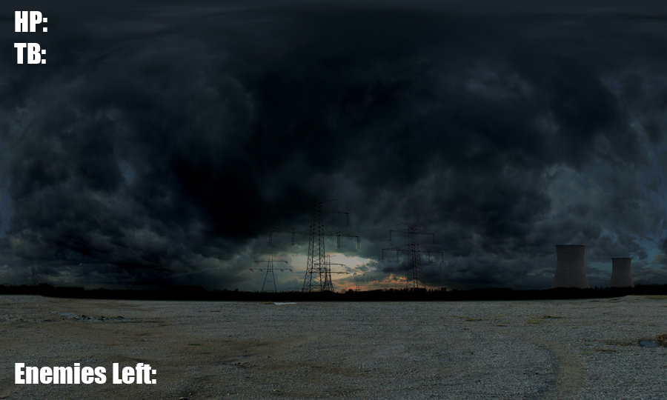

* Pressing ‘I’ will bring up inventory.
  + Weapons or items can be used from the inventory.

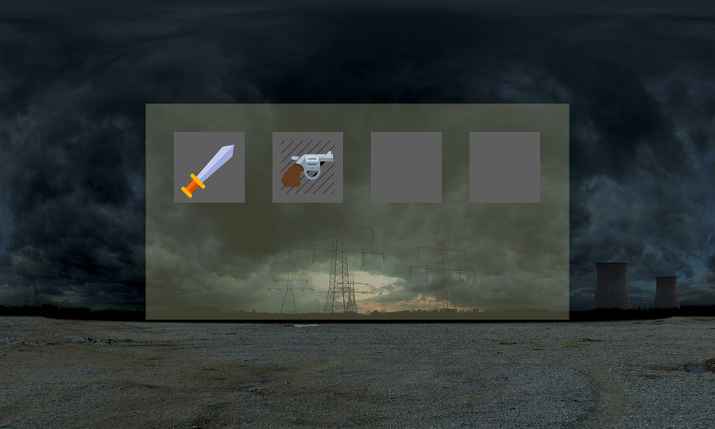

**Tasks**

**AGILE FRAMEWORK WILL BE USED; Tasks interchangeable.**

**Everyone:**

* **User Interface**
  + Splash Screen
    - Display Team Name
  + Main Menu
    - New Game
      * Start a new scene
    - Load Game
      * Check if text file is available
        + Not available: Start a new scene
        + Available: Load according to condition
    - Survival
      * Start a survival game scene
    - Instructions
      * Displaying an image for controls
    - Exit
      * End program
  + Pause Menu
    - Continue
      * Unfreeze screen
    - Restart
      * Restart scene
    - Return to Main Menu
      * Start Main Menu scene
  + Game Screen
    - Health Power [Left Top]
      * Represented by a text value
      * Integer variable; max: 100, lowest: 0, death: < 0
    - Torch Battery [Below HP]
      * Battery icons



* + - Enemies Left [Bottom Left]
      * Represented by a text value
      * Integer variable
  + Inventory
    - Translucent background
    - Square spacing for item icons
      * Displaying weapon icons onto square spacing if obtained
    - Esc for closing inventory
  + NPC
    - Similar to Inventory but with purchase option
* **Story**
  + Tutorial Level
  + Level 1
  + Level 2
  + Level 3
  + Level 4
  + Boss/Bonus Level
* **Save Game/Load Game**
  + Saving values to a text file
  + Reading the values from text file
  + Check if values from text file is equal to a certain condition in code
  + Load the game scene according to the condition
* **Gameplay**
  + Projectile
    - Create an object for projectile
    - Make projectile appears when keypress
    - Moves projectile forward
    - Detect if projectile touches enemy [object]
    - Deleting projectile when touched
    - Depleting HP of enemy when projectile touches
  + Tutorial Level
    - Displaying instructions on controls
      * Wall displaying WASD for Movement
      * Prompt press ‘E’ to pick torchlight when player approaches a torchlight
    - Trap an enemy in a cage looking object
      * Displaying “This is your enemy” when player approaches it
  + Boss/Bonus Level
    - Huge boss character model
  + Damaging platform
    - Reduce HP every second when camera position is same as damaging platform
  + Items
    - Weapons
      * Fist
        + Moves on z-axis
        + Range + 3
      * Sword
        + Moves on x-axis
        + Range + 10
      * Gun
        + Moves on z-axis
        + Shoots projectile
        + Range + 50
    - Support
      * HP Battery
        + Increases HP
      * Torch Battery
        + Increases Torch Battery
  + Equipping of Weapons
    - Fist
      * Bind fist to camera
      * Translate when used
      * Detect if enemy is + 3 position of fist
    - Sword
      * Bind sword to camera
      * Translate and Rotate when used
      * Detect if enemy is + 5 position of sword
    - Gun
      * Bind gun to camera
      * Rotate when used
      * Detect if projectile touches enemy
  + Timer
    - Time limit depends on level
      * Reduces by 1 every second
      * Game over when time < 0

**Beckham:**

* Inventory [Major Task]
  + Storing of item to a class
* Time limit
  + Reduces time variable by 1 every second
* Level 3

**Eugene:**

* Environment Framework and Collision detection [Major Task]
  + Detect if next position is an object
  + Prevent camera from moving if next position is an object
* Jumping for player
  + Increase position.y when spacebar is pressed
  + Decrease position.y to 0 when position.y > 0
* Binding of weapon to player
  + If player is in a certain range of an object, enable keypress ‘E’
  + Translate and Rotate weapon to camera
* Level 4

**Ming Xiu:**

* User interface and Game logic [Major Task]
* Enemy [Model]
  + Different enemy model for different levels
  + Hierarchical binding of body parts
* Enemy [Movement]
  + Random
  + Defined movement
    - Rotating arms
    - Rotating legs
* Level 1

**Yoong Soon:**

# irrKlang Audio Implementation [Major Task]

* Enemy [AI range detection]
* Enemy [Pathfinding]
* Level 2

**Project Schedule**

**Week 1:**

* Basic mechanics
  + Unable to walk through objects and walls.
  + HP dealing system; Hit enemy, enemy.hp-- Being hit by enemy, my.hp--
  + Time limit; game over.
  + Inventory; changing of weapons and healing HP when recovery item is used.
  + Transferring of one scene to another scene.
  + All levels to be properly rendered and working.

**Week 2:**

* Add on features
  + Save Game/Load Game
  + To be confirmed.
* Debugging.
* Play time test.

**Week 3:**

* Polishing of features.
* Ensuring game is bug free or close to bug free.
* Documentation of game.

**Gantt Chart**

