**Game Idea [Demolish the Towers]**

First Person Shooter game with RPG element to it.

Player objective is to get pass all of the levels by destroying all of the towers.

There will be multiple enemies attacking the player.

Game is based on Dynasty Warriors.

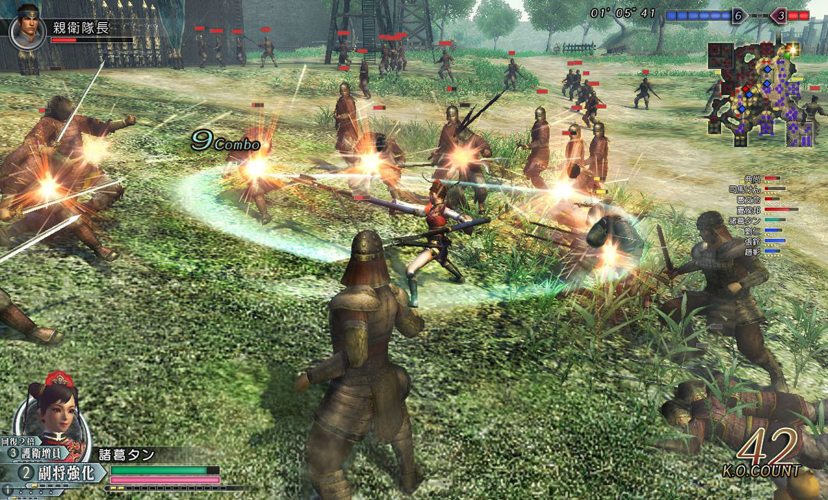

**Gameplay**

**Game Objective:**

Game is in 3D. We will attempt to make it switchable between 2D (Bird's-eye view) and 3D (First Person View).

Every scene will have a certain time limit.

Instead of killing all of the main officers in the game (Dynasty Warriors), we changed the objective to destroying all of the main towers. When towers were defeated by the player, the tower will now be the player’s property and assist him/her in battle.

Towers and enemies that were stated as the scene mission have to be completed before the time ends.

Player is to try and power-up his/her character to the fullest and complete all of the levels.

**Enemy:**

Robots [enemy] will be placed around the field.

When player reached a certain range of the enemy, the enemy will start moving towards the player.

Player can either move away from the enemy or defeat the enemy by attacking.

Each enemy will have a predefined health power [HP] and attack power [AP].

Depleting the enemy’s HP to 0 will delete it from the scene.

**Support:**

Recovery field; to heal Health Power [HP].

**Unique Selling Point**

RPG in First Person Shooter.

**Features**

**Game Mechanics:**

* Different type of weapons; gun and sword.
* Time limit for each level.
* NPC to interact with; purchasing of weapons and items.
* Movement of character using mouse/keyboard and gamepad (attempt).
* Collision detection using AABB and ray-sphere (attempt).

**User Interface [UI]:**

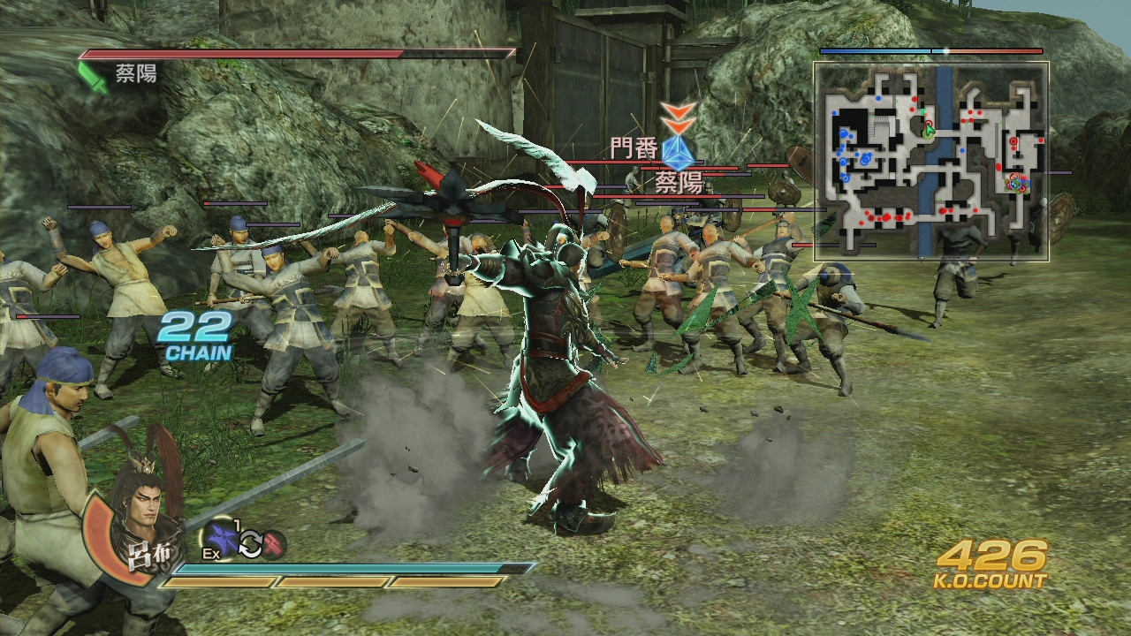

* Similar to Dynasty Warriors.
* Pressing ‘I’ in a town area will bring up the inventory.
  + Equipments can be changed from the inventory.

**Tasks**

**AGILE FRAMEWORK WILL BE USED; Tasks interchangeable.**

**Everyone:**

* Projectile
  + Create an object for projectile
  + Make projectile appears when key pressed or mouse pressed.
  + Moves projectile forward
  + Detect if projectile touches enemy [object]
  + Deleting projectile when touched
  + Depleting HP of enemy when projectile touches
* User Interface
  + Splash Screen
    - Display Team Name
  + Main Menu
    - New Game
    - Load Game
    - Instructions
    - Exit
  + Pause Menu
    - Continue
    - Restart
    - Exit
  + Game Screen
    - Health Power [Left Bottom]
    - Magic Power [Below Health Power]
    - Minimap [Top Right]
    - KO Count [Bottom Right]
  + Inventory
    - Translucent background
    - Square spacing for item icons
    - Esc for closing inventory
* Story
  + Tutorial Level
  + Level 1
  + Level 2
  + Level 3
  + Level 4
  + Boss/Bonus Level
* Save Game/Load Game
  + Saving values to a comma-separated values (CSV) file.
  + Reading the values from the CSV file.
  + Check if values from text file is equal to a certain condition in code.
  + Load the game scene according to the condition.
* Tutorial Level
  + Displaying instructions on controls
    - Letting player try out the keys before proceeding to the next section; move up for 2 seconds and move right for 2 seconds.
    - Attacking a dummy character.
* Inventory guidance
  + Teaching the player how to equip.
* Boss/Bonus Level
  + Multiple officers and horde attacking player.

**Eugene:**

* Collision detection
  + Ray-sphere collision detection for gun based equipment.
  + Prevent camera from moving if next position is an object.
* Map Editor
  + Placing objects and enemies on the scene for easy level creation.
* A.I
  + Moving enemy towards player when player is within a certain range.
* Level 4

**Lim Guan Sheng, Marcus:**

* Inventory
  + Switching of different equipments.
* Physics
* Level 1

**Yu Ming:**

* Player Attributes
* Statistics such as Health Power, Magic Power, Strength and Defense.
* Level 2

**Zhi Hao:**

* Cinematic Camera System
* Moving camera according to waypoints placed.
* Particles Manager
* Level 2

**Project Schedule**

**Week 1:**

* Basic mechanics
  + Proper ray-sphere collision detection when projectile fired.
  + Switching of equipments via inventory.
  + Transition between one scene to another. (Town to Game Level)
  + Camera panning to various location before level gameplay starts. (Showing the player the areas involved)
  + Damage system based on attack, defense and health power.
  + User-interface for battle field.

**Week 2:**

* Addon features
  + Save Game/Load Game
  + To be confirmed.
* Debugging.
* Play time test.

**Week 3:**

* Polishing of features.
* Ensuring game is bug free or close to bug free.
* Documentation of game.