**Medical Image analysis using Brain tumor detection**

**2. Introduction:**

Artificial intelligence (AI) technology has been a major factor in the recent rapid transformation of the healthcare industry brought about by technology advancements. Artificial Intelligence (AI) is a computer system that mimics human intelligence and has numerous medical applications. The fight against brain tumors is one such area. In the field of medicine, brain tumors represent a significant public health concern, and proper diagnosis, treatment, and follow-up procedures are essential. AI has emerged as a key instrument for enhancing these procedures and holds considerable promise for the early detection and management of brain tumors.

The location of brain tumors affects human health1. By combining technologies like big data analytics, machine learning, and deep learning, artificial intelligence (AI) is intended to assist in the diagnosis and treatment of complex diseases like brain tumors. Through the analysis of brain imaging methods like Magnetic Resonance Imaging (MRI), AI is able to identify and categorize tumors. The location, class, size, and aggressiveness of tumors can all be ascertained with the aid of AI algorithms. In addition to helping patients understand their health better, this assists doctors in providing a diagnosis and treatment plan that is more accurate [1].

There are 4 types of brain tumor images like: Gliomas, Meningiomas, Pituitary and No tumor images. Gliomas represent a diverse group of brain tumors with varying prognoses and treatment options. Early detection and a multidisciplinary approach to treatment are crucial for improving outcomes and quality of life for patients with gliomas. Ongoing research and advancements in medical technology continue to provide new insights and therapies for managing this challenging group of brain tumors. Meningiomas are a type of brain tumor that originates from the meninges, the protective membranes covering the brain and spinal cord. They are the most common type of primary brain tumor, accounting for about one-third of all brain tumors. Meningiomas are typically slow-growing and often benign, although some can be malignant. pituitary gland is a tiny organ at the base of the brain, often called the "master gland" because it controls many other glands and bodily functions by releasing hormones. Sometimes, tumors can grow in this gland, and these are called pituitary tumors. No Tumor image does not contain any type of tumor i.e. there is no brain tumor in the image.

In recent years, many methods have been presented for the automatic classification of brain tumors, which can be divided into Machine Learning (ML) and Deep Learning (DL) methods based on feature fusion, feature selection and the learning mechanism. In ML methods, feature extraction and feature selection are fundamental to classification [2] [3]. However, DL methods learn by extracting features directly from images. New DL methods, especially CNNs, offer excellent accuracy and are greatly employed in medical image analysis, including MRI analysis [4] [5] [6]. The disadvantages compared to traditional ML methods are also that it requires a large training dataset, high complexity of time. In addition, choosing the accurate deep learning model can be an intimidating task, requiring knowledge of numerous parameters, training methods, and topologies. Numerous Deep leaning-based models have been utilized for the brain tumor detection, i.e., VGG-16, VGG19, CNN, RESNET -100, AlexNet, EfcientNetB4, InceptionV3 and etc.

**3. Literature Review:**

MRI imaging is actively used in contemporary medical procedures to diagnose brain cancer. This section thoroughly examines the reputation for excellence in the detection and classification of brain tumors. In recent years, many researchers performed work on the detection, segmentation, and classification of brain tumors. The importance of this topic is pertinacious in the medical community. This research work describes methods for the detection of brain tumors. Methods to diagnose brain tumors include generative and discriminatory methods to distinguish brain images. a lot of research has been directed toward the adaptation of deep learning models in diagnosing brain tumors. Academicians have put in their efforts and with the help of high-end computing devices, higher accuracy has been achieved.

Maqsood et al. [7] demonstrated a brain tumor detection method based on fuzzy logic and the U-NET CNN architecture. Contrast enhancement, the fuzzy logic-based edge detection method, and U-NET CNN classification were used in this method. A contrast enhancement method is applied to the source images for pre-processing, followed by an edge detection method based on fuzzy logic to discover the edges in the contrast enhanced images, and finally a dual tree-complex wavelet transform is applied at various scale levels. The characteristics are generated from decomposed sub-band images, which are then classed using the U-NET CNN classification method, which distinguishes between meningioma and non-meningioma in brain imaging. The presented method was compared against various recently developed algorithms, and achieved an accuracy rate of 98.59%.

Togacar et al. [8] developed a BrainMRNet network using the modulo and hypercolumn method. First, the source images were pre-processed and afterwards they proceeded to the attention modulo. The attention modulo regulates the main areas of the image and directs the image to the convolutional layer. One of the primary strategies utilized in the convolutional layers of the BrainMRNet model is the hypercolumn. With this method, the attributes extracted from each layer are retained in the array tree of the last layer and attained an accuracy rate of 96.05%.

Sajjad et al. [9] developed a CNN based brain tumor detection and classification method. The authors used a Cascade CNN algorithm for the brain tumor segmentation and a fine tuned VGG19 is used for the tumor classification and attained an accuracy of 94.58%. Prastawa et al. [10] demonstrate how to segregate tumor areas in brain MRIs by detecting borderline pixels. This method detects only the aberrant borders of the tumor region however, not the inner border of the tumor region and hence achieved an accuracy of 88.17%.

Swati et al. [11] used a fine-tuned pre-trained VGG19 model on contrast-enhanced MRI (CE-MRI) to improve the results and obtained an average accuracy rate of 94.82%. Kumar et al. [12] proposed a brain tumor method using ResNet50 CNN model and global average pooling to resolve the problem of overfitting and obtained an average accuracy rate of 97.48%. Anaraki et al. [13] proposed a strategy based on CNN and GA (genetic algorithm) to classify various types of Glioma images using MRI data. The proposed system used GA for an automatic selection of CNN structure. They obtained 90.9% accuracy predicting Glioma images of three types. Besides, the study brought an accuracy of 94.2 % in the classification of Glioma, Meningioma, and Pituitary.

Gumaei et al. [14] proposed a hybrid feature extraction method for brain tumor classification using a regularized extreme learning machine (RELM). The min–max normalization contrast enhancement method is used as a preprocessing step and the hybrid PCA-NGIST method is used for the feature extraction, and the RELM method is employed for the classification of the brain tumor. This work obtained an accuracy rate of 94.23%. Swati et al. [15] used a fine-tuned pre-trained VGG19 model on contrast-enhanced MRI (CE-MRI) to improve the results and obtained an average accuracy rate of 94.82%. Kumar et al. [16] proposed a brain tumor method using ResNet50 CNN model and global average pooling to resolve the problem of overfitting and obtained an average accuracy rate of 97.48%.

**Table.1 Detailed summaries of current research on the detection and classification of brain tumors**

|  |  |  |  |
| --- | --- | --- | --- |
| **References** | **Methodology** | **Algorithms** | **Results** |
| Maqsood et al. [7] | Brain tumor detection method | Fuzzy logic, U-NET CNN | Accuracy - 98.59% |
| Togacar et al. [8] | BrainMRNet network | BrainMRNet model | Accuracy – 96.5% |
| Sajjad et al. [9] | Brain tumor detection and classification | Cascade CNN and VGG19 | Accuracy – 94.58% |
| Prastawa et al. [10] | BrainMRI | Geometric and Spatial Constraints | Accuracy – 88.17% |
| Swati et al. [11] | Fine-tunned VGG19 | Fine-tunned VGG19 | Accuracy – 94.82% |
| Kumar et al. [12] | Brain tumor method | ResNet50 CNN model | Accuracy – 97.48% |
| Anaraki et al. [13] | Brain tumor method | CNN, Genetic Algorithm | Accuracy - 90.9% |
| Gumaei et al. [14] | Brain tumor classification | PCA-NGIST and RELM | Accuracy – 94.23% |
| Swati et al. [15] | Brain tumor | fine-tuned VGG19 | Accuracy – 94.82% |
| Kumar et al. [16] | Brain tumor Method | ResNet50 and Global Average Pooling | Accuracy – 97.48% |

**4. Methodology:**

In this paper, I have to use four classes: a). Gliomas Tumor, b). Meningioma tumor, c). Pituitary tumor, d). No tumor

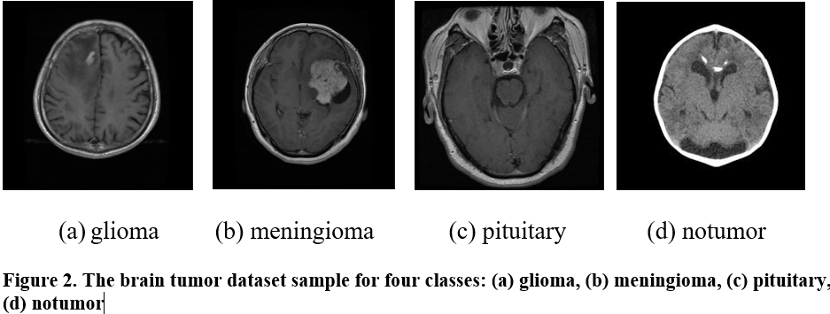



**Figure 3. The complete training, testing and validation process based on proposed deep learning models.**

The process of deep learning involves several steps: preprocessing data (cleaning, normalization, encoding), splitting it into training and testing sets, and defining the model architecture. The training process adjusts the model's parameters to minimize a loss function, followed by evaluation using metrics like accuracy, precision, and recall. If performance is unsatisfactory, hyperparameters can be adjusted, and the training process is repeated. Once the model performs well, it can make predictions on new data.

**4.1 Dataset Used:**

The brain dataset contains 7023 images of human brain MRI images which are classified into 4 classes: meningioma, glioma, pituitary and not tumor are existing in this dataset. no tumor class images were taken from the Br35H dataset. The sample of four types of brain tumor is shown in figure 2.

**4.2 Proposed Method Used:**

1. **VGG-16:** VGG 16 is a 16-layer CNN model known for its effectiveness and simplicity, using ConvNet layers with a 3 × 3 kernel size. Its pre-trained values are freely available online. The model requires a minimum input image size of 224 × 224 pixels with three channels. In neural networks, optimization algorithms evaluate neuron engagement by determining the weighted sum of inputs. Kernel functions introduce non-linearity into the output neuron. Neurons work with weights, biases, and training procedures, adjusting link weights based on output inaccuracy. Activation functions in the input layer add non-linearity, enabling the network to learn complex tasks. Figure 4 presented a VGG 16 model architecture.

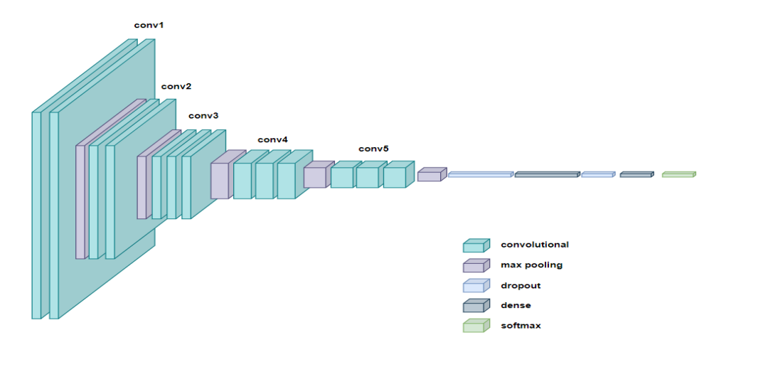

**Figure 4. Example of VGG 16 model architecture (source:** [**autors**](S.%20Karamehić%20and%20S.%20Jukić,%20)**)**

1. **Convolutional Neural Network (CNN)**

Convolutional Neural Networks (CNNs) are a type of deep learning model that works particularly well for image processing. They are programmed to automatically and adaptively learn spatial hierarchies of features from input images. A CNN typically consists of several layers, including convolutional layers that use filters to extract features such as edges, textures, and patterns, pooling layers that reduce the spatial dimensions of feature maps to reduce computational load and control overfitting, and fully connected layers that perform final classifications based on extracted features. CNNs use local connectivity, weight sharing, and hierarchical learning to achieve high performance in tasks such as image classification, object detection, and segmentation, making them essential for modern computer vision and artificial intelligence applications. Figure 5 presented a Convolutional neural network architecture.

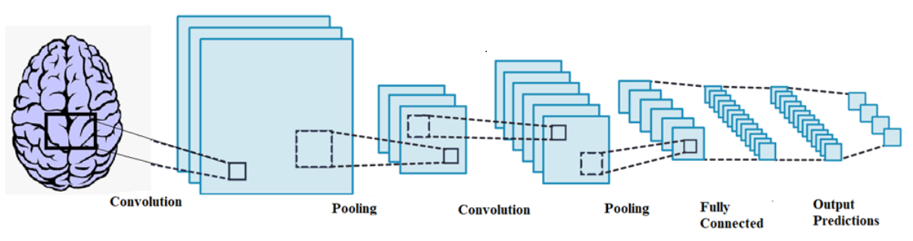

**Figure 5. Example of CNN model architecture (source:** [**autors**](C.%20L.%20Choudhury,%20C.%20Mahanty,%20R.%20Kumar%20and%20B.%20K.%20Mishra,%20%22Brain%20Tumor%20Detection%20and%20Classification%20Using%20Convolutional%20Neural%20Network%20and%20Deep%20Neural%20Network,%22%202020%20International%20Conference%20on%20Computer%20Science,%20Engineering%20and%20Applications%20(ICCSEA),%20Gunupur,%20India,%202020,%20pp.%201-4,%20doi:%2010.1109/ICCSEA49143.2020.9132874.)**)**

1. **DenseNet – 121 Model**

DenseNet-121 is a Convolutional Neural Network (CNN) known for its dense connectivity, enhancing information flow and mitigating the vanishing-gradient problem. It consists of multiple dense blocks, where each layer receives inputs from all preceding layers, ensuring efficient feature reuse and improved gradient flow. The architecture includes an initial convolution layer, followed by max pooling, dense blocks with bottleneck layers, and transition layers with 1x1 convolutions and average pooling. Global average pooling after the final dense block reduces feature maps to single values, fed into a fully connected layer with SoftMax activation for classification. DenseNet-121 is parameter-efficient and excels in image classification tasks, trained using backpropagation and optimizers like Adam or SGD, with performance evaluated on a testing set using metrics like accuracy, precision, recall, and F1-score. Figure 6 presented a DenseNet-121 model architecture.

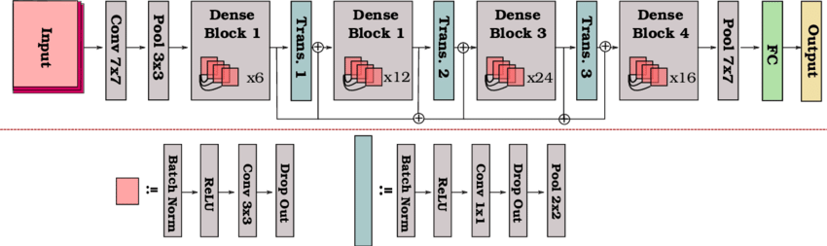

**Figure 6. Example of DenseNet-121 model architecture (source:** [**autors**](https://www.google.com/url?sa=i&url=https%3A%2F%2Fwww.researchgate.net%2Ffigure%2FA-schematic-illustration-of-the-DenseNet-121-architecture-82_fig5_334170752&psig=AOvVaw3FkUuJyBaV4-iynOGDd6J3&ust=1720176694983000&source=images&cd=vfe&opi=89978449&ved=0CBEQjRxqFwoTCOCNy9qbjYcDFQAAAAAdAAAAABAJ)**)**

1. **ResNet–50 Model**

Fine-tuning the ResNet50 model with CNN is a standard method for brain tumor detection and classification using MRIs. ResNet50, pre-trained on the ImageNet dataset, serves as a feature extractor. For brain tumor detection, the last few layers are replaced with new fully connected layers. The model is then fine-tuned on a dataset of MRI scans, updating weights using backpropagation and stochastic gradient descent. Preprocessed MRI scans enhance tumor contrast, and the output is a probability distribution indicating the presence or absence of a tumor. This approach leverages ResNet50's robust initial features and achieves high accuracy in brain tumor detection and classification. Figure 7 presented a DenseNet-121 model architecture.

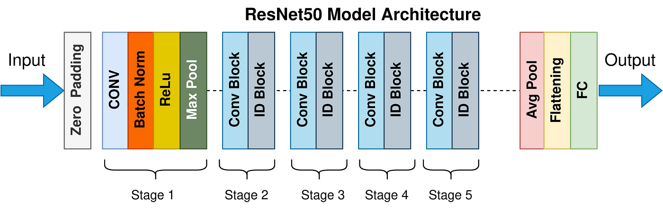

**Figure 7. Example of ResNet50 model architecture (source:** [**autors**](https://www.google.com/url?sa=i&url=https%3A%2F%2Ftowardsdatascience.com%2Fthe-annotated-resnet-50-a6c536034758&psig=AOvVaw3qarSRuOgcZ1s2wNmqoBJN&ust=1720177671825000&source=images&cd=vfe&opi=89978449&ved=0CBEQjRxqFwoTCLipq7KfjYcDFQAAAAAdAAAAABAE)**)**

1. **MobileNetV2 Model**

MobileNetV2 is a popular neural network designed for mobile and embedded devices due to its lightweight nature and small parameter count. It uses depth-wise separable convolutions to reduce parameters while maintaining accuracy. The architecture includes sequential convolutional layers with batch normalization and ReLU activation. Inspired by residual networks, it employs skip connections to enhance information flow. Unique features like linear bottlenecks and inverted residuals further boost performance. Residual connections between convolutional layers mitigate gradient issues, crucial for effective training. The model ends with a global average pooling layer for feature summarization and a fully connected layer for final predictions. Figure 8 is a MobileNetV2 Model architecture.

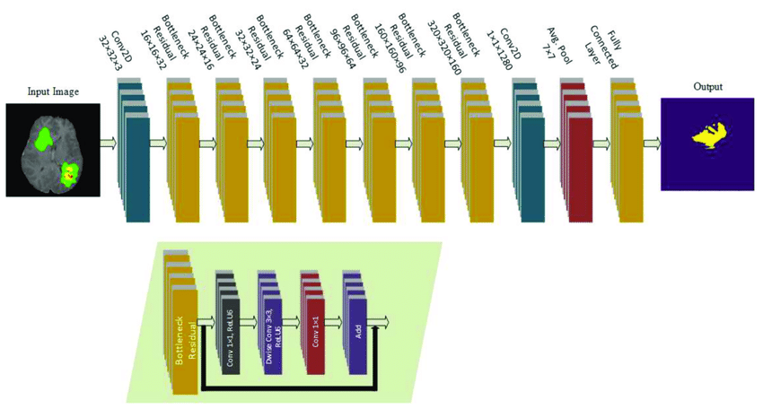

**Figure 8. Example of MobileNetV2 model architecture (source:** [**autors**](RMU-Net:%20A%20Novel%20Residual%20Mobile%20U-Net%20Model%20for%20Brain%20Tumor%20Segmentation%20from%20MR%20Images%20-%20Scientific%20Figure%20on%20ResearchGate.%20Available%20from:%20https://www.researchgate.net/figure/MobileNetV2-architecture-for-segmentation-of-brain-tumor-implemented-in-this-research_fig1_353926596%20%5baccessed%204%20Jul,%202024%5d)**)**

1. **VGG19 Model**

VGG19, developed by the University of Oxford, is renowned for its depth and simplicity in convolutional neural network architectures. With 19 layers—16 convolutional and 3 fully connected—it uses 3x3 filters and max-pooling to preserve spatial details in image processing. Despite lacking advanced features like residual connections or inception modules, VGG19 effectively learns complex image features. Trained on large datasets like ImageNet, it uses SGD or Adam optimizers for backpropagation, generating class probabilities via SoftMax activation. Widely employed in transfer learning, VGG19 excels as a feature extractor for tasks such as image classification, object detection, and segmentation in diverse applications of computer vision. Figure 9 is a VGG19 Model architecture.

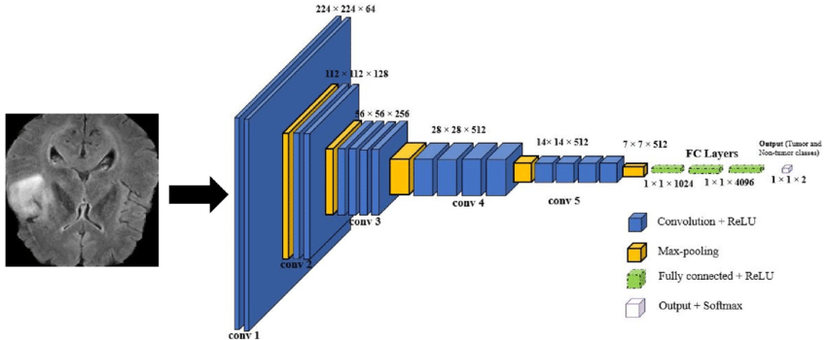

**Figure 9. Example of VGG19 model architecture (source:** [**autors**](MRI-based%20brain%20tumor%20detection%20using%20the%20fusion%20of%20histogram%20oriented%20gradients%20and%20neural%20features%20-%20Scientific%20Figure%20on%20ResearchGate.%20Available%20from:%20https:/www.researchgate.net/figure/Schematic-diagram-of-VGG19-for-our-experimental-set-up_fig2_348483474%20%5baccessed%204%20Jul,%202024%5d)**)**

1. **EfficientNet Model**

The Dense EfficientNetB0 model merges DenseNet's dense connectivity and EfficientNet's efficient scaling, optimizing both performance and efficiency in deep learning tasks. It maximizes feature reuse and gradient flow across layers, enhancing training effectiveness. By dynamically scaling network depth, width, and resolution, it achieves high accuracy with fewer parameters compared to traditional models. The architecture includes depth-wise and point-wise convolutions, batch normalization, ReLU activations, and skip connections to ensure robust information propagation and mitigate training challenges. Well-suited for mobile and embedded systems, Dense EfficientNetB0 utilizes SGD or Adam optimizers for training and excels in diverse applications like image classification, object detection, and segmentation, particularly in transfer learning scenarios. Figure 10 is a EfficientNetB0 Model architecture.

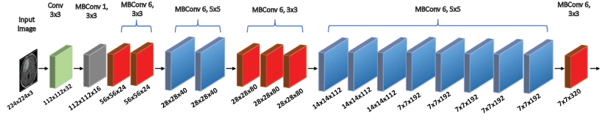

**Figure 10. Example of EfficientNetB0 model architecture (source:** [**autors**](H.%20A.%20Shah,%20F.%20Saeed,%20S.%20Yun,%20J.%20-H.%20Park,%20A.%20Paul%20and%20J.%20-M.%20Kang,%20%22A%20Robust%20Approach%20for%20Brain%20Tumor%20Detection%20in%20Magnetic%20Resonance%20Images%20Using%20Finetuned%20EfficientNet,%22%20in%20IEEE%20Access,%20vol.%2010,%20pp.%2065426-65438,%202022,%20doi:%2010.1109/ACCESS.2022.3184113.%20keywords:%20%7bTumors;Brain%20modeling;Magnetic%20resonance%20imaging;Cancer;Feature%20extraction;Convolutional%20neural%20networks;Medical%20services;Brain%20tumor;deep%20learning;convolution%20neural%20networks%20(CNN);transfer%20learning;MRI;detection%7d,)**)**

**5. Experimental Results and Analysis:**

For this study, we used the Brain Tumor MRI dataset available on Kaggle, which contains MRI images of brain tumors with corresponding segmentation masks. The dataset consists of 7023 MRI images. The dataset is separated into training and testing sets. 81.3% of the dataset is separated into training while 18.7% of the dataset is separated into testing. We have used 8 different types of Models like:

1. **VGG16 Model:**

Figure 11 represent the Model training history with Accuracy and loss values and training accuracy achieved 98% and 97% accuracy achieved on test dataset with the images of 1311.

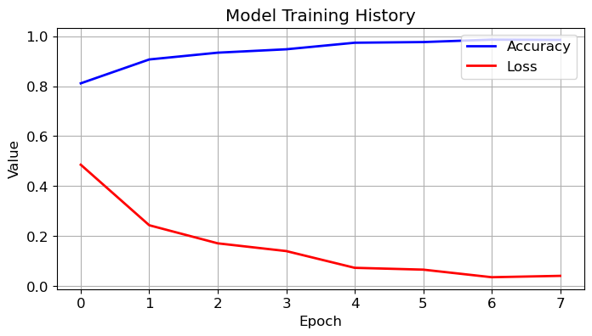

**Figure 11. Model Training History of VGG16 Model**

1. **CNN Model:**

Figure 12 represent the Model training history with Accuracy and loss values and training accuracy achieved 92% and 90% accuracy achieved on test dataset with the images of 1311.

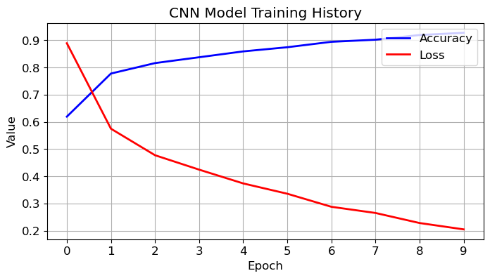

**Figure 12. Model Training History of CNN Model**

1. **DenseNet-121 Model:**

Figure 13 represent the Model training history with Accuracy and loss values and training accuracy achieved 98% and 95% accuracy achieved on test dataset with the images of 1311.

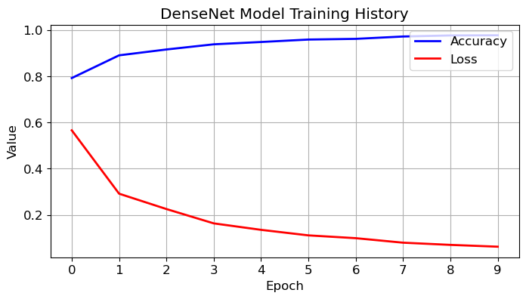

**Figure 13. Model Training History of DenseNet-121 Model**

1. **ResNet-50 Model:**

Figure 14 represent the Model training history with Accuracy and loss values and training accuracy achieved 86% and 75% accuracy achieved on test dataset with the images of 1311

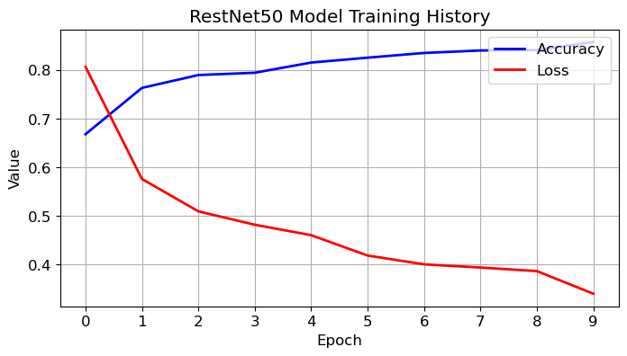

**Figure 14. Model Training History of ResNet-50 Model**

1. **MobileNetV2 Model:**

Figure 15 represent the Model training history with Accuracy and loss values and training accuracy achieved 99% and 96% accuracy achieved on test dataset with the images of 1311.

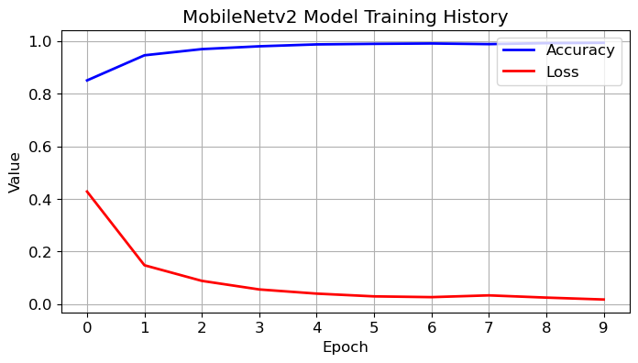

**Figure 15. Model Training History of MobileNetV2 Model**

1. **VGG19 Model:**

Figure 16 represent the Model training history with Accuracy and loss values and training accuracy achieved 98% and 96% accuracy achieved on test dataset with the images of 1311.

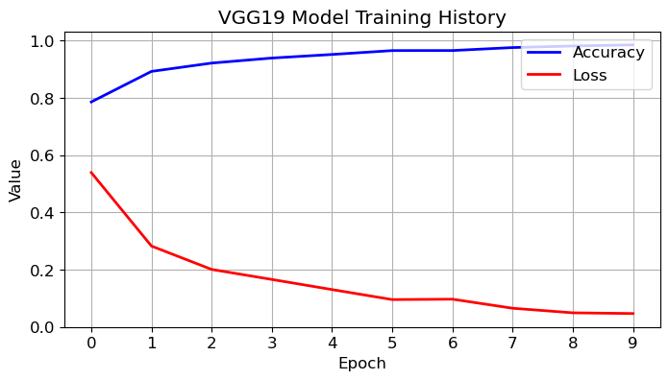

**Figure 16. Model Training History of VGG19 Model**

1. **EfficientNetB0 Model:**

Figure 17 represent the Model training history with Accuracy and loss values and training accuracy achieved 28% and 31% accuracy achieved on test dataset with the images of 1311.

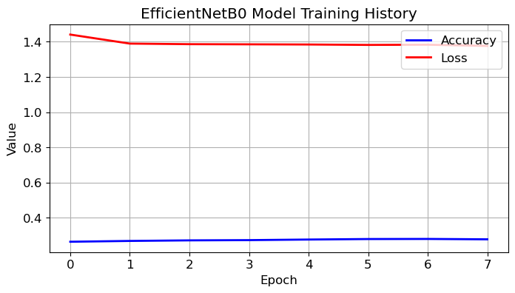

**Figure 17. Model Training History of EfficientNetB0 Model**

**6. Conclusion:**

This study explored the potential of various deep learning models for classifying brain tumors using MRI scans. We investigated seven models, including VGG16, CNN, DenseNet-121, ResNet-50, MobileNetV2, VGG19, and EfficientNetB0. The dataset included over 7000 MRI images categorized into four tumor types and a non-tumor class.

The results revealed that several models achieved high accuracy in classifying brain tumors on the test dataset. Notably, VGG16, DenseNet-121, MobileNetV2, and VGG19 demonstrated exceptional performance. This suggests that deep learning has great potential for aiding in brain tumor detection. While ResNet-50 showed moderate accuracy, EfficientNetB0 required further investigation due to its lower performance.

Overall, this work highlights the promising capabilities of deep learning for brain tumor classification. Future research can explore optimizing these models through hyperparameter tuning and potentially combining multiple models for enhanced accuracy. Additionally, incorporating data from other modalities alongside MRI scans could lead to even more robust tumor classification. It's important to remember that these models require rigorous validation in clinical settings before real-world application.

**Abstract:**

Brain tumor detection is a crucial step in effective patient treatment. This study investigated the use of deep learning models for classifying brain tumors using MRI scans. Seven models were evaluated: VGG16, CNN, DenseNet-121, ResNet-50, MobileNetV2, VGG19, and EfficientNetB0. The dataset consisted of over 7000 MRI images categorized into four tumor types and a non-tumor class. VGG16, DenseNet-121, MobileNetV2, and VGG19 achieved high accuracy on the test dataset, demonstrating deep learning's potential for brain tumor classification. While ResNet-50 showed moderate accuracy, EfficientNetB0 required further exploration due to its lower performance. These findings highlight the promise of deep learning in this domain. Future research could focus on hyperparameter tuning, combining models, and incorporating additional data modalities for enhanced accuracy. However, rigorous clinical validation is necessary before real-world deployment.

**Reference:**

1. Khaliki, M.Z., Başarslan, M.S. Brain tumor detection from images and comparison with transfer learning methods and 3-layer CNN. *Sci Rep* **14**, 2664 (2024). https://doi.org/10.1038/s41598-024-52823-9

2. Abd-Ellah, M.K.; Awad, A.I.; Khalaf, A.A.M.; Hamed, H.F.A. A review on brain tumor diagnosis from MRI images: Practical implications, key achievements, and lessons learned. Magn. Reson. Imaging 2019, 61, 300–318.

3. Sharma, A.K.; Nandal, A.; Dhaka, A.; Dixit, R. A survey on machine learning based brain retrieval algorithms in medical image analysis. Health Technol. 2020, 10, 1359–1373.

4. Ali, S.; Li, J.; Pei, Y.; Khurram, R.;Rehman, K.; Mahmood, T. A comprehensive survey on brain tumor diagnosis using deep learning and emerging hybrid techniques with multi-modal MR image. Arch. Comput. Methods Eng. 2022, 1–26.

5. Arabahmadi, M.; Farahbakhsh, R.; Rezazadeh, J. Deep learning for smart Healthcare—A survey on brain tumor detection from medical imaging. Sensors 2022, 22, 1960.

6. Magadza, T.; Viriri, S. Deep learning for brain tumor segmentation: A survey of state-of-the-art. J. Imaging 2021, 7, 19.

7. Maqsood, S.; Damasevicius, R.; Shah, F.M. An efficient approach for the detection of brain tumor using fuzzy logic and U-NET CNN classification. In International Conference on Computational Science and Its Applications; Springer: Cham, Switzerland, 2021; pp. 105–118

8. Togaçar, M.; Ergen, B.; Cömert, Z. BrainMRNet: Brain tumor detection using magnetic resonance images with a novel convolutional neural network model. Med. Hypotheses 2020, 134, 109531.

9. Sajjad, M.; Khan, S.; Muhammad, K.; Wu, W.; Ullah, A.; Baik, S.W. Multi-grade brain tumor classification using deep CNN with extensive data augmentation. J. Comput. Sci. 2019, 30, 174–182.

10. Prastawa, M.; Bullitt, E.; Ho, S.; Gerig, G. A brain tumor segmentation framework based on outlier detection. Med. Image Anal. 2004, 8, 275–283.

11. Swati, Z.N.K.; Zhao, Q.; Kabir, M.; Ali, F.; Ali, Z.; Ahmed, S.; Lu, J. Brain tumor classification for mr images using transfer learning and fine-tuning. Comput. Med. Imaging Graph. 2019, 75, 34–46

12. Kumar, R.L.; Kakarla, J.; Isunuri, B.V.; Singh, M. Multi-class brain tumor classification using residual network and global average pooling. Multimed. Tools Appl. 2021, 80, 13429–13438.

13. A. Kabir Anaraki, M. Ayati, and F. Kazemi, ‘‘Magnetic resonance imaging-based brain tumor grades classification and grading via convolutional neural networks and genetic algorithms,’’ Biocybern. Biomed. Eng., vol. 39, no. 1, pp. 63–74, Jan. 2019, doi: 10.1016/j.bbe.2018.10.004

14. Gumaei, A.; Hassan, M.M.; Hassan, M.R.; Alelaiwi, A.; Fortino, G. A hybrid feature extraction method with regularized extreme learning machine for brain tumor classification. IEEE Access 2019, 7, 36266–36273

15. Swati, Z.N.K.; Zhao, Q.; Kabir, M.; Ali, F.; Ali, Z.; Ahmed, S.; Lu, J. Brain tumor classification for mr images using transfer learning and fine-tuning. Comput. Med. Imaging Graph. 2019, 75, 34–46

16. Kumar, R.L.; Kakarla, J.; Isunuri, B.V.; Singh, M. Multi-class brain tumor classification using residual network and global average pooling. Multimed. Tools Appl. 2021, 80, 13429–13438

**Table.1 Avg Accuracy of Precision, Recall and F1 Score for all models**

|  |  |  |  |
| --- | --- | --- | --- |
| **Model Name** | **Precision** | **Recall** | **F1-Score** |
| VGG16 | 98.25% | 98% | 98% |
| CNN | 91% | 87.5% | 87.25% |
| DenseNet | 94.75% | 94.5% | 94.5% |
| ResNet50 | 81.5% | 81.75% | 81.25% |
| MobileNetV2 | 95.5% | 95% | 95.25% |
| VGG19 | 97.5% | 97.25% | 97.5% |
| EfficientNet | 7.75% | 25% | 11.75% |

**Table.2 Results of Experiment**

|  |  |  |  |  |
| --- | --- | --- | --- | --- |
| **Model Name** | **Training** | | **Testing** | |
| **Training Accuracy** | **Loss** | **Validation Accuracy** | **Loss** |
| VGG16 | 98.94% | 3.46% | 98.12% | 6.09% |
| CNN | 93.13% | 19.69% | 88.43% | 26.81% |
| DenseNet | 98.16% | 5.07 | 95% | 13.95% |
| ResNet50 | 84.86% | 37.47% | 82% | 43.69% |
| MobileNetV2 | 99.06% | 2.32% | 95.38% | 18.65% |
| VGG19 | 97.41% | 6.39% | 97.10% | 8.59% |
| EfficientNet | 28.49% | 138.52% | 30.93% | 138.41% |