**GIT HandsOnLAB - 1**

In this hands-on lab, you will learn how to:

Setup your machine with Git Configuration

Integrate notepad++.exe to Git and make it a default editor

Add a file to source code repository

**Step 1: Setup your machine with Git Configuration**

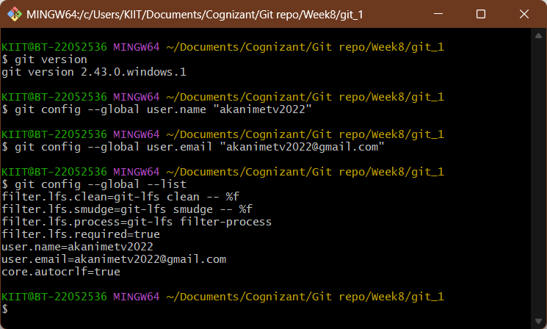

**Step 2: Integrate notepad++.exe to Git and make it a default editor**

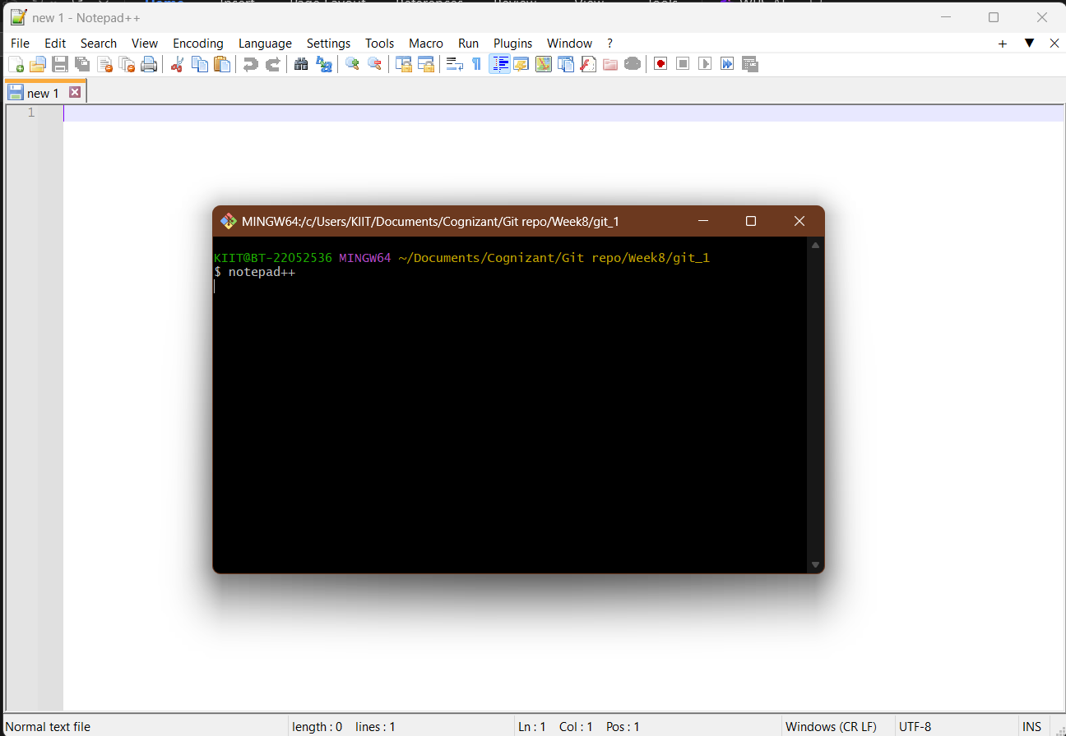

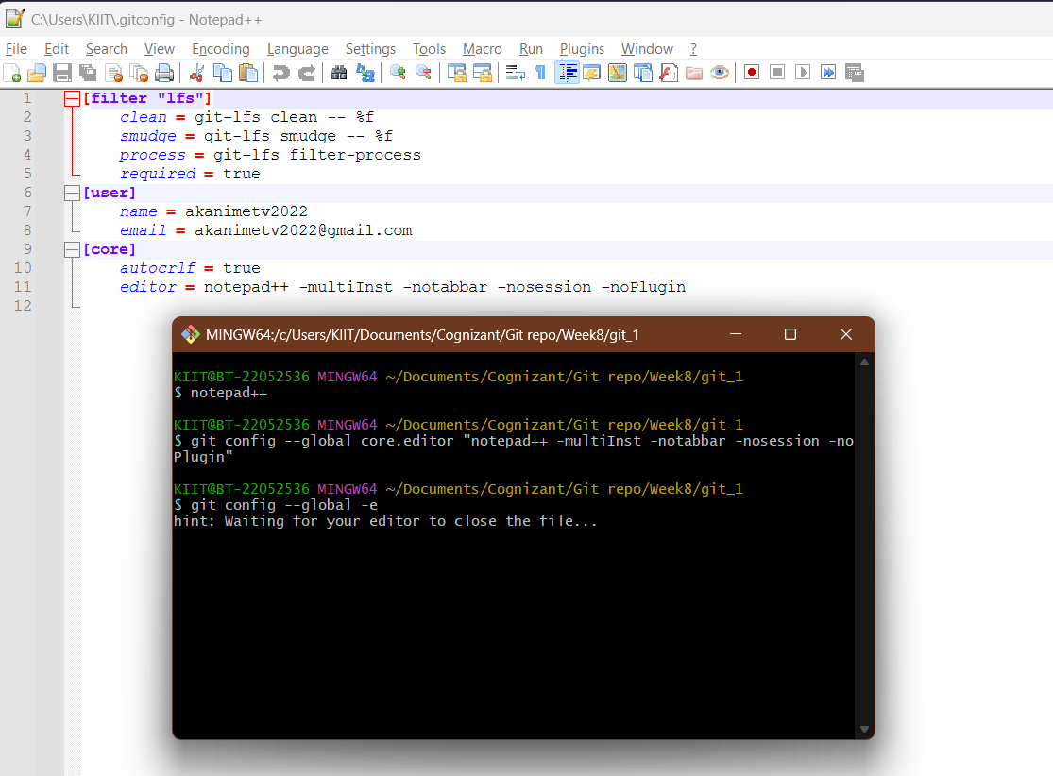

**Step 3: Add a file to source code repository**

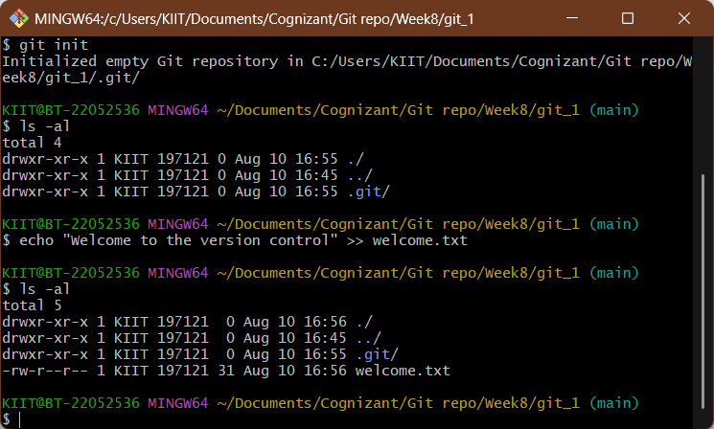

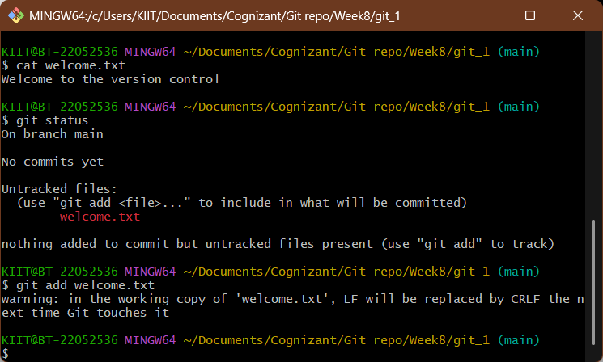

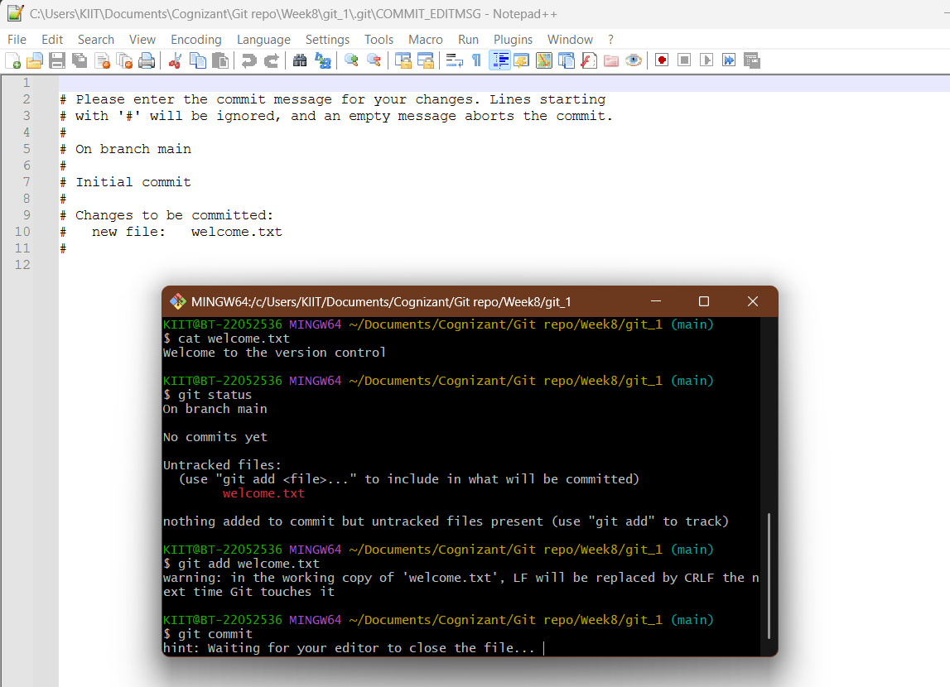

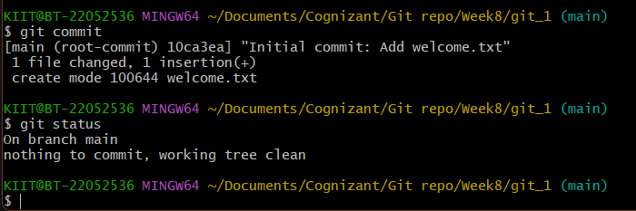

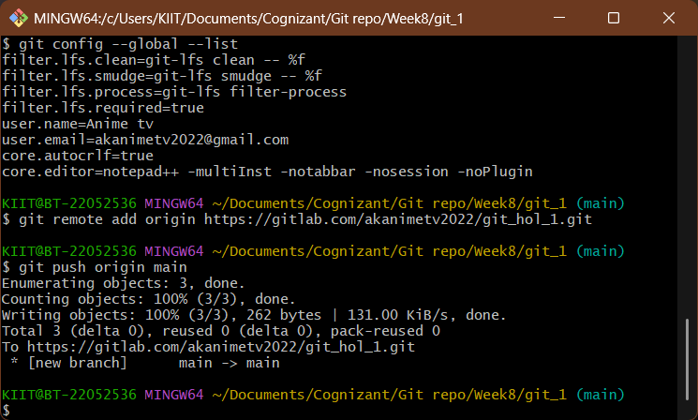

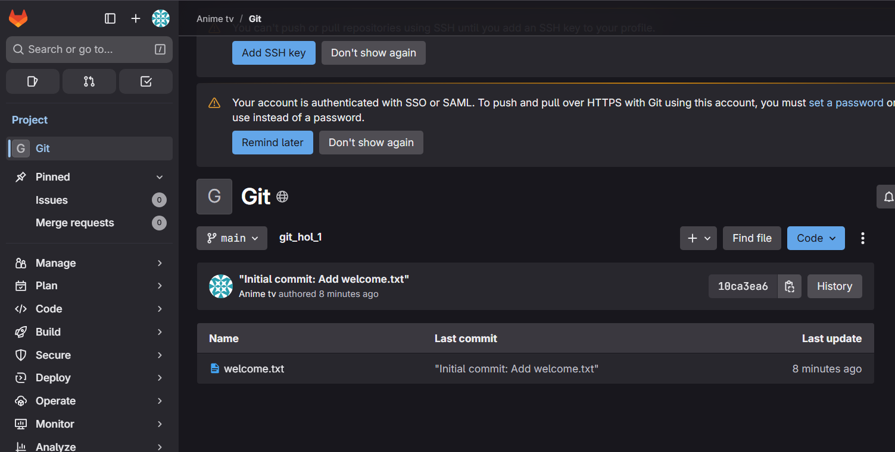

**GIT HandsOnLAB - 2**

In this hands-on lab, you will learn how to:

Implement git ignore command to ignore unwanted files and folders

Step 1: Create a local repo

Step 2: Create .log file and log folder

Step 3: Create .gitignore file

Step 4: Check git status

Step 5: Add and commit

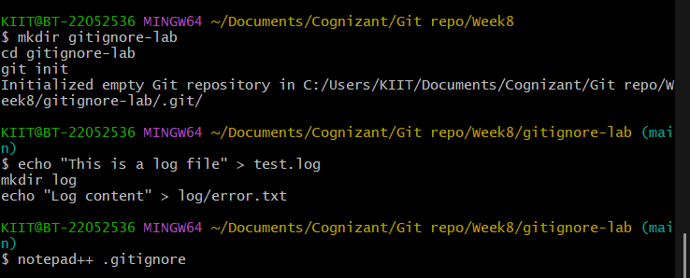

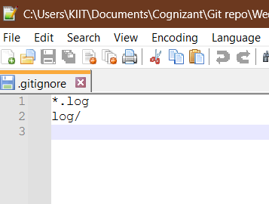

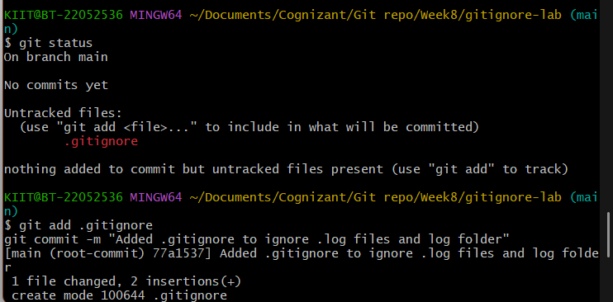

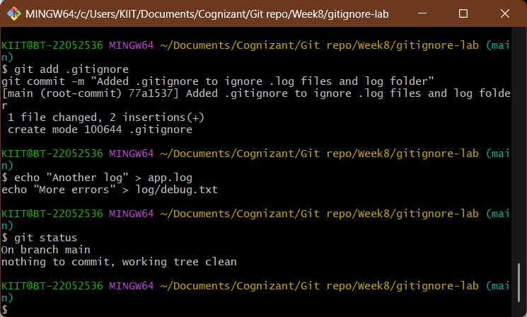

**GIT HandsOnLAB - 3**

In this hands-on lab, you will learn how to:

Construct a branch, do some changes in the branch, and merge it with master (or trunk)

**Branching**

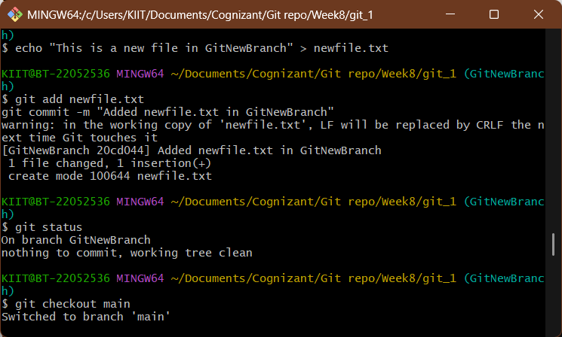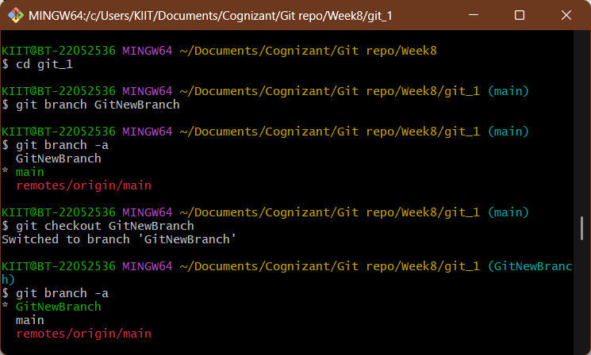

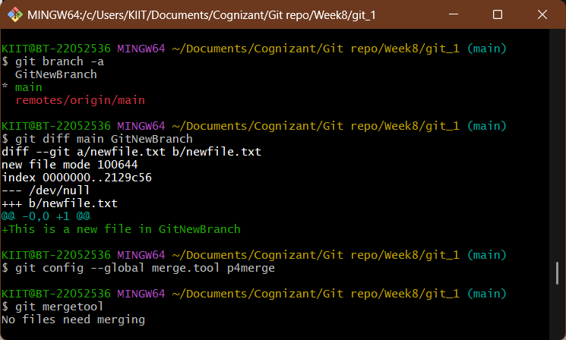

**Merging**

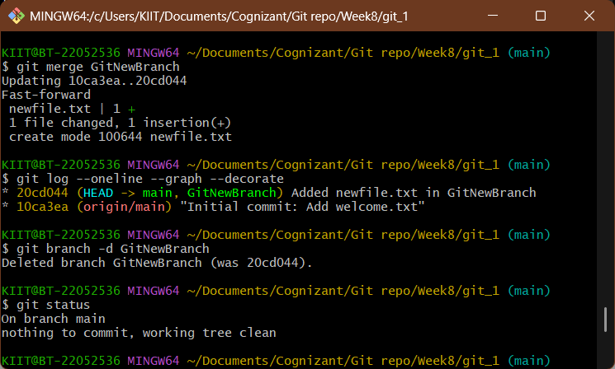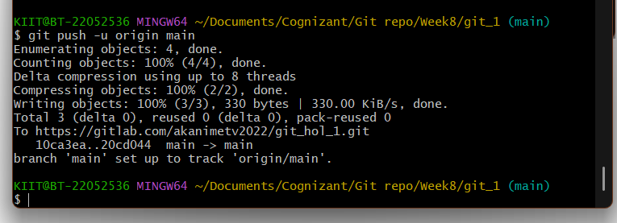

**GIT HandsOnLAB - 4**

In this hands-on lab, you will learn how to:

Implement conflict resolution when multiple users are updating the trunk (or master) in such a way that it results into a conflict with the branch’s modification.

