ML-BASED NETWORK INTRUSION DETECTOR
Program: IBM SkillsBuild Cyber Security 2026
Conducted by: BharatCares
Submitted by: Devika Jayan
Project Domain: Cybersecurity and Machine Learning

1. Abstract
The ML-Based Network Intrusion Detector is a machine-learning project designed to classify network-flow records as BENIGN or Distributed Denial of Service (DDoS) traffic. The project uses the CIC-IDS2017 dataset and a Random Forest classification algorithm.
The workflow includes dataset inspection, data cleaning, feature preparation, model training, and performance evaluation. The classifier is evaluated using accuracy, precision, recall, F1-score, and a confusion matrix. Feature importance is also examined to understand which network-flow features contribute to the model's predictions.
The project demonstrates how supervised machine learning can be applied to a cybersecurity problem. It is a dataset-based prototype rather than a live network monitoring system, and further validation would be required before real-world deployment.
2. Introduction
Network security is an important aspect of protecting computer systems and online services from malicious activities. Network attacks can affect the availability, integrity, and reliability of digital services. One such attack is a Distributed Denial of Service (DDoS) attack, in which a target service is overwhelmed with traffic, making it difficult for legitimate users to access it.
Machine learning can be used to analyse patterns in network traffic and classify records based on previously labelled examples. In this project, a Random Forest classifier is trained using the CIC-IDS2017 dataset to distinguish between benign network traffic and traffic labelled as DDoS.
The project demonstrates the application of supervised machine learning to a cybersecurity problem through data preprocessing, model training, evaluation, and prediction.
3. Problem Statement
Identifying potentially malicious network traffic is an important challenge in cybersecurity. DDoS attacks can disrupt the availability of online services, so distinguishing attack-related traffic from benign traffic is useful for network security analysis.
This project investigates whether a machine-learning model can learn patterns from labelled network-flow records and classify them as BENIGN or DDoS. The model is developed and evaluated using the CIC-IDS2017 dataset.
4. Objectives
The main objectives of this project are:
- To load and inspect a labelled network-traffic dataset.
- To clean missing values, infinite values, and duplicate records.
- To prepare network-flow features and target labels for supervised learning.
- To train a Random Forest classification model.
- To evaluate the model using accuracy, precision, recall, F1-score, and a confusion matrix.
- To examine feature importance to understand which features contribute to model predictions.
- To save and reload the trained model and demonstrate predictions on held-out records.
5. Dataset Description
The project uses the CIC-IDS2017 dataset published by the Canadian Institute for Cybersecurity. This dataset contains labelled network traffic and flow-based features that can be used for cybersecurity research and machine-learning experiments.
The CSV used during development was Friday-WorkingHours-Afternoon-DDos.pcap_ISCX.csv. The project focuses on two classes: BENIGN, representing traffic labelled as benign, and DDoS, representing traffic labelled as a Distributed Denial of Service attack.
Dataset details
- Dataset name: CIC-IDS2017
- Original number of records: 225,745
- Records after preprocessing: 223,082
- Number of columns after preprocessing: 79, including the target label
- Number of input features: 78
- Target column: Label
- Target classes: BENIGN and DDoS
The dataset was checked for missing values, infinite values, and duplicate records before training the model.
Official dataset page: https://www.unb.ca/cic/datasets/ids-2017.html
6. Tools and Technologies
The following tools and libraries were used in the project.
Python
Python was used as the primary programming language because it provides libraries for data analysis and machine learning.
Google Colab
Google Colab was used as the development environment to write and execute Python code without requiring a local machine-learning setup.
Pandas
Pandas was used to load the CSV dataset, inspect the data, clean records, manipulate columns, and prepare the feature matrix and target labels.
NumPy
NumPy was used for numerical operations and for handling infinite and invalid numerical values during preprocessing.
Scikit-learn
Scikit-learn was used to split the dataset into training and testing subsets, train the Random Forest classifier, generate predictions, and calculate evaluation metrics.
Matplotlib
Matplotlib was used to visualize the confusion matrix and feature-importance results.
Joblib
Joblib was used to save the trained model and feature names so that the model could be reloaded and reused without training it again.
7. Methodology
The project follows a supervised machine-learning workflow consisting of data preparation, model training, evaluation, and prediction.
7.1 Data Loading
The CIC-IDS2017 CSV file was loaded into a Pandas DataFrame. The dataset's dimensions, column names, data types, and class labels were inspected to understand its structure.
Whitespace was removed from column names to make them easier to access consistently.
7.2 Data Cleaning
The dataset was checked for missing values, infinite values, and duplicate rows.
Positive and negative infinity values were replaced with missing values. Rows containing missing values were removed, followed by the removal of duplicate records. The index was then reset.
After preprocessing, 223,082 records remained in the development run.
7.3 Feature and Target Preparation
The Label column was selected as the target variable, while the remaining columns were used as input features.
- X: Contains the 78 network-flow input features.
- y: Contains the target class labels, BENIGN or DDoS.
The input features represent characteristics of network flows, such as packet lengths, packet counts, flow duration, and other traffic-related measurements.
7.4 Training and Testing Split
The dataset was divided into training and testing subsets using Scikit-learn's train_test_split function.
- Training data: 80% of the records.
- Testing data: 20% of the records.
- Random state: 42.
- Stratification: Used to preserve the class proportions in the two subsets.
The training subset was used to fit the model, while the test subset was used to evaluate its predictions on records excluded from training.
7.5 Model Training
A Random Forest classifier was selected for the binary classification task.
Random Forest is an ensemble-learning algorithm that combines the outputs of multiple decision trees to produce a prediction. It can learn relationships between input features and class labels and is commonly used for classification problems involving tabular data.
The model was configured with 100 decision trees, random_state=42, and n_jobs=-1. It was trained using the prepared training features and labels.
7.6 Prediction
After training, the model was used to predict the class labels of records in the test dataset. The predicted labels were compared with the actual labels to measure model performance.
The project also included a demonstration in which the saved model was reloaded and used to predict labels for a small selection of held-out test records.
7.7 Model Saving
The trained classifier was saved as network_intrusion_detector.pkl. The ordered list of feature names was saved separately as feature_names.pkl.
Saving the model makes it possible to reload the trained classifier later without repeating the entire training process.
8. Model Evaluation
The model was evaluated using a held-out test dataset. Several classification metrics were used to assess its performance.
8.1 Accuracy
Accuracy measures the proportion of test records that the model classified correctly.
8.2 Precision
Precision measures the proportion of records predicted as a particular class that actually belong to that class.
8.3 Recall
Recall measures the proportion of actual records belonging to a class that the model correctly identifies.
8.4 F1-Score
The F1-score combines precision and recall into a single metric using their harmonic mean. It is useful for understanding the balance between these two measures.
8.5 Confusion Matrix
The confusion matrix compares the actual class labels with the predicted class labels. It shows correct predictions and classification errors for each class.
Development results
In the development run, the model achieved approximately 99.991% test accuracy.
The confusion matrix was:
Actual class | Predicted BENIGN | Predicted DDoS
BENIGN | 19,013 | 1
DDoS | 3 | 25,600
The model correctly classified 19,013 BENIGN records and 25,600 DDoS records. One BENIGN record was incorrectly classified as DDoS, while three DDoS records were incorrectly classified as BENIGN.
These results apply to the specific dataset split used during development. They do not guarantee equivalent performance on new network traffic.
The classification report generated by the notebook provides the detailed precision, recall, and F1-score values for both classes.
9. Feature Importance Analysis
Feature importance was examined using the trained Random Forest classifier. This analysis ranks input features according to their contribution to the model's tree-splitting decisions.
Some of the leading features in the development run included:
- Fwd Packet Length Max
- Fwd Packet Length Mean
- Init_Win_bytes_forward
- Bwd Packet Length Min
- Avg Fwd Segment Size
These features describe aspects of packet sizes, TCP window information, and segment measurements.
Feature importance helps explain which variables the trained model relied on most. However, it does not prove that a feature causes an attack, and correlated features may share their importance.
10. Demonstration and Working
The project demonstrates the following sequence:
- Load the CIC-IDS2017 dataset.
- Inspect and clean the records.
- Select the input features and target labels.
- Divide the data into training and testing subsets.
- Train the Random Forest classifier.
- Generate predictions on the test subset.
- Evaluate the model using classification metrics and a confusion matrix.
- Visualize feature importance.
- Save the trained model and feature names.
- Reload the saved model and demonstrate predictions on held-out records.
The demonstration uses previously collected, labelled network-flow records. It does not capture or analyse live network packets.
11. Scope and Limitations
The project demonstrates the application of supervised machine learning to a network-intrusion classification task.
Its scope is limited to distinguishing BENIGN and DDoS labels in the selected CIC-IDS2017 data. It does not cover every possible network attack, capture live packets, monitor a live network, or automatically block malicious traffic.
The evaluation uses a random training/testing split from the same dataset source. Related flows and capture-specific patterns may make results more optimistic than performance on entirely separate network captures.
A high test accuracy does not guarantee that the model will perform equally well in a real-world environment. Before deployment, the model would need independent testing on different network captures, analysis of false positives and false negatives, and additional security and reliability checks.
The model should be treated as an educational prototype and not as a replacement for established network-security tools or professional security analysis.
12. Conclusion
The ML-Based Network Intrusion Detector demonstrates how supervised machine learning can be applied to classify network-flow records as BENIGN or DDoS.
The project includes data inspection and cleaning, feature preparation, training and testing, Random Forest classification, evaluation using multiple metrics, feature-importance analysis, and model saving and reloading.
The development experiment achieved strong results on the selected CIC-IDS2017 test split. However, further validation on independent datasets and different network environments would be necessary before considering real-world deployment.
Overall, the project provides practical experience in applying Python-based machine learning techniques to a cybersecurity problem.
13. References
- Canadian Institute for Cybersecurity. CIC-IDS2017 Dataset.
https://www.unb.ca/cic/datasets/ids-2017.html
- Scikit-learn. Machine Learning in Python — Documentation.
https://scikit-learn.org/stable/
- Pandas. Python Data Analysis Library — Documentation.
https://pandas.pydata.org/docs/
- NumPy. Scientific Computing in Python — Documentation.
https://numpy.org/doc/
- Matplotlib. Visualization with Python — Documentation.
https://matplotlib.org/stable/
14.Screenshots
1. Dataset Loading and Inspection
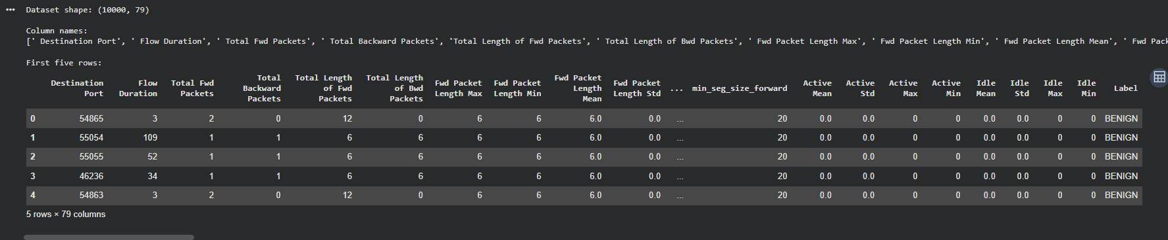

2. Data Cleaning and Preprocessing
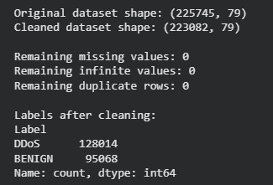

3. Random Forest Model Training and Evaluation
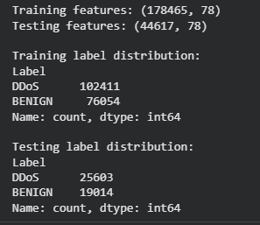
4. Confusion Matrix — Classification Performa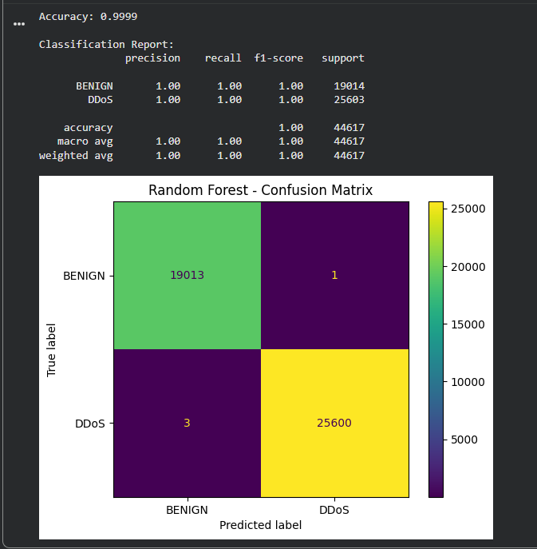nce
5. Feature Importance and Sample Prediction