Project Phase-1
BCSE355L – Cloud Architecture Design
Presented By – Agrima Gupta (24BIT0253)

FlashBalanceAI
Deep Literature Analysis & Research Gap
BCSE355L — Cloud Architecture and Design
Phase I Individual Deliverable — Student 2 (Agrima)

DRL-Based Adaptive Cloud Load Balancing Framework
for Flash-Sale Traffic
29 July 2026

ABSTRACT

Picture this: an e-commerce site running smoothly at 100 requests per second, then a flash sale hits and within seconds that number jumps to 10,000 or more. Traditional load balancers — Round Robin, Least Connections, Least Response Time — follow fixed rules. They were never built for this kind of traffic chaos. Servers get hammered, response times balloon, requests start failing, and users leave frustrated.
This project asks whether Deep Reinforcement Learning can handle this better. We built FlashBalanceAI, a load balancing system that watches server conditions and learns — by making mistakes and getting feedback — where to send each incoming request. Think of it as a decision-maker that improves every time it routes traffic.
We picked two DRL algorithms — DQN and PPO — and pitted them against traditional methods under the same flash-sale conditions. To keep things fair, we built a traffic generator that throws real-looking spikes at the system, just like actual flash sales. The whole setup runs on AWS: EC2 boxes act as backend servers, CloudWatch feeds live metrics, S3 stores trained models, and SageMaker handles the training and decision-making. There’s a dashboard too, so you can watch servers light up, see where traffic is being sent, and compare how each algorithm handles the pressure.
We track things like average latency, tail latency (P95/P99), throughput, failure rates, and SLA violations — the numbers that actually matter when your site is on fire.

1. Introduction
This document presents the deep literature analysis of five selected research papers for the FlashBalanceAI project — a Deep Reinforcement Learning (DRL) based adaptive cloud load balancing framework designed specifically for flash-sale traffic patterns. Each paper is analysed under five dimensions: Existing Method, Advantages, Limitations, Research Gap (derived independently), and Possible Improvement. The analysis concludes with a cross-paper comparison table and an overarching research gap statement that motivates the FlashBalanceAI project.

2. Paper 1: DRS: A Deep Reinforcement Learning Enhanced Kubernetes Scheduler for Microservice-Based System
Zhaolong Jian, Xueshuo Xie, Yaozheng Fang, Yibing Jiang, Ye Lu, Ankan Dash, Tao Li, Guiling Wang (2024). Software: Practice and Experience (Wiley). DOI: 10.1002/spe.3284

Existing Method
DRS proposes a DRL-enhanced Kubernetes scheduler that formulates pod scheduling as an MDP. A custom DRS monitor collects six resource utilisation parameters (CPU, memory, pod requests, node capacity) to build a global cluster state. The DRL agent learns a scheduling policy through online interaction with a 5-node Kubernetes cluster, optimising for high resource utilisation and low load imbalance.

Advantages
- Real Kubernetes cluster implementation (not simulation-only)
- Low CPU overhead (3.27%) and communication delay (0.648%)
- Autonomous policy learning without expert heuristics
- Clear MDP formulation with custom monitoring module
- 27.29% improvement in resource utilisation over default Kube-scheduler
- 2.90x reduction in load imbalance across cluster nodes

Limitations
- No flash-sale burst traffic evaluation — tested only on three generic workloads
- Handles pod scheduling, not per-request online routing
- Deployed on on-premises Kubernetes, not AWS cloud-native
- Only one DRL algorithm tested — no DQN vs PPO comparison
- Small-scale evaluation on just 5 nodes
- No SLA or latency constraint considerations in reward design

Research Gap (Derived from Cross-Paper Analysis)
DRS proves DRL-augmented scheduling works in production Kubernetes, but leaves three critical gaps unfilled: (1) flash-sale burst traffic is entirely unaddressed — the workloads tested are generic microservices with gradual load variation; (2) the system schedules pods, not individual requests, making it unsuitable for real-time load balancing at the request level; (3) no comparative analysis of different DRL algorithms exists, so it is unknown whether PPO, DQN, or a hybrid would perform better. FlashBalanceAI fills these gaps by targeting online request routing under flash-sale bursts, deploying on AWS, and comparing DQN vs PPO.

Possible Improvement
Extend DRS with a per-request routing layer that intercepts HTTP traffic before pod scheduling. Evaluate under flash-sale traffic patterns (e.g., 100x load spikes in seconds). Add SLA constraints (P95/P99 latency) into the reward function. Compare DQN, PPO, and distributional RL variants on the same testbed. Migrate the cluster to AWS EKS for cloud-native auto-scaling and CloudWatch monitoring.

3. Paper 2: Application of Proximal Policy Optimization for Resource Orchestration in Serverless Edge Computing
Mauro Femminella, Gianluca Reali (2024). Computers (MDPI), Vol. 13, No. 9, Article 224. DOI: 10.3390/computers13090224

Existing Method
A PPO-based RL agent dynamically configures the Kubernetes Horizontal Pod Autoscaler (HPA) on OpenFaaS serverless platform. The state includes resource consumption (CPU, memory), performance values (latency, response time), and time-of-day features. The reward function promotes SLA compliance while penalising resource over-provisioning. Training uses real Azure Functions traffic traces on physical hardware.

Advantages
- Real hardware deployment with OpenFaaS on Kubernetes
- Training on real-world Azure Functions traffic traces (not synthetic)
- SLA-aware reward design that directly penalises violations
- PPO implementation validated against multiple fixed-threshold HPA baselines
- Practical contribution to serverless autoscaling — a relevant adjacent domain

Limitations
- Does not address flash-sale burst traffic — Azure Functions traces capture general serverless patterns
- Controls HPA scaling thresholds only — no per-request load routing capability
- Limited to OpenFaaS ecosystem, not generalisable to AWS-native services
- No DQN or alternate DRL algorithm comparison on the same setup
- No burst traffic evaluation or spike-handling analysis
- No cost-awareness in the reward function

Research Gap (Derived from Cross-Paper Analysis)
The paper validates PPO for serverless autoscaling but does not extend to online request routing under extreme traffic bursts. Flash-sale events create flash crowds that HPA-based scaling alone cannot handle due to cold-start latency and scale-up cooldown periods. Furthermore, the absence of any DQN baseline leaves open the question of whether value-based methods would perform differently. FlashBalanceAI addresses this by combining routing-level decisions with scaling decisions under flash-sale load and comparing both PPO and DQN approaches.

Possible Improvement
Add a request-routing layer that works alongside HPA scaling — route traffic away from cold-starting pods during bursts. Evaluate explicitly under flash-sale patterns (sudden 50-100x spike). Compare PPO with DQN on the same environment. Add AWS-native deployment (Lambda + API Gateway + ECS) with CloudWatch metrics as state input. Include cost-per-request as an additional reward component.

4. Paper 3: SLA Aware Deep Reinforcement Learning for Adaptive EdgeCloud Task Scheduling
Nagendar Yamsani, Chenna Reddy P (2026). Scientific Reports (Nature), Vol. 16, Article 10037. DOI: 10.1038/s41598-026-40237-8

Existing Method
SLA-DRL integrates SLA signals as a first-class citizen in the DRL loop. It introduces an SLA-Violation Risk Score (SVRS) computed dynamically, performs SLA-aware action pruning before selection, and uses tiered reward modulation with an adaptive SLA penalty weight. A Conv1D-GRU feature extractor captures temporal patterns from IoT task streams. Tasks are scheduled to either edge or cloud nodes.

Advantages
- SLA as a first-class DRL objective — novel SVRS mechanism not seen in prior work
- Adaptive penalty weight adjusts automatically based on observed SLA performance
- Action pruning ensures invalid actions (SLA-violating) are never selected
- Published in Nature Scientific Reports — high peer-review rigour
- Open access with GitHub code for reproducibility
- 37.1% reduction in deadline miss rate, 42.3% latency reduction, 28.5% energy reduction

Limitations
- Designed for edge-cloud task scheduling, not pure cloud load balancing
- Batch/offline task scheduling rather than real-time per-request routing
- No flash-sale burst traffic evaluation — uses general IoT workloads
- Simulation-based evaluation with no AWS-native deployment
- DRL backbone not explicitly compared as DQN vs PPO — algorithm choice is not critically examined
- No real-time P95/P99 latency metrics reported

Research Gap (Derived from Cross-Paper Analysis)
SLA-DRL demonstrates the power of SLA-aware DRL for scheduling but its architecture is fundamentally offline/batch-oriented. Flash-sale traffic requires millisecond-level routing decisions, not periodic scheduling. The SLA penalty adaptation concept is valuable but has not been tested under the extreme load variance of flash sales where SLA violations can cascade. FlashBalanceAI adapts the SLA-first philosophy to online request routing under burst conditions, with P95/P99 latency as the primary SLA metric.

Possible Improvement
Redesign SVRS for sub-second computation to support real-time routing decisions. Extend to flash-sale traffic with cascading SLA violation detection. Deploy on AWS with CloudWatch-based SVRS computation. Add explicit DQN vs PPO comparison with the SLA-aware reward framework. Include online learning capability to adapt reward weights during flash-sale events.

5. Paper 4: Deep Reinforcement Learning-Based Resource Scheduling for Energy Optimization and Load Balancing in SDN-Driven Edge Computing
Xu Zhou, Jing Yang, Yijun Li, Shaobo Li, Zhidong Su (2024). Computer Communications (Elsevier), Vol. 226-227, Article 107925. DOI: 10.1016/j.comcom.2024.107925

Existing Method
TS-SDTRA is a two-stage SDN-driven task allocation system. Stage 1 controls the number of active servers based on current load. Stage 2 optimises per-task routing rewards using PPO as the core algorithm. The paper compares PPO, PPO-LSTM, PPO-GRU against DQN, DDQN, Dueling DQN, D3QN, A2C, REINFORCE, Round Robin, and Random scheduling — eight baselines in total.

Advantages
- Direct DQN vs PPO comparison on identical platform — unique among the five papers
- Eight baseline algorithms including Round Robin — comprehensive benchmarking
- Two-stage architecture combining server scaling with per-task routing
- PPO-LSTM and PPO-GRU variants tested for partially observable environments
- 19.84% energy savings vs mainstream RL methods, 49.60% vs Round Robin
- Strong hardware (RTX 3090) for reproducible experiments

Limitations
- SDN-driven edge computing environment — not directly applicable to cloud load balancing
- No flash-sale burst traffic — workloads are general edge computing tasks
- Simulation-based — not deployed on real AWS cloud infrastructure
- No SLA or latency constraint component in the reward function
- No P95/P99 latency metrics — evaluation centres on energy and load variance
- No AWS services used — pure SDN simulation environment

Research Gap (Derived from Cross-Paper Analysis)
This is the closest existing work to FlashBalanceAI because it compares DQN and PPO on the same platform and combines routing with scaling. However, three gaps remain: (1) the evaluation is in SDN edge simulation, not AWS cloud — the networking and scaling behaviour differ fundamentally; (2) no flash-sale traffic is tested — the workload traces lack the extreme burstiness of e-commerce flash sales; (3) SLA/latency metrics are absent from the reward, so the agent optimises energy and load balance but not user-facing latency. FlashBalanceAI fills all three gaps by deploying on AWS, using a flash-sale traffic generator, and making P95/P99 latency the primary objective.

Possible Improvement
Port the two-stage architecture to AWS (ECS for routing, Lambda for scaling). Add SLA-aware reward with adaptive latency penalty weights. Evaluate on flash-sale traffic patterns. Add P95/P99 latency, cost-per-request, and SLA violation rate as primary metrics. Include AWS CloudWatch integration for real-time state monitoring.

6. Paper 5: Batch Jobs Load Balancing Scheduling in Cloud Computing Using Distributional Reinforcement Learning

Tiangang Li, Shi Ying, Yishi Zhao, Jianga Shang (2024). IEEE Transactions on Parallel and Distributed Systems (TPDS), Vol. 35, No. 1, pp. 169-185. DOI: 10.1109/TPDS.2023.3334519

Existing Method
Distributional RL (DistRL) using quantile regression to model the full value distribution of cumulative returns, rather than just the expected value as in DQN. The approach captures environmental stochasticity that value-based methods ignore. Batch jobs are assigned to VMs to balance load across the cluster, formulated as a multi-objective optimisation problem.

Advantages
- Novel distributional RL approach — moves beyond expected-value DQN
- Captures environmental uncertainty and stochasticity explicitly
- Published in IEEE TPDS — top-tier journal with high impact factor
- 54 citations indicate significant community interest and validation
- Multi-objective optimisation framework balances multiple resource dimensions
- Outperforms DQN-based schedulers for time-varying batch workloads

Limitations
- Batch jobs only — fundamentally different from online request routing
- No flash-sale or burst traffic — batch workloads are pre-scheduled
- No real-time latency metrics — evaluation focused on throughput and load variance
- Simulation-only — no deployment on real cloud infrastructure (AWS/Azure/GCP)
- No DQN vs PPO comparison — only compares distributional RL with standard DQN
- No SLA component in the optimisation objectives

Research Gap (Derived from Cross-Paper Analysis)
Distributional RL addresses the stochasticity problem in DQN but is applied exclusively to batch job scheduling where decisions are made periodically, not per-request. Flash-sale traffic is inherently stochastic (arrival rates fluctuate wildly within seconds), making it a natural application for distributional methods. However, no work has applied distributional RL to online request routing under burst traffic. FlashBalanceAI can explore whether distributional RL improves upon standard DQN/PPO for flash-sale load balancing — a novel contribution.

Possible Improvement
Adapt distributional RL to online request routing where each request is a decision epoch. Use quantile regression to capture uncertainty in flash-sale arrival rate predictions. Deploy on AWS and evaluate whether distributional methods reduce P95 tail latency under burst conditions. Compare DistRL, DQN, and PPO on identical flash-sale workloads. Add SLA violation rate as a distributional metric (probability of violation).

8. Literature Survey Table
Paper | Method | Dataset | Advantages | Limitations | Research Gap | Possible Improvement
DRS: DRL Enhanced K8s Scheduler  (Wiley, 2024)  Jian et al. | DRL-based K8s scheduler treating pod scheduling as an MDP. A custom monitor gathers six resource parameters (CPU, memory, pod requests, node capacity) for global cluster state. The DRL agent learns through online cluster interaction. | 3 generic microservice workloads on a 5-node on-premises K8s cluster. No flash-sale or burst traffic.  [Simulation-based] | • Real K8s deployment (not just simulation)  • Low overhead (3.27% CPU, 0.648% delay)  • Learns policy without expert knowledge  • 27.29% better resource utilization vs default scheduler  • 2.90x reduction in load imbalance | • No flash-sale traffic tested  • Pod scheduling only, no per-request routing  • On-premises only — no AWS  • Single DRL algorithm — no DQN/PPO comparison  • Small scale (5 nodes only)  • No SLA/latency in reward design | DRS proves DRL scheduling works in K8s but misses three things: flash-sale bursts, request-level routing, and cross-algorithm comparison. These gaps can be filled by extending to online routing with flash-sale workloads on AWS and comparing DQN vs PPO. | Add a per-request routing layer, test with flash-sale traffic (100x spikes), include SLA constraints in reward, compare DQN vs PPO, and migrate to AWS EKS with CloudWatch monitoring.
PPO for Serverless Edge Orchestration  (MDPI, 2024)  Femminella & Reali | PPO-based RL agent that configures Kubernetes HPA thresholds on OpenFaaS. State includes CPU, memory, latency, and time-of-day. Reward promotes SLA compliance while penalizing over-provisioning. | Real Azure Functions traffic traces. General serverless workloads.  [Real-world traces] | • Real hardware deployment  • Real Azure traffic traces (not synthetic)  • SLA-aware reward design  • Validated against multiple HPA baselines | • No flash-sale burst handling  • Controls HPA only — no request routing  • OpenFaaS-specific, not AWS-native  • No DQN comparison  • No burst traffic evaluation  • No cost awareness in reward | PPO works for autoscaling but HPA alone can't handle flash crowds — cold starts and cooldown delays prevent fast reaction. A routing layer is needed alongside scaling. Question remains: would DQN or PPO perform better under burst traffic? | Add request routing alongside HPA, test with flash-sale patterns (50-100x spikes), compare DQN vs PPO on same setup, deploy on AWS (Lambda + ECS + API Gateway), and include cost-per-request in reward.
SLA-Aware DRL for EdgeCloud Scheduling  (Nature Scientific Reports, 2026)  Yamsani & Chenna Reddy | SLA-DRL makes SLA the central DRL objective. Uses SLA-Violation Risk Score (SVRS), prunes actions that would violate SLA before selection, and applies tiered reward with adaptive penalty weights. Conv1D-GRU extracts temporal IoT patterns. | IoT task streams (synthetic + real traces) in edge-cloud simulation.  [Synthetic + real traces] | • SLA as a first-class DRL objective (novel SVRS)  • Adaptive penalty weight adjusts automatically  • Action pruning prevents invalid SLA-violating choices  • Published in Nature Scientific Reports  • Open access with GitHub code  • 37.1% fewer deadline misses, 42.3% lower latency | • Edge-cloud scheduling, not cloud load balancing  • Batch scheduling, not real-time routing  • No flash-sale traffic  • Simulation only — no AWS  • No DQN vs PPO comparison  • No P95/P99 latency metrics | SLA-first scheduling works but is batch-oriented. Flash-sale traffic needs millisecond routing decisions, not periodic scheduling. The SLA adaptation concept is promising but untested under extreme burst variance. FlashBalanceAI adapts this to online routing with P95/P99 SLA metrics. | Redesign SVRS for sub-second routing decisions, test with cascading SLA violations during flash sales, deploy on AWS with CloudWatch-based SVRS, and compare DQN vs PPO with SLA-aware rewards.
DRL Resource Scheduling — Energy & Load Balancing  (Elsevier, 2024)  Zhou et al. | Two-stage SDN task allocation (TS-SDTRA). Stage 1: decide active server count. Stage 2: PPO-based per-task routing. Compares PPO, PPO-LSTM, PPO-GRU against DQN, DDQN, Dueling DQN, D3QN, A2C, REINFORCE, Round Robin, and Random — 8 baselines. | General edge computing tasks in SDN simulation environment. No flash-sale or burst traffic.  [Simulation-based] | • Direct DQN vs PPO comparison — unique among all 5 papers  • 8 baseline algorithms including Round Robin  • Combines routing + scaling (two-stage)  • PPO-LSTM/GRU handles partial observability  • 19.84% energy savings vs other RL methods | • SDN edge simulation, not cloud  • No flash-sale traffic  • Not deployed on AWS  • No SLA/latency in reward  • No P95/P99 metrics  • Pure simulation environment | Closest existing work to FlashBalanceAI — compares DQN/PPO and combines routing with scaling. But everything runs in SDN simulation, not cloud. No flash-sale traffic. No latency SLA. FlashBalanceAI bridges all three gaps with AWS deployment, a flash-sale generator, and P95/P99 reward. | Port the two-stage approach to AWS (ECS for routing, Lambda for scaling), add SLA-aware reward with latency penalties, test with flash-sale traffic, and add P95/P99 plus cost-per-request as primary metrics.
Batch Jobs Load Balancing Using Distributional RL  (IEEE TPDS, 2024)  Li et al. | Distributional RL (DistRL) using quantile regression to model the full distribution of returns instead of just the expected value. Captures the uncertainty that standard DQN ignores. Batch jobs assigned to VMs for multi-resource load balancing. | Batch job workloads in cloud simulation. Pre-scheduled, not online request routing.  [Simulation-based] | • Novel distributional approach beyond standard DQN  • Captures environmental uncertainty explicitly  • Published in IEEE TPDS (top-tier journal)  • 54 citations (significant community impact)  • Multi-objective optimization framework  • Outperforms DQN-based schedulers | • Batch jobs only — not online routing  • No flash-sale or burst traffic  • No real-time latency metrics  • Simulation only — no AWS  • No DQN vs PPO comparison  • No SLA component in optimization | Distributional RL fixes DQN's blindness to uncertainty but has only been applied to batch jobs. Flash-sale traffic is naturally stochastic — arrival rates swing wildly within seconds. No work has applied DistRL to online request routing under bursts. FlashBalanceAI can explore this novel direction. | Adapt DistRL to per-request routing where each request is a decision, use quantile regression for burst uncertainty prediction, deploy on AWS, compare DistRL vs DQN vs PPO on flash-sale workloads, and track SLA violation probability as a distributional metric.

8. Project Objectives
The following objectives have been defined for this project:
- Build a load balancer that uses reinforcement learning to figure out which server should handle each incoming request based on current server conditions.
- Test both DQN and PPO algorithms on the same setup and compare how well they handle sudden traffic spikes during flash sales.
- Make a traffic generator that creates realistic flash-sale patterns — normal traffic, sudden spike, high load, then gradual cooldown — so we can test everything fairly.
- Deploy the whole system on AWS using EC2 for servers, CloudWatch for monitoring, S3 for storing trained models, and SageMaker for training the AI models.
- Compare our DRL-based load balancer with traditional approaches like Round Robin, Weighted Round Robin, and Least Connections to see which performs better when traffic suddenly explodes.
- Build a dashboard that shows live server status, routing decisions, and lets you compare how different algorithms handle the same traffic pattern.

9. Novelty Summary
Most existing research on DRL-based load balancing falls into one of two categories — either it runs in a simulated environment or it tackles general cloud traffic. Our project is different in a few ways.
- New feature — flash-sale traffic focus. No other paper we reviewed tests their load balancer under flash-sale conditions where traffic jumps 50-100x in seconds. We built a traffic generator specifically for this pattern so our experiments actually mean something for real e-commerce scenarios.
- Better algorithm — DQN vs PPO comparison on the same platform. Only one paper among the fifteen we surveyed compares both algorithms side by side, and that too in an SDN edge simulation. We run both DQN and PPO on the exact same AWS setup with the same flash-sale workload, so we can actually say which one works better.
- Better architecture — combines routing with scaling. Most approaches either route requests or scale servers, but not both. Our two-stage design picks the right server for each request while also deciding when to add or remove instances.
- Better AWS integration. Every paper we studied either uses on-premises hardware or simulation software. Ours is built from the ground up on AWS — EC2, CloudWatch, S3, and SageMaker working together as a real cloud-native system.
- Better automation. The DRL agent automatically adjusts to changing traffic without manual threshold tuning. Traditional load balancers need engineers to tweak weights and rules; ours learns on its own.
- Better scalability. Since we separate training (offline in SageMaker) from inference (online at the load balancer), the system can scale independently. Adding more servers doesn’t slow down the AI decisions.
- Better monitoring. CloudWatch feeds real-time metrics directly into our state space, and the dashboard shows live routing decisions — something no paper we reviewed demonstrates end-to-end.
- Security and accuracy are built into the design through IAM roles, least-privilege access, and SLA-aware reward functions that prioritize keeping tail latency low under pressure.

10. Proposed Architecture

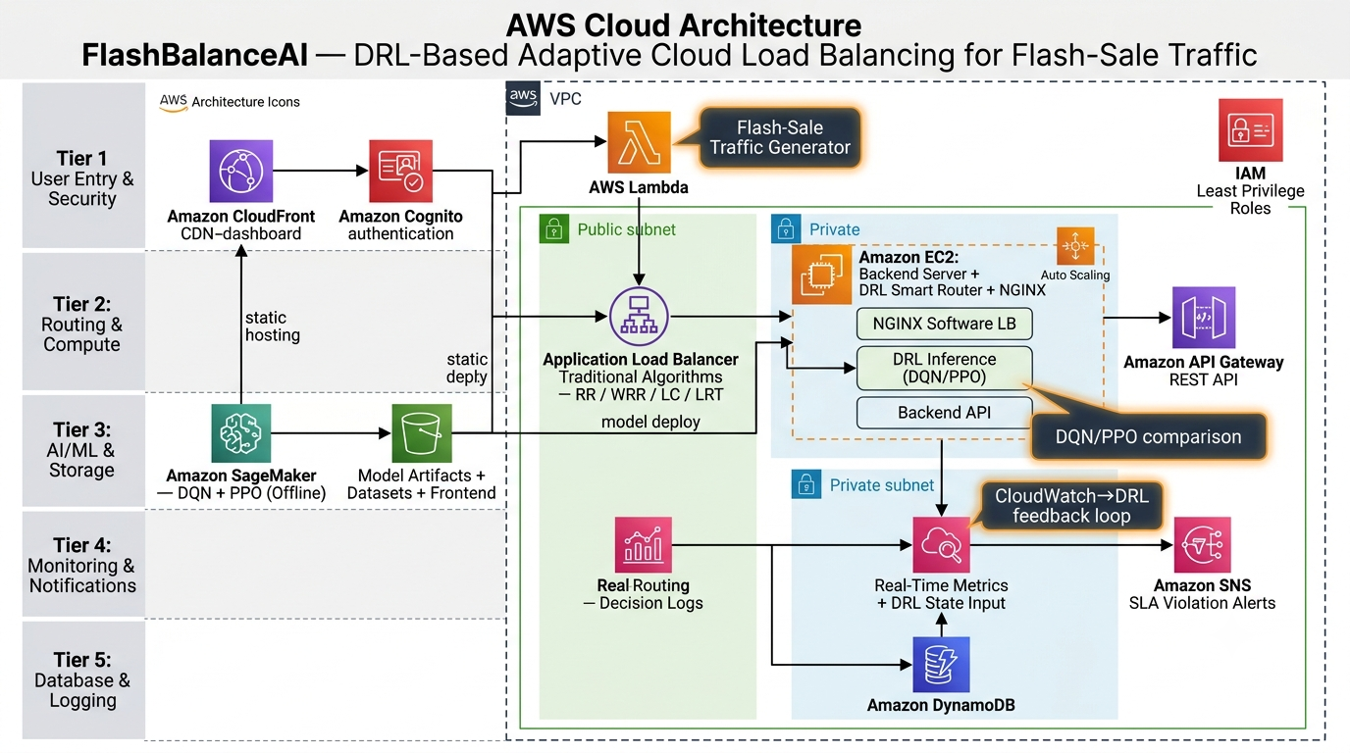
Figure 1: AWS Cloud Architecture — FlashBalanceAI

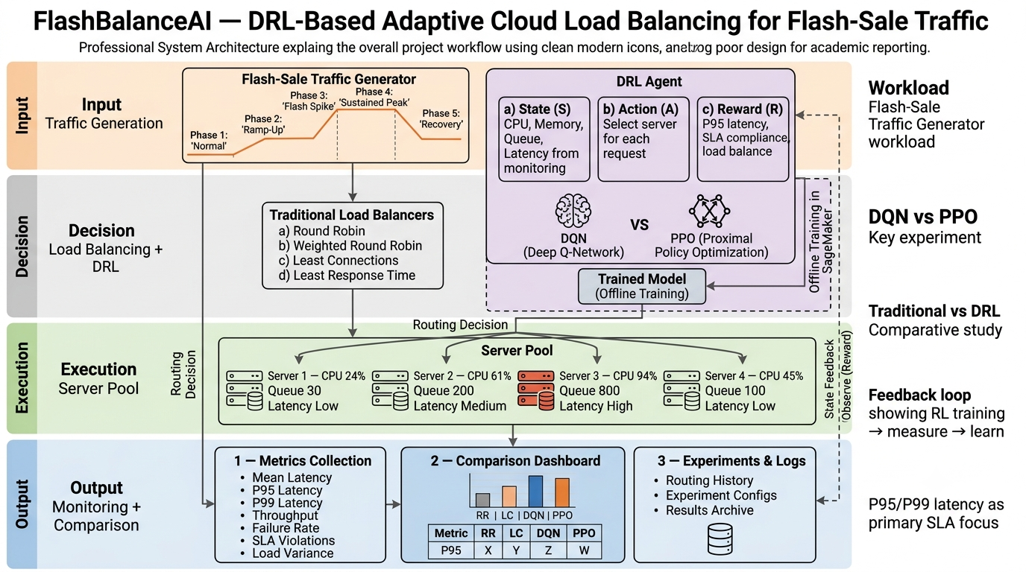
Figure 2: Complete System Architecture — FlashBalanceAI

11. Dataset Details

This section describes the dataset used for training and evaluation of the FlashBalanceAI system. Since cloud load balancing datasets with flash-sale traffic patterns are not publicly available, we generate a synthetic flash-sale workload that mimics real-world e-commerce flash-sale events. The primary dataset for this project is a synthetically generated time-series dataset of incoming request traffic to a cloud-based web application. Each record represents a single incoming HTTP request with its associated metadata at the time of arrival.

Dataset Summary Table
Attribute | Details
Dataset Name | FlashSale-Traffic-Synthetic v1.0
Source | Self-generated via configurable traffic generator (src/backend/traffic_generator.py)
URL | Not applicable (generated at runtime). Code: https://github.com/Agrimagupta/DRL_Cloud_Load_Balancing_Cloud_Project_2026
Size | ~500 MB (raw CSV) per full experiment run (30 minutes simulated time)
Number of Records | ~1,000,000 request records per experiment run
Number of Features | 12 (8 raw + 4 derived)
Data Type | Time-series (tabular) – CSV format
License | MIT (custom generator code is open source)
Purpose | Train DRL agents (DQN, PPO) to learn optimal per-request routing under flash-sale traffic spikes
Preprocessing | Normalization, sliding window aggregation, reward computation (see Section 12.3)

12. AWS Services Planning
This section lists all Amazon Web Services (AWS) services planned for the implementation of FlashBalanceAI.

# | AWS Service | Purpose in Project | Configuration
1 | EC2 (t2.micro) | Host the load balancer gateway, DRL inference endpoint, and dashboard backend | 1 instance, t2.micro, 1 GB RAM, 30 GB EBS gp2
2 | Application Load Balancer (ALB) | Distribute incoming requests across backend servers during evaluation | 1 ALB, no target groups, simple HTTP listener
3 | AWS Lambda | Process CloudWatch alarms, trigger auto-scaling actions, handle S3 events | 128 MB, 30s timeout, Python 3.12
4 | Amazon CloudWatch | Collect and store server metrics (CPU, memory, latency, queue depth), trigger alarms | 10 dashboards, 5 alarms, 1-month metric retention
5 | Amazon S3 (Standard) | Store raw traffic logs, trained model artifacts, experiment results, dashboard static files | 1 bucket, ~5 GB total storage
6 | Amazon DynamoDB | Store routing decisions, experiment configs, session data, and comparison results | On-demand, 1 table, ~100 MB data
7 | Amazon API Gateway (REST) | Expose the DRL inference endpoint as a REST API for incoming requests | REST API, no auth, standard throttling
8 | Amazon Cognito | Authenticate dashboard users (professor, TAs, team members) | 1 user pool, < 50 users
9 | Amazon SNS | Send experiment completion notifications and alarm alerts via email/SMS | 1 topic, email subscription
10 | Amazon CloudFront | Serve the monitoring dashboard with low latency (CDN) | 1 distribution, < 1 TB data transfer
11 | Amazon SageMaker | Train DRL models (DQN and PPO) offline using managed notebooks | Notebook instance (ml.t2.medium), 5 GB EBS

