

RESEARCH PROPOSAL
Design and Implementation of a Low-Cost
Multichannel Surface Electromyography Control Interface
for Upper-Limb Prosthetic Rehabilitation

Student | Ian Kiarie Kabura
Registration Number | ENE212-0069/2022
School | School of Electrical, Electronics and Information Engineering
Department | Electrical and Electronic Engineering
Course | B.Sc. Electronics and Computer Engineering
Supervisor | Dr Irene Muisyo
Date | 24th September 2026

Executive Summary
This proposal presents the design and implementation of a low-cost, four-channel surface electromyography (sEMG) control interface for upper-limb prosthetic rehabilitation. The proposed system captures residual-limb muscle activity through surface electrodes, conditions the signals using a dedicated analog front-end, samples four channels at 2 kHz on an ESP32-S3, extracts time-domain features, and performs on-device gesture classification using a compact 1D convolutional neural network (1D-CNN). The classified gestures are translated into commands for a 2-DOF 3D-printed prosthetic gripper, while a Bluetooth Low Energy (BLE) mobile application provides guided calibration, live monitoring and performance feedback.
Core engineering target
Demonstrate an end-to-end, untethered 4-channel sEMG control pipeline with a hardware BOM below USD 20, real-time gesture classification above 80% accuracy across five test subjects, and end-to-end inference latency below 50 ms.

Acquisition | Embedded intelligence | Actuation | User interface
4 channels • 2 kHz/channel | 1D-CNN • INT8 • <100 KB | PCA9685 • 2 servo motors | BLE • calibration • monitoring

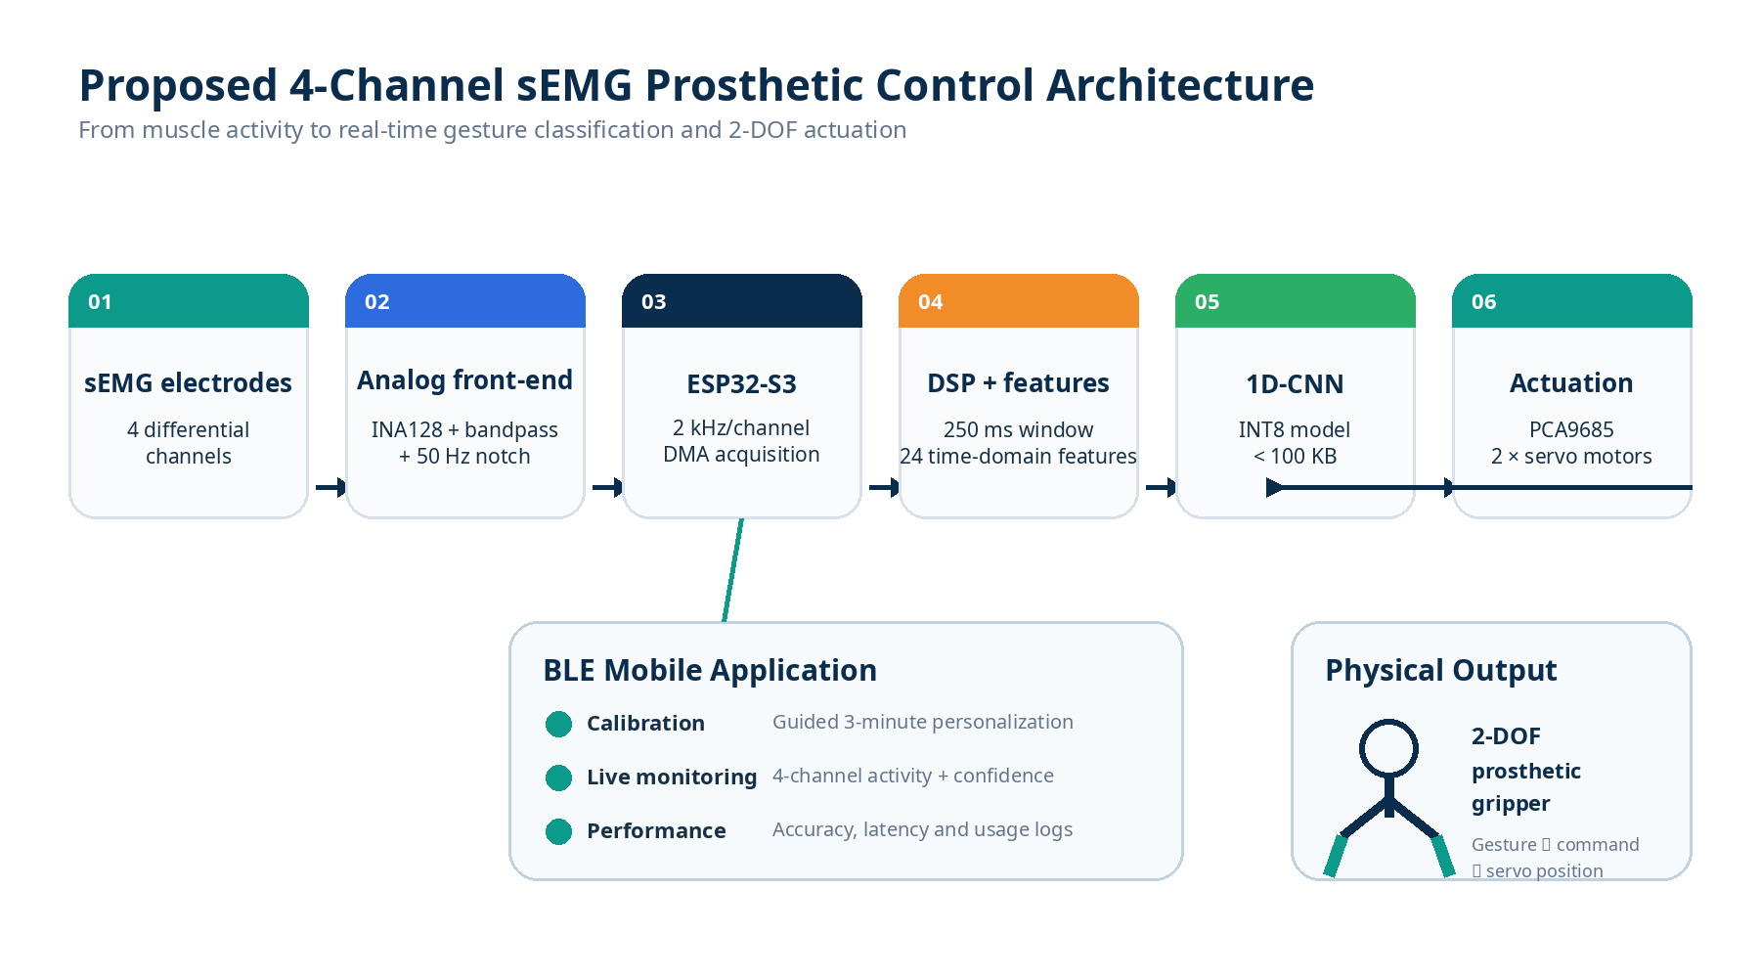
Figure 1. Integrated system architecture: the acquisition, processing, classification, actuation and BLE application layers are treated as independently testable modules.

1. Background
Surface electromyography (sEMG) is a non-invasive technique for observing electrical activity associated with voluntary skeletal-muscle contraction. Motor-unit action potentials produce small voltage variations at the skin surface; after amplification and filtering, these signals can be analysed to infer intended movement. Typical sEMG energy is concentrated approximately within the 20–500 Hz range, while practical measurements are affected by motion artefacts, electrode–skin impedance, mains interference and electronic noise.
For myoelectric prosthetic control, electrodes positioned over residual-limb musculature provide the input to a signal-conditioning and classification pipeline. The system amplifies the differential signal, suppresses unwanted frequency components, samples the conditioned waveform, computes discriminative features and maps the resulting feature vector to a gesture. The gesture can then be translated into actuator commands for a prosthetic mechanism.
Commercial myoelectric systems can provide high recognition performance but may involve substantial acquisition and control hardware costs. The proposal therefore investigates whether modern low-cost embedded hardware—particularly the ESP32-S3, compact instrumentation amplifiers, commodity passive components and TinyML deployment—can support a complete multichannel control interface at a substantially lower component cost.

1.1 Motivation
- Reduce the electronics cost barrier associated with myoelectric control research and rehabilitation prototypes.
- Move signal processing and inference onto the embedded device so that the system can operate without a continuous PC connection.
- Use four channels as a practical balance between spatial information, electrode count, hardware complexity and computational load.
- Provide a repeatable calibration workflow so that the system can adapt to user-specific sEMG characteristics.
- Demonstrate the complete chain from physiological signal acquisition to mechanical actuation rather than evaluating classification in isolation.

2. Problem Statement
Access to upper-limb prosthetic and assistive technologies is constrained by cost, availability and the complexity of fitting and controlling devices. The proposed work focuses specifically on the electronic control interface: the sensing, signal conditioning, embedded processing, gesture classification and actuator-control layers that sit between muscle activity and mechanical movement.
Within the reviewed literature, low-cost prototypes often demonstrate only part of the complete pipeline—for example, single-channel classification, offline machine-learning evaluation or mechanical integration without compact on-device inference. This creates an engineering opportunity for a system that combines four-channel acquisition, embedded machine learning, BLE-assisted personalization and physical actuation in one reproducible platform.
Research question
Can a complete four-channel myoelectric control system—from skin electrode to mechanical grip—be designed, built and validated for a component cost below USD 20 using commercially available components and open-source tools?

3. Objectives

3.1 Main Objective
To design, implement and validate a low-cost four-channel surface electromyography acquisition and gesture-classification system based on an ESP32-S3 microcontroller, targeting real-time recognition of eight hand gestures with greater than 80% accuracy and latency below 50 ms, and to demonstrate the classified output through a 2-DOF prosthetic gripper.

3.2 Specific Objectives
- Design and fabricate a four-channel analog front-end using INA128 instrumentation amplifiers, Sallen-Key band-pass filtering (20–500 Hz) and a 50 Hz twin-T notch stage, targeting an sEMG signal-to-noise ratio above 20 dB and inter-channel crosstalk below −40 dB.
- Implement a real-time digital signal-processing pipeline on the ESP32-S3 at 2 kHz per channel, extracting 24 time-domain features—six per channel—within a 250 ms analysis window.
- Train an eight-class 1D-CNN using the NinaPro DB5 dataset, quantize the model to INT8 with a target size below 100 KB, and deploy it on the ESP32-S3 using TensorFlow Lite for Microcontrollers.
- Implement a BLE-based calibration protocol that guides a new user through an approximately three-minute personalized calibration session and evaluates whether personalization improves cross-user recognition.
- Integrate the gesture output with a PCA9685-driven 2-DOF 3D-printed prosthetic gripper using two servo motors, and validate the end-to-end system with five test subjects.

4. Related Studies and Research Gap
Recent work demonstrates that embedded processors can support sEMG gesture recognition, while deep-learning approaches can achieve strong classification performance when computational resources are available. Personalization is also important because sEMG signals vary substantially across users and electrode placements. The proposed project brings these strands together into a resource-constrained, experimentally testable platform.

4.1 Evidence from the Reviewed Literature
Study | Channels | On-device ML | Prosthetic integration | Reported cost | Relevance
Salgado et al. [1] | 1 | Yes | No | Not reported | Embedded sEMG proof of concept
Mekruksavanich et al. [2] | 16 | No, GPU | No | N/A | Deep-learning accuracy
Lee et al. [3] | Multiple | Edge-capable | No | N/A | Personalisation
Molinari et al. [4] | 64 | FPGA | Yes | > $500 | High-density wearable platform
Furtado et al. [5] | sEMG | Partial | Yes | Low-cost | Mechanical integration
Proposed project | 4 | Yes, ESP32-S3 | Yes | < $20 | Combined low-cost architecture
Table 1. Comparison of the reviewed systems and the proposed project. Costs are reported as described in the supplied literature review; the proposed cost is a project target.

4.2 Research Gap
The reviewed studies address important components of the problem, but the proposal is designed around their intersection: four-channel acquisition, embedded classification, user personalization, prosthetic actuation and a very low electronics BOM. The contribution is therefore not a claim of a new physiological sensing principle; it is an integrated engineering implementation and validation of a low-cost end-to-end control interface.
Proposed contribution
A modular, reproducible platform in which the analog front-end, embedded DSP, TinyML classifier, BLE calibration workflow and 2-DOF actuator interface can each be tested independently and then validated as a complete system.

5. Proposed System Design

5.1 Signal Specification
Parameter | Proposed specification
Signal type | Surface EMG, differential measurement
Channels | 4 forearm channels: flexor carpi radialis, extensor digitorum, flexor digitorum superficialis and brachioradialis
Raw amplitude | Approximately 50 µV to 5 mV
Frequency band | 20–500 Hz with 50 Hz notch rejection
Sampling rate | 2 kHz per channel
Analysis window | 250 ms (500 samples), 50 ms step, 80% overlap
Features/channel | MAV, RMS, WL, ZC, SSC and variance
Feature vector | 24 elements (6 features × 4 channels)
Table 2. Proposed sEMG acquisition and feature-extraction specification.

5.2 Eight Target Gesture Classes
Class | Gesture | Functional relevance
0 | Rest | Baseline; no actuation
1 | Open hand | Release objects
2 | Power grasp | Grip objects
3 | Pinch grip | Fine manipulation
4 | Point | Directional control
5 | Wrist flexion | Repositioning
6 | Wrist extension | Repositioning
7 | Thumbs up | Social gesture or mode selection

5.3 Hardware Architecture
The hardware is divided into an analog acquisition section and a digital control section. Four differential electrode pairs feed INA128 instrumentation amplifiers. Each channel then passes through a 20–500 Hz Sallen-Key band-pass stage, a 50 Hz twin-T notch filter and an adjustable gain stage. The conditioned channels are sampled by the ESP32-S3. The embedded processor performs windowing and feature extraction before invoking the gesture classifier.
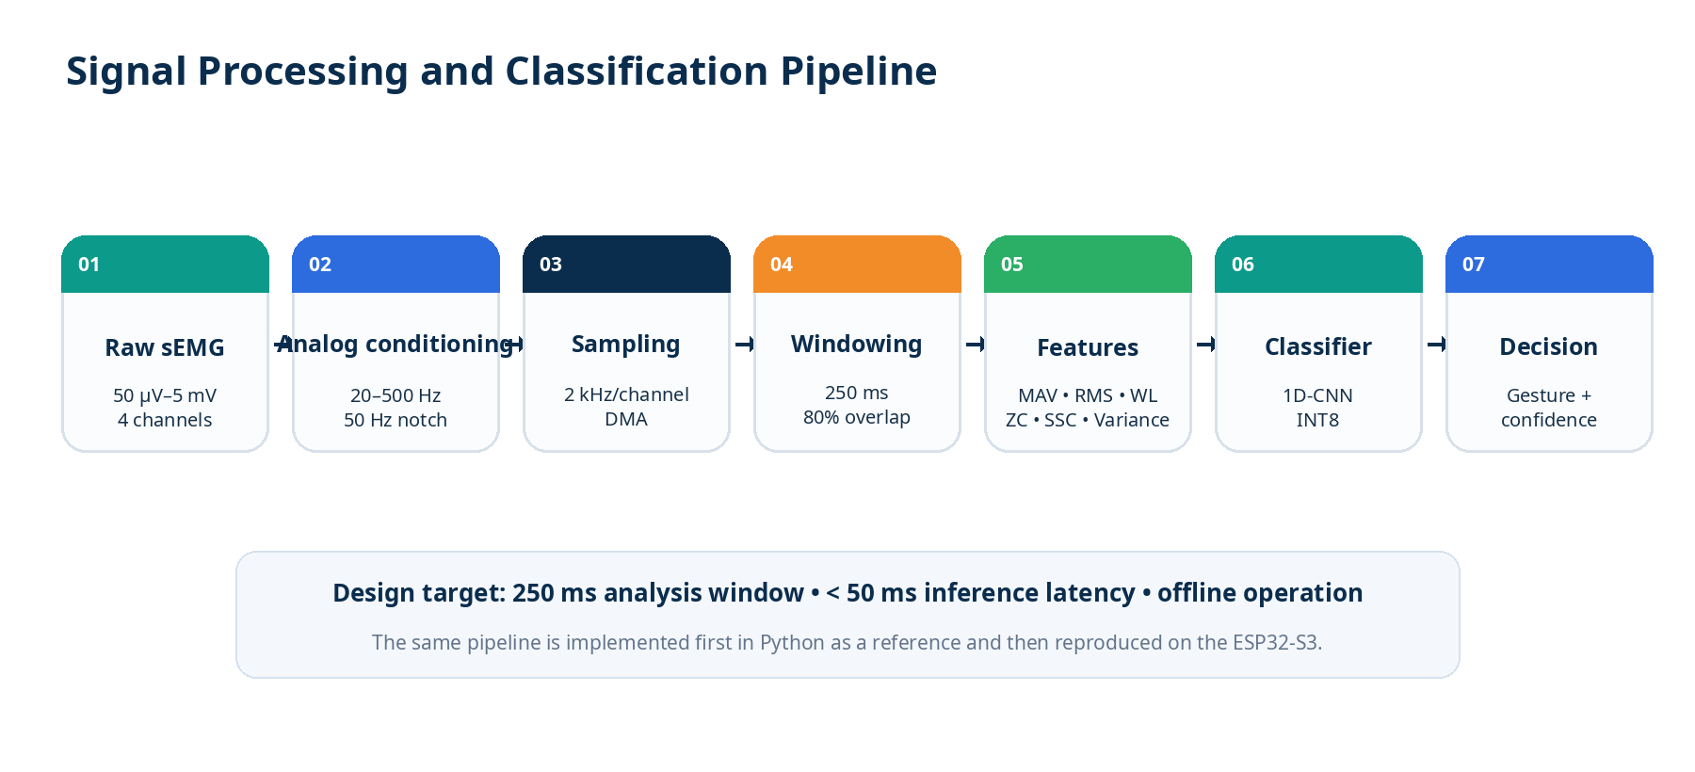
Figure 2. Signal-processing pipeline and timing targets.
Figure 3. Full system architecture, including the BLE application and physical gripper output.

5.4 Embedded Machine Learning
The machine-learning component will begin with conventional baselines—linear discriminant analysis (LDA), support vector machine (SVM) and random forest (RF)—to establish a performance reference. The target model is a compact one-dimensional convolutional neural network operating on the extracted feature sequence. After training, the model will be quantized to INT8 and benchmarked for model size, memory use and inference time before deployment through TensorFlow Lite for Microcontrollers.

5.5 Actuation and Safety Logic
Gesture predictions will not be sent directly to the motors without decision filtering. A confidence threshold, temporal debounce and command hold time will be used to reduce unintended transitions caused by transient classification errors. The PCA9685 provides a dedicated PWM interface to the two servo motors used by the 2-DOF gripper.

5.6 BLE Mobile Application
The mobile application is designed as a practical interface for setup and monitoring rather than as part of the core classification loop. It communicates with the ESP32-S3 over BLE and provides device connection status, guided calibration, live channel activity, predicted gesture and confidence, and basic performance history.
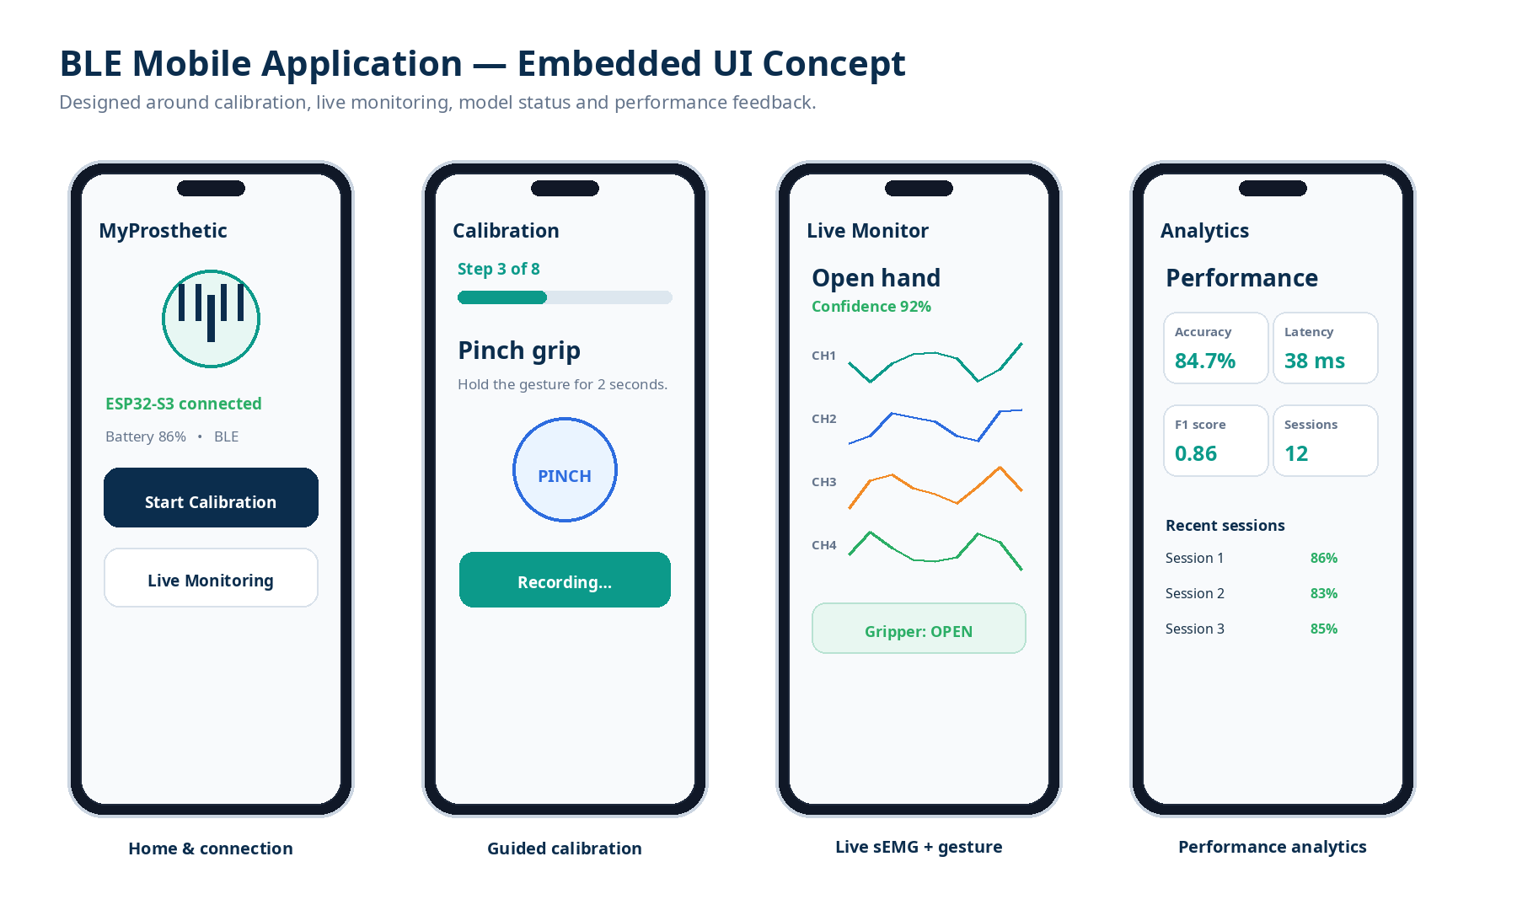
Figure 4. Embedded mobile-application mockups: connection/home, guided calibration, live monitoring and performance analytics.

6. Methodology
The project follows an iterative engineering methodology. Each phase produces a measurable artefact and a validation checkpoint before the next level of integration. This reduces the risk of debugging the complete system as a single opaque unit.
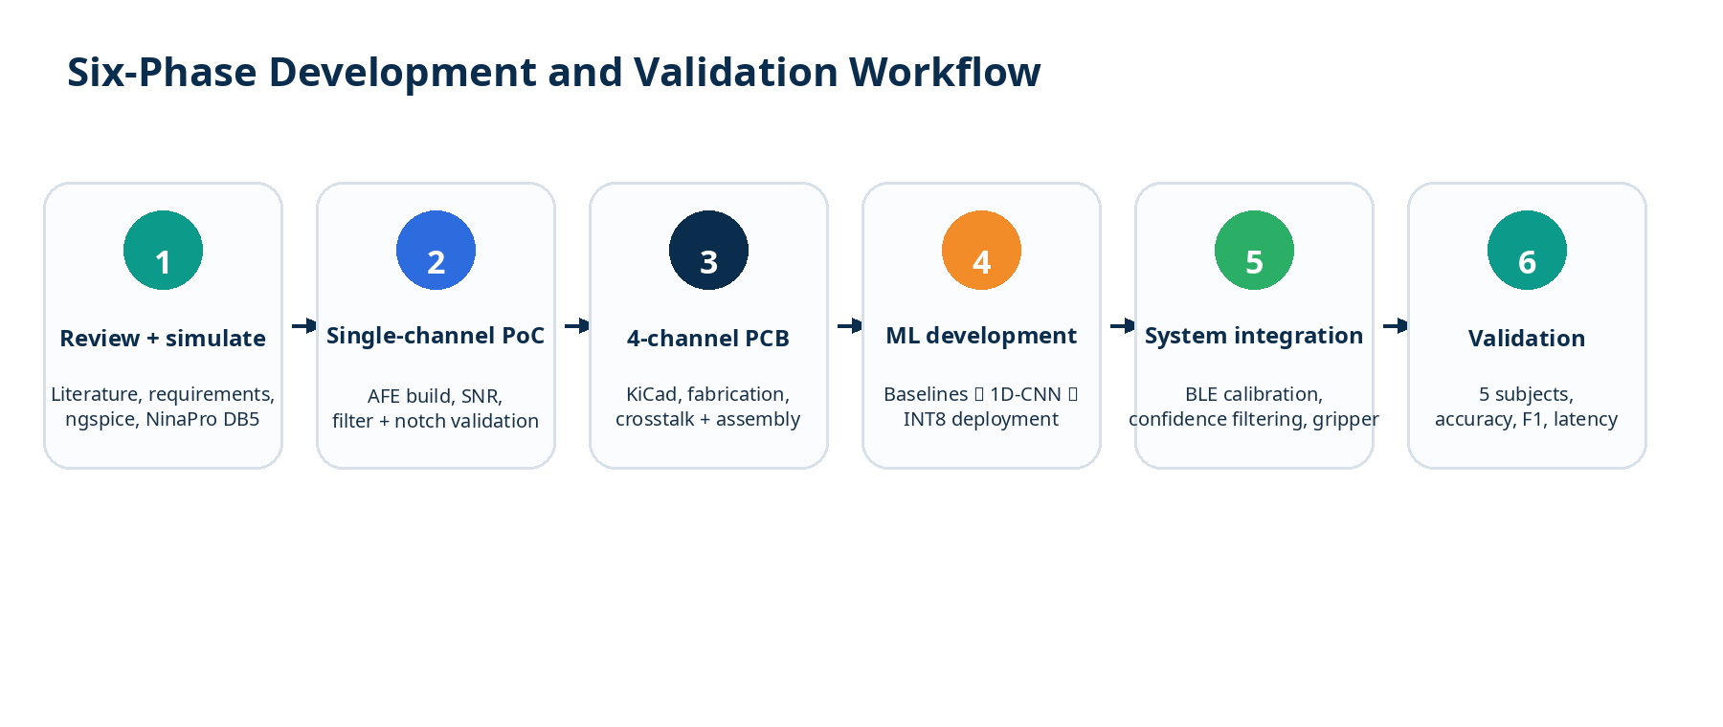
Figure 5. Six-phase development and validation workflow.

Phase 1 — Literature review and simulation
Define requirements; review sEMG acquisition and classification literature; simulate amplifier and filter stages in ngspice; perform tolerance analysis; prepare NinaPro DB5 data.

Phase 2 — Single-channel proof of concept
Build one complete analog channel; measure gain, frequency response, 50 Hz rejection, noise and signal-to-noise ratio using laboratory instrumentation.

Phase 3 — PCB design and fabrication
Translate the validated channel into a four-channel KiCad design with controlled analog/digital grounding, matched signal paths and guard traces; fabricate and assemble the prototype.

Phase 4 — ML training and deployment
Extract the selected features; train LDA, SVM, RF and 1D-CNN baselines; quantize the target network; compare Python inference with ESP32-S3 inference.

Phase 5 — System integration
Connect electrodes, AFE, ESP32-S3, classifier, BLE application and gripper; implement confidence filtering, debounce and calibration logic.

Phase 6 — Validation
Measure electrical, computational and system-level metrics; conduct the five-subject evaluation; analyse accuracy, F1 score, latency and user observations.

6.1 Experimental Validation
Validation will be organised into four layers:
- Electrical validation: gain, frequency response, 50 Hz rejection, signal-to-noise ratio and inter-channel crosstalk.
- Embedded validation: sampling stability, feature-extraction execution time, RAM/flash use and classifier inference latency.
- Machine-learning validation: macro F1 score on held-out data, confusion matrix and per-class performance.
- End-to-end validation: gesture recognition accuracy, actuation correctness and repeatability across five test subjects.

6.2 Performance Targets
Layer | Metric | Target
Electronics | Signal-to-noise ratio | > 20 dB
Electronics | Inter-channel crosstalk | < −40 dB
ML | Offline macro F1 on NinaPro DB5 | ≥ 0.85
Embedded ML | INT8 model size | < 100 KB
Real-time | End-to-end inference latency | < 50 ms
System | Mean real-time accuracy across 5 subjects | ≥ 80%
Cost | Electronics hardware BOM | < USD 20
Prototype | Prototype BOM target | < USD 65
Table 3. Primary engineering and validation targets.

6.3 Cost Demonstration
Because affordability is a central project requirement, costs will be reported transparently in three tiers. Tier A isolates the electronics BOM, Tier B captures the prototype hardware required for the physical demonstration, and Tier C estimates the electronics cost at 100 or more units using volume component pricing.
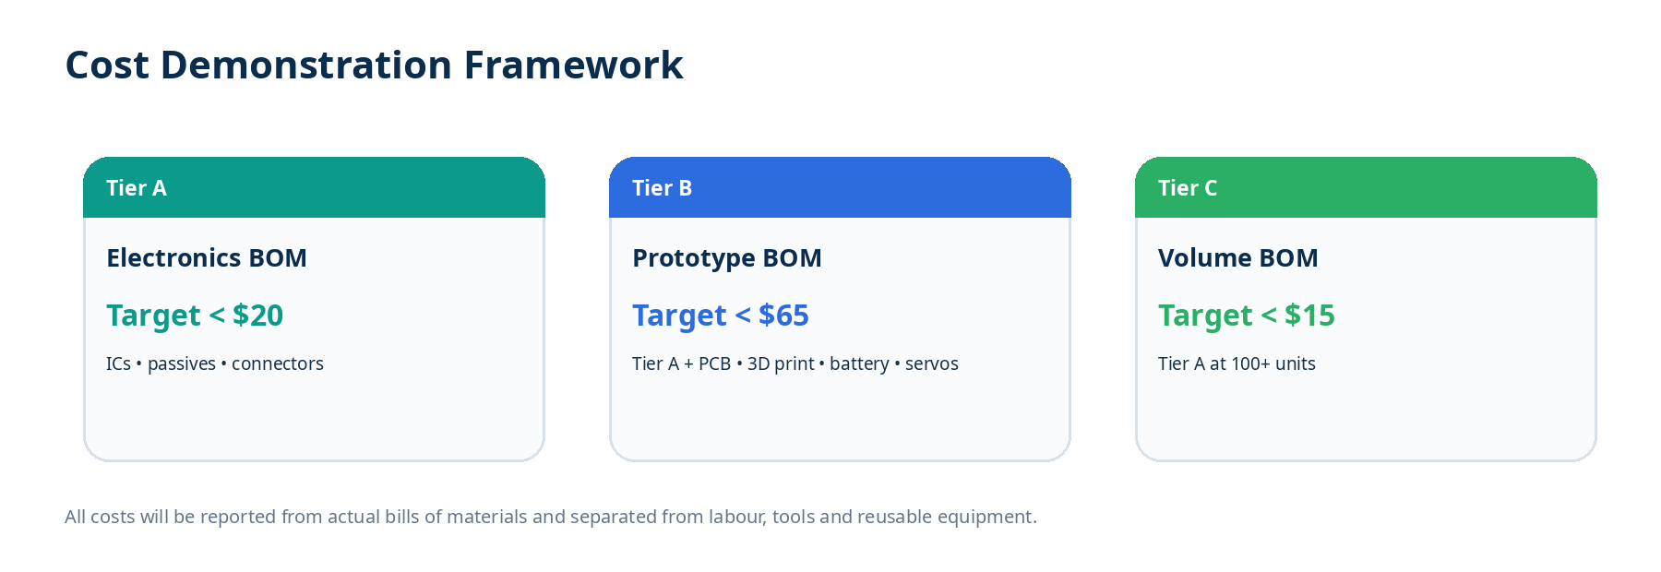
Figure 6. Cost reporting framework. Actual bills of materials will be used for the final cost demonstration.

7. End-to-End Demonstration
The final demonstration will show the system operating without a continuous USB or PC connection:
- A participant is fitted with four Ag/AgCl surface electrodes on the forearm using the placement defined during the hardware setup.
- The BLE application confirms device connectivity and guides the participant through the approximately three-minute calibration sequence.
- The ESP32-S3 acquires the four channels at 2 kHz, performs the digital processing pipeline and classifies the selected gesture.
- The classified command is filtered by the decision logic and translated into a servo position command.
- The 2-DOF 3D-printed gripper performs the corresponding motion.
- The mobile application displays the predicted gesture, confidence and live channel activity while performance data are logged for analysis.
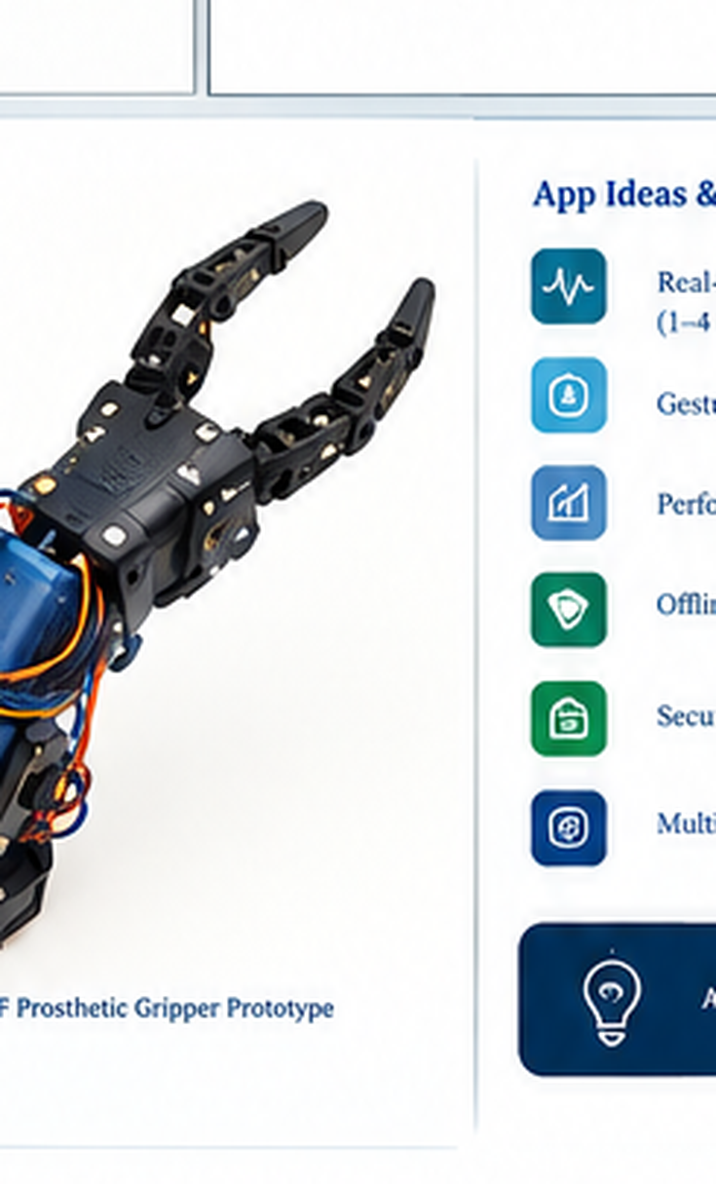
Figure 7. 2-DOF prosthetic gripper concept shown in the supplied design reference; the final mechanical prototype will be documented separately with fabrication drawings and component specifications.

8. Expected Outcomes
- A validated four-channel sEMG acquisition board and embedded control unit.
- A real-time ESP32-S3 DSP pipeline implementing the defined 24-element feature vector.
- A compact INT8 gesture-classification model suitable for on-device inference.
- A BLE mobile application for connection, calibration, monitoring and performance feedback.
- A functional 2-DOF prosthetic gripper demonstrator controlled from classified muscle activity.
- A quantitative cost report demonstrating the electronics BOM against the project target.
- A reproducible experimental dataset and evaluation report covering accuracy, F1 score, latency, noise and crosstalk.

9. Ethical, Safety and Data Considerations
- Human-subject testing will only be conducted after the required institutional approval and informed consent procedures are satisfied.
- The prototype is a research and rehabilitation demonstrator, not a certified clinical prosthesis or medical device.
- Participant data will be minimised, pseudonymised where appropriate and stored with access restricted to the research team.
- The actuator system will include software limits and a physical power-disconnect mechanism so that testing can be stopped immediately.
- The participant will be able to withdraw from a test session without penalty.

10. Proposed Work Plan
Period | Activity
1–2 | Literature review, requirements and system specification
3–4 | Analog simulation and single-channel AFE prototype
5–7 | PCB design, fabrication and electrical validation
6–9 | NinaPro data preparation, baseline models and 1D-CNN
9–10 | INT8 quantization and ESP32-S3 deployment
10–11 | BLE application and calibration workflow
11–12 | Gripper integration and system testing
13 | Five-subject validation and data analysis
14 | Final documentation, demonstration and presentation
Table 4. Indicative 14-week implementation plan; dates may be aligned with the department's official project calendar.

11. Deliverables
ID | Deliverable | Evidence
D1 | Requirements and literature review package | System specification, literature matrix and risk register.
D2 | Validated 4-channel AFE | Schematic, PCB design files, fabricated board and electrical test results.
D3 | Embedded DSP + ML firmware | ESP32-S3 firmware, feature extraction, INT8 model and deployment notes.
D4 | BLE mobile application | Calibration, live monitoring and performance screens.
D5 | 2-DOF gripper demonstrator | Mechanical assembly, servo interface and gesture-to-motion mapping.
D6 | Validation and final report | Experimental results, cost analysis, limitations and recommendations.

12. References
[1] J. A. M. Salgado, J. A. S. Espino, R. A. B. Vargas, et al., “Single-channel sEMG hand gesture classification using an artificial neural network implemented on an ESP32 microcontroller,” IEEE Access, vol. 13, pp. 28756–28768, 2025.
[2] S. Mekruksavanich, N. Hnoohom, and A. Jitpattanakul, “Deep residual network with channel attention for improving hand gesture recognition with surface electromyography signal,” IEEE Access, vol. 14, 2026.
[3] H. Lee, M. Jiang, Z. Yang, and Q. Zhao, “FedEMG: Achieving generalization, personalization, and resource efficiency in EMG-based upper-limb rehabilitation through federated prototype learning,” IEEE Transactions on Neural Systems and Rehabilitation Engineering, vol. 33, 2025.
[4] R. G. Molinari, V. Aviles-Carrillo, G. A. G. De Villa, et al., “A wearable platform for real-time control of a prosthetic hand by high-density EMG,” IEEE Access, vol. 14, 2026.
[5] D. M. Furtado, L. B. Palma, et al., “A modular low-cost myoelectric prosthetic hand,” in Proc. IEEE International Forum on Electrical Engineering (IFEE), 2026.
[6] P. Prakash, M. Juneja, H. Kaur, and N. R. Gopinathan, “Advances in EMG, EEG, and hybrid-based prosthetic arm control: A comprehensive review on machine learning, deep learning, and multimodal approaches,” Archives of Computational Methods in Engineering, 2026.
[7] B. Abdikenov, D. Zholtayev, K. Suleimenov, et al., “Emerging frontiers in robotic upper-limb prostheses: Mechanisms, materials, tactile sensors and machine learning-based EMG control,” Sensors, vol. 25, no. 13, p. 3892, 2025.
[8] F. Del Pup, E. Tentori, and M. Atzori, “Multimodal surface EMG hand gesture recognition using query-based transformers for prosthetic control,” arXiv:2607.22779, 2026.
[9] R. Geddam, M. Awais, V. Tiwari, and H. Ghayvat, “sEMGCareHCI: sEMG-based finger position prediction for amputee-centric human-computer interaction,” npj Biomedical Innovations, 2026.
[10] World Health Organization, Global Report on Assistive Technology. Geneva: World Health Organization, 2022.

Appendix A. Visual Design and Component Map
The following visual map consolidates the main physical components represented in the proposal. It is included to make the implementation concept immediately understandable to reviewers; component selection remains subject to availability, laboratory verification and final BOM optimisation.
Subsystem | Representative component | Role
Microcontroller | ESP32-S3 | Acquisition, DSP, BLE and embedded inference
Instrumentation amplifier | INA128 | Differential sEMG amplification
Band-pass filter | Sallen-Key | 20–500 Hz signal conditioning
Notch filter | Twin-T | 50 Hz mains rejection
ML accelerator | ESP32-S3 + TFLite Micro | INT8 gesture inference
PWM driver | PCA9685 | Two-channel servo control
Actuators | 2 × servo motors | 2-DOF gripper movement
Electrodes | Ag/AgCl surface electrodes | Muscle activity sensing

