DineFlow
Hospitality Management System
Web and Mobile Applications — Complete Documentation
by Devkodz
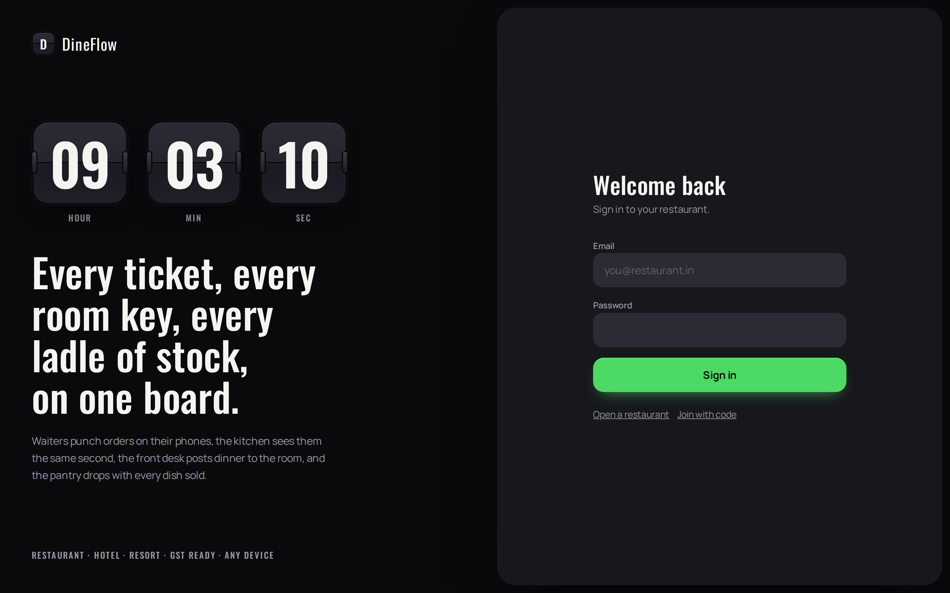

Field | Value
Document | DineFlow — Complete Documentation, Web and Mobile Applications
Version | 22.2
Issued | 5 September 2026
Applies to | Web application (Next.js 15), Mobile application (Expo / React Native), Database schema migrations 0001–0020
Audience | Property owners and managers, staff trainers, system administrators, implementation engineers
Status | Released. Verified by eight database test harnesses and an automated link and route audit.
Prepared by | Devkodz — software development company. See section 11.

Contents
Each screen in sections 4 and 5 begins on its own page. Diagrams appear as numbered figures; highlighted panels mark points that matter in practice.
 | Section | Contents
— | Overview | In one paragraph · What it replaces · Who uses what · The system in numbers · How a day runs · What makes it different · What it does not do · How to read this document
1 | Introduction | 1.1 Purpose and scope · 1.2 System overview · 1.3 Roles and authority · 1.4 Definitions
2 | System architecture | 2.1 Components · 2.2 Data model · 2.3 Security · 2.4 Offline operation · 2.5 Verification · 2.6 Modules · 2.7 Performance · 2.8 Data ownership
3 | User interface standards | 3.1 Visual system · 3.2 Typography and colour · 3.3 Motion · 3.4 Themes · 3.5 Accessibility
4 | Web application — screen reference | 4.1 Authentication · 4.2 Master control · 4.3 Control room · 4.4 Service operations · 4.5 Accommodation · 4.6 Inventory and menu · 4.7 Intelligence and records · 4.8 Administration
5 | Mobile application — screen reference | 5.1 Design conventions · 5.2 Navigation · 5.3 Screens (fifteen)
6 | Guest-facing services | 6.1 Storefront · 6.2 Queue · 6.3 Business record
7 | Integrations and connections | 7.1 Custody of credentials · 7.2 Assist
8 | Installation and deployment | 8.1 Prerequisites · 8.2 Timings · 8.3 Database · 8.4 Launcher · 8.5 Web application · 8.6 Mobile application · 8.7 Configuring a property · 8.8 Demonstration data · 8.9 Publication · 8.10 On-premises · 8.11 Acceptance
9 | Operations and support | 9.1 Daily procedure · 9.2 Who does what · 9.3 Diagnosis · 9.4 Backup · 9.5 Updating · 9.6 Verification
10 | Appendices | 10.1 Delivered documents · 10.2 Roles and default permissions · 10.3 Database migrations · 10.4 Limitations
11 | About Devkodz | 11.1 The company · 11.2 How we work · 11.3 What we build · 11.4 DineFlow at a glance · 11.5 Contact and support

1 Introduction

1.1 Purpose and scope of this document
This document is the complete reference for the DineFlow hospitality management system. It describes both delivered applications — the web application and the mobile application — together with the database, the integrations, the installation procedure and the operating procedures.
It is written to be used in four ways: as a specification of what the system does; as a training reference for staff, screen by screen; as an installation and deployment manual; and as an operations handbook for the person responsible for the system in a property.
Every screenshot in this document is a render of the delivered application, produced from the shipped source. Every command is taken from the delivered files and was executed during preparation of this document.
NOTE Sections 4 and 5 document every screen of both applications. Section 8 is the complete installation procedure. Section 11 describes Devkodz, who built the system.

Out of scope
- Payment gateway integration. Bills are settled by cash, UPI QR code, card machine or room folio; no gateway is included.
- Direct Swiggy and Zomato partner APIs, which require partner approval held by the restaurant. The supported route is the aggregator webhook described in section 7.
- Real-time OTA APIs, which require certification. Two-way iCal synchronisation is supplied instead.
- The WhatsApp Business API. Sharing uses the WhatsApp share sheet, which requires no account and no per-message fee.

1.2 System overview
DineFlow operates a restaurant, a hotel or a resort as one system. Orders taken on a handheld device appear on the kitchen display in the same second. The front desk posts restaurant charges to a room folio. Each dish sold deducts its recipe from the pantry. Guests reserve a table or place an order through a page belonging to the property, at no commission. The proprietor sees the day's takings on a single board, and the till is reconciled at close of business in under a minute. The system continues to operate when the internet connection is lost.
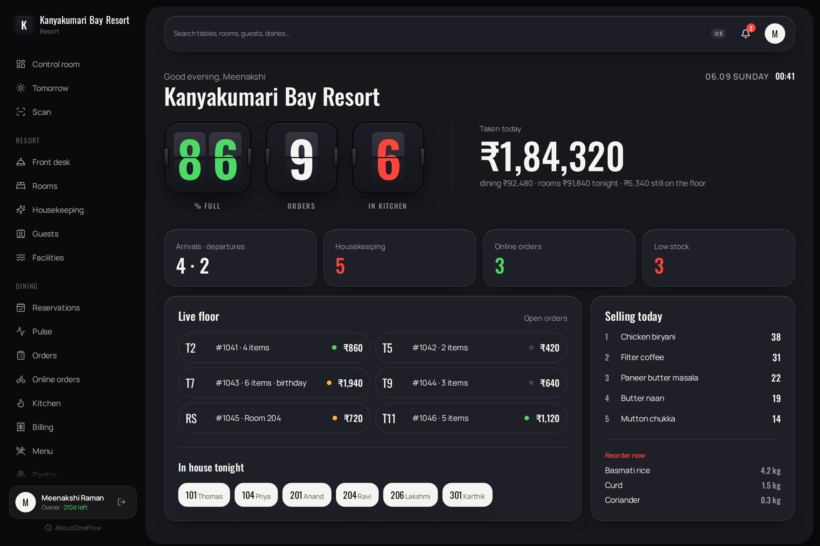
Figure 1.1 — Control room, the proprietor's default screen (web application)
KEY POINT One system, not several. The order taken at the table, the ticket in the kitchen, the stock deducted, the charge posted to a room and the figure on the proprietor's board are the same event seen from different places.

1.3 Roles and authority
Authority is arranged in three layers. Each layer may grant only what it itself holds, and only to the layer below it. This is enforced in the database, not in the applications.
Role | Signs in to | Authority
Master | Master control only | Creates properties; determines which modules each property may open; issues membership keys; may act as any property's proprietor for support purposes.
Owner | Their own property | Holds everything the master has permitted; appoints staff; determines which sections each employee may open.
Manager | Their own property | As the owner, excluding Settings; may not alter an owner's record.
Employee | Their own property | Sees only the sections permitted to them. A section that is withheld is absent from the menu and unreachable by direct address.
Authority is arranged in three layers. Each layer may grant only what it itself holds, and only to the layer below it. This is enforced in the database, not in the applications.
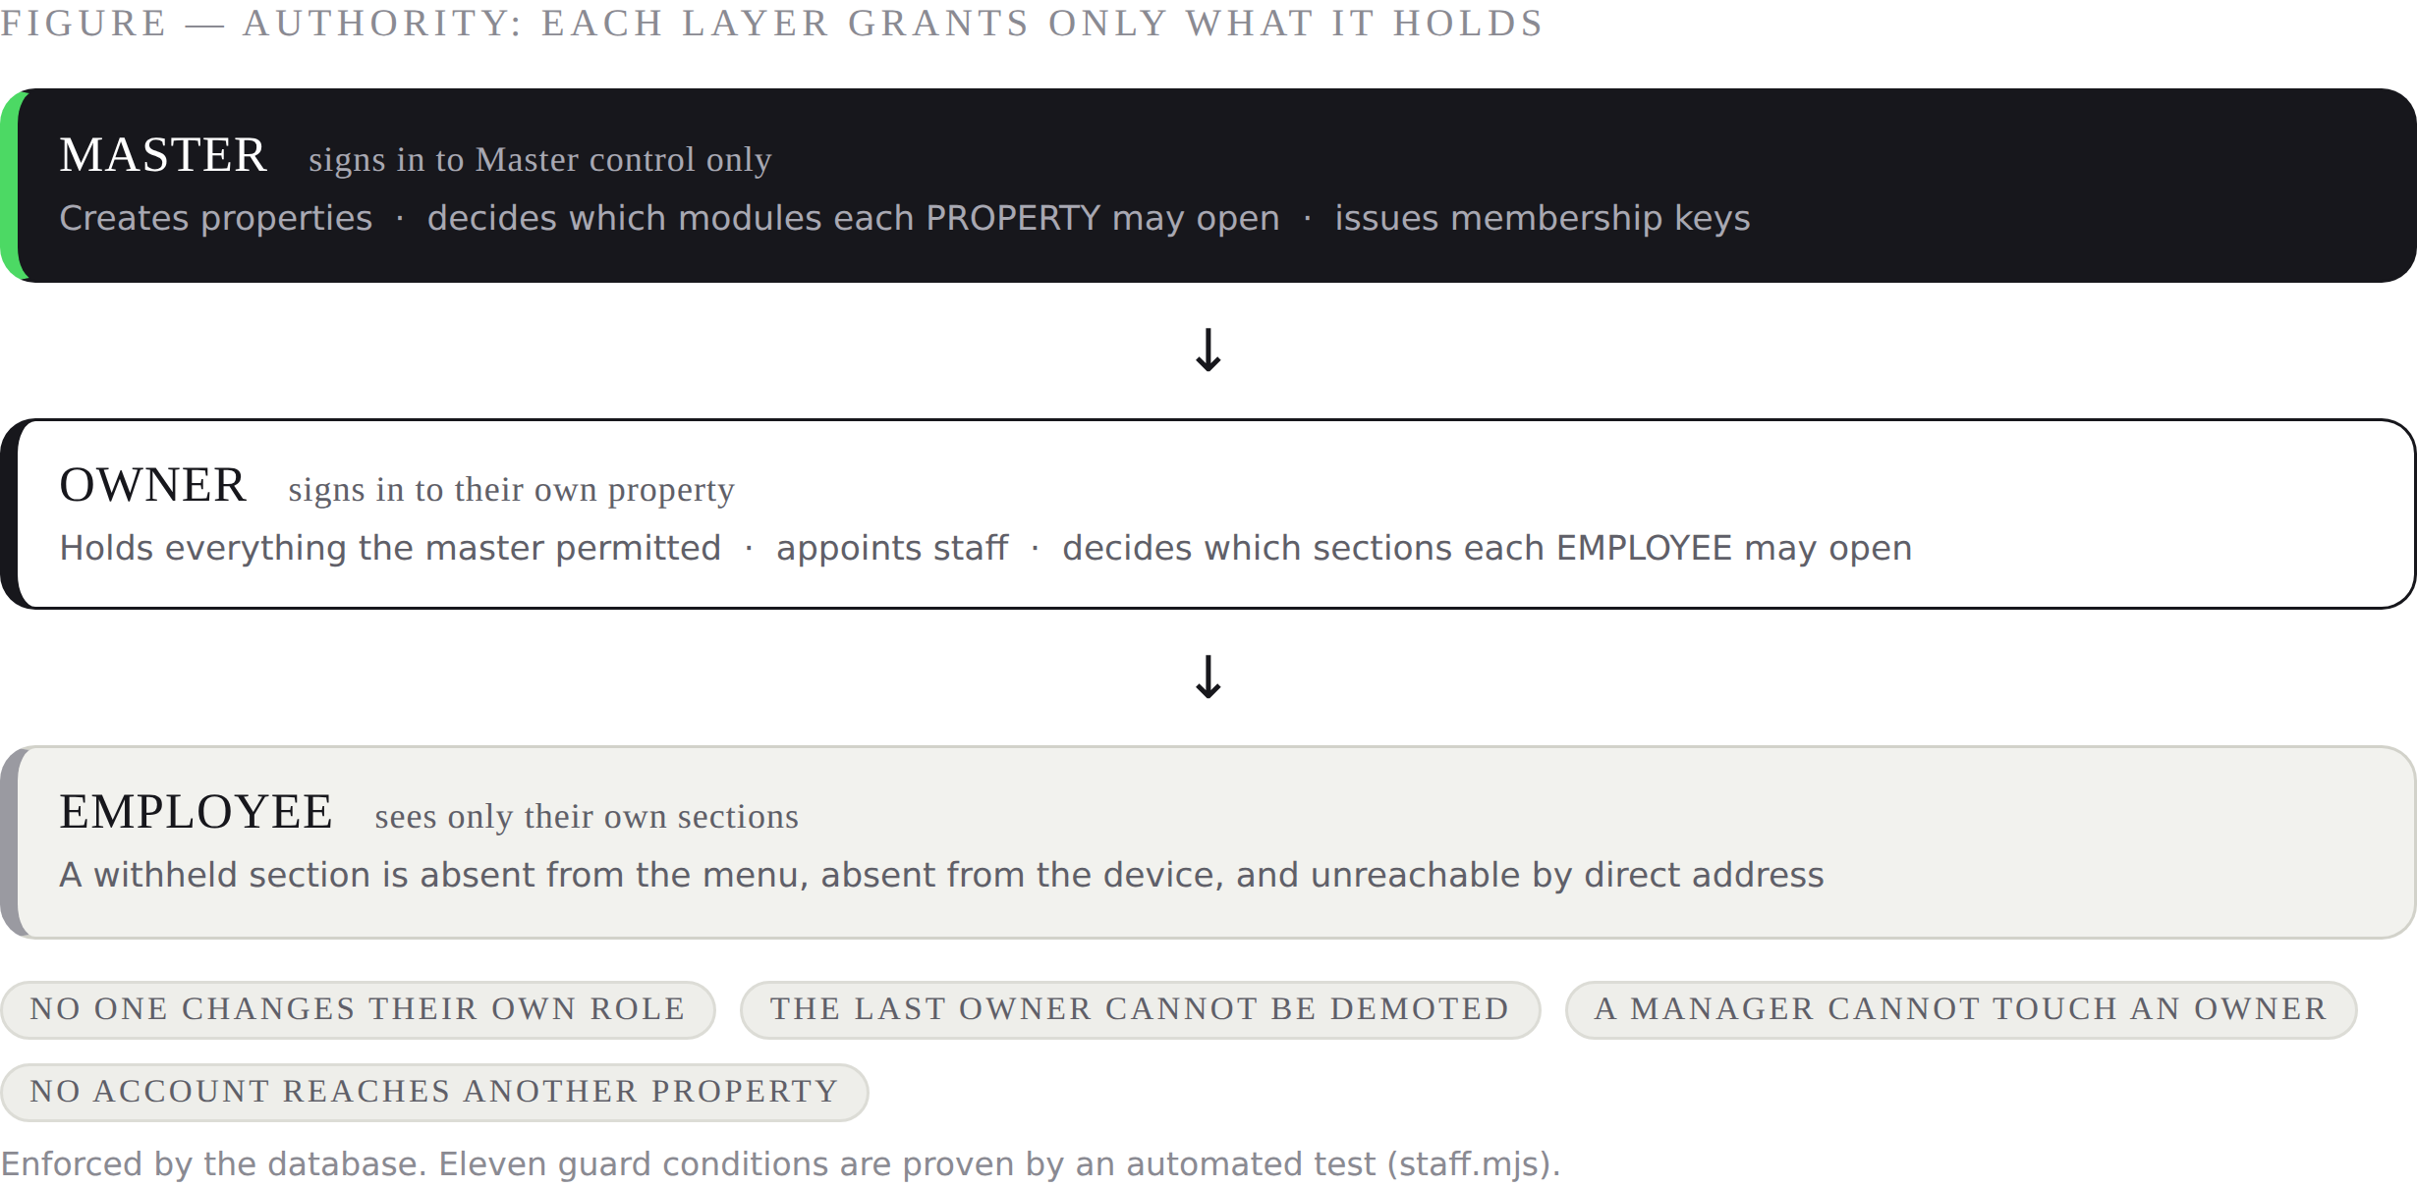
Figure 1.2 — Authority: each layer grants only what it holds
Safeguards enforced by the database: no person may alter their own role or deactivate themselves; the last remaining owner may not be demoted; a manager may neither alter nor create an owner; no account may reach into another property. These eleven guard conditions are proven by an automated test (section 2.5).

1.4 Definitions
Term | Meaning
Property | One restaurant, hotel or resort. All data is partitioned by property.
Module | A section of the application, such as Kitchen or Pantry, which may be permitted or withheld.
KOT | Kitchen order ticket: the printed or displayed instruction to prepare a set of items.
Folio | The running account of charges against an occupied room.
Outbox | The device-side queue holding actions taken while the connection is unavailable.
Cover | One guest served in the restaurant.
Dwell | The elapsed time between a table's first order and its bill being settled.
Box | An on-premises server that runs the property when the internet is unavailable.

Overview
This overview states, in one reading, what DineFlow is, what it replaces, who uses which part of it, and what it costs a property to run. The sections that follow document each of these points in full.

In one paragraph
DineFlow runs a restaurant, a hotel or a resort as a single system. A waiter takes an order on a telephone; the kitchen sees it in the same second and the pantry is deducted by recipe. The front desk posts dinner to a room folio and issues one tax invoice at departure. Guests reserve a table or order from a page the property owns, at no commission. The proprietor reads the day's takings, the floor and the kitchen from one board, and reconciles the till at close in under a minute. When the internet fails, everything continues on the device and is delivered exactly once when the line returns.
KEY POINT The system is delivered complete: two applications, the database with its rules, the installation procedure, the verification harnesses and this documentation. Nothing essential is left to be sourced separately.

What it replaces
Commonly used today | Replaced by | What is gained
A billing machine or point-of-sale terminal | Orders and Billing | The same order becomes the kitchen ticket, the stock deduction, the bill and the day's figure — entered once.
A paper ticket rail in the kitchen | Kitchen display | Elapsed time on every ticket; nothing lost; the waiter sees when an item is ready.
A stock register or spreadsheet | Pantry and recipes | Stock moves by itself as dishes sell; the gap between predicted and counted is measured in rupees.
A hotel diary or separate property system | Front desk, Rooms, Housekeeping | One folio for the room and the restaurant; double-booking prevented by the database.
Aggregator commission of 18–25% | The property's own storefront | Reservations and orders at no commission, on a page carrying the property's own name.
A guess at the wait, at the door | Pulse | A quotation learned from the property's own service, and a queue guests watch from their own telephone.
Bank statements assembled by hand | Proof of business | Months sealed and chained; a verifiable link that a lender opens directly.

Who uses what
Person | Where | Uses
Proprietor | Web, and telephone when away | Control room, reports, tomorrow's brief, settings, staff, proof of business
Manager | Web and telephone | Everything except settings; usually the floor, the kitchen and billing
Waiter | Telephone | Tables, order pad, pulse, reservations
Cook | A tablet or screen in the kitchen | The kitchen display only
Cashier | Web at the counter | Billing, invoices, shift close, reservations
Front desk | Web at the desk | Front desk, rooms, guests, reservations, housekeeping
Housekeeper | Telephone | Housekeeping and rooms
Storekeeper | Telephone and web | Pantry, purchases, counts, market list, labour
Guest | Their own telephone | Storefront, queue, and nothing else — no account, no installation

The system in numbers
20 | operator screens on the web | 15 | screens in the mobile application
3 | guest-facing pages | 5 | tabs on the telephone
20 | database migrations | 123 | database functions
8 | verification harnesses | 11 | guard conditions on staff authority
24 | modules that may be permitted or withheld | 0% | commission on guest orders
2 | themes, dark and light | 0 | connection required to keep working

DineFlow runs a restaurant, a hotel or a resort as a single system. A waiter takes an order on a telephone; the kitchen sees it in the same second and the pantry is deducted by recipe. The front desk posts dinner to a room folio and issues one tax invoice at departure. Guests reserve a table or order from a page the property owns, at no commission. The proprietor reads the day's takings, the floor and the kitchen from one board, and reconciles the till at close in under a minute. When the internet fails, everything continues on the device and is delivered exactly once when the line returns.
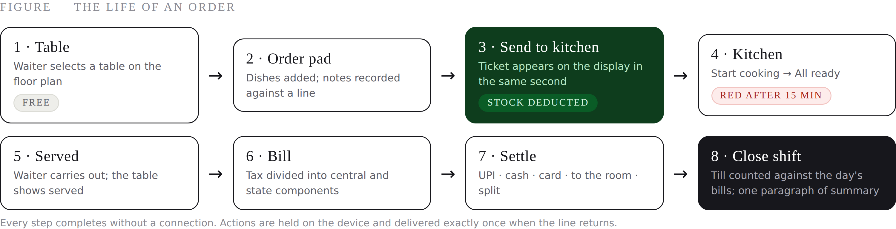
Figure O.1 — The life of an order, from the table to the closed shift
The same sequence, in the words a proprietor would use: the waiter opens the table and adds dishes; sending to the kitchen prints or displays the ticket and takes the ingredients out of stock; the cook works down the ticket and marks it ready; the waiter carries it out; the bill is produced with the tax already divided; payment is recorded; and at close of business the till is counted against what the system says it should hold, with the difference stated before anything is submitted.

What makes it different
- It keeps working with no connection — not partially, but every action a shift requires, on both applications, with delivery proven to happen exactly once.
- The rules live in the database, so they cannot be bypassed by any client, present or future.
- Authority runs in three layers and only downwards; nobody can grant more than they hold, and the last owner cannot lock themselves out.
- Wait times, tomorrow's covers and leak detection are learned from the property's own trading, not from an industry average.
- Guest-facing pages belong to the property and charge no commission.
- It is delivered with proof: eight harnesses the property can run, and an audit of every link and button.

What it does not do
Stated plainly, so that nothing is discovered late: there is no payment gateway (bills settle by cash, UPI code, card machine or room folio); there is no direct Swiggy or Zomato partner interface (the supported route is an aggregator webhook, section 7); travel agency exchange is by two-way calendar rather than a real-time interface; and messaging uses the WhatsApp share sheet rather than the paid business interface. Each has a working substitute described in this document.

How to read this document
If you are | Read
Evaluating the system | This overview, then sections 1 and 2, then the screen references in 4 and 5
Installing it | Section 8 from beginning to end, with section 7 beside it for the connections you need
Training staff | Sections 4 and 5. Each screen states its purpose, its contents, its operations and who may open it
Operating it daily | Section 9, and the acceptance checklist at 8.10
Responsible for it technically | Sections 2, 7 and 9.5

TIP Every screen entry in sections 4 and 5 follows the same four headings — Purpose, Contents, Operations, and who it is permitted to — so a particular fact is always found in the same place.

2 System architecture
Stated plainly, so that nothing is discovered late: there is no payment gateway (bills settle by cash, UPI code, card machine or room folio); there is no direct Swiggy or Zomato partner interface (the supported route is an aggregator webhook, section 7); travel agency exchange is by two-way calendar rather than a real-time interface; and messaging uses the WhatsApp share sheet rather than the paid business interface. Each has a working substitute described in this document.
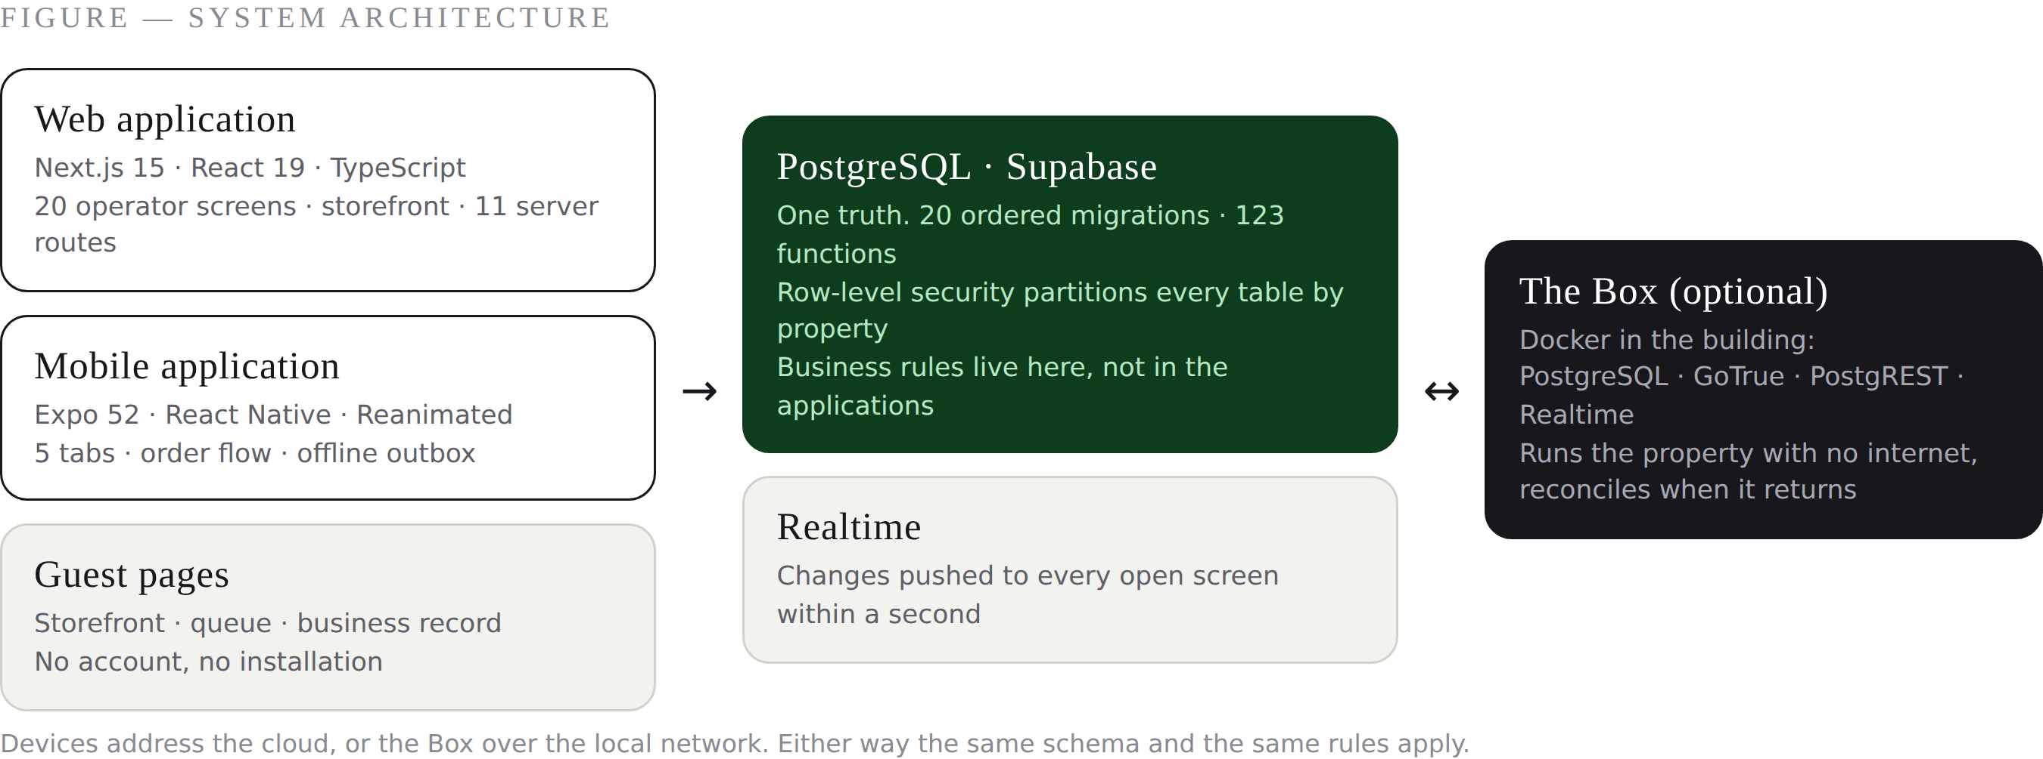
Figure 2.1 — System architecture
Component | Technology | Responsibility
Web application | Next.js 15, React 19, TypeScript, Tailwind CSS 4 | All twenty operator screens, the public storefront, the guest queue page, the shareable business record, and eleven server routes.
Mobile application | Expo 52, React Native, Reanimated | The seven screens required on the floor: control, orders, kitchen, pulse, rooms, pantry, scan, and the order flow.
Database | PostgreSQL on Supabase | All data and all business rules. Twenty ordered migrations define the schema, 123 functions and row-level security.
On-premises server (optional) | Docker: PostgreSQL, GoTrue, PostgREST, Realtime | Runs the property over the local network when the internet is unavailable, and reconciles with the cloud when it returns.

2.2 Data model and integrity
KEY POINT Business rules live in the database. A rule proven there holds for the web application, the mobile application, an integration, and anything built later — it cannot be bypassed by a client.
Business rules are held in the database rather than in the applications, so that they apply equally to the web application, the mobile application and any future client. Examples of rules enforced at this level:
- A room may not be double-booked; overlapping reservations are rejected.
- Selling a dish deducts its recipe from stock through a trigger, not through application code.
- Goods and services tax is computed and divided evenly into central and state components at the point of billing.
- A sealed monthly record is fingerprinted and chained to the month preceding it; altering a sealed figure invalidates every subsequent month.
- District network figures are withheld unless at least five properties are contributing (k-anonymity).

2.3 Security model
- Row-level security partitions every table by property. A signed-in person cannot read another property's data even by direct query.
- The browser and the mobile application hold only the public anonymous key. The service key, which bypasses row-level security, is held on the server and is used solely by the three inbound routes (aggregator webhook, calendar export, scheduled synchronisation).
- The direct database connection string is used once, to apply migrations, and is never present in any client.
- Module permissions are evaluated on the server for every request. A withheld module is unreachable by direct address, not merely hidden from the menu.
- Inbound integrations authenticate by a per-channel token of 32 hexadecimal characters, issued and revoked by the property.

2.4 Offline operation and synchronisation
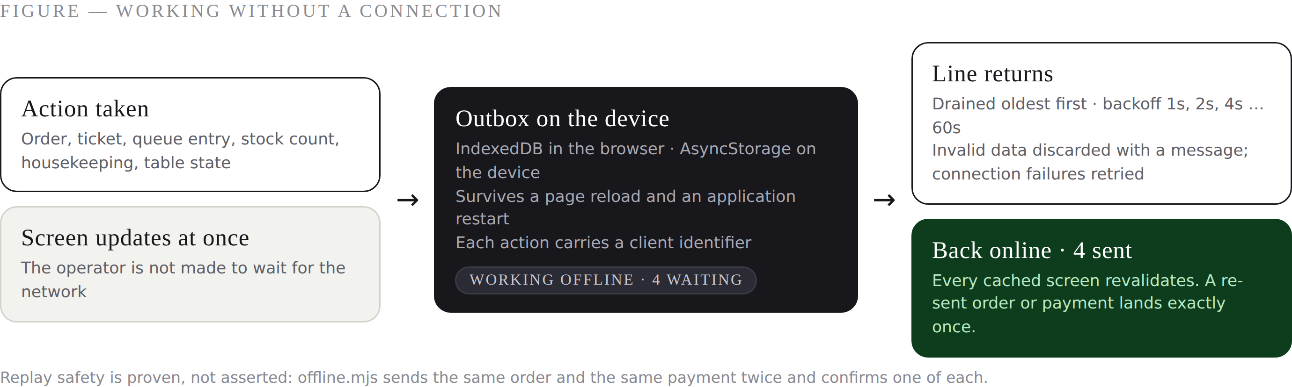
Figure 2.2 — Working without a connection
Actions taken without a connection are recorded in a device-side outbox and transmitted when the connection returns. Reads are served from a device-side cache, so a screen opens with real data rather than a blank.
Behaviour | Implementation
Actions covered | Orders, kitchen ticket progress, individual item states, walk-in queue entries, stock counts and movements, housekeeping states, table states.
Persistence | IndexedDB in the browser; AsyncStorage on the device. The queue survives a page reload and an application restart.
Retry policy | Exponential backoff from one second to a ceiling of one minute. Failures caused by invalid data are discarded with a message; failures caused by the connection are retried up to six times.
Duplicate prevention | Each action carries a client identifier. Re-transmission after a lost reply produces exactly one order and one payment. Proven by automated test.
Restoration | On reconnection the queue is drained oldest first and every cached screen is revalidated. The operator is informed: “Back online · 4 sent.”

CAUTION The duplicate-prevention behaviour is the one that protects money. A re-transmitted order creates one order, and a re-transmitted payment is taken once — proven by test, not asserted.

2.5 Verification and quality assurance
Every database migration is executed against a genuine PostgreSQL engine before release. Eight test harnesses are supplied with the system and may be run at any time by the property's engineer.
Harness | What it proves
run.mjs | All twenty migrations apply, in order, from an empty database.
flow.mjs | Every remote procedure operates end to end against a seeded estate.
verify.mjs | Tenant separation, stock deduction, tax arithmetic, double-booking prevention, tamper detection, k-anonymity, capacity limits, membership expiry.
pulse.mjs | Dwell-time learning, table stages, wait quotations, the guest queue.
v15.mjs | Leak detection and shift reconciliation, including the post-midnight business day.
offline.mjs | Replay safety: a re-transmitted order or payment is recorded exactly once.
access.mjs | The master's authority over property modules, and an owner's inability to assume it.
staff.mjs | Eleven guard conditions governing an owner's authority over employees.

In addition, an automated audit checks every link and button in both applications against the routes and database functions that exist. At the time of issue: 48 link targets against 47 web routes and 11 server routes, all resolving; 15 mobile targets against 13 screens, all resolving; 92 database functions and 45 tables referenced by the applications, all present.

2.6 Modules
Twenty-four modules may be permitted or withheld per property and per employee. Two — Control room and Settings — are always present, so that a person always has somewhere to arrive and a proprietor always has a means of configuring the property.
Group | Modules
Front of house | Orders and tables · Reservations · Pulse · Online orders · Channels
Accommodation | Front desk · Rooms · Housekeeping · Guests · Facilities
Kitchen and stock | Kitchen · Menu · Pantry · Scan · Tomorrow's brief
Money | Billing · Invoices · Reports · Proof of business
People and network | Labour · Staff · Neighbours
Always present | Control room · Settings

The set a person actually sees is the intersection of four things: the modules the property type supports (a restaurant has no rooms), the modules the role may hold, the modules the master permitted the property, and the sections the proprietor ticked for that individual. This single rule is applied by the web sidebar, the mobile tab bar and the server route guard alike.

2.7 Performance
Measured on the sign-in page against the production build, as the median of four loads:
Measure | Figure | Note
Time to first byte | 22 ms | Session and database client are memoised per request
First contentful paint | 78 ms | The browser pre-connects to the database host before the first query
Page load complete | 59 ms | Assist is loaded after the screen has painted
JavaScript delivered | 155 kB | Charting and the assistant load only when opened
Live update latency | under one second | Pushed from the database; a slow poll acts as a safety net

NOTE Everyday use runs the production build. The development server, which compiles each page on first visit, is reserved for engineers and is offered as launcher option 11.

2.8 Data ownership, retention and export
- All data belongs to the property. Devkodz retains no interest in it.
- Every table is partitioned by property in the database itself, so one property's data is not merely hidden from another but unreachable.
- Reports and the tax summary export from the application; the database provider permits a full export at any time.
- Sealed monthly records constitute an independent, verifiable history that survives even a change of system.
- Deleting a property removes its data; the sealed record chain is the only artefact designed to outlive it.

3 User interface standards

3.1 Visual system
The interface is modelled on a split-flap departure board. The governing requirement is legibility at distance in a working kitchen: significant figures are presented as large pale numerals in dark tiles, one colour signifies a live condition, and each screen is a rounded card on a dark ground.
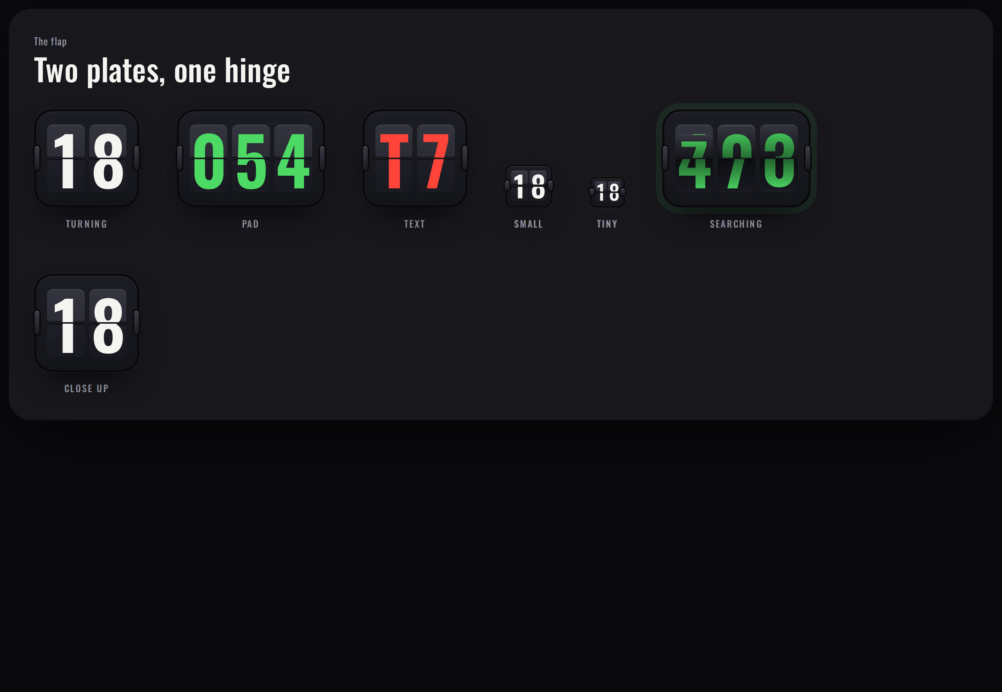
Figure 3.1 — The flip tile at each size. Each character comprises two plates separated at the hinge.
When a character changes, the upper plate of the outgoing character folds down onto the hinge and darkens; the lower plate of the incoming character then falls into place. Characters change independently, so 19 becoming 20 turns two plates and 21 becoming 22 turns one. Each plate is sized to its character, so a percentage sign or a rupee symbol occupies a wider plate than a digit.

3.2 Typography and colour
Element | Specification
Display and numerals | Oswald, condensed, tabular figures. Used for every quantity, title and label.
Body | Manrope. Used for anything read as prose.
Ground (dark) | #17171C wall, #1F2027 cards, #0A0A0D gutter
Ground (light) | #ECECE7 wall, #FFFFFF cards, #0A0A0D gutter
Live / confirm | #4CD964 dark, #1FA84A light
Attention | #FF453A dark, #D9302A light. Reserved for conditions requiring action.

3.3 Motion
Four springs govern every animation: one for controls answering a touch, one for elements arriving, one for heavy surfaces such as sheets and pages, and a mechanical curve for the flap, which should not bounce. Kitchen tickets retain their identity when moving between columns, so a ticket travels rather than disappearing and reappearing.

3.4 Themes
Dark is the default and is intended for kitchens and evening service. Light is intended for a daylight counter. The choice is per device and may be set to follow the operating system. Guest-facing pages are always light. The flip tiles remain dark in both themes, as they constitute the product's mark.
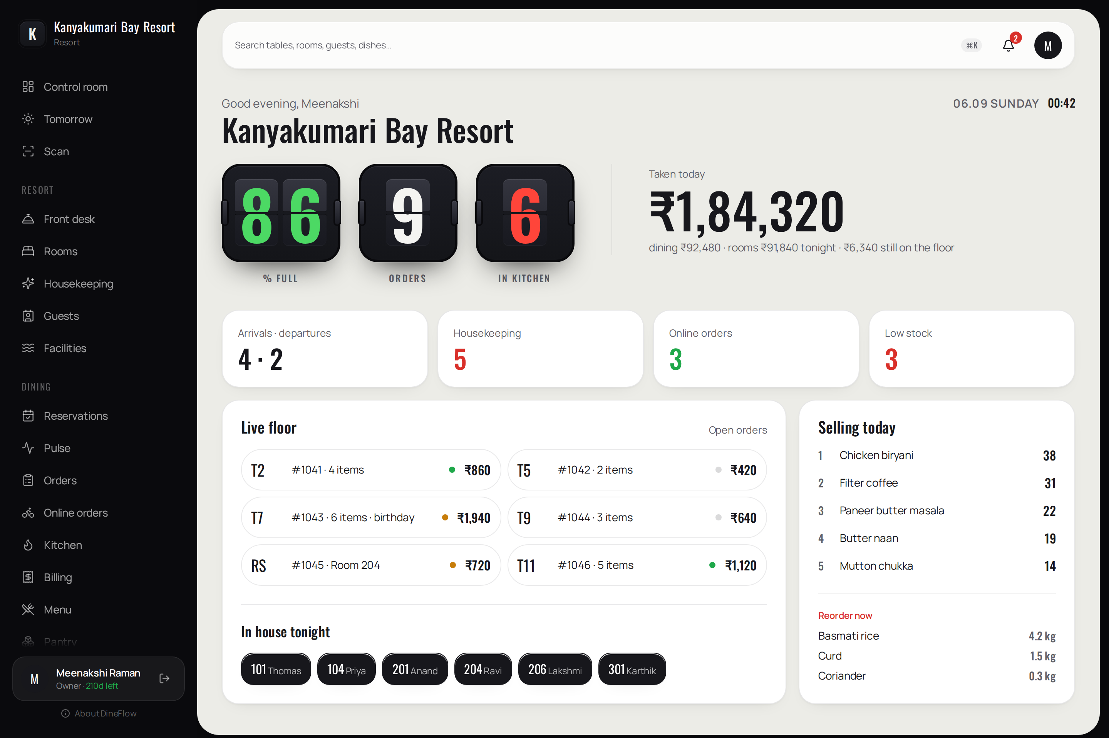
Figure 3.2 — The control room in the light theme
TIP The dark theme is intended for kitchens and evening service. Light is intended for a daylight counter. Guest pages are always light so that a stranger's telephone shows something familiar.

3.5 Accessibility
- Input controls are 48 pixels high; touch targets are at least 44 pixels.
- Body text is 15 to 16 pixels. Numerals on tiles are far larger by design.
- Text contrast meets or exceeds WCAG AA in both themes; this was measured across a screen containing every component, not estimated.
- Focus rings are visible on every interactive element.
- A reduced-motion preference suppresses all animation, presenting final states only.
- Changing figures are announced to assistive technology.

4 Web application — screen reference
The web application presents twenty operator screens. Each is documented below with its purpose, contents, available operations and the roles permitted to open it. Availability is further governed by the master's property permissions and the owner's employee permissions (section 1.3).

4.1 Authentication
The web application presents twenty operator screens. Each is documented below with its purpose, contents, available operations and the roles permitted to open it. Availability is further governed by the master's property permissions and the owner's employee permissions (section 1.3).

Figure 4.0 — Sign in
Purpose. Entry to the system. The wall carries a live clock; the card carries the credentials.
- Electronic mail address and password.
- “Open a restaurant” for a new property.
- “Join with code” for an employee invited by a proprietor, requiring no electronic mail address.
On submission the system determines whether the account is the master. The master is directed to Master control; all others are directed to their property's control room.

4.2 Master control

4.2.1 Master control
Permitted to: The master account only. Every other account is redirected to its own property.
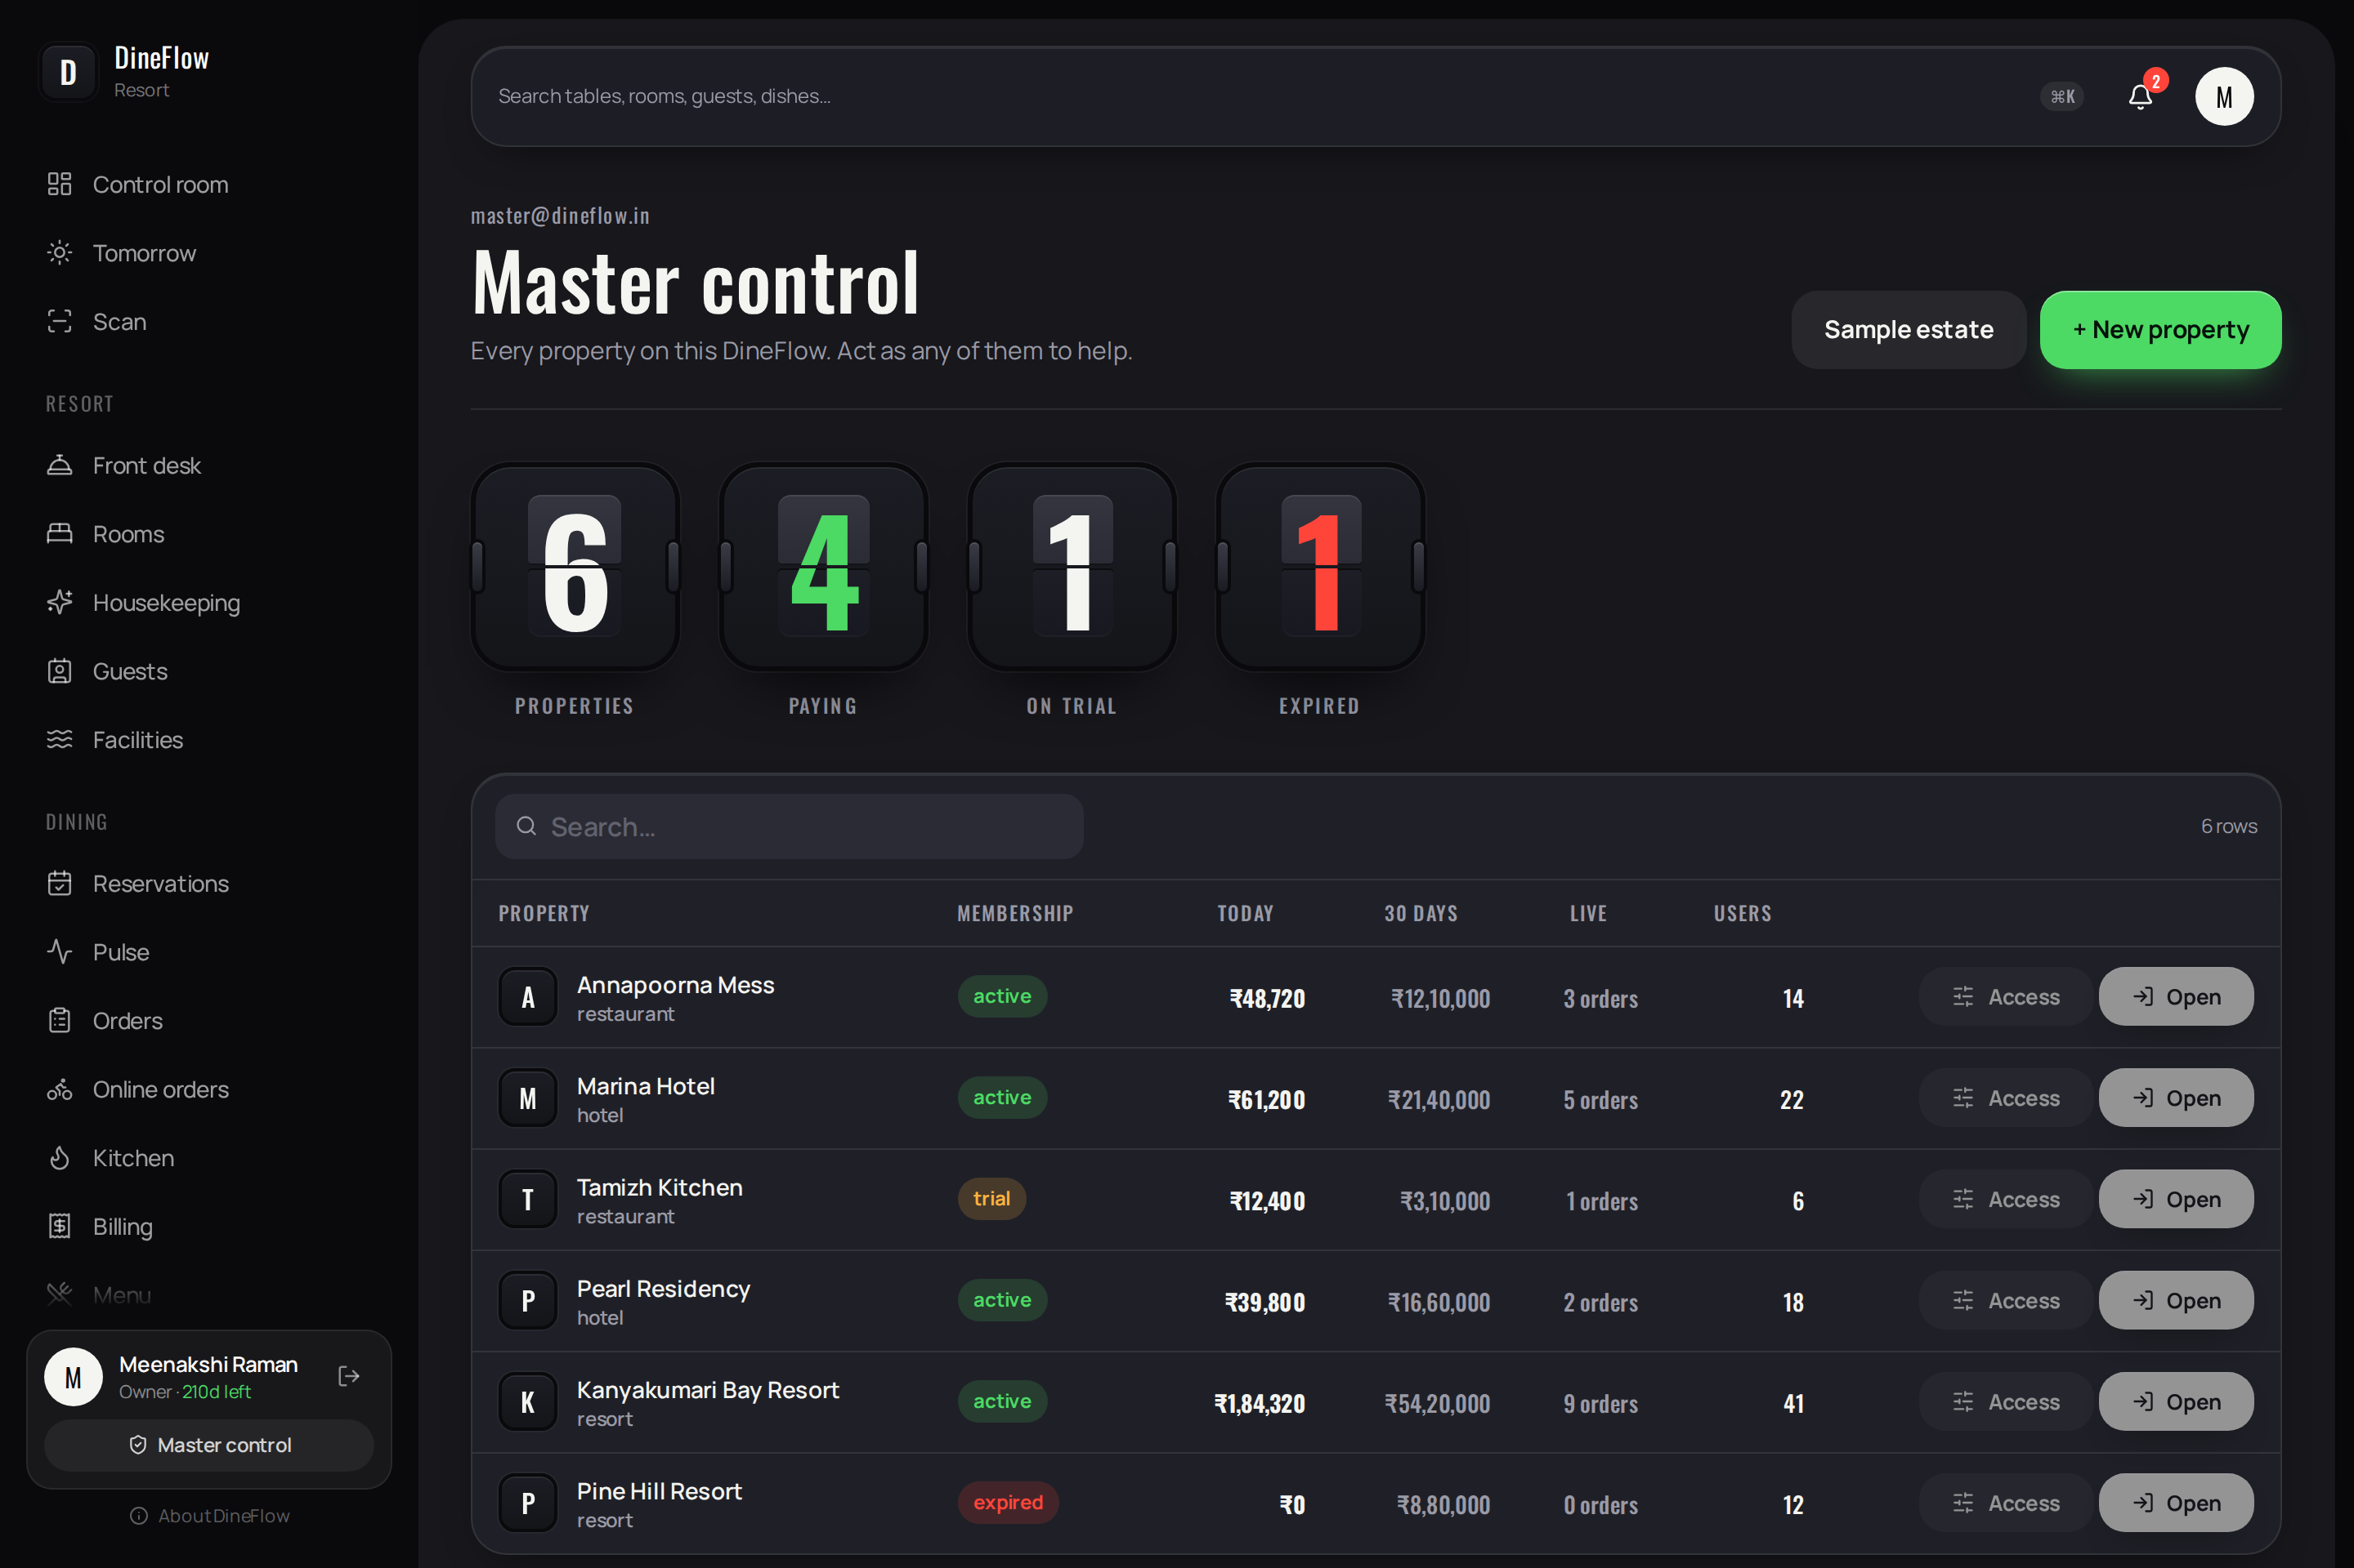
Figure 4.1 — Master control
Purpose. The master's sole screen. It lists every property on the installation with its membership, today's takings and the levers available to the operator of the installation.
Contents:
- Four figures: properties, paying, on trial, expired.
- A sortable and searchable table of properties, showing type, membership with days remaining, today's and thirty days' takings, live orders and user count.
- A second tab listing membership keys and their use.
- Controls to load or examine a demonstration estate and to change the master password.
Operations:
- New property — records the name, the type and the proprietor's electronic mail address, and begins a seven-day trial.
- Access — determines which modules the property may open (Figure 4.2).
- Open — assumes the proprietor's view for support purposes; a banner indicates this and returns the operator here.
- Issue key — produces a membership key of 30, 90 or 365 days for the proprietor to enter.

4.2.2 Master control — Access
Determination of the modules a property may open. Control room and Settings may never be withheld, so that a proprietor always has somewhere to arrive and a means of leaving. A module withheld here is absent from the proprietor's menu, absent from every employee's device, and unreachable by direct address.
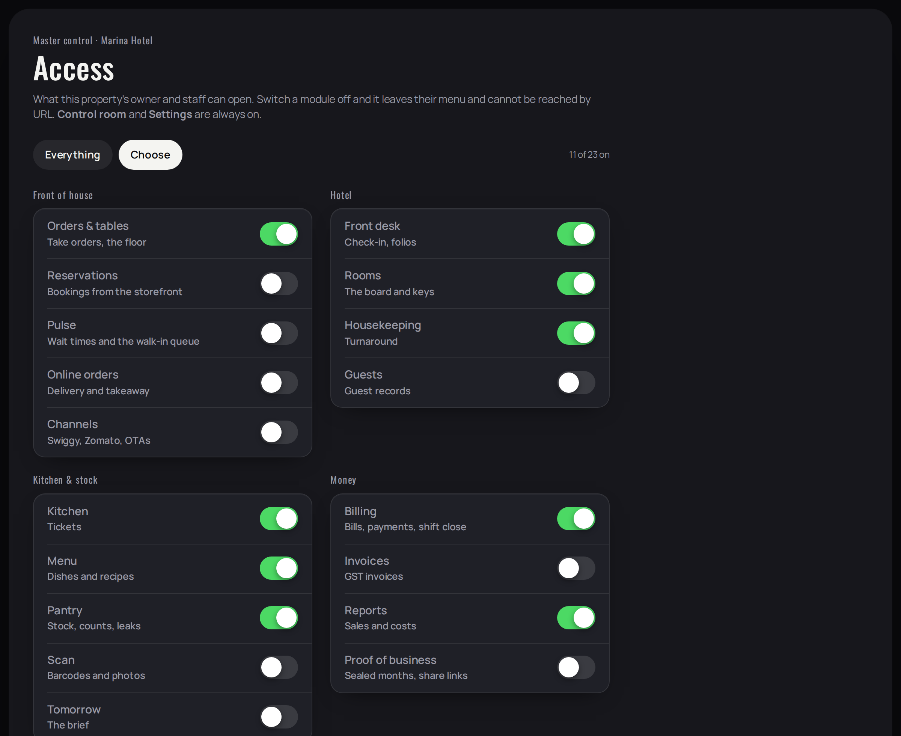
Figure 4.2 — Master control, Access

4.3 Control room

4.3.1 Control room
Permitted to: Every role. This screen may never be withheld.

Figure 4.2 — Control room
Purpose. The proprietor's default screen, presenting the state of the business at this moment.
Contents:
- Salutation, property name and the date line.
- Three flip tiles: occupancy or tables in use, open orders, and tickets in the kitchen — the last turning red when a ticket is late and green when items are ready.
- Takings for the day, with the amount still unbilled on the floor.
- The live floor: every open table with its total and a state indicator.
- Best-selling items and ingredients requiring reorder. For accommodation properties, guests in house, arrivals and departures, and rooms to be turned.
Operations:
- Every figure is a link to the screen that explains it.
- The screen refreshes itself as orders and tickets change; no manual refresh is required.

4.4 Service operations

Figure 4.3 — The life of an order
NOTE Every step below completes without a connection. What is punched offline is held on the device and delivered exactly once when the line returns.

4.4.1 Tables
Permitted to: Owner, manager, cashier, waiter.
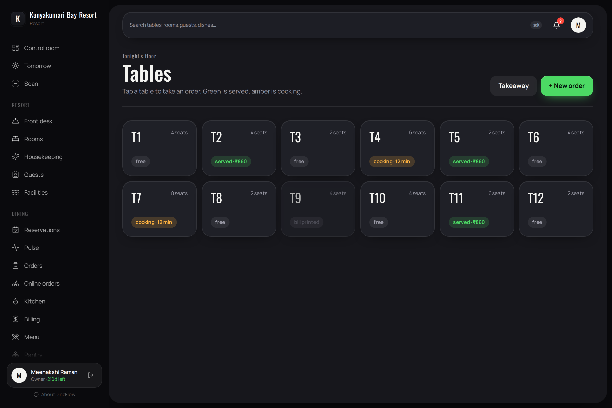
Figure 4.3 — Tables
Purpose. The floor plan. One card per table showing its capacity and its state.
Contents:
- Zones presented as a segmented control.
- Each table shows a state: free, cooking with elapsed time, served with the running total, or bill printed.
Operations:
- Select a table to open the order pad.
- Takeaway creates an order with no table.
- New order begins a fresh order.

4.4.2 Order pad
Permitted to: Owner, manager, cashier, waiter.
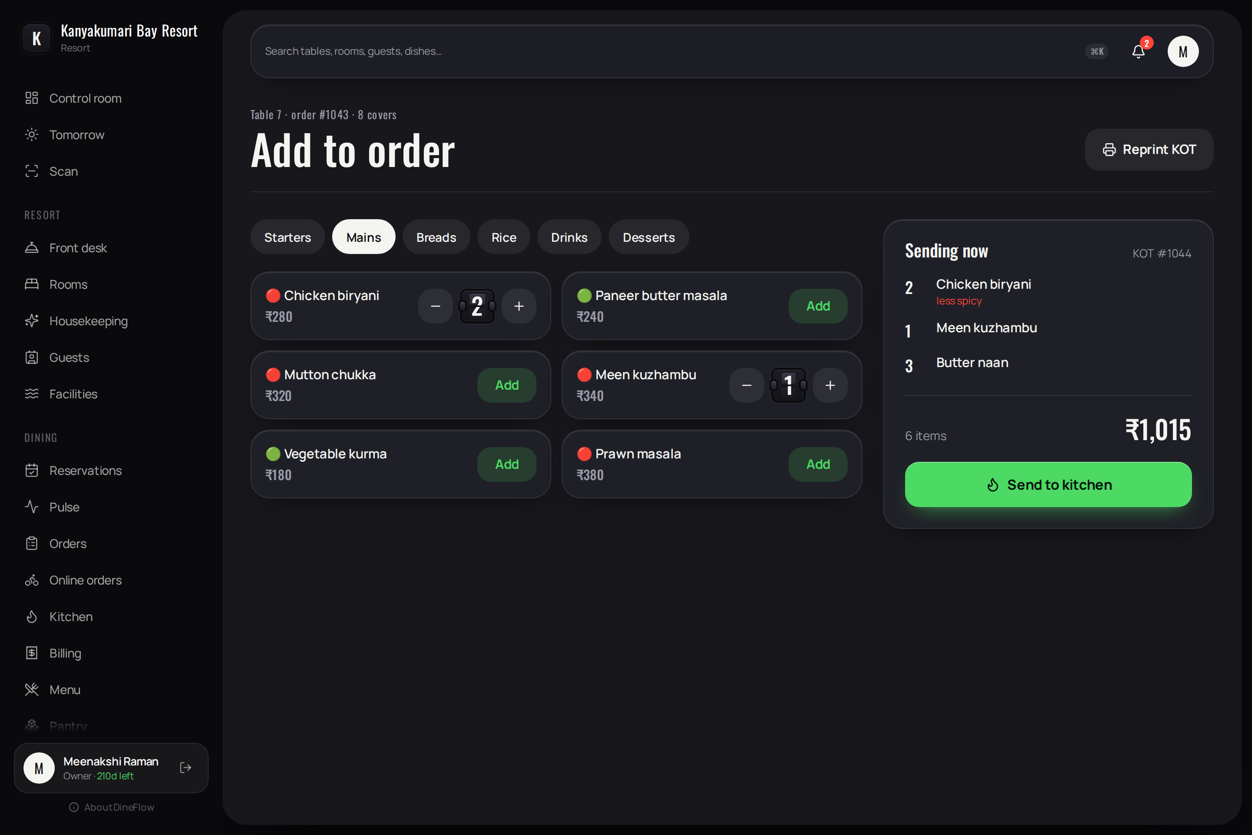
Figure 4.4 — Order pad
Purpose. Composition of an order.
Contents:
- Category filters and the dishes with prices and dietary indicator.
- Quantities presented in small flip tiles with decrement and increment controls.
- The ticket under composition, with any instruction recorded against a line.
- The running total.
Operations:
- Send to kitchen — the ticket appears on the kitchen display in the same second and stock is deducted through the recipe.
- Reprint the kitchen order ticket.
- The operation completes without a connection; the order is held in the outbox and delivered exactly once.

4.4.3 Kitchen
Permitted to: Owner, manager, chef.
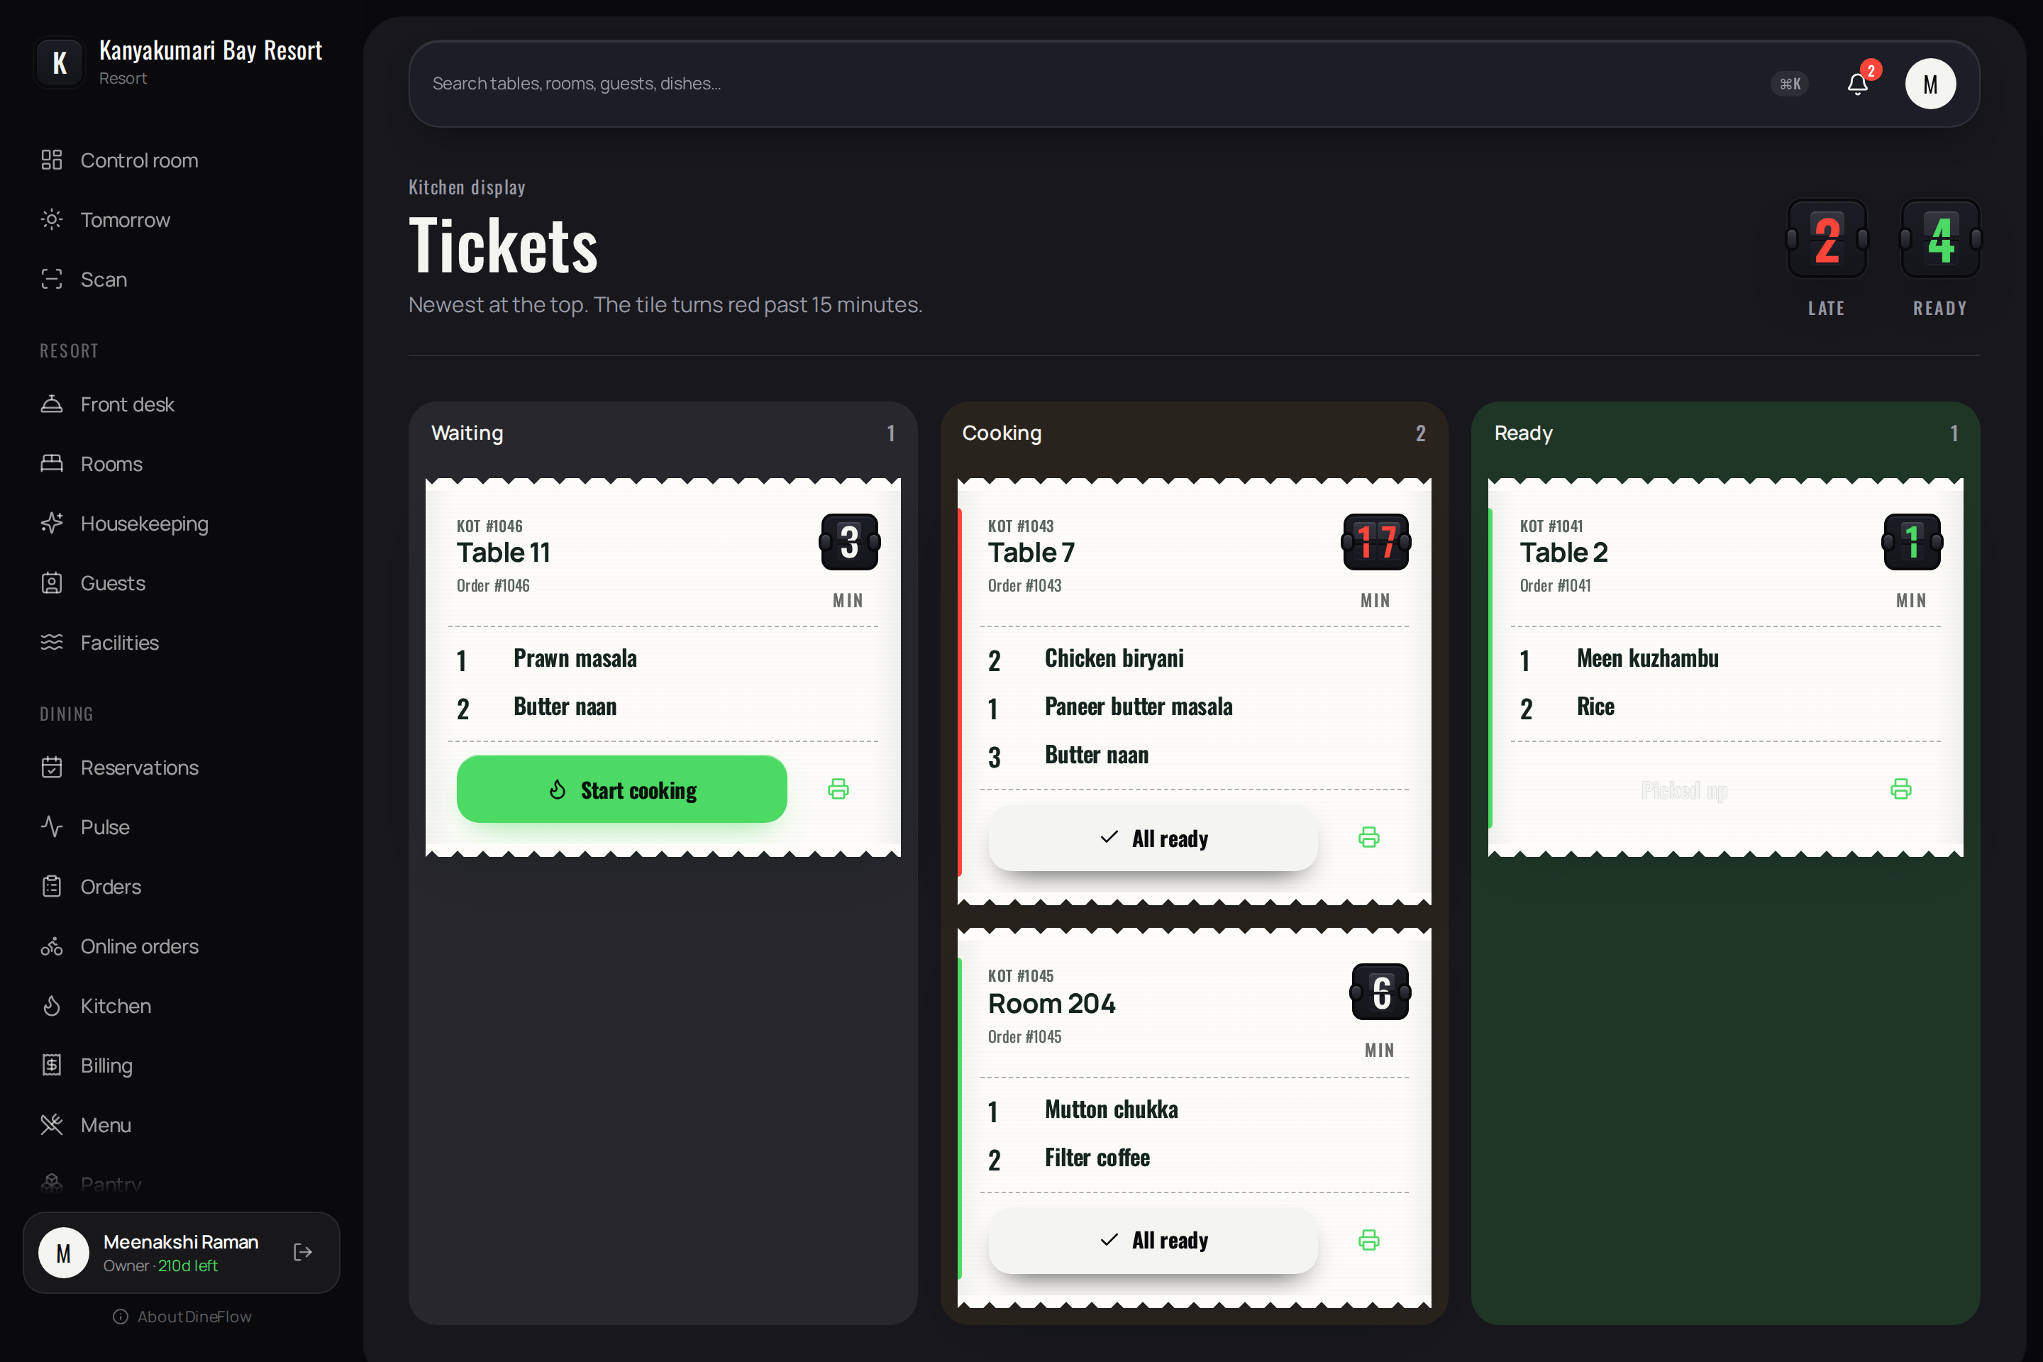
Figure 4.5 — Kitchen
Purpose. The kitchen display. Three columns present tickets awaiting preparation, in preparation, and ready.
Contents:
- Counts of late and ready tickets as flip tiles.
- Each ticket presented as a kitchen order ticket with its number, the table or room, the lines, and an elapsed-time tile that turns red after fifteen minutes.
Operations:
- Start cooking, All ready, Picked up.
- An individual line may be marked ready.
- Tickets travel between columns; the operation completes without a connection.

4.4.4 Billing
Permitted to: Owner, manager, cashier.
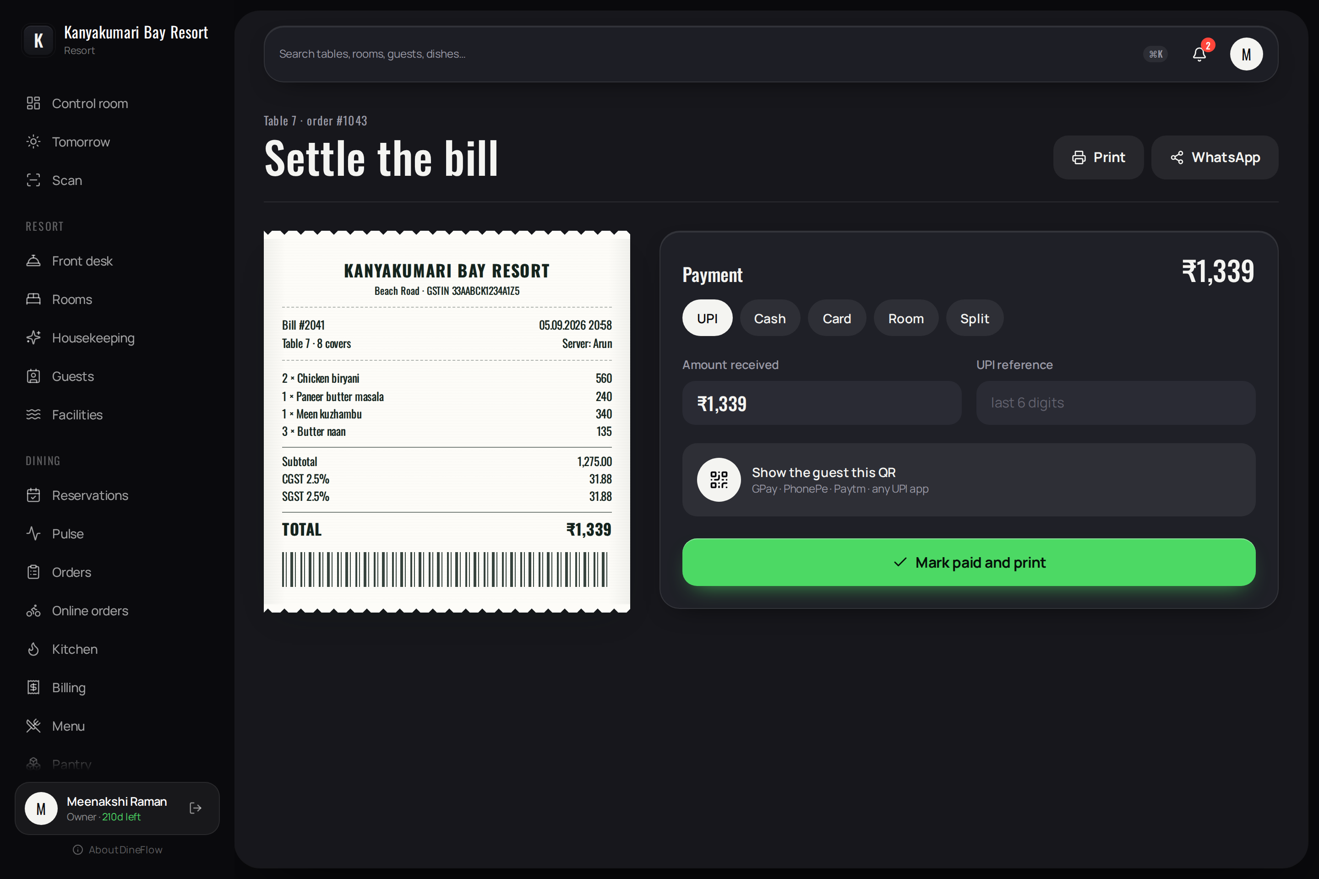
Figure 4.6 — Billing
Purpose. Settlement of a bill and reconciliation of the shift.
Contents:
- The thermal receipt exactly as it prints: property, registration number, lines, tax divided into central and state components, discounts, total and barcode.
- Payment by unified payments interface, cash, card, room folio or a split; a code for the guest to scan.
Operations:
- Mark paid and print. Send the bill by the messaging share sheet.
- Close shift — presents the expected contents of the till against the counted cash, states the difference before submission, and produces a single paragraph of summary. After midnight the business day is counted from the previous morning.

4.4.5 Pulse
Permitted to: Owner, manager, cashier, waiter.
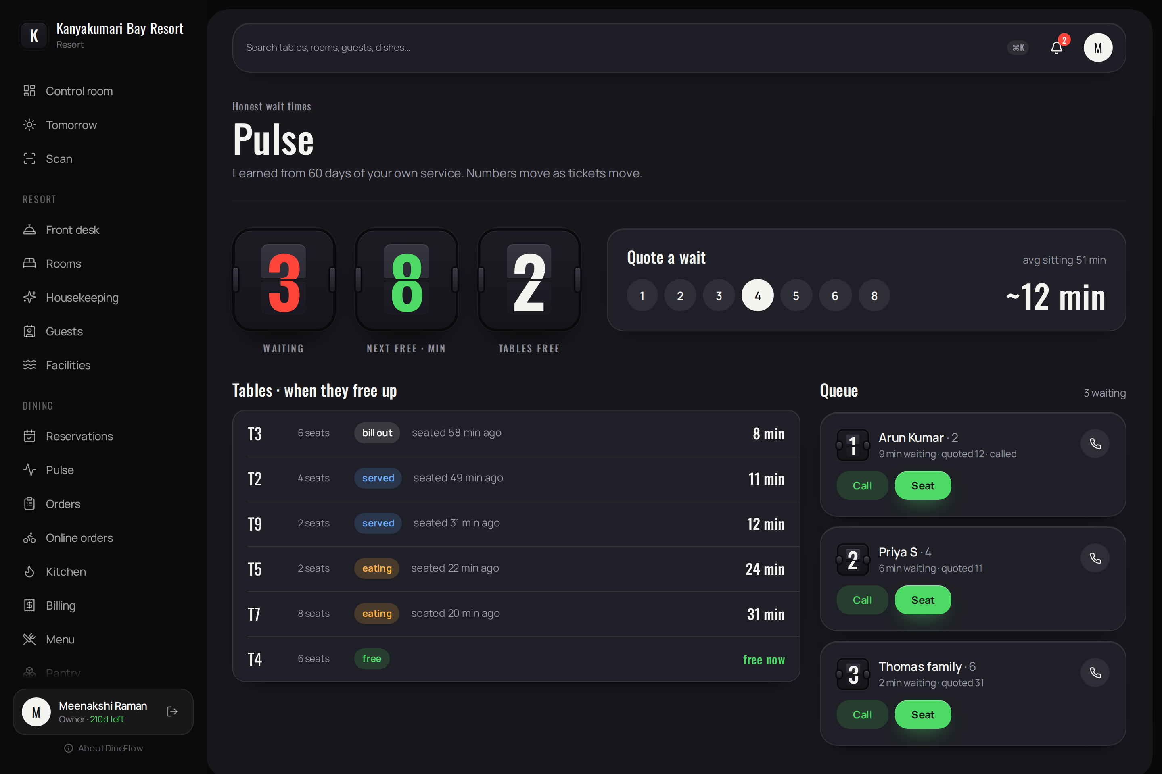
Figure 4.7 — Pulse
Purpose. Quotation of waiting times and management of the queue at the door.
Contents:
- Parties waiting, minutes until the next table, and tables free.
- A quotation for a chosen party size, derived from each occupied table's ticket progress and the property's own history of sitting durations.
- Every table with its stage and the minutes remaining; the queue with each party's wait and the time quoted to them.
Operations:
- Add a party; call; seat, which offers only tables large enough.
- Publish a code at the door: guests join from their own telephone and observe their position, with a countdown; on being seated their telephone displays the table.

4.4.6 Reservations
Permitted to: Owner, manager, cashier, waiter, front desk.
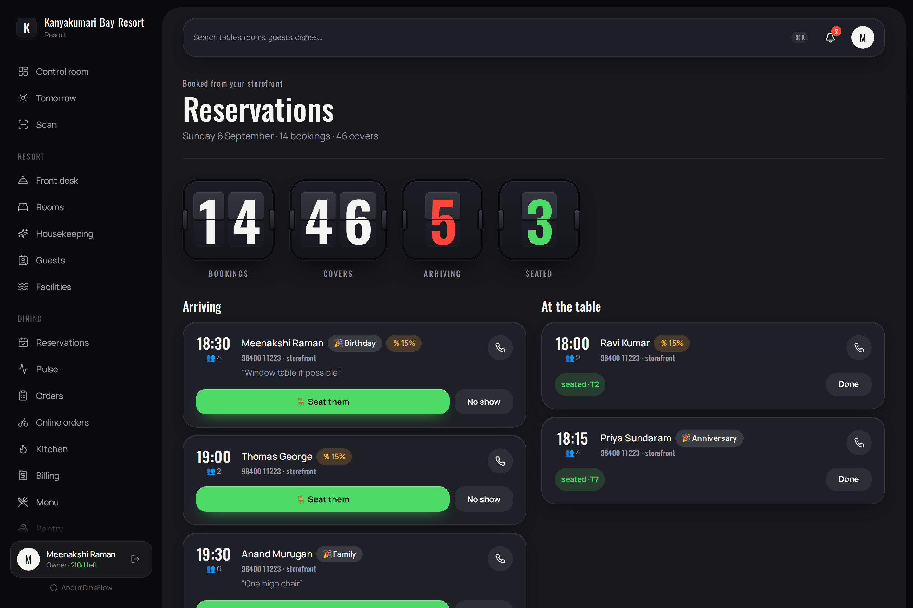
Figure 4.8 — Reservations
Purpose. Table reservations received through the property's public page.
Contents:
- Bookings, covers, parties arriving and parties seated.
- Each reservation with the time, party size, occasion, the offer applied and the guest's note.
Operations:
- Seat, which offers a table; record a non-arrival; telephone the guest.

4.5 Accommodation operations
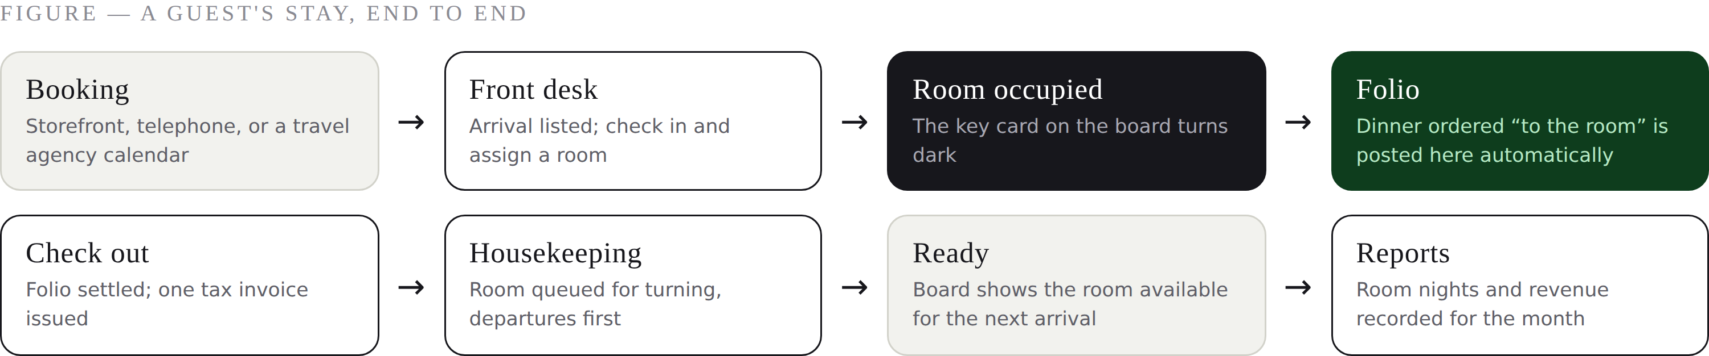
Figure 4.8 — A guest's stay, end to end

4.5.1 Rooms
Permitted to: Owner, manager, front desk; housekeeping may view.
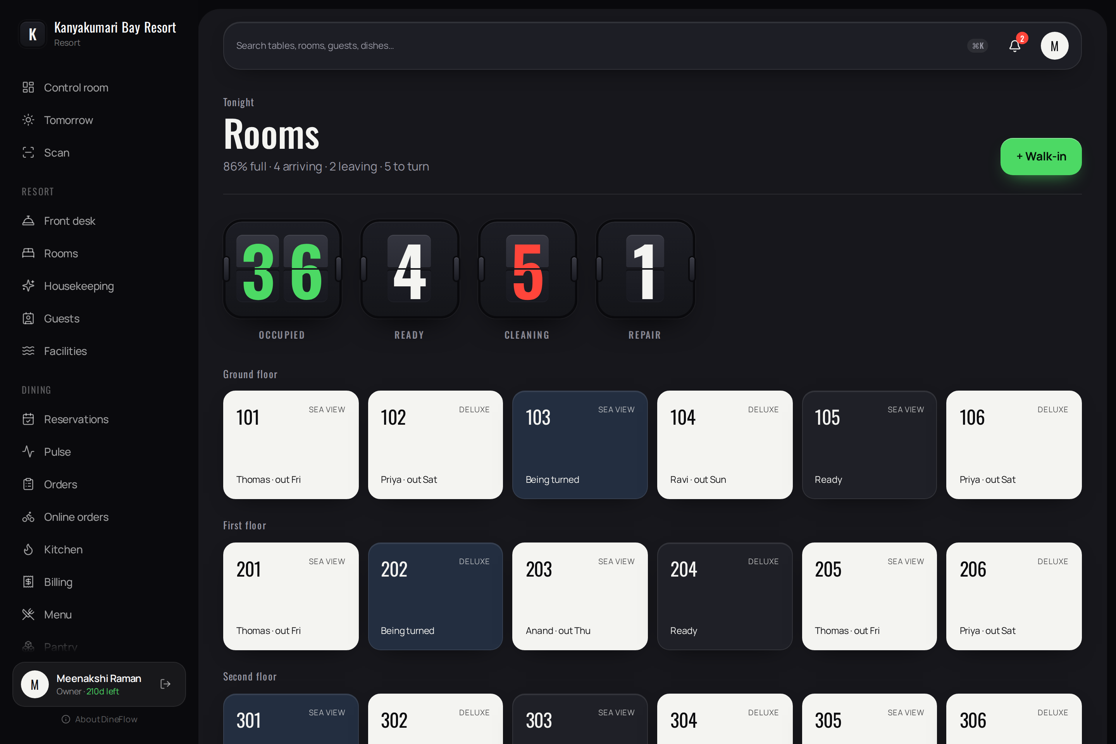
Figure 4.9 — Rooms
Purpose. The room board.
Contents:
- Occupied, ready, being cleaned and out of service, as flip tiles.
- Rooms grouped by floor, each presented as a key card carrying its number, type, occupant and departure date.
Operations:
- Select a room for its folio. Record a walk-in. Rates may be set by date.

4.5.2 Front desk
Permitted to: Owner, manager, cashier, front desk.
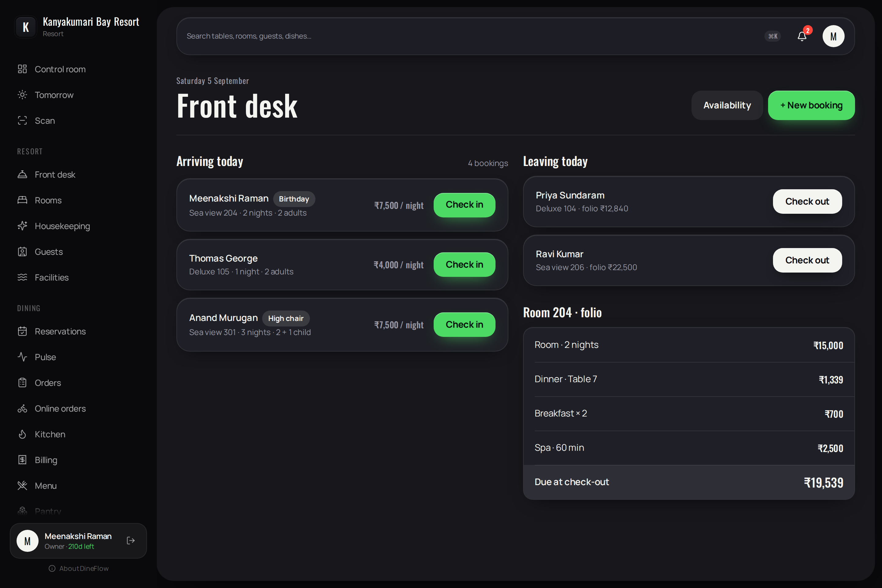
Figure 4.10 — Front desk
Purpose. Arrivals, departures and folios.
Contents:
- Arrivals with room, nights, occupancy and rate; departures with the folio total.
- The folio itself: room nights, restaurant charges posted from the dining room, and other services, with the amount due.
Operations:
- Check in, which assigns a room. Check out, which settles the folio and issues one tax invoice.
- Examine availability; record a new booking.

4.5.3 Housekeeping
Permitted to: Owner, manager, front desk, housekeeping.
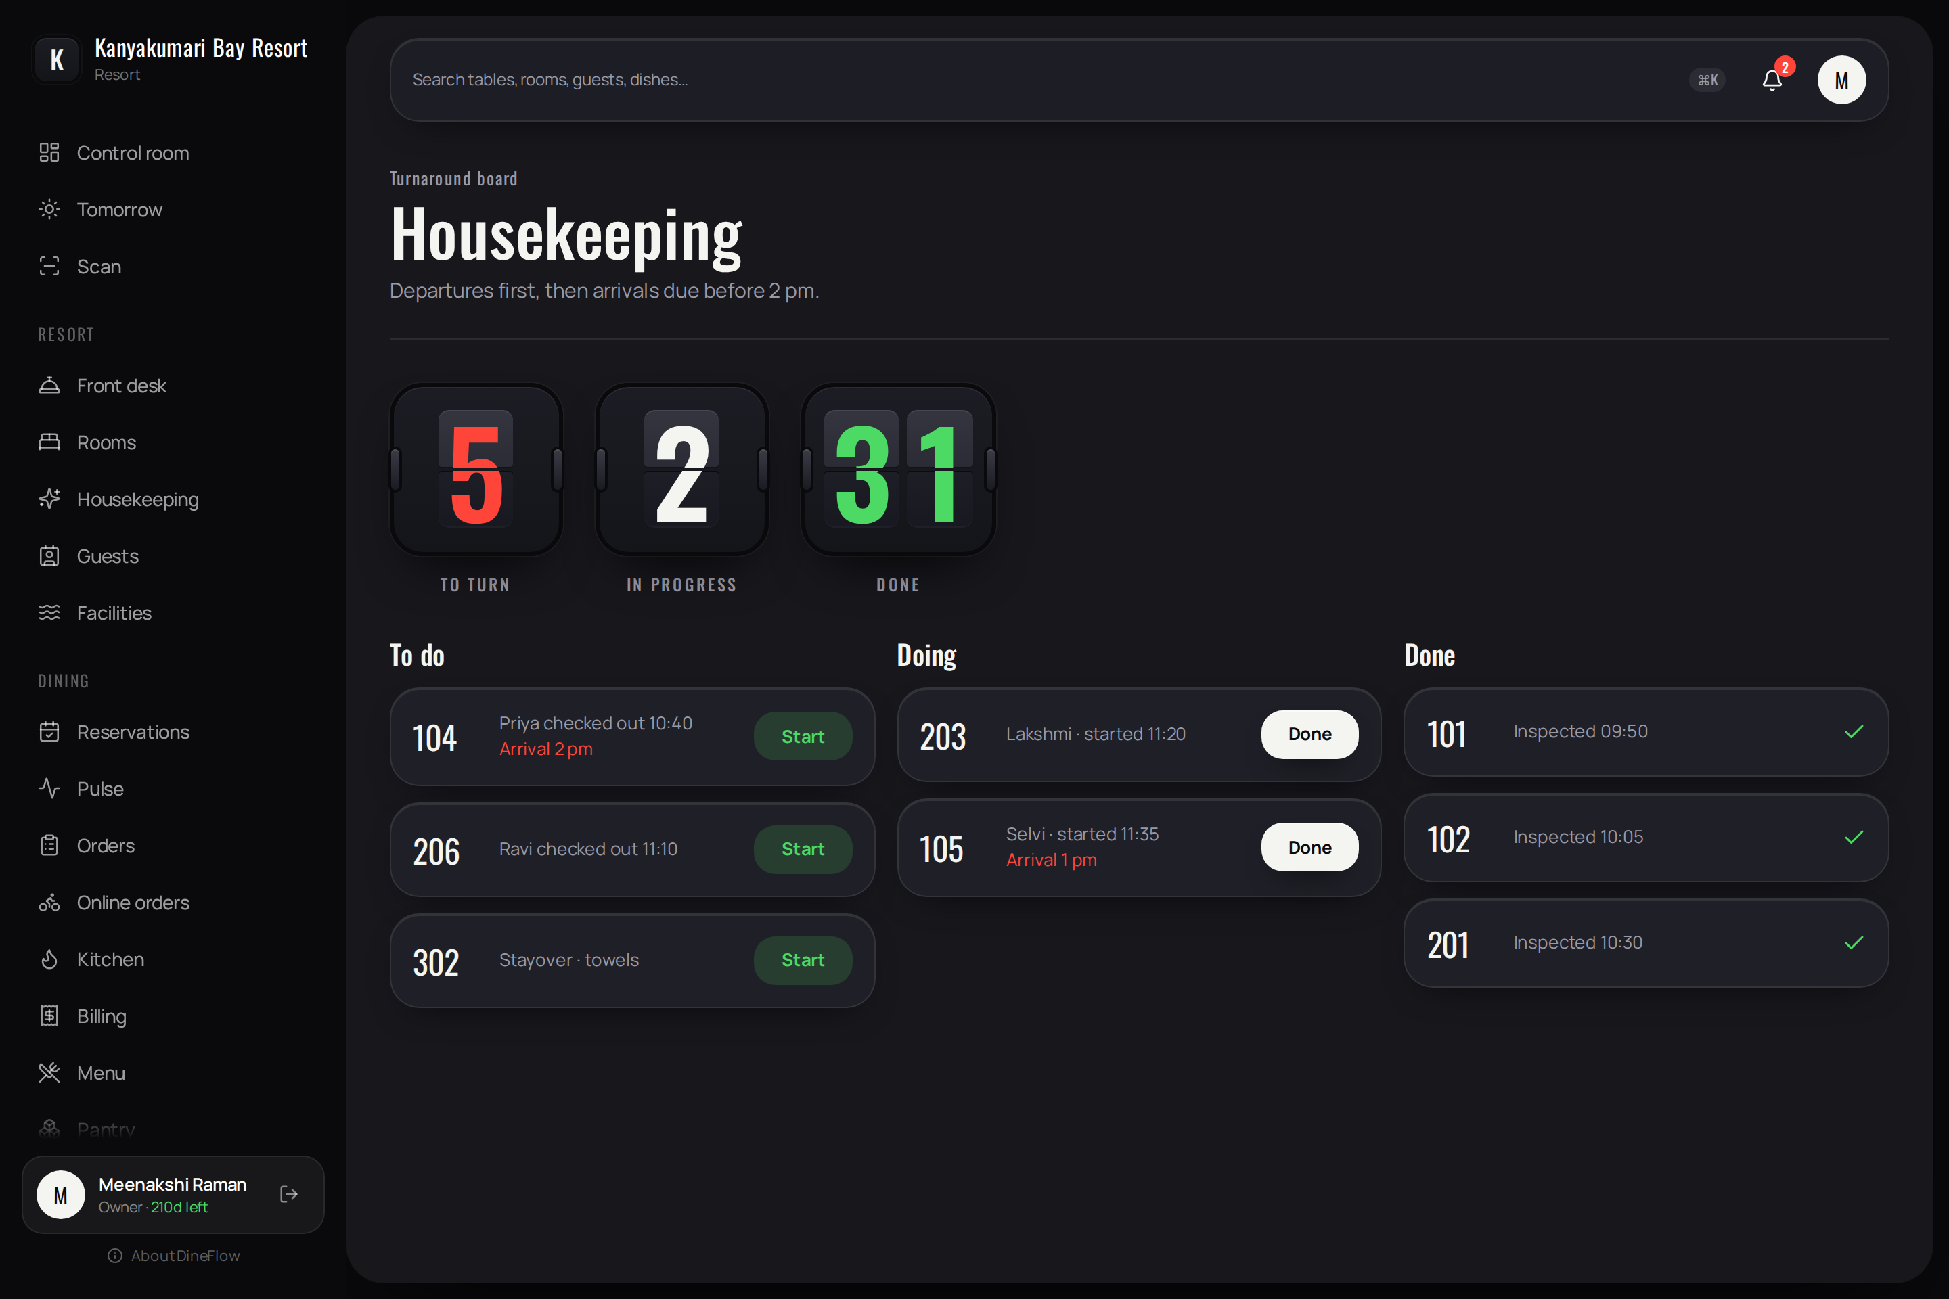
Figure 4.11 — Housekeeping
Purpose. The turnaround board, ordered by urgency: departures first, then rooms required for arrivals before two o'clock.
Contents:
- To do, in progress and completed, with the attendant's name and the time started, and arrival deadlines marked.
Operations:
- Start and Done, recorded from the attendant's telephone; the room's card updates for the front desk.

4.6 Inventory and menu
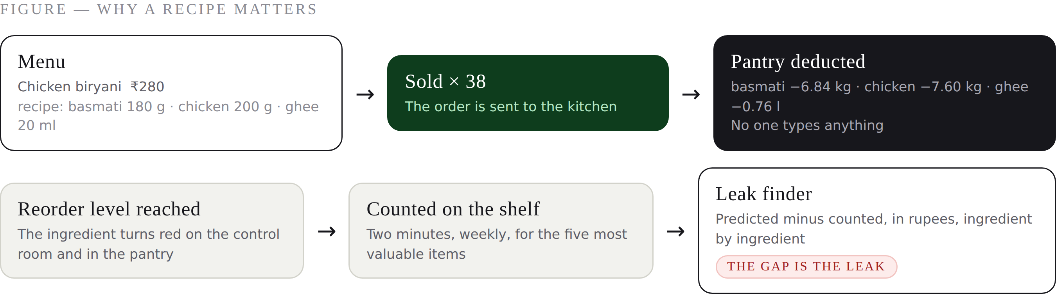
Figure 4.11 — Why a recipe matters
KEY POINT A dish without a recipe still sells; it simply does not move stock. Recording the recipes of the ten best-selling dishes captures most of the benefit on the first day.

4.6.1 Pantry
Permitted to: Owner, manager, store; chef may view.
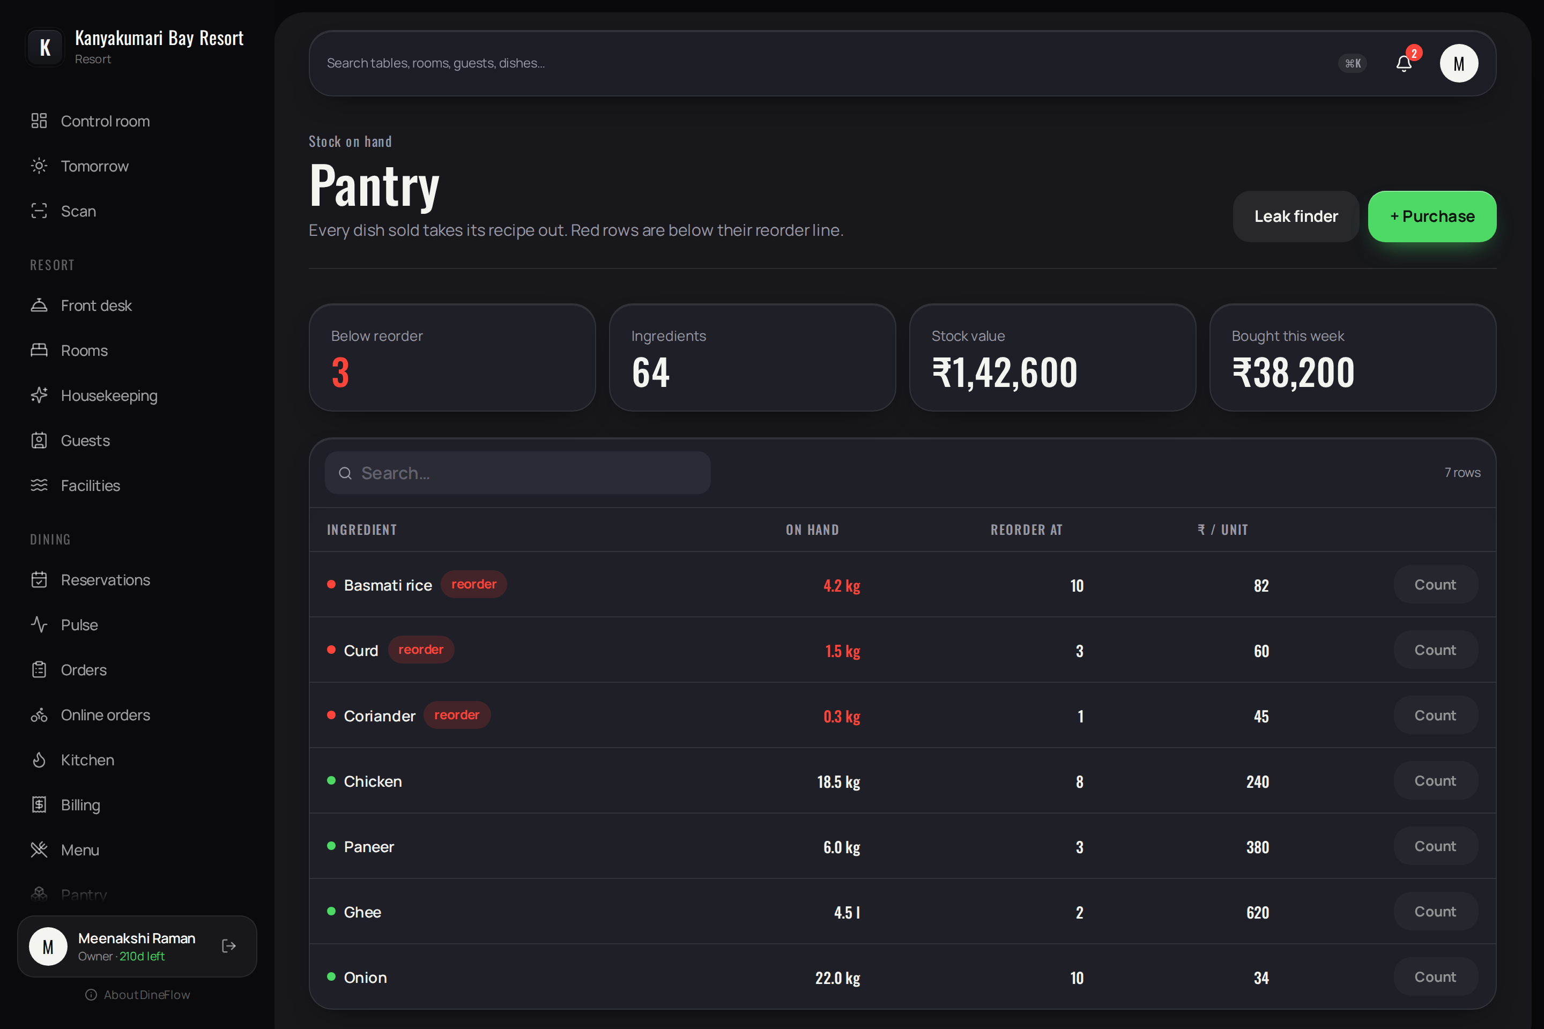
Figure 4.12 — Pantry
Purpose. Stock in hand. Each dish sold deducts its recipe.
Contents:
- Ingredients below their reorder level, count of ingredients, value of stock and purchases for the week.
- A sortable, searchable table: cost per unit, quantity in hand, reorder level.
Operations:
- Record a purchase, wastage or adjustment. Conduct a stock count.
- Leak finder — compares the quantity the recipes predict against the quantity counted, expressed in currency, ingredient by ingredient, since the last count.

4.6.2 Menu
Permitted to: Owner, manager, chef.
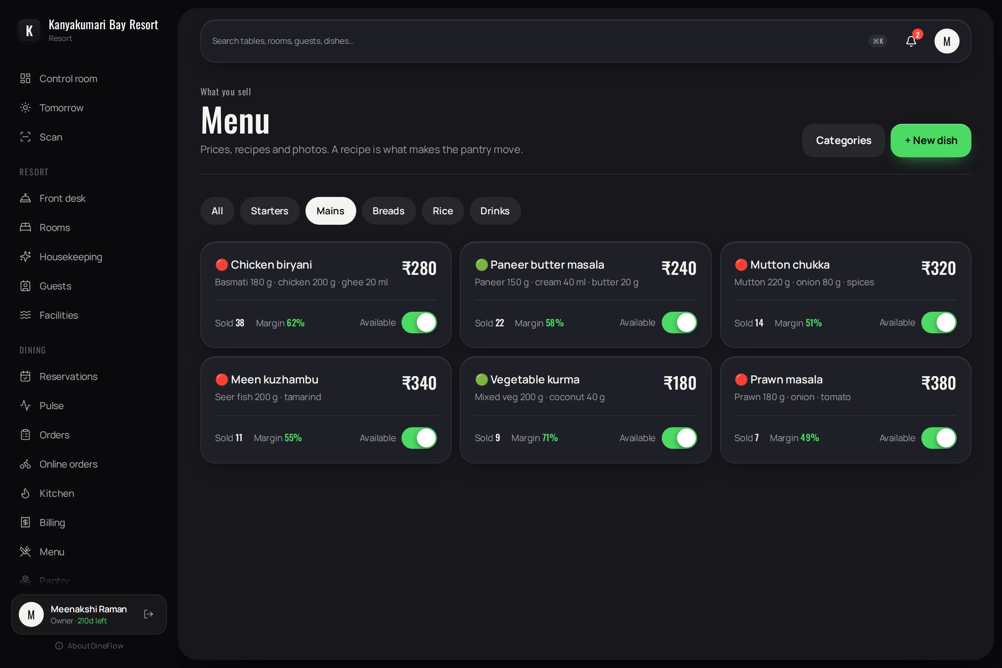
Figure 4.13 — Menu
Purpose. Dishes, prices, recipes and availability.
Contents:
- Category filters. Each dish with its dietary indicator, price, recipe, quantity sold today, margin and an availability switch.
Operations:
- Record a dish and its recipe. The recipe is the mechanism by which stock is deducted automatically.

4.7 Intelligence and records

4.7.1 Tomorrow's brief
Permitted to: Owner, manager, chef, store.
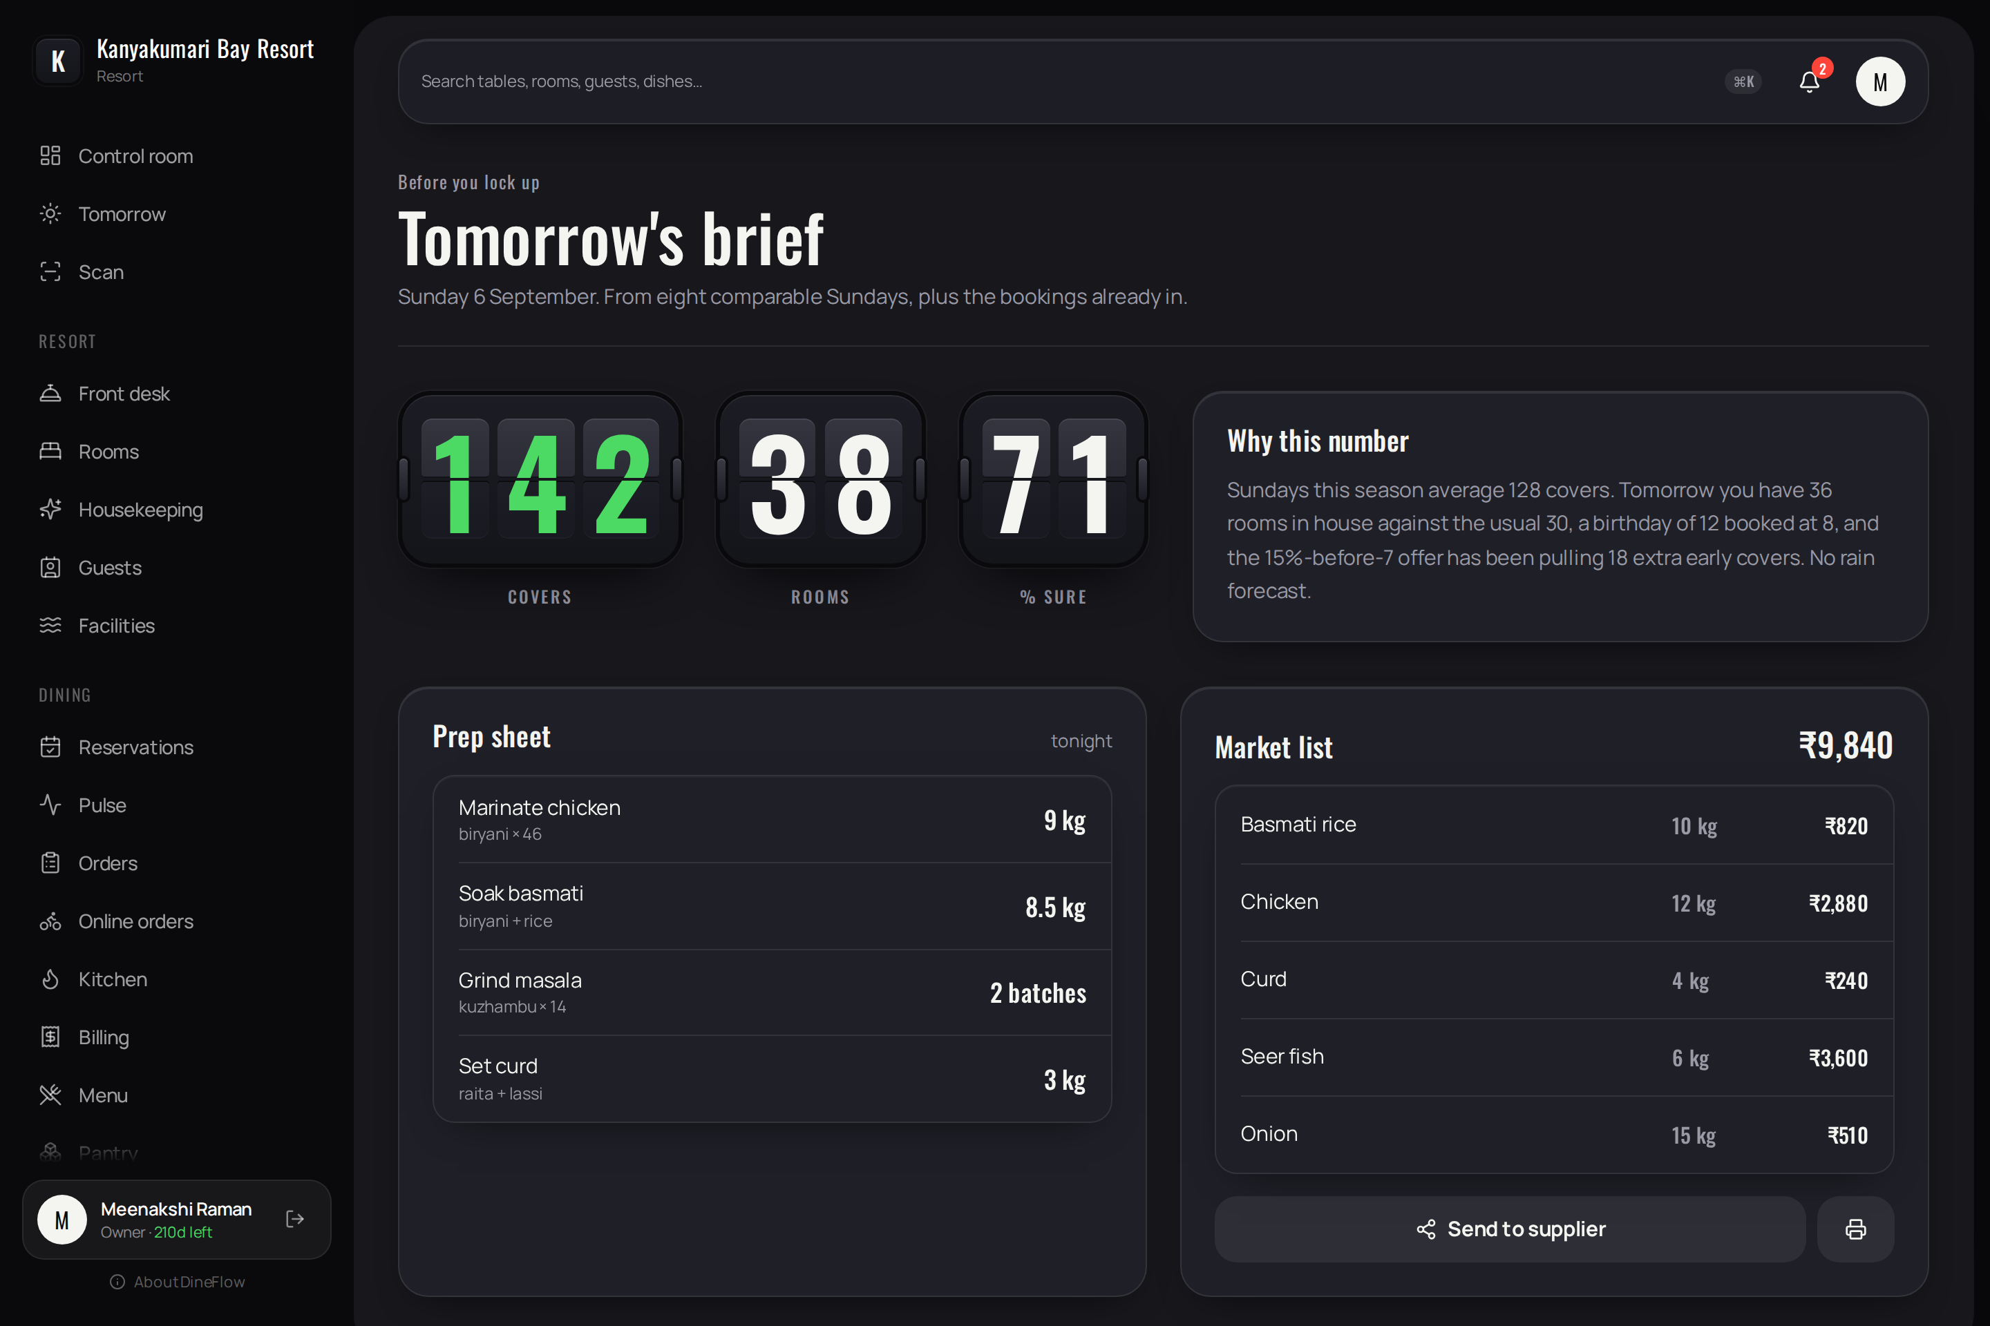
Figure 4.14 — Tomorrow's brief
Purpose. Preparation for the following day, prepared before closing.
Contents:
- Predicted covers and rooms, with a confidence figure, derived from comparable days and the reservations already held.
- A statement of the reasoning. A preparation sheet and a market list with estimated cost.
Operations:
- Send the market list to the supplier; print it. The prediction is graded against the outcome the following day.

4.7.2 Neighbours
Permitted to: Owner, manager, store.
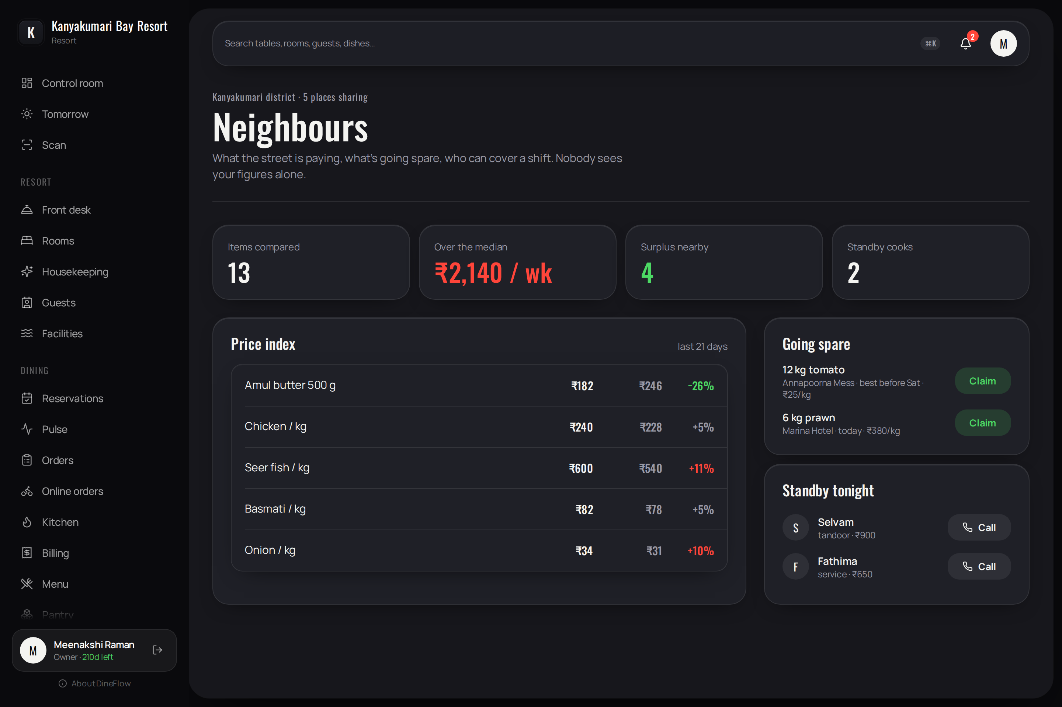
Figure 4.15 — Neighbours
Purpose. An optional district network. Participating properties contribute purchase prices, surplus stock and available relief staff.
Contents:
- Items compared, the amount paid above the district median, surplus nearby and relief staff available.
- A price index comparing the property's prices against the district median.
Operations:
- Claim surplus stock; telephone relief staff; publish the property's own surplus.
- No property's figures are ever shown alone: below five contributors the page is withheld.

4.7.3 Proof of business
Permitted to: Owner, manager.
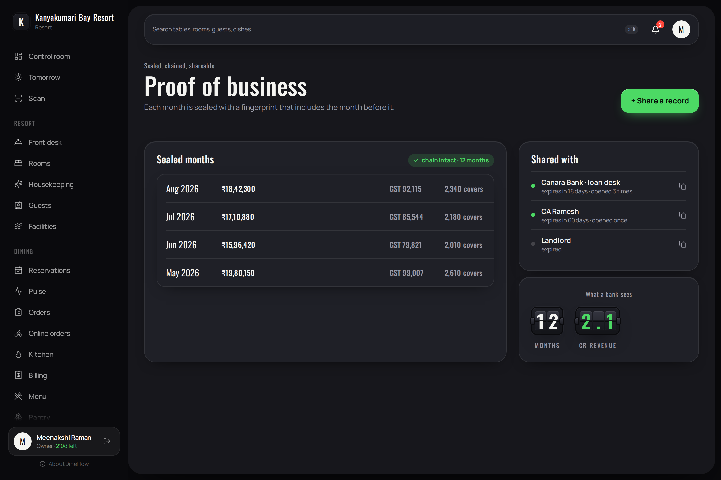
Figure 4.16 — Proof of business
Purpose. A verifiable record of trading, for a lender or an accountant.
Contents:
- Each month sealed with a fingerprint that incorporates the month preceding it, with revenue, tax and covers.
- Links issued, their expiry and the number of times opened.
Operations:
- Issue an expiring, revocable link. The recipient's page verifies the chain when opened. Alteration of a sealed figure is detected and reported.

4.7.4 Labour
Permitted to: Owner, manager, store.
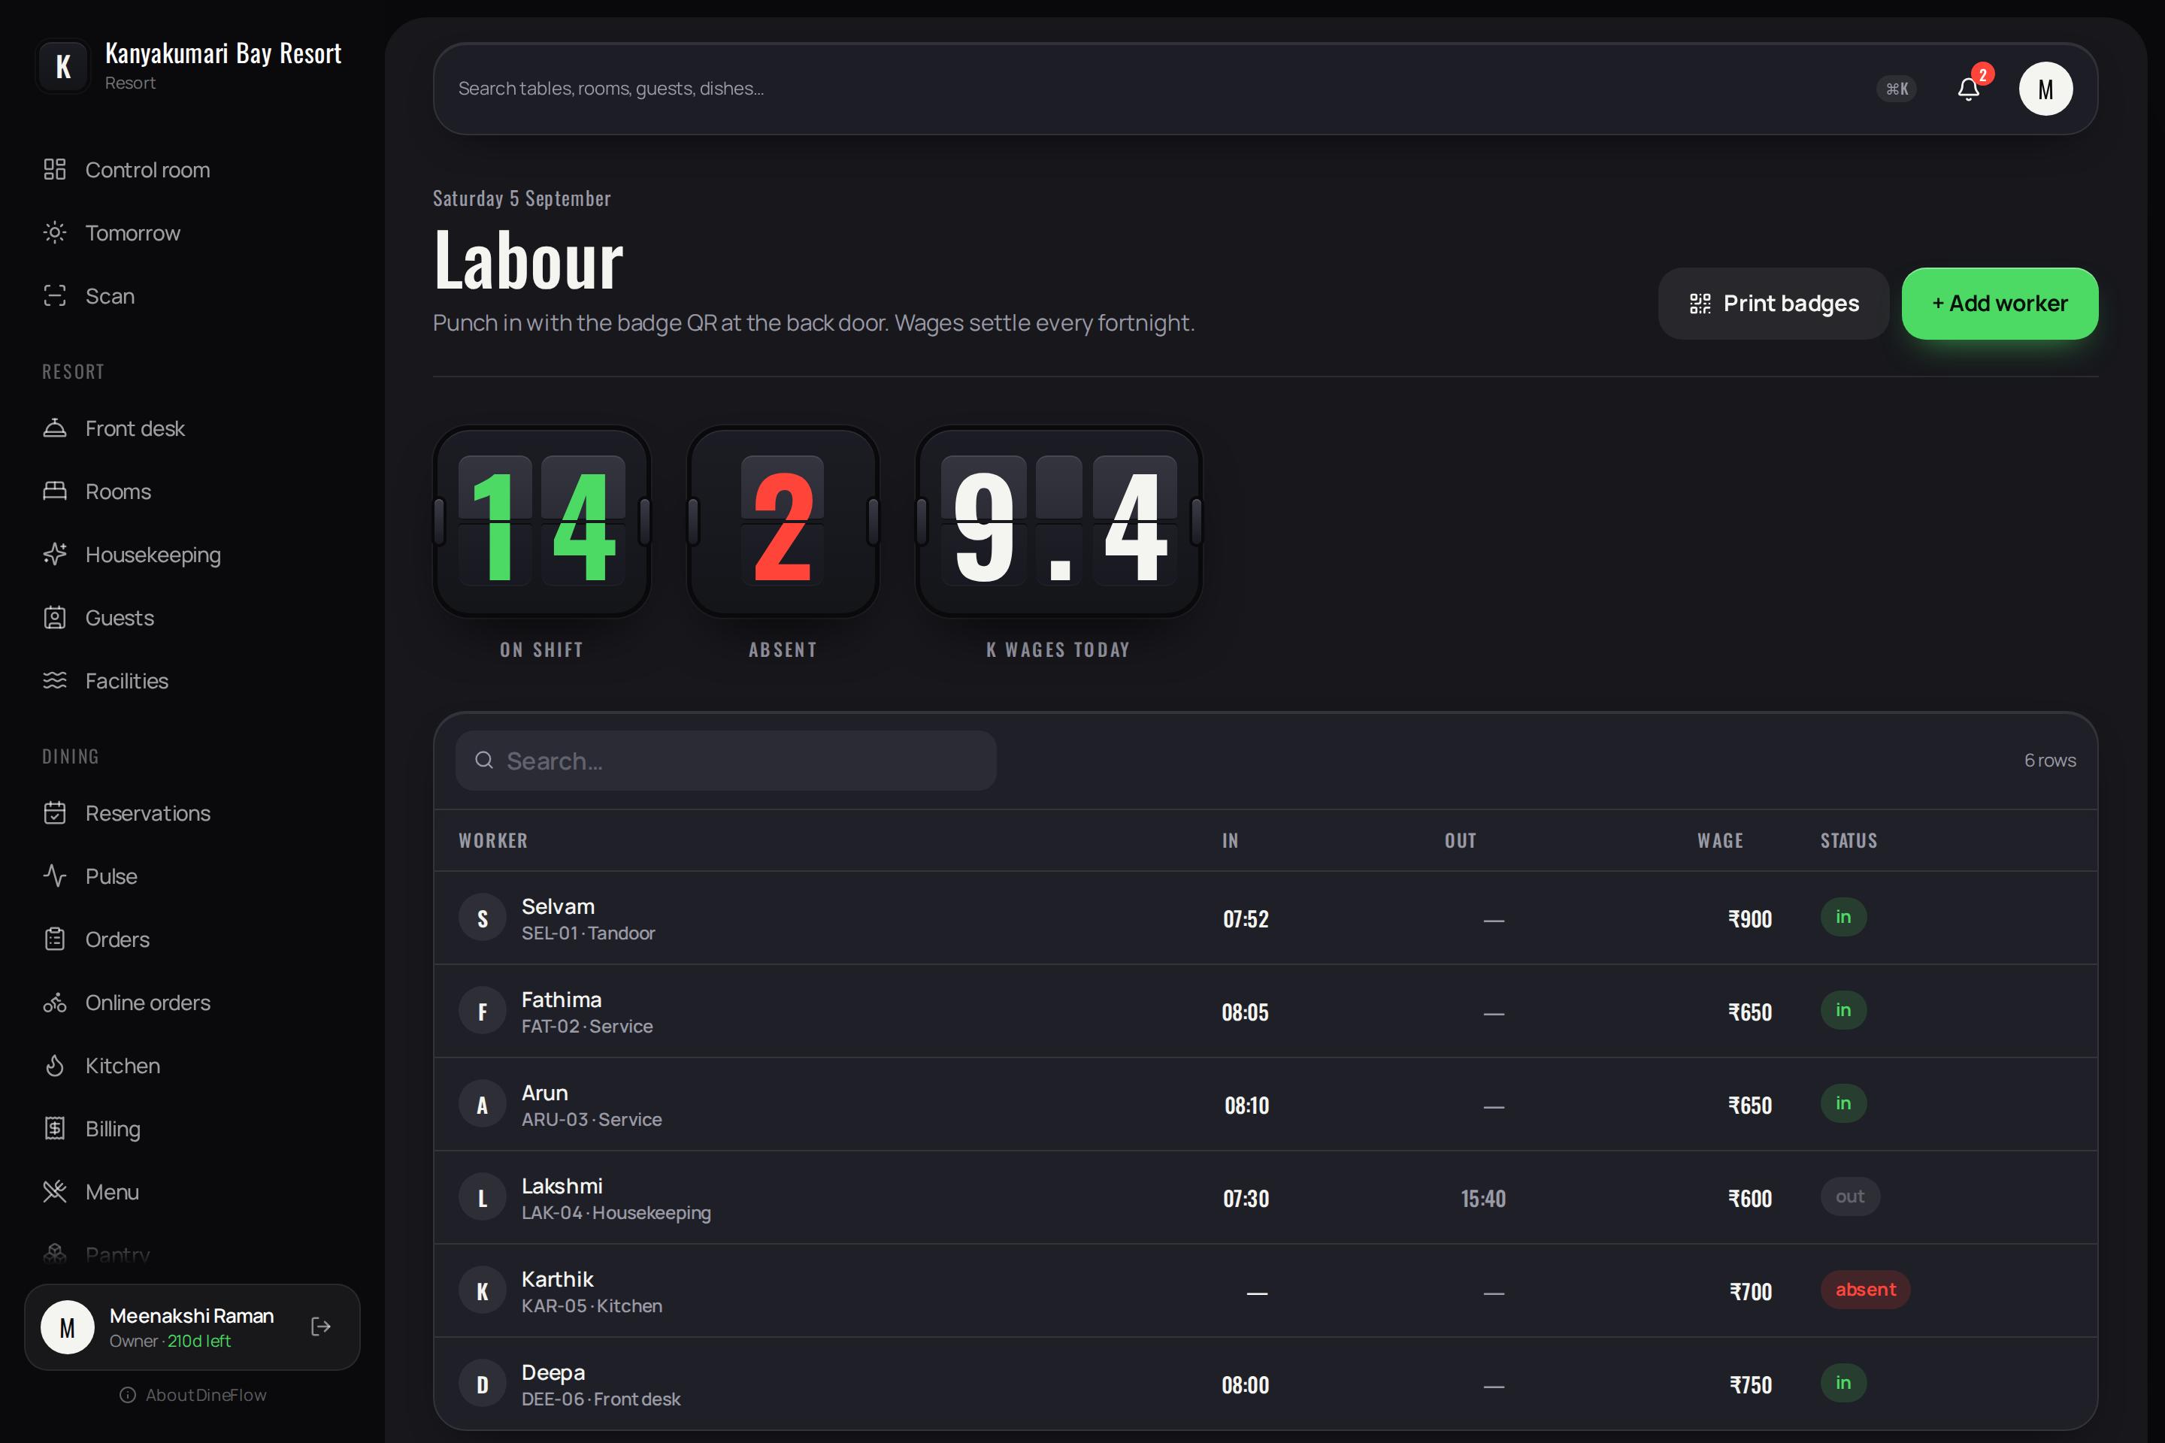
Figure 4.17 — Labour
Purpose. Attendance and wages.
Contents:
- Staff on shift, absent, and wages for the day.
- A table of workers with code, skill, times of entry and departure, wage and state.
Operations:
- Print attendance badges; record a worker; settle wages for the fortnight.

4.7.5 Reports
Permitted to: Owner, manager, cashier.
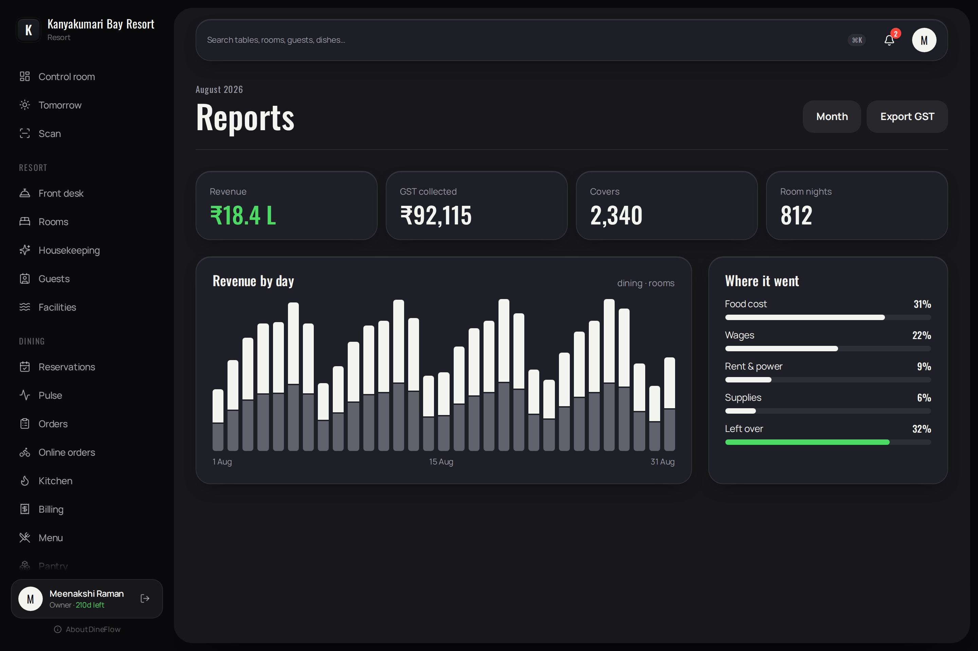
Figure 4.18 — Reports
Purpose. The trading month.
Contents:
- Revenue, tax collected, covers and room nights.
- Revenue by day, dining and accommodation distinguished; distribution of costs.
Operations:
- Select a month; export the tax summary.

4.8 Administration

4.8.1 Staff
Permitted to: Owner, manager.
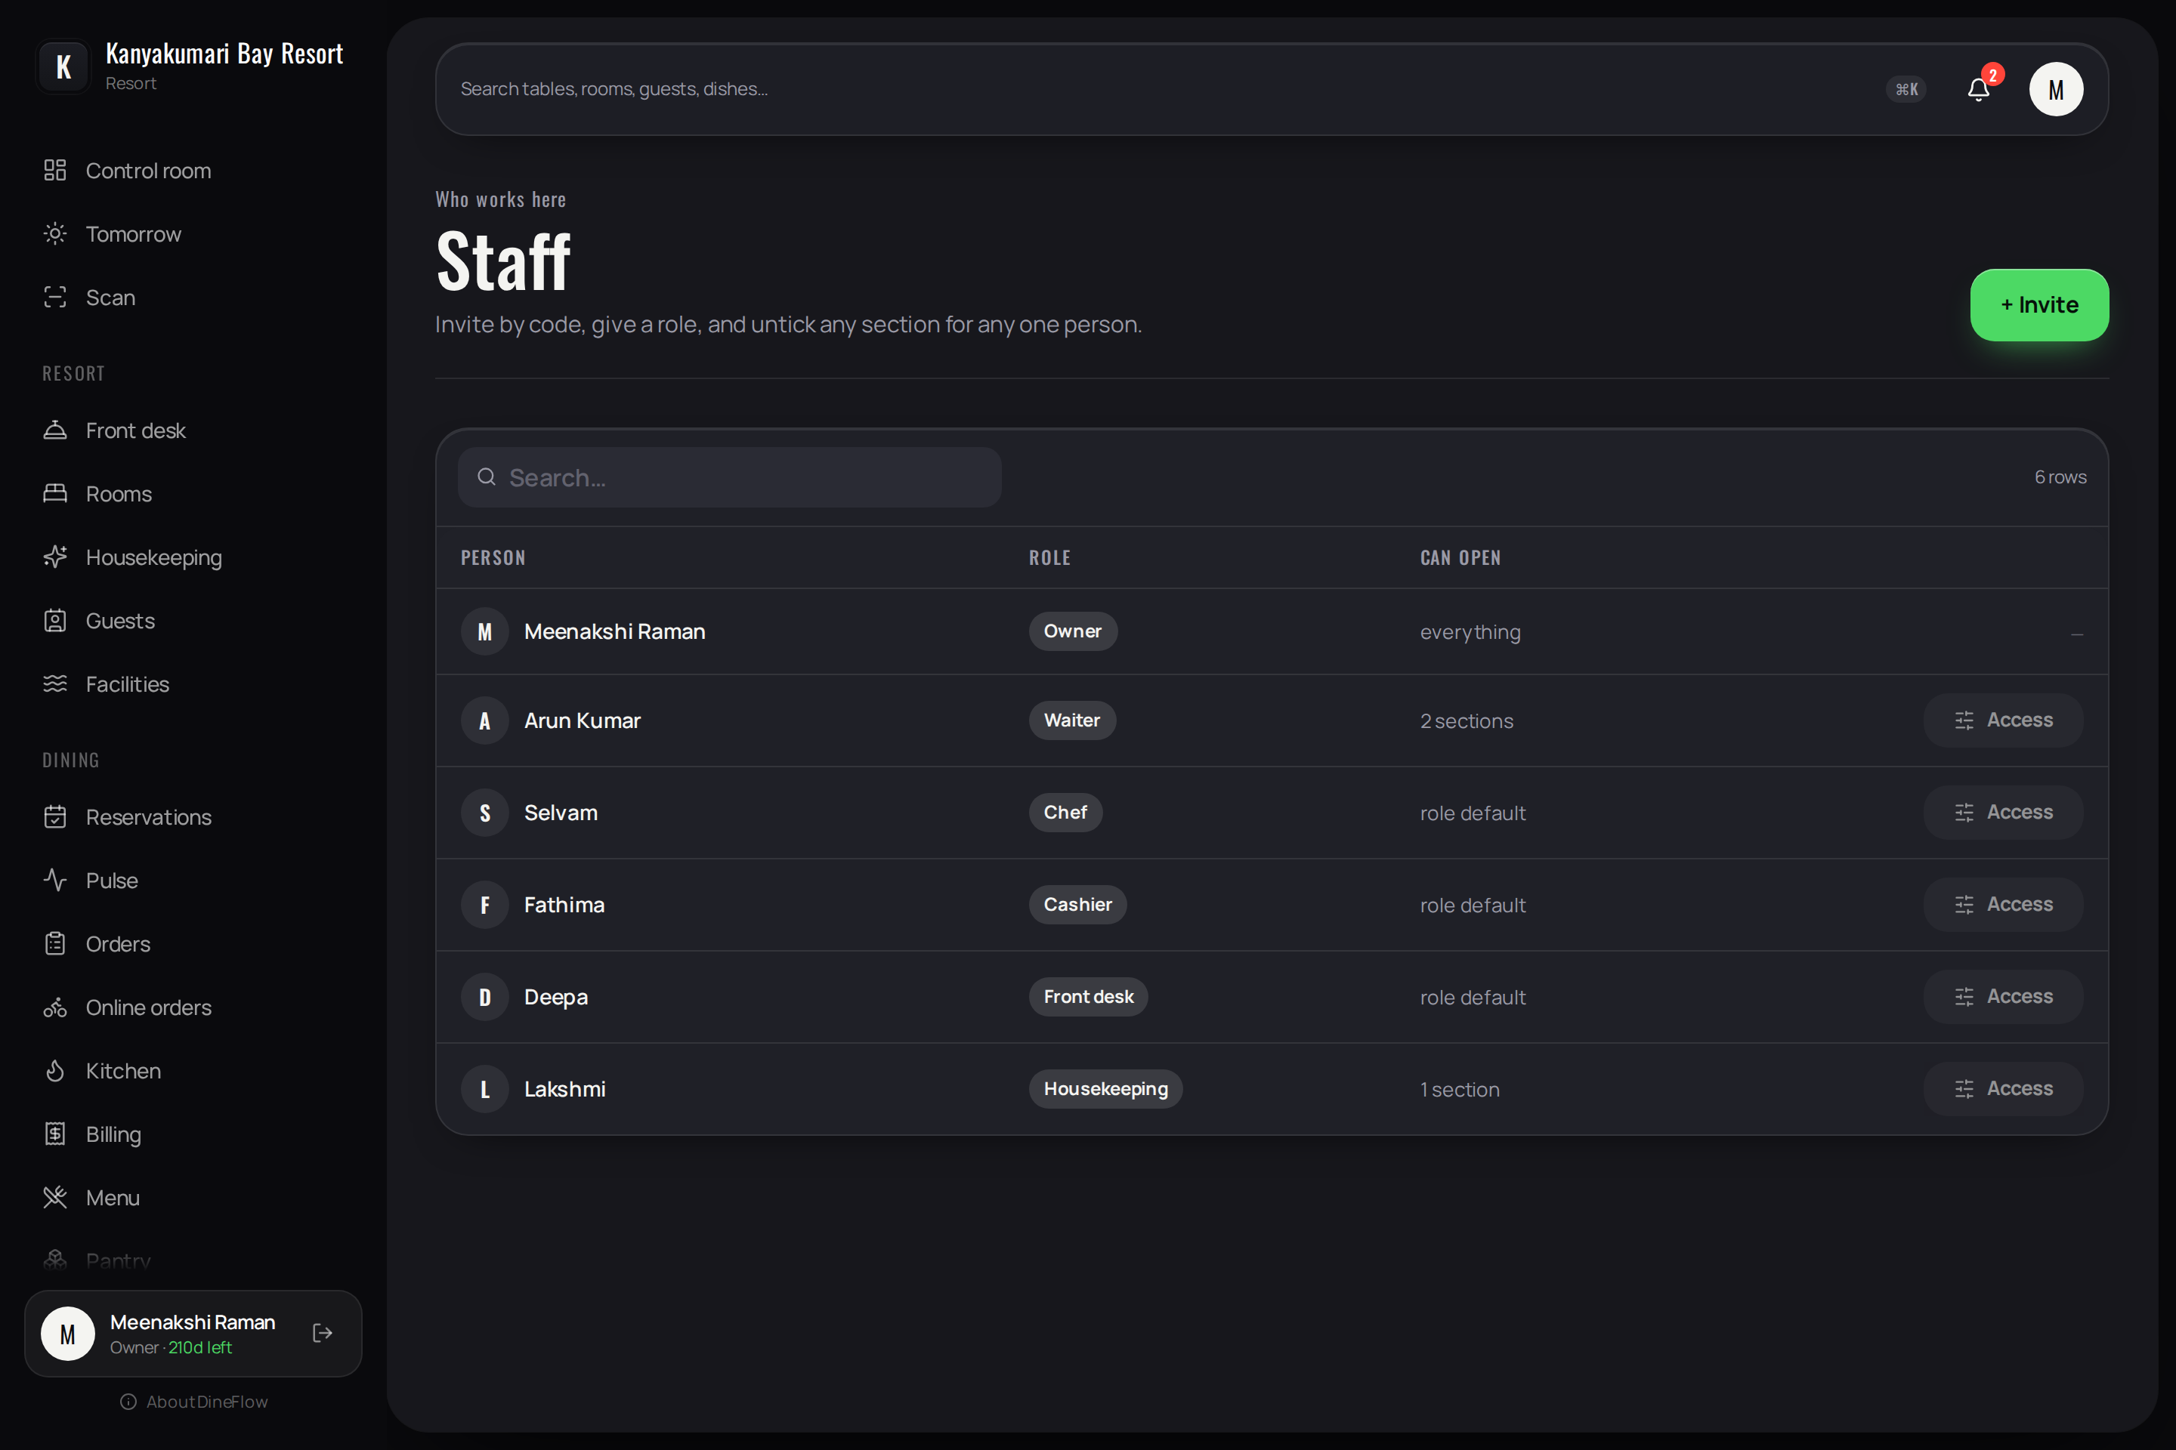
Figure 4.19 — Staff
Purpose. Appointment of employees and determination of what each may open.
Contents:
- Each person with their role and whether they hold the role's default permissions or a narrower set.
Operations:
- Invite by code; the person enters it under “Join with code”.
- Access — set the role and withhold individual sections. Only sections the master has permitted the property, and which the role may hold, are offered.

4.8.2 Staff — Access
Determination of the sections an individual employee may open. The sections offered are those the master has permitted the property, intersected with those the chosen role may hold, so a proprietor cannot grant more than they themselves possess. An owner is never restricted by this screen.
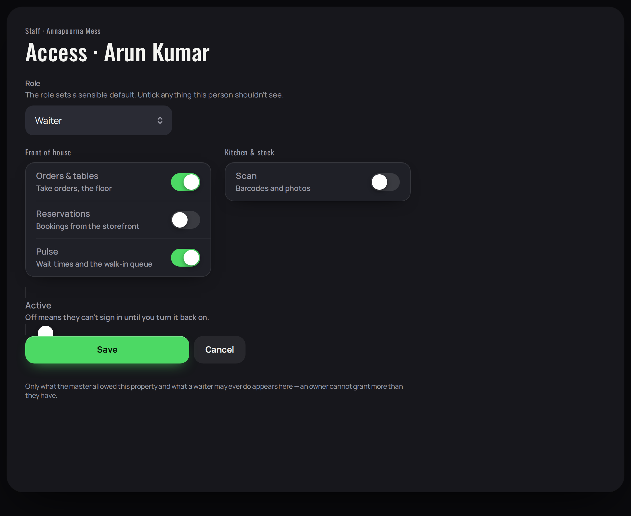
Figure 4.20 — Staff, Access

4.8.3 Settings
Permitted to: Owner only.
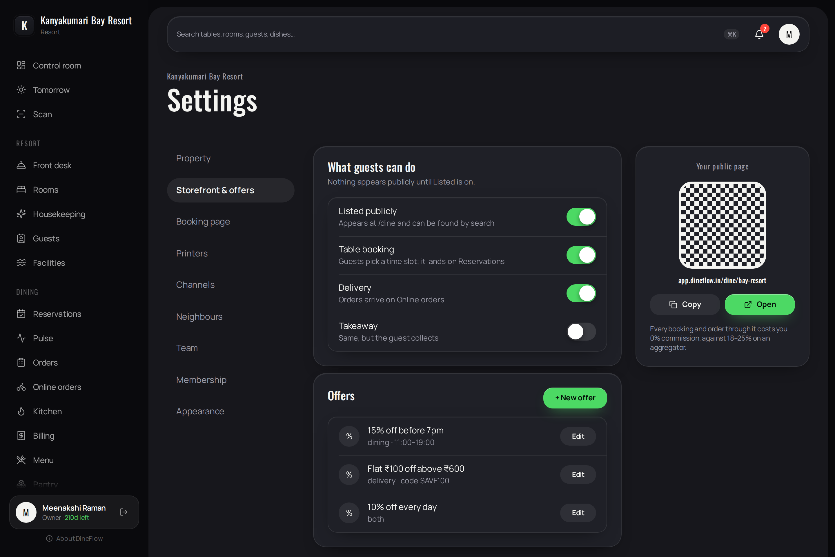
Figure 4.20 — Settings
Purpose. Configuration of the property.
Contents:
- Property: name, logo, brand colour, registration number, tax rate, service charge, check-in and check-out times.
- Storefront and offers, booking page, printers, channels, district network, team, membership, appearance.
Operations:
- The logo and brand colour replace DineFlow's mark on the proprietor's screens.
- An offer such as “15% before seven o'clock” is presented to guests against the affected time slots.

5 Mobile application — screen reference
The mobile application is not a reduced copy of the web application. It is built to the conventions of the platform and to the working conditions of a service floor: one hand, a moving room, and frequently no signal.

5.1 Design conventions
Convention | Application
Large title | Each screen opens with a context line above a large title, which is the first thing read.
Inset grouped lists | Related rows are presented in a rounded group with separators inset from the leading edge, and an explanatory line beneath where required.
Row structure | Leading element, title and detail, trailing value, and a chevron where the row leads somewhere. Rows are 52 points high.
Bottom sheets | Actions and forms are presented in a sheet that follows the thumb and is dismissed by dragging down or by a flick.
Targets and feedback | Touch targets are at least 44 points. Every action produces haptic feedback.
Refresh | Every list screen supports pull to refresh, in addition to updating itself as data changes.
Offline | Every action is written to the outbox when there is no signal and delivered exactly once on reconnection.

5.2 Navigation
Five tabs, in the order in which a shift proceeds: Control, Orders, Kitchen, Pulse and More. Rooms, Pantry, Scan, appearance and sign-out are held under More. An employee sees only the tabs their proprietor has permitted. Each tab is a card on a dark ground; dragging a card sideways moves to the adjacent section.
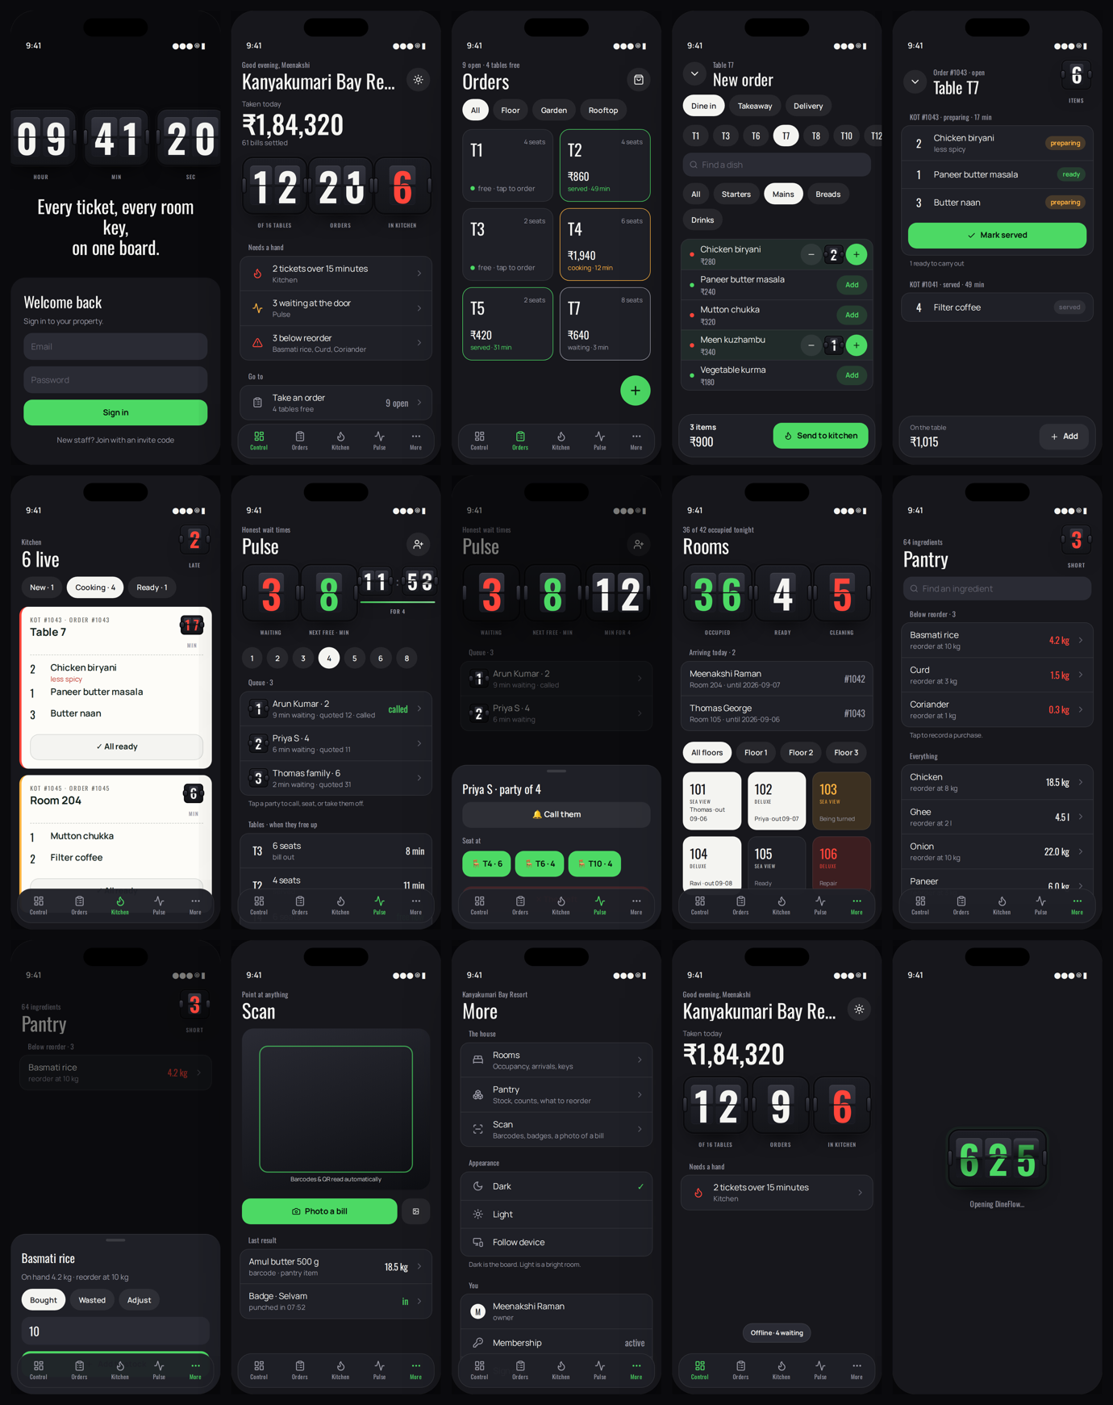
Figure 5.0 — The complete mobile application

5.3 Screens

5.3.1 Sign in
Permitted to: Everyone.
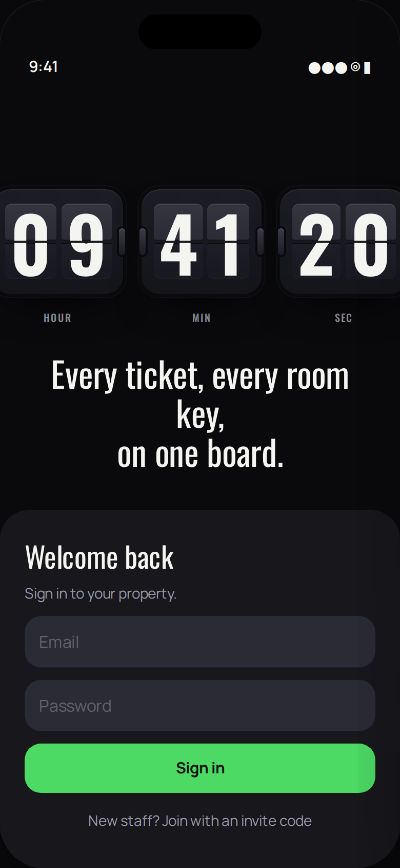
Figure 5.1 — Sign in (mobile application)
Purpose. Entry to the system on a handheld device.
Contents:
- A live clock in three flip tiles on the wall.
- The credentials presented in a card that rises from the foot of the screen, so the keyboard never obscures the button.
Operations:
- Sign in. Join with an invitation code.

5.3.2 Control
Permitted to: Everyone.
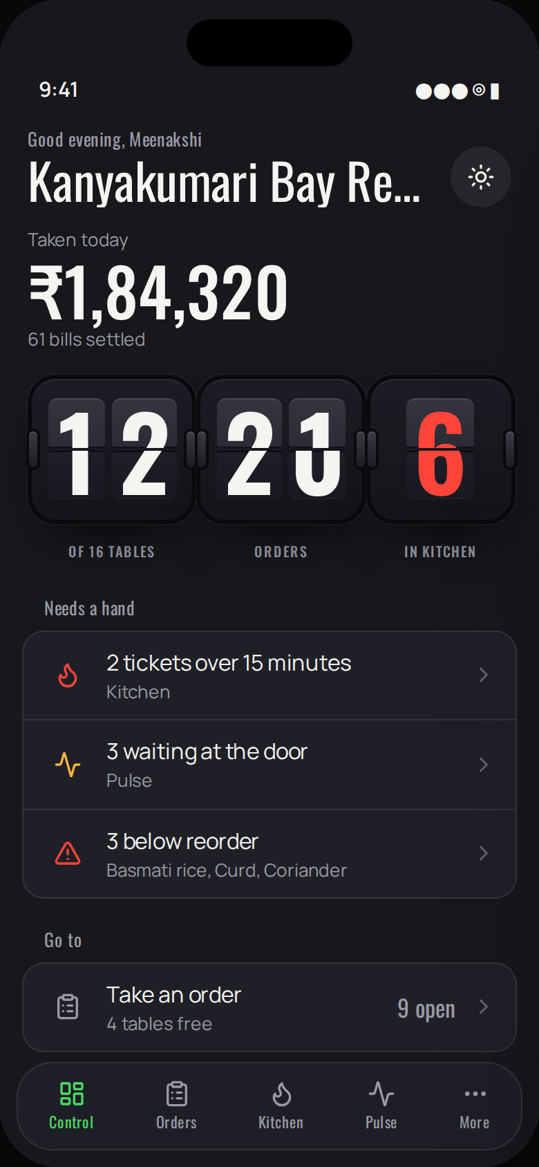
Figure 5.2 — Control (mobile application)
Purpose. The state of the property at this moment, arranged for a proprietor glancing at a telephone.
Contents:
- Takings for the day, presented first and largest.
- Three flip tiles sized to the width of the device: tables in use, open orders, tickets in the kitchen.
- “Needs a hand”, which lists only what is late, ready, waiting or short.
- “Go to”, the three destinations used most.
Operations:
- Each row opens the screen that explains it. Pull down to refresh.
- The sun and moon control switches between the dark and light themes.

5.3.3 Orders
Permitted to: Owner, manager, cashier, waiter.
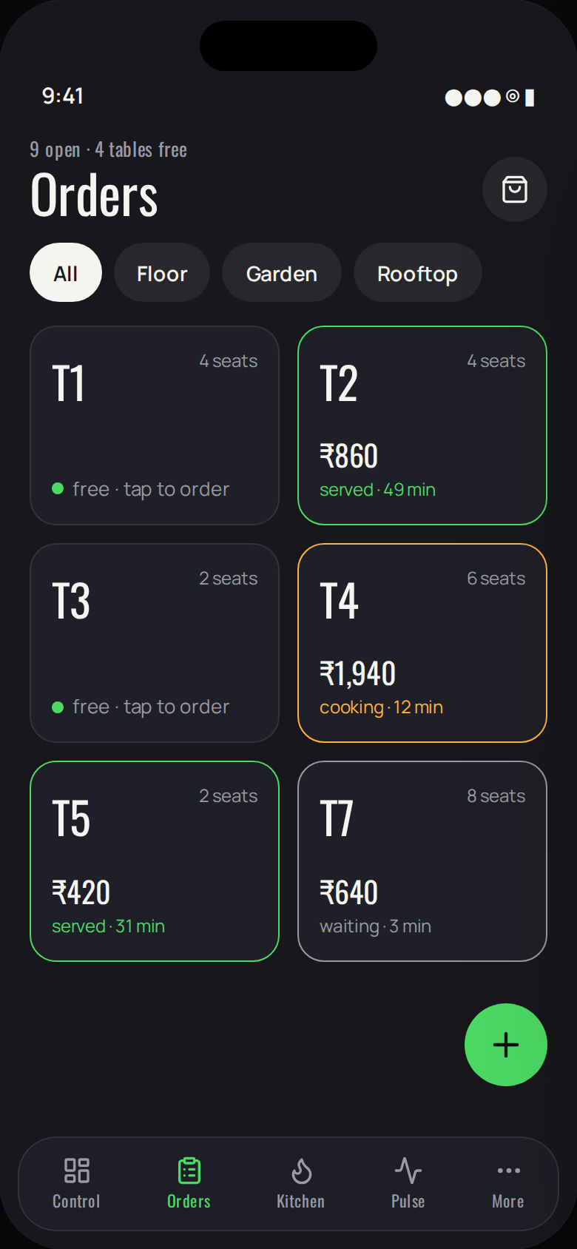
Figure 5.3 — Orders (mobile application)
Purpose. The floor, as a grid of table cards two across.
Contents:
- Zone filters. Each card carries the table, its capacity, and its state expressed as the border colour and one line — free, cooking with elapsed time, or served with the total.
- Takeaway and delivery orders are listed below the grid.
Operations:
- Select a table to open its order or to begin one. The floating control begins a new order.

5.3.4 Order pad
Permitted to: Owner, manager, cashier, waiter.
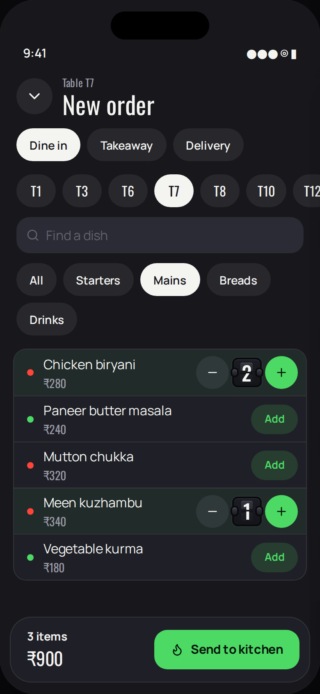
Figure 5.4 — Order pad (mobile application)
Purpose. Composition of an order on a handheld device.
Contents:
- Order type, a scrolling row of tables, a search field and category filters.
- One row per dish; the Add control becomes a decrement–quantity–increment group, the quantity presented in a flip tile.
- The basket presented as a floating bar carrying the count and the total.
Operations:
- Send to kitchen. The operation completes without a signal.

5.3.5 Open order
Permitted to: Owner, manager, cashier, waiter.
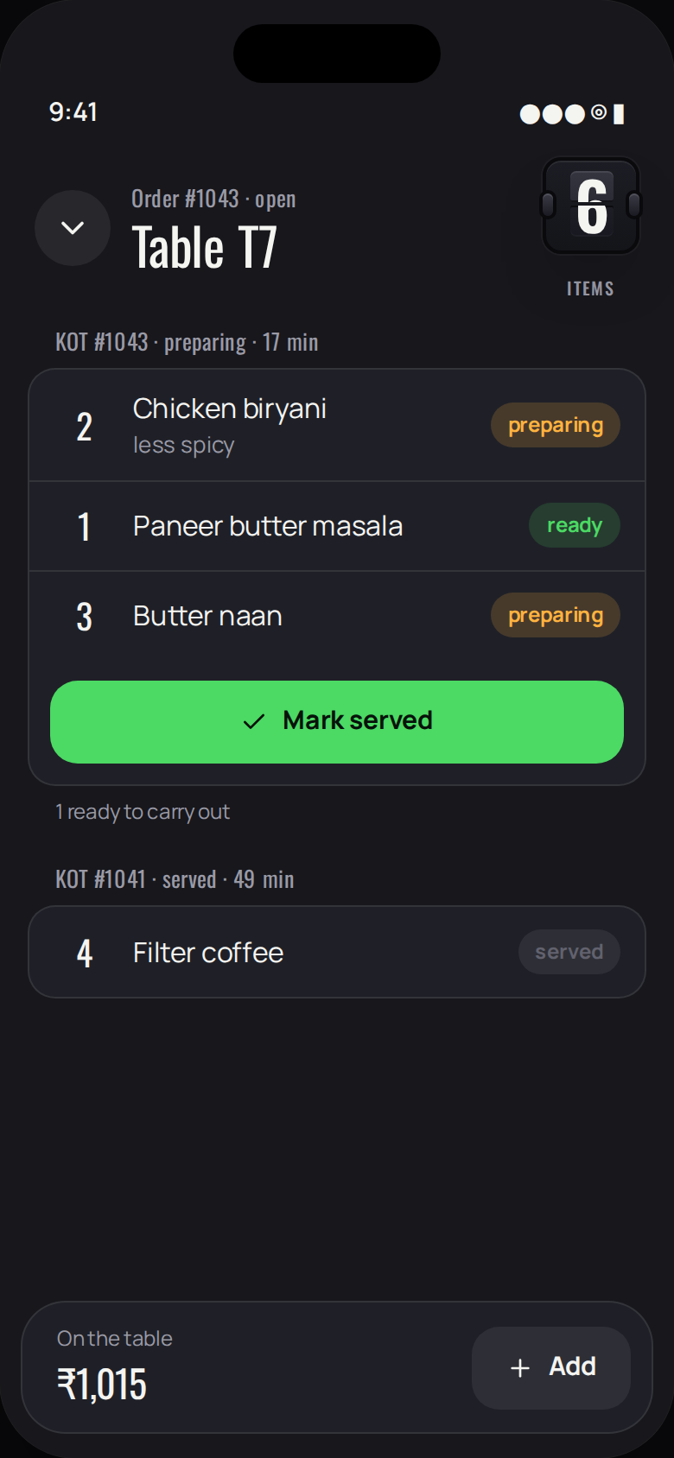
Figure 5.5 — Open order (mobile application)
Purpose. An order in progress.
Contents:
- One group per kitchen order ticket, with its elapsed time; each line with its state.
- The running total presented in the floating bar.
Operations:
- Mark served when items are ready. Add further items.

5.3.6 Kitchen
Permitted to: Owner, manager, chef.
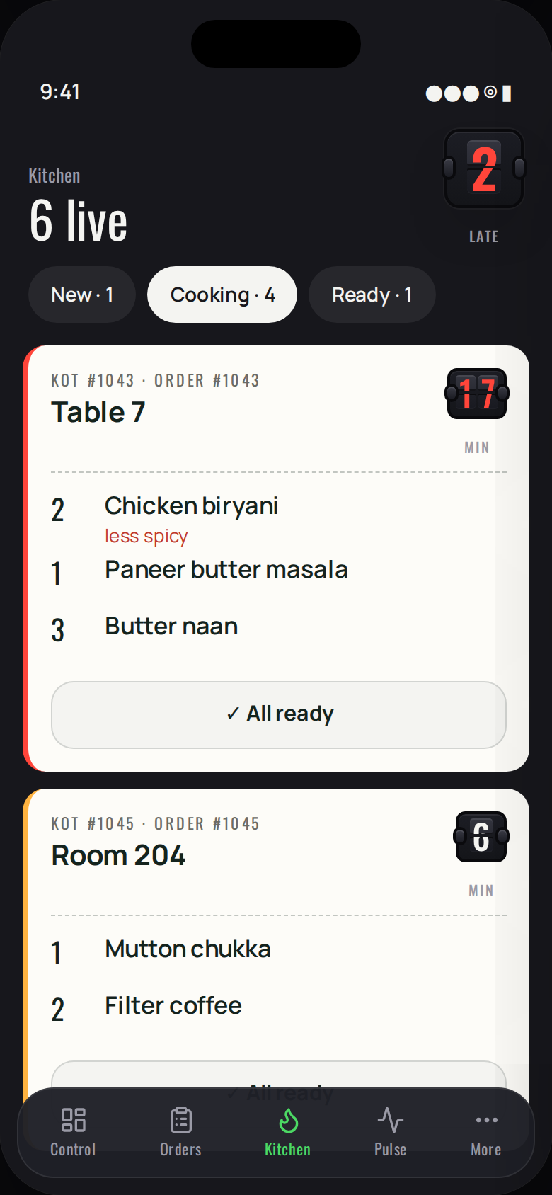
Figure 5.6 — Kitchen (mobile application)
Purpose. The kitchen display adapted to a single column.
Contents:
- Filters carrying the count in each state, so the cook knows what is behind them.
- Each ticket presented full width on a paper card, with the elapsed time as a flip tile that turns red after fifteen minutes.
- The action is placed at the foot of the card, where the thumb rests.
Operations:
- Start cooking, All ready, Picked up; an individual line may be marked ready.

5.3.7 Pulse
Permitted to: Owner, manager, cashier, waiter.
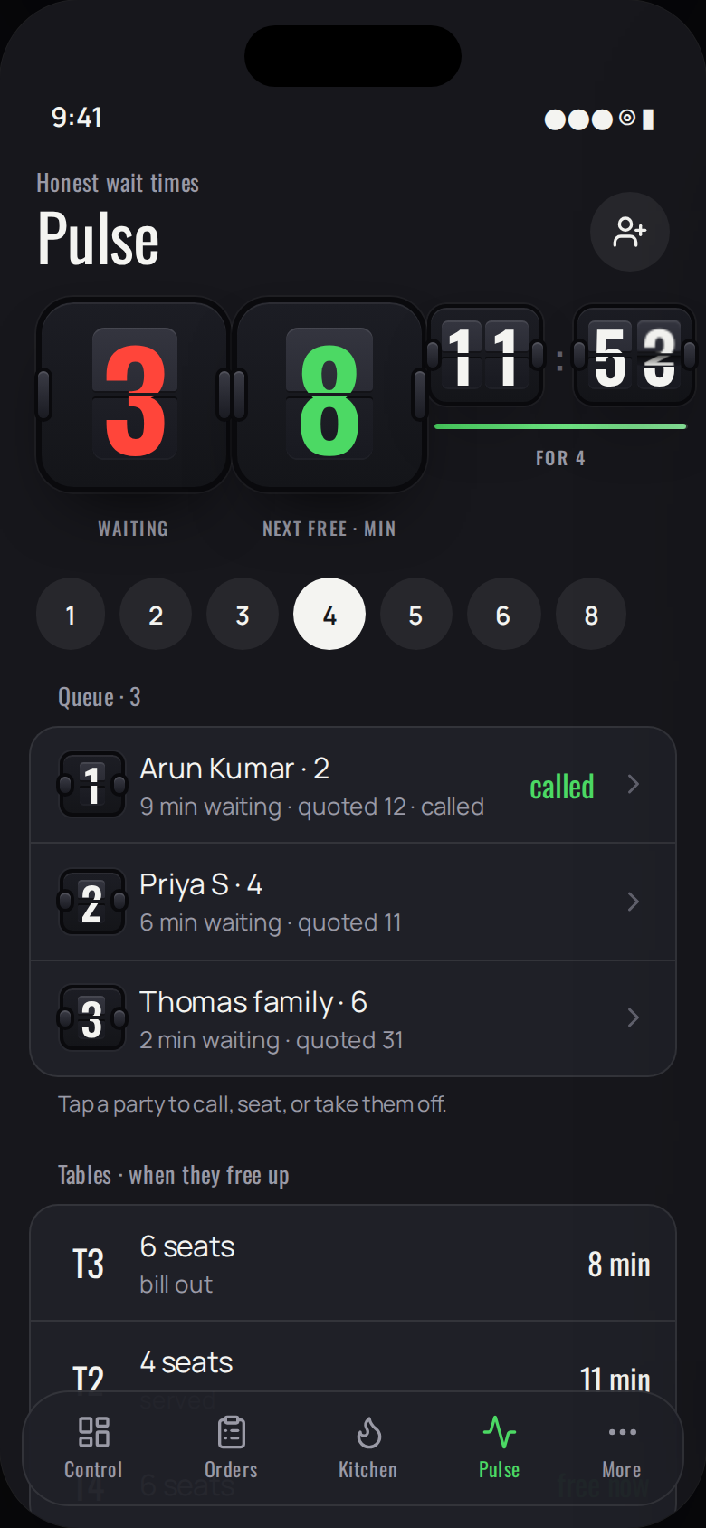
Figure 5.7 — Pulse (mobile application)
Purpose. Waiting times and the queue, for the person at the door.
Contents:
- Parties waiting, minutes until the next table, and the quotation for the chosen party size, presented as a countdown.
- The queue and the tables with the minutes remaining.
Operations:
- Select a party size for a quotation; add a party; select a party for its actions.

5.3.8 Pulse — party actions
Permitted to: Owner, manager, cashier, waiter.
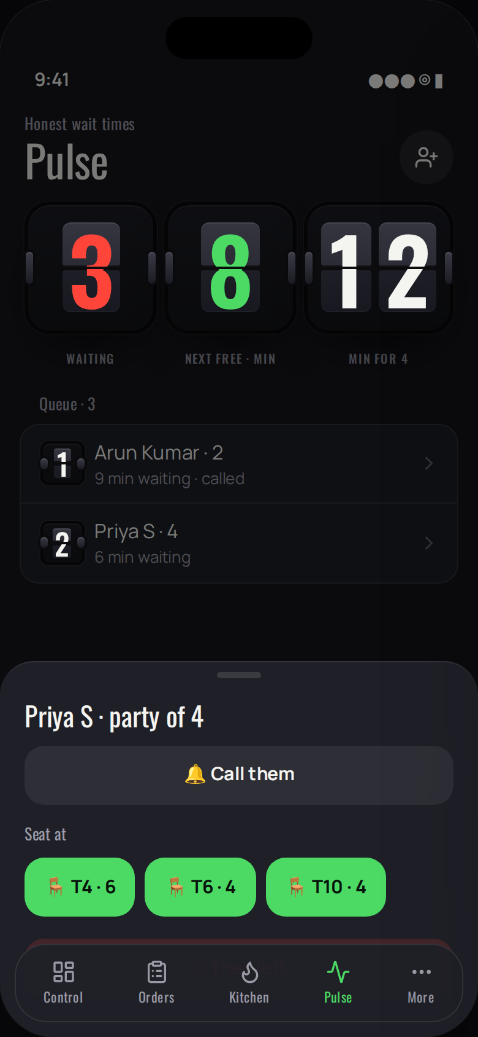
Figure 5.8 — Pulse — party actions (mobile application)
Purpose. Actions for a waiting party, presented in a sheet so that the list beneath remains legible.
Contents:
- Call; the tables large enough for the party; and the option to record that the party has left.
Operations:
- Each action is a full-height control. The sheet is dismissed by dragging down.

5.3.9 Rooms
Permitted to: Owner, manager, front desk, housekeeping.
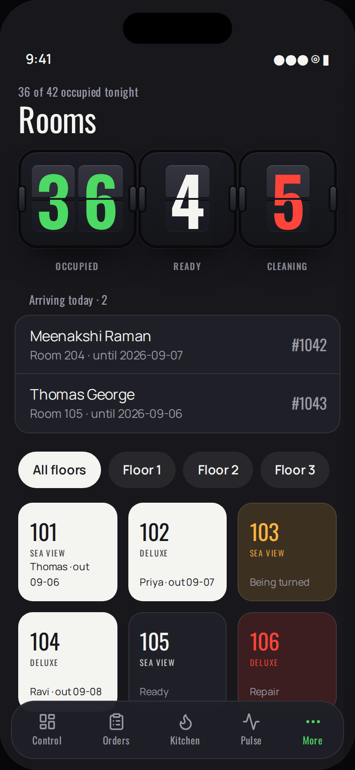
Figure 5.9 — Rooms (mobile application)
Purpose. The room board, three key cards across.
Contents:
- Occupied, ready and being cleaned, as flip tiles. Arrivals for the day. Floors as filters.
- Each card carries the room number, type and occupant; its state is the card's colour.
Operations:
- Select a room for its actions: mark ready, send to cleaning, or place out of service.

5.3.10 Pantry
Permitted to: Owner, manager, store.
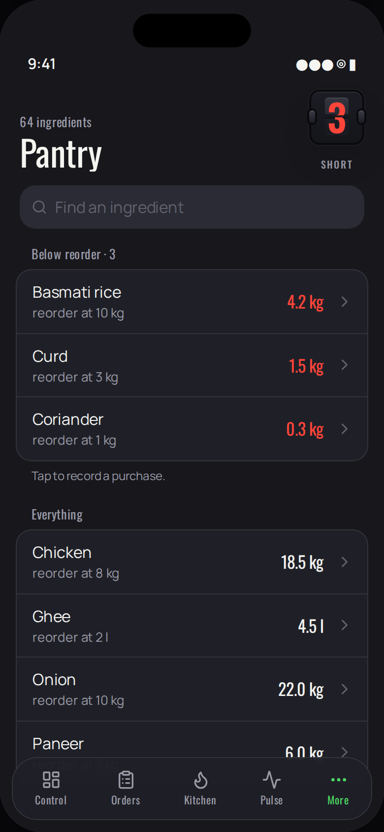
Figure 5.10 — Pantry (mobile application)
Purpose. Stock, arranged so that what is short is seen first.
Contents:
- A search field; ingredients below their reorder level; then all ingredients with the quantity in hand.
Operations:
- Select an ingredient to record a movement.

5.3.11 Pantry — record a movement
Permitted to: Owner, manager, store.
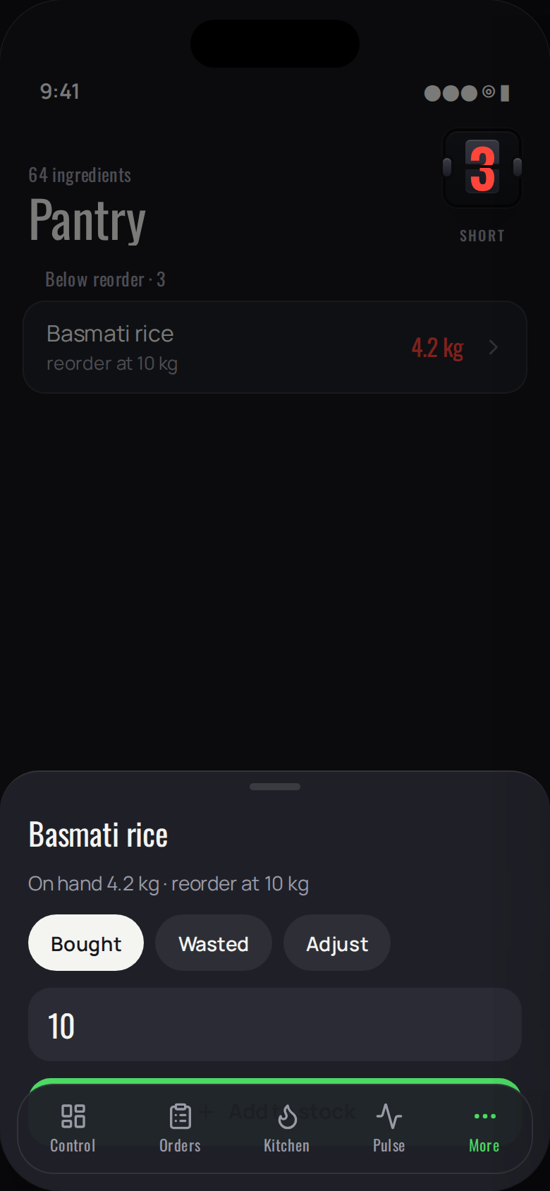
Figure 5.11 — Pantry — record a movement (mobile application)
Purpose. Recording a purchase, wastage or adjustment.
Contents:
- The quantity in hand and the reorder level; the kind of movement; a large numeric field.
Operations:
- Confirm. Without a signal the movement is held in the outbox.

5.3.12 Scan
Permitted to: Owner, manager, store, chef, waiter, housekeeping.
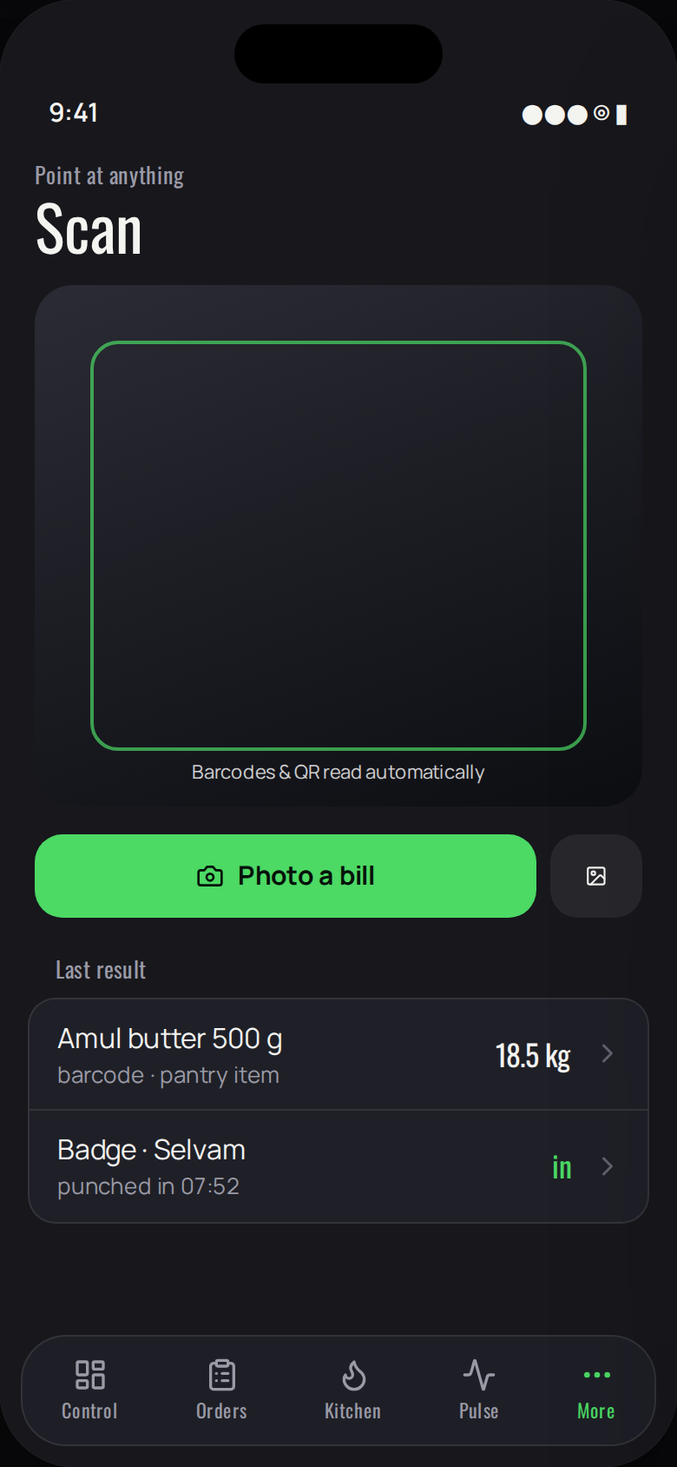
Figure 5.12 — Scan (mobile application)
Purpose. The camera, used for barcodes, attendance badges and photographs of supplier bills.
Contents:
- The viewfinder; controls to photograph a bill or select an image; the most recent results.
Operations:
- Barcodes and codes are recognised automatically. A photographed bill is read into a purchase where the optional recognition key is configured.

5.3.13 More
Permitted to: Everyone.
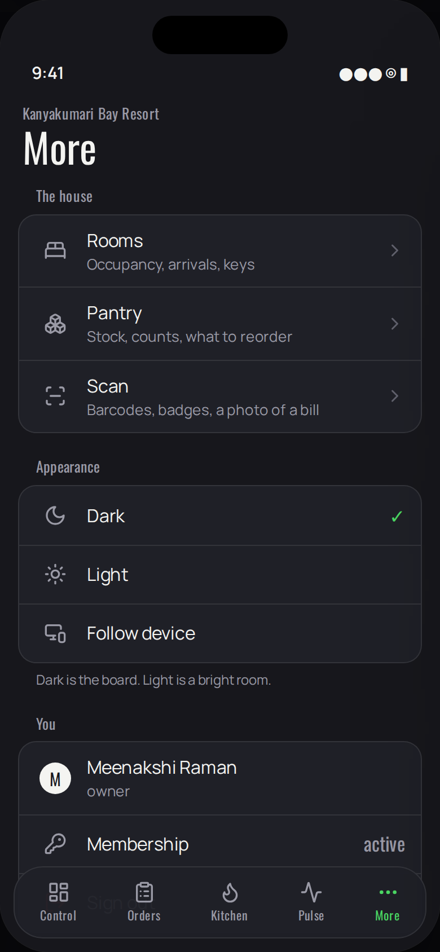
Figure 5.13 — More (mobile application)
Purpose. Everything not held in a tab, in the manner of a settings application.
Contents:
- The house: rooms, pantry, scan. Appearance: dark, light, follow the device. The person: name, role, membership, sign out. About DineFlow.
Operations:
- Select a destination or an appearance.

5.3.14 Working without a connection
Permitted to: Everyone.
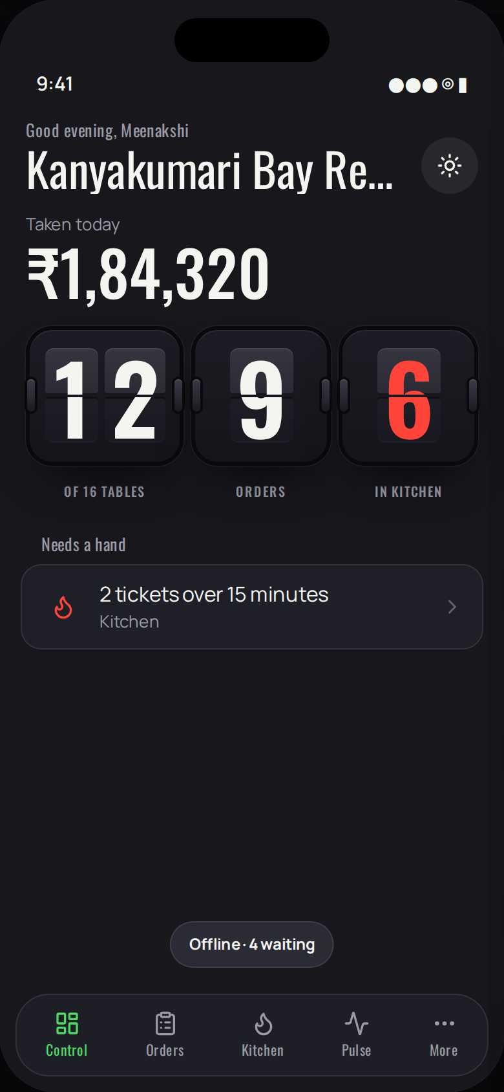
Figure 5.14 — Working without a connection (mobile application)
Purpose. The state of the application when the connection is unavailable.
Contents:
- A discreet indicator states that the application is offline and how many actions are held.
- All screens continue to present the data last received.
Operations:
- Work proceeds unchanged. On reconnection the indicator states how many actions were delivered.

5.3.15 Opening
Permitted to: Everyone.
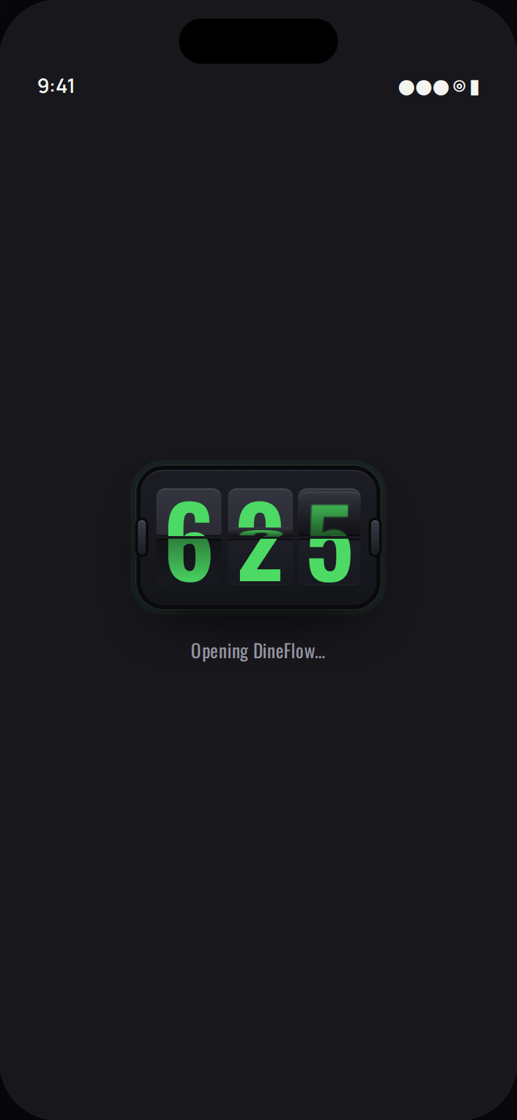
Figure 5.15 — Opening (mobile application)
Purpose. The application while fonts and the theme are loaded.
Contents:
- The board searching for its number, and a line describing the work in progress.
Operations:
- No action is required; the screen is presented for no longer than necessary.

6 Guest-facing services
Three pages are published for guests. They require no account and no application, and they are always presented in the light theme.

6.1 Storefront
At /dine a guest may search the district; at /dine/<property> they may reserve a table or place an order for delivery or collection. An offer configured by the property is presented against the time slots it affects. No commission is charged on any reservation or order placed through these pages, against the eighteen to twenty-five per cent customary on an aggregator.
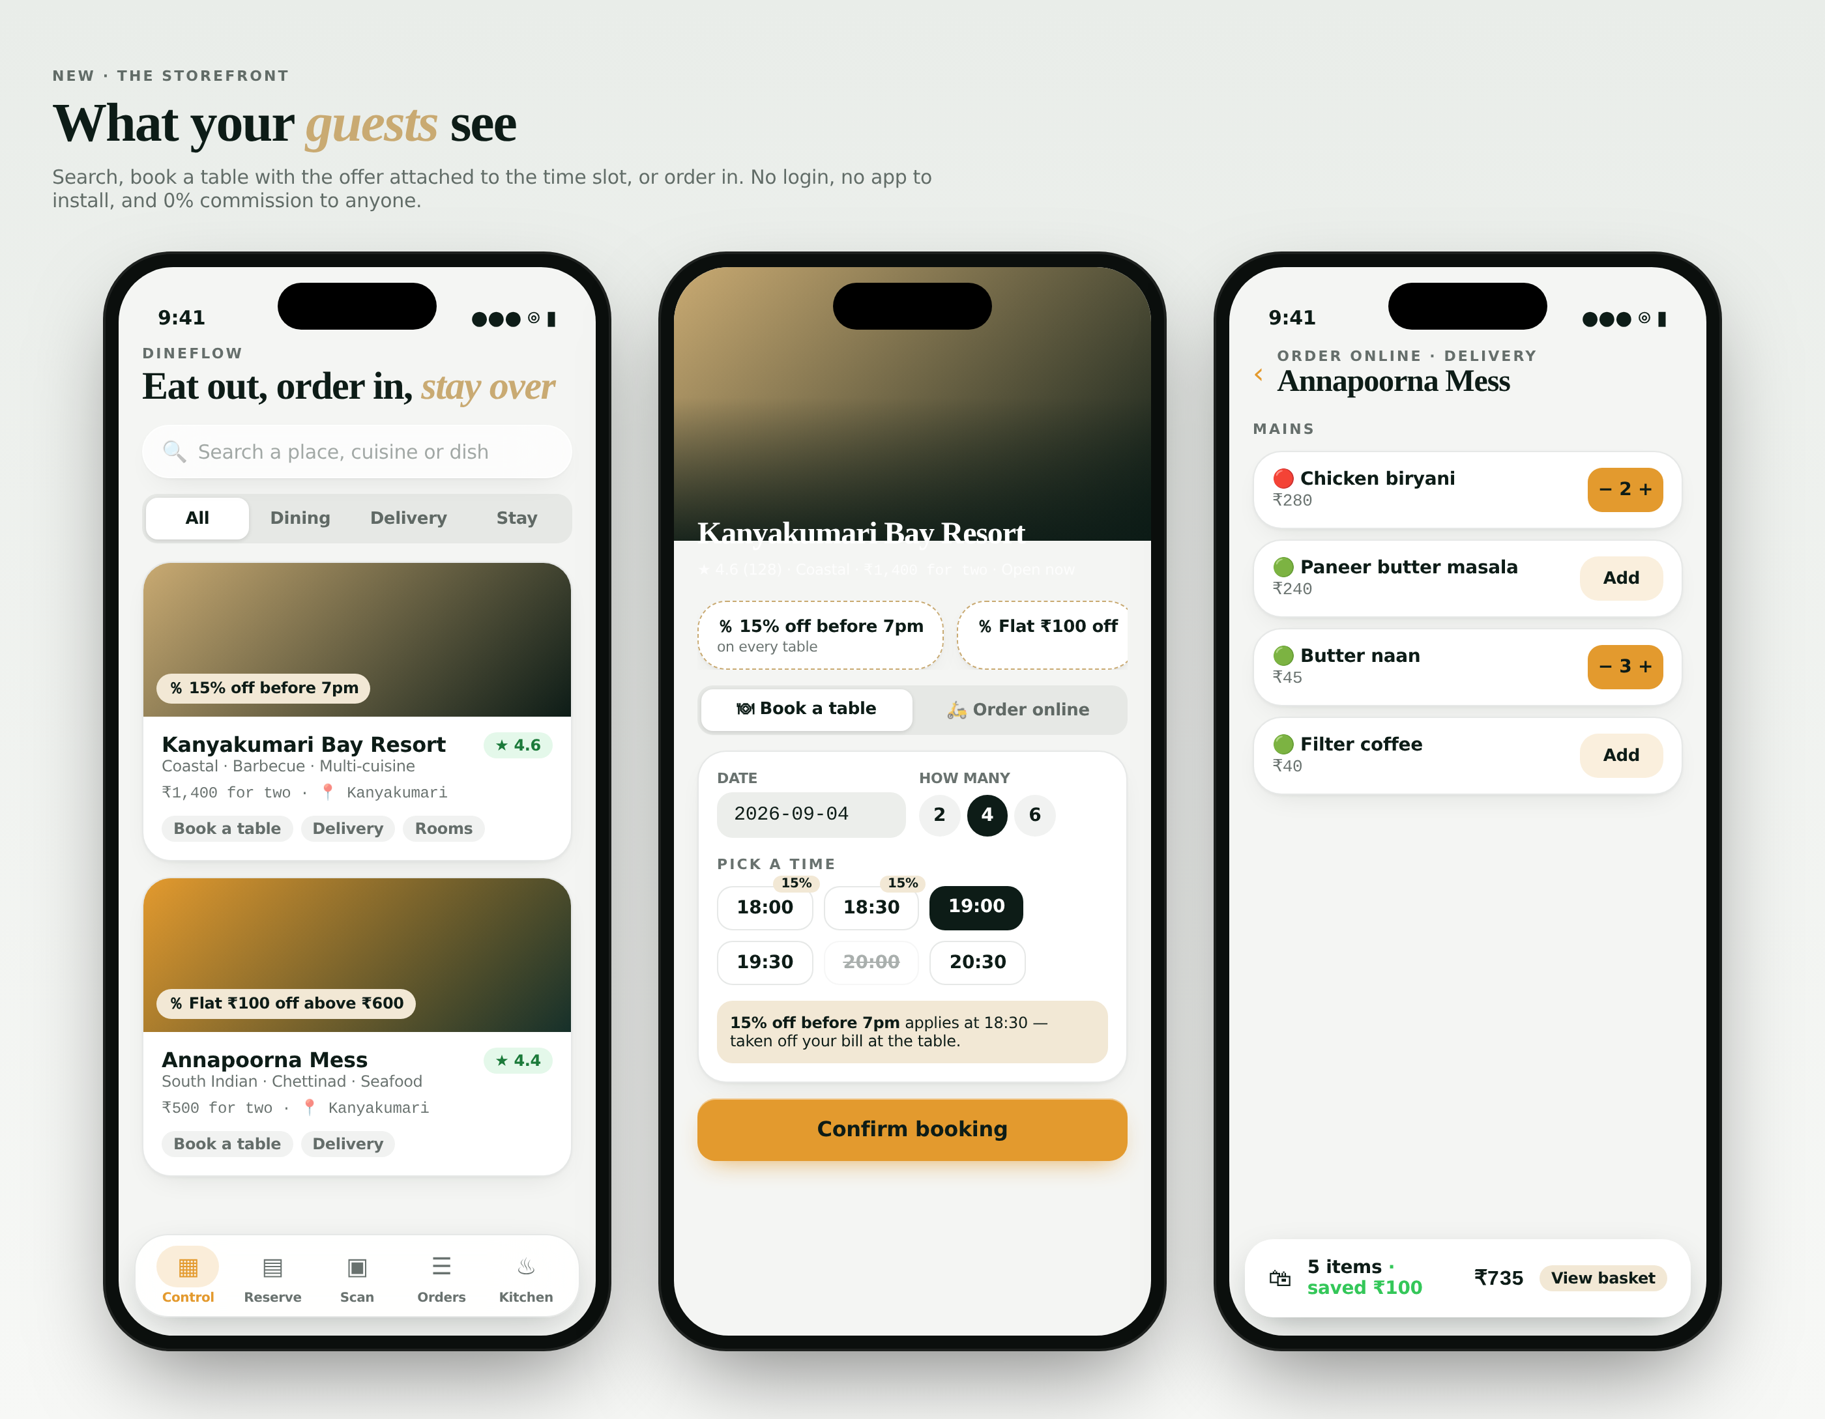
Figure 6.1 — Discovery, the property page, and ordering

6.2 Queue
Where a property publishes the code at its door, a guest joins the queue from their own telephone and observes their position with a live countdown. When the party is seated, their telephone displays the table number. No short message service is used and nothing is installed.

Figure 6.2 — The guest's telephone while waiting

6.3 Business record
Where a property issues a record link, the recipient — typically a lender or an accountant — sees monthly revenue, tax paid, covers and room nights, verified against the sealed chain at the moment the page is opened. The link expires on the date set by the property and may be revoked.

7 Integrations and connections
Fourteen connections are available. Three are required; the remainder are optional and independent, and the system operates fully without any of them. Step-by-step instructions for each, with the means of verifying it, are held in CONNECTIONS-GUIDE.md accompanying the system.
No. | Connection | Required | Credential held in
1 | Database — web application | Yes | apps/web/.env.local
2 | Database — mobile application | Yes, for the mobile application | apps/mobile/.env
3 | Direct database connection, for migrations | Yes, once | apps/web/.env.local
4 | Service key, for inbound routes | For 7, 8 and 9 | apps/web/.env.local
5 | Live updates | Automatic | —
6 | Language model, for Assist and Scan | Optional | apps/web/.env.local
7 | Aggregator webhook | Optional | Per channel, in the application
8 | Calendar exchange with travel agencies | Optional | Per channel, in the application
9 | Scheduled calendar synchronisation | Optional | apps/web/.env.local
10 | Thermal printers | Optional | In the application; bridge on a workstation
11 | Messaging share sheet | Automatic | —
12 | On-premises server | Optional | .env at the installation root
13 | Hosting | For public operation | Hosting provider
14 | Mobile application builds | For an installable application | Build service account

7.1 Custody of credentials
Credential | Server | Browser | Mobile | Source control
Anonymous key | Yes | Yes, by design | Yes, by design | No
Direct database connection | Yes | No | No | No
Service key | Yes | No | No | No
Language model key | Yes | No | No | No
Channel and calendar tokens | In the database | Displayed once | No | No

Should any private credential appear in a message, a screenshot or a repository, it must be reset: the database keys from the project settings, the language model key from its console, and a channel token by deleting and re-creating the channel.

7.2 Assist
A mark in the corner of every operator screen opens an assistant that reads the current screen together with a summary of the whole property. It notices conditions before they are asked about — a ticket over fifteen minutes, a party waiting too long, an unpaid bill, stock below its reorder level — and presents them as cards, with a count on the mark. It answers questions in plain language and may perform a short list of actions, each only after explicit confirmation. Without the optional language model key it still opens and presents the facts it can read.
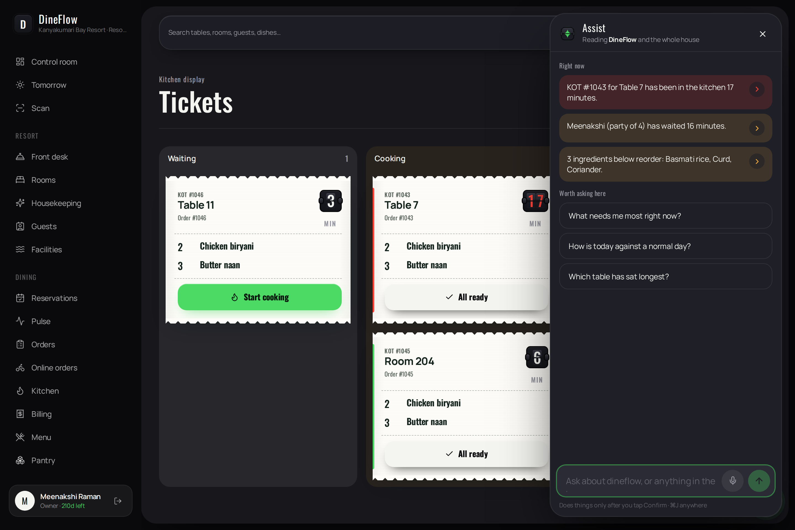
Figure 7.1 — Assist, open on the kitchen screen

8 Installation and deployment
This section is the complete installation procedure for both applications. Each step states what is required, what is to be entered, and what indicates success. The procedure may be interrupted at any step and resumed later.
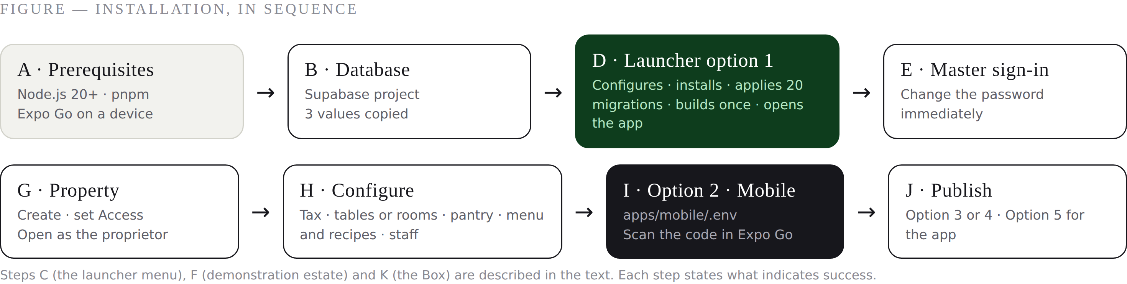
Figure 8.1 — Installation, in sequence

8.1 Prerequisites
Requirement | Specification | Verification
Operating system | Windows 10 or 11, macOS 12 or later, or Ubuntu 22.04 or later. 8 GB of memory is comfortable. | —
Node.js | Version 20 or later, from nodejs.org (long-term support release) | node -v returns v20 or v22
pnpm | Installed with: npm i -g pnpm | pnpm -v returns a version
Internet connection | Required for installation. See section 8.9 for operation without one. | —
Mobile device | Android or iOS with Expo Go, on the same network as the computer | —
Docker Desktop | Only for the on-premises server (section 8.9) | —

8.2 How long each step takes
Step | Typical duration | Repeated?
Installing Node.js and pnpm | 5 minutes | Once per computer
Creating the database project | 3 minutes, plus a wait for provisioning | Once per installation
Launcher option 1, first run | 5 to 8 minutes, mostly dependencies | Once; later starts take seconds
Applying the migrations | under a minute | Re-run safely at any time
Configuring one property | 30 to 60 minutes, depending on the size of the menu | Once per property
Installing the mobile application | 5 minutes | Once per device for Expo Go
Publishing to hosting | 5 to 10 minutes | Once, then on each update
Building the installable mobile application | 5 to 10 minutes in the build service | On each release

8.3 Provisioning the database
- At supabase.com, create an account and a new project named dineflow. Choose a strong database password and record it. Select the Mumbai region (ap-south-1) for installations in India.
- Wait for the project to report that it is ready.
- Under Project Settings → API, copy the Project URL and the anonymous public key.
- Under Project Settings → Database → Connection string, copy the URI and substitute the password recorded in step 1. This is the direct database connection.
- Under Authentication → URL configuration, set the site address to http://localhost:3000 for now.
- Under Authentication → Providers → Email, leave confirmation disabled during installation so that invited staff may sign in immediately.
Three values are now held: the project address, the anonymous key, and the direct database connection.

8.4 The installation launcher
Unpack the delivered archive. Open the launcher: on Windows, Start-DineFlow.bat; on macOS, Start-DineFlow.command; on Linux or in any terminal, ./start.sh. The menu presented is the operating manual for the installation:
1 Local: configure + install + database + open web app
2 Local: start the mobile app (Expo Go on your phone)
3 Live: deploy web to Vercel (one command)
4 Live: run on your own server with Docker
5 Live: build Android APK / Play Store / iOS
6 Configure Supabase keys again
7 Database only: run/repair migrations + master admin
8 Start the thermal print bridge (LAN printers)
9 Box: run the building on this computer — works with AND without internet
10 Box: restore a backup
11 Developer: live-reload server (slower first page, instant edits)

8.5 Installing the web application
Select option 1. The launcher requests the three values from section 8.3 and then:
- writes the configuration file apps/web/.env.local;
- installs dependencies, which takes two to five minutes on first execution;
- applies the twenty database migrations in order and creates the master account;
- builds the application once, taking approximately one minute; subsequent starts omit this step unless the source has changed;
- starts the application and opens http://localhost:3000.
Success is indicated by the sign-in page: a dark wall carrying a live clock, with the sign-in card to its right. Option 1 runs the production build, so each page is served in well under one tenth of a second. Option 11 provides the development server with live reload, and is required only by engineers modifying the source.
The configuration file written, for reference:
# apps/web/.env.local
NEXT_PUBLIC_SUPABASE_URL=https://<project>.supabase.co
NEXT_PUBLIC_SUPABASE_ANON_KEY=eyJhbGciOi…
DATABASE_URL=postgresql://postgres:<password>@db.<project>.supabase.co:5432/postgres

# optional, added later as required:
SUPABASE_SERVICE_ROLE_KEY=eyJ… # aggregator webhooks, calendars
ANTHROPIC_API_KEY=sk-ant-… # Assist and Scan
CRON_SECRET=<a long random phrase> # scheduled calendar synchronisation
NEXT_PUBLIC_APP_URL=https://app.example.in # once published

CAUTION The master password below is published in this document and in the delivered files. It must be changed before the system is exposed to anyone outside the installation team.

8.5.1 First sign-in
Field | Value
Address | master@dineflow.in
Password | DineFlow@Master2026

The master account is directed to Master control, not to a property. This password is published in this document and in the delivered files and must therefore be changed immediately, under Master control → Change master password.
TIP Option 1 runs the production build, so pages open in well under a tenth of a second. Option 11 is the development server with live reload, and is needed only by engineers changing the source.

8.6 Installing the mobile application
- Copy apps/mobile/.env.example to apps/mobile/.env.
- Set EXPO_PUBLIC_SUPABASE_URL and EXPO_PUBLIC_SUPABASE_ANON_KEY to the values from section 8.2.
- Set EXPO_PUBLIC_WEB_URL to the computer's address on the local network, for example http://192.168.1.10:3000 (ipconfig on Windows, ifconfig on macOS). Once the web application is published, set this to its public address.
- Select launcher option 2. The launcher starts the development service and displays a code.
- On the device, open Expo Go and scan the code.
Success is indicated by the application opening on the board, then presenting sign-in. These values are incorporated at start; if the file is changed, the service must be restarted.
# apps/mobile/.env
EXPO_PUBLIC_SUPABASE_URL=https://<project>.supabase.co
EXPO_PUBLIC_SUPABASE_ANON_KEY=eyJhbGciOi…
EXPO_PUBLIC_WEB_URL=http://192.168.1.10:3000

8.7 Configuring a property
- In Master control, select New property and record the name, the type and the proprietor's address. A seven-day trial begins; a membership key makes it permanent.
- On the property's row, select Access and determine which modules the property may open. Control room and Settings may never be withheld.
- Select Open to assume the proprietor's view, or sign in as the proprietor.
- Under Settings → Property, record the logo, brand colour, registration number, address, telephone, tax rate, service charge and, for accommodation, the check-in and check-out times.
- Under Settings → Tables, record every table with its capacity and zone. The capacity governs wait quotations and the limits applied to public reservations.
- Under Rooms, record the room types with their rates, then each room against its type.
- Under Pantry, record every ingredient purchased, with its unit, cost and reorder level.
- Under Menu, record the dishes and then their recipes. The recipe is the mechanism by which stock is deducted automatically; the ten best-selling dishes are sufficient to begin.
- Under Staff, invite each employee by code and, where required, withhold individual sections under Access.
IMPORTANT The values in apps/mobile/.env are incorporated when the service starts. If the file is changed, the service must be stopped and started again.

8.8 Demonstration data
Master control → Sample estate installs six properties with sixty days of trading, for training and evaluation. Every proprietor in the demonstration estate uses the password Dine@1234. The demonstration estate must be removed before the system carries live trade; the delivered file SAMPLE-LOGINS.md contains the statement that removes it.
CAUTION The demonstration estate uses published passwords. It must be removed before the system carries live trade; SAMPLE-LOGINS.md contains the statement that removes it.

8.9 Publication
Method | Procedure | Notes
Managed hosting | Option 3. An account at vercel.com; the launcher installs the command-line tool and deploys with the configured values. | Free at the scale of one property. An address of the form <name>.vercel.app is issued.
Own server | Option 4. The launcher builds a container image and writes a compose file. | Any virtual private server. Place a reverse proxy in front for transport security.
Mobile application | Option 5, then 1 for an installable Android package, 2 for the Play Store, or 3 for iOS. | A free build-service account is required. The Android package may be distributed directly to staff.

On publication, the public address must be recorded in three places: NEXT_PUBLIC_APP_URL; the authentication URL configuration of the database project; and EXPO_PUBLIC_WEB_URL in the mobile application before it is built.

8.10 On-premises operation
Where the internet connection is unreliable, option 9 configures an always-powered workstation in the building as an on-premises server. Devices and the counter address it over the local network whether or not the internet is available; when it is available, the on-premises server and the cloud reconcile with one another, and the public storefront continues to accept reservations. The workstation requires Docker Desktop. Backups are taken nightly; option 10 restores one.
IMPORTANT On publication the public address must be recorded in three places. Omitting the authentication configuration is the most common cause of sign-in failing after a deployment.

8.11 Acceptance checklist
The following should be completed before the system carries live trade:
- The master password has been changed.
- The demonstration estate has been removed.
- The registration number, address and tax rate have been recorded.
- Every table carries its correct capacity; every room is assigned to a type.
- The best-selling dishes carry recipes; every ingredient carries a reorder level; one stock count has been taken.
- Every employee has been invited, given a role, and their permissions confirmed.
- A test order has been carried from the handheld device through the kitchen to a settled bill.
- The printer produces a test receipt.
- The network has been disconnected for one minute during an order, and the system reported the actions delivered on reconnection.
- The public address is recorded in the authentication configuration.
- The code at the door opens the storefront on a device not belonging to the property.

9 Operations and support

9.1 Daily procedure
Time | Procedure | Screen
Opening | Confirm nothing is outstanding from the previous service; review ingredients below reorder level. | Control room, Pantry
Service | Take orders; advance tickets; quote waits at the door; settle bills. | Tables, Kitchen, Pulse, Billing
Accommodation | Check in arrivals; post charges to folios; release rooms as they are turned. | Front desk, Rooms, Housekeeping
Close | Reconcile the till against the day's bills; record the summary. | Billing → Close shift
Before closing | Review the following day's prediction, preparation sheet and market list. | Tomorrow's brief
Weekly | Count the five most valuable ingredients; review the leak report and the district price index. | Pantry, Neighbours
Monthly | Seal the month; review the trading report; export the tax summary. | Proof of business, Reports

9.2 Who does what
Responsibility | Held by | Frequency
Opening and closing the shift, reconciling the till | Manager or cashier | Every service
Recording purchases and wastage | Storekeeper | Daily
Counting the most valuable ingredients | Storekeeper with the proprietor | Weekly
Reviewing the leak report and the price index | Proprietor | Weekly
Appointing and removing staff, and setting their access | Proprietor | As required
Sealing the month and issuing record links | Proprietor | Monthly
Applying updates and running the verification | Whoever installed the system | On each release
Restoring a backup | Whoever installed the system | Rarely, and by decision

9.3 Diagnosis
Symptom | Cause | Remedy
Database connection missing, or authentication failed | The connection string is incorrect | Option 6; enter the string with the actual password
Sign-in does not complete | Incorrect project address or key; or the project is suspended for inactivity | Option 6; or restore the project from its dashboard
A relation does not exist | A migration did not apply | Option 7; migrations are written to be re-applied safely
The mobile application cannot connect | Device and computer on different networks, or the port is blocked | Place both on the same network and scan the code again
Nothing prints | The print bridge is not running, or the printer is asleep | Option 8; power-cycle the printer; use a browser supporting device access
A section is absent from the menu | It has been withheld by the master or by the proprietor | Master control → Access, or Staff → Access
An employee cannot sign in | The account is deactivated, or the membership has expired | Staff → Access; or Settings → Membership
The system reports itself offline while the connection is sound | The browser has not detected the restored connection | Wait twenty seconds; the system tests the connection and restores itself
Assist reports that a key is required | The optional language model key is not configured | Optional; record it in the configuration file and restart

A repair that preserves data: stop the application and run option 7. Every migration is re-applied and the master account is re-created; orders, bills and bookings are unaffected.
KEY POINT A repair that preserves data: stop the application and run option 7. Every migration is re-applied and the master account re-created; orders, bills and bookings are untouched.

9.4 Backup and restoration
- The database provider takes daily backups; these are restored from the project dashboard.
- The on-premises server takes its own nightly backup; option 10 lists and restores them.
- Proof of business constitutes a third, independent record of every sealed month.

9.5 Updating the system
Unpack the new archive over the existing installation, retaining apps/web/.env.local and apps/mobile/.env. Run option 7 to apply any new migrations, then option 1. Every migration is written to be re-applied without loss.

9.6 Verification by the property
The supplied harnesses may be executed at any time; each completes in approximately one minute.
npm i @electric-sql/pglite # once
node scripts/sqltest/run.mjs # all twenty migrations apply, in order
node scripts/sqltest/flow.mjs # every procedure, end to end
node scripts/sqltest/verify.mjs # tenancy, stock, tax, chain, k-anonymity
node scripts/sqltest/pulse.mjs # dwell, stages, quotations, guest queue
node scripts/sqltest/v15.mjs # leak detection and shift reconciliation
node scripts/sqltest/offline.mjs # replay safety
node scripts/sqltest/access.mjs # master authority over properties
node scripts/sqltest/staff.mjs # owner authority over employees
python3 scripts/check-links.py # every link and button resolves

TIP Run the harnesses in section 9.6 after any update. Green means the database logic and every route are intact.

10 Appendices

10.1 Delivered documents
File | Contents
DineFlow-Documentation.docx / .pdf | This document.
STARTUP-GUIDE.md | The installation procedure in thirty parts, in plain language.
CONNECTIONS-GUIDE.md | Every connection, step by step, with the means of verifying each.
TEST-GUIDE.md | A sixty-minute acceptance walk-through stating what should be observed at each step.
BEGINNER-GUIDE.md | The same material for a reader with no technical background.
SETUP-GUIDE.md | Architecture and the complete change history.
SAMPLE-LOGINS.md | Demonstration accounts and the statement that removes them.
scripts/sqltest/README.md | The verification harnesses and how to run them.

10.2 Roles and default permissions
Role | Sections opened by default
Owner | Everything permitted to the property
Manager | Everything except Settings
Cashier | Orders, billing, invoices, reports, reservations, pulse, front desk
Waiter | Orders, reservations, pulse, scan
Chef | Kitchen, menu, online orders, tomorrow's brief, scan
Store | Pantry, labour, tomorrow's brief, neighbours, scan
Front desk | Front desk, rooms, guests, facilities, housekeeping, reservations, channels
Housekeeping | Housekeeping, rooms, scan

10.3 Database migrations
Migration | Introduces
0001–0005 | Restaurant core: orders, kitchen, billing, menu, recipes, pantry, tax, tenancy; accommodation; scanning and labour; offline tolerance and printing; public endpoints
0006–0010 | Tomorrow's brief; district network; proof of business; on-premises server and hybrid synchronisation
0011–0015 | Master account; performance indexes; property creation; demonstration estate; public storefront
0016–0020 | Pulse; leak detection and shift reconciliation; property module permissions; employee permissions; property branding

10.4 Limitations at the date of issue
The following have been prepared but not exercised in a working property, and should be confirmed during acceptance: a physical thermal printer; a database project under sustained load; the installable mobile application on a physical device; and a full service with staff. Section 8.10 is the checklist for these.

11 About Devkodz
DineFlow is designed, built and supported by Devkodz.

11.1 The company
Devkodz is a software development company. We build applications that are used all day by people who are not sitting at a desk — in kitchens, at counters, on shop floors and at front desks — and we build them to keep working when the conditions are imperfect: a dropped connection, a cheap handset, a screen read from across a room, an operator who has thirty seconds and both hands full.
We take a product from the first conversation to the running system: the interface, the database, the applications for web and telephone, the deployment, the documentation and the support that follows.

11.2 How we work
Principle | In practice
Measure, do not assume | Interface work is verified against measurements taken from the running application — pixel positions, overflow, frame timings, contrast ratios — not from an impression.
Prove the rules where they live | Business rules are placed in the database and proven against a genuine engine before release. DineFlow ships with eight such proofs, which the client may run at any time.
Design for the worst minute | The busiest minute of service, with no connection, is the design case. Everything else is easier.
Documentation is part of the product | A system is delivered with the document you are reading, an installation guide, a connections guide, an acceptance walk-through and a plain-language guide for staff.
Say what is not built | Every deliverable states plainly what has not been done and what has not yet been exercised in a live setting.

11.3 What we build
- Products for hospitality, retail, manufacturing and clinical practice, on web and on mobile.
- Systems that operate offline and reconcile when the connection returns.
- On-premises deployments for buildings whose connectivity cannot be relied upon.
- Design systems and interfaces built for their working environment rather than for a showcase.
- Migration of existing operations onto a single system, with the historic data brought across.

11.4 DineFlow at a glance
Product | DineFlow — hospitality management for restaurants, hotels and resorts
Built by | Devkodz
Applications | Web (20 operator screens, 3 guest pages) and mobile (15 screens, Android and iOS)
Database | PostgreSQL — 20 migrations, 123 functions, row-level security
Verification | 8 database harnesses, an automated link and route audit
Operates offline | Yes, on both applications, with an optional on-premises server
Commission on guest orders | None
Version at this issue | 22.2, 5 September 2026

KEY POINT Devkodz retains no interest in a property's trade. All data belongs to the property, is partitioned from every other property by the database, and may be exported at any time.

11.5 Contact and support
For implementation, training, additional properties, or changes to this system, contact Devkodz through the channel agreed at delivery. When reporting a problem, the following shortens the diagnosis considerably: the screen you were on, what you expected, what happened instead, whether the connection was available, and whether the problem repeats.
TIP Before reporting a fault, run the verification harnesses listed in section 9.6. If they pass, the database and the routes are intact and the problem is elsewhere — which is useful to know at the outset.

DineFlow is a product of Devkodz.
End of document.

