**SQL**

**Question 1**

What will be the result of the query below?

**SELECT** * **FROM** runners **WHERE** id **NOT** **IN** (**SELECT** winner_id **FROM** races)

Explain your answer and also provide an alternative version of this query that will avoid the issue that it exposes.

**Solution**

This query is used for extracting record from runner table where id not present in winner id records

Here is code

use dev;

CREATE TABLE runner (

id INT ,

name VARCHAR(255)

);

CREATE TABLE race (

id INT,

event VARCHAR(255),

winner_id INT

);

INSERT INTO runner (id, name) VALUES

(1, 'Runner1'),

(2, 'Runner2'),

(3, 'Runner3'),

(4, 'Runner4'),

(5, 'Runner5');

select * from runners;

INSERT INTO race (id, event, winner_id) VALUES

(1, 'Race1', 2),

(2, 'Race2', 3),

(3, 'Race3', 2),

(4, 'Race4', null);

select * from race;

SELECT * FROM runner WHERE id NOT IN (SELECT winner_id FROM race);

**Question 2**

Given two tables created as follows

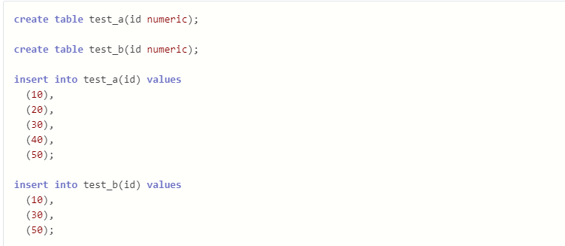

Write a query to fetch values in table test_a that are and not in test_b without using the NOT keyword.

**Solution :-**

**Code**

SELECT a.id

FROM test_a a

LEFT JOIN test_b b ON a.id = b.id

WHERE b.id IS NULL;

In this code for extracting id which are not present in test_b so in our code i am using left join which is used to extract all the data from left side and common record from right table

**Question 3**

**Given the following tables:**

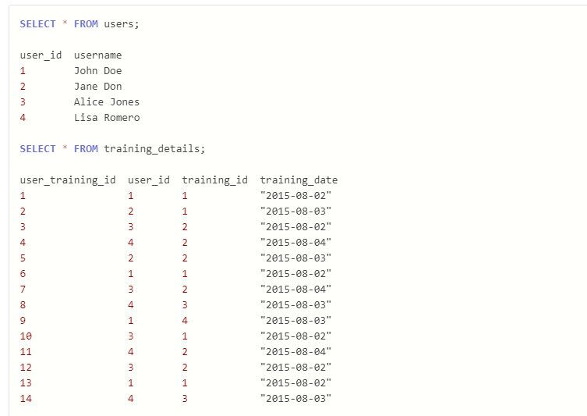

**Write a query to to get the list of users who took the a training lesson more than once in the same day, grouped by user and training lesson, each ordered from the most recent lesson date to oldest date.**

**Solution 3**

Here is a code

CREATE TABLE users (

user_id INT PRIMARY KEY,

user_name VARCHAR(255)

);

INSERT INTO users (user_id, user_name) VALUES

(1, 'John'),

(2, 'John Dea'),

(3, 'Alisa'),

(4, 'Lisa');

CREATE TABLE training_detail (

user_training_id INT PRIMARY KEY,

user_id INT,

training_id INT,

training_date DATE,

FOREIGN KEY (user_id) REFERENCES users(user_id)

);

INSERT INTO training_detail (user_training_id, user_id, training_id, training_date) VALUES

(1, 1, 101, '2024-03-10'),

(2, 2, 102, '2024-03-10'),

(3, 3, 101, '2024-03-11'),

(4, 4, 103, '2024-03-12'),

(5, 1, 101, '2024-03-10'),

(6, 2, 102, '2024-03-10');

SELECT

u.user_id,

u.user_name,

td.training_id,

COUNT(*) AS lesson_count,

MAX(td.training_date) AS most_recent_date

FROM

users u

JOIN

training_detail td ON u.user_id = td.user_id

GROUP BY

u.user_id, u.user_name, td.training_id, td.training_date

HAVING

lesson_count > 1

ORDER BY

most_recent_date DESC;

**Output:-**

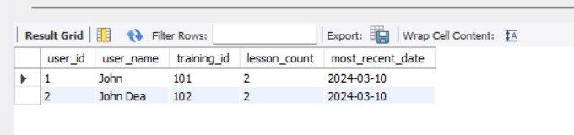

Here in this code we are fetching a records which the lesson count is more than 1 in this we used a join on user_id from both the tables

Returns a

User_id

User_name :- from user table only the those where count of lesson is greater than 1

Training_id :-

Lesson_count

recent_date

**Question 4**

**Soution 4 :-**

Code ➖

CREATE TABLE Employee (

Emp_id INT PRIMARY KEY,

Emp_name VARCHAR(255) NOT NULL,

Salary DECIMAL(10,2) NOT NULL,

Manager_id INT

);

INSERT INTO Employee (Emp_id, Emp_name, Salary, Manager_id)

VALUES(10, 'anil', 50000.00, 18),

(11, 'vikas', 75000.00, 16),

(12, 'nisha', 40000.00, 18),

(13, 'Nidhi', 60000.00, 17),

(14, 'priya', 80000.00, 18),

(15, 'mohit', 45000.00, 18),

(16, 'rajesh', 90000.00, null),

(17, 'raman', 55000.00, 16),

(18, 'santosh', 65000.00, 17)

;

select * from employee;

SELECT E2.EMP_ID, E2.EMP_NAME, AVG(E1.SALARY)

FROM Employee E1

INNER JOIN Employee E2

ON E1.MANAGER_ID = E2.EMP_ID

GROUP BY E2.EMP_ID, E2.EMP_NAME;

Here in this query we are using inner join fetching record from same table on manager_id column and emp_id we just grouped record