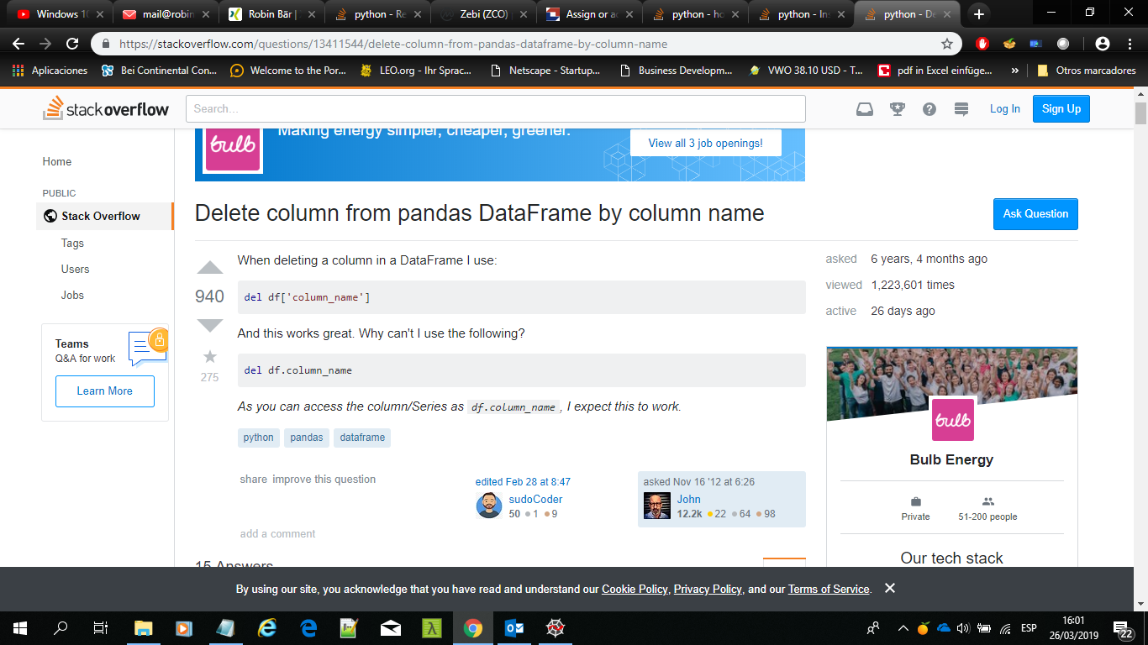

<https://stackoverflow.com/questions/40996272/select-2-ranges-of-columns-to-load-read-csv-in-pandas>