**Project Documentation**

**Name: Arnav Deore & Saniya Bohara**

**Declaration by Student**

I hereby declare that this project, titled "Student Portal – (used by specific college students)" is an original work conducted by me and my team. The information and data presented in this document are genuine and have been compiled as part of my academic requirements. Any external resources used have been duly cited.

**Acknowledgment**

I would like to express my gratitude to my faculty, mentors, and peers who provided guidance and support throughout this project. Special thanks to my institution for providing the necessary resources and infrastructure to complete this work.

**1. Introduction**

**Motivation**

In today's digital era, the integration of technology into educational systems has revolutionized how information is disseminated, and how students and educators interact. Despite the advancements in online education tools, many colleges still face challenges in creating centralized platforms where students can access all essential academic resources. This project aims to address these issues by creating a unified web portal that will serve as a one-stop solution for students of College

**Problem Statement**

The current academic systems in place for students are often isolated and not optimized for seamless user experience. Students typically rely on manual procedures for course registration, receiving course syllabi, and getting academic updates. Additionally, the lack of an integrated feedback system for students and limited access to academic resources such as past exam papers and study guides makes it difficult for students to plan their academic workload effectively.

**Purpose:**

The primary purpose of this project is to create an all-encompassing platform for college students that provides essential academic resources and features in a single place, enabling them to manage their academic tasks with ease.

**Objectives**:

1. To develop a secure and user-friendly platform that allows students to sign in and access all academic-related features.
2. To create an efficient course registration system for students to enrol in courses.
3. To provide essential academic resources such as syllabus, previous year question papers, and AI-driven study planners.
4. To facilitate an effective teacher feedback system, allowing students to provide feedback on instructors.
5. To offer an event calendar that keeps students informed about upcoming academic events, exams, and extracurricular activities.

**Goals**:

* Implement a secure sign-up/sign-in process for students and faculty.
* Develop features like course registration, teacher feedback, academic resources, and event management.
* Enhance student learning by providing access to previous year questions and an AI-based study planner.

**Literature Survey**

The current academic landscape includes various digital platforms aimed at improving student learning and engagement. Some commonly used systems include:

* **Student Information Systems (SIS)**: These systems typically handle registration, grades, and class schedules, but are often disconnected from student feedback systems or academic resources.
* **Online Study Tools**: Tools like Quizlet and Google Classroom offer resource-sharing capabilities but lack deep integration with the academic process within the institution.

**Project Scope and Limitations**

**Scope:**

• Development of an integrated platform for students to access all academic resources in one place.

• Focus on academic features like course registration, syllabi, teacher feedback, previous year questions, and AI-driven study planners.

• Event calendar to track academic and extracurricular events.

**Limitations:**

* The platform will not include non-academic features like personal social media or external integrations beyond the college’s resources.
* The project is limited to the functionality outlined in the documentation and will not support features like faculty-to-faculty communication or integration with external academic systems.

**2. System Analysis**

**Existing Systems**

* Traditional planners (physical and digital)
* Separate academic resource platforms

**Project Perspective & Features**

* **AI Study Planner**: Suggests optimal study schedules.
* **Feedback System**: Collects faculty feedback on performance.
* **Event Calendar**: Event calendar for academic and extracurricular activities.

**Stakeholders**

* **Primary Users**: Students
* **Secondary Users**: Admin

**3. Requirement Analysis**

**Functional Requirements**

* **Sign-up/Sign-in**: A secure authentication system for students and faculty to access the platform.
* **Course Registration**: Students should be able to register for courses based on their academic program.
* **Academic Resources**: Students can access syllabi, past question papers, and use AI-based study planners.
* **Teacher Feedback**: Students should be able to rate and provide feedback on courses and instructors.
* **Event Calendar**: A dynamic calendar for upcoming academic and extracurricular events.

**Performance Requirements**

* **Software**: Web application (HTML, CSS, JavaScript). Scalable backend architecture
* **Database**: MySQL or MongoDB for managing student data, course registrations, and academic resources.
* **Server**: A hosting service like to deploy the platform.
* **Browser Compatibility**: The platform should be compatible with major web browsers such as Chrome, Firefox, and Safari.

**Security Requirements**

* Secure login with encryption for user authentication.
* Role-based access control for students and faculty members.
* Data protection for sensitive student and academic information.

**4. System Design**

**Entity-Relationship Diagram (ERD)**

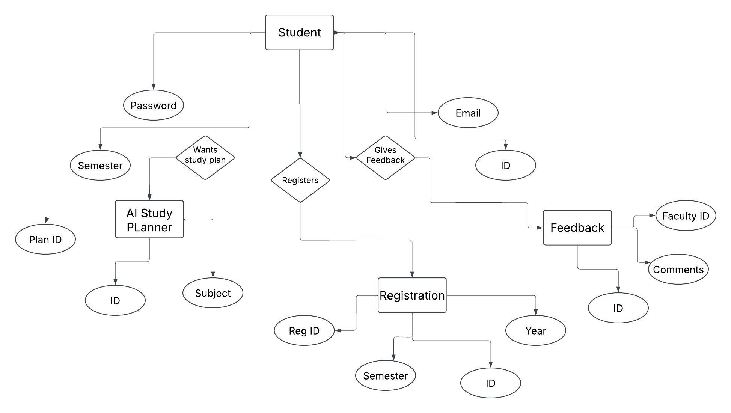

**Data Flow Diagram (DFD)**

**Level 0**

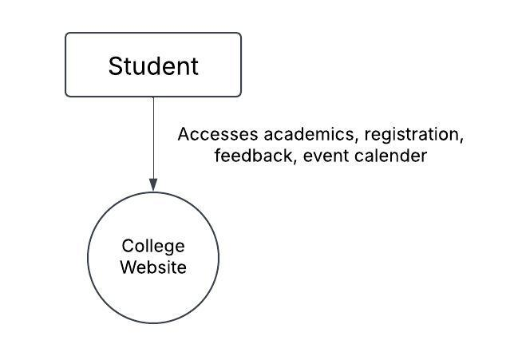

**Level 1**

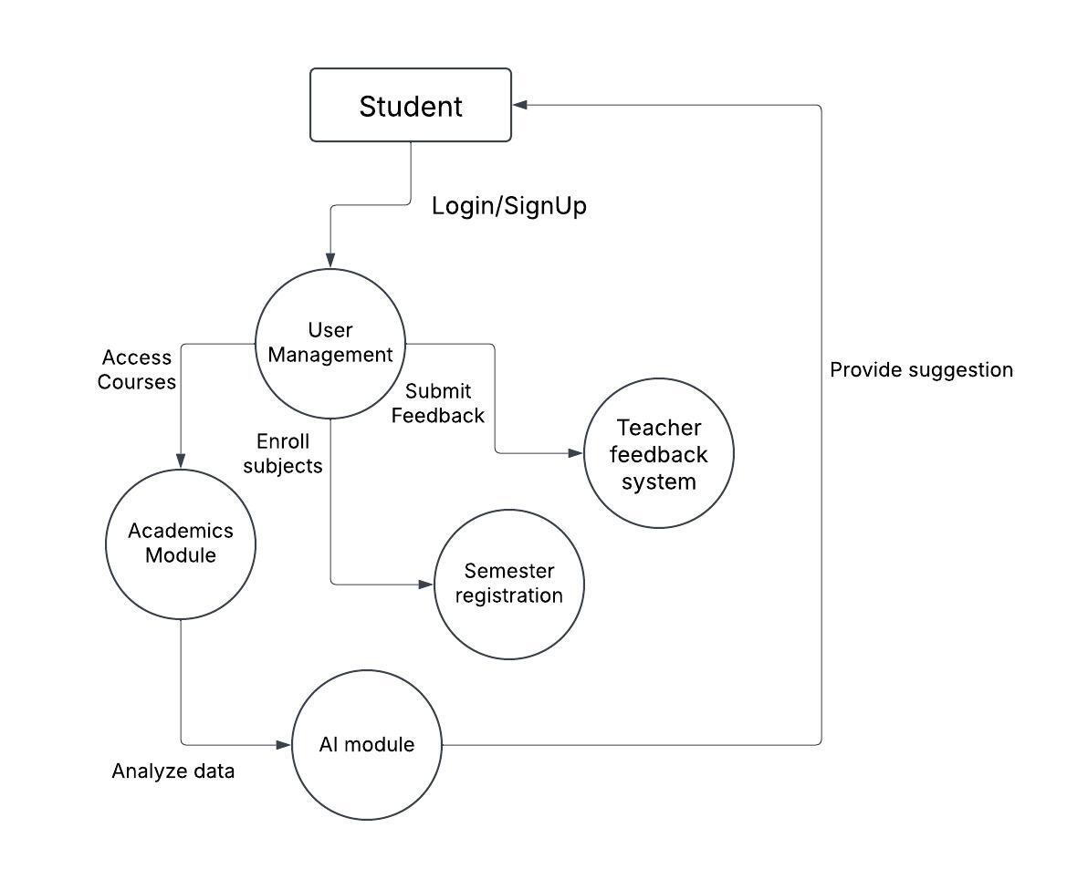

**5. Implementation Details**

**Software & Hardware Specification**

* **Frontend:** HTML, CSS, JavaScript
* **Backend:** PHP (WAMP Server), SQL (phpMyAdmin)
* **Hosting:** Local WAMP/XAMPP server (for testing)

**6. Input/output Reports**

* Student course registration data.
* Teacher feedback submissions.
* Event and academic schedule inputs from the administration.
* Confirmation of successful registration.
* Feedback summary reports for faculty.
* Academic calendar events displayed for users.

**7. Conclusion & Recommendations**

**Conclusion**

This project will significantly improve the student experience by consolidating essential academic features into one user-friendly platform. It will reduce the complexity of navigating multiple systems and enable students to manage their academic life more effectively.

**Recommendations**

* Improve UI/UX for better usability.
* Implement a mobile application version.
* Enhance AI algorithms for more accurate study recommendations.
* Additional features like online exams or virtual classrooms could be added as the system matures.

**8. Future Scope**

* Integration with external academic platforms (Google Scholar, online courses).
* AI-powered voice assistant for study-related queries.
* Gamification to enhance student engagement.
* A mobile version of the website for more on-the-go access to academic resources.

**9. Bibliography & References**

There is no reference taken for this project. It is purely self-made.