PROPOSAL FOR REVIEW
AnnaSutra 2.0
Farmer-First Trade and Traceability Architecture
Core process, entity-by-entity algorithms and block diagrams for a platform whose first customer is the farmer.
Item | Detail
Prepared | 22 October 2026
Basis | Review of the current build (git commit 69b5878): lots, handover, tolerance, disputes, hash-chained ledger, 11 languages
Audience | Product owner, architects, FPO and mandi partners, pilot sponsors
Status | Design proposal. Nothing in this document has been built or validated with farmers yet.
How to read | Sections 1-6 explain the core concept. Section 7 gives one chapter and one block diagram per entity. Sections 8-14 cover special flows, scoring, money, data, roadmap and risks.

HONEST FRAMING No design is flawless. This proposal is built to fail safely: every known weakness is listed in Section 14 with a containment, and every number is labelled as a starting hypothesis to be tuned in a pilot.

1 Executive summary
Where we are. AnnaSutra today proves where a lot of produce travelled: lots, a two-step handover, tolerance checks and a tamper-evident ledger. That is valuable to consumers and regulators. For a farmer it is not yet valuable, because the system records custody and weight but not money, and it quietly treats every farmer problem as a data-entry problem.
The thesis. A traceability system survives only if the person who does the most work, the farmer, is paid faster, cheated less and rewarded for proof. So the design inverts the priority: money and trust come first, and traceability becomes the by-product of honest trade.
Seven structural moves
- Make the Trade the central object: price, quantity, payment terms and delivery terms are recorded together. A handover becomes the delivery step of a trade.
- Separate title from custody: carriers and warehouses hold goods but never own them, and transit loss is attributed by agreed terms, never silently to the farmer.
- Pay the undisputed amount immediately: only the contested part waits. Money is never held hostage to a small disagreement.
- Remove the pre-link requirement: any verified or provisional party can trade through an open handshake that works with no network.
- Make evidence two-sided: both parties sign the weigh slip; a rejection needs a reason and a photo; unevidenced rejections do not stop payment.
- Show reputation before dispatch: the farmer sees the buyer's Pay-Score; buyers see the farmer's trust band. Scores unlock benefits and never gate market access.
- Return value to the farmer: mandi price band at listing, a consent-based credit passport, and a visible share of the consumer rupee.
Outcome targets (hypotheses to prove in a pilot, not promises)
Metric | Why it matters to a farmer | Starting target
Delivery-to-payment time | Cash flow is the farmer's biggest daily constraint | Median under 24 h; 90% of cash and UPI trades paid within 24 h
Unevidenced rejections | Arbitrary cuts are a major leak in income | Zero rejections accepted without reason code and photo
Unscheduled mandi deductions | Opaque deductions erode net price | Zero (every deduction maps to a published schedule line)
Time to first lot (assisted) | Onboarding friction kills adoption | Under 5 minutes with an agent, under 10 minutes self-service
Dispute resolution median | Unresolved disputes freeze money | Under 72 h from case open
Farmers with a credit passport | Credit exclusion is a root problem | Share of active farmers who consent to export a verified history

One trade, end to end (the example the platform must be able to run)
# | Moment | What happens | Rail
1 | Harvest morning | Ramesh (farmer) declares 400 kg tomatoes from Plot 2 by app or voice. Platform creates the lot and QR and shows today's mandi band for his district. | Goods
2 | +10 min | He opens Sell, picks Direct and scans retailer Sunita's shop QR. Sunita is verified with Pay-Score 86 (Reliable). Default terms: UPI on delivery. He sets Rs 20/kg: expected Rs 8,000. | Money + Trust
3 | +15 min (no network) | His phone signs a Handover Token naming Sunita. QR appears on his screen. Nothing needs the internet. | Goods
4 | At the shop | Sunita scans the token, weighs: 392 kg accepted, 6 kg rotten (reason + photo), 2 kg unaccounted. She countersigns on her phone. | Goods + Trust
5 | Network returns | Both phones sync. Platform verifies two signatures and the one-time nonce. Tolerance check passes (2 kg is below the allowed tolerance). Events are written to the ledger. | Ledger
6 | Seconds later | Split-pay: UPI request for 392 x Rs 20 = Rs 7,840 goes to Sunita. The 6 kg (Rs 120) is offered back to Ramesh: accept the rejection or contest within 24 h. | Money
7 | Minutes later | Sunita pays; UTR is recorded. Ramesh taps Confirm on 'Rs 7,840 received'. Title moves to Sunita. Trade is SETTLED. | Money
8 | Same day | Ramesh's delivery accuracy and Sunita's on-time payment update. A verified entry is added to his credit passport. Sunita prints consumer QR labels. | Trust + Insight
9 | Next day | A shopper scans the pack: district, harvest date, two handovers, evidence level per claim. A freshness rating flows back to Ramesh as aggregated feedback. | Insight

2 Real farmer problems and the design response
Each feature in this proposal exists to remove a specific, observable pain. Features that do not map to a problem here were left out.
# | Farmer problem | Root cause in a traceability-only design | Design response | KPI
1 | Late, partial or unpaid sales | Payment is outside the record; the buyer controls timing | Trade object with payment terms, risk-based credit rule, split-pay, overdue ladder, Pay-Score shown before dispatch | Hours from delivery to payment
2 | Arbitrary rejection and weight cuts | Only the buyer records weight and quality | Dual-signed weigh slip, tolerance, mandatory reason + photo, rejection-anomaly detection, rejected qty stays with farmer | Rejection rate vs peers
3 | Opaque mandi deductions | Commission-agent statements are unaudited | Itemised account-sale; only scheduled deductions allowed; farmer sees it before payout | Unscheduled deductions = 0
4 | Price blindness | Farmer has no reference at the moment of sale | Mandi price band at listing, floor nudge, farmer-share view | Price vs mandi modal
5 | Closed networks and forced pre-linking | Both sides must be registered and linked in advance | Open handshake with provisional T0 accounts; trust earned, not pre-arranged | Share of trades with new counterparties
6 | Poor connectivity, low digital literacy | App-only forms, always-online assumption | Offline signed tokens, voice / IVR / WhatsApp, assisted entry by agents with consent | Time to first lot
7 | Credit exclusion | No verified transaction history | Consent-based credit passport via Account Aggregator; pay-today-against-receivable option | Loans enabled
8 | Spoilage and transit loss blamed on the farmer | Custody and ownership conflated; no transit evidence | Title vs custody split, carrier telemetry, loss attribution by delivery terms | Transit loss %
9 | No reward for quality or traceability | Premium has no channel to flow back | Verified-origin premium line item, quality score, consumer feedback loop | Premium per kg
10 | Data exploitation | Everything visible to everyone in the chain | DPDP-style consent, price visible only to the two trading parties, k-anonymous insights | Consent coverage

3 Twelve design laws
These are the rules every later decision is checked against. When two laws conflict, the lower number wins.
# | Law | Meaning in practice
1 | The farmer is paid before anyone gets a dashboard. | Money rail ships first.
2 | A trade is a contract, not a status change. | Price, quantity, terms and delivery are one signed object.
3 | Title and custody are different things. | The party holding goods is not necessarily the owner.
4 | Pay the undisputed amount immediately. | Only the contested part waits for resolution.
5 | Both sides weigh; evidence beats assertion. | No rejection without reason code and photo.
6 | Offline is the normal case. | Every field action must complete with no network and sync later.
7 | No pre-linking. | Any verified or provisional party can trade; trust is earned and visible.
8 | A score is a ticket, never a gate. | Scores unlock benefits; they never block a farmer from selling.
9 | Data belongs to the farmer. | Consent, minimum visibility, and the right to export.
10 | The platform never holds the farmer's money. | Payments move peer to peer through licensed rails.
11 | Every claim shows its evidence level. | Self-declared, peer-vouched or verified is always visible.
12 | Boring technology, loud guarantees. | Proven components; strong, testable invariants.

4 Core concept: four rails on one ledger
Goods move, money settles, trust is earned and insight flows back. Each rail has its own objects and rules, but all four write to the same append-only, hash-chained ledger, so any dispute can be replayed from evidence.
Object | Question it answers | Key fields | Status in current build
Lot | What physical batch? | crop, qty, grade, plot, harvest date, origin claims with evidence level, owner, custodian | Exists (add owner separate from custodian)
Trade | On what terms? | seller, buyer, qty, price/kg, premium, payment terms, delivery terms, state | NEW
Custody | Who physically holds it? | custodian, pickup and drop events, telemetry | Exists (handover)
Title | Who owns it? | owner, transfer trigger (payment or acceptance) | NEW
Weigh slip | What was counted, by whom? | declared, accepted, rejected lines (reason, photo), both signatures | NEW (partly in handover payload)
Payment | Was the farmer paid? | amount, method (UPI, cash, bank), UTR, proof, confirmation by seller | NEW
Case | What is contested? | level, SLA, evidence pack, outcome | Evolves from dispute
Score | Who is reliable? | trust band, Pay-Score, quality score, evidence of components | NEW

WHY TITLE AND CUSTODY MUST BE SEPARATE Today the system has one field, custodian. When a carrier holds goods, or a commission agent sells on consignment, that field cannot say whose goods they are, who bears loss, or who must be paid. Splitting title from custody lets a carrier hold goods without owning them, lets a farmer keep title until paid (for new buyers), and makes every loss attributable.

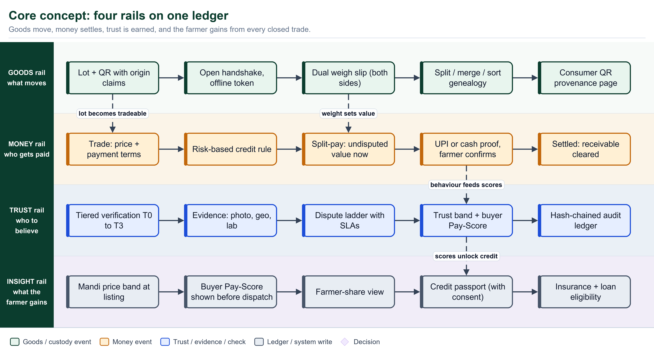
Figure: Four rails: goods, money, trust and insight, tied together by dashed couplings

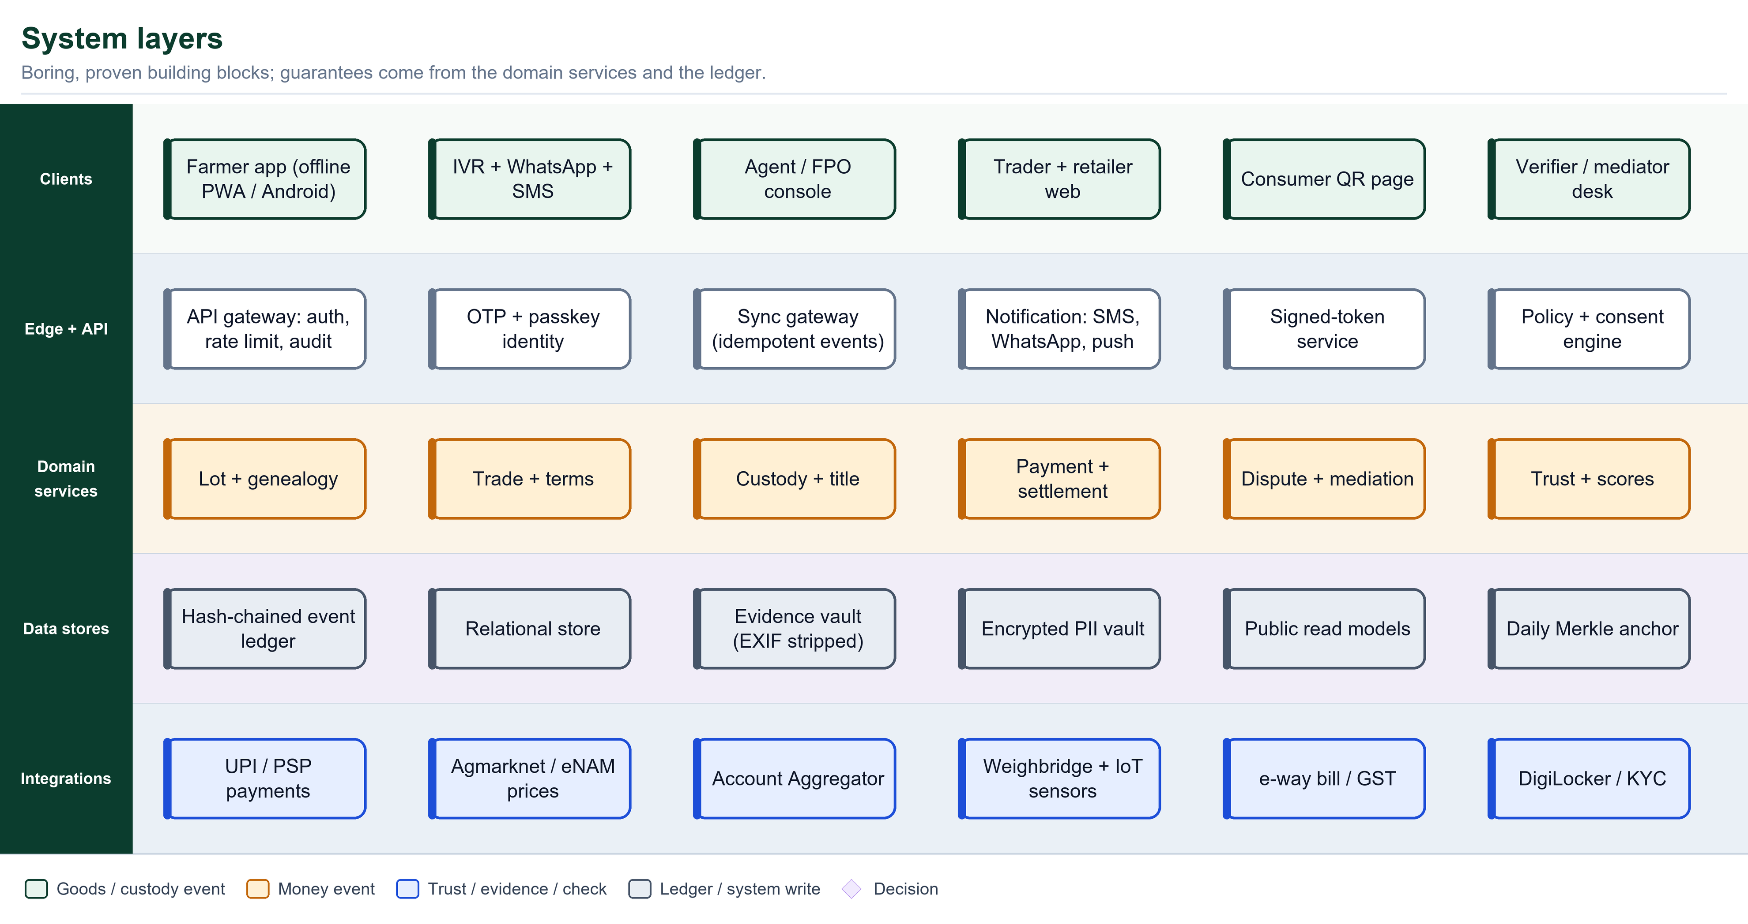
Figure: System layers: clients, edge, domain services, data stores and integrations

5 The Trade lifecycle
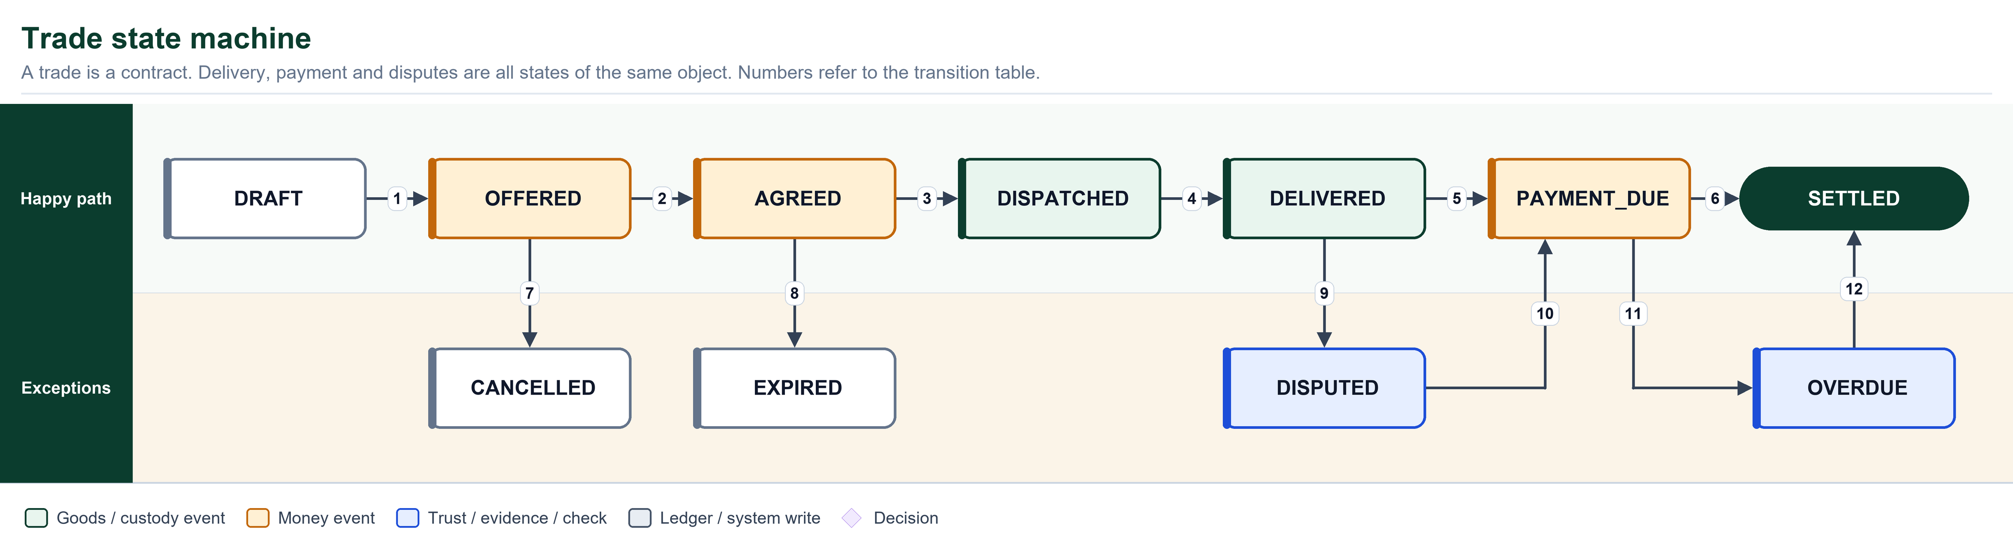
Figure: Trade state machine (numbers refer to the table on the next page)

Transition table
# | From | To | Trigger | Written to ledger
1 | DRAFT | OFFERED | Seller publishes price and terms | TRADE_OFFERED
2 | OFFERED | AGREED | Buyer accepts (or scans token) | TRADE_AGREED
3 | AGREED | DISPATCHED | Handover Token signed; pickup | HANDOVER_OPEN
4 | DISPATCHED | DELIVERED | Dual-signed weigh slip synced | HANDOVER_RECEIVED, WEIGH_SLIP
5 | DELIVERED | PAYMENT_DUE | Settlement computed (accepted qty x price + premium) | SETTLEMENT
6 | PAYMENT_DUE | SETTLED | Payment proof + seller confirmation (or PSP callback) | PAYMENT_CONFIRMED, TITLE_TRANSFER
7 | OFFERED | CANCELLED | Either party withdraws before agreement | TRADE_CANCELLED
8 | AGREED | EXPIRED | No dispatch before deadline | TRADE_EXPIRED
9 | DELIVERED | DISPUTED | Evidenced rejection or discrepancy beyond tolerance | CASE_OPENED
10 | DISPUTED | PAYMENT_DUE | Case resolved; adjusted amount agreed | CASE_RESOLVED
11 | PAYMENT_DUE | OVERDUE | Due date passed unpaid | PAYMENT_OVERDUE
12 | OVERDUE | SETTLED | Paid late; Pay-Score penalty applied | PAYMENT_CONFIRMED_LATE

Risk-based payment terms (the rule that protects the farmer)
The platform proposes the loosest terms that the buyer's standing justifies. The seller may always choose stricter terms. If the seller chooses looser terms than proposed, the app shows a clear warning and records 'seller accepted risk'. Thresholds below are starting values to tune in the pilot.
Buyer standing | Allowed terms | Title moves when | Reason
New, provisional (T0), or first trade between this pair | Cash or UPI on delivery only | Undisputed amount is paid | No history; remove credit risk entirely
Verified, Pay-Score below 80 or fewer than 5 trades with this seller | UPI on delivery, or T+1 | Weigh slip accepted and payment claim recorded | Some history; short exposure
Proven: Pay-Score 80 or above, 5 or more trades with this seller | T+3 up to credit limit | Weigh slip accepted; receivable tracked | Reliable record earns credit
Institution or FPO-guaranteed buyer | Per written agreement | Per agreement; receivable tracked | Contractual and reputational backing
Any buyer with an overdue above 7 days | Cash on delivery only | Undisputed amount is paid | Active default risk

Delivery terms (who bears transit risk)
Term | Risk passes to buyer | Typical use
Ex-farm | At pickup (carrier arranged by buyer) | Retailer or wholesaler collects from the field
Delivered | At receiver's acceptance of the weigh slip | Farmer or aggregator arranges transport
Carrier-liable | Per carrier agreement; loss beyond tolerance is claimed from the carrier | Third-party logistics with telemetry

6 The universal handshake and settlement algorithm
Every entity hands goods to another using the same protocol. It replaces the current requirement that both organisations be pre-linked as trusted partners. Instead, the two phones prove physical presence by exchanging signatures.
Handover Token and receipt (offline-safe)
HandoverToken (signed by seller device key)
token_id, trade_id, lot_code
declared_qty_kg, price_per_kg, premium_per_kg
payment_terms, delivery_terms
seller_id, buyer_id (named when seller scans buyer ID QR)
nonce (single use), issued_at, expires_at
default 72 h; 12-24 h for leafy and highly perishable crops

ReceiptToken (signed by buyer device key)
token_id, accepted_qty_kg
rejects[ {qty_kg, reason_code, photo_hash} ]
condition, crates_counted, geo, time

Sync rules at the server
1. Verify both signatures and that the buyer key matches buyer_id.
2. Reject if nonce already consumed (idempotent by event_id).
3. Apply events in custody-chain order (single-writer: only the
current custodian may emit events for a lot).
4. If either side is still offline, state stays DISPATCHED; goods
and money are unaffected, only the record lags.

Settlement algorithm
function COMPUTE_SETTLEMENT(trade, slip):
D = trade.declared_qty
C = slip.accepted_qty
R = sum(line.qty for line in slip.rejects)
U = D - C - R # unaccounted quantity
tol = max(2 * scale_resolution, k_crop * D)

for line in slip.rejects:
if not line.reason_code or not line.photo_hash:
line.status = CLAIM_PENDING_EVIDENCE # buyer has EVIDENCE_WINDOW
C = C + line.qty # value stays payable now

undisputed_value = C * (trade.price + trade.premium)
pay_now(trade, undisputed_value) # split-pay, never held

if abs(U) > tol:
open_case(trade, QTY_DISCREPANCY, U) # tolerance exceeded
for line in evidenced_rejects:
offer_back_to_seller(line) # accept | reprice | take back | contest

trade.due_date = delivered_at + trade.terms.days
return Settlement(pay_now = undisputed_value, due = trade.due_date)

DESIGN NOTE Tolerance still decides whether an alert or case opens, as in the current build. What changes is that tolerance no longer delays money: the undisputed value is always payable immediately, and the contested part is isolated.

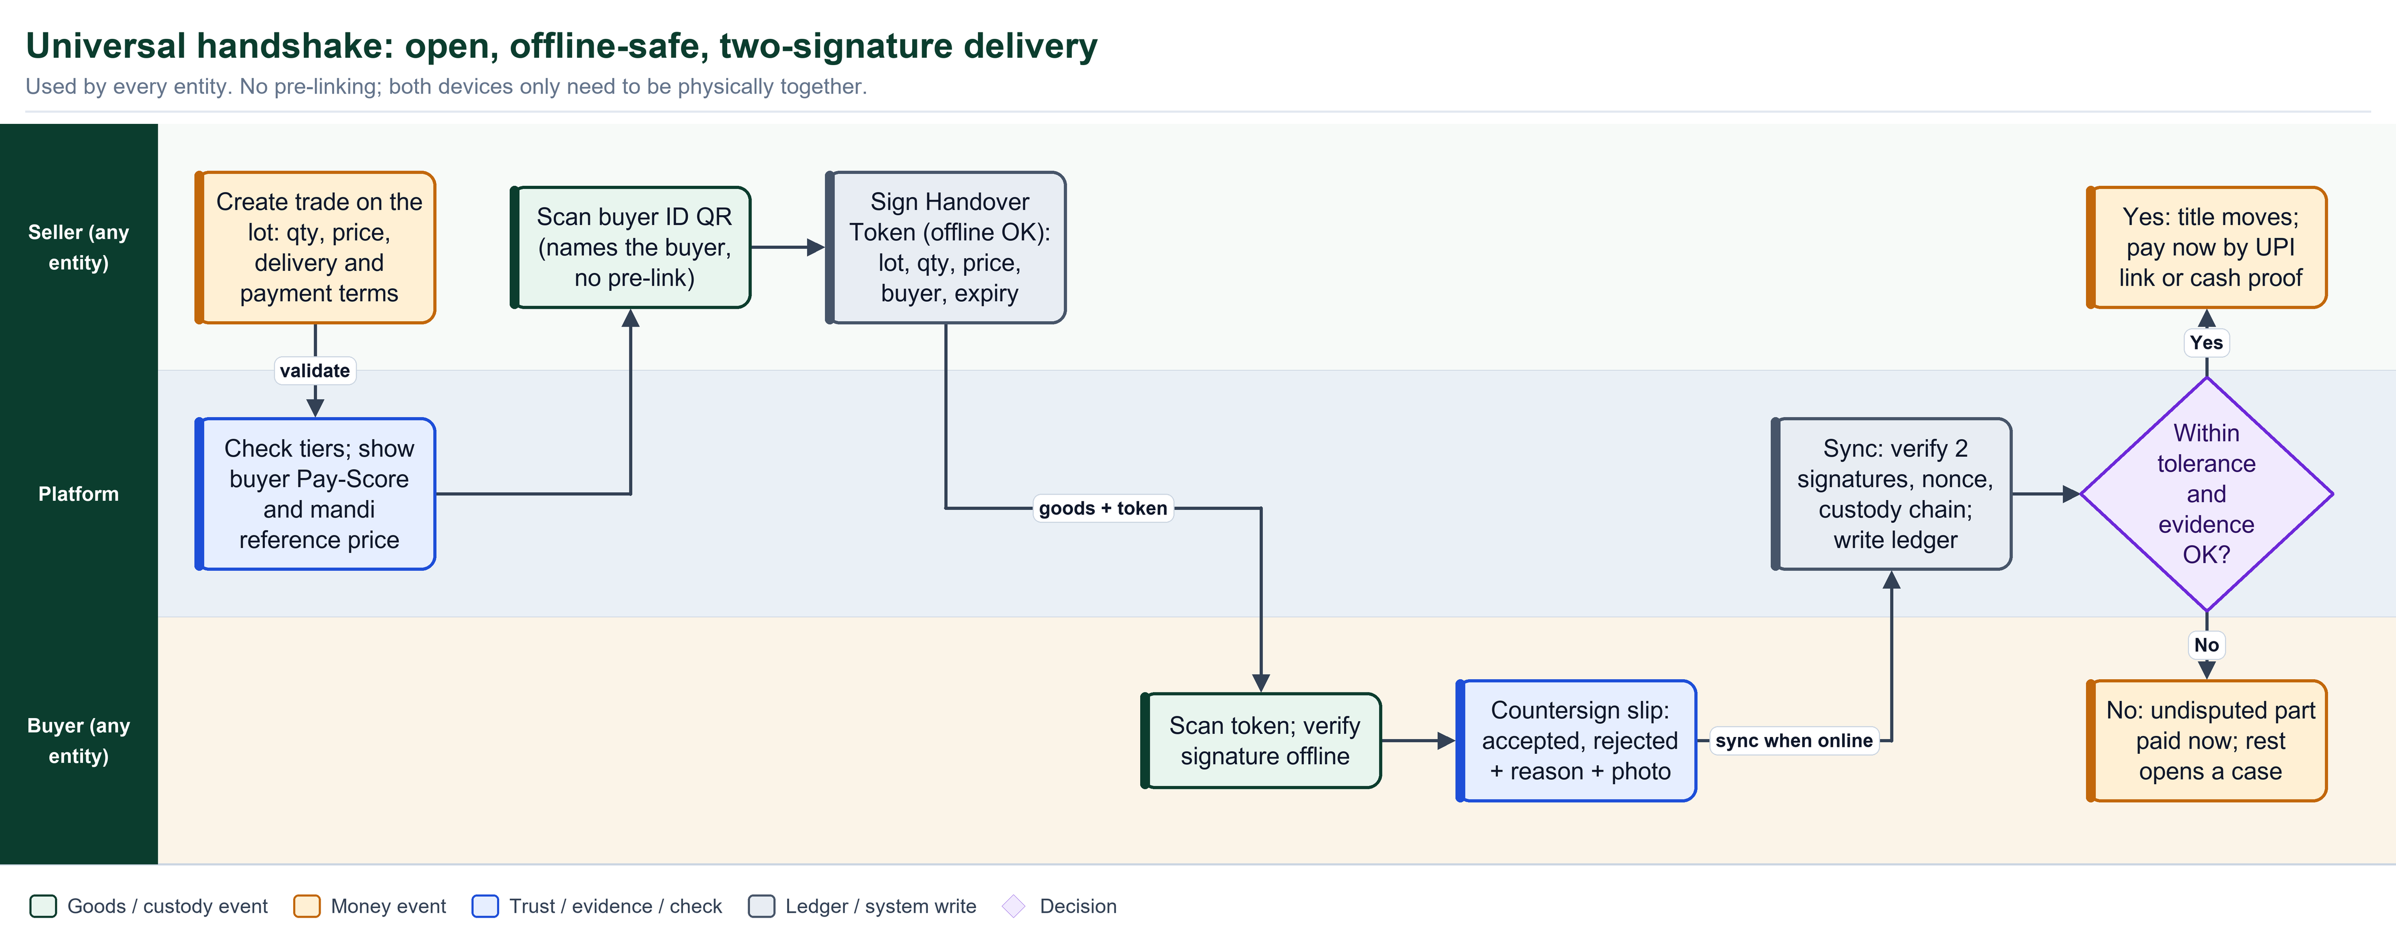
Figure: Universal handshake: used by every entity, offline-safe, two signatures

7 Entity-by-entity design
Each entity has a promise, a boundary (what it does and never does), a pseudocode algorithm, enforced invariants, KPIs and a swimlane block diagram. All diagrams use one legend: green = goods or custody event, saffron = money event, blue = trust or evidence check, grey = ledger or system write, purple diamond = decision.
# | Entity | One-line job | Maps to current role
7.1 | Producer (farmer) | Create honest lots and get paid fast | FARMER / Producer
7.2 | Aggregator / FPO | Pool lots fairly, pay same day, share upside | AGGREGATOR
7.3 | Wholesaler / commission agent | Run an auditable market and statement | WHOLESALER
7.4 | Distributor / carrier | Hold custody (not title), prove condition | DISTRIBUTOR / OPERATOR
7.5 | Retailer | Buy from anyone verified, sell with consumer QR | RETAILER
7.6 | Consumer | See provenance, give feedback, thank the grower | Public view
7.7 | Verifier / mediator / admin | Keep the network honest and fast | Admin, LAB

7.1 Producer (farmer)
PROMISE TO THIS ENTITY Sell at a fair price, get paid fast, and keep my proof. I should never need a computer, a pre-arranged buyer, or a lawyer.

Does | Never does
- Register by phone number (or via an agent with consent)  - Declare harvest and create lots with QR  - See the mandi price band, set price and terms  - Hand over by scan and offline token  - Confirm payment received (tap, OTP or voice)  - Export a consent-based credit passport | - Pre-link buyers before selling  - Pay any fee for the core flow  - Accept a rejection that lacks reason and photo  - Have plot geometry shown publicly  - Have the price overwritten by anyone downstream

Algorithm (pseudocode)
procedure SELL_LOT(farmer, lot):
ref = MANDI_REFERENCE(lot.crop, lot.district) # Agmarknet / eNAM band
route = farmer.choose(DIRECT | FPO | MANDI)
buyer = farmer.pick_or_scan(route) # no pre-link needed
assert buyer.tier >= required_tier(lot.qty) # provisional T0 allowed
terms = DEFAULT_TERMS(farmer, buyer) # risk-based (Section 5)
price = farmer.set_price(prefill = ref.modal)
warn_if(price < 0.9 * ref.min) # floor nudge, not a block
trade = CREATE_TRADE(lot, buyer, qty, price, terms, delivery_terms)
token = SIGN_HANDOVER_TOKEN(trade, buyer.pubkey, ttl) # works offline
on receipt_token(slip):
s = COMPUTE_SETTLEMENT(trade, slip) # split-pay now
notify(farmer, s)
on payment_marked(utr):
farmer.confirm() or PSP_VERIFY(utr)
UPDATE_SCORES(trade); ADD_TO_CREDIT_PASSPORT(trade)

Invariants the system enforces
- Farmer-set price is never changed by a downstream party.
- Rejected quantity stays under the farmer's title until a disposal is agreed.
- A trade is SETTLED only after farmer confirmation or a PSP-verified payment.
- An agent-assisted entry needs farmer consent (OTP, voice or thumb) within 24 h or is flagged.
- Yield plausibility: qty per plot per season cannot exceed area x crop max yield x slack.
How we know it works (KPIs)
- Time to first lot (assisted and self-service)
- Median hours from delivery to confirmed payment
- Share of trades settled without dispute
- Realised price vs mandi modal price

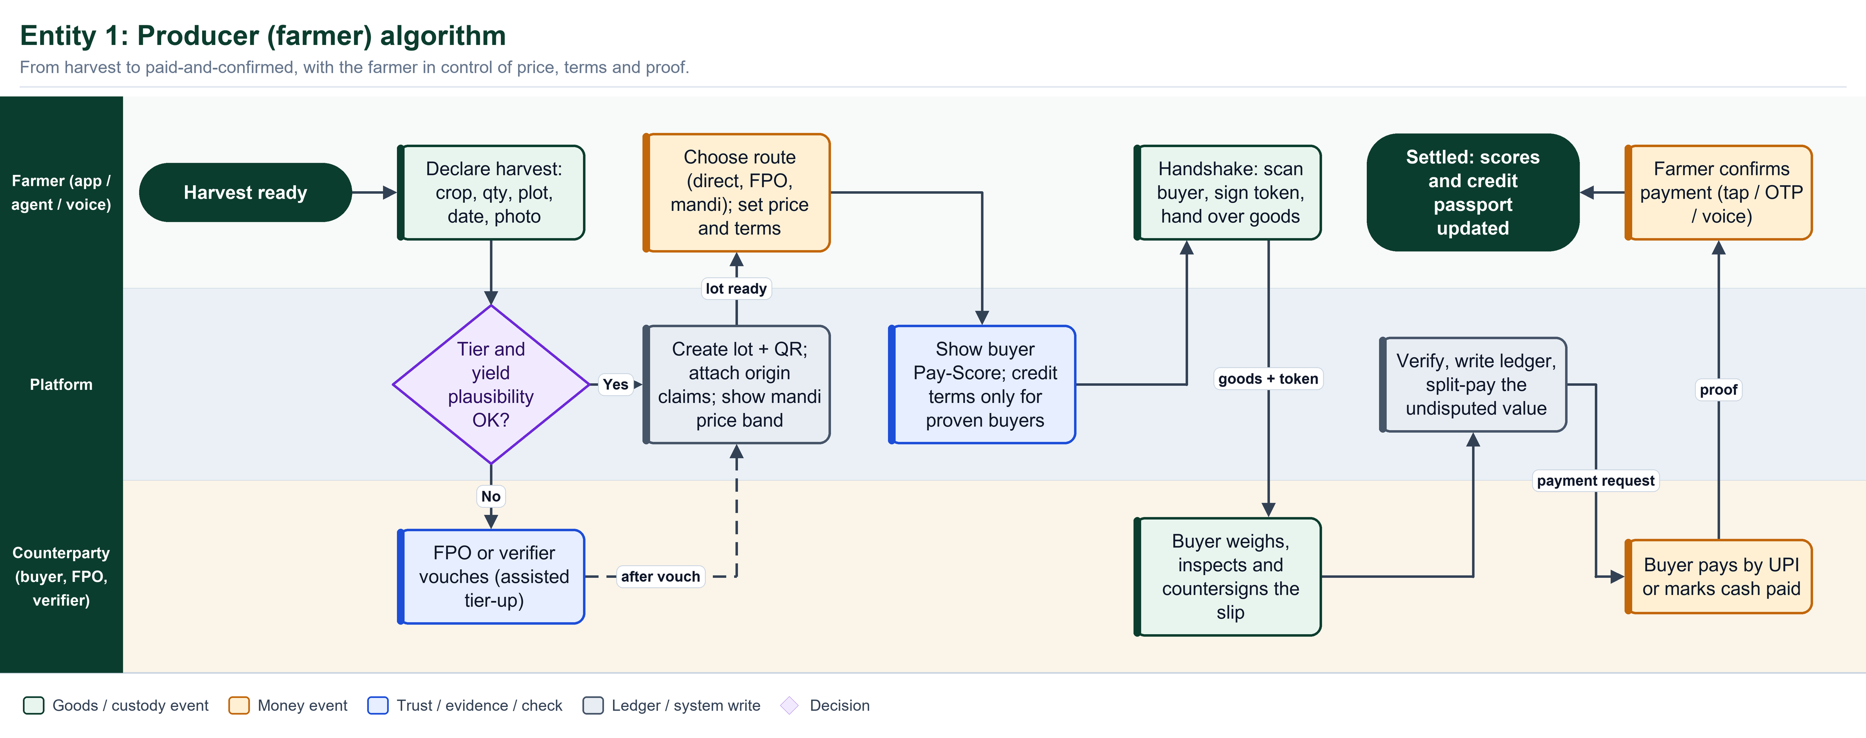
Figure: Producer algorithm swimlane: from harvest to paid-and-confirmed

7.2 Aggregator / FPO collection centre
PROMISE TO THIS ENTITY Let me pool many small farmers into sellable lots, pay them the same day, keep a transparent margin, and share upside fairly.

Does | Never does
- Publish a daily rate card by grade before opening  - Weigh in front of the farmer with a digital slip and photo  - Pay farmers same day (UPI batch or cash with OTP receipt)  - Merge lots while preserving each farmer's contribution share  - Sort into grade lots with new QR labels  - Sell through the standard sell flow | - Change the rate card mid-day without publishing  - Pay below the card without evidence  - Hide who contributed what to a pooled lot  - Hold farmer money for later sale outcomes

Algorithm (pseudocode)
procedure COLLECTION_DAY(centre):
publish(RATE_CARD(crop, grade, today)) # before opening
for each farmer arrival:
slip = WEIGH_BOTH_SIDES(farmer.lot) # photo, time, geo
grade = QUALITY_CHECK(slip) # moisture, size, defects
if grade.meets(rate_card):
rate = rate_card[grade]
payable = slip.net_qty * rate
TRADE(farmer -> centre, payable, terms = SAME_DAY)
PAY_NOW(farmer, payable) # batch UPI or cash + OTP
else:
REGRADE_WITH_EVIDENCE(farmer, slip) # accept | withdraw | mediate
at cutoff:
pool = MERGE(lots, keep_shares = TRUE) # farmer share ledger
for lot in SORT_GRADE(pool): SELL_LOT(centre, lot)
for lot in sold_lots:
excess = lot.realised - lot.rate_paid - centre.margin_cap
if excess > 0: SHARE(excess, farmers, by = contribution_share)

Invariants the system enforces
- For every pooled lot, the sum of farmer shares equals 1 and each farmer's slip is retained.
- A pay-SLA breach by the aggregator triggers the same overdue ladder as any buyer.
- Margin cap per FPO charter is configurable; excess over rate paid plus cap is shared pro-rata.
- Re-grading needs evidence; the farmer may accept, withdraw or ask mediation.
How we know it works (KPIs)
- Share of farmers paid same day
- Collection-to-sale time
- Premium share distributed per season
- Re-grade dispute rate

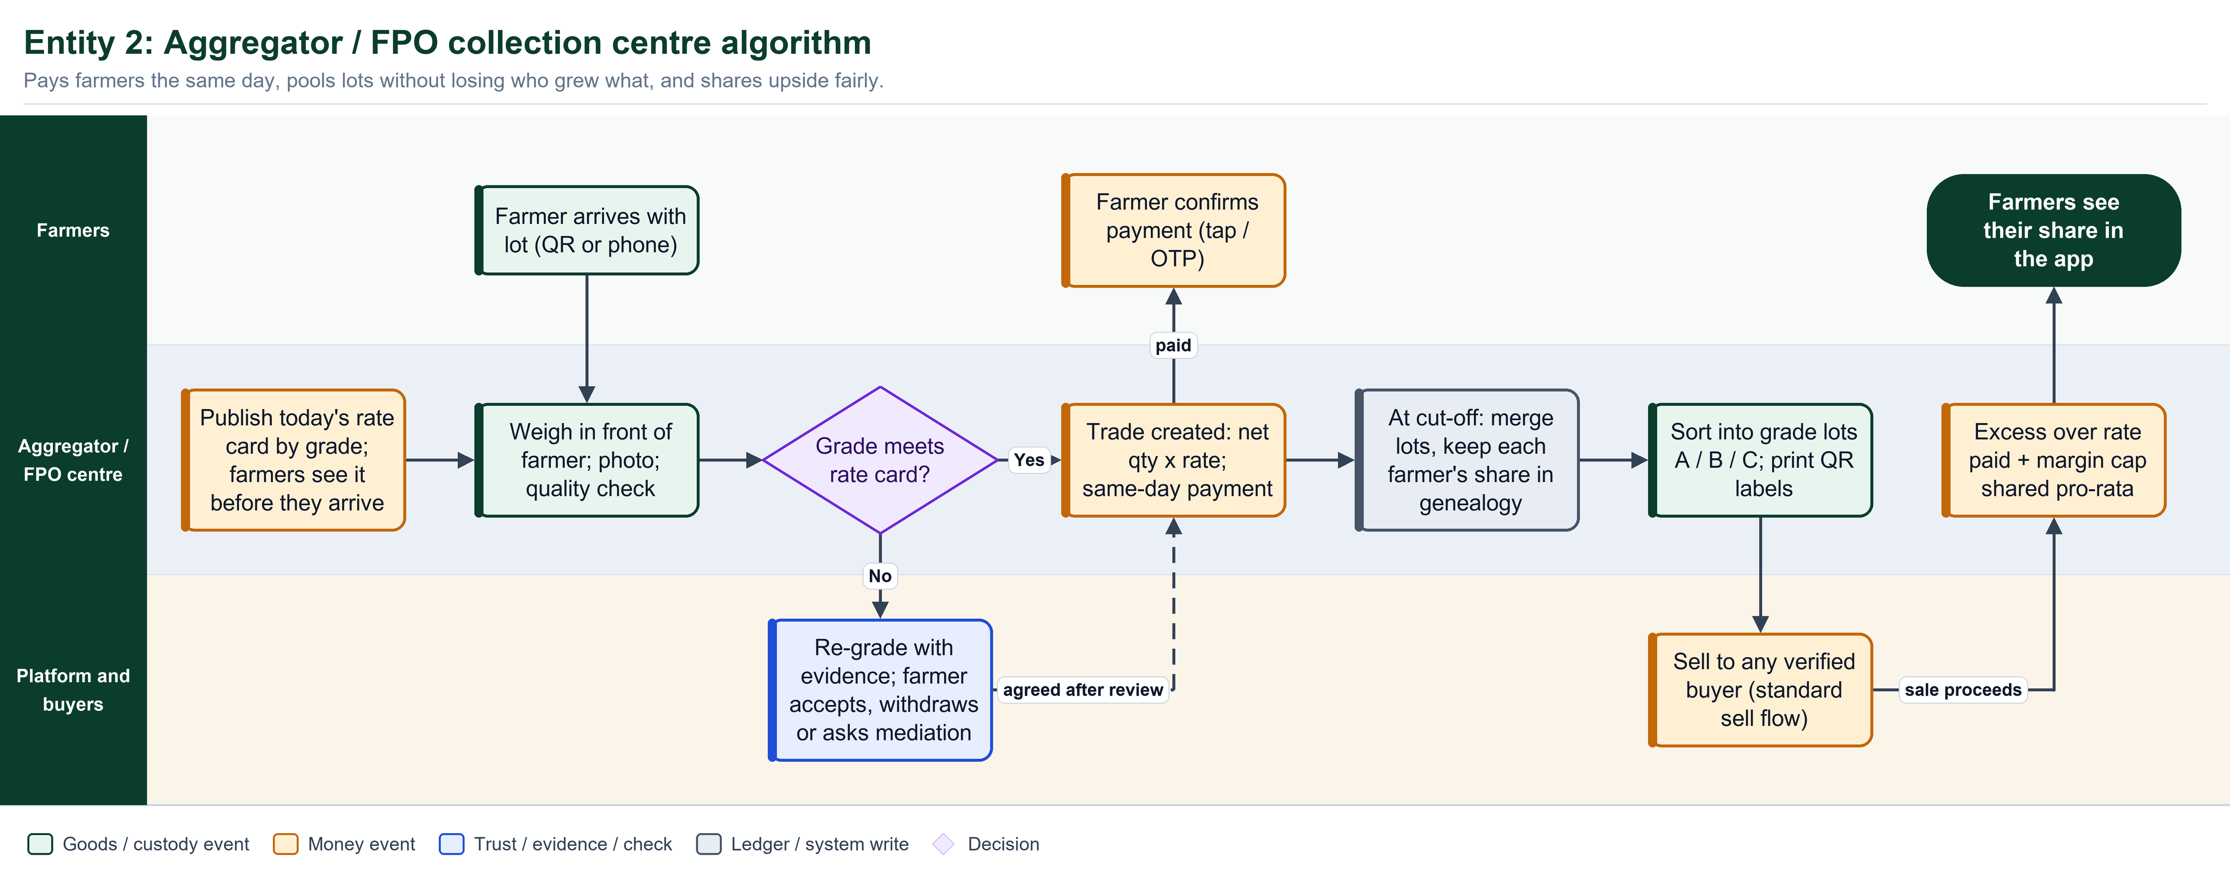
Figure: Aggregator / FPO algorithm swimlane: same-day pay, fair pooling, shared upside

7.3 Wholesaler / commission agent
PROMISE TO THIS ENTITY Let me run a fast market where every bid, every deduction and every payout is on the record, so my reputation becomes an asset instead of a rumour.

Does | Never does
- Receive consignments with weigh, temperature and quality checks  - Operate in principal or commission mode  - Log every auction bid with time  - Split into sale lots and issue new QR labels  - Issue an itemised account-sale statement before payout  - Pay net to the seller within the published SLA | - Deduct any charge not on the published schedule  - Pay out before the seller has seen the statement  - Sell on commission without a logged bid  - Change the schedule mid-season without notice

Algorithm (pseudocode)
procedure MANDI_SALE(agent, lot):
receive(lot) via HANDSHAKE # weigh, temp, quality
mode = agent.mode(lot) # PRINCIPAL | COMMISSION
if mode == COMMISSION:
log = AUCTION_LOG(lot) # bidder, price, time
sale_price = log.winning_bid
for split in SPLIT(lot, buyers):
TRADE(agent -> buyer, split) # one trade per split
stmt = ACCOUNT_SALE(
gross = sum(split.value),
deductions = [d for d in charges if d in SCHEDULE(mandi)],
blocked = [d for d in charges if d not in SCHEDULE(mandi)])
assert stmt.blocked == []
SHOW_TO_SELLER(stmt); WAIT(seller.approve_or_query)
PAY(seller, stmt.net, within = mandi.payout_sla)
else: # PRINCIPAL
TRADE(seller -> agent, price) # agent buys, takes title
PAY(seller, per_terms)
resell via SELL_LOT
UPDATE_SCORES(); DEDUCTION_ANALYTICS(mandi)

Invariants the system enforces
- gross = sum of sale legs; net = gross minus the sum of scheduled deductions.
- Each deduction line carries a schedule ID and a receipt; unscheduled lines are blocked.
- The seller sees the statement before payout and may query any line.
- Payout SLA per mandi (T+X) is configured; breach opens the overdue ladder.
How we know it works (KPIs)
- Unscheduled deductions (target zero)
- Hours from sale to account-sale statement
- Dispute rate per mandi
- Median payout delay

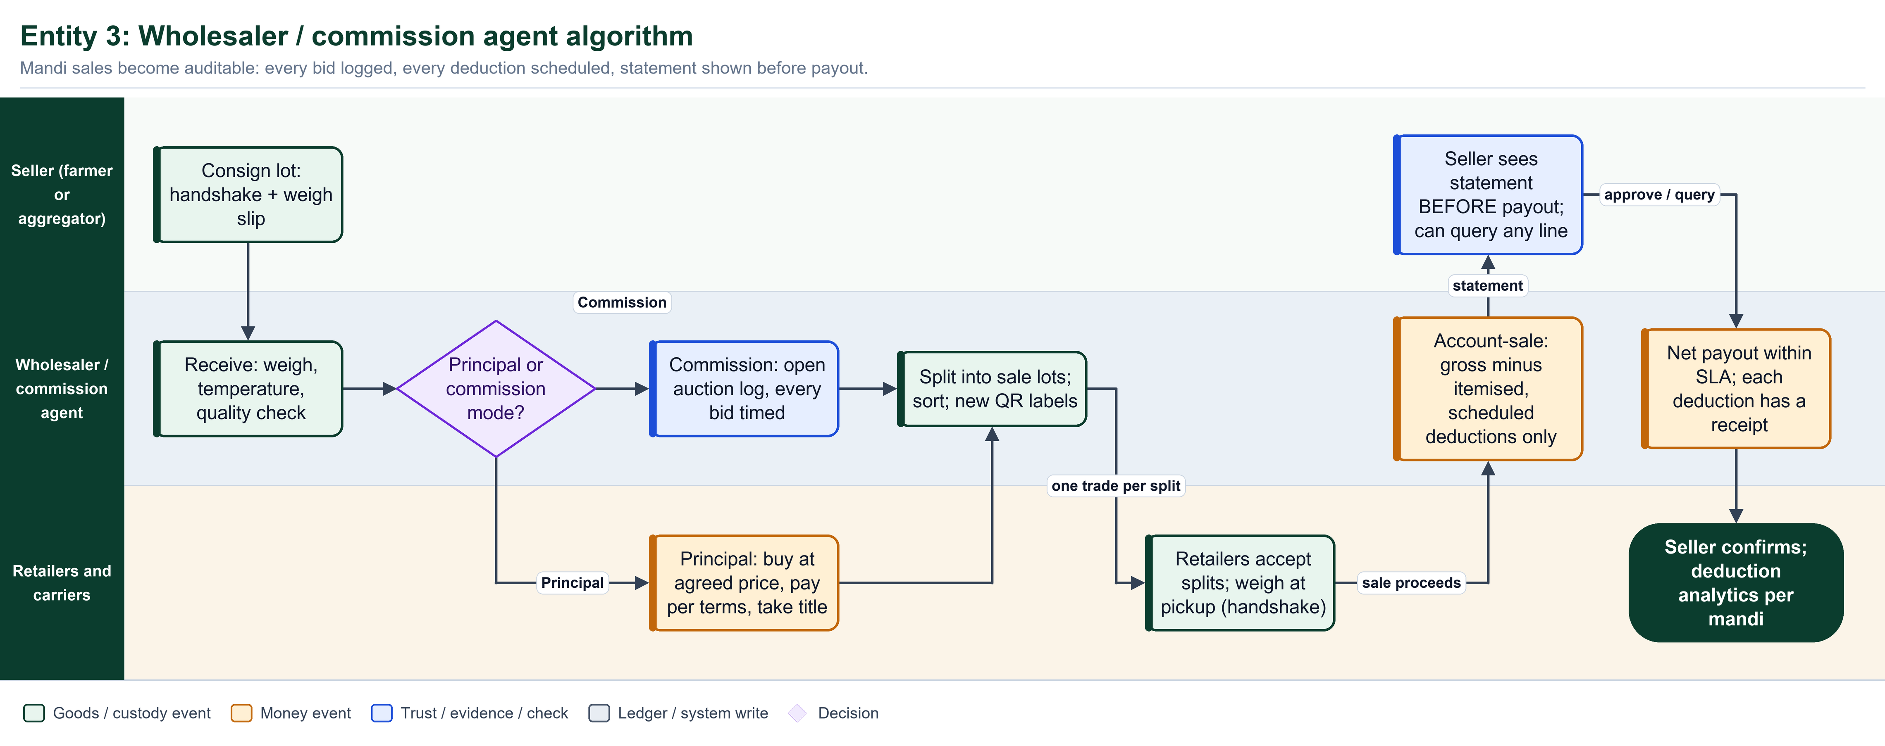
Figure: Wholesaler / commission agent algorithm swimlane: auditable statement before payout

7.4 Distributor / carrier
PROMISE TO THIS ENTITY Let me move produce safely, prove its condition at every kilometre, and be judged on what actually happened to it in my custody.

Does | Never does
- Count crates, photograph and read temperature at pickup  - Log GPS, temperature and door-open events (offline buffer)  - Hand over via the same handshake at drop  - Attach a freight invoice to the trade it served | - Take title to the goods  - Settle transit loss with the farmer  - Edit telemetry after the fact  - Mark a leg closed without receiver counts

Algorithm (pseudocode)
procedure CARRY(carrier, leg):
PICKUP: count crates, photo, temperature -> PICKUP_EVENT # custody only
while in_transit:
every N minutes: LOG(gps, temp, door_events) # buffer offline
if temp > limit for > t or route_dev > x or delay > ETA + slack:
ALERT(owner, receiver); ADJUST_SHELF_LIFE(lot)
DELIVER: receiver HANDSHAKE (recount, weigh)
loss = pickup_qty - drop_qty
if abs(loss) <= tolerance(leg):
CLOSE_LEG(leg); LINK_FREIGHT_INVOICE(leg.trade)
else:
attribute = BY_DELIVERY_TERMS(leg) # ex-farm | delivered | carrier-liable
OPEN_CLAIM(attribute.party, loss) # never silently the farmer

Invariants the system enforces
- Custody is not title: a carrier holds goods without owning them.
- Every leg has pickup and drop evidence (counts, weight where available, temperature).
- Cold-chain or route breach raises an alert to owner and receiver immediately.
- Transit loss beyond tolerance is attributed by delivery terms and claimed from the carrier when the carrier was in custody.
How we know it works (KPIs)
- Transit loss percent per route
- Cold-chain breach rate
- On-time delivery
- Claims resolved within SLA

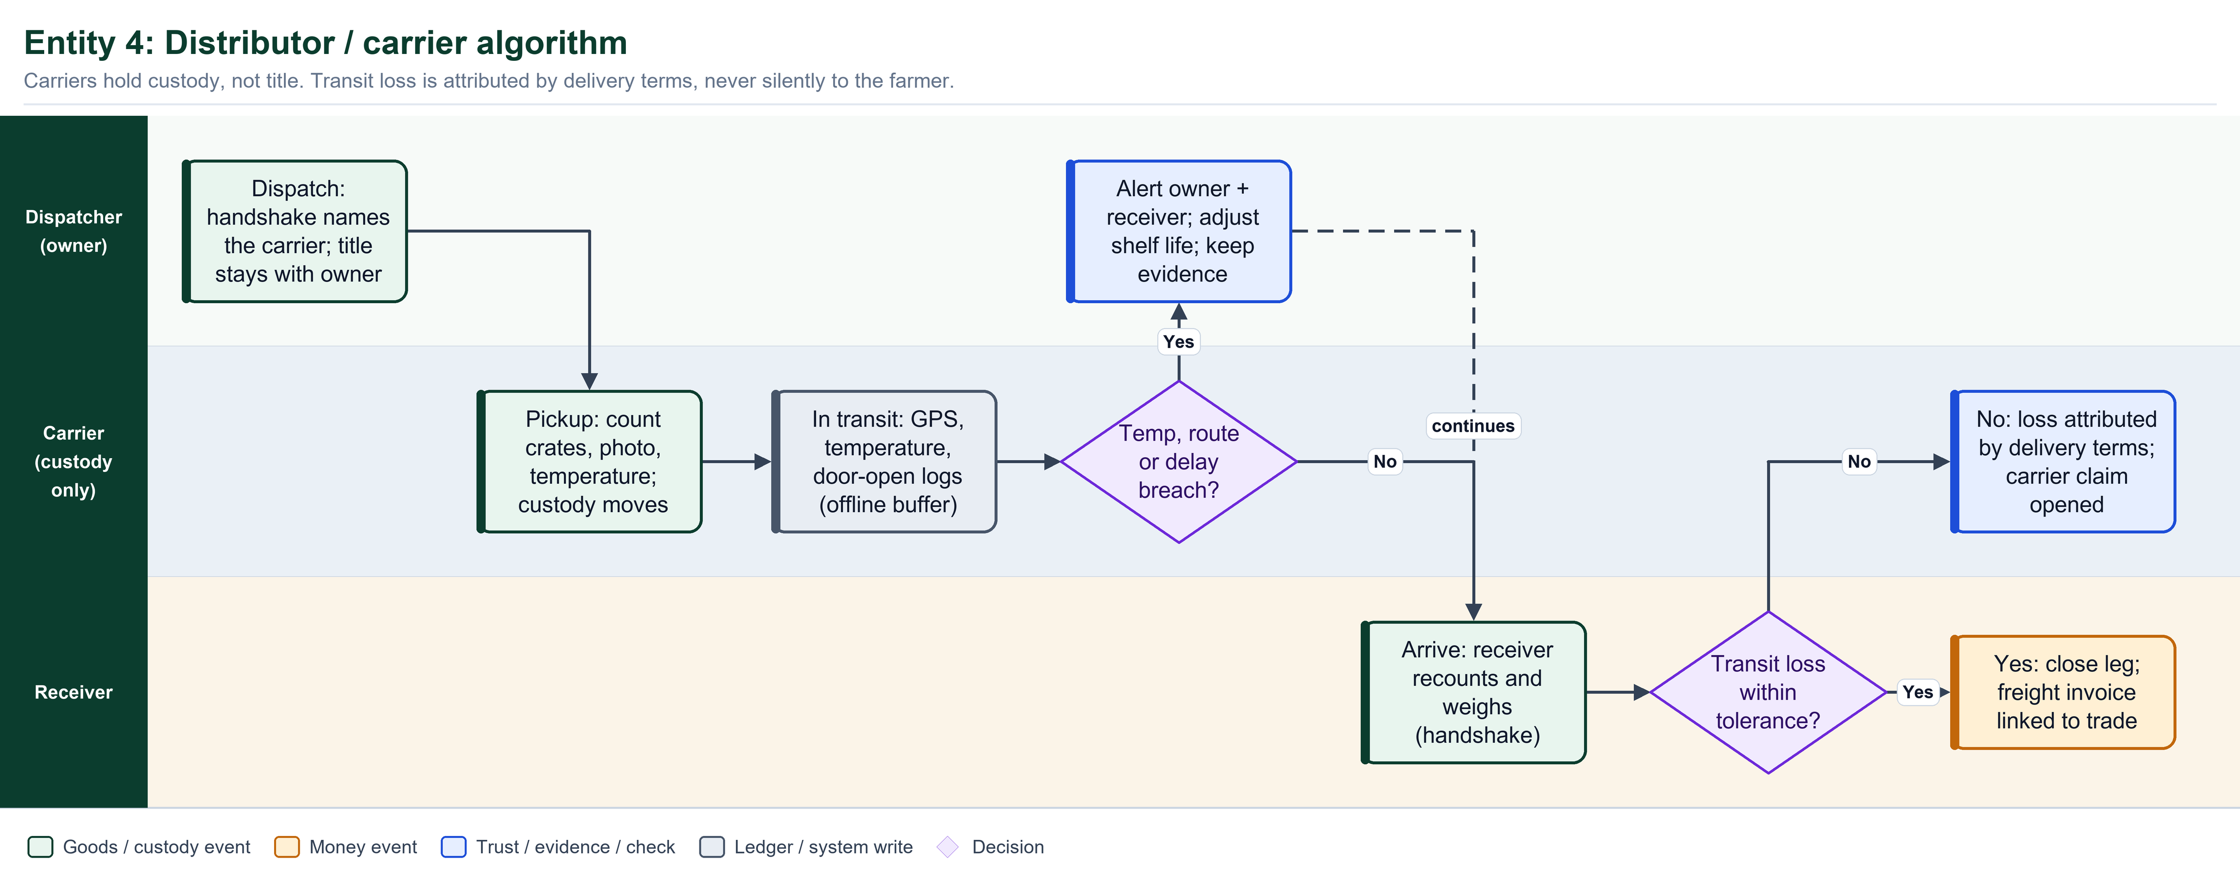
Figure: Distributor / carrier algorithm swimlane: custody without title

7.5 Retailer
PROMISE TO THIS ENTITY Let me buy fresh produce straight from a farmer or any verified supplier, sell it with a consumer QR, and show I treat suppliers fairly.

Does | Never does
- Receive with weigh, temperature, quality and shelf-life check  - Accept or reject with reason code and photo  - Pay per terms and show the SLA clock to the supplier  - Split to shelf batches and print consumer QR labels  - Log waste and demand signals  - Respond to recalls | - Reject without reason and photo  - Hold rejected goods without an agreed disposal  - Ignore a recall notice  - Buy only from pre-linked suppliers

Algorithm (pseudocode)
procedure RETAIL(retailer):
scan supplier QR; SIGN receipt via HANDSHAKE # direct from farmer OK
check = weigh + temperature + quality + shelf_life_remaining(lot)
if check.fails(min_shelf_life):
REJECT(lot, reason_code, photo) # stays with supplier
else:
PAY(supplier, per_terms) # UPI or cash + OTP
split lot into shelf batches; PRINT consumer QR with best_before
sell at POS:
decrement on_hand
if shelf_life < threshold: MARK_DOWN(batch)
log waste(reason) -> demand_signal(supplier)
on RECALL(lot):
QUARANTINE(batches); BLOCK_POS(batches); NOTIFY(upstream)
if lot.verified_origin and premium_agreed:
premium_line_item credited to supplier in the trade

Invariants the system enforces
- Rejected quantity stays under the supplier's title until disposal is agreed.
- Payment due date is visible to the supplier from the moment of delivery.
- A recall notice must be acknowledged within SLA; unacknowledged notices escalate.
- Rejection rate far above peer median for the same crop triggers an anomaly flag and lowers Pay-Score.
How we know it works (KPIs)
- Rejection rate vs peers
- Days payable
- Waste percent
- Recall response time

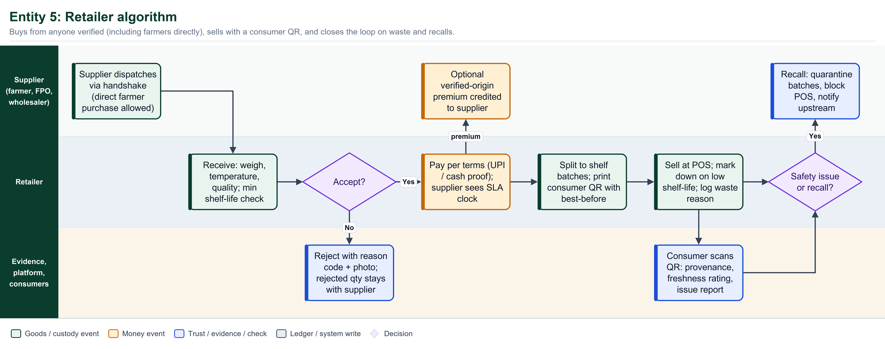
Figure: Retailer algorithm swimlane: fair sourcing, labelling and recalls

7.6 Consumer
PROMISE TO THIS ENTITY Let me know what I am eating and who grew it, with nothing hidden and nothing about the farmer that they did not agree to share.

Does | Never does
- Scan the QR on a pack  - See origin district, harvest date, journey and evidence level per claim  - See an anonymised farmer-share indicator  - Rate freshness, report an issue, optionally send a UPI thank-you | - See prices of any trade  - See farmer phone, ID or plot geometry  - Trigger a recall alone (reports are clustered and reviewed)

Algorithm (pseudocode)
procedure CONSUMER_SCAN(qr):
lot = RESOLVE(qr)
view = PUBLIC_VIEW(lot) # consented fields only; no prices; no PII
show(view.origin_district, view.harvest_date, view.journey)
for claim in view.claims: show(claim.text, claim.evidence_level)
if k_anonymity_ok(lot): show(FARMER_SHARE(lot)) # aggregated band
actions = [RATE_FRESHNESS, THANK_FARMER_UPI, REPORT_ISSUE]
if action == REPORT_ISSUE:
signal = CLUSTER(report, lot)
if signal.count >= threshold or report.severity == SAFETY:
QUEUE_FOR_VERIFIER(lot) # may open recall
AGGREGATE_FEEDBACK(lot) -> farmer, retailer # anonymous, weekly

Invariants the system enforces
- Public view is built only from consented, zero-PII read models.
- Farmer-share indicator shows only when enough trades exist (k-anonymity).
- Issue reports are rate-limited and clustered by lot to resist abuse.
- Thank-you tips go UPI direct to the farmer with the farmer's consent.
How we know it works (KPIs)
- Scans per lot
- Report-to-review time
- Share of scanners who rate or tip
- Feedback delivered to farmers per week

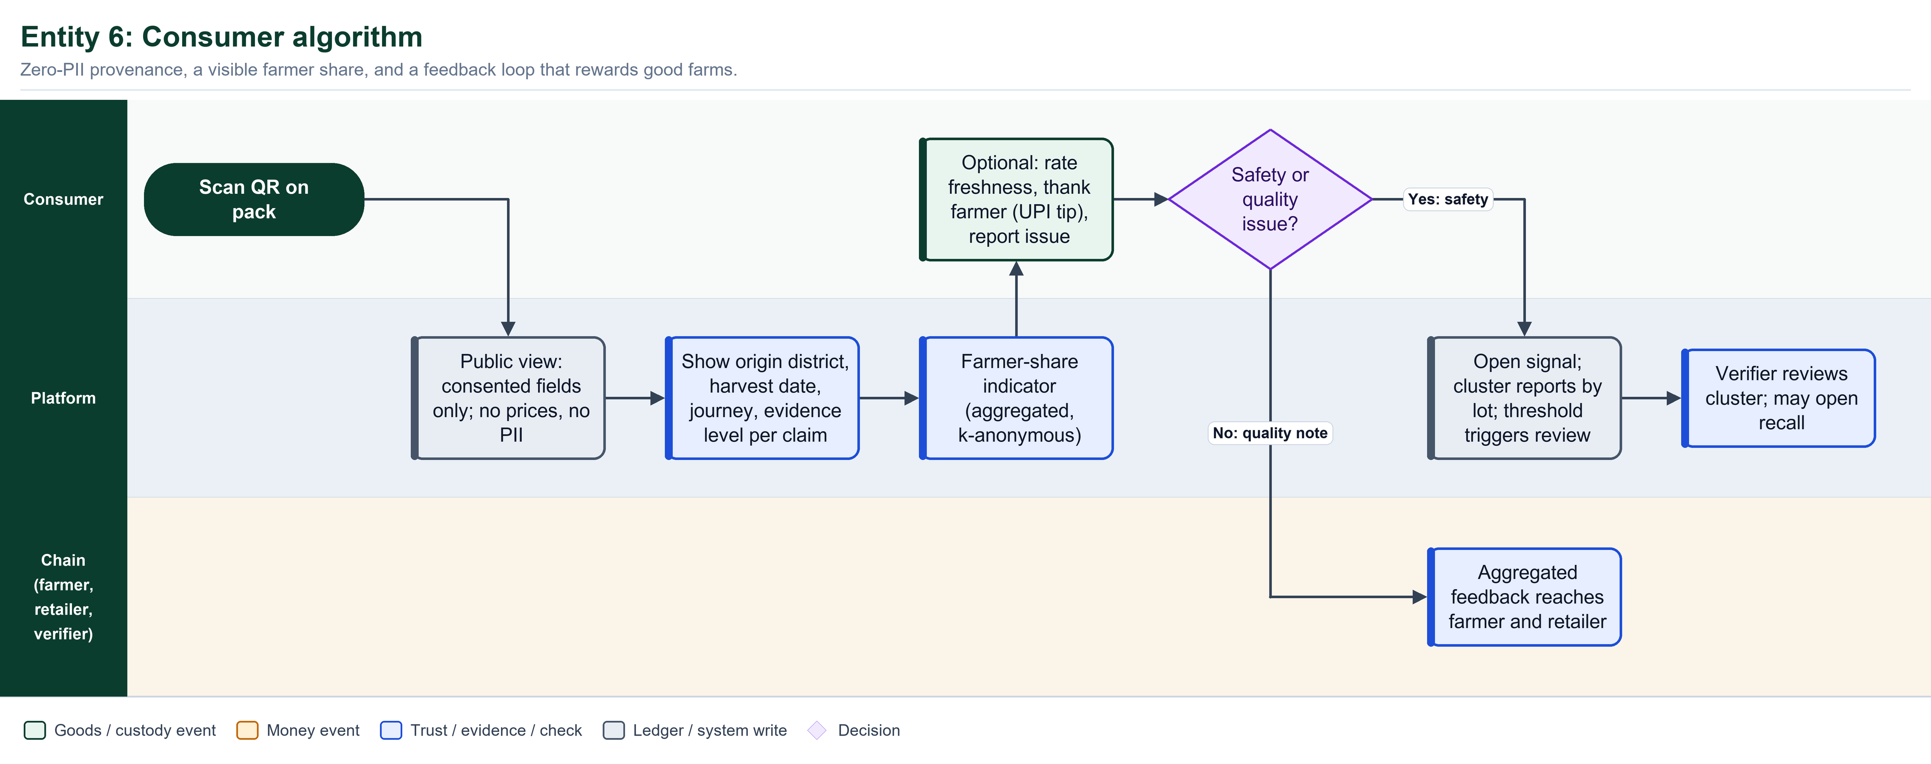
Figure: Consumer algorithm swimlane: provenance, feedback and signals

7.7 Verifier / mediator / admin (and lab)
PROMISE TO THIS ENTITY Let me keep the network honest and fast: onboard in minutes, catch fraud early, resolve disputes before they freeze money.

Does | Never does
- Review flagged registrations and vouch for new farmers  - Sample re-verification of plots and facilities  - Mediate cases using an auto-built evidence pack  - Open and track recalls  - Attach lab results as high-evidence claims | - Reveal personal data without a logged reason  - Edit or delete a ledger event  - Decide a case without reading the evidence pack  - Approve their own relatives

Algorithm (pseudocode)
procedure ONBOARD(applicant):
flags = AUTO_CHECKS(applicant)
# duplicate ID or plot, geo mismatch, qty > area * max_yield * slack,
# shared device or phone clusters, velocity spike vs 90-day baseline
if flags.empty: APPROVE_TIER(applicant, tier = T0_or_T1); ISSUE_QR_AND_CODE()
else: QUEUE_HUMAN_REVIEW(applicant, sla = SLA[tier])
decision = verifier.decide(MORE_INFO | APPROVE | REJECT)
notify(applicant, reason_in_local_language)

procedure MEDIATE(case):
pack = BUILD_EVIDENCE_PACK(case) # slips, photos, geo, timeline, scores
proposal = RULES_PROPOSAL(pack) # then human adjusts within policy
if parties.accept(proposal): CLOSE(case, outcome)
else: ESCALATE(case, APMC_or_ODR)
WRITE_LEDGER(CASE_RESOLVED); UPDATE_SCORES(case.parties)

Invariants the system enforces
- Ledger is append-only; corrections are new events that supersede, never edits.
- Every sensitive reveal is audit-logged (already built).
- Tier-3 approvals need dual control.
- Verification SLA by tier; breaches are visible to the applicant.
How we know it works (KPIs)
- Verification SLA met
- Dispute resolution median
- Fraud-flag precision (true flags / all flags)
- Recall completion time

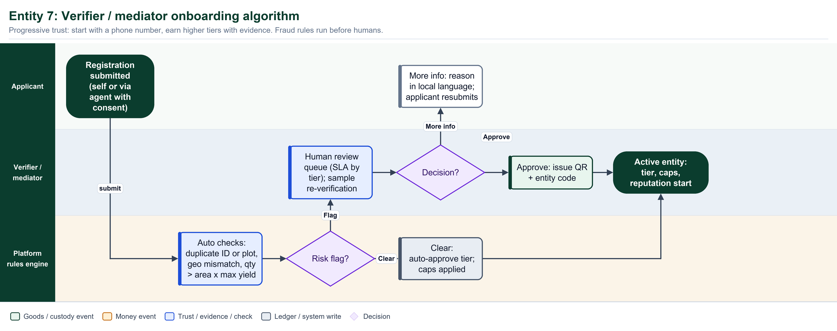
Figure: Verifier / mediator onboarding algorithm: progressive trust, fraud rules before humans

8 Special flows
8.1 Farmer sells directly to a retailer
This is the case the current build makes awkward: the code does not check roles, but it requires a bilateral trusted-partner link, so a farmer and a shop that have never met cannot trade without a registration and invitation dance. The proposed flow removes that step.
- Scan, do not search: the farmer scans the retailer's entity QR (shop sign or phone). The retailer need not be pre-registered.
- Provisional account: an unknown retailer gets a provisional T0 account by OTP in about 30 seconds, limited to cash or UPI on delivery.
- Defaults protect the farmer: terms are prefilled from the mandi band and the risk rule; credit is unavailable for provisional buyers.
- Same-day money: split-pay requests the full undisputed value at weighing; only a rejected part can be contested.
- The record is the same: a two-step journey on the consumer page, with the same ledger guarantees.

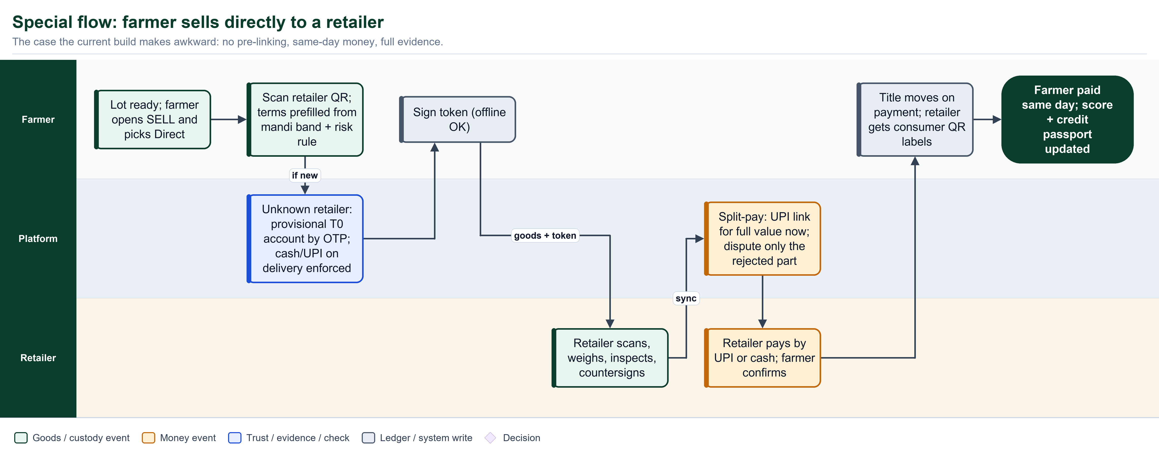
Figure: Direct farmer-to-retailer sale: no pre-linking, same-day money

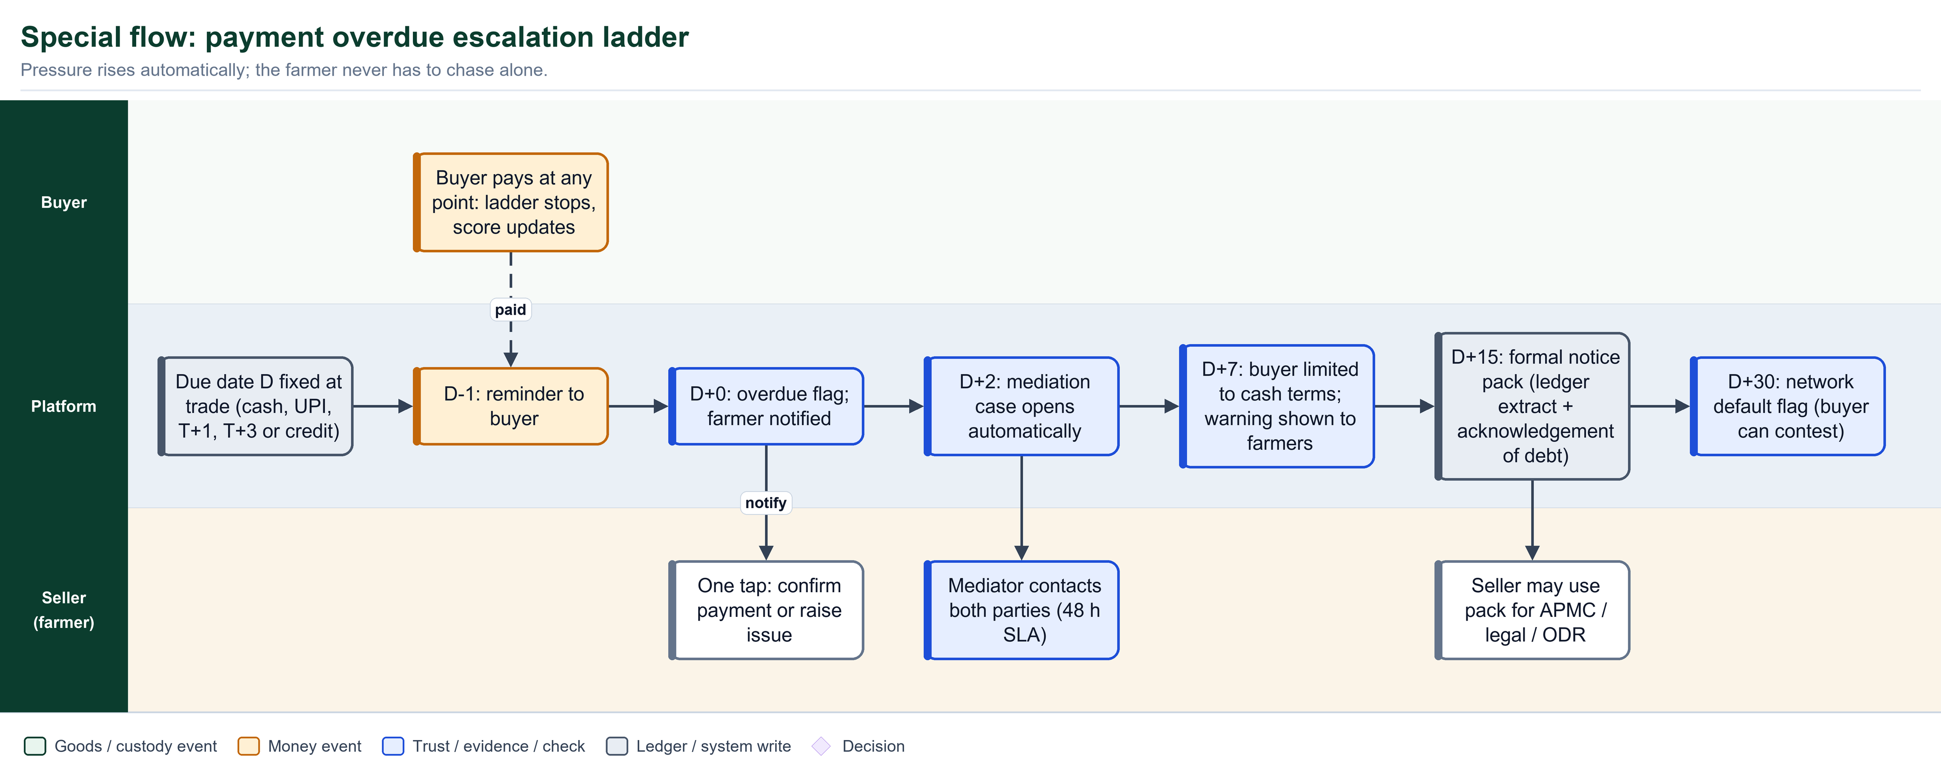
Figure: Payment overdue escalation ladder

8.2 Overdue ladder rules
The ladder applies only to credit and delayed terms. Dates are relative to the agreed due date D. All timings are starting values.
When | Automatic action | Who is told
D-1 | Reminder with one-tap pay link | Buyer
D+0 | Mark OVERDUE; show on both parties' screens | Buyer, farmer
D+2 | Open a mediation case automatically | Mediator, both parties
D+7 | Buyer limited to cash terms; warning shown to farmers viewing this buyer | Buyer, prospective sellers
D+15 | Generate formal notice pack: ledger extract and acknowledgement of debt | Farmer, buyer
D+30 | Network default flag (buyer may contest with evidence) | Network (band only)

LEGAL CAUTION The legal weight of an acknowledgement of debt or a notice pack depends on jurisdiction and drafting. Have counsel review the templates before relying on them.

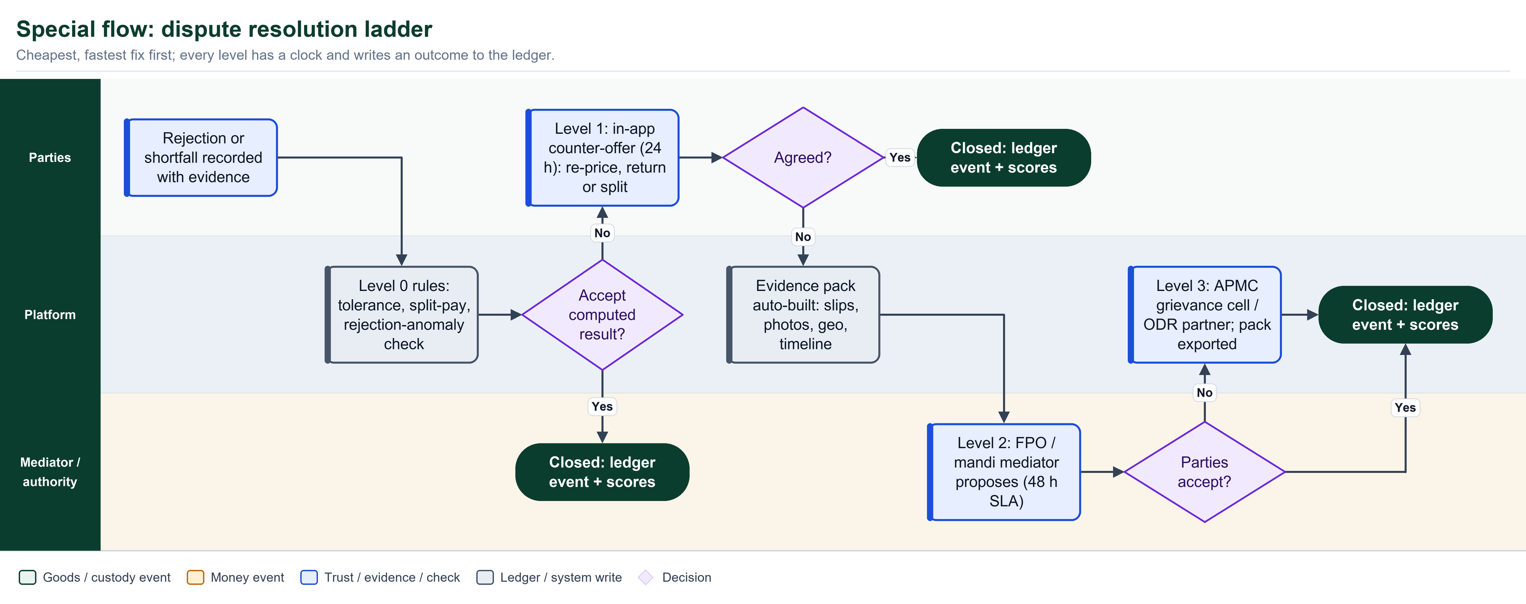
Figure: Dispute resolution ladder: cheapest, fastest fix first

9 Trust and reputation algorithms
PRINCIPLE A score is a ticket, never a gate. It can unlock credit, premiums and faster terms. It must never stop a verified farmer from selling or hide them from buyers.

Producer trust score (0 to 100)
T = 100 * ( 0.30*D + 0.25*Q + 0.20*V + 0.15*R + 0.10*F )

D = delivery accuracy share of trades delivered within tolerance and on time
Q = quality consistency 1 - rejection rate of this farmer's lots, normalised
against peers for the same crop and season
V = verification depth T0 = 0.25, T1 = 0.50, T2 = 0.80, T3 = 1.00
R = reliability share of committed volume actually delivered
F = fairness disputes settled amicably or upheld, vs claims found false

History weighting: exponential, 90-day half-life.
Shown only after 5 trades; before that the band is NEW.

Buyer Pay-Score (0 to 100), shown to farmers before dispatch
P = 100 * ( 0.45*O + 0.20*U + 0.15*L + 0.10*N + 0.10*V )

O = on-time payment rate (by value)
U = undisputed rate 1 - abusive-rejection ratio (rejection rate far above
peer median for the same crop is penalised)
L = lateness severity 1 - min(1, mean_days_late / 7)
N = history depth min(1, completed_trades / 30)
V = verification depth as above

credit_limit = base_limit(tier) * (P / 100)^2 # only if P >= 60 and no overdue > 7 days
First trade between any pair is always cash or UPI on delivery.

Band | Score | Shown to the other side as
Reliable | 80 and above | Green badge plus on-time percent
Good | 60 to 79 | Blue badge plus on-time percent
Watch | 40 to 59 | Amber badge plus on-time percent and last overdue
Risky | Below 40 | Red badge plus on-time percent and open overdues
New | Fewer than 5 trades | Grey badge; cash or UPI on delivery only

Fraud and plausibility rules (run before any human sees a case)
- Yield plausibility: qty per plot per season must not exceed area x crop maximum yield x slack.
- Geo consistency: lot GPS far from the plot centroid is flagged.
- Velocity: volume above 3x the 90-day baseline goes to review.
- Circular trading: repeated trades between the same pair with no onward movement, or parties sharing a device or phone cluster, are flagged.
- Price outliers: prices far above or below the mandi band (either direction) are flagged for review, not blocked.
- Rejection anomaly: a buyer's rejection rate above twice the peer median for the same crop in 30 days lowers U and alerts a mediator.
Fairness safeguards: every score shows its components, farmers can appeal a component, weather-driven variation is normalised against peers, and a yearly bias review checks outcomes across gender, land size and region.
10 Money, data and compliance
Payment architecture (phased, never holding funds)
Phase | How money moves | How the platform knows | Limits
1: Record and nudge | Platform creates a UPI intent link or QR (payee = seller, amount, reference = trade ID). Cash is also supported. | Buyer enters UTR; seller confirms by tap, OTP or voice | Relies on seller confirmation; fake UTR is caught by the seller
2: Auto-reconcile | Same, via a licensed PSP payment link or collect request | PSP webhook marks paid in seconds; reconciliation report | Needs PSP partner and merchant onboarding
3: Assured settlement (optional) | For credit sales, a regulated lender may pay the farmer today against the buyer's receivable | Receivable and Pay-Score data, consent-based | Platform does not lend; lender terms apply

Who can see what
Data | Farmer | Direct counterparty | Other chain members | Consumer | Verifier / mediator
Trade price | Own trades | Own trade only | No | No | Only in an open case
Quantities, weigh slips | Own | Own trade | Own legs | No | Case only
Farmer name and photo | Self | Yes | First name and district | First name and district, only with consent | Yes (reveal logged)
Plot geometry | Self | No | No | District or block only | T2+ verification only
Phone and ID documents | Self | Masked phone | No | No | Reveal logged
Scores | Full components | Band + on-time % | Band | No | Full, in a case

Compliance checklist (to validate with counsel before launch)
Area | Design position | Action needed
Personal data (DPDP Act 2023) | Consent per purpose, minimum visibility, export and erasure for non-ledger data; ledger stores pseudonymous references | Privacy notice in local languages; consent manager design
Payments (RBI rules) | Platform holds no funds; UPI and licensed PSPs only; any escrow via an authorised arrangement | Legal review and PSP agreement
Mandi rules (state APMC) | Deduction schedules are configured per mandi and state | Obtain schedules for the pilot mandi
Food safety traceability (FSSAI) | Batch codes, supplier records and retention aligned to current requirements | Check retention periods and label content
GST and e-way bill | Link e-way bill numbers on movements; platform does not file returns | Confirm integration scope
Electronic records as evidence | Signed, timestamped, hash-chained records with audit trail | Counsel review of notice and acknowledgement templates

11 Data model: what is new and how it connects
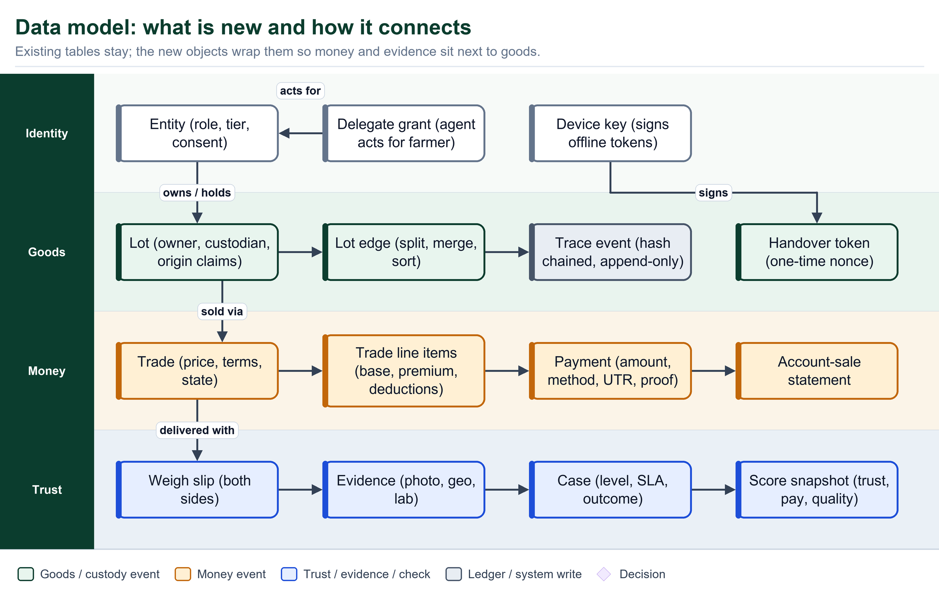
Figure: Data model: new objects wrap existing tables so money and evidence sit beside goods

Keep, evolve or add
Current element | Decision | Change
Hash-chained trace events and daily Merkle anchor | Keep | Add event types: TRADE_*, PAYMENT_*, TITLE_TRANSFER, WEIGH_SLIP, REJECT, REPRICE, CASE_*
Lot, lot edges (split, merge, sort), mass balance | Keep + extend | Add owner_org separate from custodian_org; origin claims with evidence level
Handover (two-step custody) | Evolve | Becomes the delivery step of a Trade; carries token_id; no mandatory partner link
PartnerLink (bilateral trusted partner) | Evolve | Optional 'preferred partner' relationship for credit terms and auto-accept; no longer required to trade
Tolerance and discrepancy alerts | Keep + extend | Tolerance triggers alert or case but no longer delays undisputed payment
Dispute states | Evolve | Four-level ladder with SLAs and evidence pack
OTP and passkey identity, consent records, encrypted sensitive data | Keep + extend | Add tiers T0-T3, delegate grants, device keys for signing
Offline sync batch endpoint | Evolve | Accepts signed tokens and receipts; idempotent by event_id; nonce single-use
Public view read model, QR labels | Keep + extend | Add evidence level per claim, farmer-share indicator, feedback
11-language UI | Keep + extend | Add voice and IVR prompts; same string keys
Trade, TradeLine, Payment, WeighSlip, Evidence, Case, ScoreSnapshot, Delegate, DeviceKey, HandoverToken, AccountSale, PriceReference | Add | New tables; see figure above

12 Incentives and business model (hypotheses)
The farmer never pays for the core flow. Others pay because the platform lowers their cost or risk.
Who pays | For what | Why they would
Retailers and brands | Verified-origin premium; traceability and recall readiness; freshness and waste analytics | Fresher produce, fewer recalls, marketing value
Aggregators, wholesalers, agents | Software for settlement, account-sale and score portability | Fewer disputes, faster working-capital turns, access to credit
Lenders and insurers | Consent-based access to verified transaction history | Lower underwriting cost and loss rates
Government and FPO programmes | Rollout, assisted-entry agents, mandi digitisation | Measurable farmer income and loss reduction
Consumers (optional) | UPI thank-you to the grower | Goodwill; fully optional

13 Roadmap, pilot and success measures
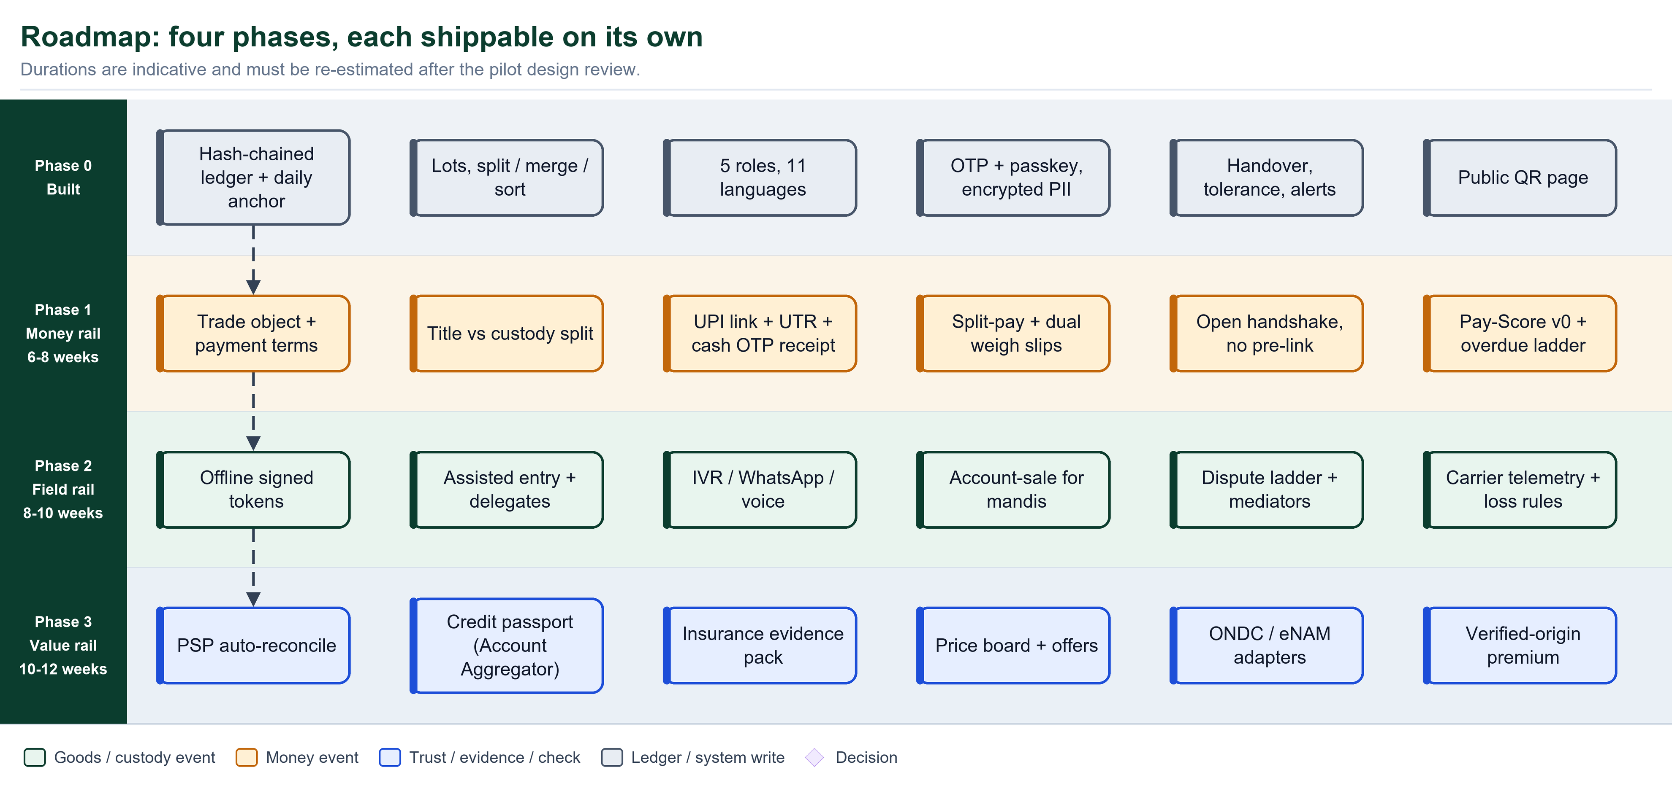
Figure: Four phases, each shippable on its own (durations are indicative)

Pilot design
Item | Proposal
Crop | One perishable crop with many intermediaries and visible spoilage (for example tomato)
Geography | One district cluster
Participants | One FPO (100 to 300 farmers), 2 to 3 aggregators, 1 mandi with about 5 commission agents, 15 to 25 retailers, 2 carriers
Duration | 2 weeks baseline measurement, then 10 to 12 weeks live
Comparison | Pilot farmers vs similar non-pilot neighbours on payment delay, rejection percent, deductions and net price
Go / no-go | Median delivery-to-payment under 24 h; unevidenced rejections zero; at least 70% of assisted farmers transact again within 30 days

Phase exit criteria
Phase | Exit criteria
1: Money rail | Every pilot trade has terms and a payment record; split-pay works; ledger invariants unchanged; no data loss
2: Field rail | Offline tokens sync with zero double-spend in tests; assisted entry live; account-sale statements issued; dispute ladder SLAs measured
3: Value rail | PSP reconciliation live; first credit-passport exports with consent; price board in use

14 Known weaknesses, risks and open decisions
Risk | How it shows up | Containment
Low farmer adoption | Forms, language, no smartphone | Assisted agents, voice and IVR, FPO champions, immediate money benefit
Intermediary resistance | Commission agents resist transparency | Start with willing early adopters; portable Pay-Score gives them credit access; align with mandi authority
Fake data and collusion | False lots, circular trading | Plausibility and anomaly rules, evidence levels, sample audits, device clustering
Payment fraud | Fake UTR, false 'paid' claims | Seller confirmation; PSP webhook in Phase 2
Regulatory exposure | Holding funds, legal weight of notices | No funds held; licensed partners; counsel review
Connectivity | No network at farm or mandi | Offline tokens, SMS fallback, store-and-forward
Score misuse or bias | Excluding small or remote farmers | Ticket-not-gate law, appeals, normalisation, yearly bias audit
Privacy breach | PII exposure | Encryption, minimum visibility, reveal logging (existing), DPDP processes
Complexity creep | Too many features at once | Four phases, feature flags, boring technology
Third-party dependency | Price feed or PSP outage | Cache with last-known band; manual UTR fallback

Open decisions for stakeholders
- Operator and liability: who is the legal operator and who is liable for dispute outcomes?
- Pilot jurisdiction: which state APMC rules and which mandi schedule apply?
- PSP partner: which licensed payment provider and what onboarding timeline?
- Discovery: adopt an open commerce protocol for buyer discovery, or stay with scan-to-trade first?
- Premium funding: who funds the verified-origin premium and how is it priced?
- Mediator panel: composition, training and neutrality safeguards.
Assumptions to validate with farmers before building
- How long do farmers wait for payment today, by buyer type, and what do they lose when it is late?
- What share have a working UPI handle and use it?
- How is weighing done at the farm gate, collection centre and mandi, and who owns the scale?
- Would farmers rather confirm payment by tap, OTP or voice call?
- What are they willing to share (plot map, ID) and with whom?
- Does an FPO or agent they already trust exist locally to run assisted entry?
A Appendix A: API sketch
Endpoint | Purpose
POST /v1/trades | Create an offer on a lot
POST /v1/trades/{id}/accept | Buyer accepts
POST /v1/trades/{id}/token | Issue a signed handover token (also works offline on device)
POST /v1/sync/events | Batch, idempotent upload of signed events and receipts
POST /v1/trades/{id}/weigh-slip | Submit or countersign a weigh slip
POST /v1/trades/{id}/payments | Record a payment (method, UTR, proof)
POST /v1/payments/{id}/confirm | Seller confirms receipt
POST /v1/trades/{id}/cases | Open a case with evidence
GET /v1/price-reference?crop=&district= | Mandi price band
GET /v1/entities/{id}/score | Band and components, visibility-filtered
GET /v1/me/credit-passport | Consent-gated verified history
POST /v1/delegates | Grant an agent authority to act for a farmer

B Appendix B: Glossary
Term | Meaning
Lot | A physical batch of produce with a QR code
Trade | A contract between seller and buyer on a lot quantity with price and terms
Custody | Physical possession of goods
Title | Legal ownership of goods
Handshake | The two-signature, offline-safe handover protocol
Token | A signed, single-use record exchanged at handover
Split-pay | Paying the undisputed value immediately while isolating the contested part
Pay-Score | Buyer reliability score shown to farmers
Tier (T0-T3) | Verification depth: phone, identity or vouch, land or licence, audited
Delegate | An agent authorised by a farmer to act on their behalf
Account-sale | Itemised statement of a commission sale: gross minus scheduled deductions
Credit passport | Consent-based export of verified transaction history

