Q) Write a program to implement Quick sort using divide and conquer method.

Code 🡪

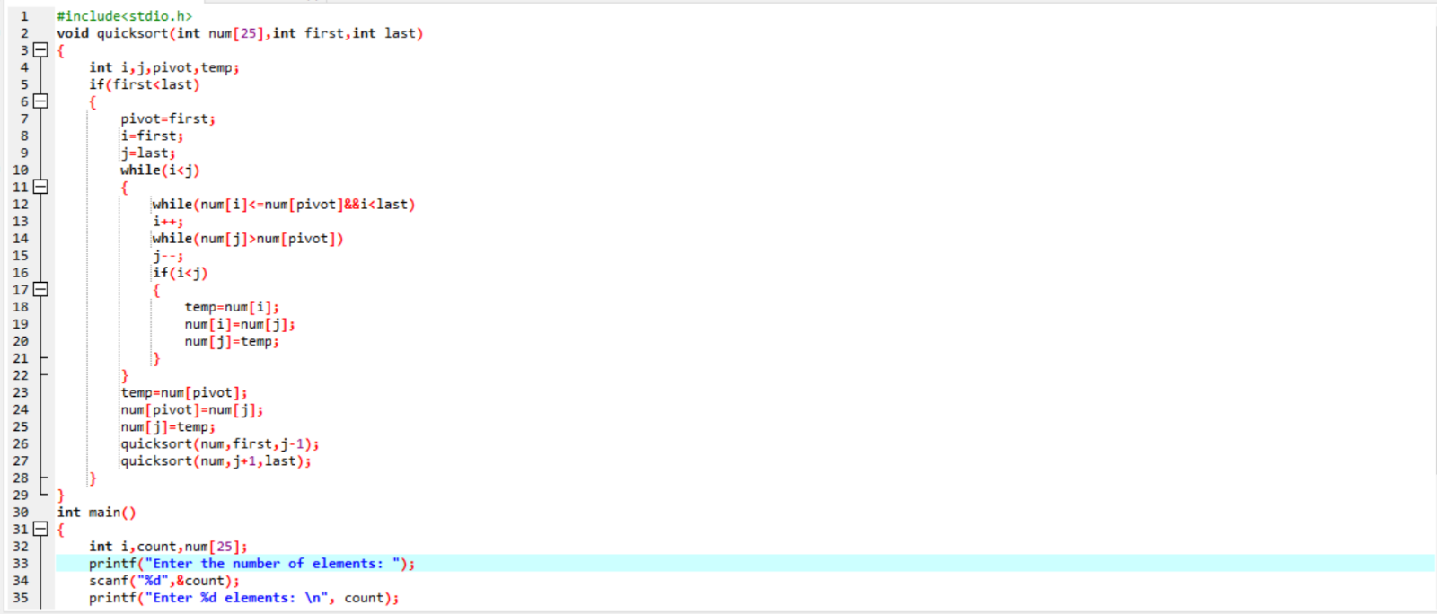

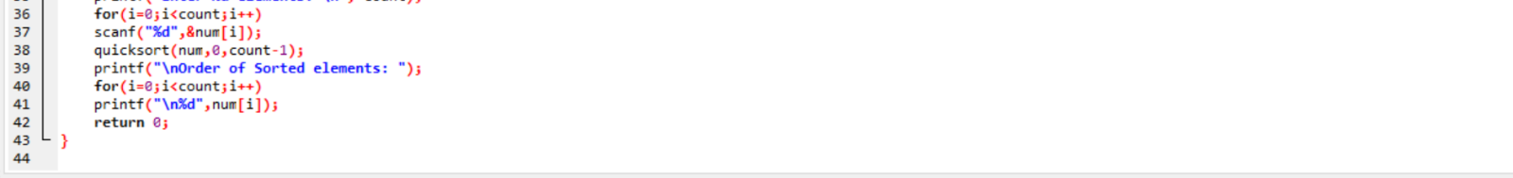

P.T.O.

Output 🡪

