Q) Write a program to implement Matrix Chain Multiplication.  
A1,A2,A3 and A4 is given with P0=5,P1=4,P2=6,P3=2 and P4=7. Compute M[1,4].

Code 🡪

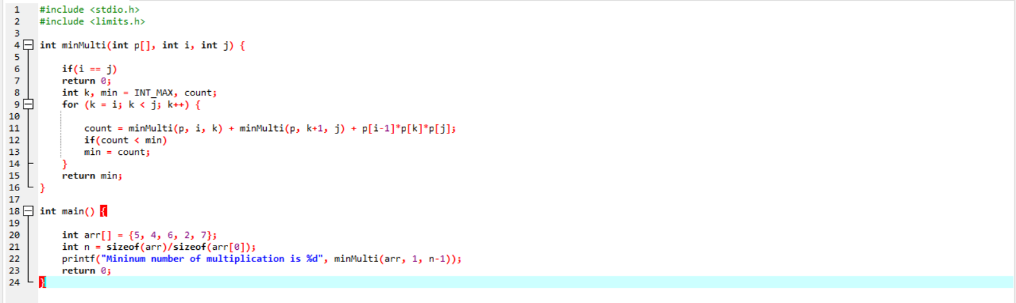

Output 🡪

