Q) Write a program to implement Knapsack algorithm.

Code 🡪

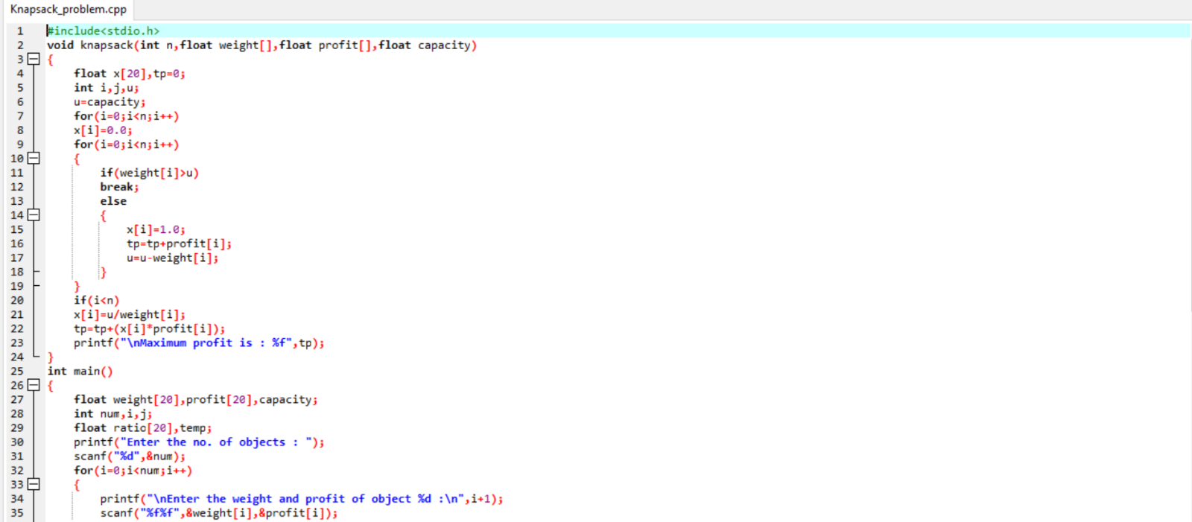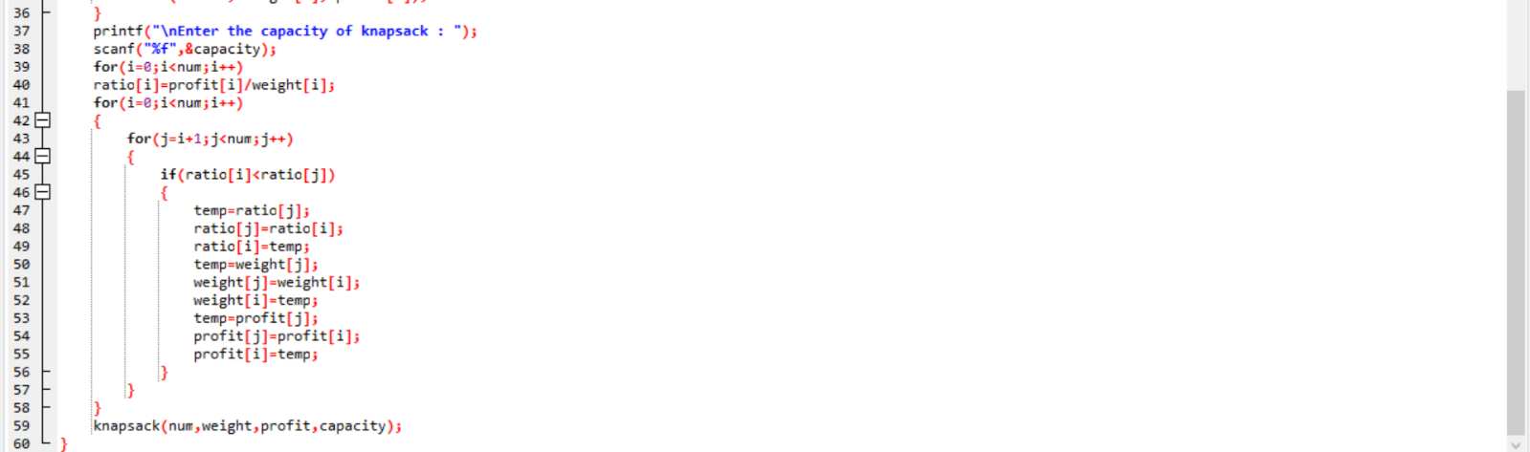

Output 🡪

