Q) Single source shortest path problem (using DIJKSTRA’S ALGORITHM).

Code 🡪

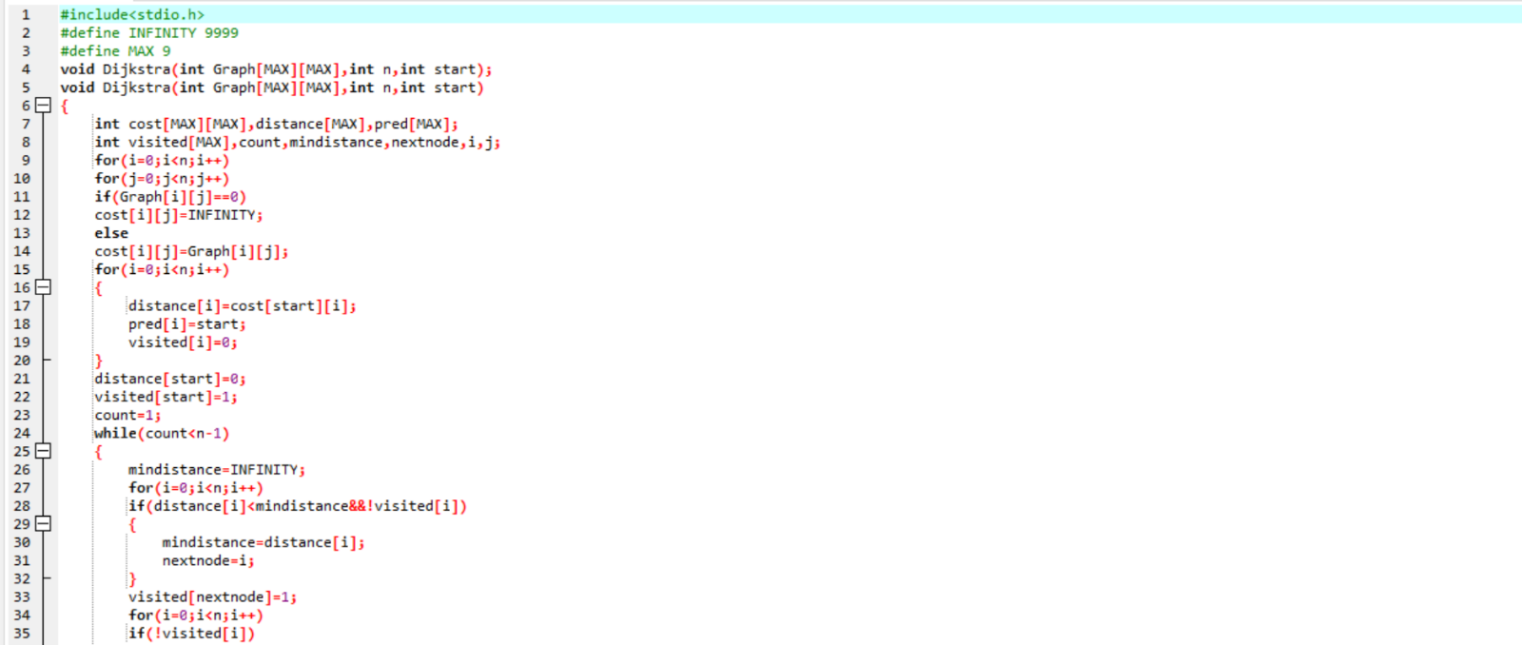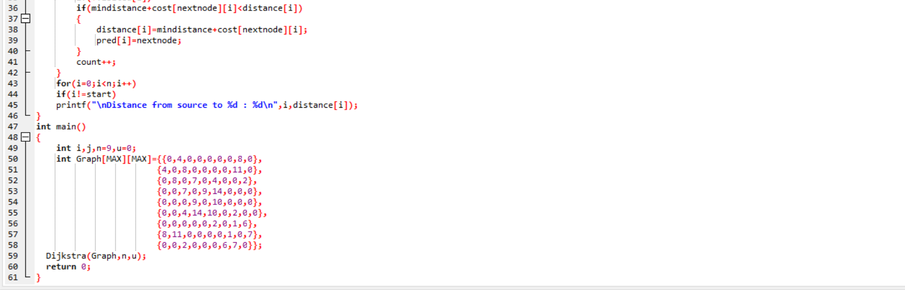

Output 🡪

