Assessment of VR for Mental Health and Anxiety: Learning from Technology

# Mayuree Binjolkar

for Submission University of Washington,

Tacoma

e-mail address

# Dev Gandhi

for Submission University of Washington,

Tacoma

e-mail address

## ABSTRACT

In the recent times, there has been a high emphasis on innovative methods for anxiety management and many new applications of Virtual Reality (VR) are being studied in this domain. While anxiety management can be done both at the institutional and the personal level, using a technology can VR can help in coming up with personalized solutions for anxiety management. Motivated by this, the goal of our study is to understand the current state of VR with respect to anxiety management and suggest potential improvements for its development for anxiety management. We carry out a literature survey and an online survey to understand both the existing research and people’s general perception. Results show that while not many people have tried VR for this purpose, more people plan to use it in the future and research shows promising advancements as well.

## Introduction

Currently, the term anxiety is used in the fields of psychology and psychiatry. It is often confused with having unpleasant emotions such as sorrow or anger. However, anxiety is a state which can be characterised by subjective feelings of nervousness and tension. The process is generally consisting of activation and then a discharge of the autonomic nervous system. As an example, the absence of anxiety is indicated by calmness and serenity. While many individuals develop coping and defence mechanisms to deal with anxiety, many are not able to handle specific situations that can worsen their state and make them feel frightened and panicked. More specifically, both anxiety and fear are highly concentrated experiences that can emotionally affect and disrupt normalcy in daily living environment. Therefore, it is imperative to find methods and mitigation strategies that can help in reduction of anxiety and help an individual to lead an emotionally stable daily routine.

In the recent years, there has been use of newer methodologies for the management of mental health and anxiety. To deal with anxiety, methods such as exposure therapy has been used.

Permission to make digital or hard copies of all or part of this work for personal or classroom use is granted without fee provided that copies are not made or distributed for profit or commercial advantage and that copies bear this notice and the full citation on the first page. Copyrights for components of this work owned by others than the author(s) must be honored. Abstracting with credit is permitted. To copy otherwise, or republish, to post on servers or to redistribute to lists, requires prior specific permission and/or a fee. Request permissions from [permissions@acm.org.](mailto:permissions@acm.org)

*CHI’20,* April 25–30, 2020, Honolulu, HI, USA

© 2020 Copyright held by the owner/author(s). Publication rights licensed to ACM. ISBN 978-1-4503-6708-0/20/04. . . $15.00

DOI: <https://doi.org/10.1145/3313831.XXXXXXX>

Research studies such as [17] have shown that exposure therapy was effective in reduction of the negative symptoms. Neural circuits have also been found to be involved in effective regulation across many different disorders as shown in [1]. However, many of these methodologies might not be accessible to individuals for the self management of anxiety. Newer technologies such as Virtual Reality (VR) have also gained traction for different applications ([17],[16]). This technology has been making valuable contributions to the field of gaming, product development and transportation.

However, it has also begun to make its impact in the field of mental health management, providing users with ample options to try out in terms of mindfulness and yoga applications. It provides its users a sense of presence in a three dimensional environment and both the visuals and audio can be used to calm themselves.

Based on this, in this project we have examined the existing use of VR for the use of anxiety management as well as the potential trust in this technology to provide people an alternative option for anxiety management.

## Related Work

Based on our research objective, we have looked at some relevant studies that provide us better insights and motivation for identifying the gaps in the existing research. [23] presents a study in which expert clinicians provide their perspectives on designing VR applications that can help in managing periprocedural anxiety in children. The results from this study highlighted many considerations that can prove to be integral to clinicians and their practices and in turn, provide some foundation knowledge for designing VR applications. One of the limitations of this study was that it did not include any children in the research investigation and including that information is a potential area of improvement. Another study, [21] examined the differences in the

psycho-physiological reaction of individuals to different levels of anxious situations. This study involved controlled setting experiments that used both a VR applications as well as an electrocardiogram. The results from this study were helpful in understanding the manifestation of anxiety in adults. Also, it highlighted a need for the development of person centered solutions where each persons anxiety would hold significant value in the development of their treatment options. One of the issues with this study was that the sample size used (9 females and 9 males) was big enough to infer statistically significant results. Similar to this study, [19]

described a case study in which a prototype was developed called Snap. The goal of creating this was to target customized digital health domain and similar to the previous study, emphasize on the unique experiences of anixety, especially in people that have Autism. More specifically, this study looked at adults with High Functioning Autism and their role in development of do-it-yourself (DIY) technology which can allow people to self-manage anxiety. One of the interesting feedbacks of this study is to look at the positive experiences of the people and how they can be encouraged and used in self management DIY technologies.

In terms of applications, [22] uses VR to help children overcome bedtime anxiety. This work takes motivation from children psychology and develops a virtual room where users can select things that might or might not be related to children’s fears. Another work, [5] present a demo of a modular web based VR framework that allows two people to meet through mediated audio-visual interaction, while being engaged in some sort of content. This study successfully held a three day demo session with around 75 participants and collected information about the video immersion experience of people. Although the results were promising and showed highly immersive VR experience, the latency of the game was mentioned as an issue.

## Method

For this research project, we have looked at the use of VR for anxiety using two steps; the first step focuses on understand its use through a brief literature survey; the second step involves designing a survey and getting information from individuals about their specific experience with VR for anxiety as well as their general exposure to VR applications.

**Hardware and Software Needs**

For the scope of our research project, we will not be using any specific hardware. However, the impact of hardware on VR is big as it is foundational to developing an immersive VR experience. Based on this, we have provided some description of the hardware involved in using the anxiety related VR application development and usage. As mentioned before, we are asking the users for their experience with several

anxiety-relieving applications as the part of this research project. Anyone who uses these applications will be needing the specific HMDs(Head Mounted Displays) of different VR applications. Many of these are functional only with the

in-house supported HMD. There will also be a need of using other components which will provide the haptic feedback for the analysis of the sensory feels during the project. The sensors for some of the VR applications will are in-house. For one of the projects i.e Amelia Virtual Care, it uses electrodermal response sensor and its purpose is to understand galvanic skin response. Also, there is a

cutting-edge development in terms of the VR headset by oVRcome VR anxiety relieving app. Apart from that virtually better exposure therapy it provides phobia suits, addiction suit, relaxation suit etc. which enables to bring to life a state of the art virtual reality exposure therapy system for patients. There are only few but needed implications of the hardware in this project. Majorly it’s needed to understand that what are aggression on VR anxiety relieving features can exist, how

well it performs in real-time. Majorly anyone using these headsets will need VR headsets, haptic feedback sensors, chairs and sound canceling headphones. Other minor non-VR related equipment such as blind-folds might also be needed to use these applications.

For the software implementation part in this term project, there are different software features as per the need of the application. The software implementation of different applications varies as per the design, need and it’s vision is to solve the problem. However, it can still be generalized. There has definitely been a usage of AR and VR technologies in creating the applications. The platforms and software such as UnityVR, Apple ARkit, Vuforia, Wikitude, Kudan, AR Toolkit etc. provide the development foundation to these applications. These applications also use machine learning (ML) at a high level to understand the neural working of the brain and sensory part coming form the hardware’s haptic feedback sensors. For the implementation of the applications on the platform, there is also a large usage of Android SDKs as well as Apple iOS SDKs. Few of the applications use cloud computing technology affiliated either with Microsoft Azure, AWS, IBM cloud etc. for storing and analysis of the data in real-time. The software implementation for the website of the VR applications uses HTML, CSS, Javascripts, APIs, and SQLs. Understanding the overall software implementation process is core to this term project and all the software explained above are founding base to the applications and website.

**Virtual Reality Applications for Survey**

In this study we ask general questions about VR related anxiety application and their impact on the users. The reason for making this choice was that hardly any people within the graduate student community around us (who also were more exposed to VR) were familiar with any VR related anxiety relieving application.However, our original intent was to survey 5 specific virtual reality anxiety applications.

The first application that we looked at was called Oxford VR. The main goal of this application is to provide psychological treatment that is based on scientific evidence and that uses state-of-the-art immersive VR technology. This application consists of an automated virtual coach. Another application that we were interested to look at was oVRcome VR. This application is innovative in the sense that it brings VR exposure therapy to our smartphones and can help in overcoming social anxiety and phobias at home. Another application that we wanted to potentially examine is Amelia Virtual Care. It is a fast and affordable VR tool for that is used for mental health mitigation and supports many psychologists. While these three above applications were specifically designed to target anxiety and related issues, relaxation and mindfulness can also transitively impact the over all anxiety levels in an individual and can improve the mental health.

Based on this we tried examining two applications. The first application is Nature Trek VR and it is an application that exists as a part of the Oculus Quest VR platform. This application is associated with relaxation and mind-fullness and it is expected that since it is a default part of the Oculus system, any user that has the hardware might be using this

application. Similarly, we were also interested in looking at an underwater VR application called Ocean Rift.

**Experimental Procedure**

In this study, we have used survey based methods to collect information and examine the use of the VR based anxiety management applications (similar to in the previous section). The main goal was to understand whether these applications benefited or affected the users in any manner; whether they gained more traction during the pandemic; whether they were able to benefit the user in the short and long term; and whether the user was able to trust the technology and deal with its pros and cons as the VR technological developments accelerate. All these questions were be examined through conducting a literature survey and an online survey. The online survey consisted of meticulously designed survey questions that were able to reduce the sample and statistical bias in our results, as well as cover up the broader idea of this research project. It is important to note that all immersive VR experiences are subjective and while we aim to collect as objective information as possible, it is impossible to avoid certain subjectivity. To take care of this issue, we did not only include survey questions similar to the NASA TLX, but also provided the participants to add any subjective information.

*Literature Survey*

For the literature survey, we carried out keyword search on Google Scholar. The key words were used in combination with each other. These keys words were "Virtual", "Reality","Anxiety", "VR", "VR app", and "cure". The initial search results gave us around 403,000 articles. To filter out the results further we selected articles only after 2005 and this reduced the number of articles to around 180,000. Thereafter, we specifically went through the abstracts of the first 5 pages of the search results and obtained the most relevant literature to our project.

*Survey Information*

The survey was desgined using Google Form and was posted on online media such as Facebook and WhatsApp and also sent out through the university mailing lists. Although our goal was to have 100 survey responses and have at least 50 percent of them full completed with no question left unanswered, we were only able to get 25 responses. The limitations in obtaining more survey participants can probably be attributed to the lack of experience and inaccessibility to VR-based devices. The survey information consisted of mainly four parts. The first part of the survey consisted of demographic information. It is to be noted that we tried our best to ask only those demographic questions that would not be offensive to any of our survey participants. We provided the participants to opt out of certain questions that they might not be comfortable with such as revealing their gender or ethnicity. The second part of the survey consisted of the participants’ experience with the different VR applications and whether they have experienced any benefits or downsides from its use. The third part of the survey consisted of the participants opinions on the use of such VR applications during the pandemic and any specific experiences that they might have wanted to cite related to it. The fourth part will

consisted of more general questions related to the trust of the participant in VR use for mental health and the awareness associated with it.

The questions asked in our Google form have been shown in Figures 1, 2, 3 and 4.

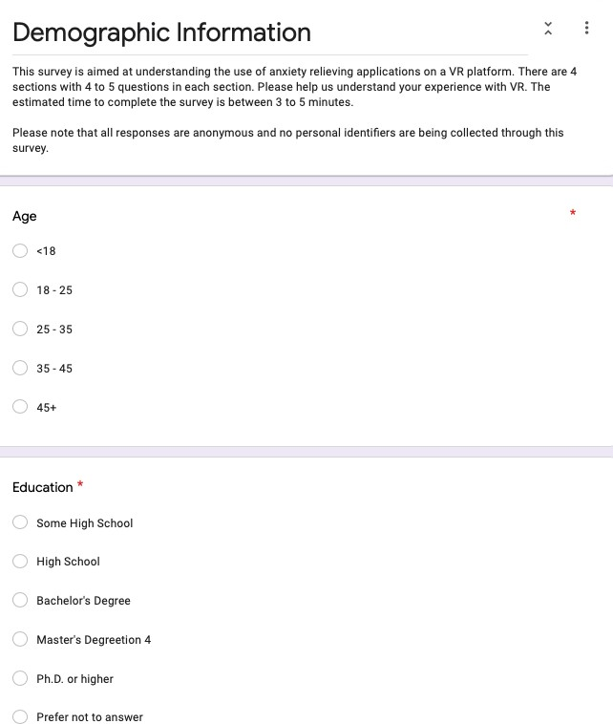

Figure 1: Google Form Questions - Part 1

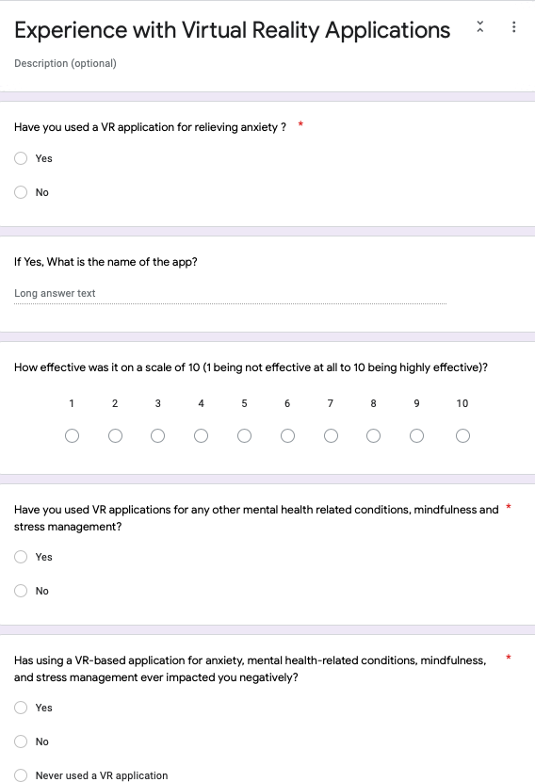

Figure 2: Google Form Questions - Part 2

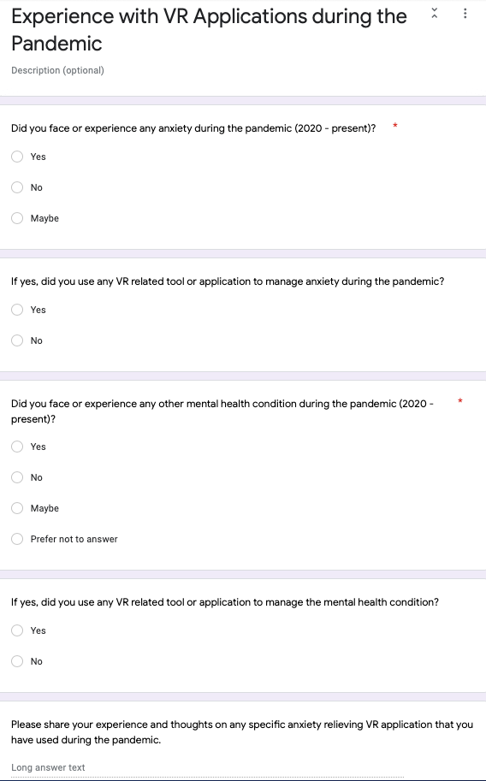Figure 3: Google Form Questions - Part 3

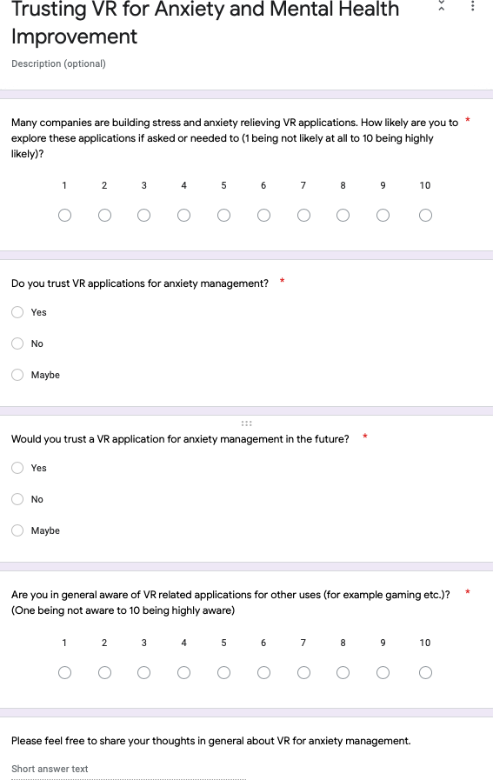

Figure 4: Google Form Questions - Part 4

**Data Analysis**

Based on the response rate of the survey questions, we wanted to be able to draw statistically significant inferences. One of our key goals was to be able to compare the survey answers for different age groups such as 18-25, 25-35 and 36 above. However, this was highly dependent on the survey response rate. Another goal was to use measures of central tendency such as mean and median to examine the role of each VR application in mitigating anxiety. It is also important to note while a "percentage of participants" for various survey questions might be a good metric to provide a detailed perspective to the reader for certain results, it was important to also cite the "number of participants" so that the reader was able to understand the limitations of this study.

We will also be focusing on communicating our results using bar charts and pie charts. These allowed us to initiate a subjective discussion at the end of our research study and thereby, help in the development of the future work.

## Results

**Literature Survey**

The studies looked at for the literature survey have been shown in tables 5, 6, 7 and 8. These were the most relevant studies to our research goal.

In Figure 5, it can be seen that [12], [9] and [4] show positive results in terms of the respective VR applications being able to positively impact anxiety reduction. [12] mentions VR as an alternative intervention treatment and talks about the reduction in hypertension. [18] and [9] are both focused on methods for the younger population and children.

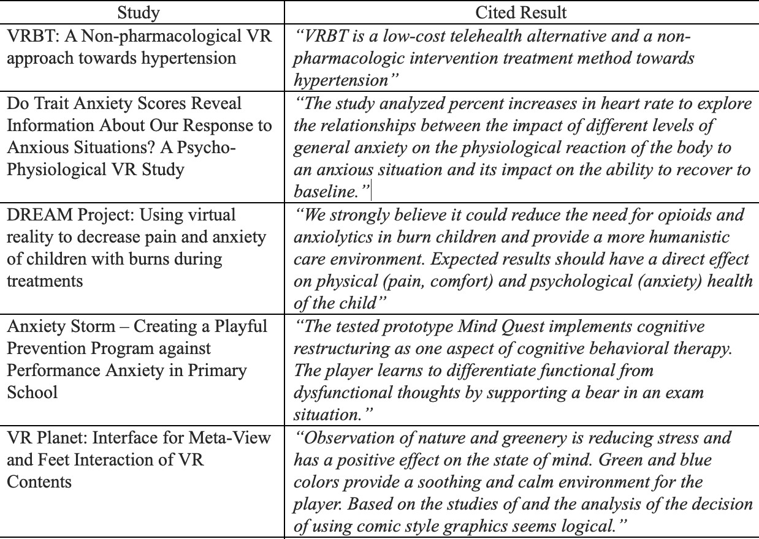

Figure 5: Literature Review Part 1

In Figure 6, it can be seen that the studies [5], [13], [3] and

[8] show that using VR has helped the users to have a higher level of activity and can be personalized for anxiety management of a single user. It is interesting to see in [10] that the students do not feel comfortable using an application in class due to peer stress and might shy away from using it.

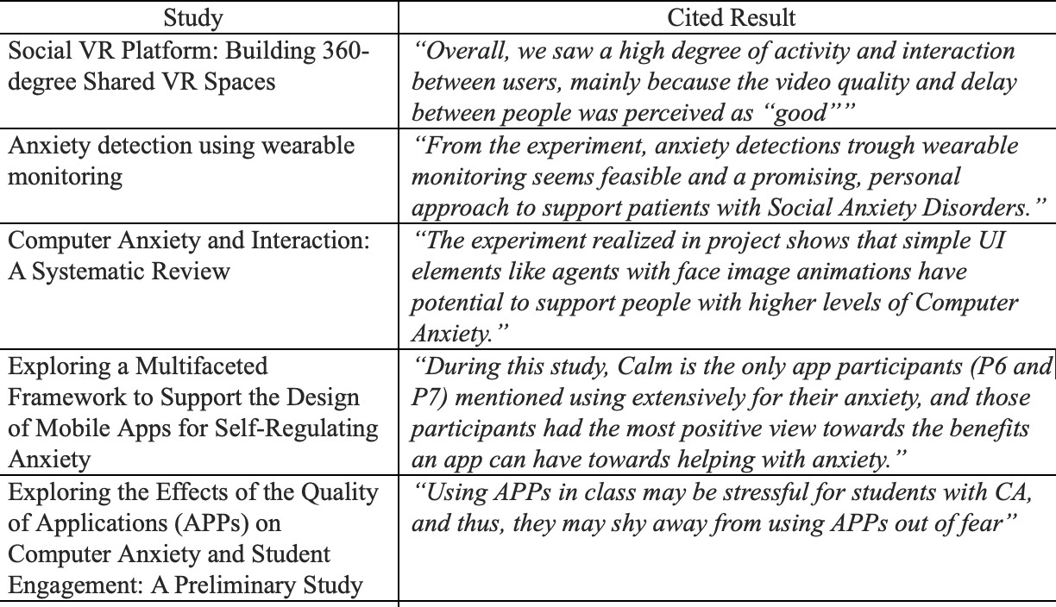

Figure 6: Literature Review Part 2

In Figure 7, the studies [11], [21], [15], [24] and [7] do not focus specifically on the VR related technology but methods that probably can be augmented with the VR technology and the situational anxiety. [15] look at using a sound based technology for anxiety self tests and understanding user trust.

[24] and [7] talk about anxiety in specific settings and situations.

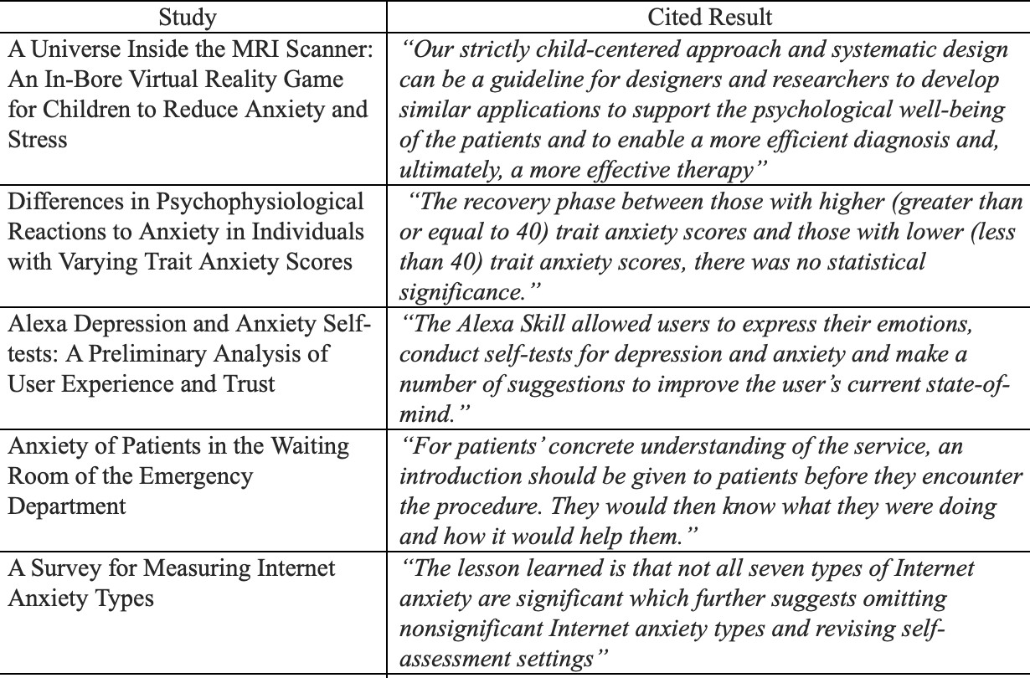

Figure 7: Literature Review Part 3

In Figure 8, [2] looks the different elements within VR and their design and the impact it can have on designing anxiety applications. Both [6] and [20] look at VR elements for identification of anxiety. Also, [14] provides a unique perspective of plant based games and their usage in handling anxiety management.

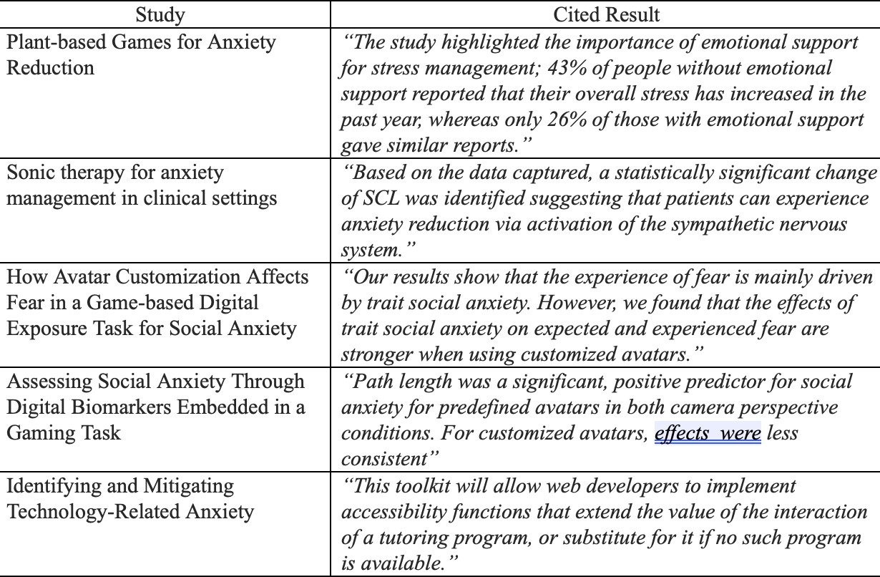

Figure 8: Literature Review Part 4

**Online Survey Results**

The online survey results for demographics showed that 44 (n=11) percent of the survey respondents were between the age of 25 and 35 and 52 (n=13) percent were between the age of 18 and 25. Only one survey respondent was over the age of

1. In terms of their educational qualification, 40 (n=10) percent of the respondents either had or were in the process of obtaining their Masters degree and 52 (n=13) percent were in the process of obtaining their Bachelor degree or had already completed it. Only 8 percent (n=2) of the respondents were in the process of obtaining their PhD or had completed it.

Only 1 respondent out of the 25 respondents had used a VR application for relieving anxiety and the application that they mentioned that they had used was "Oculus". The responses to the effectiveness of using a VR application for relieving anxiety has been shown in Figure 9. 72 percent (n=18) respondents have never used a VR application and 24 percent (n=6) have never used VR for anxiety management.

In part 3 of the survey pertaining to specific questions about the pandemic, 44 percent (n=11) of the respondents said that they faced some anxiety during the pandemic. However, only

one of them used any VR aplication to deal with their anxiety. In terms of other mental health conditions, only 8 percent (n=2) faced such conditions (Figure **??**) and no one used any VR application to manage the mental health condition.

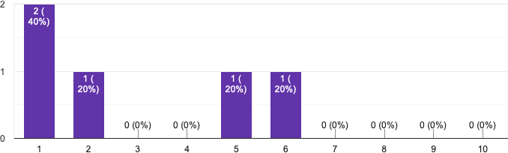

Figure 9: Bar Graph showing the effectiveness of using a VR anxiety relieving application on a scale of 10 (1 being not effective at all to 10 being highly effective)

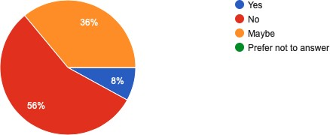

Figure 10: Pie chart showing the distribution of people who faced any other mental health condition other than anxiety during the pandemic

In terms of future use and trust of VR application, the answer to the question related to the use of VR application for stress management when asked by a company was very divided and the bar graph shown in Figure 11. Around 32 (n=8) percent of the participants said that they trust VR applications for anxiety management and 40 percent (n=10) said that they might or might not trust the VR for this purpose. However, around 36 percent (n=9) of the respondents said that they will trust VR applications for anxiety management in the future. In terms of the general awareness of the respondents with respect to VR applications, the results have been shown in Figure 12.

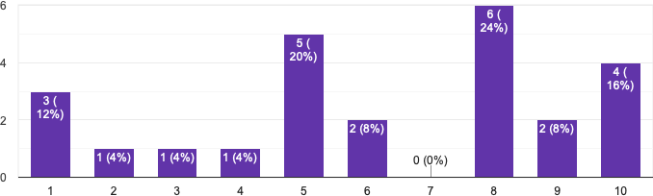

Figure 11: Bar graph showing the answer to the question "Many companies are building stress and anxiety relieving VR applications. How likely are you to explore these applications if asked or needed to (1 being not likely at all to 10 being highly likely)?"

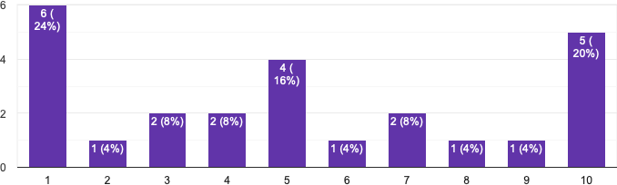

Figure 12: Bar graph showing the answer to the question "Are you in general aware of VR related applications for other uses (for example gaming etc.)? (One being not aware to 10 being highly aware)"

## Discussion

For the literature survey it was interesting to find that many applications such as [18] and [9] were focused on the younger population and anxiety management in school going children was a popular motivation for VR applications. It could also be seen that while different applications were using different hardware and software, personalized anxiety management was being considered in many cases. This directly has implications on the further development of the VR technology and making it easier to be used for personal use in general. Another interesting find from the literature was that, different situations might require different ways and media to cope with anxiety management and situational anxiety could be a possible motivation for many future VR applications. Using different elements within the VR environment to both identify and mitigate anxiety can help in understanding the different anxiety levels of each of the user and then providing the appropriate mitigation strategy in terms of VR. One of the results that stood out was that people, especially children in general might find it hard to use VR for stress management in their classroom setting as that might put peer presssure on them. This provides a thought for food in terms of how people can be more comfortable to use VR in a group setting to take full advantage of this technology.

As can be seen from the online results, only one participant had used a VR application for anxiety management. This is probably due to the fact that the number of people aware of VR applications are not very high and many of them might not be fully aware of how to use it (Figure 12). It could also be seen that many of them were unsure of whether VR application would be able to help them in the future for anxiety management. However, this could also be due to the fact that many times people are not able to realise that they have anxiety and they need mitigation strategies for it. This is evident from the questions related to anxiety and mental health condition during the pandemic to which 32 percent and 36 percent of the respondents replied that they were not sure about whether they had any anixety or mental health related issues. It could be seen that when they would asked to try out VR based stress management strategies by their employer, more respondents were ready to use it. Based on the results the lack of use of VR related technology can also be attributed to the lack of exposure to VR in general and that is evident in Figure 12.

## Conclusions

In conclusion, we were able to examine the use of VR for anxiety management and this was done through a literature

survey and an online survey. The results from the online survey showed that people in general are not aware of VR technologies and mostly people have not used VR for anxiety management. From the literature review it was interesting to find the anxiety relieving applications being designed for the younger population and the innovation was in terms of both being able to detect as well as mitigate anxiety.

Some of the limitations of this study were that we were not able to collect enough data for the online survey and although we tried to make sure that it did not have any sampling bias, it was not possible due to both time constraints and the inaccessibility to more media. The survey could have been more comprehensive and focused on several different applications. For the literature survey, a more stratified approach can be followed in the future that separates the literature about the technology development from the literature that has controlled experiments. That will help us to assess the use and progress of VR for anxiety management in a more organized manner.

## Acknowledgements

We would like to thank Prof. Chunming Gao for guiding us and providing helpful feedback during the quarter.

## References

* 1. Rudi De Raedt. 2006. Does neuroscience hold promise for the further development of behavior therapy? The case of emotional change after exposure in anxiety and depression. *Scandinavian Journal of Psychology* 47, 3 (2006), 225–236.
  2. Martin Johannes Dechant, Max V Birk, Youssef Shiban, Knut Schnell, and Regan L Mandryk. 2021. How Avatar Customization Affects Fear in a Game-based Digital Exposure Task for Social Anxiety. *Proceedings of the ACM on Human-Computer Interaction* 5, CHI PLAY (2021), 1–27.
  3. Thiago Donizetti dos Santos and Vagner Figueredo de Santana. 2018. Computer anxiety and interaction: A systematic review. In *Proceedings of the 15th International Web for All Conference*. 1–10.
  4. Kevin Fan, Liwei Chan, Daiya Kato, Kouta Minamizawa, and Masahiko Inami. 2016. VR planet: interface for meta-view and feet interaction of VR contents. In *ACM SIGGRAPH 2016 VR Village*. 1–2.
  5. Simon NB Gunkel, Martin Prins, Hans Stokking, and Omar Niamut. 2017. Social VR platform: Building

360-degree shared VR spaces. In *Adjunct Publication of the 2017 ACM International Conference on Interactive Experiences for TV and Online Video*. 83–84.

* 1. Martin Johannes Dechant, Julian Frommel, and Regan Mandryk. 2021. Assessing social anxiety through digital biomarkers embedded in a gaming task. In *Proceedings of the 2021 CHI Conference on Human Factors in Computing Systems*. 1–15.
  2. Santosh Kumar Kalwar, Kari Heikkinen, and Jari Porras. 2012. A survey for measuring internet anxiety types. In *Proceedings of the 13th International Conference on Computer Systems and Technologies*. 337–344.
  3. Trinh Le, Hashini Senaratne, Michael McQuaid, and Garreth W Tigwell. 2021. Exploring a Multifaceted Framework to Support the Design of Mobile Apps for Self-Regulating Anxiety. In *Extended Abstracts of the 2021 CHI Conference on Human Factors in Computing Systems*. 1–7.
  4. Sylvie Le May, David Paquin, Jean-Simon Fortin, and Christelle Khadra. 2016. DREAM project: Using virtual reality to decrease pain and anxiety of children with burns during treatments. In *Proceedings of the 2016 Virtual Reality International Conference*. 1–4.
  5. Jung-Chieh Lee and Liangnan Xiong. 2018. Exploring the Effects of the Quality of Applications (APPs) on Computer Anxiety and Student Engagement: A Preliminary Study. In *Proceedings of the 2018 2nd International Conference on Software and e-Business*. 44–48.
  6. Stefan Liszio, Oliver Basu, and Maic Masuch. 2020. A universe inside the MRI scanner: an in-bore virtual reality game for children to reduce anxiety and stress. In *Proceedings of the Annual Symposium on*

*Computer-Human Interaction in Play*. 46–57.

* 1. Yui Lo, Qinglan Shan, Jie Xu, Lei Shao, Li Dong, Peiwu Qin, and Yuhan Dong. 2021. VRBT: A

Non-pharmacological VR approach towards hypertension. In *Proceedings of the 27th ACM Symposium on Virtual Reality Software and Technology*. 1–2.

* 1. Darién Miranda, Marco Calderón, and Jesus Favela. 2014. Anxiety detection using wearable monitoring. In *Proceedings of the 5th Mexican conference on*

*human-computer interaction*. 34–41.

* 1. Taiwoo Park, Tianyu Hu, and Jina Huh. 2016.

Plant-based games for anxiety reduction. In *Proceedings of the 2016 Annual Symposium on Computer-Human Interaction in Play*. 199–204.

* 1. Juan C Quiroz, Tristan Bongolan, and Kiran Ijaz. 2020. Alexa depression and anxiety self-tests: a preliminary analysis of user experience and trust. In *Adjunct Proceedings of the 2020 ACM International Joint Conference on Pervasive and Ubiquitous Computing and Proceedings of the 2020 ACM International Symposium on Wearable Computers*. 494–496.
  2. Albert A Rizzo, J Galen Buckwalter, and Ulrich Neumann. 1997. Virtual reality and cognitive rehabilitation: A brief review of the future. *The Journal of head trauma rehabilitation* (1997).
  3. Barbara Olasov Rothbaum and Ann C Schwartz. 2002. Exposure therapy for posttraumatic stress disorder. *American journal of psychotherapy* 56, 1 (2002), 59–75.
  4. Ralf Schmidt, Stephanie Scheja, Thanh Thu Lam, and Maic Masuch. 2015. Anxiety storm: Creating a playful prevention program against performance anxiety in primary school. In *Proceedings of the 14th International*

*Conference on Interaction Design and Children*. 251–254.

* 1. Will Simm, Maria Angela Ferrario, Adrian Gradinar, Marcia Tavares Smith, Stephen Forshaw, Ian Smith, and Jon Whittle. 2016. Anxiety and autism: towards personalized digital health. In *Proceedings of the 2016 CHI Conference on Human Factors in Computing Systems*. 1270–1281.
  2. Kelly Steelman and Charles Wallace. 2017. Identifying and Mitigating Technology-Related Anxiety. In *Proceedings of the 19th International ACM SIGACCESS Conference on Computers and Accessibility*. 323–324.
  3. Ramesh Tadayon, Chetan Gupta, Debbie Crews, and Troy McDaniel. 2018. Differences in psychophysiological reactions to anxiety in individuals with varying trait anxiety scores. In *Proceedings of the 3rd International Workshop on Multimedia for Personal* *Health and Health Care*. 19–24.
  4. Vy Dang Ha Thanh, Ondris Pui, and Martin Constable. 2017. Room VR: a VR therapy game for children who fear the dark. In *SIGGRAPH Asia 2017 Posters*. 1–2.
  5. Soojeong Yoo, Andrew Weatherall, Gail Wong, Sarah Scott, Minal Menezes, Nicholas Wood, Ajit Pillai, and Naseem Ahmadpour. 2019. Clinician perspective on VR Games for Managing Periprocedural Anxiety in Children. In *Proceedings of the 31st Australian Conference on Human-Computer-Interaction*. 280–284.
  6. JungKyoon Yoon and Marieke Sonneveld. 2010. Anxiety of patients in the waiting room of the emergency department. In *Proceedings of the fourth international conference on Tangible, embedded, and embodied interaction*. 279–286.