**Step 1.** Download the installer. Here, we need to start with at least 3.8, since conda will drop even Python 3.7 when 3.11 is released. Python 3.6 is so much outdated now – let’s get away from it.

wget https://repo.anaconda.com/miniconda/Miniconda3-py39_4.12.0-Linux-x86_64.sh .

**Step 2.** Run the installer, passing the prefix where conda shall be installed (in my case, it is /mnt/d/WORK/SOFTWARE/Conda, where the installer currently is)

sh ./Miniconda3-py39_4.12.0-Linux-x86_64.sh -b -u -p /mnt/d/WORK/SOFTWARE/Conda

**Step 3.** Add the path to the .bashrc in the home directory of Ubuntu user profile

Restart Ubuntu and check that the base conda environment is available/activated and that it has the right version of Python

**Step 4.** Create new conda environment (libra):

conda create -n libra

**Step 5.** Update the base conda environment:

conda update -n base -c defaults conda

**Step 6.** Activate libra environment before installing other packages

**Step 7.** Install the packages in this order:

7.1.

conda install conda-build=3.22.0

7.2.

conda install -c conda-forge gcc_linux-64=12.2.0 gxx_linux-64=12.2.0

There are some safety warnings at this point, but let’s see how important they are.

conda install make=4.2.1

conda install -c conda-forge cmake=3.24.2

conda install git

conda install -c conda-forge boost-cpp=1.80.0

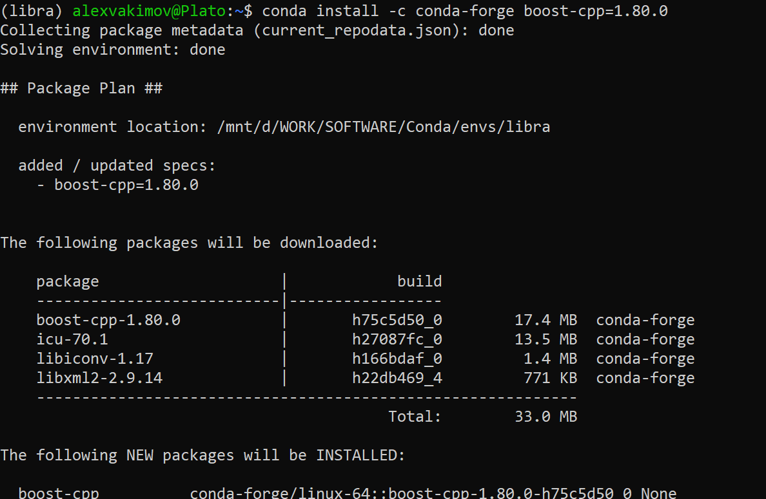

conda install -c psi4 libint2=2.7.1

conda install -c conda-forge eigen=3.4.0

conda install -c conda-forge gmp=6.2.1

conda install -c conda-forge mpfr=4.1.0

conda install -c conda-forge numpy (installs version 1.21.6, I think)

conda install -c conda-forge scipy (this installs 1.7.3 at the time being)

conda install -c conda-forge matplotlib (installs v3.5.2)

conda install -c conda-forge jupyter_core (installs v4.11.1)

conda install -c conda-forge imageio=2.6.1

conda install -c conda-forge llvm-openmp=14.0.4

conda install -c conda-forge h5py=3.7.0

conda install -c conda-forge py3dmol=1.8.1

(sorry – no picture)

conda install -c conda-forge python-devtools

python3 -m pip install python-dev-tools --user --upgrade

conda install -c conda-forge boost=1.80.0

**Build with Ninja:**

Install Ninja: