Isolate genomic DNA using Qiagen DNeasy Kit – Done by Moyle Lab

DNA Quantification using Qubit dsDNA Assay - 1 uL – Done by Moyle Lab

Dilute DNA to a standard concentration DNA – dilute with Epure H20 – Done by Moyle Lab (10 ng/uL)

Digest the genomic DNA samples with NdeI.
- Prepare a digestion master mix. Add per sample:
2 µL NEB CutSmart Buffer
0.15 µL NdeI (3U) use NEB enzyme conc : 4000U of 20,000U/mL
7.85 µL water
10 µL total

+ 10 µL sample (100ng DNA)

MM - 162 samples
(make enough MM for 200 samples)
400 µL NEB CutSmart Buffer
30 µL NdeI
1,570 µL water

- Incubate at 37°C for 3h in a thermocycler.
Inactivate at 65°C for 20 minutes in a thermocycler.

Ligate bar-coded adapters and pool samples.
Add to each digest:
- 1 uL of adapter oligos (5 uM stock solns) - Use plate of SJM 40 uM annealed adapters that were diluted to 5 uM
- 29 uL of mastermix:

- Add to each sample of digested genomic DNA:
5 µL 10X T4 DNA Ligase Buffer
0.38 µL T4 ligase (150 U) use NEB enzyme conc : 100,000U of 400,000U/mL
23.62 µL water
29 µL total

MM - 162 samples
(make enough MM for 185 samples)
925 µL 10X T4 DNA Ligase Buffer
70.3 µL T4 Ligase
4,369.7 µL water

- Ligate in a thermocycler at 25°C for 2 hours. Inactivate at 65°C for 10 minutes.

Isopropanol precipitation
- Use pipet to take up 50uL from each well – put liquid into a 15 mL tube
  - 4050 uL of P1-81 / 4050 uL of P2-81
- Add: 1/10th volume of 3M sodium acetate pH5.2
  - 405 uL of P1-81 / 405 uL of P2-81
- 1 volume of isopropanol.
  - 4050 uL of P1-81 / 4050 uL of P2-81
- Mix the 15mL tube well by inverting several times
- Aliquot the sample evenly between 7 1.7mL eppi tubes:
  - P1-81: 1215 uL/tube P2-81: 1215 uL/tube
- Chill overnight at 4°C for isopropanol precipitation.

Isopropanol precipitation (cont’d)
- Pellet the precipitate by centrifuging at 14000X for 9 min. Notes: white pellets
- Carefully pipet off the supernatant.
- Wash the sides of the tube with 1000 uL cold 70% ethanol.
- Centrifuge at 4000X for another 5 minutes and remove the supernatant.
- Remove excess ethanol and dry pellets on 29C heat block for 5 minutes
- Resuspend the pellet in each 1.7 mL tube in:
  - 15 µL 10mM Tris-HCl + 0.1% Tween20, pH 8.5.
- Heat 30 minutes at 65°C.
- Pool the 7 1.7 mL Eppis from each plate in new tube – end with ~100uL per sample

Phenol:Chloroform Extraction
- Add an equal volume of phenol:chloroform.
- Mix gently; spin for 10 minutes at max speed.
- Remove aqueous layer (top layer) to a new tube.
- Dump the bottom layer into phenol:chloroform liquid waste container.
- Add equal volume of chloroform.
- Mix; spin 5 minutes at max speed.
- Remove aqueous (top) layer to a new tube. Dump bottom layer into waste container.
Volumes of Phenol:Chloroform
Sample | Volume of Sample | Volume of P:C | Volume of Sample |  | Volume of Chloro | Date Completed
P1-81 | 100 | 100 | 100 |  | 100 | 8/02/2022
P2-81 | 100 | 100 | 100 |  | 100 | 8/02/2022

Bead purify using the Agencourt AMPure PCR purification kit.
- Swirl bottle to resuspend beads.
- Check volume of each sample
- Add 1.5 volume of beads, mix.
- Incubate at RT 10 min.
- Place on magnet 5 min.
- Aspirate and discard supernatant.
- Add 200 µl of fresh ETOH 80%.
  - Incubate at RT 1 min.
  - Aspirate and discard supernatant.
- Repeat ETOH wash.
- Take off magnet - Dry at 37 C for 2-3 minutes
- Off the magnet, resuspend in 32 µl of 10mM Tris-HCl + 0.1% Tween20, pH 8.5.
- Incubate at RT 3 min.
- Place back on magnet for 5 min.
- Transfer supernatant to a new tube - Spec 1 µl of DNA on Qubit.
Needed to make dilution for Qubit assay: P1-81 1/8 dil. / P1-81 1/4 dil.
Volumes Post Phenol:Chloroform & Qubit Results Post Bead Purification
Sample | Volume | Volume of Beads | Qubit Conc ng/uL | uL DNA | Total ng
P1-81 | 97 | 145.5 | 510.4 | 30 | 15,312
P2-81 | 85 | 127.5 | 290.4 | 30 | 8,712
For loading sample into Pippin, maximum input is 5000ng.
P1-81: 9.80 uL DNA / 20.2 uL 10mM Tris
P2-81: 17.22 uL DNA / 12.78 uL 10mM Tris

Run pooled sample on a BluePippin Prep 2% Cassette with internal standards.
-use cassette 2% DF Marker V2
- Make sure pooled sample is at 30uL – otherwise bring volume up to 30uL with 10mM Tris-HCl
- Allow loading solution and sample to equilibrate to RT
- Combine 30uL DNA sample with 10uL loading solution/marker mix (labeled marker V2)
- Use Internal Standards.
- Mix samples and briefly centrifuge
- Set Pippin Prep to elute the 495-605 bp range of the DNA fragments

Buffer Exchange sample following elution from Pippin cassette
- Swirl bottle to resuspend beads.
- Check volume of each sample
- Add 2X volume of beads, mix.
- Incubate at RT 10 min.
- Place on magnet 5 min.
- Aspirate and discard supernatant.
- Add 200 µl of fresh ETOH 80%.
  - Incubate at RT 1 min.
  - Aspirate and discard supernatant.
- Repeat ETOH wash.
- Take off magnet - Dry at 37 C for 3 minutes
- Off the magnet, resuspend in 20 µl of 10mM Tris-HCl + 0.1% Tween20, pH 8.5
- Incubate at RT 3 min.
- Place back on magnet for 5 min.
- Transfer supernatant to a new tube.
- Spec 1 µl of DNA on Qubit.

Volumes Post Pippin Prep & Qubit Post Pippin + Buffer Exchange
Sample | Volume | Volume of Beads | Qubit Conc ng/uL | uL DNA | Total Nanograms
P1-81 | 42 | 84 | 0.310 | 18 | 5.58
P2-81 | 55 | 110 | 0.496 | 18 | 8.928

Amplify bar-coded fragments using the Phusion PCR kit and FC1 and FC2 primers
per 50 µL reaction:
10 µL 5X Phusion buffer
1.0 µL 10mM dNTP
2.5 µL FC1 (10 µM) primer
2.5 µL FC2 (10 µM) primer
0.5 µL Phusion enzyme
x µL (1-2 ng template DNA) – 2ng of template if possible
33.5-x µL water

Run the FC_PCR program for 13 cycles
The program should be:
1. 98°C 30 sec
2. 98°C 10 sec ----
3. 62°C 15 sec 13 cycles
4. 72°C 15 sec ----
5. 72°C 7 min
6. 4°C -
- Move PCR product to 1.7mL tube - Save 1 µL of PCR product to Qubit

PCR reactions per plate: P1: 3 reactions, P2: 4 reactions
PCR Setup & Bead Purification Amounts
Sample | Qubit Conc ng/uL | uL DNA | uL Epure H20 | FC1/FC2 Primer |  | Volume Post PCR | Volume Beads (.8X)
P1-81 | 0.310 | 6 | 27.5 | UDI-01 |  | 145 | 116
P2-81 | 0.496 | 4 | 29.5 | UDI-02 |  | 195 | 156

Bead purify using AMPure Beads to remove all primer dimers and DNA up to 150 bp
- Combine all PCR reactions from a single plate into 1 bead clean up tube
- Check volume of each sample
- Swirl bottle to resuspend beads.
- Add (0.8 volume) of beads, mix.
- Incubate at RT 10 min.
- Place on magnet 5 min.
- Aspirate and discard supernatant – Save 1uL sup to Qubit
- Add 200 µl of fresh ETOH 80%.
  - Incubate at RT 1 min.
  - Aspirate and discard supernatant.
- Repeat ETOH wash.
- Take tubes off magnet - Dry at 37 C for 3 mins
- Off the magnet, resuspend in 20 µl of 10mM Tris-HCl + 0.1% Tween20, pH 8.5
- Incubate at RT 3 min.
- Place back on magnet for 5 min.
- Transfer supernatant to a new tube.
- Spec 1 µl of MSG Library on Qubit.
 |  | Qubit Results and MSG DNA Library Concentrations
Sample | Post PCR Conc ng/uL |  | Bead Discard Conc ng/uL | MSG Library Conc ng/uL | uL Left | bp Size | Total Nanograms | FC1/FC2 Primer
P1-81 | 7.90 |  | 3.62 | 1.24 | 17 | 618 | 21.08 | UDI-01
P2-81 | 6.50 |  | 3.44 | 1.15 | 17 | 623 | 19.55 | UDI-02

P1-81
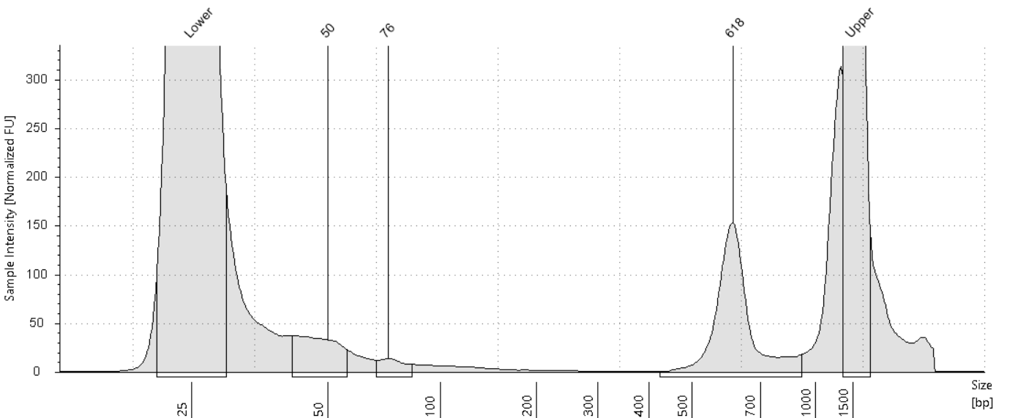

P2-81

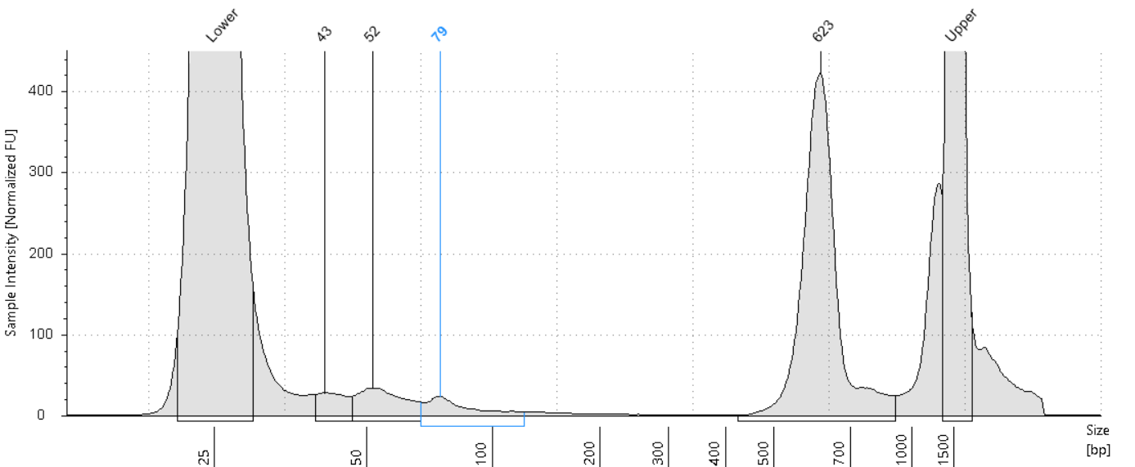

Repeat Bead Purification Due to Off-Target Peaks in Library Prep

Bead purify using AMPure Beads to remove all primer dimers and DNA up to 150 bp
- Check volume of each sample – Bring volume up to 30uL
- Swirl bottle to resuspend beads.
- Add (0.8 volume) of beads, mix. Added 24uL of beads
- Incubate at RT 10 min.
- Place on magnet 5 min.
- Aspirate and discard supernatant
- Add 200 µl of fresh ETOH 80%.
  - Incubate at RT 1 min.
  - Aspirate and discard supernatant.
- Repeat ETOH wash.
- Take tubes off magnet - Dry at 37 C for 3 mins
- Off the magnet, resuspend in 20 µl of 10mM Tris-HCl + 0.1% Tween20, pH 8.5
- Incubate at RT 3 min.
- Place back on magnet for 5 min.
- Transfer supernatant to a new tube.
- Spec 1 µl of MSG Library on Qubit.

Qubit Results and MSG DNA Library Concentrations
Sample | MSG Library Conc ng/uL | uL Left | bp Size | Total Nanograms | FC1/FC2 Primer
P1-81 | 0.614 | 16.5 | 610 | 10.131 | UDI-01
P2-81 | 1.69 | 16.5 | 622 | 27.885 | UDI-02

P1-81
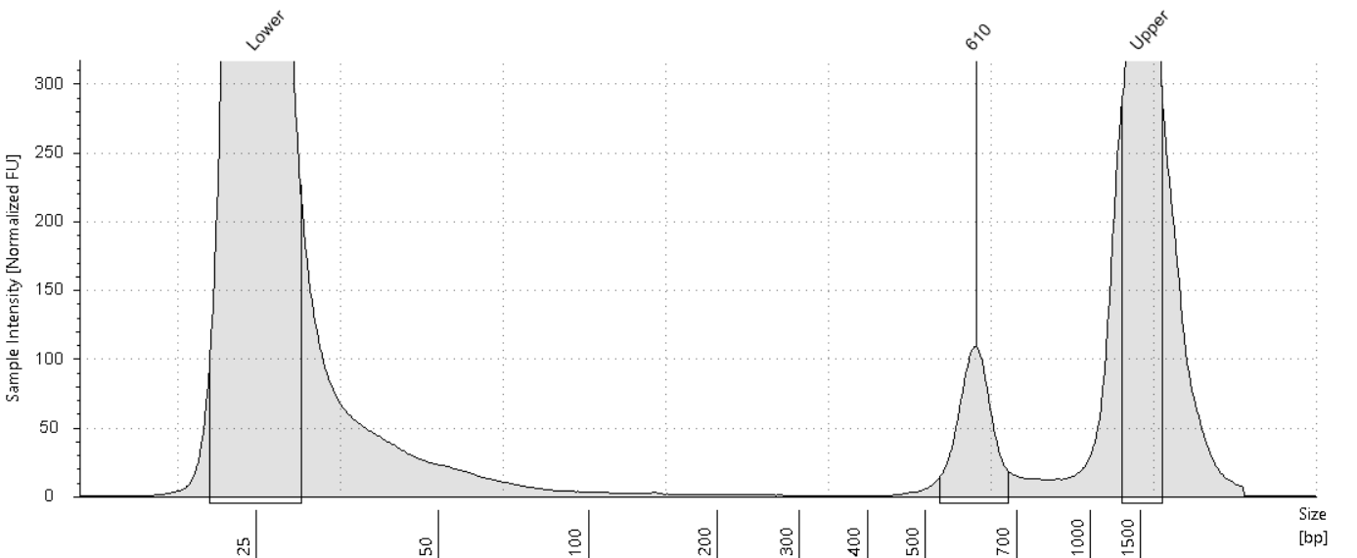

P2-81
