Isolate genomic DNA using Qiagen DNeasy Kit – Done by Moyle Lab

DNA Quantification using Qubit dsDNA Assay - 1 uL – Done by Moyle Lab

Dilute DNA to a standard concentration DNA – dilute with Epure H20 – Done by Moyle Lab (10 ng/uL)

Digest the genomic DNA samples with NdeI.
- Prepare a digestion master mix. Add per sample:
2 µL NEB CutSmart Buffer
0.15 µL NdeI (3U) use NEB enzyme conc : 4000U of 20,000U/mL
7.85 µL water
10 µL total

+ 10 µL sample (100ng DNA)

MM - 150 samples (P1-75 / P2-75)
(make enough MM for 180 samples)
360 µL NEB CutSmart Buffer
27 µL NdeI
1413 µL water

- In a thermocycler: Incubate at 37°C for 3 hours (to digest gDNA).
In a thermocyler: Incubate at 65°C for 20 minutes (to inactivate enzyme).

Ligate bar-coded adapters and pool samples.
Add to each digest:
- 1 uL of adapter oligos (5 uM stock solns) - Use plate of SJM 40 uM annealed adapters that were diluted to 5 uM
- 29 uL of mastermix:

- Add to each sample of digested genomic DNA:
5 µL 10X T4 DNA Ligase Buffer
0.38 µL T4 ligase (150 U) use NEB enzyme conc : 100,000U of 400,000U/mL
23.62 µL water
29 µL total

MM - 150 samples (P1-75 / P2-75)
(make enough MM for 165 samples)
825 µL 10X T4 DNA Ligase Buffer
62.7 µL T4 Ligase
3897.3 µL water

- In a thermocycler: Incubate at 25°C for 2 hours (to ligate adapters).
- In a thermocycler: Incubate at 65°C for 10 minutes (to inactivate enzyme).

Isopropanol precipitation
- Use pipet to take up 50uL from each well – put liquid into a 15 mL tube
  - 3720 uL of P1-75 / 3660 uL of P2-75
- Add: 1/10th volume of 3M sodium acetate pH5.2
  - 372 uL of P1-75 / 366 uL of P2-75
- 1 volume of isopropanol.
  - 3720 uL of P1-75 / 3660 uL of P2-75
- Mix the 15mL tube well by inverting several times
- Aliquot the sample evenly between 7 1.7mL eppi tubes:
  - P1-75: 1116 uL/tube P2-75: 1098 uL/tube
- Chill overnight at 4°C for isopropanol precipitation.

Isopropanol precipitation (cont’d)
- Pellet the precipitate by centrifuging at 14000X for 9 min. Notes: small, white pellets
- Carefully pipet off the supernatant.
- Wash the sides of the tube with 1000 uL cold 70% ethanol.
- Centrifuge at 4000X for another 5 minutes and remove the supernatant.
- Remove excess ethanol and dry pellets on 29C heat block for 5 minutes
- Resuspend the pellet in each 1.7 mL tube in:
  - 15 µL 10mM Tris-HCl + 0.1% Tween20, pH 8.5.
- Heat 30 minutes at 65°C.
- Pool the 7 1.7 mL Eppis from each plate in new tube – end with ~100uL per sample

Phenol:Chloroform Extraction
- Add an equal volume of phenol:chloroform.
- Mix gently; spin for 10 minutes at max speed.
- Remove aqueous layer (top layer) to a new tube.
- Dump the bottom layer into phenol:chloroform liquid waste container.
- Add equal volume of chloroform.
- Mix; spin 5 minutes at max speed.
- Remove aqueous (top) layer to a new tube. Dump bottom layer into waste container.
Volumes of Phenol:Chloroform
Sample | Volume of Sample | Volume of P:C | Volume of Sample |  | Volume of Chloro | Date Completed
P1-75 | 105 | 105 | 105 |  | 105 | 06/01/23
P2-75 | 105 | 105 | 104 |  | 104 | 06/01/23

Bead purify using the Agencourt AMPure PCR purification kit.
- Swirl bottle to resuspend beads.
- Check volume of each sample
- Add 1.5 volume of beads, mix.
- Incubate at RT 10 min.
- Place on magnet 5 min.
- Aspirate and discard supernatant.
- Add 200 µl of fresh ETOH 80%.
  - Incubate at RT 1 min.
  - Aspirate and discard supernatant.
- Repeat ETOH wash.
- Take off magnet - Dry at 37 C for 2-3 minutes
- Off the magnet, resuspend in 32 µl of 10mM Tris-HCl + 0.1% Tween20, pH 8.5.
- Incubate at RT 3 min.
- Place back on magnet for 5 min.
- Transfer supernatant to a new tube - Spec 1 µl of DNA on Qubit.
Needed to make dilution for Qubit assay: ¼ dilution

P1 ¼ dilution: 41.4
P2 ¼ dilution: 43.6

Volumes Post Phenol:Chloroform & Qubit Results Post Bead Purification
Sample | Volume | Volume of Beads | Qubit Conc ng/uL | uL DNA | Total ng
P1-75 | 95 | 142.5 | 165.6 | 30 | 4968
P2-75 | 96 | 144 | 174.4 | 30 | 5232
For loading sample into Pippin, maximum input is 5000ng.
P1-75: 30uL DNA +10uL Marker V2
P2-75: 28uL DNA + 2uL 10mM Tris + 10 uL Marker V2

When preparing samples for Pippin, ended up needing to add an additional 4ul of Tris buffer to P1 tube and 3ul remaining P2 sample+1ul Tris buffer to P2 tube to ensure loading cassette with 40ul

Run pooled sample on a BluePippin Prep 2% Cassette with internal standards.
-use cassette 2% DF Marker V2
- Make sure pooled sample is at 30uL – otherwise bring volume up to 30uL with 10mM Tris-HCl
- Allow loading solution and sample to equilibrate to RT
- Combine 30uL DNA sample with 10uL loading solution/marker mix (labeled marker V2)
- Use Internal Standards.
- Mix samples and briefly centrifuge
- Set Pippin Prep to elute the 495-605 bp range of the DNA fragments

Buffer Exchange sample following elution from Pippin cassette
- Swirl bottle to resuspend beads.
- Check volume of each sample
- Add 2X volume of beads, mix.
- Incubate at RT 10 min.
- Place on magnet 5 min.
- Aspirate and discard supernatant.
- Add 200 µl of fresh ETOH 80%.
  - Incubate at RT 1 min.
  - Aspirate and discard supernatant.
- Repeat ETOH wash.
- Take off magnet - Dry at 37 C for 3 minutes
- Off the magnet, resuspend in 20 µl of 10mM Tris-HCl + 0.1% Tween20, pH 8.5
- Incubate at RT 3 min.
- Place back on magnet for 5 min.
- Transfer supernatant to a new tube.
- Spec 1 µl of DNA on Qubit.

Volumes Post Pippin Prep & Qubit Post Pippin + Buffer Exchange
Sample | Volume | Volume of Beads | Qubit Conc ng/uL | uL DNA | Total Nanograms
P1-75 | 42 | 84 | 0.420 | 18 | 7.56
P2-75 | 42 | 84 | 1.64 | 18 | 29.52

Amplify bar-coded fragments using the Phusion PCR kit and FC1 and FC2 primers
per 50 µL reaction:
10 µL 5X Phusion buffer
1.0 µL 10mM dNTP
2.5 µL FC1 (10 µM) primer
2.5 µL FC2 (10 µM) primer
0.5 µL Phusion enzyme
x µL (1-2 ng template DNA) – 2ng of template if possible
33.5-x µL water

Run the FC_PCR program for 13 cycles
The program should be:
1. 98°C 30 sec
2. 98°C 10 sec ----
3. 62°C 15 sec 13 cycles
4. 72°C 15 sec ----
5. 72°C 7 min
6. 4°C -
- Move PCR product to 1.7mL tube - Save 1 µL of PCR product to Qubit

PCR reactions per plate: P1-75: 4 reactions, P2-75: 4 reactions
PCR Setup & Bead Purification Amounts
Sample | Qubit Conc ng/uL | uL DNA | uL Epure H20 | FC1/FC2 Primer |  | Volume Post PCR | Volume Beads (.8X)
P1-75 | 0.420 | 4.5 | 29 | UDI-04 |  | 199 | 159.2
P2-75 | 1.64 | 1.22 | 32.28 | UDI-05 |  | 199 | 159.2

Bead purify using AMPure Beads to remove all primer dimers and DNA up to 150 bp
- Combine all PCR reactions from a single plate into 1 bead clean up tube
- Check volume of each sample
- Swirl bottle to resuspend beads.
- Add (0.8 volume) of beads, mix.
- Incubate at RT 10 min.
- Place on magnet 5 min.
- Aspirate and discard supernatant – Save 1uL sup to Qubit
- Add 200 µl of fresh ETOH 80%.
  - Incubate at RT 1 min.
  - Aspirate and discard supernatant.
- Repeat ETOH wash.
- Take tubes off magnet - Dry at 37 C for 3 mins
- Off the magnet, resuspend in 20 µl of 10mM Tris-HCl + 0.1% Tween20, pH 8.5
- Incubate at RT 3 min.
- Place back on magnet for 5 min.
- Transfer supernatant to a new tube.
- Spec 1 µl of MSG Library on Qubit.
 |  | Qubit Results and MSG DNA Library Concentrations
Sample | Post PCR Conc ng/uL |  | Bead Discard Conc ng/uL | MSG Library Conc ng/uL | uL Left | bp Size | nM Conc | FC1/FC2 Primer
P1-75 | 2.42 |  | 1.10 | 7.40 | 17 | 633 | 19.23866368 | UDI-04
P2-75 | 2.60 |  | 1.76 | 3.76 | 17 | 634 | 9.759908838 | UDI-05

P1-75
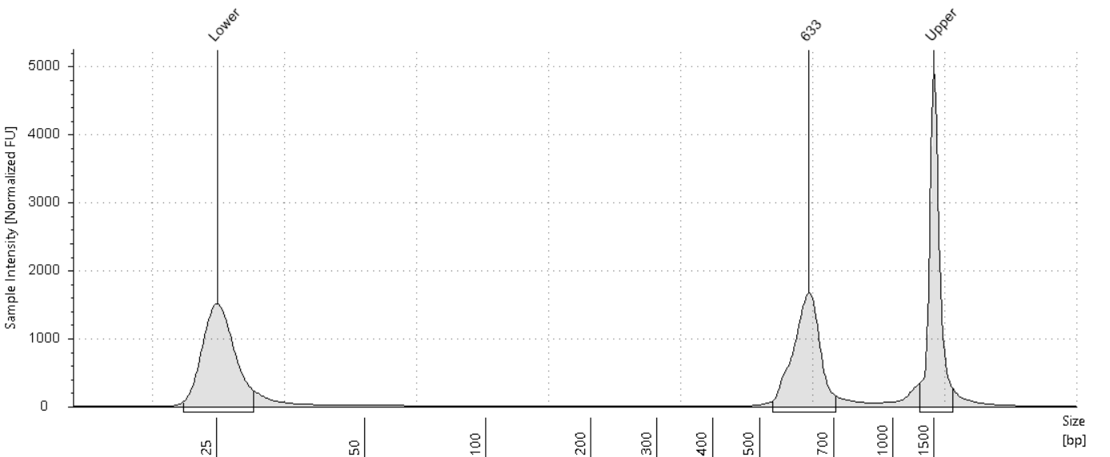

P2-75

