Isolate genomic DNA using Qiagen DNeasy Kit – Done by Moyle Lab

DNA Quantification using Qubit dsDNA Assay - 1 uL – Done by Moyle Lab

Dilute DNA to a standard concentration DNA – dilute with Epure H20 – Done by Moyle Lab (10 ng/uL)

Digest the genomic DNA samples with NdeI.
- Prepare a digestion master mix. Add per sample:
2 µL NEB CutSmart Buffer
0.15 µL NdeI (3U) use NEB enzyme conc : 4000U of 20,000U/mL
7.85 µL water
10 µL total

+ 10 µL sample (100ng DNA)

MM - 165 samples (P1-83 / P2-82)
(make enough MM for 190 samples)
380 µL NEB CutSmart Buffer
28.5 µL NdeI
1,491.5 µL water

- In a thermocycler: Incubate at 37°C for 3 hours (to digest gDNA).
In a thermocyler: Incubate at 65°C for 20 minutes (to inactivate enzyme).

Ligate bar-coded adapters and pool samples.
Add to each digest:
- 1 uL of adapter oligos (5 uM stock solns) - Use plate of SJM 40 uM annealed adapters that were diluted to 5 uM
- 29 uL of mastermix:

- Add to each sample of digested genomic DNA:
5 µL 10X T4 DNA Ligase Buffer
0.38 µL T4 ligase (150 U) use NEB enzyme conc : 100,000U of 400,000U/mL
23.62 µL water
29 µL total

MM - 165 samples (P1-83 / P2-82)
(make enough MM for 180 samples)
900 µL 10X T4 DNA Ligase Buffer
68.4 µL T4 Ligase
4,251.6 µL water

- In a thermocycler: Incubate at 25°C for 2 hours (to ligate adapters).
- In a thermocycler: Incubate at 65°C for 10 minutes (to inactivate enzyme).

Isopropanol precipitation
- Use pipet to take up 50uL from each well – put liquid into a 15 mL tube
  - 4150 uL of P1-83 / 4100 uL of P2-82
- Add: 1/10th volume of 3M sodium acetate pH5.2
  - 415 uL of P1-83 / 410 uL of P2-82
- 1 volume of isopropanol.
  - 4150 uL of P1-83 / 4100 uL of P2-82
- Mix the 15mL tube well by inverting several times
- Aliquot the sample evenly between 7 1.7mL eppi tubes:
  - P1-83: 1245 uL/tube P2-96: 1230 uL/tube
- Chill overnight at 4°C for isopropanol precipitation.

Isopropanol precipitation (cont’d)
- Pellet the precipitate by centrifuging at 14000X for 9 min. Notes: small, white pellets
- Carefully pipet off the supernatant.
- Wash the sides of the tube with 1000 uL cold 70% ethanol.
- Centrifuge at 4000X for another 5 minutes and remove the supernatant.
- Remove excess ethanol and dry pellets on 29C heat block for 5 minutes
- Resuspend the pellet in each 1.7 mL tube in:
  - 15 µL 10mM Tris-HCl + 0.1% Tween20, pH 8.5.
- Heat 30 minutes at 65°C.
- Pool the 7 1.7 mL Eppis from each plate in new tube – end with ~100uL per sample

Phenol:Chloroform Extraction
- Add an equal volume of phenol:chloroform.
- Mix gently; spin for 10 minutes at max speed.
- Remove aqueous layer (top layer) to a new tube.
- Dump the bottom layer into phenol:chloroform liquid waste container.
- Add equal volume of chloroform.
- Mix; spin 5 minutes at max speed.
- Remove aqueous (top) layer to a new tube. Dump bottom layer into waste container.
Volumes of Phenol:Chloroform
Sample | Volume of Sample | Volume of P:C | Volume of Sample |  | Volume of Chloro | Date Completed
P1-83 | 100 | 100 | 100 |  | 100 | 12/6/22
P2-82 | 100 | 100 | 100 |  | 100 | 12/6/22

Bead purify using the Agencourt AMPure PCR purification kit.
- Swirl bottle to resuspend beads.
- Check volume of each sample
- Add 1.5 volume of beads, mix.
- Incubate at RT 10 min.
- Place on magnet 5 min.
- Aspirate and discard supernatant.
- Add 200 µl of fresh ETOH 80%.
  - Incubate at RT 1 min.
  - Aspirate and discard supernatant.
- Repeat ETOH wash.
- Take off magnet - Dry at 37 C for 2-3 minutes
- Off the magnet, resuspend in 32 µl of 10mM Tris-HCl + 0.1% Tween20, pH 8.5.
- Incubate at RT 3 min.
- Place back on magnet for 5 min.
- Transfer supernatant to a new tube - Spec 1 µl of DNA on Qubit.
Needed to make dilution for Qubit assay: ¼ dilution
Volumes Post Phenol:Chloroform & Qubit Results Post Bead Purification
Sample | Volume | Volume of Beads | Qubit Conc ng/uL | uL DNA | Total ng
P1-83 | 90 | 135 | 150.4 | 30 | 4512
P2-82 | 90 | 135 | 201.6 | 30 | 6048
For loading sample into Pippin, maximum input is 5000ng.
P1-83: 30 uL DNA – 10uL Marker V2
P2-82: 24.8 uL DNA + 5.2 uL 10mM Tris – 10 uL Marker V2

Run pooled sample on a BluePippin Prep 2% Cassette with internal standards.
-use cassette 2% DF Marker V2
- Make sure pooled sample is at 30uL – otherwise bring volume up to 30uL with 10mM Tris-HCl
- Allow loading solution and sample to equilibrate to RT
- Combine 30uL DNA sample with 10uL loading solution/marker mix (labeled marker V2)
- Use Internal Standards.
- Mix samples and briefly centrifuge
- Set Pippin Prep to elute the 495-605 bp range of the DNA fragments

Buffer Exchange sample following elution from Pippin cassette
- Swirl bottle to resuspend beads.
- Check volume of each sample
- Add 2X volume of beads, mix.
- Incubate at RT 10 min.
- Place on magnet 5 min.
- Aspirate and discard supernatant.
- Add 200 µl of fresh ETOH 80%.
  - Incubate at RT 1 min.
  - Aspirate and discard supernatant.
- Repeat ETOH wash.
- Take off magnet - Dry at 37 C for 3 minutes
- Off the magnet, resuspend in 20 µl of 10mM Tris-HCl + 0.1% Tween20, pH 8.5
- Incubate at RT 3 min.
- Place back on magnet for 5 min.
- Transfer supernatant to a new tube.
- Spec 1 µl of DNA on Qubit.

Volumes Post Pippin Prep & Qubit Post Pippin + Buffer Exchange
Sample | Volume | Volume of Beads | Qubit Conc ng/uL | uL DNA | Total Nanograms
P1-83 | 43 | 86 | 0.926 | 18 | 16.668
P2-82 | 43 | 86 | 0.892 | 18 | 16.056

Amplify bar-coded fragments using the Phusion PCR kit and FC1 and FC2 primers
per 50 µL reaction:
10 µL 5X Phusion buffer
1.0 µL 10mM dNTP
2.5 µL FC1 (10 µM) primer
2.5 µL FC2 (10 µM) primer
0.5 µL Phusion enzyme
x µL (1-2 ng template DNA) – 2ng of template if possible
33.5-x µL water

Run the FC_PCR program for 13 cycles
The program should be:
1. 98°C 30 sec
2. 98°C 10 sec ----
3. 62°C 15 sec 13 cycles
4. 72°C 15 sec ----
5. 72°C 7 min
6. 4°C -
- Move PCR product to 1.7mL tube - Save 1 µL of PCR product to Qubit

PCR reactions per plate: P1-83: 4 reactions, P2-82: 4 reactions
PCR Setup & Bead Purification Amounts
Sample | Qubit Conc ng/uL | uL DNA | uL Epure H20 | FC1/FC2 Primer |  | Volume Post PCR | Volume Beads (.8X)
P1-83 | 0.926 | 2.2 | 31.3 | UDI-01 |  | 200 | 160
P2-82 | 0.892 | 2.3 | 31.2 | UDI-02 |  | 200 | 160

Bead purify using AMPure Beads to remove all primer dimers and DNA up to 150 bp
- Combine all PCR reactions from a single plate into 1 bead clean up tube
- Check volume of each sample
- Swirl bottle to resuspend beads.
- Add (0.8 volume) of beads, mix.
- Incubate at RT 10 min.
- Place on magnet 5 min.
- Aspirate and discard supernatant – Save 1uL sup to Qubit
- Add 200 µl of fresh ETOH 80%.
  - Incubate at RT 1 min.
  - Aspirate and discard supernatant.
- Repeat ETOH wash.
- Take tubes off magnet - Dry at 37 C for 3 mins
- Off the magnet, resuspend in 20 µl of 10mM Tris-HCl + 0.1% Tween20, pH 8.5
- Incubate at RT 3 min.
- Place back on magnet for 5 min.
- Transfer supernatant to a new tube.
- Spec 1 µl of MSG Library on Qubit.
 |  | Qubit Results and MSG DNA Library Concentrations
Sample | Post PCR Conc ng/uL |  | Bead Discard Conc ng/uL | MSG Library Conc ng/uL | uL Left | bp Size | Total Nanograms | FC1/FC2 Primer
P1-83 | 6.44 |  | 3.42 | 2.04 | 17 | 624 | 34.68 | UDI-01
P2-82 | 5.58 |  | 3.36 | 3.00 | 17 | 618 | 51.0 | UDI-02

P1-83
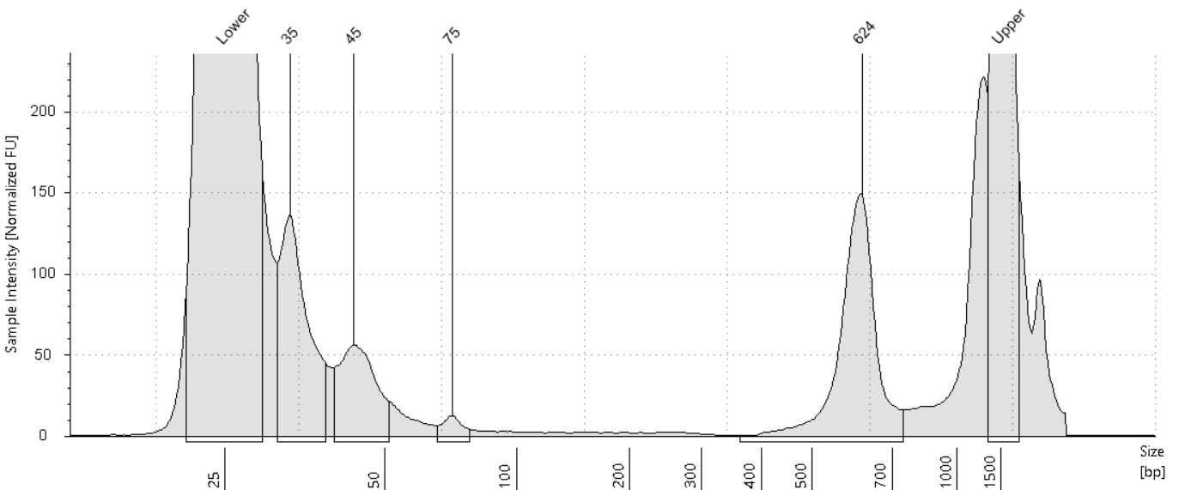

35 bp – 34.59%
45 bp – 18.67%
75 bp – 2.16%
624 bp – 44.58%

P2-82
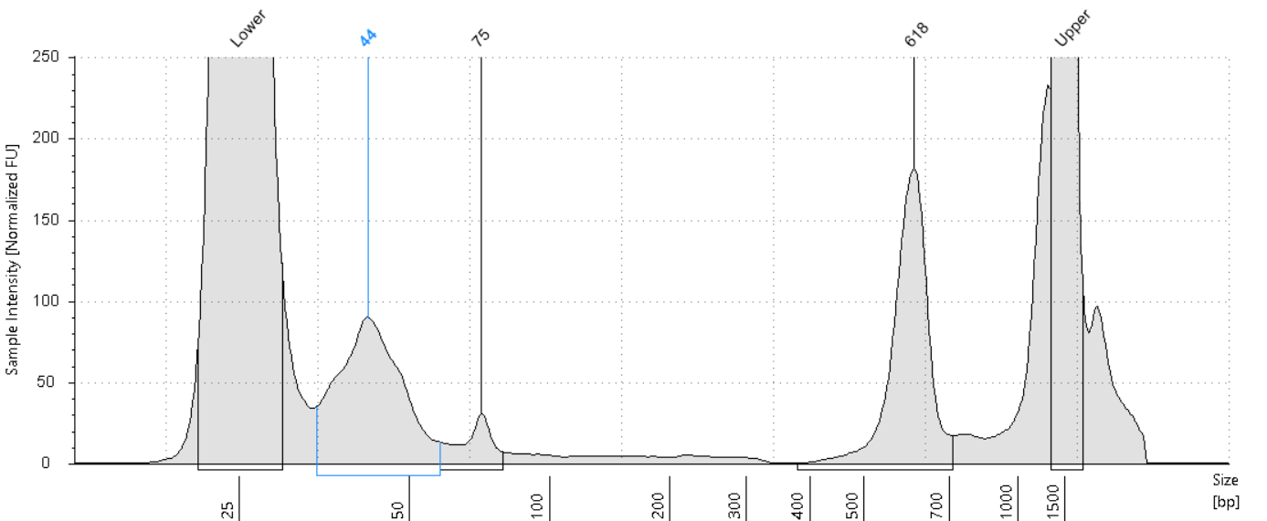
44 bp – 45.06%
75 bp – 6.71%
618 bp – 48.23%

Repeat Bead Purification Due to Off-Target Peaks in Library Prep

Bead purify using AMPure Beads to remove all primer dimers and DNA up to 150 bp
- Check volume of each sample – Bring volume up to 30uL
- Swirl bottle to resuspend beads.
- Add (0.8 volume) of beads, mix. Added 24uL of beads
- Incubate at RT 10 min.
- Place on magnet 5 min.
- Aspirate and discard supernatant
- Add 200 µl of fresh ETOH 80%.
  - Incubate at RT 1 min.
  - Aspirate and discard supernatant.
- Repeat ETOH wash.
- Take tubes off magnet - Dry at 37 C for 3 mins
- Off the magnet, resuspend in 20 µl of 10mM Tris-HCl + 0.1% Tween20, pH 8.5
- Incubate at RT 3 min.
- Place back on magnet for 5 min.
- Transfer supernatant to a new tube.
- Spec 1 µl of MSG Library on Qubit.

Qubit Results and MSG DNA Library Concentrations
Sample | MSG Library Conc ng/uL | uL Left | bp Size | Total Nanograms | FC1/FC2 Primer
P1-83 | 0.592 | 17 | 627 | 10.064 | UDI-01
P2-82 | 0.710 | 17 | 616 | 12.07 | UDI-02

P1-83
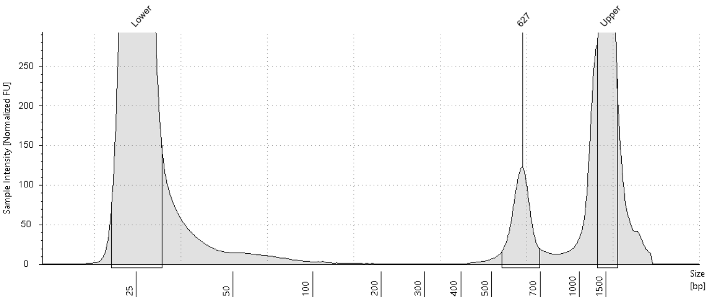

P2-82
