Sample Schema Objects

Action Type – how an alert will be communicated

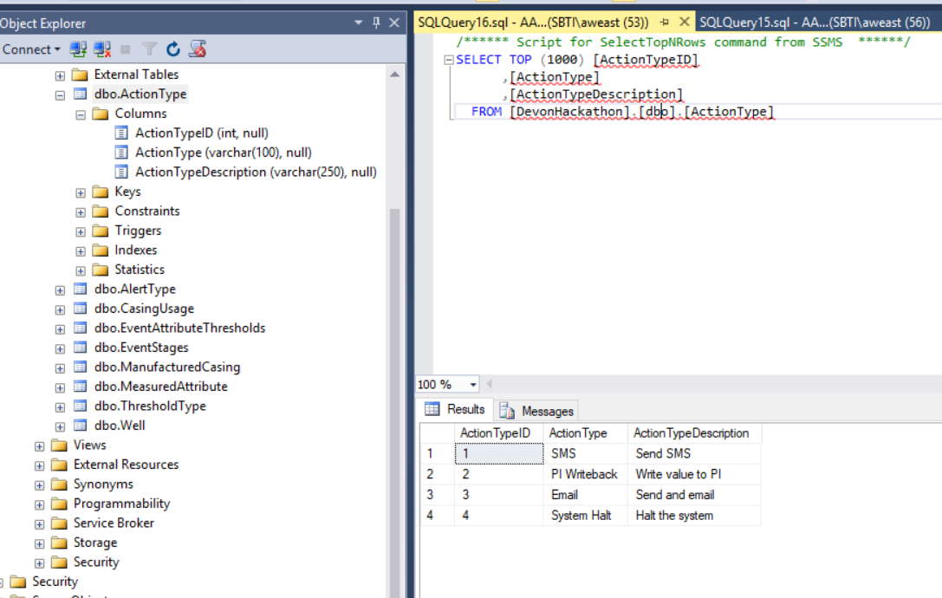

Alert Type – the types of alerts that are desired

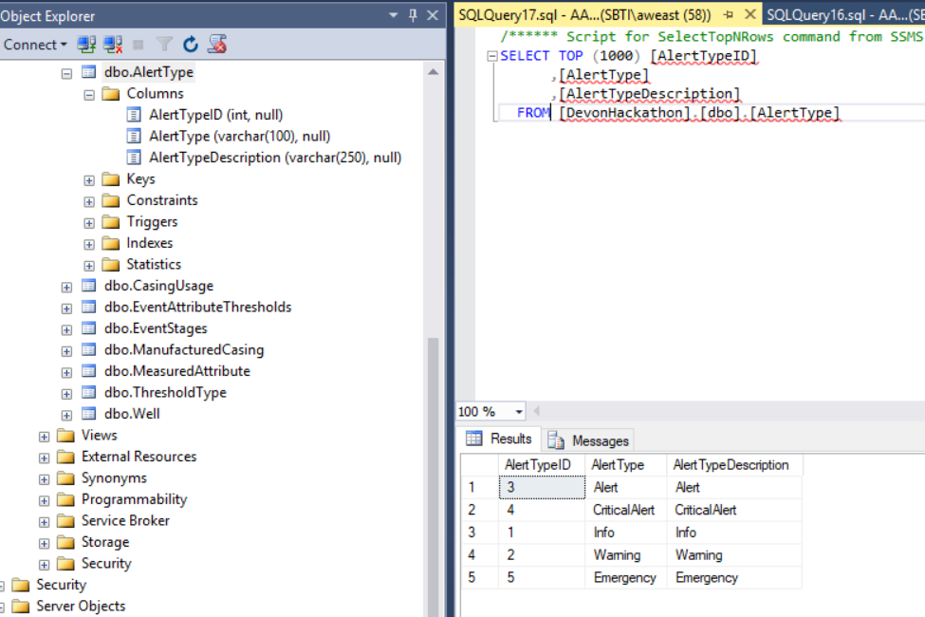

Event Stage – event stages as defined in PI AF

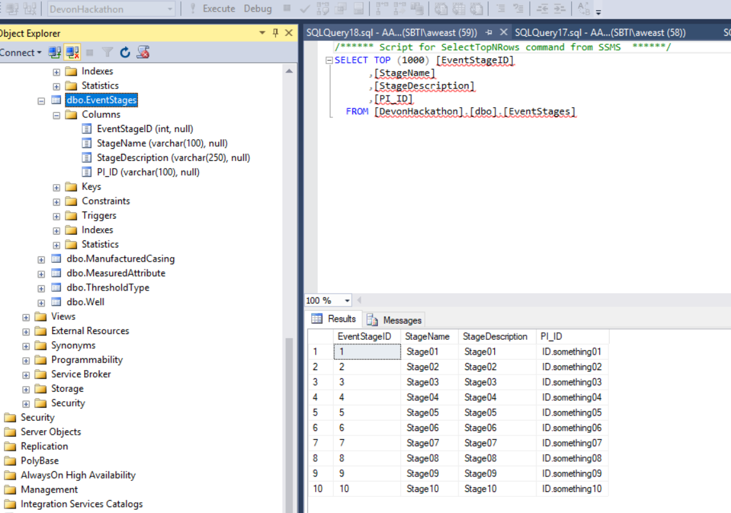

Measurement Attribute – attributes being measured by PI to create events and alerts for

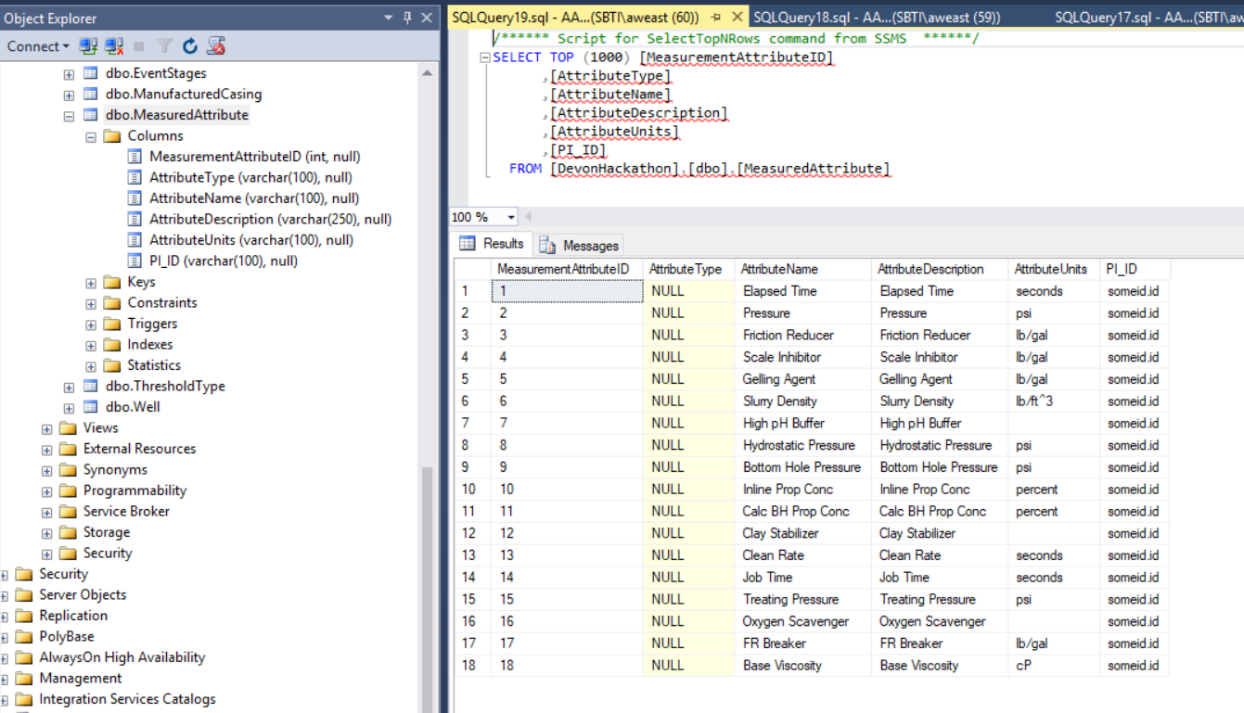

Threshold Type – The types of thresholds that would be defined and monitored

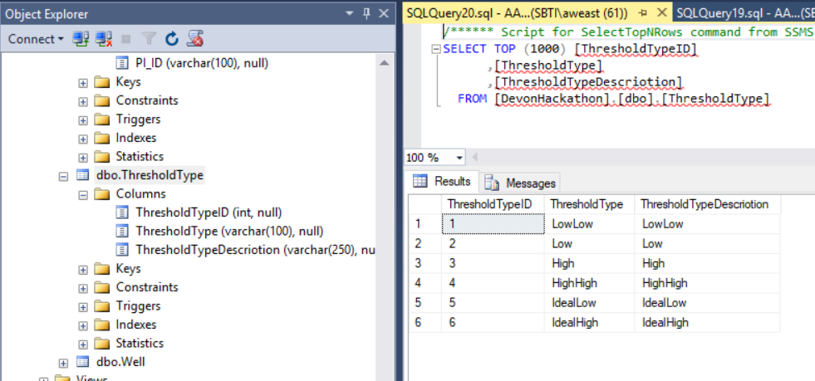

User – this would be some set of the AD directory or other existing user listing

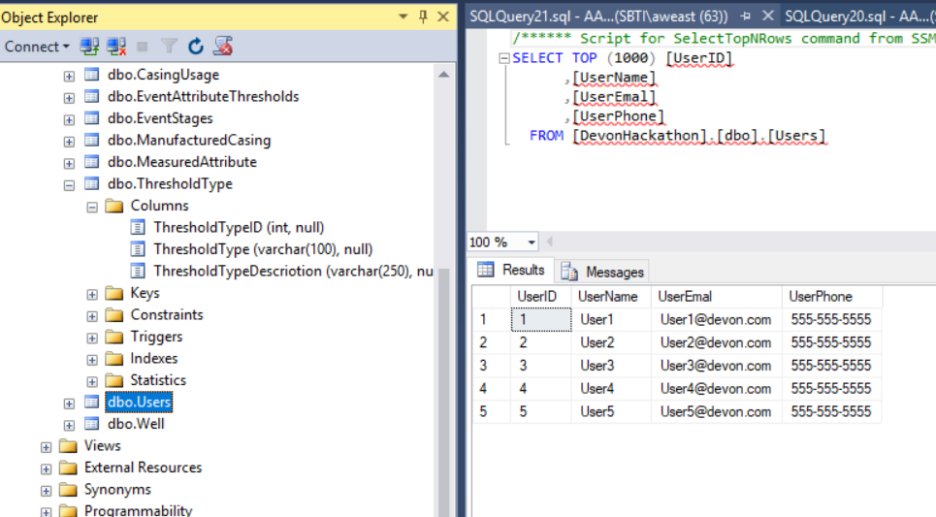

Well – A subset of well information from existing well management systems

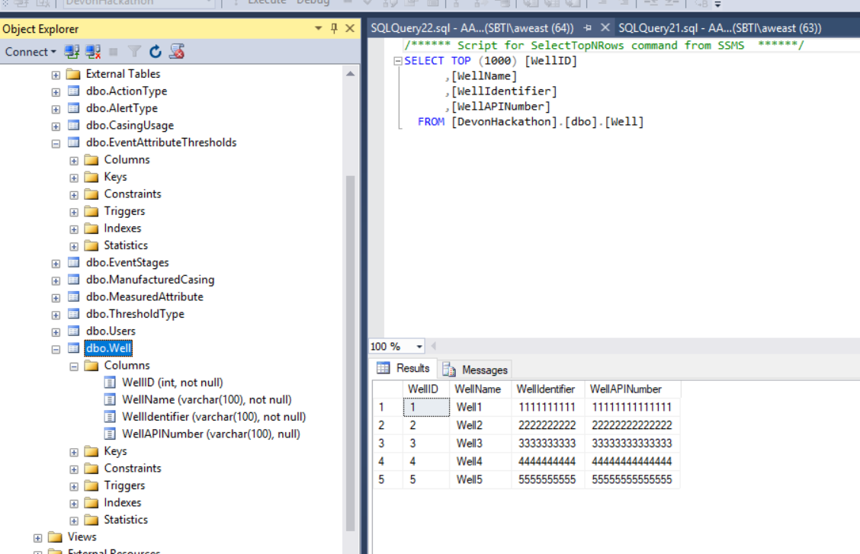

Event Attribute Thresholds – collecting events and thresholds to alert on by stage and well. Multiple alerts and thresholds per attribute and stage could be set. Engineers could have templates to “pre-set” most of this. The PIC could add extra alerts that they are concerned with.

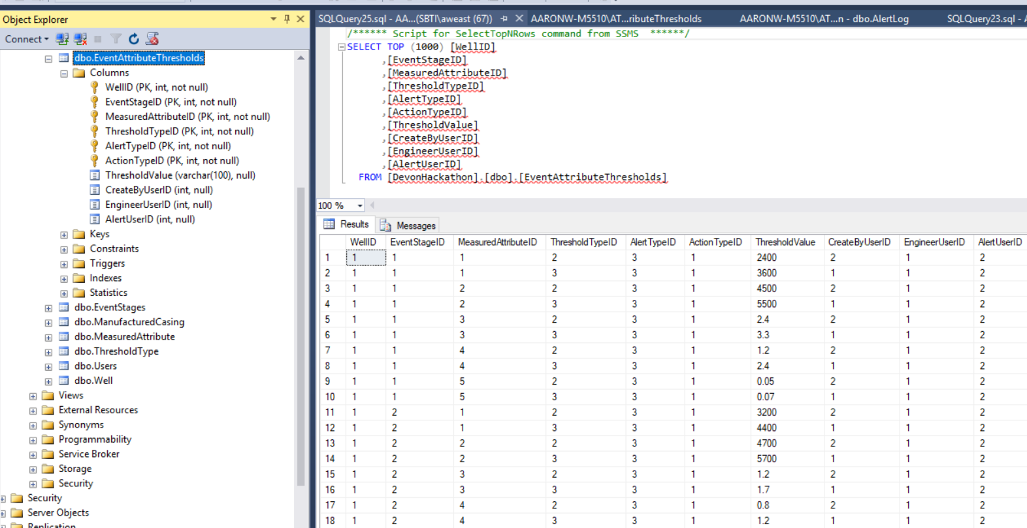

Alert Log – A log of the alerts sent

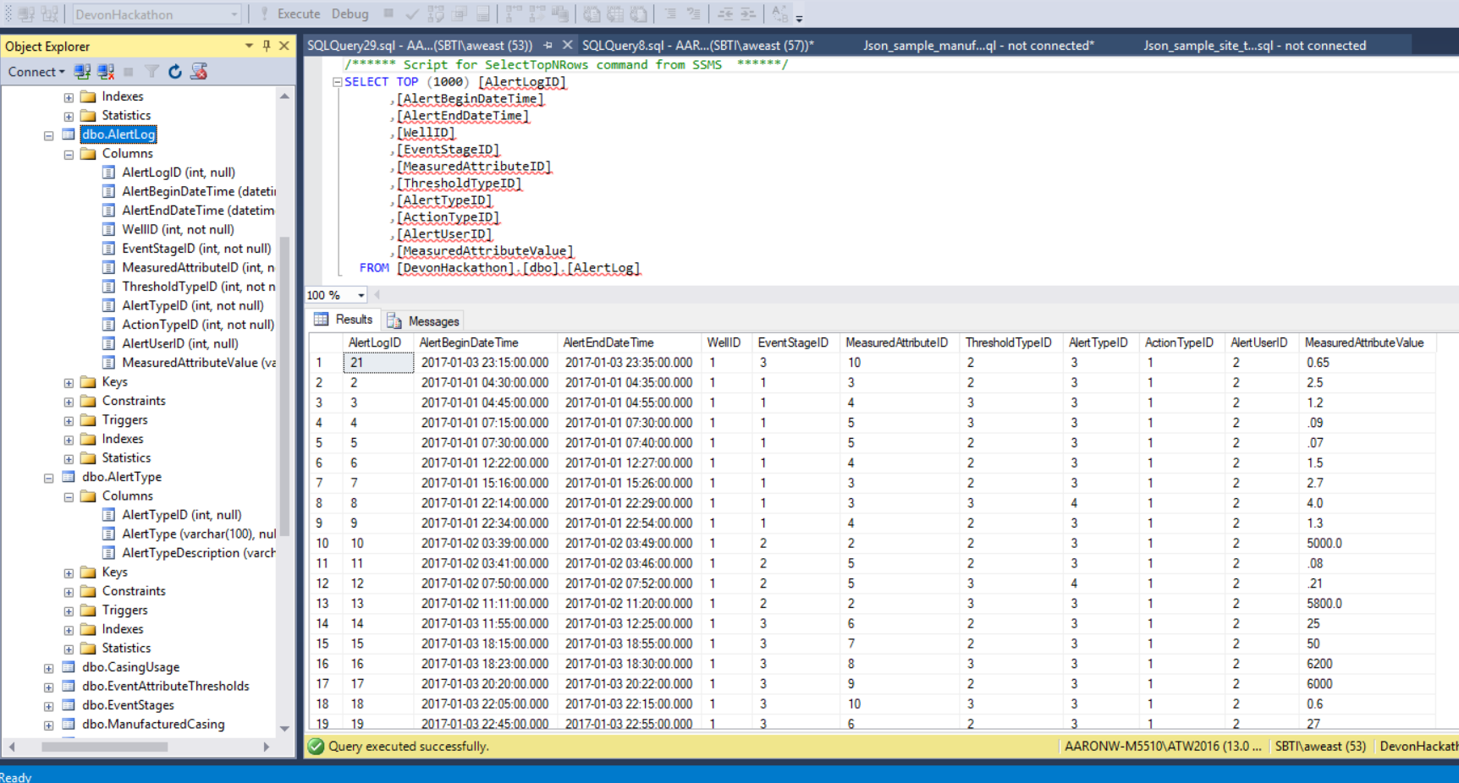

Alert Details – a view to pull the alert log and it’s dimensional descriptions together for analysis

