Devon Hackathon – Stonebridge Solution Outline: Casing Pipe Measurement Improvements

# Overview

The premise behind this proposed solution is that the best place to measure casing pipe is at the source of the pipe, which is Devon’s pipe suppliers. This is just a solution outline as the Stonebridge team focused on their Completions challenge entry.

There are several reasons to have the supplier measure the casing pipe length for Devon

* The pipe is presumably being measured by the pipe supplier already
* The pipe can me measured in a more controlled environment than can be provided at a rig site
* The pipe manufacturer should be able to measure more consistently and accurately than the workers on site

This solution presents several challenges to overcome

* Convincing the manufacturer to perform this value-add activity
* Getting multiple vendors to adhere to a common documentation standard
* Getting the measurement to the rig site
* Reading the measurement on-site
* Getting the measurement readings back to Devon in pipe-rack order
* Exporting the lengths to other systems at Devon

## Convincing the manufacturers to perform this value-add activity

This should be achievable – witness Walmart’s consistent push back to their vendors to provide more and more work and services to retain their shelf-space. There may be an incremental cost that needs to be added to the cost of pipe for this service, but the anticipation is that it should be more cost effective and accurate having this done in the plant rather than having it done in the field.

## Getting multiple vendors to adhere to a common documentation standard

Devon should define a data model to be populated with pipe length and several other metrics of interest. These metrics should at least include the following items to meet current functionality. This data will be exported to Devon on a regular basis (presumably daily) and could/should be housed as an azure cloud solution to eliminate the vendor’s need to access the Devon network.

* ID
* OD
* Nominal Length
* Measured Length
* Thread Length
* Net Length (measured – thread)
* Weight
* Grade
* Top Thread

Additional fields that could / should be collected

* Manufacturer’s name
* Manufacture date
* A serial number and/or a GUID to use for identifying the pipe later in the database

## Getting the measurements to the rig site

QR code labels containing the previously mentioned data fields can be generated at the manufacturer site and affixed to the pipe, ensuring that the correct measurement gets to the rig site. For redundancy purposes, at least two labels should be used for each pipe, and they can be affixed to the pipe itself or to the pipe’s thread caps if that is feasible.

## Reading the measurement on-site

Any mobile device such as a phone or a tablet computer outfitted with a QR code reader (simply a camera and an app or website) can be used to read the pipe’s information once it is on the pipe rack (and possibly while on the truck) and store it locally or online in an application that allows the field personnel to add notes and details to them. An online solution, presuming consistent internet connectivity, would be to do this in a custom-developed but not overly complex web site.

## Getting the measurement readings back to Devon in pipe-rack order

The pipes should be scanned in pipe-rack order, which will provide them with timestamps allowing their data to be kept in sequence later on. The data would also be sent back to Devon with information on what well the pipe was used on and who scanned and/or sent the data back to Devon. That would be set/input by the app user. This data can /should also be hosted in a cloud database.

## Exporting the pipe lengths to other systems at Devon

Once the pipe measurements are sent to Devon (whether cloud based or local), the data can be queried by the engineers and other interested parties for analysis. Queries can be designed in a format compatible with export to additional data systems and/or processes can be designed to automatically export the data and import it into other data systems.

# Technical Examples

The following are technical examples of how each of these tasks might be accomplished

## Convincing the manufacturer to perform this value-add activity

Supplying the manufacturers with QR labelers if they don’t have one may be a cost-effective tactic to encourage their cooperation. These are relatively inexpensive but the key functionality would be the ability to easily and quickly create a customize label for each pipe. If they already have compatible labeling equipment, simply paying for the incremental cost of the labeling may be enough.

## Getting multiple vendors to adhere to a common documentation standard

If there is no existing standard, Devon should create one. The vendors can imbed a simple .json file in their QR code labels that looks like the following and can be used with other customers in addition to Devon:

{

"ManufacturerName": "SupplierABC",

"ManufactureDate": "2017-12-01",

"SerialNumber": "XYZ-0000000012345",

"GUID": "6c1a7c27-a1f5-4b7a-9545-76cb7d44c4b6",

"CustomerName": "Devon",

"ID": 5.50,

"OD": 4.892,

"NominalLength": 45.0,

"MeasuredLength": 45.01,

"ThreadLength": 1.85,

"NetLength": 43.16,

"Weight": 17,

"Grade": "P110RY",

"TopThread": "CDC-HTQ"

}

This .json data will go with the pipe via the QR label, but it also could/should be sent to Devon prior to the pipe’s arrival in the field. A simple .CSV file with the same data fields can be sent to Devon (cloud DB) and loaded with a relatively simple SSIS process or with a web interface. The load method used is less important than collecting the same data in the same format from each vendor. Of utmost importance is the creation of a serial number and/or GUID in the .json for each piece of pipe so that it can be uniquely tracked.

Sample data table:

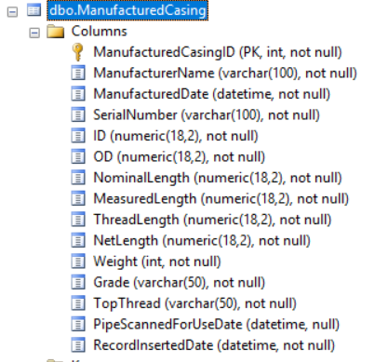

## Getting the measurement to the rig site

Here is a sample QR code made from a .json data file similar to the one previously shown. Two or more labels on each pipe would provide insurance against label damage as well as giving multiple options for reading the QR code in the field. If one or more labels can be placed on the thread cap, and if pipe rack order can be inferred from the pipe’s position on the truck, then they could be scanned in pipe rack order on the truck prior to unloading. One of the biggest benefits to the QR label is that it does not matter what job site the pipe is delivered to so long as it is labeled correctly. It may also be useful to have the QR label include the human readable information in case the QR labels are damaged.



## Reading the measurement on-site

There are many off the shelf QR reader applications. Apps for android, blackberry, iOS already exist. Tying one of these into a lightweight custom app or web service for data collection and additional input (notes, etc.) would be best.

## Getting the measurement readings back to Devon in pipe-rack order

The defined workflow would include the mandate that the field staff scan the pipes in pipe rack order. The timestamp of the QR scan will determine the order going forward in the data. The data can be stored in a simple data model like the following:

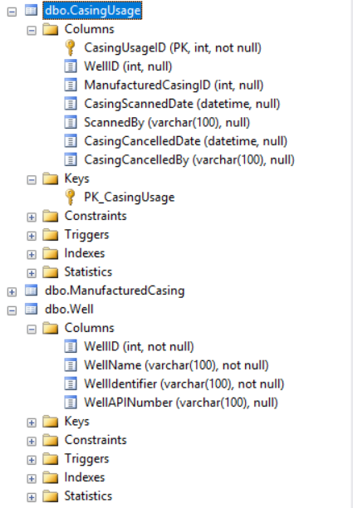

Some basic well data should be pushed from Devon to the cloud database to be able to match the scanned pipes to the well they were used on. The QR reading app/web site can push raw data in .json format to the cloud server where a stored procedure can make the appropriate data lookups and joins.

## Exporting the pipe lengths to other systems at Devon

Use pre-formatted queries that match the import processes for other systems

## Contingency plans / Robustness

* Incorrect scans – add functionality to reversean entry
* Network down – go back to the pen and pencil method. Add functionality to edit entries after the fact