CNC High strength pneumatic gripper Manual

SUMMARY

This document is a guide for customers to analyze common problems on site and provide solutions to the problems.

Disclaimers

We have tested the content described in this document. However, errors are inevitable and cannot be guaranteed to be absolutely correct and fully meet your usage needs. The content of this document may be updated at any time, and we welcome your suggestions for improvement. The document content may be updated at any time
If there are any changes, no prior notice will be given

Catalogue
1 Overview of Installation of 1CNC High Strength Pneumatic Claw 3
2 Pneumatic Claw and Air Circuit Installation 4
2.1 Installation of Pneumatic Claw 4
2.2 Relay harness connection 5
2.3 Gas path installation 6
3 Claw Test 8

Overview of Installation of 1CNC High Strength Pneumatic Claw
Installing high-strength pneumatic grippers at the end of the robot can help the robot quickly deploy material grasping in different scenariosThis manual describes the installation method of high-strength pneumatic gripper for CNC workstation

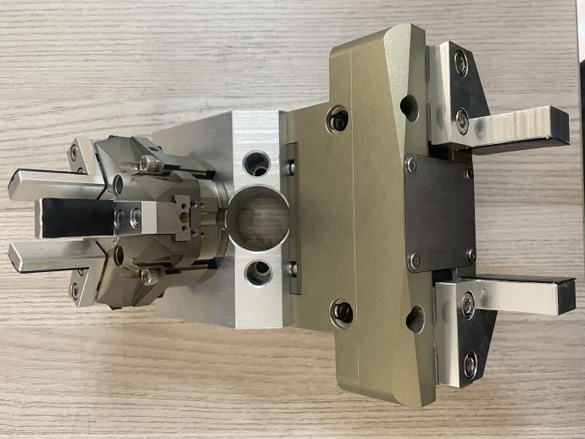
1-1 High strength pneumatic gripper

Pneumatic Claw and Air Circuit Installation

Installation of Pneumatic Claw
Install the pneumatic gripper onto the end of the robot using M6 * 16 hexagonal cylindrical head screws.
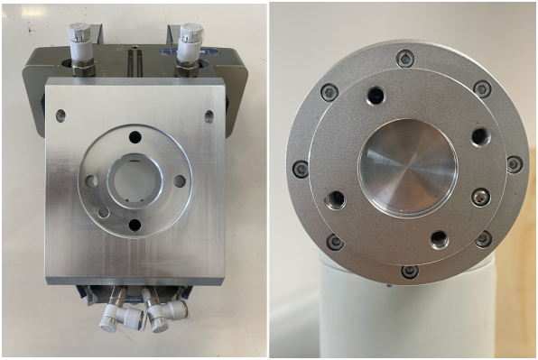
2-1 Install pneumatic gripper

Relay harness connection
Connect the relay harness to the DO port of the robot control box, as shown in Figure 2-2.
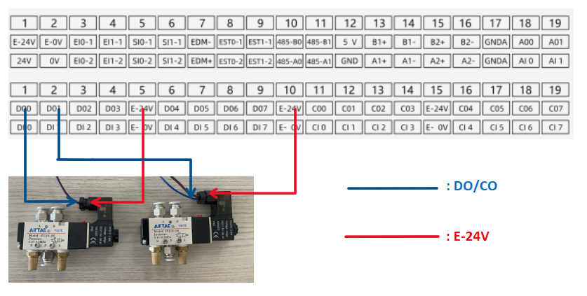
2-2 Relay harness connection

Gas path installation
Connect the air pipe from the two-piece assembly in the CNC workstation to two solenoid valves through a splitter, as shown in Figure 2-3
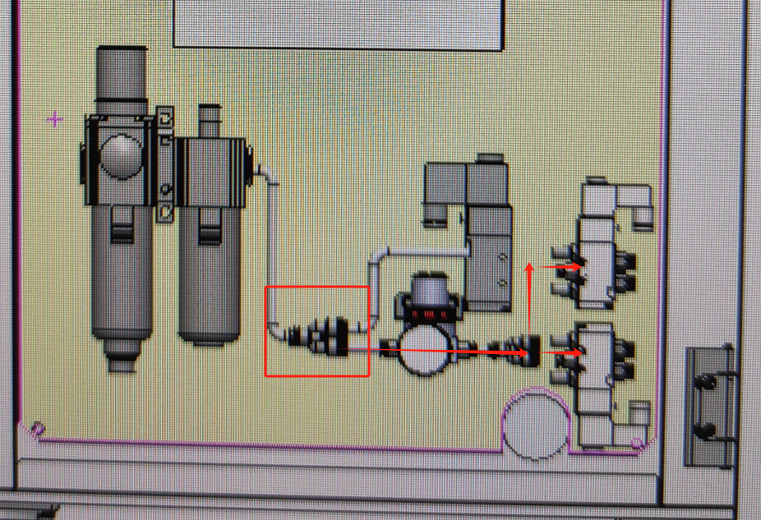
2-3 Diverter air path diversion

Connect the two solenoid valves to the clamp via two separate air paths.
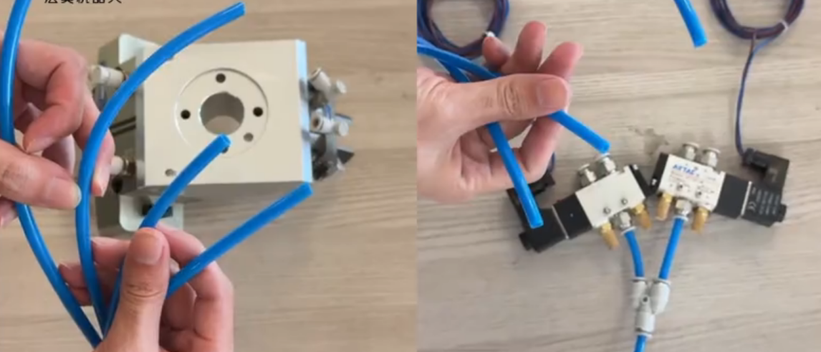
2-4 Tracheal Connection 1

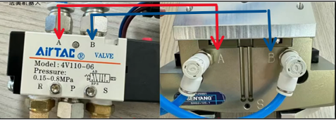
Note that the AB ports of the solenoid valve correspond to the AB ports of the jaws respectively
2-5 Tracheal connection2

Claw Test

Open the gas source, write the robot program, control the DO signal of the control box to test the gripper action.
