**OSPF Topology (Online Exam)**

|  |  |
| --- | --- |
| **Name: Devopriya Tirtho** | **ID: 160204033** |

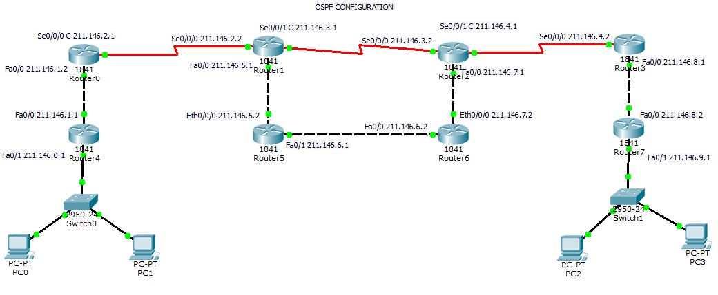

* **Area Should be Zero for all network and OSPF ID is 1 for all network too!!!**
* **Subnet by default Class C [255.255.255.0]**

**Addressing Table**

|  |  |  |  |  |
| --- | --- | --- | --- | --- |
| **Device** | **Interface** | **IP Address** | **Subnet Mask** | **Default Gateway** |
| **Router 0** | **Fa0/0** | **211.146.1.2** | **255.255.255.0** | **N/A** |
|  | **Se2/0** | **211.146.2.1** | **255.255.255.0** | **N/A** |
| **Router 1** | **Fa0/0** | **211.146.5.1** | **255.255.255.0** | **N/A** |
|  | **Se2/0** | **211.146.2.2** | **255.255.255.0** | **N/A** |
|  | **Se3/0** | **211.146.3.1** | **255.255.255.0** | **N/A** |
| **Router 2** | **Fa0/0** | **211.146.7.1** | **255.255.255.0** | **N/A** |
|  | **Se2/0** | **211.146.3.2** | **255.255.255.0** | **N/A** |
|  | **Se3/0** | **211.146.4.1** | **255.255.255.0** | **N/A** |
| **Router 3** | **Fa0/0** | **211.146.8.1** | **255.255.255.0** | **N/A** |
|  | **Se2/0** | **211.146.4.2** | **255.255.255.0** | **N/A** |
| **Router 4** | **Fa0/0** | **211.146.1.1** | **255.255.255.0** | **N/A** |
|  | **Fa1/0** | **211.146.0.1** | **255.255.255.0** | **N/A** |
| **Router 5** | **Fa0/0** | **211.146.5.2** | **255.255.255.0** | **N/A** |
|  | **Fa1/0** | **211.146.6.1** | **255.255.255.0** | **N/A** |
| **Router 6** | **Fa0/0** | **211.146.7.2** | **255.255.255.0** | **N/A** |
|  | **Fa1/0** | **211.146.6.2** | **255.255.255.0** | **N/A** |
| **Router 7** | **Fa0/0** | **211.146.8.2** | **255.255.255.0** | **N/A** |
|  | **Fa1/0** | **211.146.9.1** | **255.255.255.0** | **N/A** |
| **PC 0** | **N/A** | **211.146.0.2** | **255.255.255.0** | **211.146.0.1** |
| **PC 1** | **N/A** | **211.146.0.3** | **255.255.255.0** | **211.146.0.1** |
| **PC 2** | **N/A** | **211.146.9.2** | **255.255.255.0** | **211.146.9.1** |
| **PC 3** | **N/A** | **211.146.9.3** | **255.255.255.0** | **211.146.9.1** |

**Configuration**

|  |  |
| --- | --- |
| **Device** | **Command** |
| **R0** | **Router>enable**  **Router#config t**  **Enter configuration commands, one per line. End with CNTL/Z.**  **Router(config)#router ospf 1**  **Router(config-router)#network 211.146.1.0 0.0.0.255 area 0**  **Router(config-router)#network 211.146.2.0 0.0.0.255 area 0**  **Router(config-router)#exit** |
| **R1** | **Router>enable**  **Router#config t**  **Enter configuration commands, one per line. End with CNTL/Z.**  **Router(config)#router ospf 1**  **Router(config-router)#network 211.146.3.0 0.0.0.255 area 0**  **Router(config-router)#network 211.146.5.0 0.0.0.255 area 0**  **Router(config-router)#network 211.146.2.0 0.0.0.255 area 0**  **Router(config-router)#exit** |
| **R2** | **Router>enable**  **Router#config t**  **Enter configuration commands, one per line. End with CNTL/Z.**  **Router(config)#router ospf 1**  **Router(config-router)#network 211.146.3.0 0.0.0.255 area 0**  **Router(config-router)#network 211.146.7.0 0.0.0.255 area 0**  **Router(config-router)#network 211.146.4.0 0.0.0.255 area 0**  **Router(config-router)#exit** |
| **R3** | **Router>enable**  **Router#config t**  **Enter configuration commands, one per line. End with CNTL/Z.**  **Router(config)#router ospf 1**  **Router(config-router)#network 211.146.4.0 0.0.0.255 area 0**  **Router(config-router)#network 211.146.8.0 0.0.0.255 area 0**  **Router(config-router)#exit** |
| **R4** | **Router>enable**  **Router#config t**  **Enter configuration commands, one per line. End with CNTL/Z.**  **Router(config)#router ospf 1**  **Router(config-router)#network 211.146.1.0 0.0.0.255 area 0**  **Router(config-router)#network 211.146.0.0 0.0.0.255 area 0**  **Router(config-router)#exit** |
| **R5** | **Router>enable**  **Router#config t**  **Enter configuration commands, one per line. End with CNTL/Z.**  **Router(config)#router ospf 1**  **Router(config-router)#network 211.146.6.0 0.0.0.255 area 0**  **Router(config-router)#network 211.146.5.0 0.0.0.255 area 0**  **Router(config-router)#exit** |
| **R6** | **Router>enable**  **Router#config t**  **Enter configuration commands, one per line. End with CNTL/Z.**  **Router(config)#router ospf 1**  **Router(config-router)#network 211.146.6.0 0.0.0.255 area 0**  **Router(config-router)#network 211.146.7.0 0.0.0.255 area 0**  **Router(config-router)#exit** |
| **R7** | **Router>enable**  **Router#config t**  **Enter configuration commands, one per line. End with CNTL/Z.**  **Router(config)#router ospf 1**  **Router(config-router)#network 211.146.9.0 0.0.0.255 area 0**  **Router(config-router)#network 211.146.8.0 0.0.0.255 area 0**  **Router(config-router)#exit** |