<https://qprofiles.my.webex.com/qprofiles.my/j.php?MTID=mfc71232c94ff27b7f908c542aa7c069c>

Steps to install & to deploy Prometheus stack:

1. Open the K8s Master Terminal.
2. Use the ready Helm Chart to deploy Prometheus stack

<https://artifacthub.io/packages/helm/prometheus-community/kube-prometheus-stack>

1. Run below commands

a. helm repo add prometheus-community https://prometheus-community.github.io/helm-charts

b. helm repo update

c. helm install .

1. helm install [RELEASE_NAME] prometheus-community/kube-prometheus-stack

helm install monotoring prometheus-community/kube-prometheus-stack

1. Helm list --- > to confirm the release name, chart version & app Version.



1. kubectl get deploy -🡪 to check all the deployments related to monitoring -graphana

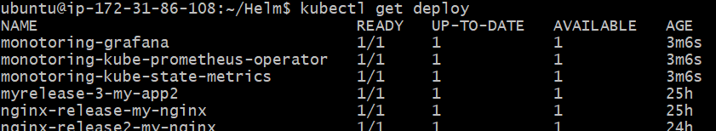

1. Kubectl get svc --🡪 to check the services related to monitoring -graphana

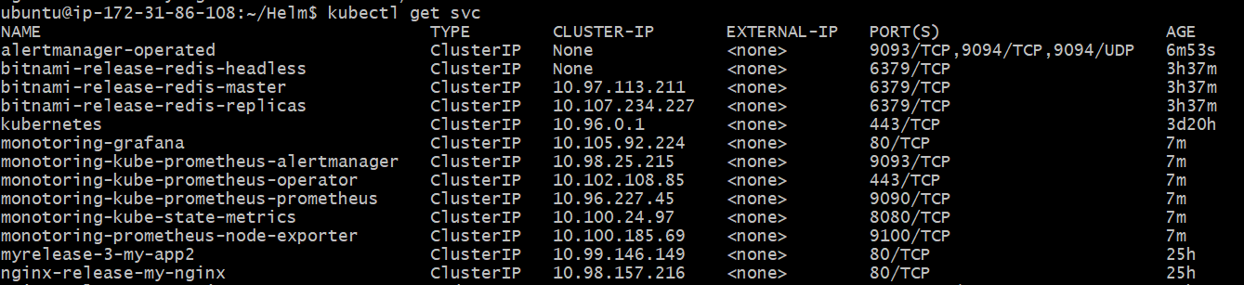

1. kubectl edit svc monotoring-grafana -🡪 to edit the service from clusterIp to NodePort

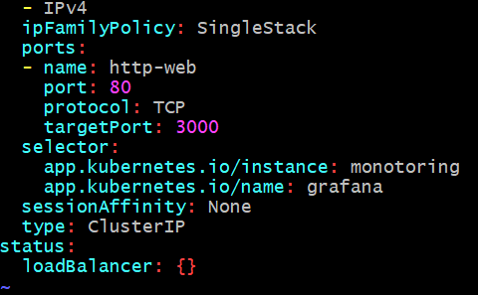 to 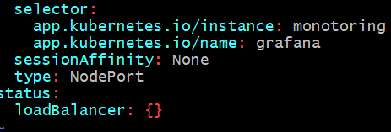

1. Kubectl get svc to the updates from ClusterIP to NodePort

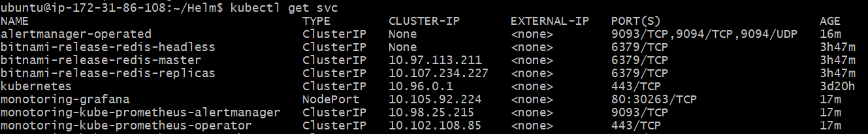

1. Open the browser & type workernodeip:Nodeportmap to get Graphana dash board

[Grafana](http://54.225.4.26:30263/login) 54.225.4.26:30263/login

1. kubectl get secret to get monotoring-grafana secrets
2. kubectl get secret monotoring-grafana -o yaml ---🡪 to get secret
3. Type --🡪 echo "YWRtaW4=" | base64 -d to get decrypted data as **admin**
4. Type --🡪 echo "cHJvbS1vcGVyYXRvcg==" | base64 -d to get decrypted data as **prom-operator**
5. Login to Grafana, go to the dashboard and and Click on Import and enter the ID no

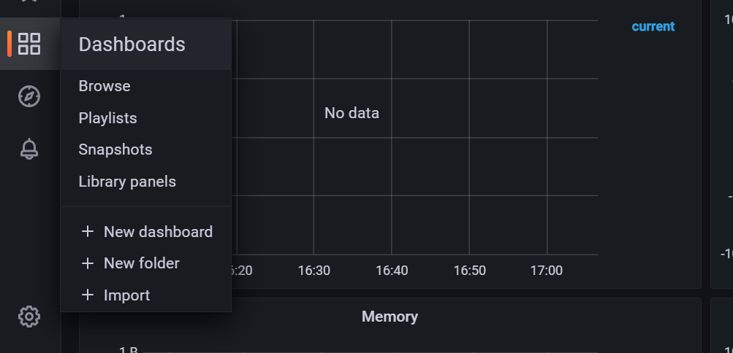

1. Copy ID to clipboard

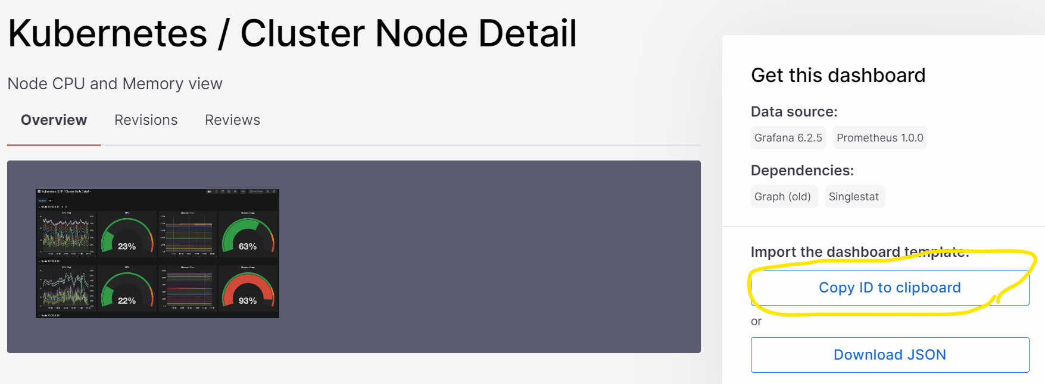

1. Paste it and load it

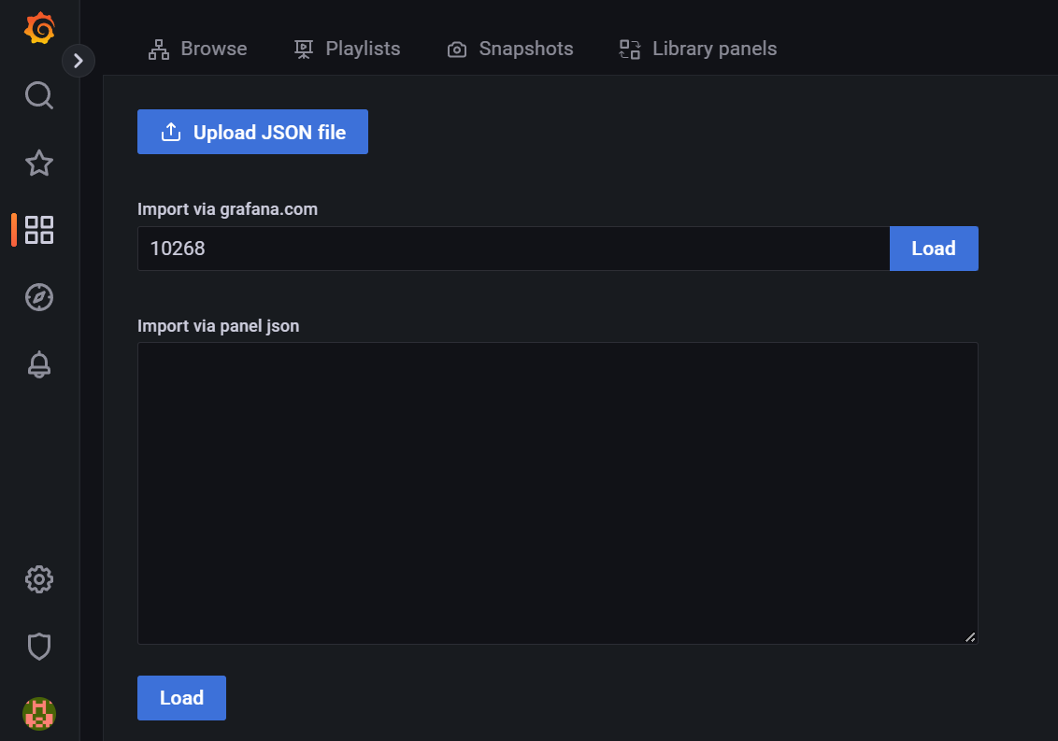

1. Select Prometheus default & run Import .

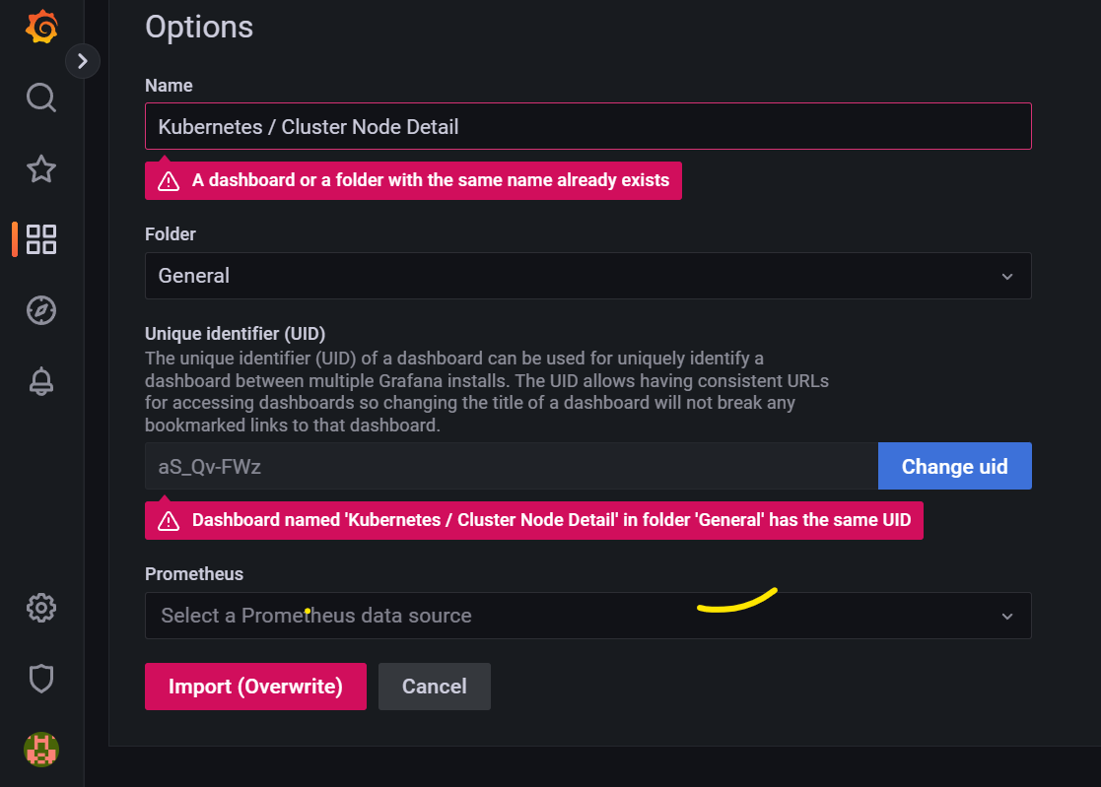

1. Grafana Dash board will be displayed

