# **How to start and stop Ec2 instances using Lambda function**

I have created AMI using Lambda function, also I have automated the process using CloudWatch

Create new policy

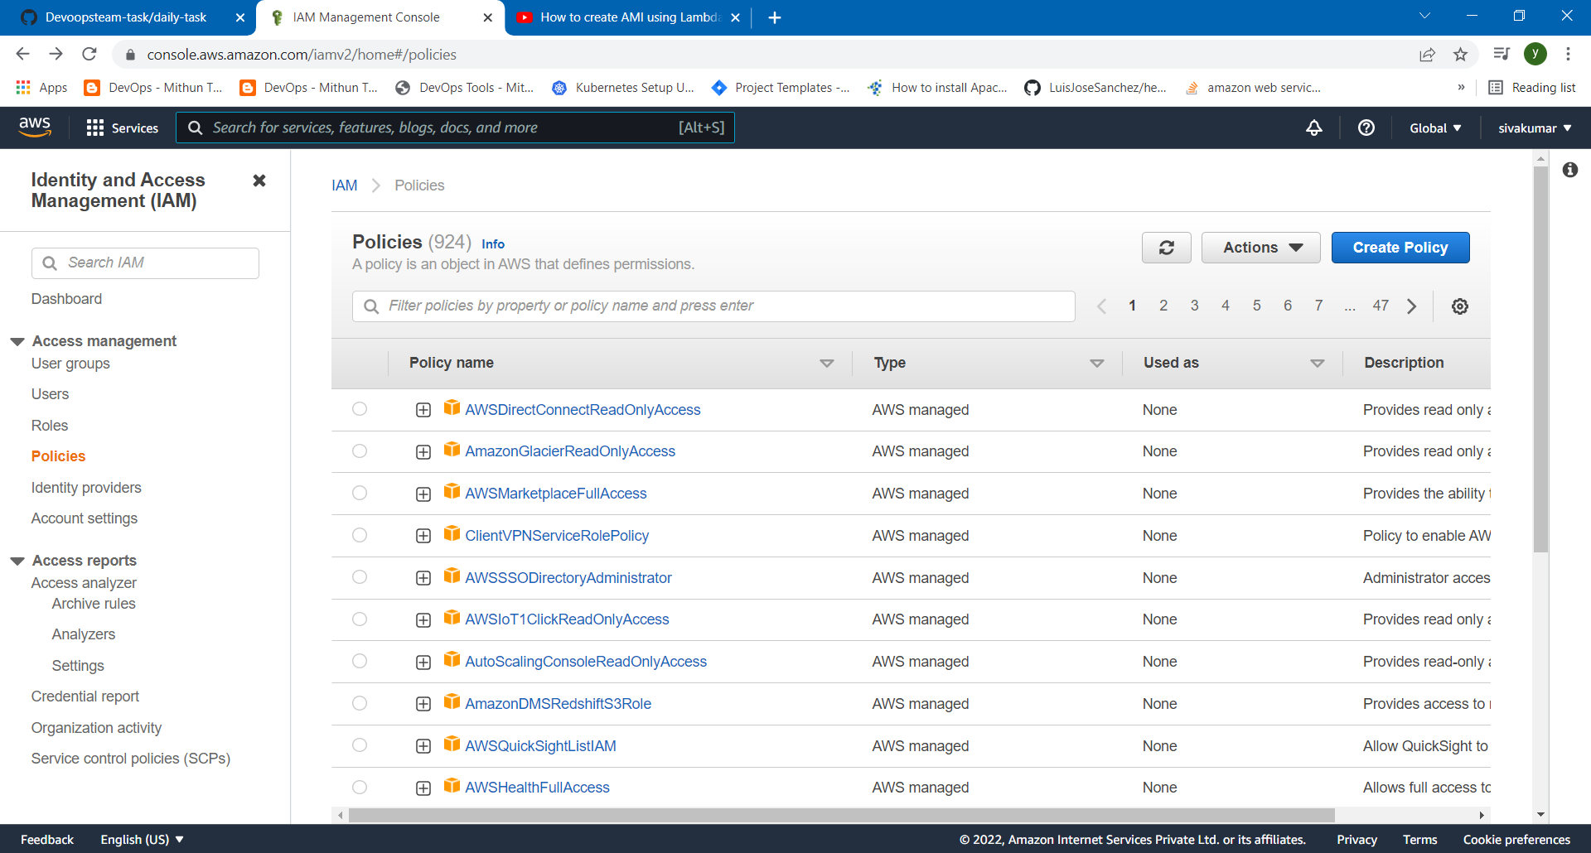

Click the JSON and remove JSON format Enter new formate click next

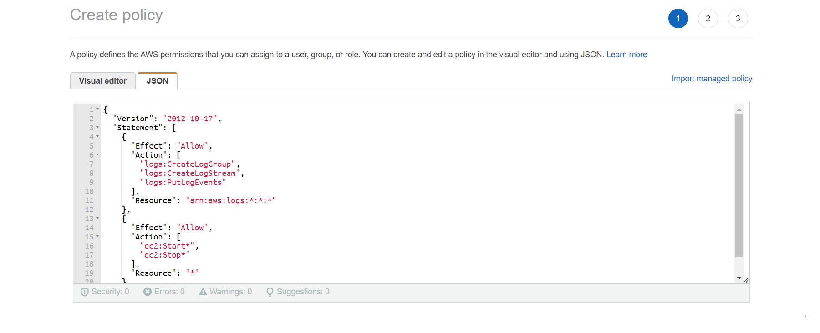

Enter the Policy name and save it

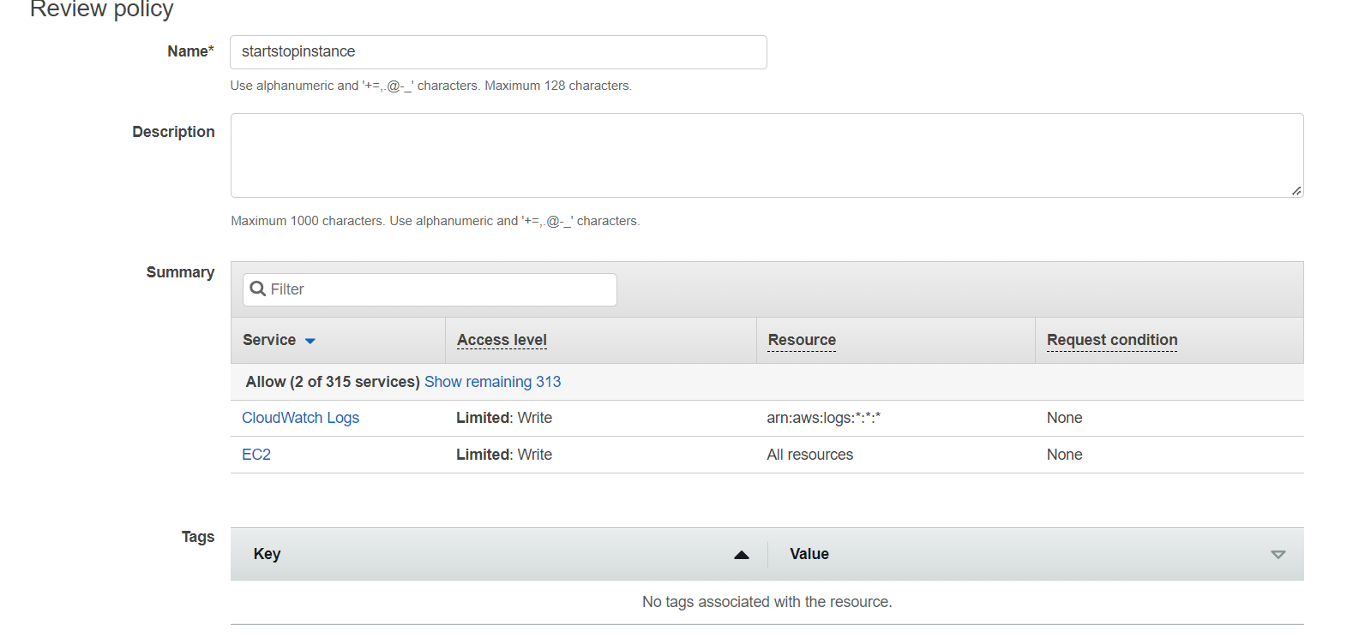

Policy is added

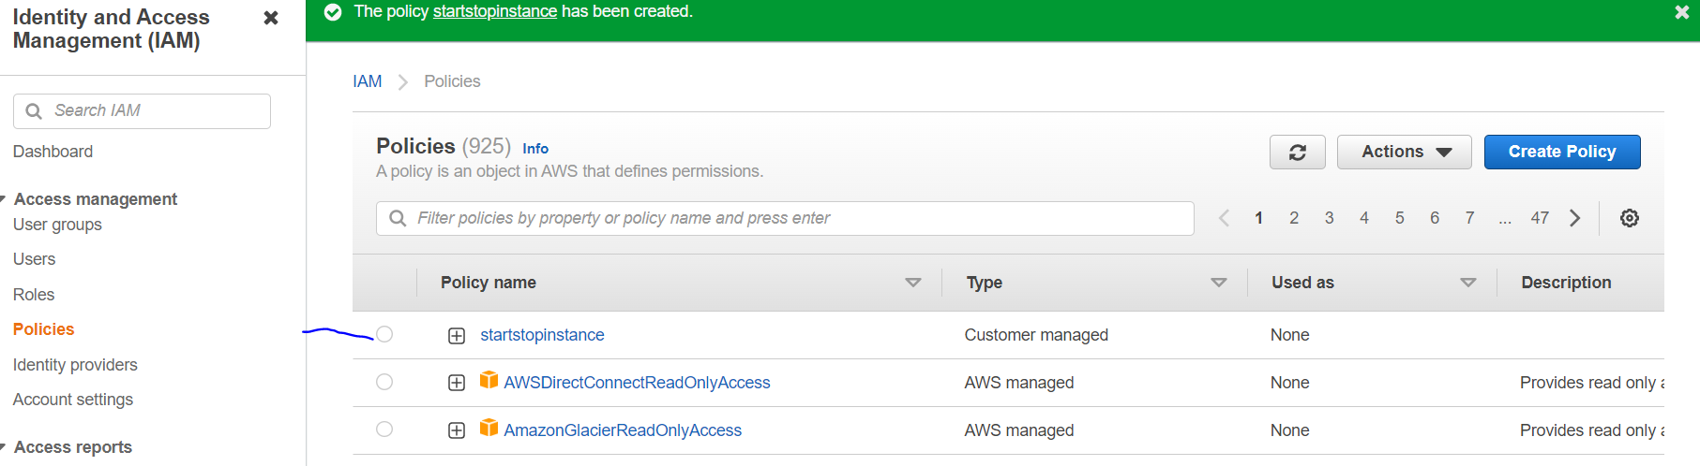

Now I am going to create IAM roles and select the Lambda and click the next

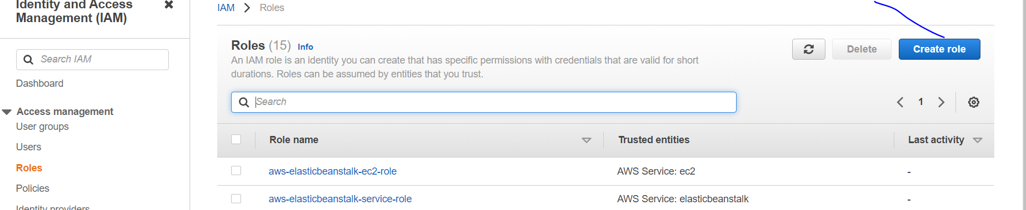

. Select the lambda

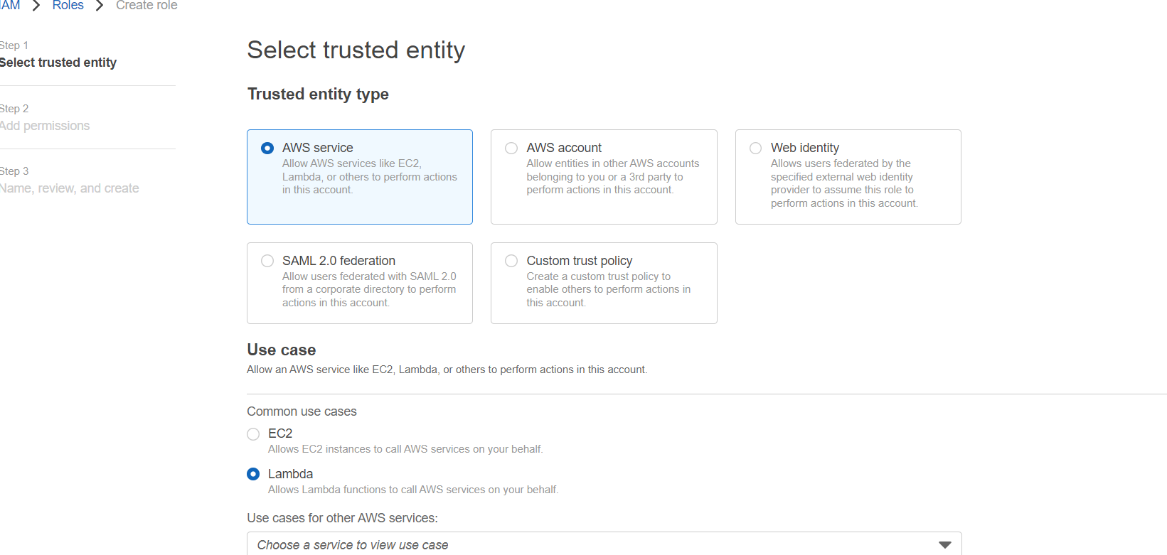

Please select the permissions policies startstopinstance click next

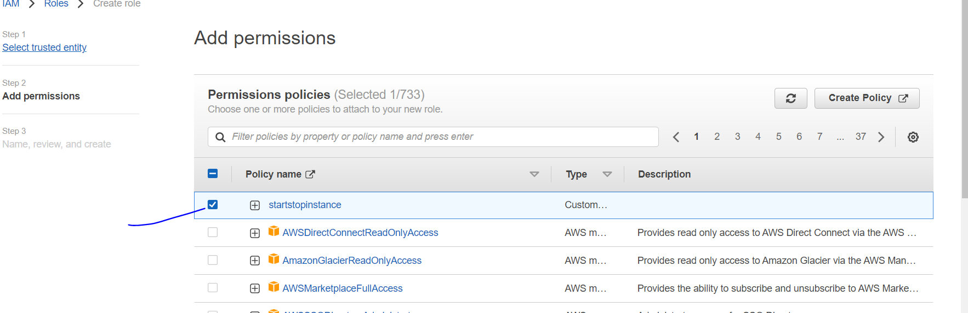

And give the name of the role details click next

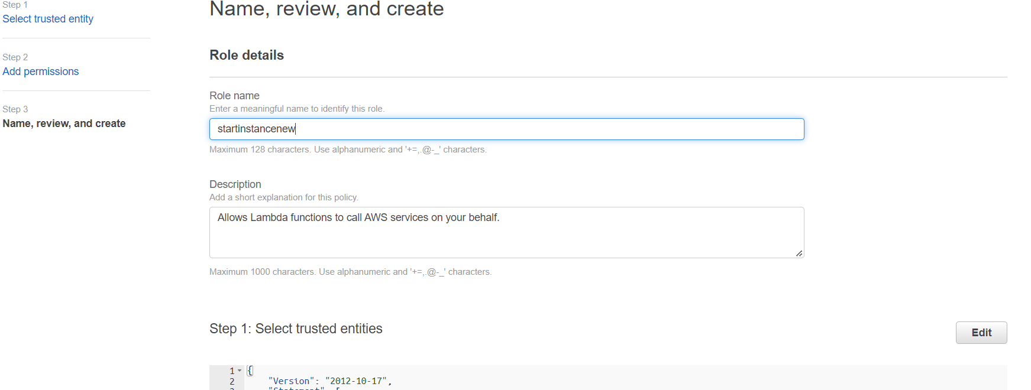

Now my role is created

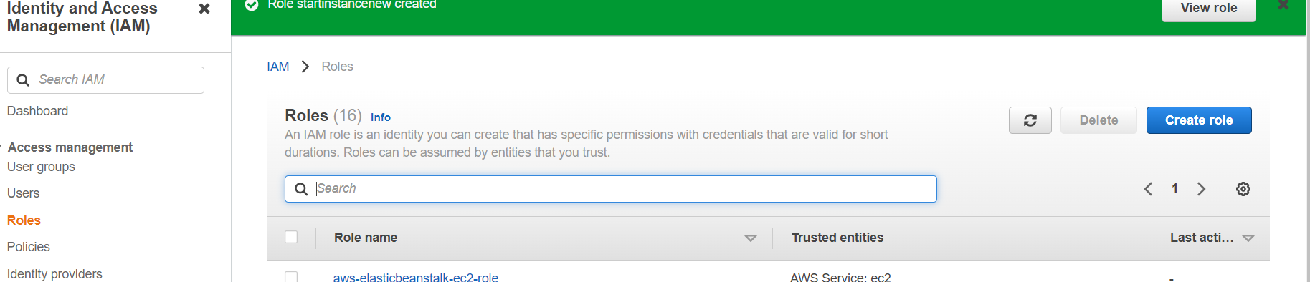

Now I’m going to create lambda service

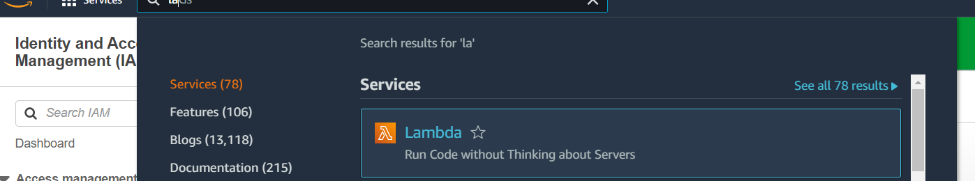

Create lambda functions enter the name and select the python 3.7 here we select the existing role startinstancenew

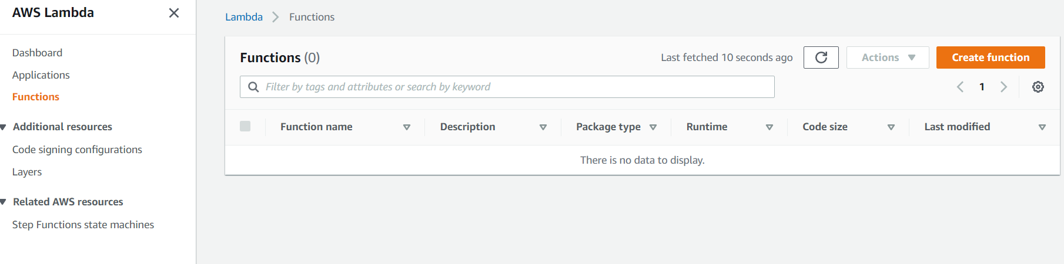

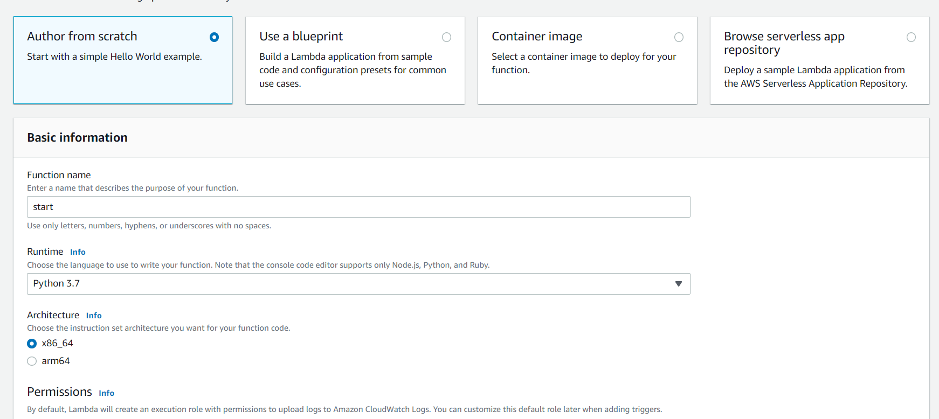

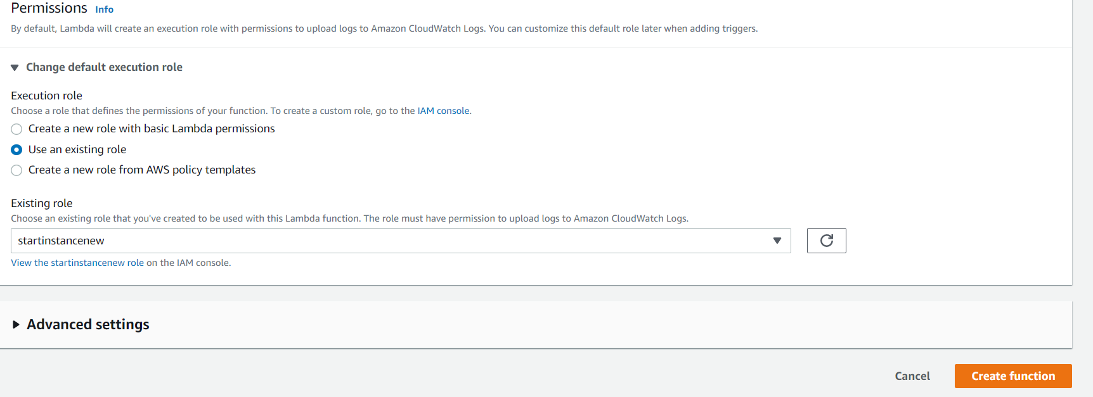

Please remove script

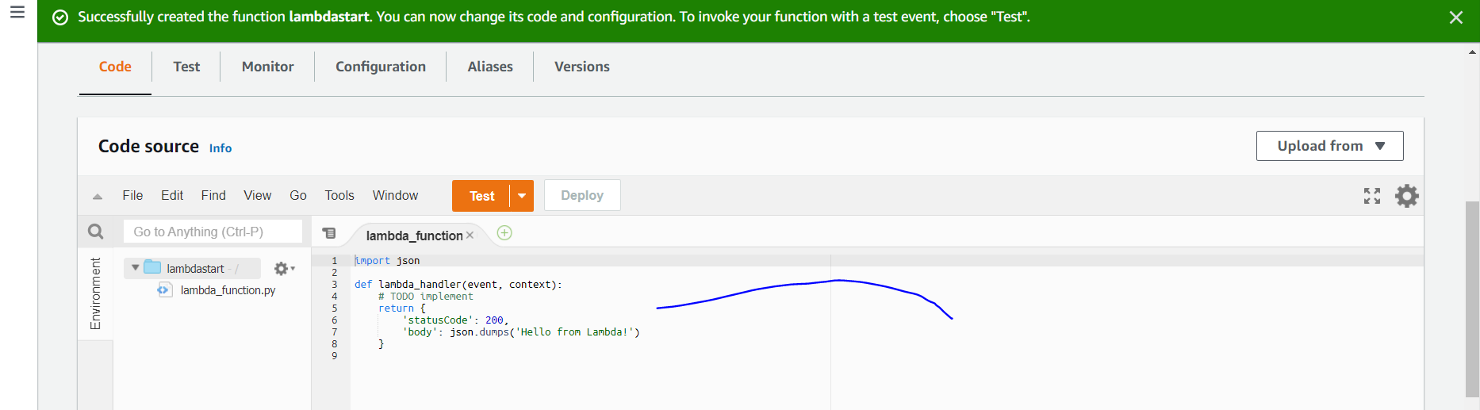

Please go to the ec2 instance

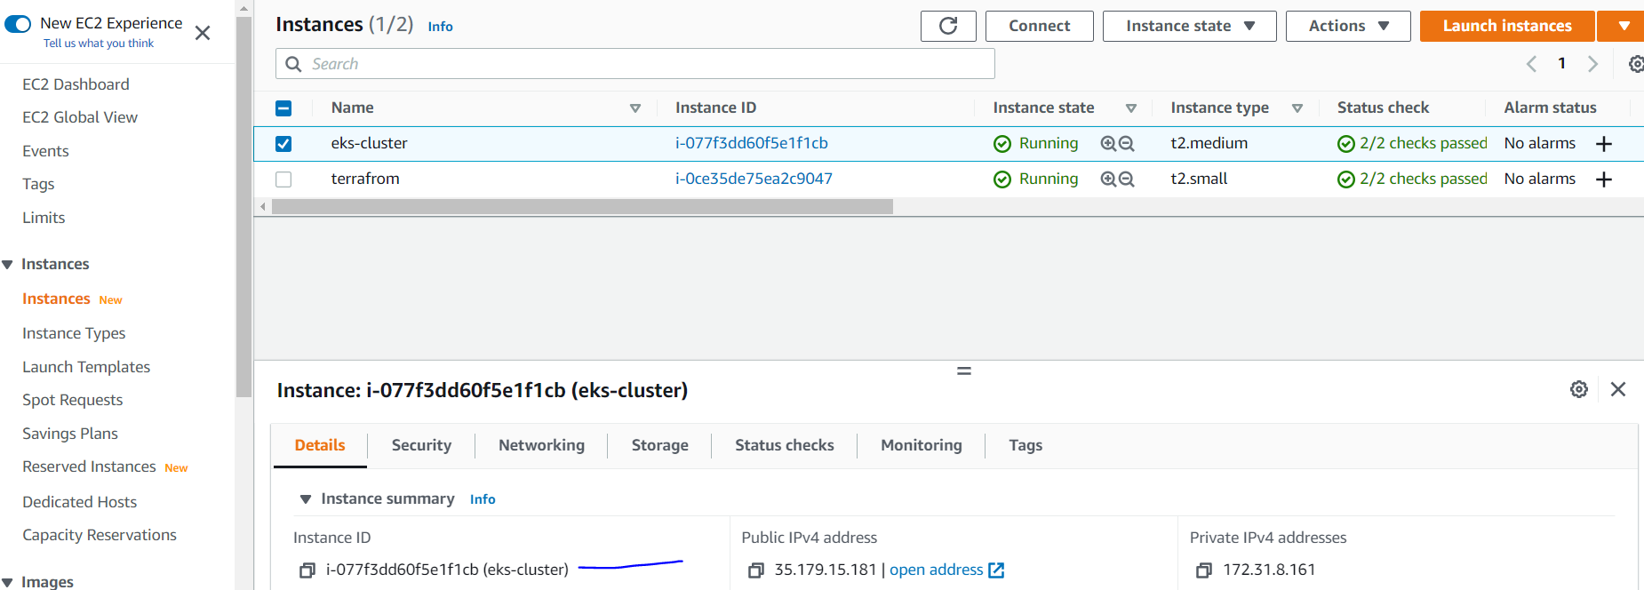

I copy the two ec2 instance id and regions. Go to the script

And paste here both ids and region here and click on deploy after click the test and enter the name and save it. again click the test .

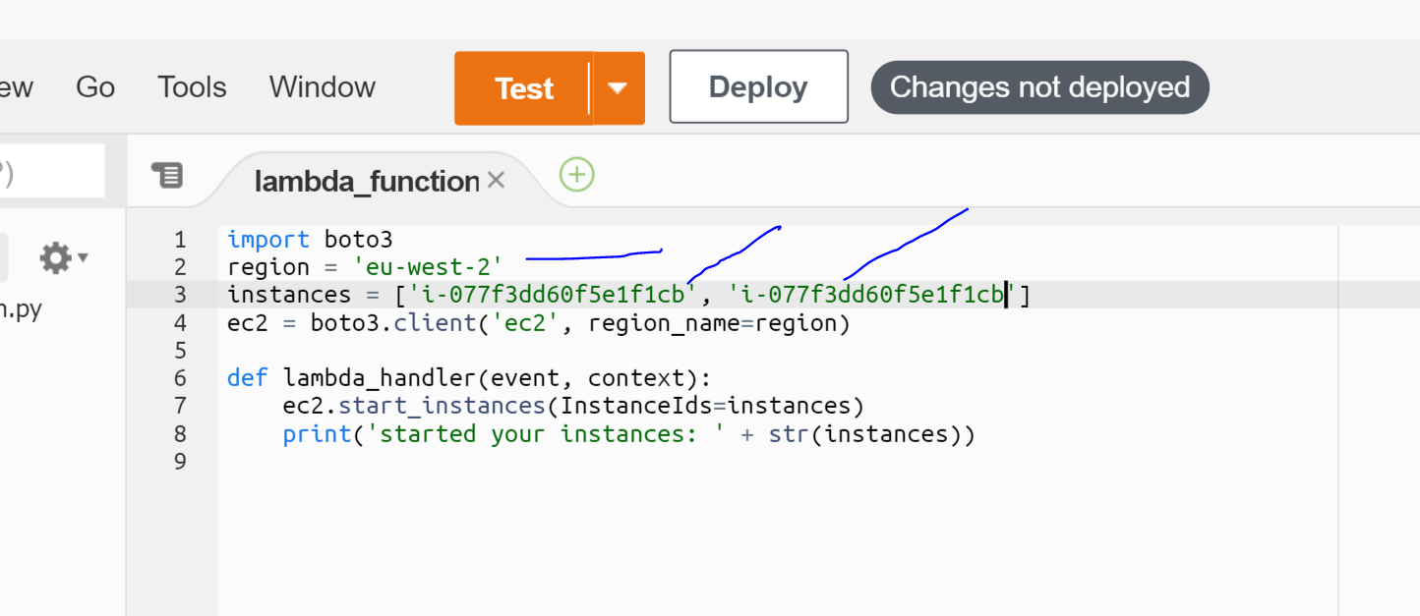

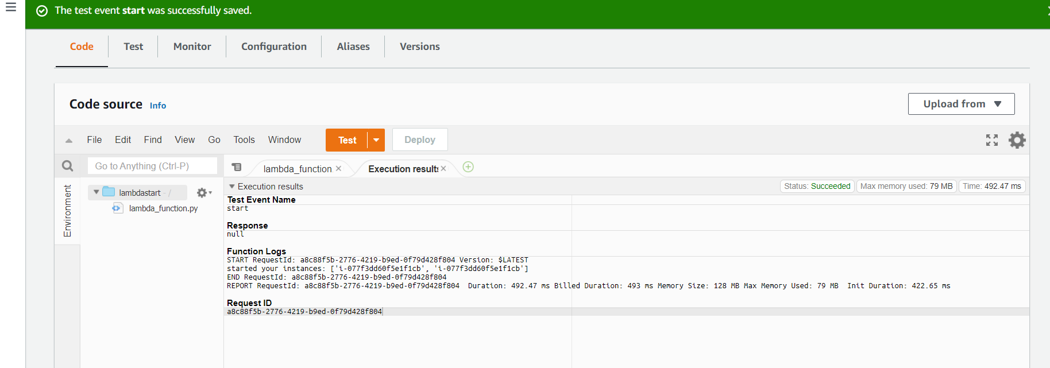

Now I’m going to check my ec2 instance start or not

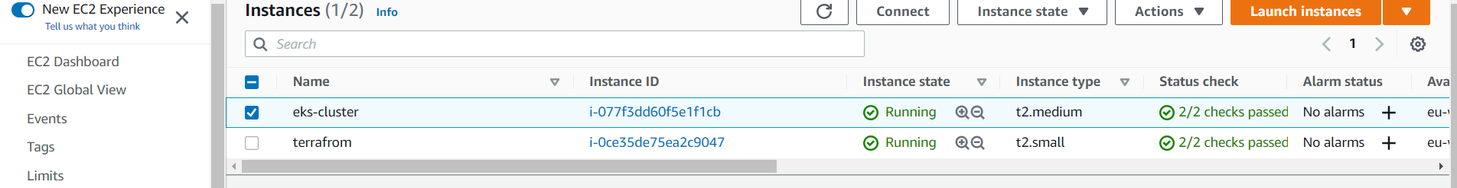

Again I go create stop instance in lambda service.

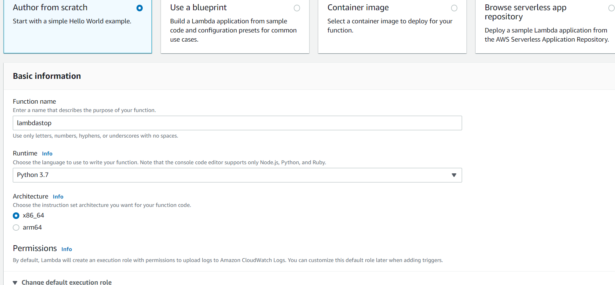

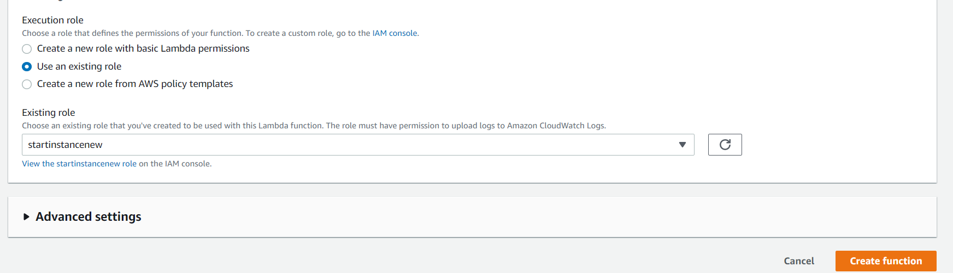

Please remove the script

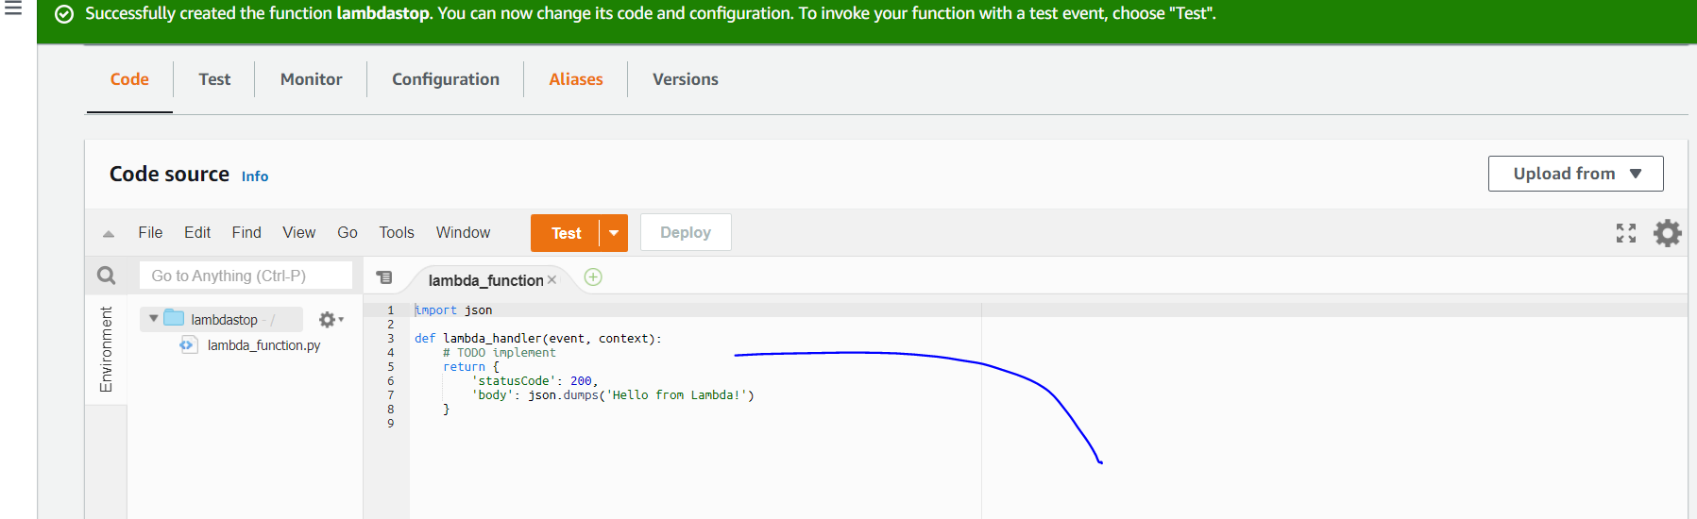

I copy the two ec2 instance id and regions. Go to the script

And paste here both ids and region here and click on deploy after click the test and enter the name and save it. again click the test .

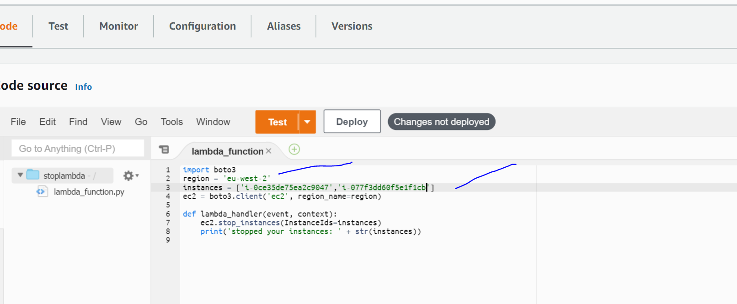

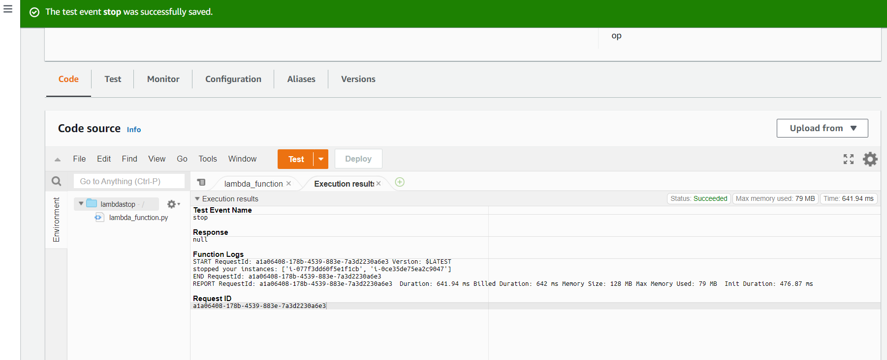

Here automatically system was stoped

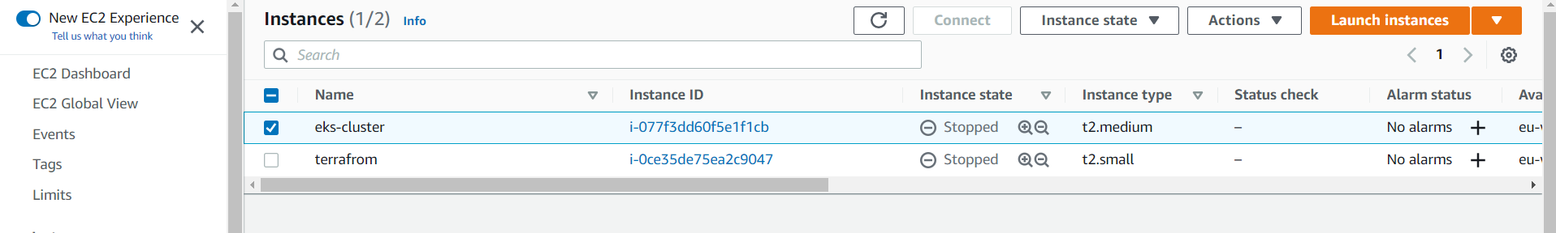

====================================================

Python scripts

jason

{

"Version": "2012-10-17",

"Statement": [

{

"Effect": "Allow",

"Action": [

"logs:CreateLogGroup",

"logs:CreateLogStream",

"logs:PutLogEvents"

],

"Resource": "arn:aws:logs:*:*:*"

},

{

"Effect": "Allow",

"Action": [

"ec2:Start*",

"ec2:Stop*"

],

"Resource": "*"

}

]

}

----------------------------------------------------------------------------------

stop

import boto3

region = 'ap-south-1'

instances = ['i-070ce588ad11318ec']

ec2 = boto3.client('ec2', region_name=region)

def lambda_handler(event, context):

ec2.stop_instances(InstanceIds=instances)

print('stopped your instances: ' + str(instances))

----------------------------------------------------------------------------------

start

import boto3

region = 'ap-south-1'

instances = ['i-12345', 'i-2345']

ec2 = boto3.client('ec2', region_name=region)

def lambda_handler(event, context):

ec2.start_instances(InstanceIds=instances)

print('started your instances: ' + str(instances))

Now I’m going to create cloudwatch

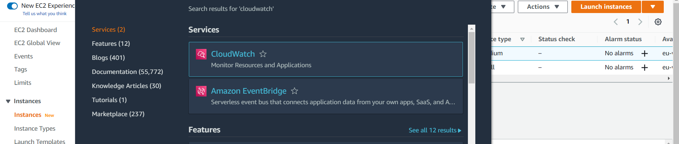

Click Rules

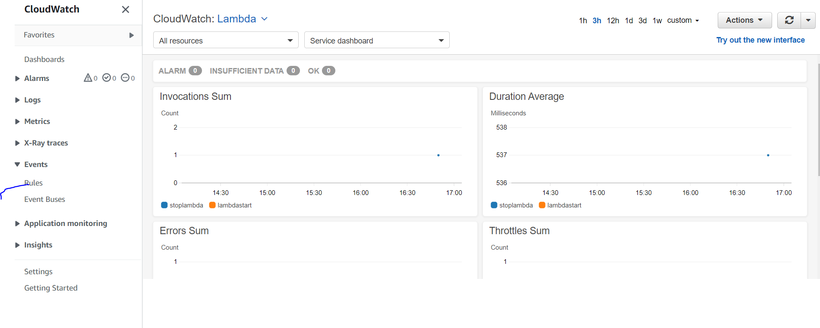

Click Back cloudwatch Events

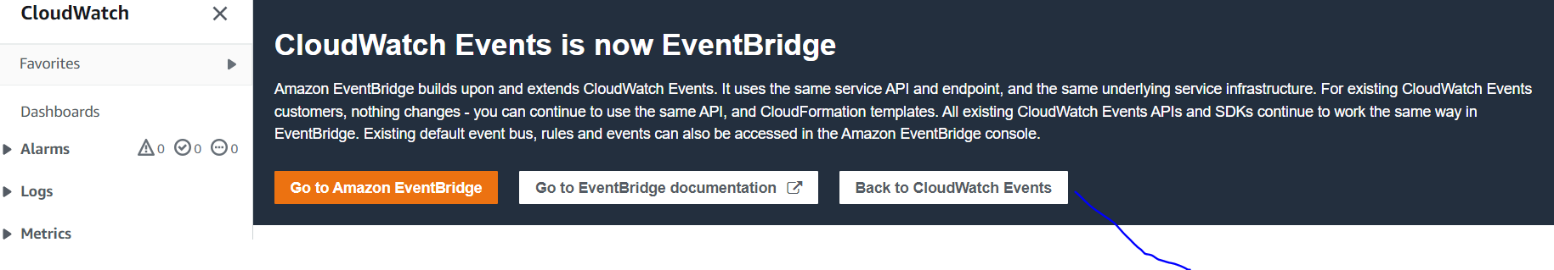

Create rule

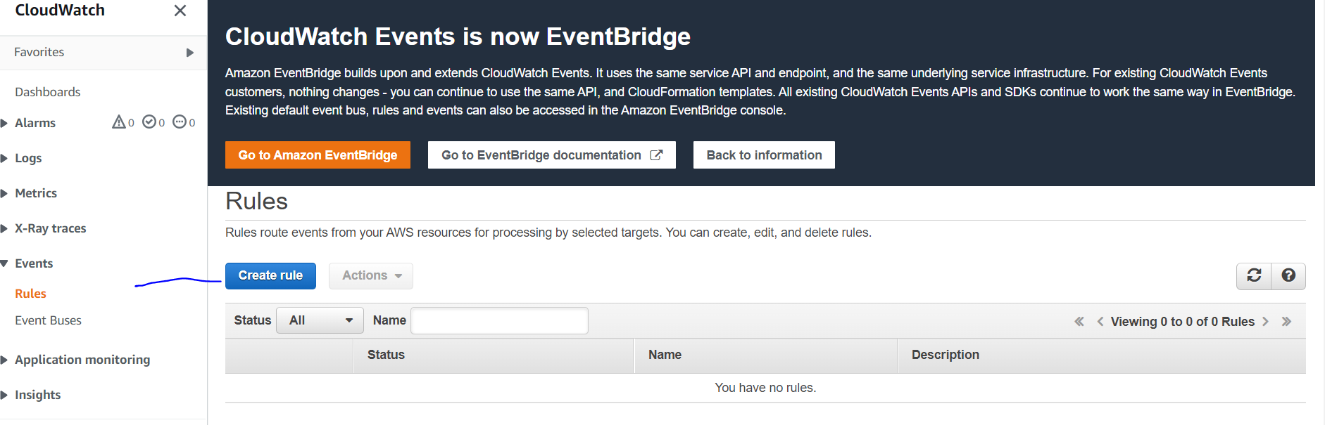

Here we select the schedule click the cron expression and click left side add target it will display select the lambda function

And select the lambdstart and save it.

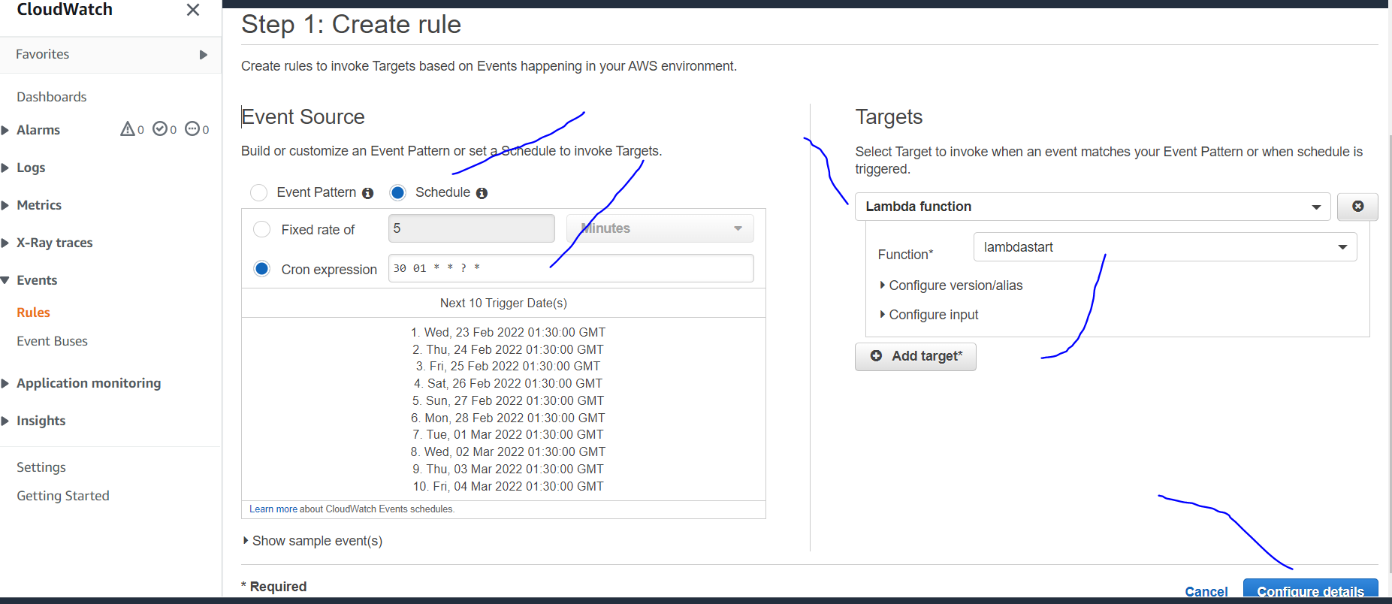

Here we giving the name and description

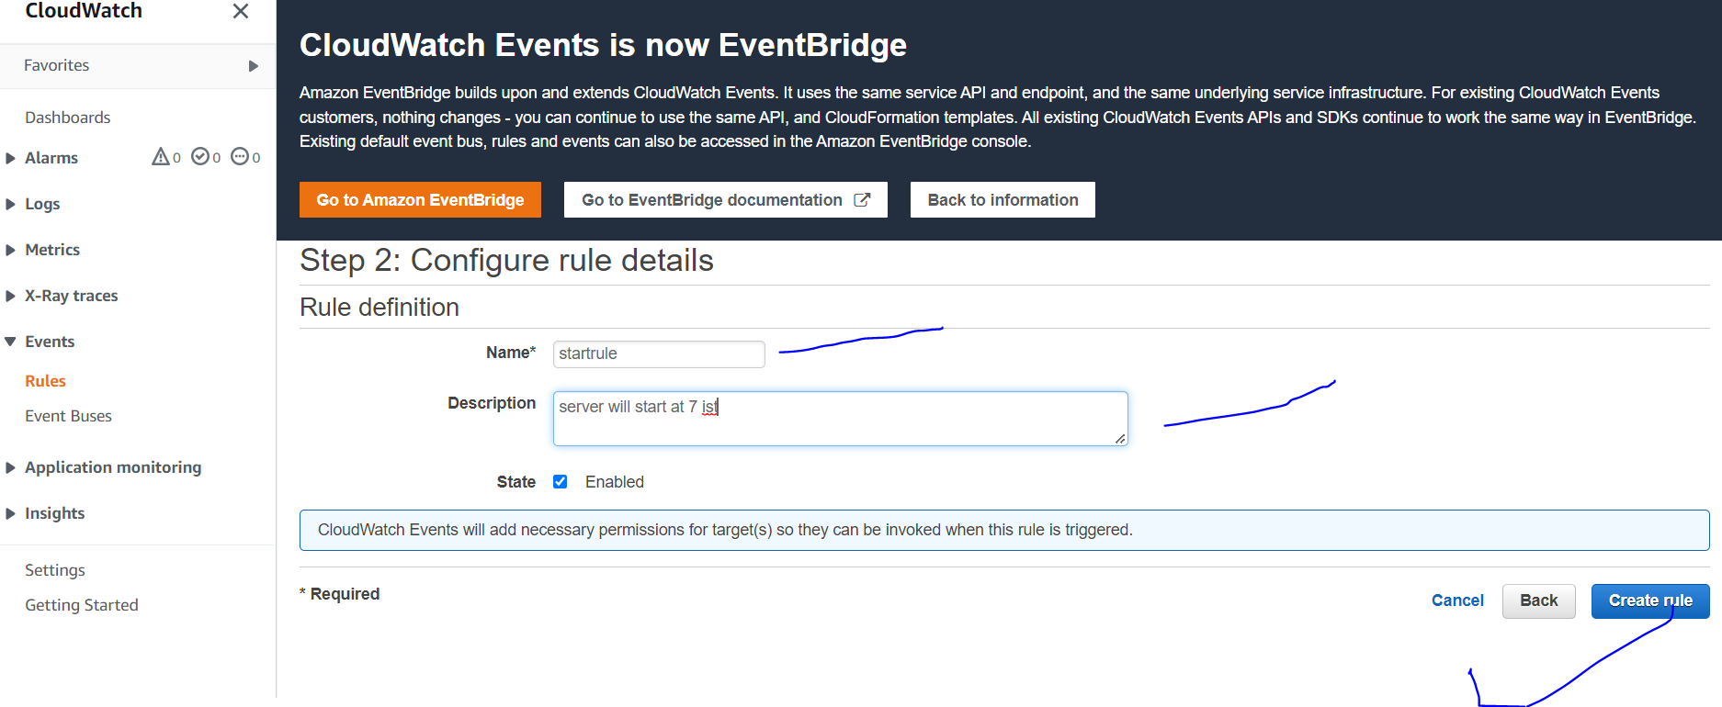

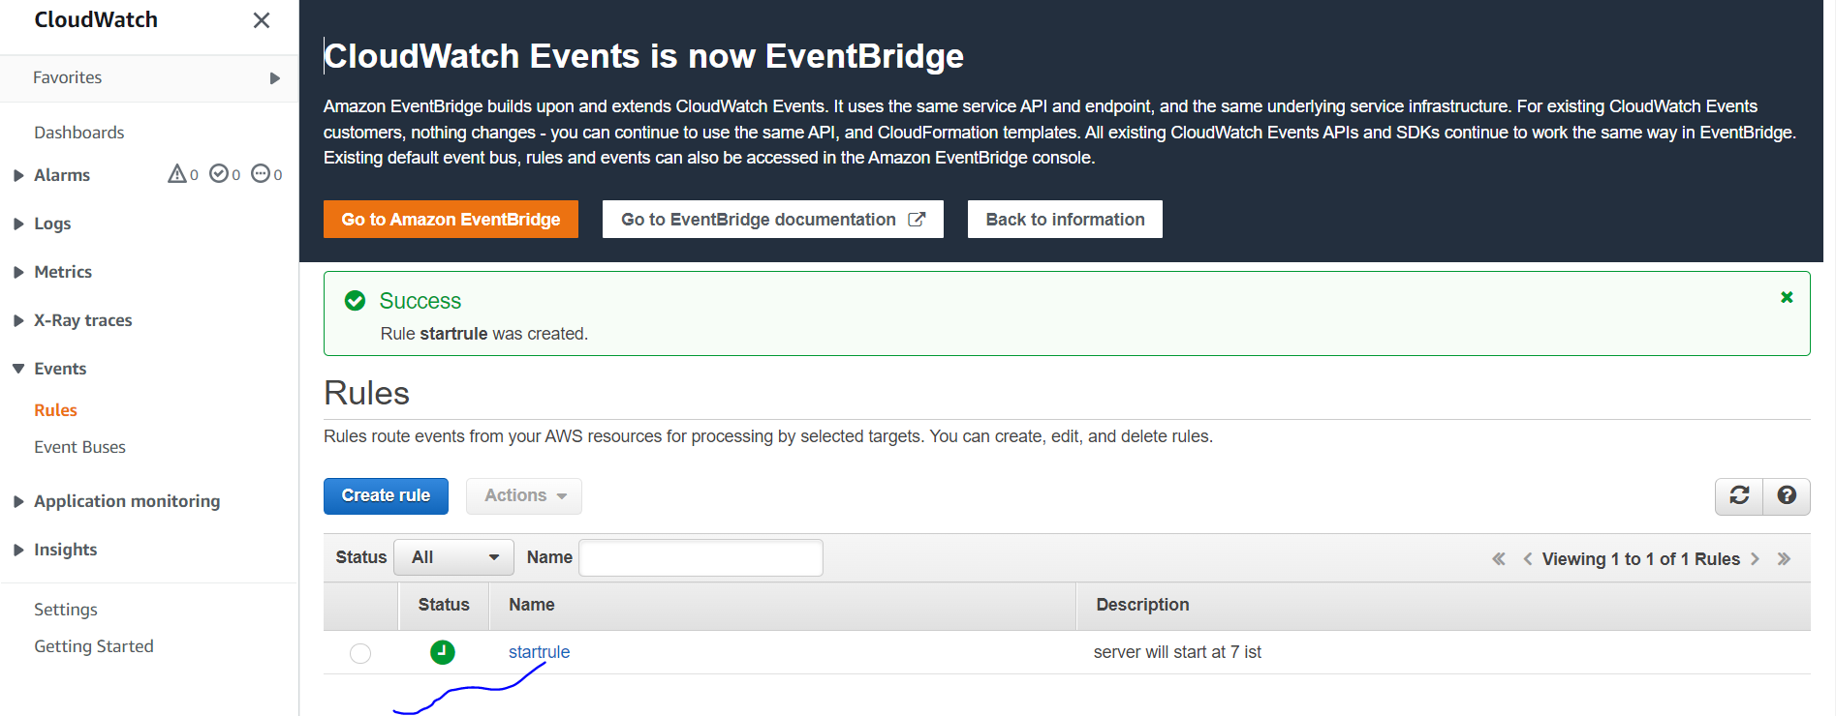

Now again we creating stop rule click on create rule.

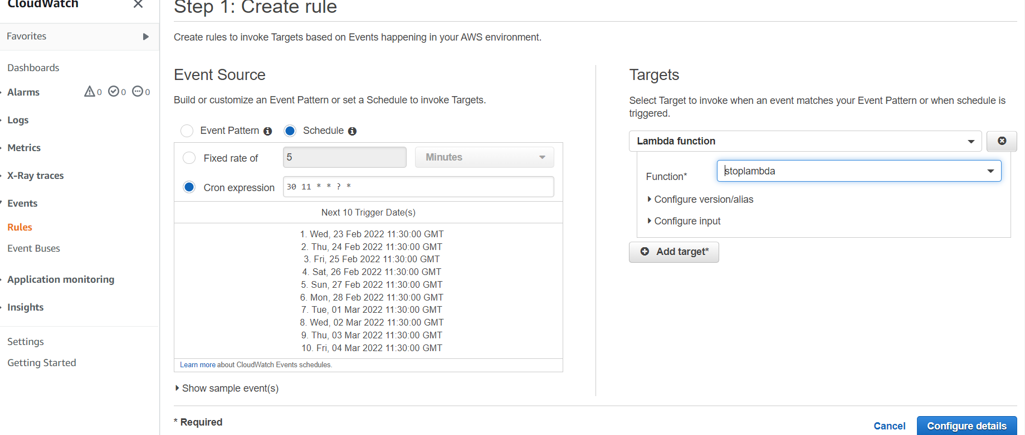

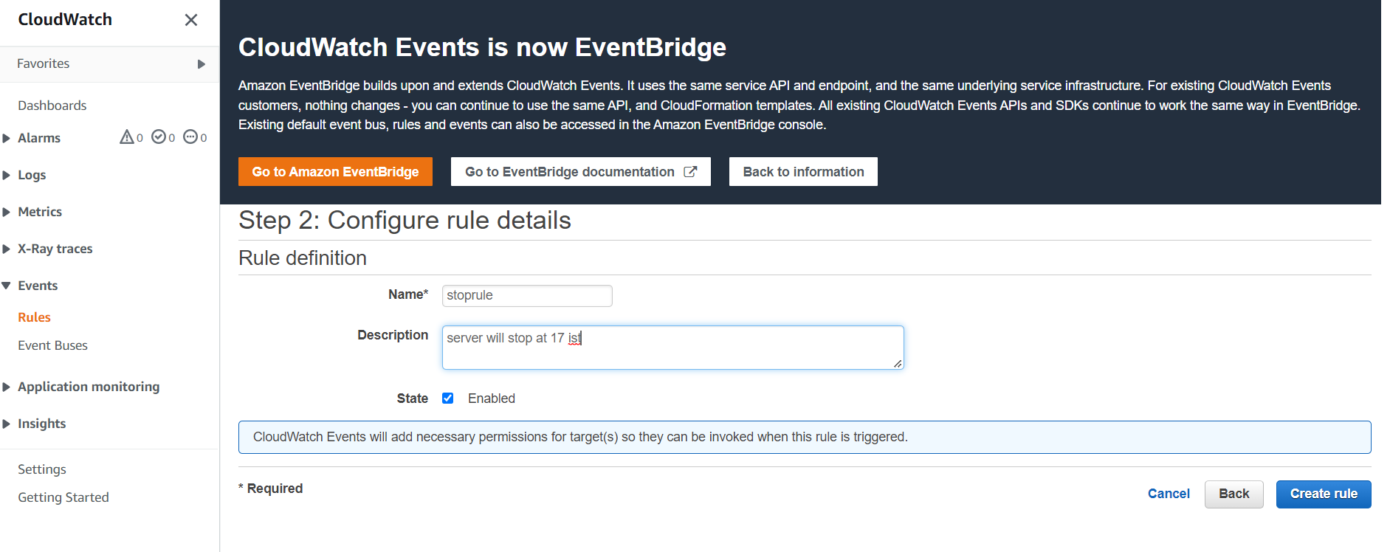

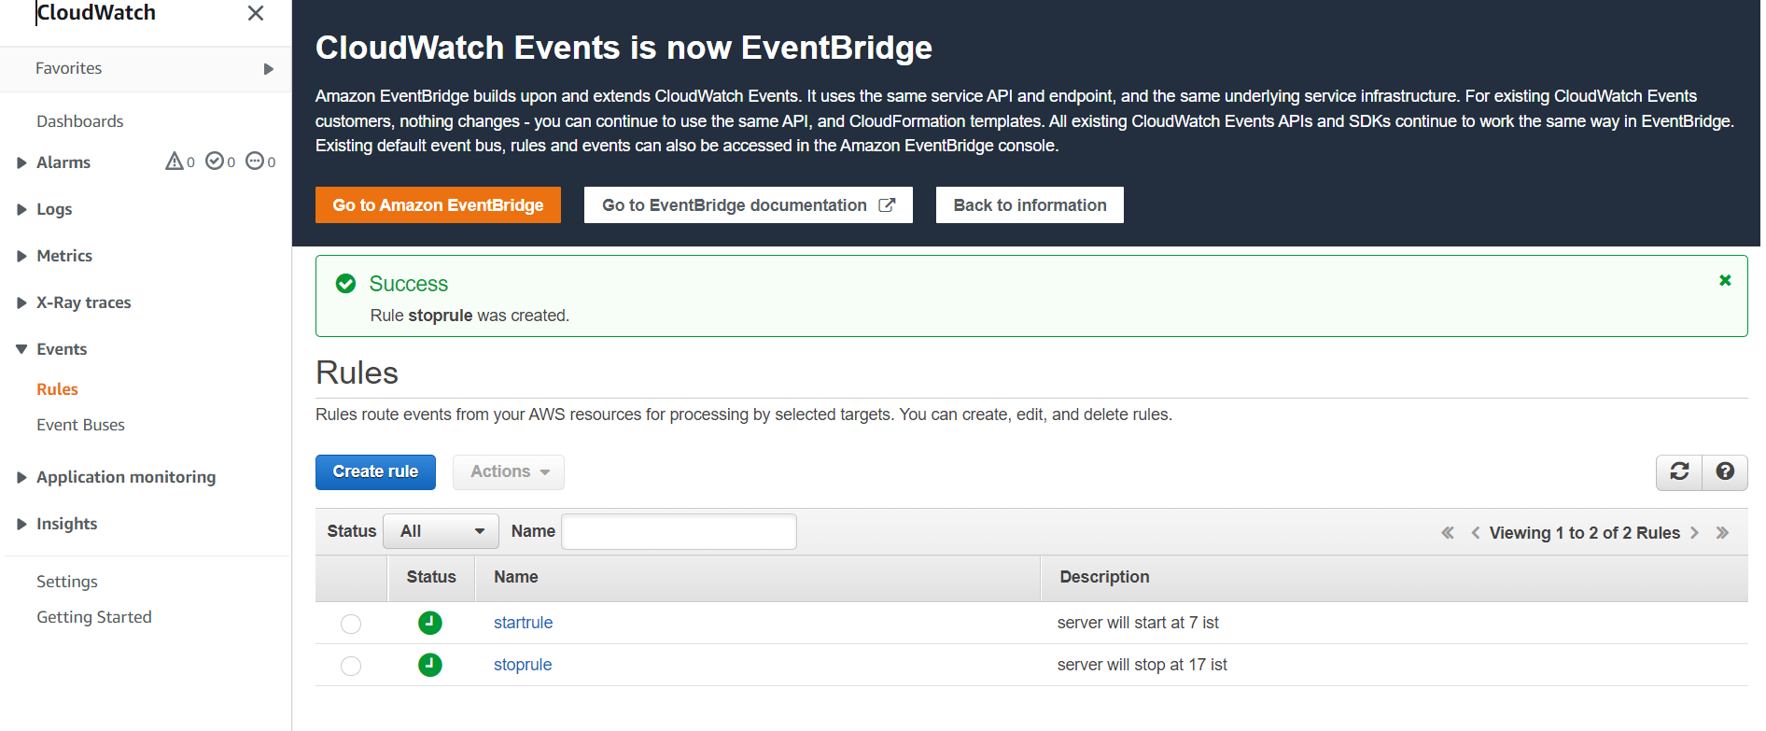

This way lambda creating the ec2 machine we start or stop