Project 1 Library Solution

Scenario

A library has a large CD collection which it needs to catalogue. It needs to store information in a database and have a web front end. You will need to design, implement and deploy part of the system.

The objective of this project is to produce a web application which implements the catalogue. The information required for each CD is:

* Title
* Artist(s)
* Year of release
* Number of tracks
* Total playing time

Each CD will also have a list of tracks containing the following information:

* Title
* Author(s)
* Playing time

The tools and technologies used are:

* Java 8
* JUnit
* Hibernate
* Docker
* MySQL
* Tomcat

Solution

This solution uses MySQL Docker reference from capstone lab-1 project.

Deliverables

* The deliverables are:
* The data manager Java file
* The library controller Java file
* The JSP which displays the CD list
* A screen shot of the web page showing the list of CDs
* A screen shot of Jenkins web page to build, the project
* A screen shot of Jenkins to run unit test cases
* A screen shot of Jenkins to deploy the Library project in Tomcat

Database Setup

1. Create a data volume

docker volume create --name cd_library_data

1. Launch MySQL server in a container using file runServer.

./runServer

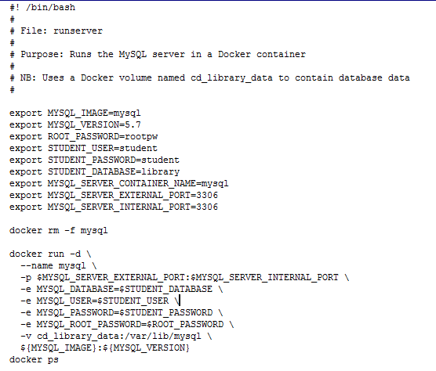

1. Write an SQL script called sql/library.sql which will create table and insert data.



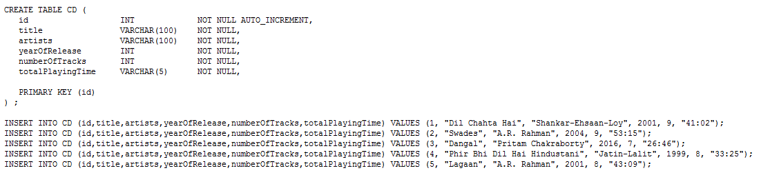

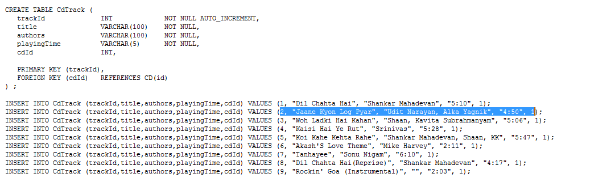

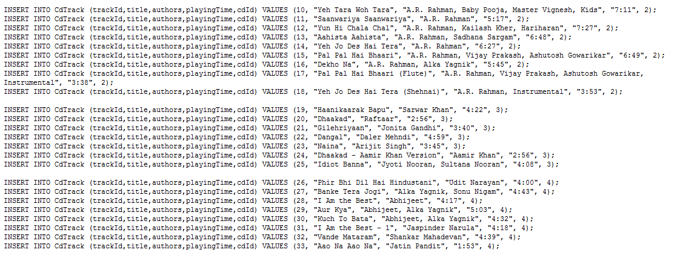

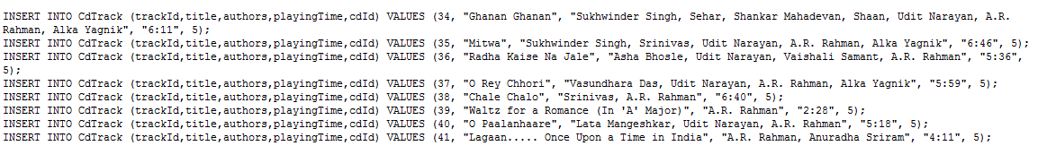

1. Run the runclient script to start a client container



1. Connect to the database and load SQL script

mysql –h 172.17.0.2 –u student -p library

1. Verify tables are created with data

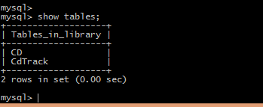

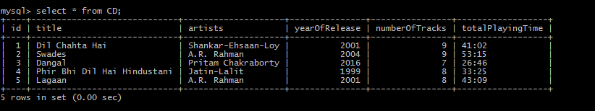

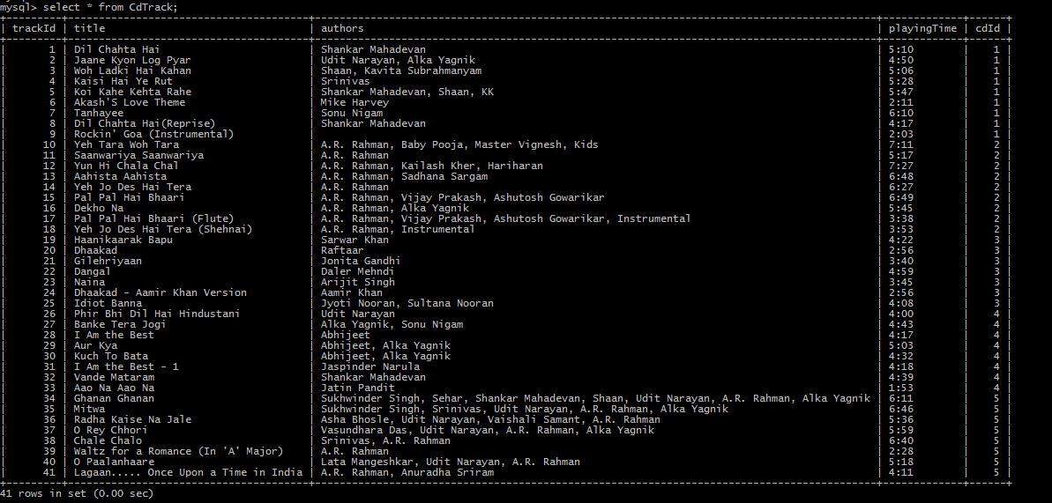

Project Code

The code base is developed using java spring MVC framework. IDE used is eclipse.

The source code is available on GitHub - <https://github.com/DevopsProject1/CdLibraryMgmt>

1. POJO classes: CD.java

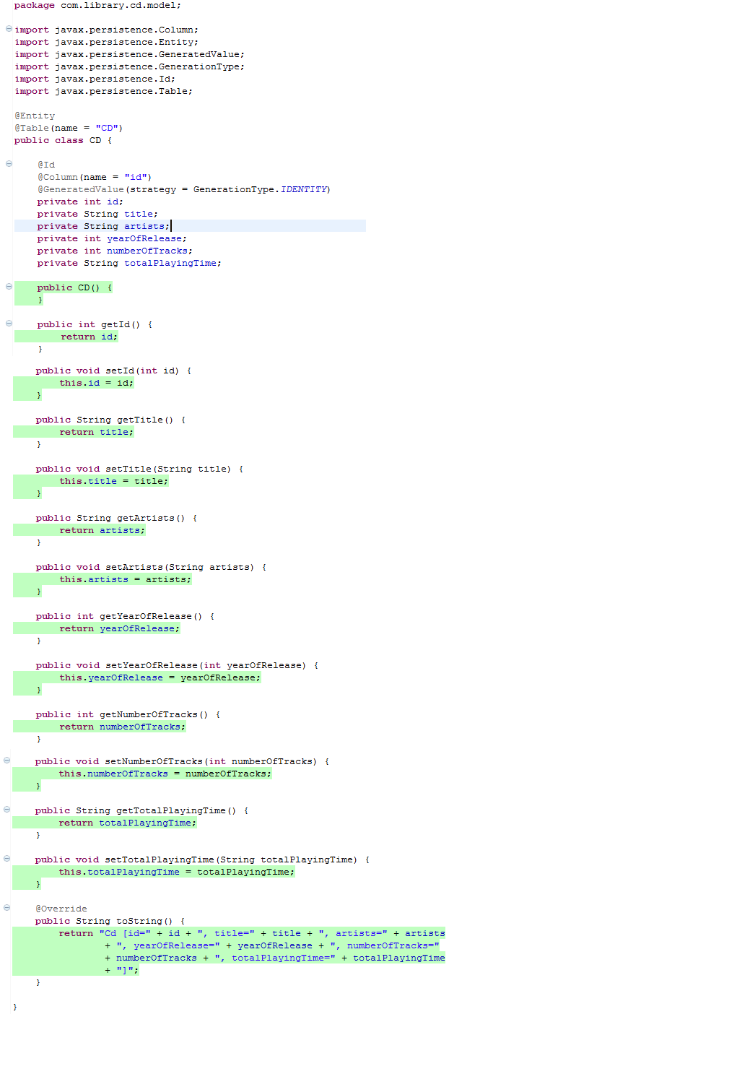

CdTrack.java

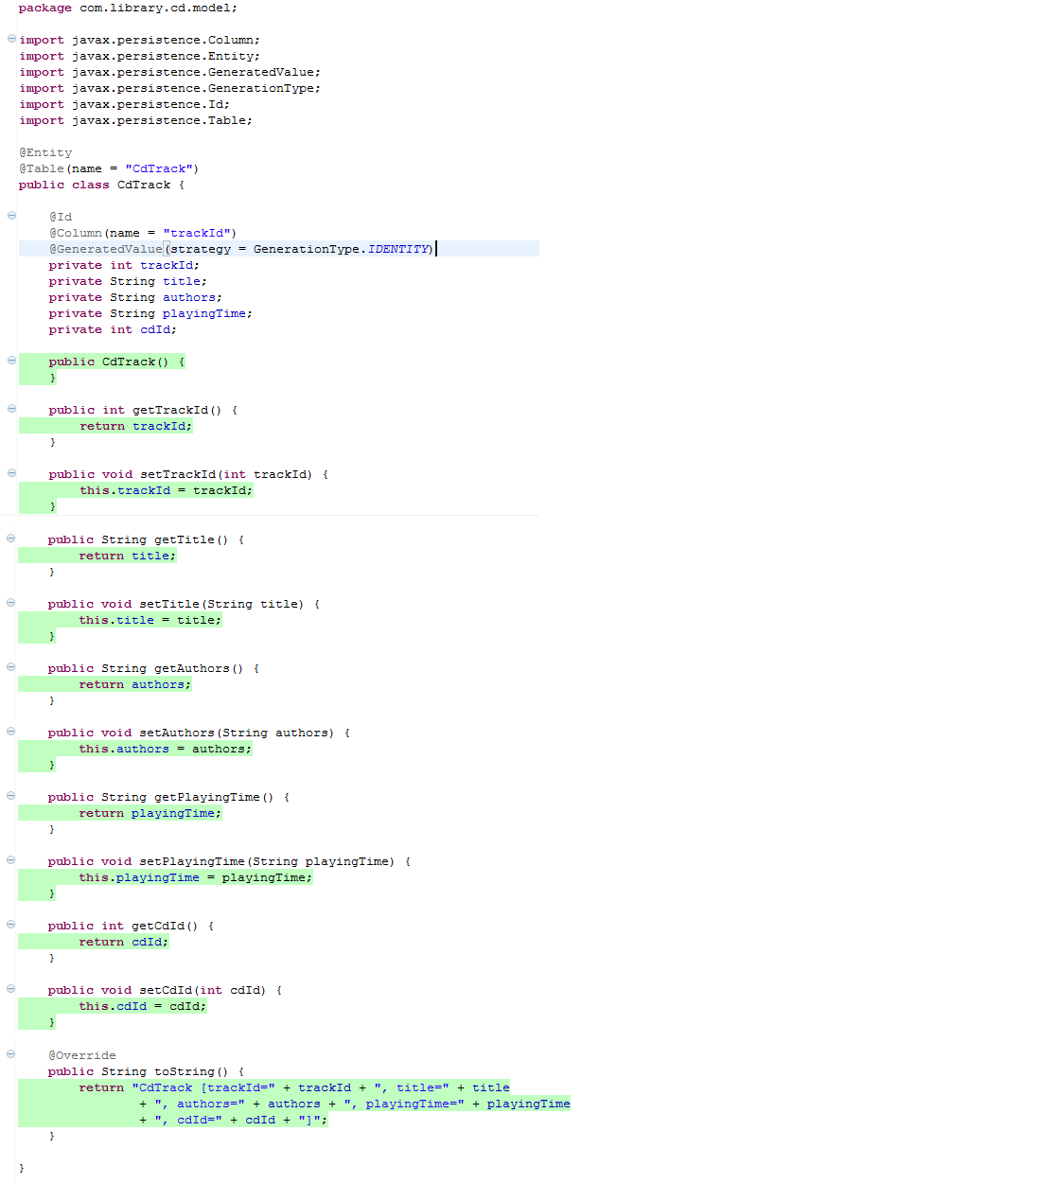

1. DAO classes:

CdDAO.java

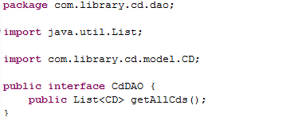

CdDAOImpl.java

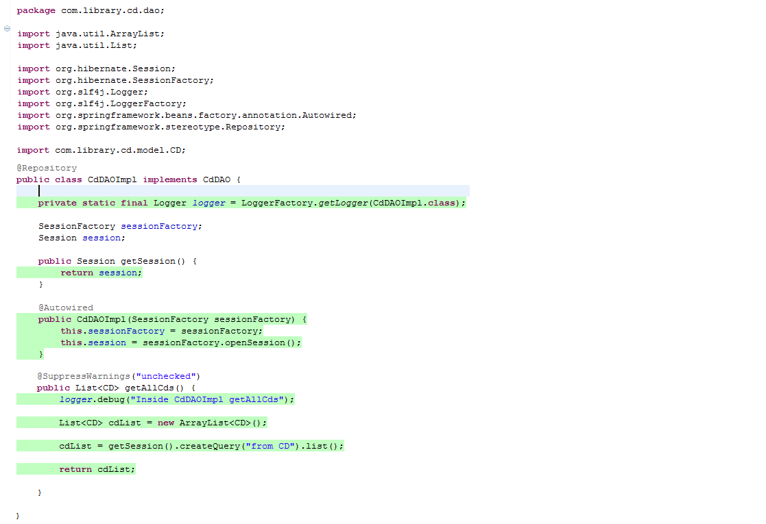

CdTrackDAO.java

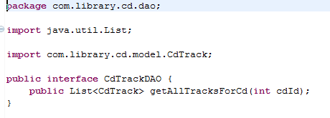

CdTrackDAOImpl.java

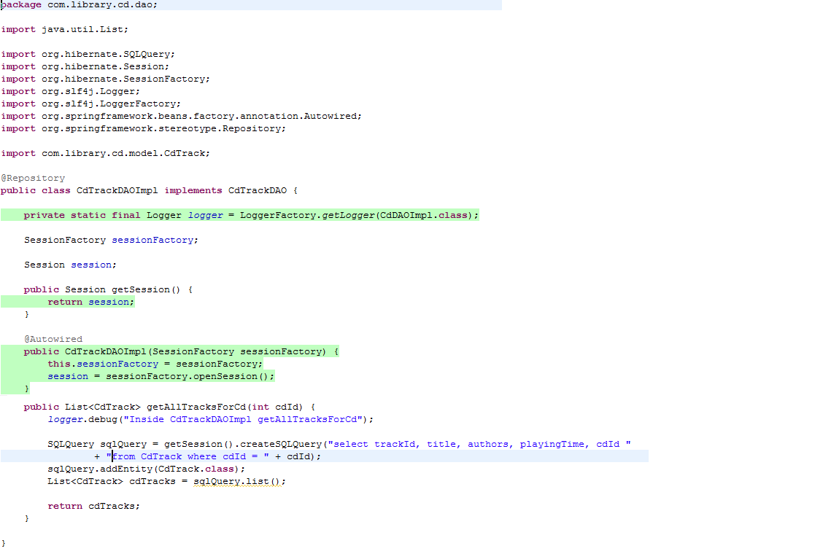

1. Service/Manager classes:

CdLibraryManager.java

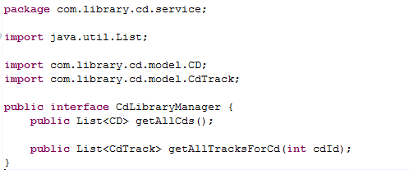

CdLibraryManagerImpl.java

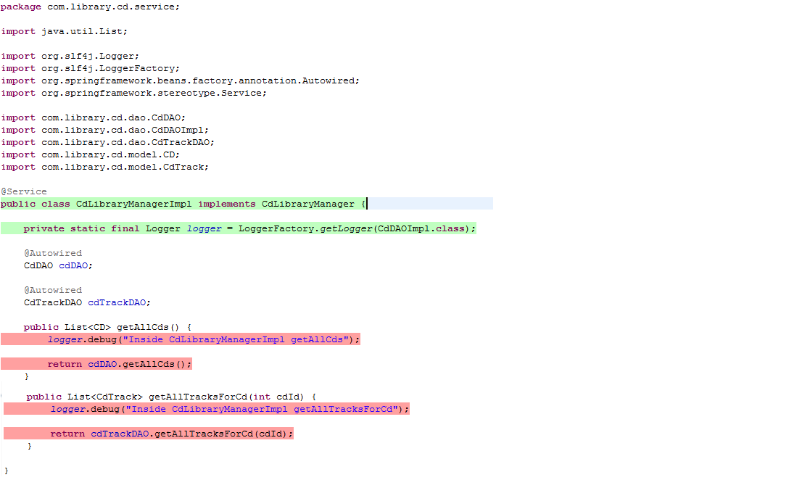

1. Controller classes:

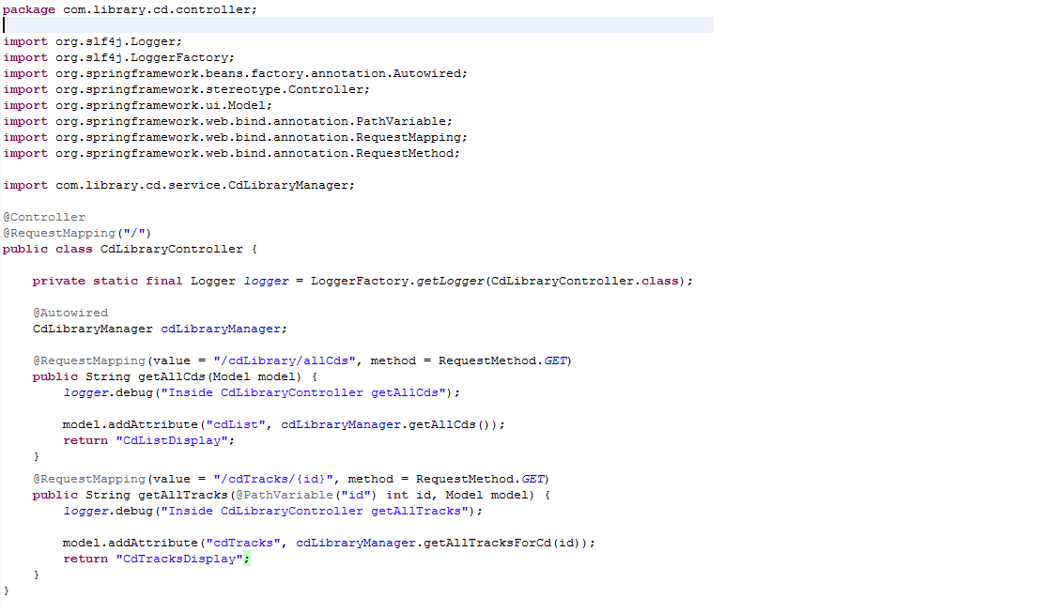

1. Junit test classes for DAO/Service and controller layer:

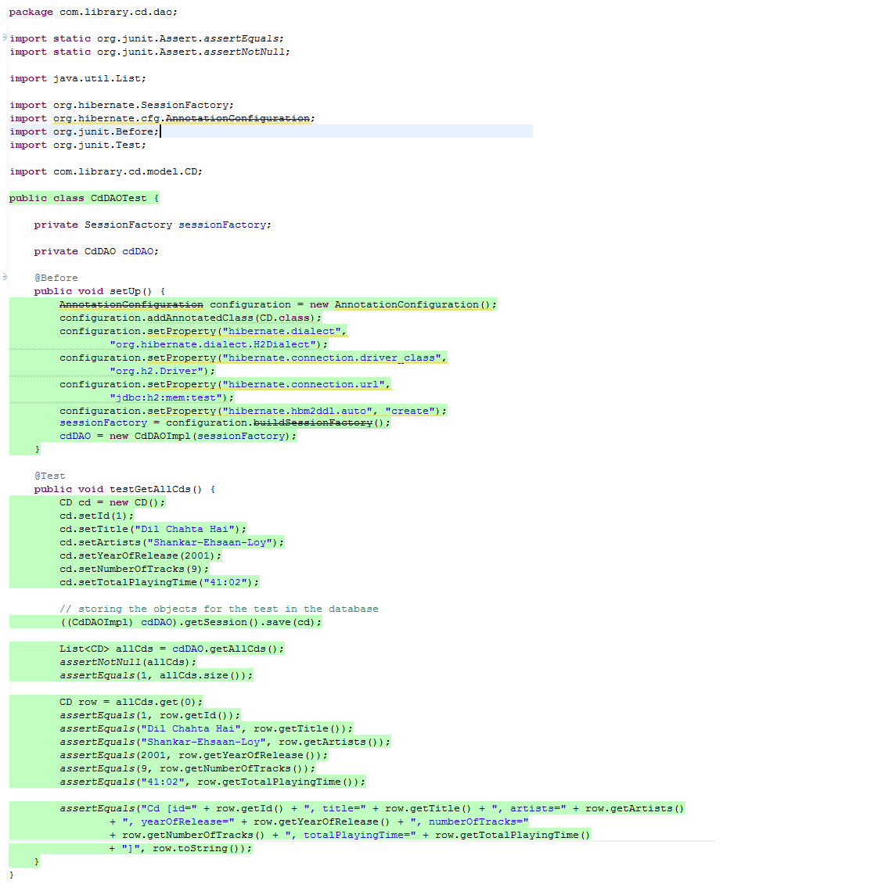

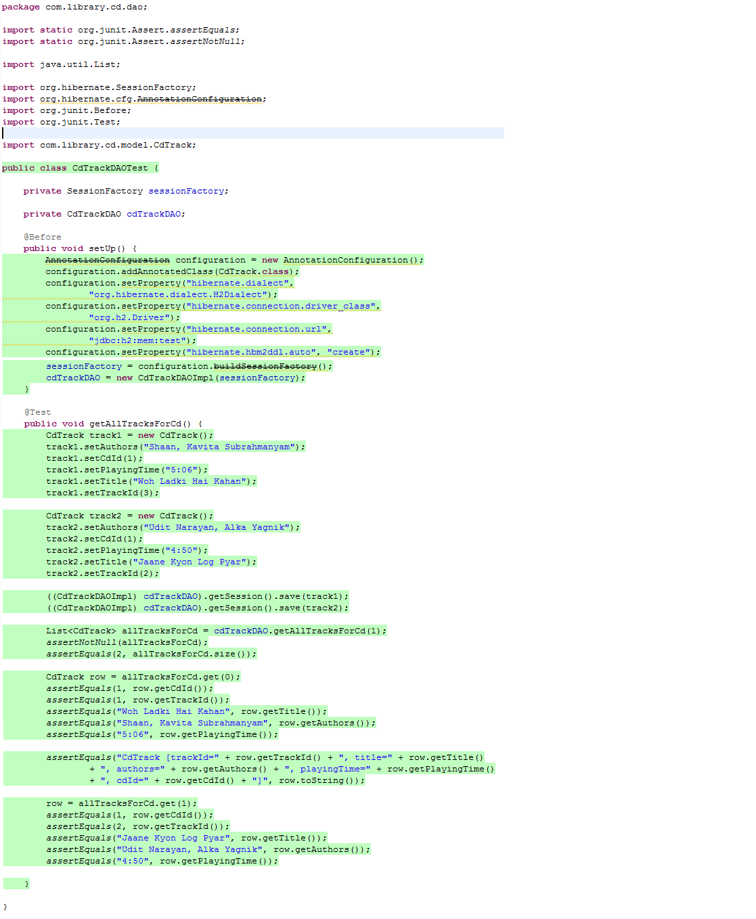

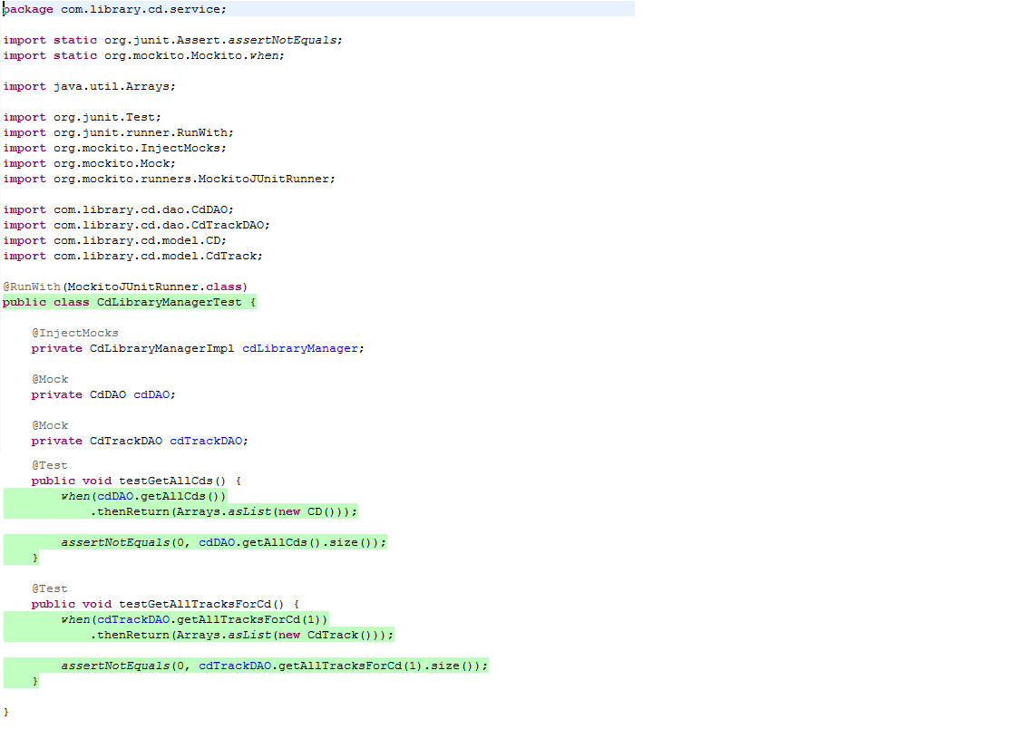

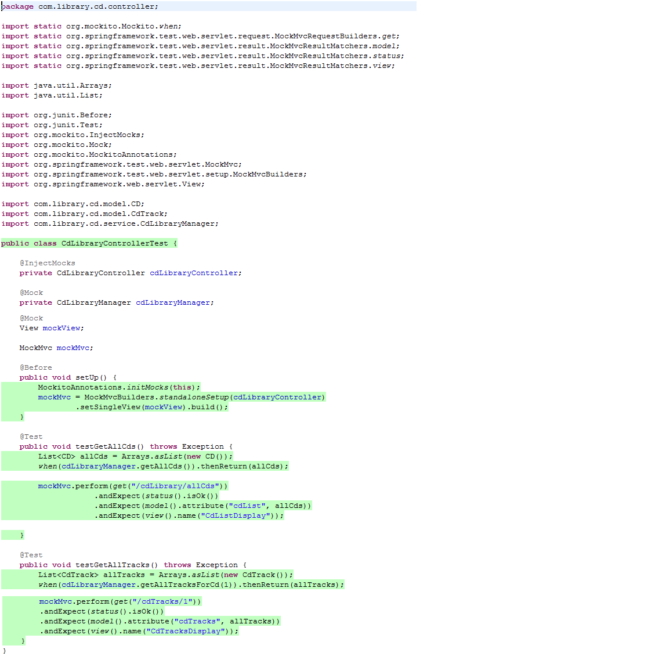

1. spring-servlet.xml:

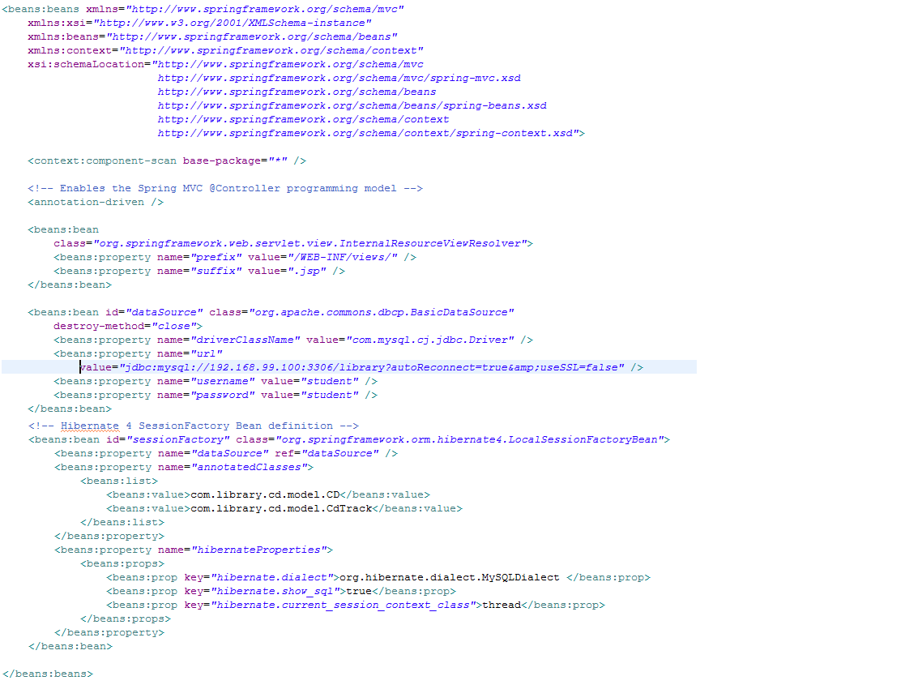

1. web.xml

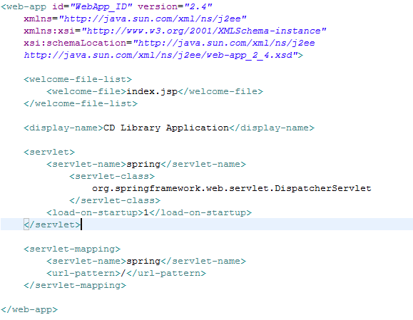

1. Index.jsp



1. Views

CdListDisplay.jsp

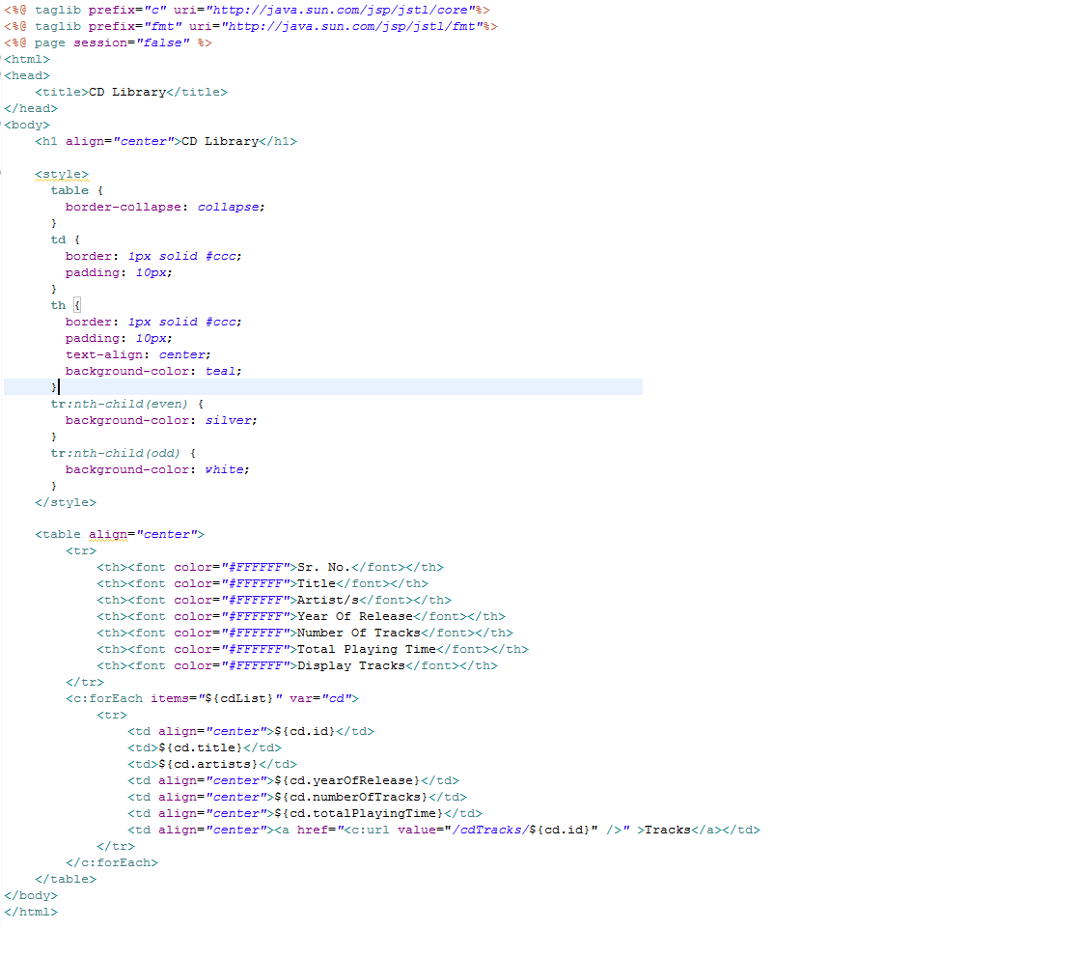

CdTracksDisplay.jsp

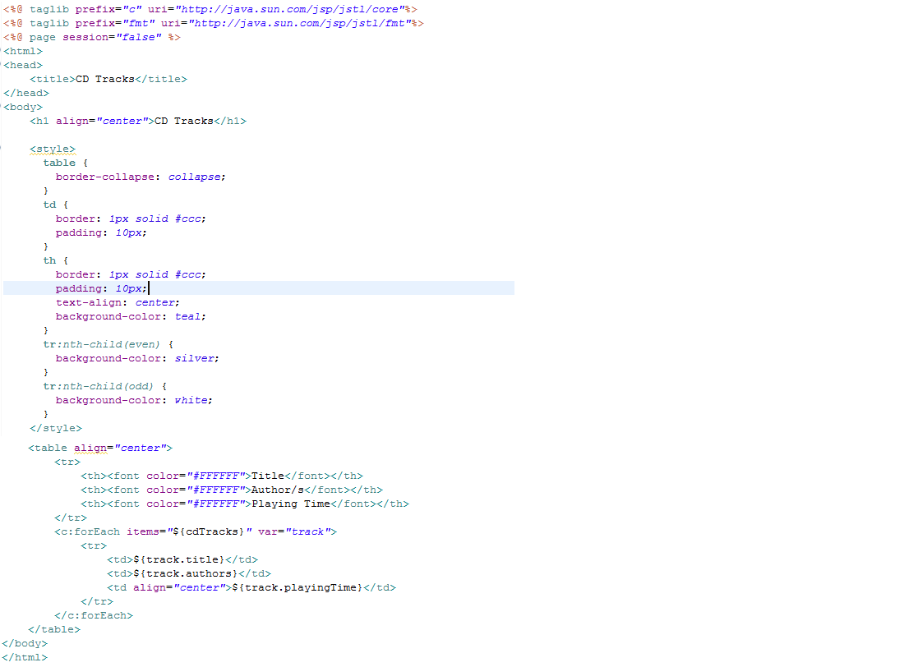

JSP pages

1. Main CD display page

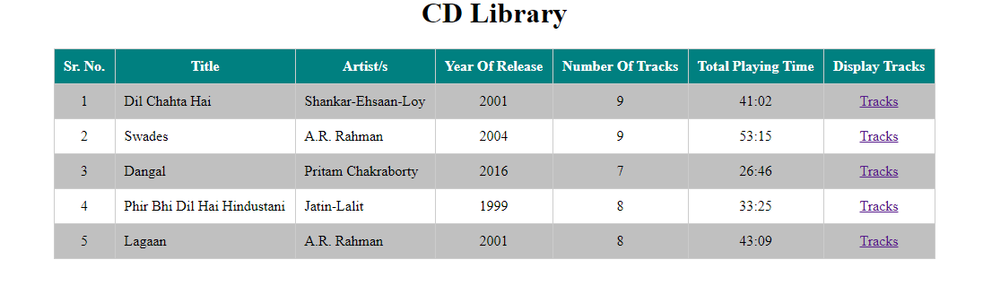

1. On clicking the “Tracks” link will display page with listing of tracks.

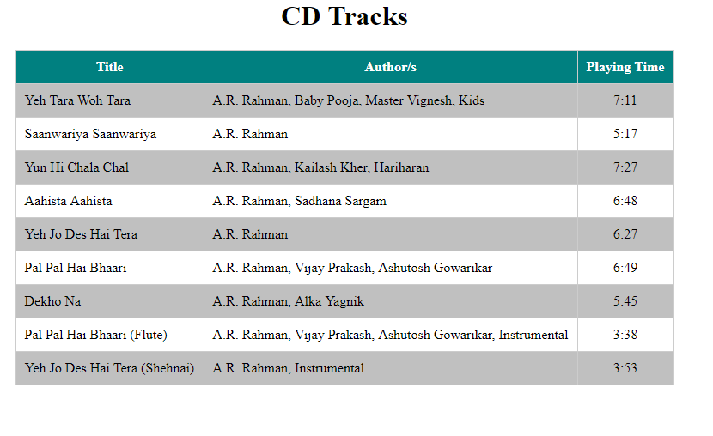

Jenkin’s Jobs

1. Code build job

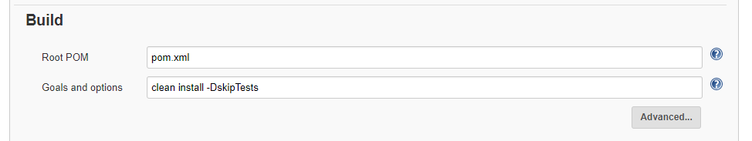

1. Code test job

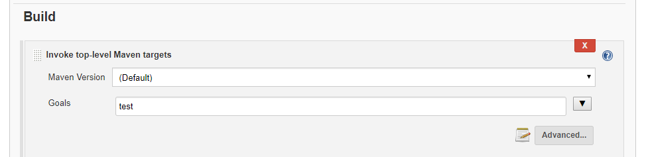

1. Deployment to tomcat job

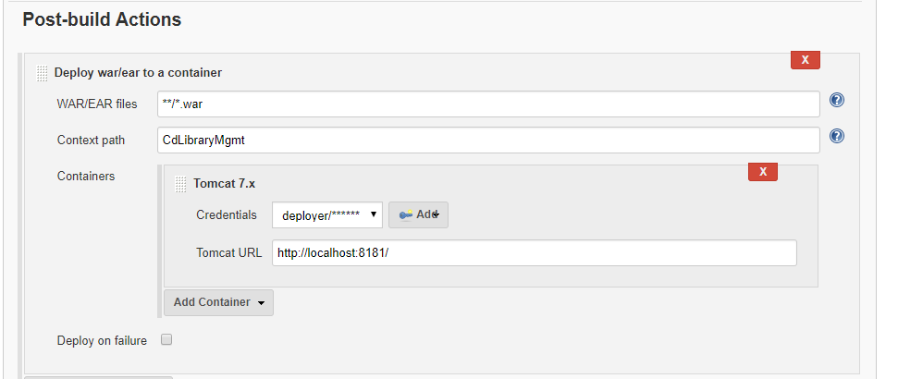

1. Build pipeline view

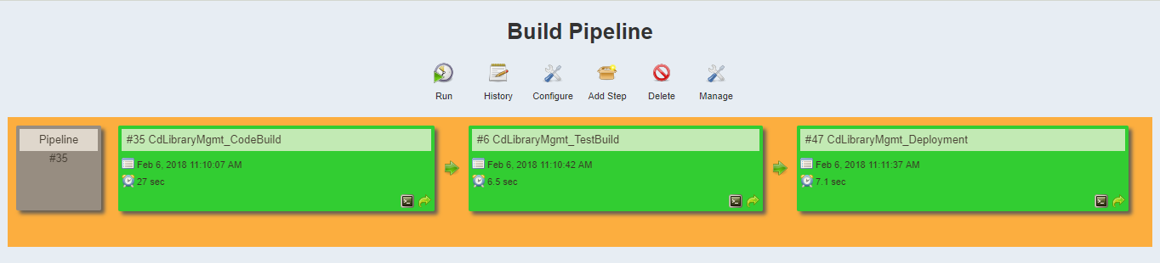

Code test and deployment jobs uses the build workspace. The custom workspace configuration is as below:

