Here we will learn how to deal with Jenkins like Installation, configuring, etc…

Let’s Start with Jenkins installation,

**Note: in this we will be using Ubuntu OS for working and it should pretty much similar for a Linux base machines and if any changes with respect to OS will be notified.**

* let’s follow this steps,
  + wget -q -O - https://pkg.jenkins.io/debian/jenkins-ci.org.key | sudo apt-key add –
  + sudo sh -c 'echo deb http://pkg.jenkins.io/debian-stable binary/ > /etc/apt/sources.list.d/jenkins.list'
  + sudo apt-get update
  + sudo apt-get install Jenkins
* These above steps will install Jenkins and apt-get update will make the system update the cache all the time so before installing something we need to take an update of the cache or else it will mess the things so better we take the update every time no and then.

Error in installing the Jenkins,

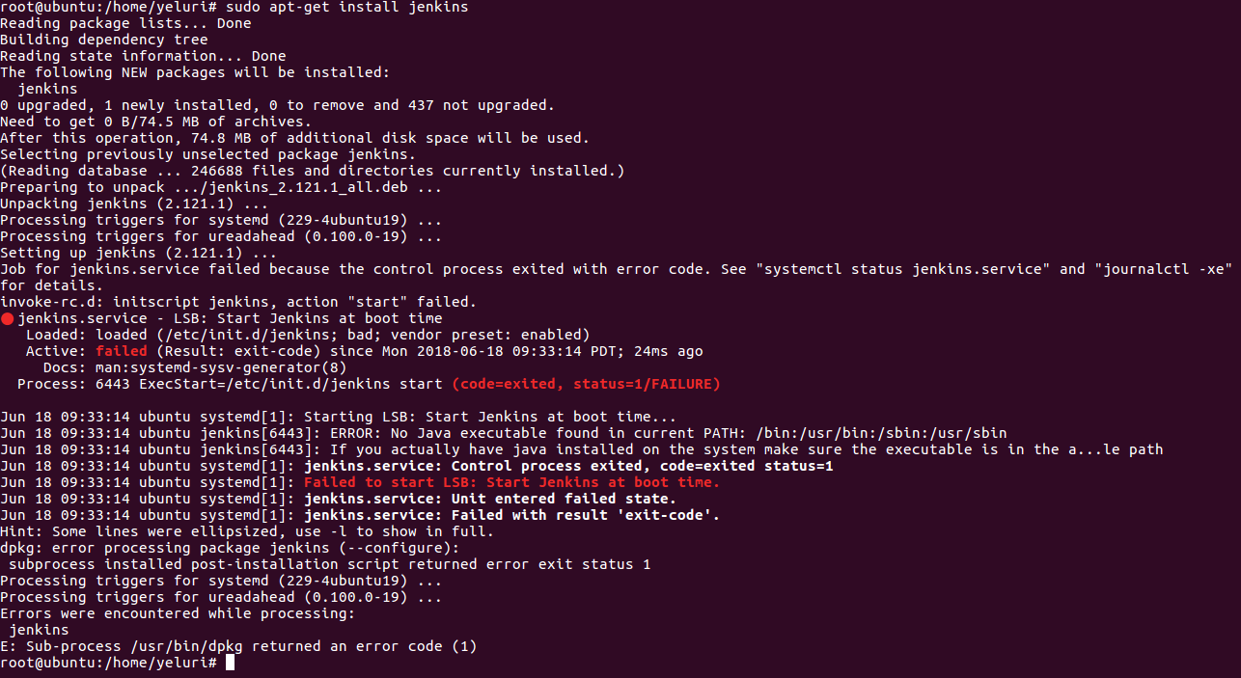

1. **Obtain application specific password**
   * sing-in to gmail account >> navigate to settings >> privacy and security settings
   * setup two step verification settings (because without two step verification we cannot generate application specific password)
   * after setting up two step verification setting in gmail account navigate back to security and privacy settings
   * click on application specific password >> give the name of the application in the drop down as Jenkins *(google by default does not have any specific application password setting for Jenkins)* >> this will generate password note down the password generated

**Note** : *Since the Password has a overall control over you gmail account disclosing it may lead serious consequences*

1. **Setup SMTP configuration for sending the gmail**
   * navigate in the following path from dashboard after logging in manage Jenkins >> configure system >> scroll down to email notification section
   * enter the following parameters
   * smtp server : smtp.gmail.com
   * default user email suffix : @gmail.com
   * select advanced
   * check smtp authentication
   * username : (Your gmail id)
   * password : (application specific password generated from previous step)
   * check use SSL
   * SMTP port : 465
   * Reply to address : noreply@gmail.com(optional)
   * Charset : UTF-8 (by default it is UTF-8)
   * select Test configuration mail
   * Test e-mail recipient : <enter recipient email id >

click on test configuration which will send a test mail to the recipient e-mail id