Python:
Print()– Built-in function to print lines
print(*objects, sep=' ', end='\n')
\n – new line character
Sep- Defines what separates multiple items.
End-Defines what appears at the end.

Literals:
Integers – without fraction (200,100023,-90,1_000_000)
Octal Number – 0o123

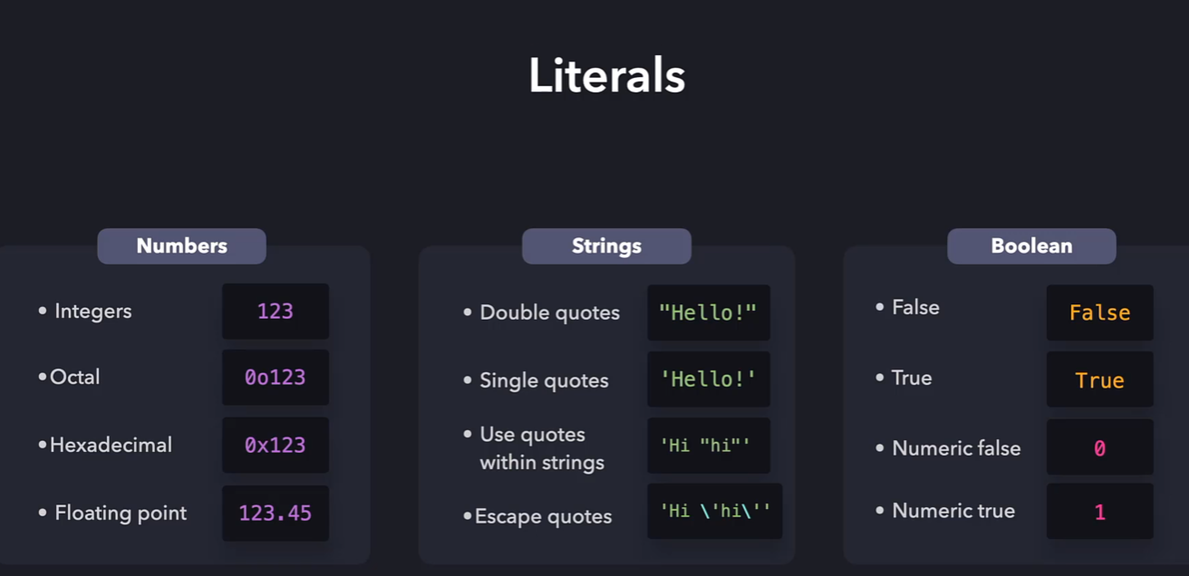
Operators:
Arithmetic operators -7:
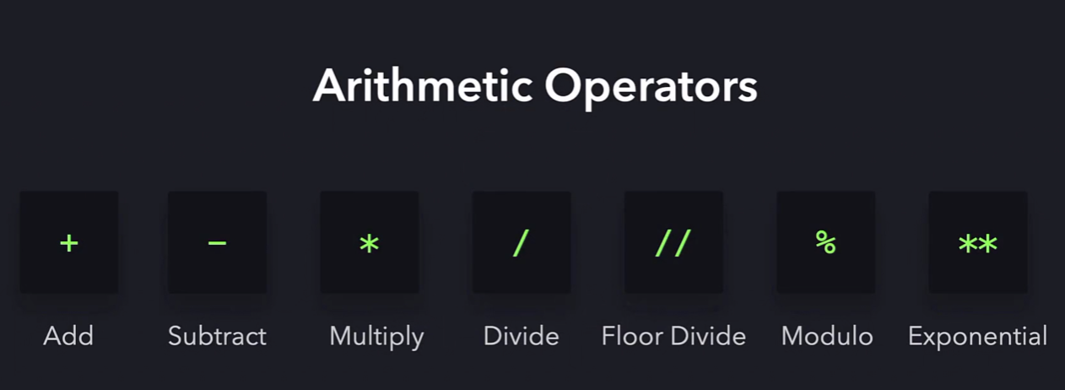
Exponentials - ** (2**3)
Modulo – 5%2 =1 (provides reminder after division)
Unary and Binary operators:
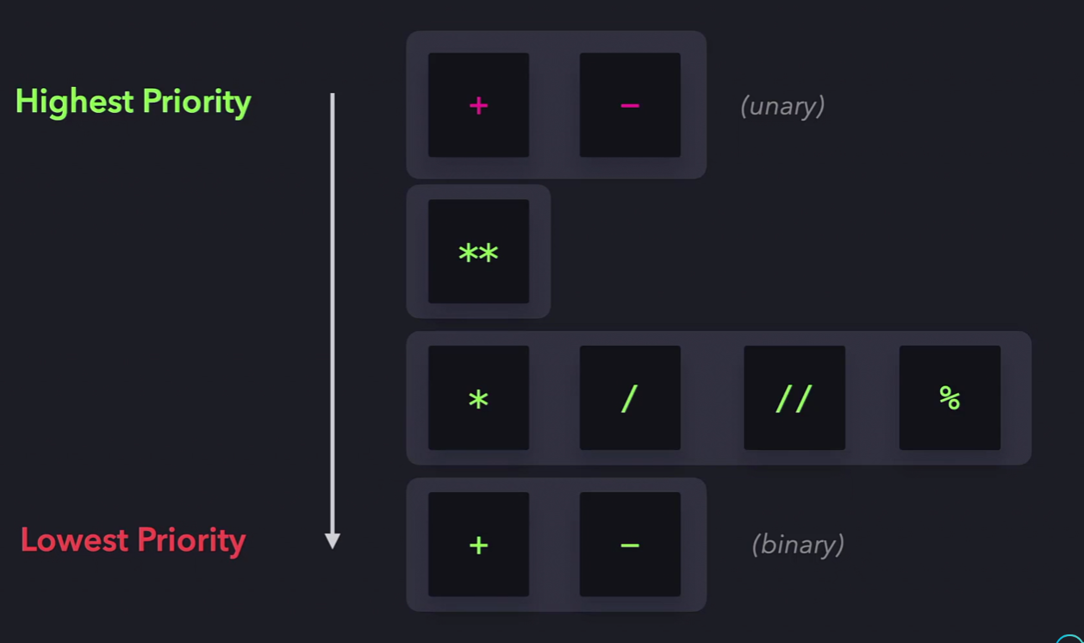
Variables: A bucket to store values, Variables can be redeclared
Shortcut operator:
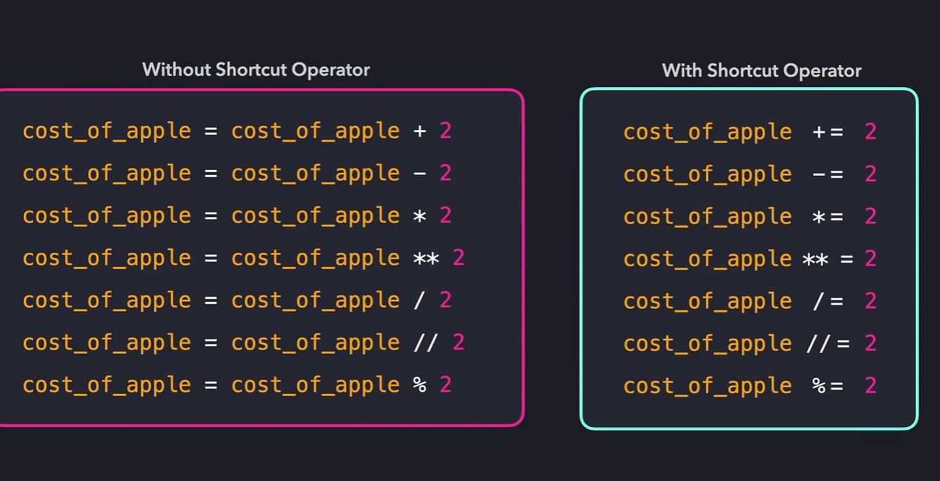
name = "Alice" # string
age = 25 # integer
height = 5.6 # float
is_active = True # boolean

