Table 2. I\* Syntax Coverage

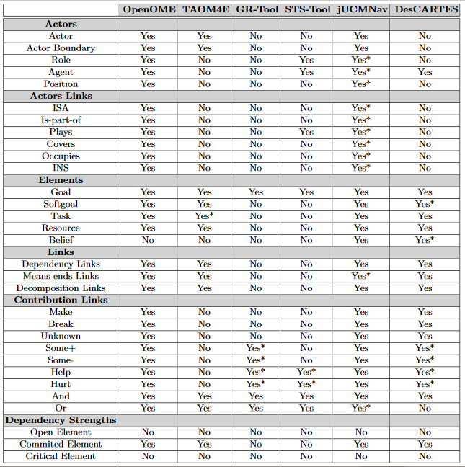

Table 3. I\* Semantic Analysis

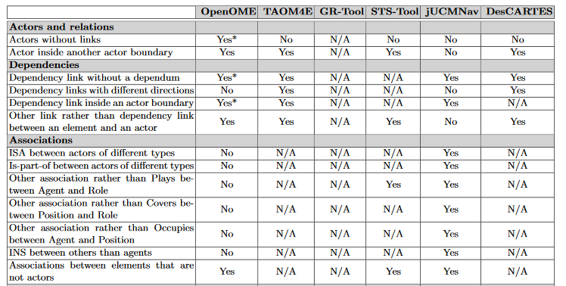

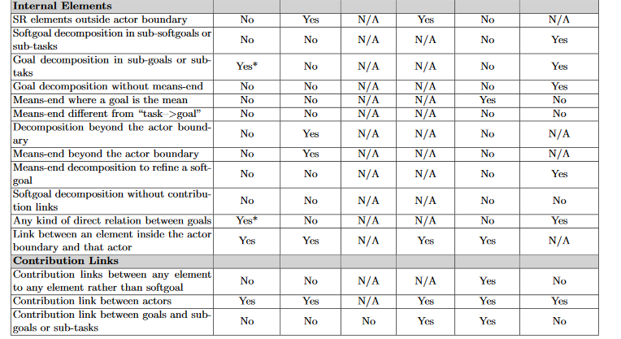

Source : <http://citeseerx.ist.psu.edu/viewdoc/download?doi=10.1.1.421.2124&rep=rep1&type=pdf#page=53>