11.comments

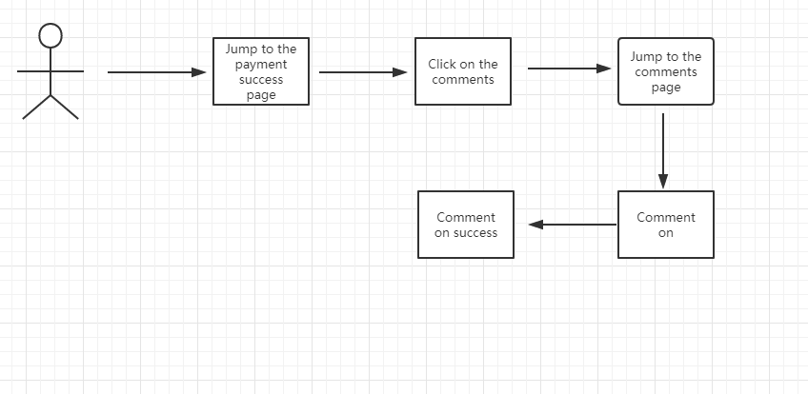

|  |  |
| --- | --- |
| Use case: 11 | comments |
| Related Requirem’ts | Req-5 |
| Initiating Actor | user |
| Actor’s Goal | Can satisfy already bought the customer to express the opinion, may provide the reference value for other customers |
| Participating Actors | User, Data base |
| Preconditions | The user must pay successfully first |
| Postconditions | Display successfully in the comments page |
| Flow of Events for Main Success Scenario | 1. Click the comment button  2. Comment |
|  |  |

11.说明：After successful payment, users can directly enter the comment page on the payment page and click the comment to directly comment.

12.View order status

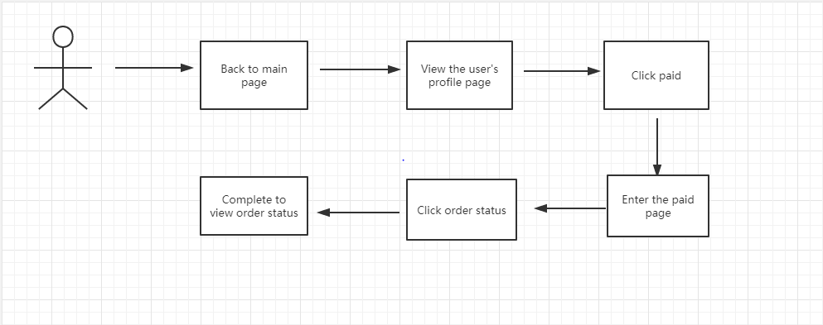

|  |  |
| --- | --- |
| Use case: 12 | View order status |
| Related Requirem’ts | Req-7 |
| Initiating Actor | user |
| Actor’s Goal | Users can know the status of goods in real time |
| Participating Actors | User, Data base |
| Preconditions | The user must log in successfully |
| Postconditions | The user browses the order information successfully |
| Flow of Events for Main Success Scenario | （1) click the user to view the order.  (2) the system displays the list of historical orders.  (3) select a specific order.  (4) display the order number, delivery time, receipt time, name of consignee, delivery address, contact number, price and total price of the goods contained in the order of a specific order. |

12.说明：After the user has successfully paid, go back to the main page. Click "purchased" in the user's personal page, and the order status can be viewed in the purchased page.