**Software engineering**

### Project Proposal

### software engineering project proposals

**12/5/2019**



Team: Shadowrocket

Team Member:

|  |  |
| --- | --- |
| Name | FHSU ID |
| William | 66195207 |
| Chandler | 66088445 |
| Palmer | 23137342 |
| Caden | 84751102 |
| Guy | 84651951 |
| Jay | 49038231 |

Github URL: <https://github.com/Devourd/SIAS-RENTAL-PLATFORM>

Table of Contents

Page Title

Problem diagnosis…………………………………..…………………….3

Proposed treatment……………………………………………………….5

Plan of work……………………………………………………………………………7

1. **Problem diagnosis:**

The problem we want to solve is to reuse the limited resources in our lives so that they can play a greater role. For example, I have a very expensive suit, but I only need to wear it several times on formal occasions, and most of the rest of the time is idle, which is not a good thing for the owner of the suit, because the size and style of the suit is fixed. Over time, the suit may not be in line with the trend, or it may not be used because of changes in the owner's body. In the whole process, the use of suits is very limited, resulting in a lot of waste. So its owner wants to rent out his clothes or sell them when they can't wear them. Others, who don't have a suitable suit, go to the mall to buy a suit that is very expensive, and he knows he can't wear it several times. So he would choose to rent a clothing store, rent a suit to use, or buy a very cheap suit, or find a friend to borrow one. Instead of having all your friends have the right suit, and they have no obligation to lend it to you, you can easily be rejected. Because you can make their clothes worn out and your friends can't benefit from it. So the demand for suits has a high probability of choosing the first two, thus forming a transaction. This often happens in schools. It's like buying a washing machine in our dormitory in school. I only use it when I wash big things. The rest of the time it is idle, and the school's public washing machine is very limited, can not meet the needs of students to wash clothes. And students often forget their clothes in the public washing machine, which also caused great trouble to later classmates. So they need to use a washing machine. And as a student, they often consume impulsively, and they buy many things that they don't even use several times. They may have purchased them simply because of a discount or because the item looks good. There are more such problems in schools, and they have not been solved. In fact, these situations are all one, that is, some resources in society can not be effectively allocated. Some people can't find what they want cheaply, and these things often exist in people who don't use them often or even don't use them. This has resulted in a great waste of resources, and the existing market mechanisms and systems can not completely solve such problems. This is my true feeling as a student.

1. **Proposed treatment:**

We refer to the current very hot part-time economy, so that those idle goods play a role in creating value. It's like Airbnb. Airbnb builds an online platform to let idle housing in society be rented out again, which not only benefits landlords, but also makes some wealthy travelers live in comfortable houses. Like Uber, they let idle private cars in society bring their fellow travellers on the road. Passers-by also pay the driver. Such a model not only enables the owner of the goods to obtain economic benefits, but also enables those short-term needs to get the services they need. That's how our business model works. We want to carry out such projects in schools, because the same students have a lot of things that are not often used, such as a pair of AJ shoes, his earphones and so on. These items are also needed by other students. Because the students on campus are graduating and new students are entering at the same time, the campus market is sustainable. And we can also charge a certain service fee behind every successful transaction to ensure the effective operation of the product platform. Through the above points, we have established not only our own business model, but also the market and profit model. We will help students in schools to trade and rent their goods by building an intra-school trading platform and integrating information. We can let those students who have idle items upload their items on the platform, choose to rent or sell them, and the price is determined by the students themselves. Students who need items can browse the mall of the platform and search for the items they need. Click on the item to contact the student who sells the item and establish the final price and distribution. And what we need to do is through the online platform, and can accurately guarantee the legitimate rights and interests of both sides of the transaction. Only in this way can more students be attracted to the platform for trading. So we will keep the transaction records and collect the personal information of the students through the application of accounts. If students can find what they need to do on the platform, while others can sell or rent what they don't need, and the items can successfully reach the students, then the project has been successful.

1. **Plan of work:**

Our early work plan has a linear progression that breaks down the entire project into several parts. Then assigned to each group member. We hope that every part of the project will be completed smoothly

Our first part has been completed. At the beginning of the project, we have made a clear division of work for the entire work plan, and we have made specific requirements for the date of completion of the work, so as to ensure the completion of the project. Below we use the Gantt chart to show the work plan of project one. 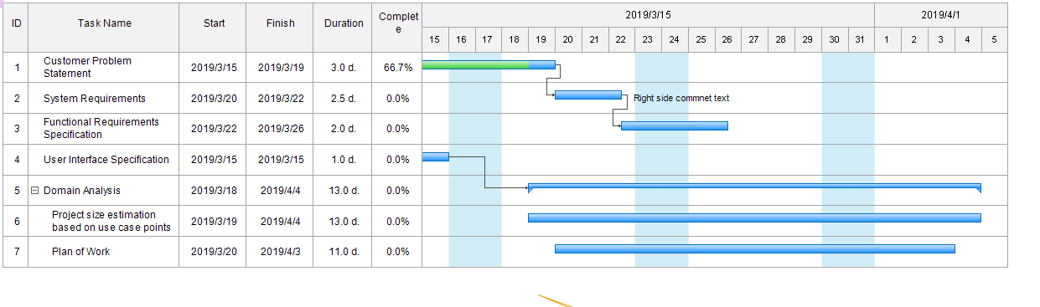

At the same time, we also made a plan Gantt chart of the whole project to ensure that we have a clear understanding of the whole project. We will clearly indicate the time and end time of the project in the figure. 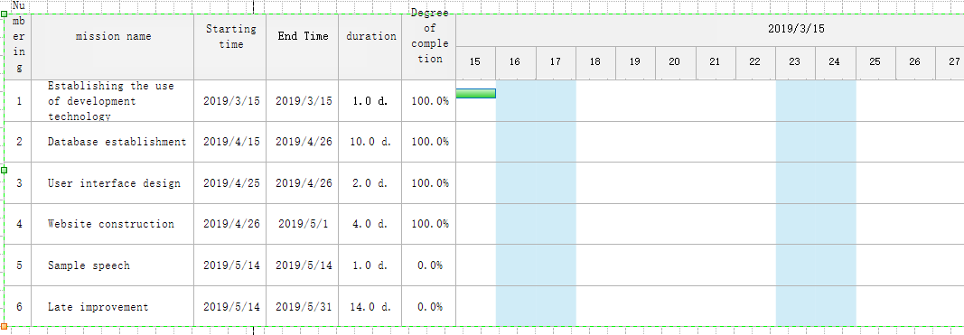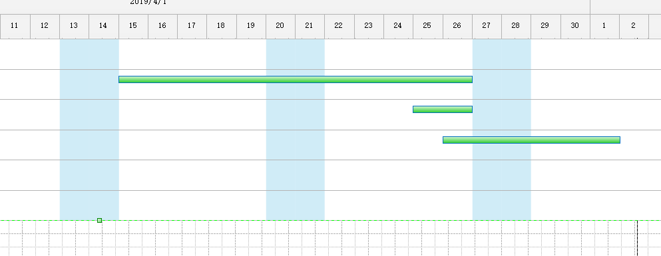

In the early stage, our development focus was on the website, but with the continuous development of mobile devices, our users may have demand for mobile phones. We will continue to investigate user needs and make new improvements according to market needs. Once our website is built, we may test it, correct the problems we find, and discover some of the features that we have found that we don't have, and add new features.

For our current shopping software, we will do a lot of work in the future to improve and optimize the software to provide better service to users. Large item information is a prerequisite for ensuring traffic to the shopping platform, so it is important to expand the user base. Vigorously promote our item trading platform to allow more people to register and publish items. We can push the item information according to the user's past shopping, let the user feel the intimate service, remind the user to have their favorite items on the shelves. In order to maintain a large flow of the platform, we must ensure that the user's shopping is comfortable. So we have some feedback on the problems caused by the software for some customers shopping, and timely improvement