**Software engineering**

### Project Proposal

**Reports 1**

**10/5/2019**

****Team: Shadowrocket

Team Member:

|  |  |
| --- | --- |
| Name | FHSU ID |
| William | 66195207 |
| Chandler | 66088445 |
| Palmer | 23137342 |
| Caden | 84751102 |
| Guy | 84651951 |
| Jay | 49038231 |

Github URL: <https://github.com/Devourd/SIAS-RENTAL-PLATFORM>

Table of Contents

Page Title Page No.

Customer Statement of Requirements…….…….……….………………. 3

System requirements……………………………………………………....8

Functional Requirements Specification…………………………………...10

User Interface Specification…………………………………….…….......31

Project Management…………………………………………….…….......35

Task Assignment…………………………………………………………..38

References………………………………………………………………39

Customer Statement of Requirements

1.1 Problem Statement

Nowadays, the Internet has penetrated into various fields of people's lives. E-commerce has increasingly occupied people's lives in recent years, and has penetrated into every aspect of the economy and life. The economic benefits and survey data generated by the e-commerce market show that e-commerce has become an important direction for the development of the network economy and the real economy. In fact, renting this kind of consumption is not much in our campus life. Usually when we need a certain kind of goods, our way is to buy directly. However, after the purchase, the usage rate of the goods may be very low, and it may not be used in life. It becomes an idle product in life, which makes us feel regretful to purchase it. This irrational impulse consumption not only wastes money, but also wastes the functions of the goods themselves, especially valuable electronic goods. We are very distressed by the difficulty of handling idle products in our lives, so we are eager to have a platform to properly handle the idle goods (electronic products) in our lives so that everything can realize its value. Here is an example of this:

* Student A's problem: Sias shopaholic, bought a lot of goods, bought a SLR camera, but its usage rate is too low, wasting money and goods.
* Student A's solution: a. Private transactions

b. Don't care

From the above, we can see that student A is unsafe and unreliable through private transactions, and his question has not been resolved.

When we entered the university, we all thought that we had time to learn more skills and need to buy equipment, but we didn’t know if we would like this skill. If we want to learn, we will spend a lot of money to buy equipment (I want to learn Photography, but I have to spend a lot of money to buy a SLR. If I don't want to learn photography in the middle, then this is a waste of SLR. I want to try other hobbies but no economic conditions. This also makes us very upset, so I hope to have a platform to provide us with goods, in simple terms, can rent goods on the platform to meet the needs of the university's interest life. Here is an example of this:

* Student A's question: I am interested in photography and want to buy a SLR camera, but the economic conditions are not up to, and I don't know if I am suitable for learning it.
* Student A's solution: no one.

From the above we can see that Student B has no solution. Unable to meet the needs of life.

Through the above two situations, I hope that there is a platform to provide us with services for handling idle goods and rental goods, which is urgently needed by our Sias students.

**Proposed Solution**

We will develop a website platform. The Sias leasing platform is an online platform for renting products (such as electronic products) and releasing rental information for the target students. We aim to provide our students with a good information exchange platform for product rental, to help them solve the problem of accumulated idle products in their hands and to enjoy life without spending a lot of money. There are quite a few websites for renting goods, but there are almost no websites for college students who rent products in Sias. We will treat the development and application of the website with a good attitude and provide a good rental platform for college students. Student A can post the idle SLR camera to this platform. This platform will process the goods of Student A. Student B can find the SLR camera through this platform and choose to rent, so that the needs of Student A and Student B can be satisfied.

**Two different actors’needs:**

* Actor – Lessor: He has the need to rent idle items on this platform.
* Actor – Lessee: He has a demand for renting certain goods on this platform.

**Mode of operation:**

Our project is online and offline. On the online, we provide students with a rent and rental information. Users on this platform can post rental information. See the products you need online. If you are in the information posted by your classmates, you can directly contact the publisher, face-to-face transactions. If the information you see in our section can be paid online, offline, you can also go online. Direct trading. In this process, after the completion of the rental, both parties can evaluate the satisfaction level, and at the same time assess the credit of the two parties. For those who have insufficient credit, we will manage and provide a good rental atmosphere for the platform.

**Target population:**

In terms of item recycling, it is mainly for students who are about to graduate in the fourth year. Most of the items they can't take away are very practical, and they are all sold at low prices, which saves us a certain cost in the initial stage. For all students in the rental of goods, they can rent things on our website, or they can find the items they want to rent in the item rental information sent by the students.

**Functional Features (Summary) - Users will be able to:**

1. Publish personal idle items online

2. Search and view all products in the platform

3. Users who post idle items can delete the release information.

4.Select goods and lease

5.View personal rented out products

6.View personal rental products

7. Full purchase of goods

8. User feedback

**1.2 Glossary of Terms**

*Admin* - Responsible for reviewing user-posted items in the background

*Application* - The main program that the user will interact with. This app is for user friendly and is located on the website.

*Database* - contains user data, rental product information, rental product information, digital settlement services or entity information

*Developers* - People involved in creating the front end of the Sias leasing platform website and its back end

*User address*: Address information of the user who rented the product

*Commodity User Interface*: The product interface that users see when they log in to the website.

*User* - the person who uses the Sias rental platform for leasing transactions

*QR Code*: QR code (abbreviated from Quick Response Code) is the trademark for a type of matrix barcode or two-dimensional barcode. In this report, the QR code is used for user Alipay payment.

*Verification code*: When the user registers the account, the combination code next to it needs to be verified.

*User Account*: The number used by the user after registration is the user account.

**System Requirements**

Functional Requirements:

|  |  |  |
| --- | --- | --- |
| Req-x | Priority weight | Requirement description |
| Req-1: | 2 | Users want to be able to easily and quickly register their account and stay logged in. |
| Req-2: | 3 | A clear and simple UI design allows users to quickly find the features they need |
| Req-3: | 2 | The user upload product interface needs to be compatible with various types of description files, including text, images, videos, etc. |
| Req-4: | 2 | Users can filter out the products they want to rent through various custom conditions. |
| Req-5 | 2 | The evaluation function of the product is an important basis for the user to judge whether the product is good or bad, and the feedback from the previous consumer can also provide suggestions for the improvement of the merchant. |
| Req-6 | 1 | Users can upload items in a simple process and can modify/delete items |
| Req-7 | 1 | Users can maintain their personal information, shipping address, etc., and be able to view their order status in a timely manner |
| Req-8 | 2 | Introduce a simple and diversified payment method that facilitates fast transactions and completes orders |

Nonfunctional Requirements

|  |  |  |
| --- | --- | --- |
| Req-x | Priority weight | Requirement description |
| Req-9 | 3 | The system can continuously and continuously online at 7 * 24 hours to meet different levels of user needs. |
| Req-10 | 2 | Ability to meet multi-user usage at the same time, avoiding website crash events |
| Req-11 | 2 | Website product inventory information should be updated in a timely manner |
| Req-12 | 3 | Ability to respond quickly to user requests, typically within 5 seconds |

Functional Requirements Specification

A: stakeholder.

1: students.

2: teacher.

3: investment company.

4: school

B: Actors and objectives.

Users need to visit the website to address their need for the reuse of idle goods and the purchase of goods at low prices. The site links two demanders to create an exclusive platform for trading and renting idle goods. Users who want to make a profit on restricted items need to upload photos and ideal prices of the items they want to sell or rent on the site. Users who want to use items can search for items on the site. Choose the right items to trade with the seller.

Users of the site can access it on both the mobile and CP sides.

Item search services help buyers find what they want and help sellers refer to prices.

Chat service is to help buyers and sellers to negotiate the price and the distribution of goods, the seller's price may be too high, and buyers want to use, chat can timely communicate with buyers and sellers to promote transactions. At the same time, users can choose their own offline distribution can also choose the delivery service of the website.

Distribution service is to help users to carry out the distribution of goods, users need to pay additional distribution costs.

The settlement service is to help users complete the transaction of goods online, once the user chooses to pay online, the website can extract the service fee from it. At the same time, it will leave the user's transaction information in the background, which can provide users with high-quality rights protection, and users will also choose more online payment.

The database service is used to store the seller's product information to help buyers search. And by recording transaction information to protect the interests of users, users can view their own transaction information in their own transactions, contact the background by telephone or report to protect their rights.

The registered account service is used to collect users' location information and personal information to facilitate distribution on campus. At the same time, detailed personal information can also protect the legitimate rights and interests of users. We can according to the user's information timely mediation or violation of the user mediation and litigation.

Use Cases

Use Case 1: Registration

|  |  |
| --- | --- |
| Use Case UC-1： | Registration |
| Related Requirem’ts: | REQ1 |
| Initiating Actor: | User |
| Actor‘s Goal | Users can register their own account password on the website and can log in successfully. |
| Participating Actors: | Database, users |
| Preconditions: | User opens the website registration page |
| Postconditions: | nothing worth mentioning |
| Flow of Events for Main Success Sccnario: | 1: User enters his own account, password  2: User registration information is stored in the database |

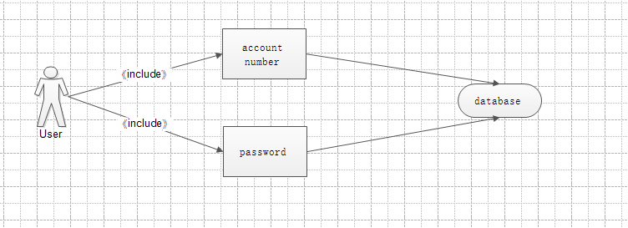

Use Case 2: Login

|  |  |
| --- | --- |
| Use Case UC-2： | Login |
| Related Requirem’ts: | REQ2 |
| Initiating Actor: | User |
| Actor‘s Goal | Users enter their own account password into the website system |
| Participating Actors: | Database, users |
| Preconditions: | The password account is successfully registered. |
| Postconditions: | nothing worth mentioning |
| Flow of Events for Main Success Sccnario: | 1: User input account password  2: Click the OK button |

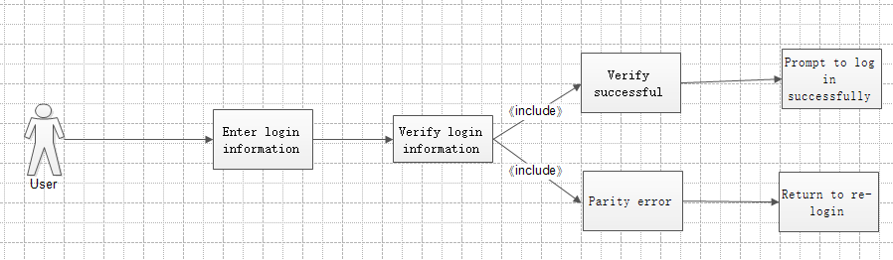

Use Case 3: Manage personal information

|  |  |
| --- | --- |
| Use case: 3 | Manage personal information |
| Related Requirem’ts | Req-2、Req-3 |
| Initiating Actor | user |
| Actor’s Goal | Improve or modify user’s personal information, including name, contact information, shipping address, etc. |
| Participating Actors | User, Data base |
| Preconditions | The user has successfully logged in and is ready to maintain personal information |
| Postconditions | Successfully connected to the system database for read/write operations |
| Flow of Events for Main Success Scenario | 1. Select the information box to be maintained.  2. Add/modify information that needs to be maintained  3. Click OK to save your changes. |

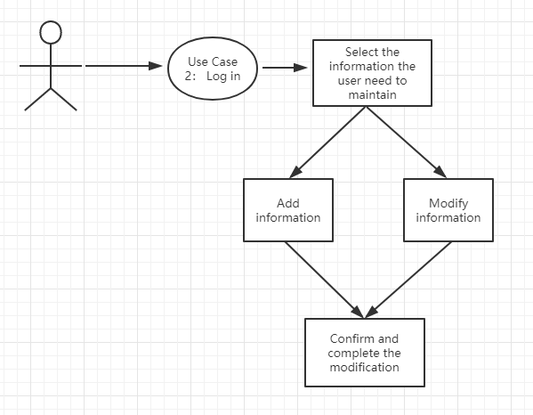

Use Case 4: Publish goods

|  |
| --- |
| USE CASE 4：Publish goods |
| **Related Requirements:** REQ1, REQ2, REQ3  **Initiating Actor:** User(lessor)  **Actor’s Goal:** Want to rent their own products on this platform **Participating Actors:** User(lessor), Smart Phone  **Preconditions:** Support from the system, goods can be reviewed in the background and can be stored in the database.  **Postconditions:** Provide product information feedback.  **Flow of Events for Main Success Scenario:**  *→*User provides product information to system in the product release interface  *←*Provide product information entry interface  *←*User input product information  *←*Waiting for background check  *←*examination passed, and product successfully published  **Flow of Events for Extensions (Alternate Scenarios):**  *→*User provides login request to software  *←*Provide user registration interface  *→*User created credentials  *→*User provides login request to software  *←*Provide user registration interface  *→*User created credentials |
| *→*User provides product information to system  *←*Provide product information entry interface  *←*User input product information  *←*Waiting for background check  *←*The review failed and the release of the item was illegal  *←*Return to the product release interface and feed back to the user |

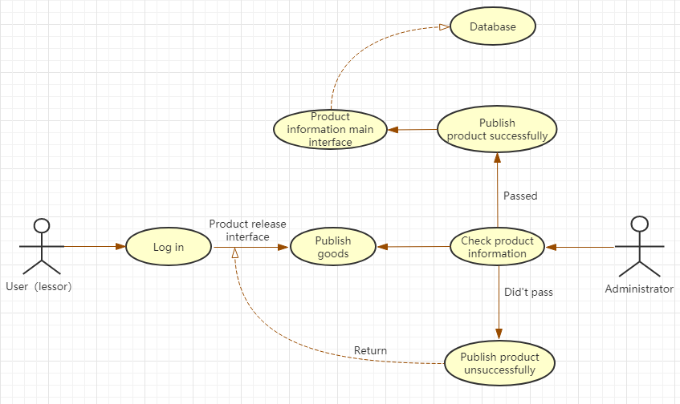

Uploading a product is a very important part for the user（lessor）. The user first has to log in to the website, enter the product release interface, and then publish the product, waiting for the background administrator to check. If the check is passed, the product information will be displayed on the homepage of the website. If the check fails, the system will return to the product release interface and feedback to the user（lessor）.

Use Case 5: Delete/Modify product

|  |
| --- |
| USE CASE 5*：*Delete**/**Modify product |
| **Related Requirements:** REQ1, REQ6  **Initiating Actor:** User(lessor)  **Actor’s Goal:** Want to delete his own published product  **Participating Actors:** User(lessor), Smart Phone  **Preconditions:** This feature is available in the system  **Postconditions:** Provide information feedback.  **Flow of Events for Main Success Scenario:**  *→*User requests to enter personal product information management interface  *←*Provide user personal product information  *←*User selects the product and clicks delete  *←*Delete product information successfully |

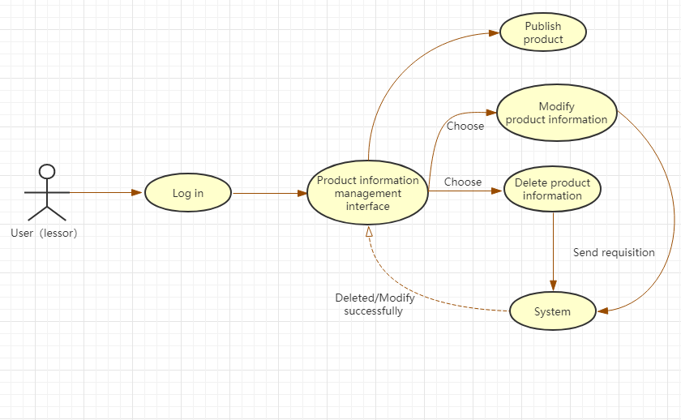

If the user（lessor） wants to delete the published item, we use this use case to achieve. First, the user（lessor） logs in to the website, enters the product information management interface, selects the product information that you want to delete and clicks “Delete”, sends the request to the system, and finally deletes successfully, and feedback to the product information management interface. Modifying the product is also similar to this process.

Use Case 6: Search and view goods

|  |  |
| --- | --- |
| Use case | Search and view goods |
| Related Requirem’ts | Req1、Req2、Req4 |
| Initiating Actor | user |
| Actor’s Goal | Open the website click on the search box and enter search keywords |
| Participating Actors | Commodity database |
| Preconditions | Users need to open the site and successfully log on to their account, open  the phone storage rights. |
| Postconditions | Access to the background database of the website |
| Flow of Events for Main Success Scenario | 1. Log on to the website account number 2. Open the mall interface 3. Click on the search box 4. Enter search keywords 5. Show search items |

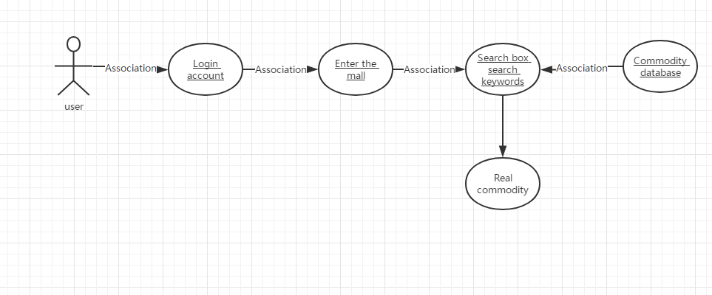

Use Case 7: Filter goods according to specific conditions

|  |  |
| --- | --- |
| Use case | Filter goods according to specific conditions |
| Related Requirem’ts | Req1、Req2、Req4 |
| Initiating Actor | user |
| Actor’s Goal | Open the website click on the search box and enter search keywords |
| Participating Actors | Commodity database |
| Preconditions | Users need to open the site and successfully log in to their account, open the search box and set the search criteria, and turn on phone storage permissions. |
| Postconditions | Access the database and search by search restrictions |
| Flow of Events for Main Success Scenario | 1.Log on to the website account number  2.Open the mall interface  3.Click on the search box  4.Enter search keywords  6. Set your own search restrictions  5.Show search items |

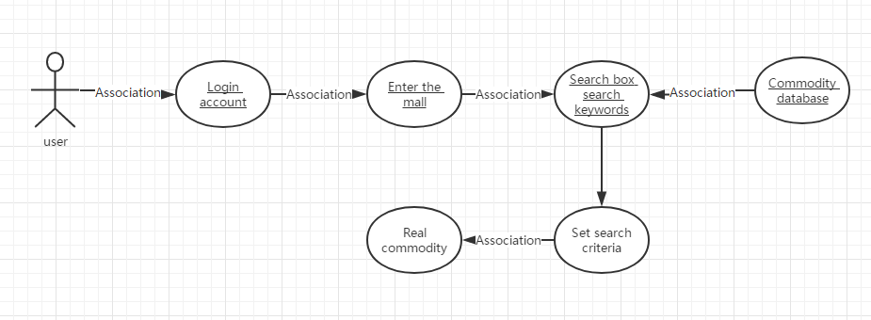

Use Case 8: Shopping cart checkout

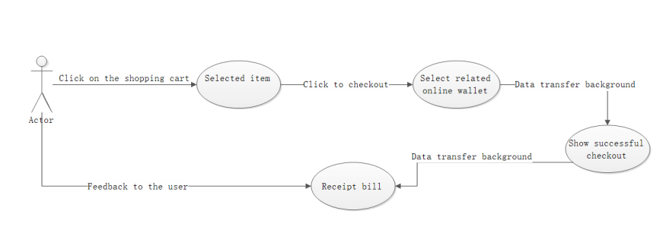

|  |  |
| --- | --- |
| User case | Shopping cart checkout |
| Related Requirem’ts | Already added the item to the shopping cart |
| Initiating Actor | user |
| Actor’s Goal | Check out the goods in the shopping cart |
| Participating Actors | System background, user, web page, internet |
| Preconditions | The relevant purchase information of the product has been completed before being added to the shopping cart. |
| Postconditions | Run related background settlement system |
| Flow of Events for Main Success Scenario | 1. Select related products to add to the shopping cart 2. Click the shopping cart button 3. Selected billing item 4. Click OK to settle 5. Use the relevant online wallet to settle 6. Successful settlement, feedback credentials |

Use Case 9: Full purchase of goods

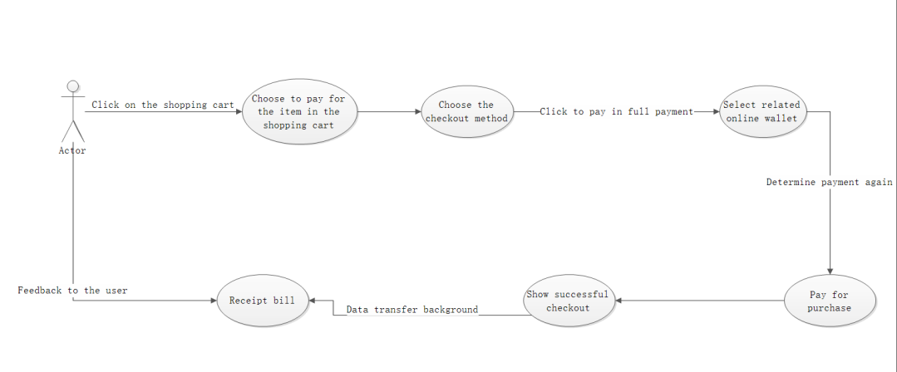

|  |  |
| --- | --- |
| User case | Full purchase of goods |
| Related Requirem’ts | Related rental products support full purchase |
| Initiating Actor | user |
| Actor’s Goal | Purchase second-hand goods for permanent use |
| Participating Actors | Website system, buyer, provider, data network |
| Preconditions | Let the lessee agree to pay the full purchase of the goods |
| Post conditions | Have enough balance in the wallet |

Use Case 10: Payment procedure

|  |  |
| --- | --- |
| Use case: 10 | payment procedure |
| Related Requirem’ts | Req-8 |
| Initiating Actor | user |
| Actor’s Goal | Confirm the price of the item purchased by the user and pay |
| Participating Actors | User, Data base |
| Preconditions | The user has added the item he wants to purchase to the shopping cart and is ready to check out |
| Postconditions | The system detects the price, quantity and other information of the product selected by the user and calculates the price. The database checks the inventory information and prepares for modification. |
| Flow of Events for Main Success Scenario | 1. Confirm the quantity, price and other information of the items to be settled  2. Choose a payment method  3. Payment  4. Confirm payment success |

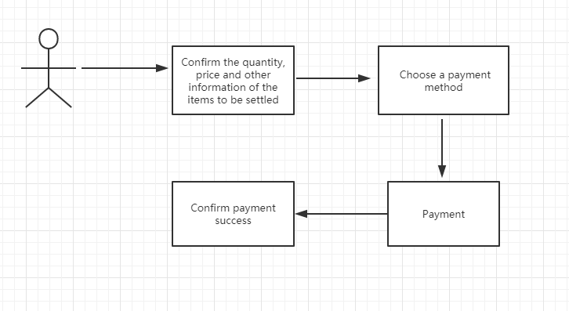

Use Case 11: comments

|  |  |
| --- | --- |
| Use case: 11 | comments |
| Related Requirem’ts | Req-5 |
| Initiating Actor | user |
| Actor’s Goal | Can satisfy already bought the customer to express the opinion, may provide the reference value for other customers |
| Participating Actors | User, Data base |
| Preconditions | The user must pay successfully first |
| Postconditions | Display successfully in the comments page |

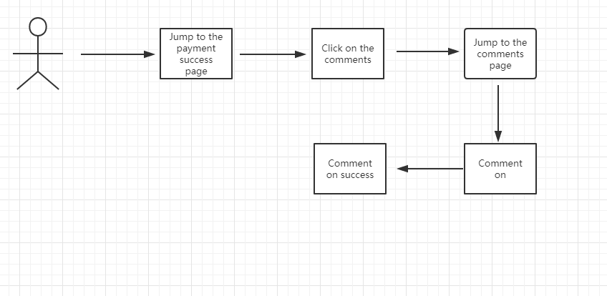

Use Case 12: View order status

|  |  |
| --- | --- |
| Use case: 12 | View order status |
| Related Requirem’ts | Req-7 |
| Initiating Actor | user |
| Actor’s Goal | Users can know the status of goods in real time |
| Participating Actors | User, Data base |
| Preconditions | The user must log in successfully |
| Postconditions | The user browses the order information successfully |
| Flow of Events for Main Success Scenario | （1) click the user to view the order.  (2) the system displays the list of historical orders.  (3) select a specific order.  (4) display the order number, delivery time, receipt time, name of consignee, delivery address, contact number, price and total price of the goods contained in the order of a specific order. |

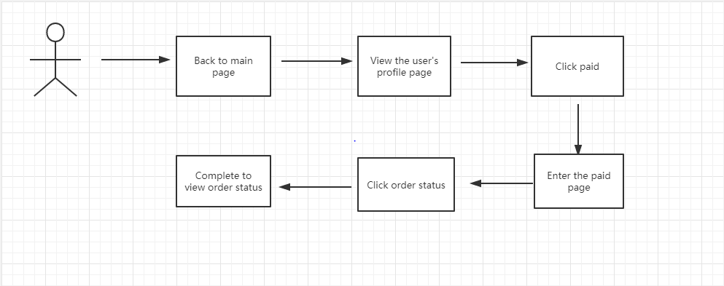

User Interface Specification

According to the software function design, the user will go through the following steps：

Users who need to rent：

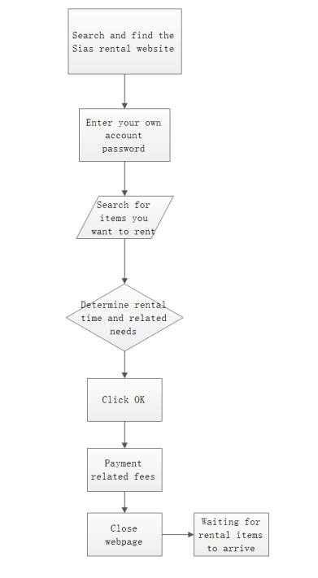

Users who want to be rented：

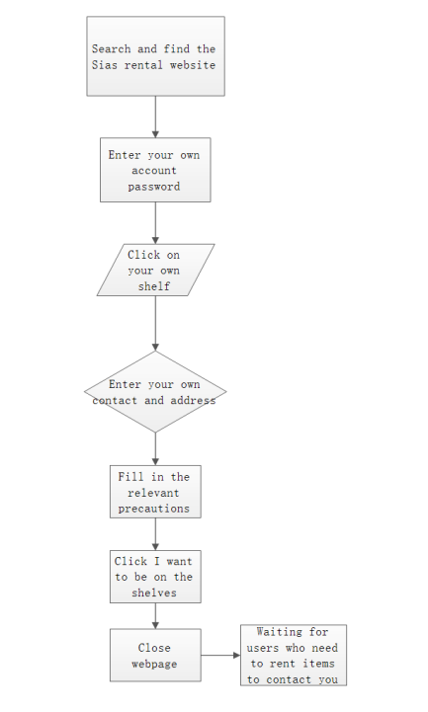

|  |  |  |
| --- | --- | --- |
| Operation | Example | Remarks |
| Open the web page to search for Sias leases in Baidu |  | Any search engine can |
| Enter your own username and password |  |  |
| Find what you want to rent |  |  |
| Determine the number of days you want to rent |  | The longer the lease time, the lower the price depends on whether the leaser agrees |
| Click to pay |  |  |
| Precautions after the leaser negotiates with the leased party | For example: how to calculate damage, whether you need to pay the relevant deposit, whether you need to fill in an informed letter, how to check, etc. | This item must determine the specific requirements and precautions of both parties. |
| Waiting for the leaser to determine the lease |  |  |
| Close Application |  | Close webpage |

Project Management

Our early work plan has a linear progression that breaks down the entire project into several parts. Then assigned to each group member. We hope that every part of the project will be completed smoothly

Our first part has been completed. At the beginning of the project, we have made a clear division of work for the entire work plan, and we have made specific requirements for the date of completion of the work, so as to ensure the completion of the project. Below we use the Gantt chart to show the work plan of project one. 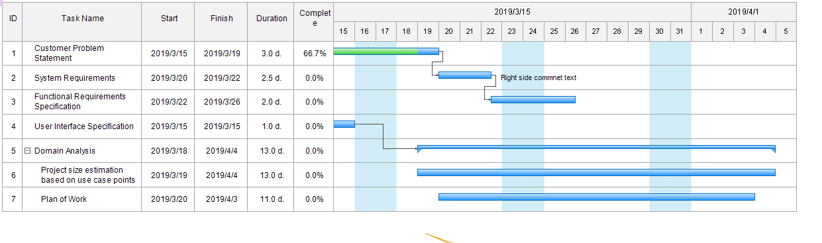

At the same time, we also made a plan Gantt chart of the whole project to ensure that we have a clear understanding of the whole project. We will clearly indicate the time and end time of the project in the figure. 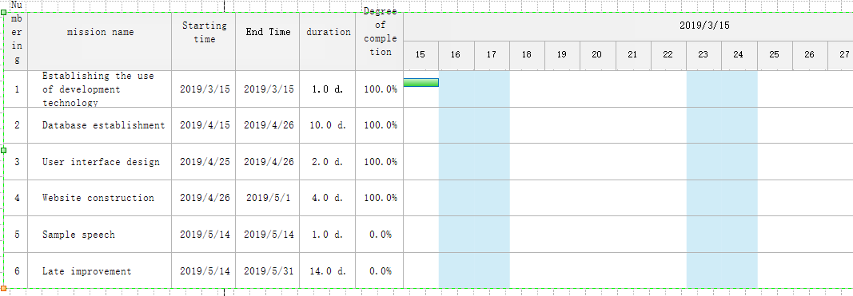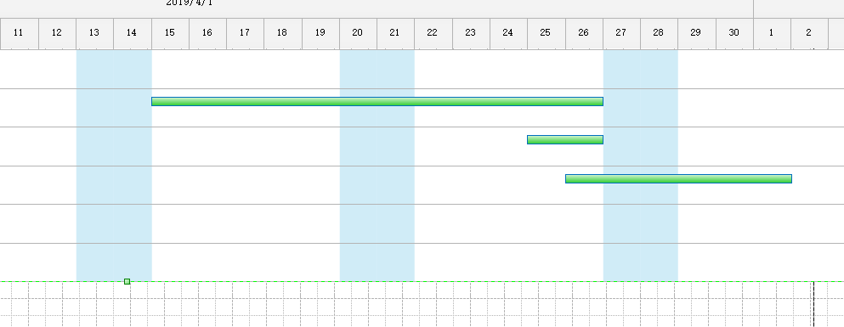

In the early stage, our development focus was on the website, but with the continuous development of mobile devices, our users may have demand for mobile phones. We will continue to investigate user needs and make new improvements according to market needs. Once our website is built, we may test it, correct the problems we find, and discover some of the features that we have found that we don't have, and add new features.

For our current shopping software, we will do a lot of work in the future to improve and optimize the software to provide better service to users. Large item information is a prerequisite for ensuring traffic to the shopping platform, so it is important to expand the user base. Vigorously promote our item trading platform to allow more people to register and publish items. We can push the item information according to the user's past shopping, let the user feel the intimate service, remind the user to have their favorite items on the shelves. In order to maintain a large flow of the platform, we must ensure that the user's shopping is comfortable. So we have some feedback on the problems caused by the software for some customers shopping, and timely improvement

Task Assignment

|  |  |  |  |  |  |  |  |
| --- | --- | --- | --- | --- | --- | --- | --- |
| Team Name: Shadowrocket | | William | Chandler | Palme | Caden | Guy | Jay |
| Responsi bility levels | Customer Statement of Requirements |  |  |  | **√** |  |  |
| System requirements | **√** |  |  |  |  |  |
| Functional Requirements Specification | UC-3,  UC-10 | UC-8,  UC-9 | UC-1  UC-2 | UC-4,  UC-5 | UC-11  UC-12 | Actors and Goals, Actors and Goals.  UC-6,  UC-7 |
| User Interface Specification |  | **√** |  |  | **√** |  |
| Project Management |  |  | **√** | **√** |  |  |

References

Java <https://www.w3cschool.cn/>

Java <https://www.runoob.com/>

<https://www.oracle.com/technetwork/java/javase/downloads/index.html>

SQL server <https://www.microsoft.com/zh-cn/sql-server/sql-server-downloads>

Drawing tool <https://www.processon.com/diagrams/new#template>

Tomcat <http://tomcat.apache.org/>