A: stakeholder.   
1: students.   
2: teacher.   
3: investment company.   
4: school

B: Actors and objectives.   
Users need to visit the website to address their need for the reuse of idle goods and the purchase of goods at low prices. The site links two demanders to create an exclusive platform for trading and renting idle goods. Users who want to make a profit on restricted items need to upload photos and ideal prices of the items they want to sell or rent on the site. Users who want to use items can search for items on the site. Choose the right items to trade with the seller.   
Users of the site can access it on both the mobile and CP sides.   
Item search services help buyers find what they want and help sellers refer to prices.   
Chat service is to help buyers and sellers to negotiate the price and the distribution of goods, the seller's price may be too high, and buyers want to use, chat can timely communicate with buyers and sellers to promote transactions. At the same time, users can choose their own offline distribution can also choose the delivery service of the website.   
Distribution service is to help users to carry out the distribution of goods, users need to pay additional distribution costs.   
The settlement service is to help users complete the transaction of goods online, once the user chooses to pay online, the website can extract the service fee from it. At the same time, it will leave the user's transaction information in the background, which can provide users with high-quality rights protection, and users will also choose more online payment.   
The database service is used to store the seller's product information to help buyers search. And by recording transaction information to protect the interests of users, users can view their own transaction information in their own transactions, contact the background by telephone or report to protect their rights.   
The registered account service is used to collect users' location information and personal information to facilitate distribution on campus. At the same time, detailed personal information can also protect the legitimate rights and interests of users. We can according to the user's information timely mediation or violation of the user mediation and litigation.

**Use Case 6 Search and view goods**

|  |  |
| --- | --- |
| User case | Search and view goods |
| Related Requirem’ts | Req1、Req2、Req4 |
| Initiating Actor | user |
| Actor’s Goal | Open the website click on the search box and enter search keywords |
| Participating Actors | Commodity database |
| Preconditions | Users need to open the site and successfully log on to their account, open  the phone storage rights. |
| Postconditions | Access to the background database of the website |
| Flow of Events for Main Success Scenario | 1. Log on to the website account number 2. Open the mall interface 3. Click on the search box 4. Enter search keywords 5. Show search items |

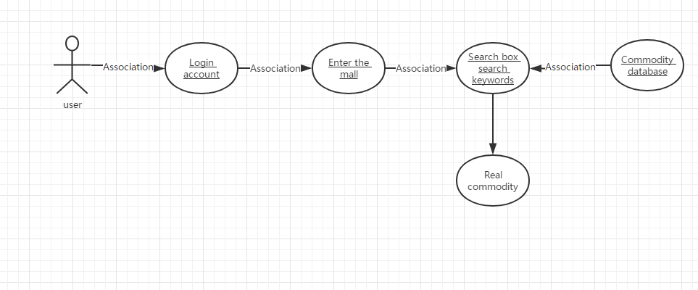

**Use Case 6 C**

|  |  |
| --- | --- |
| User case | Filter goods according to specific conditions |
| Related Requirem’ts | Req1、Req2、Req4 |
| Initiating Actor | user |
| Actor’s Goal | Open the website click on the search box and enter search keywords |
| Participating Actors | Commodity database |
| Preconditions | Users need to open the site and successfully log in to their account, open the search box and set the search criteria, and turn on phone storage permissions. |
| Postconditions | Access the database and search by search restrictions |
| Flow of Events for Main Success Scenario | 1.Log on to the website account number  2.Open the mall interface  3.Click on the search box  4.Enter search keywords  6. Set your own search restrictions  5.Show search items |

